A study of the induction of polytene chromosome puffing by heat shock treatment in Drosophila virilis

By Betia Salas
6993328

Bio2133 Section A5

Demonstrators
Salma Iqbal

January 15, 2014

Department of Biology

University of Ottawa

Figure 1. Isolated salivary gland cells of the Drosophila virilis, A, a stained wet mount showing the structures of isolated Drosophila virilis salivary gland cells at room temperature and B, a stained wet mount showing the structures of isolated Drosophila virilis salivary gland cells after brief heat shock treatment at 37C. The salivary gland cells from the fruit fly larvae of Drosophila virilis were isolated and stained in order to prepare a stained wet mount of the polytene chromosomes within their nuclei at both room temperature and at a higher temperature of 37C. The structures labeled B indicate bands whilst structures labeled I indicate interbands. The scale bar is 12 m for both A and B.

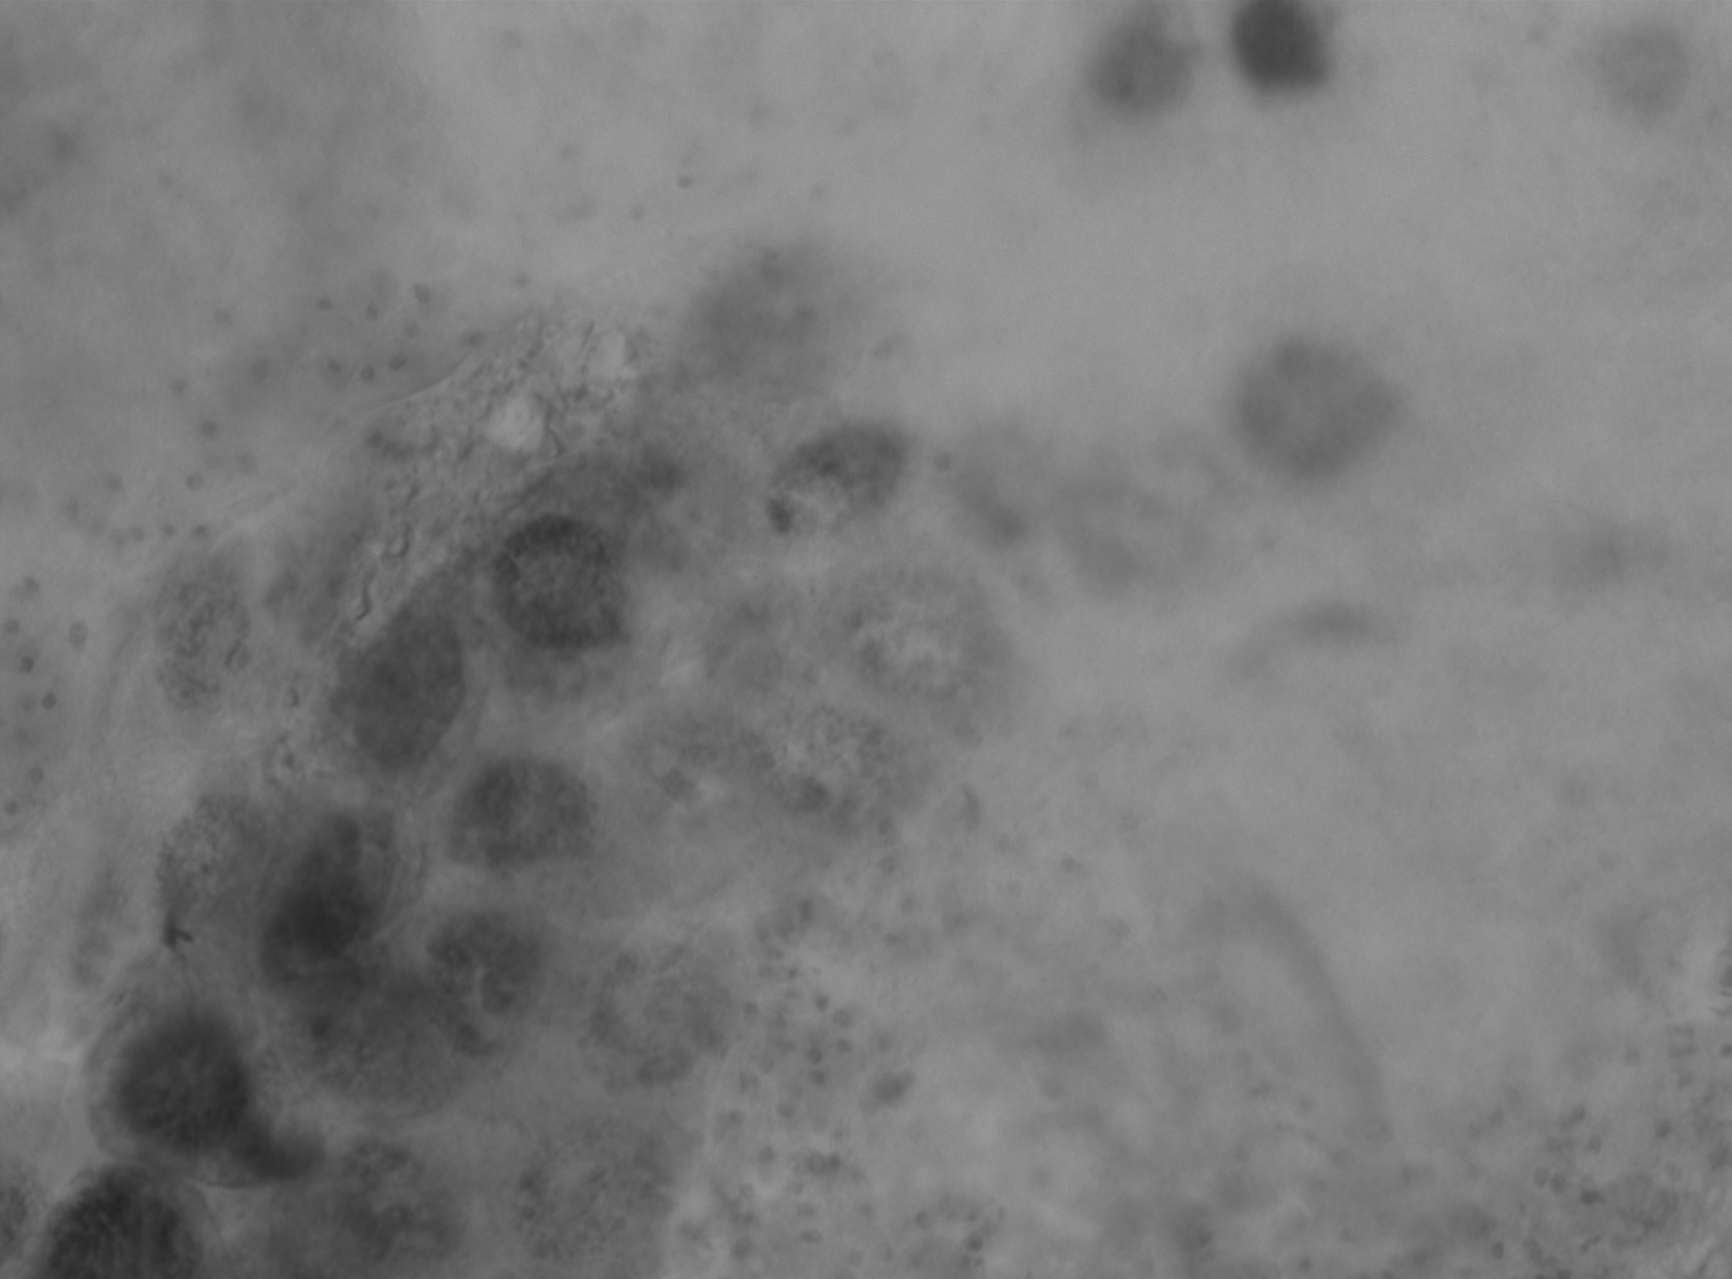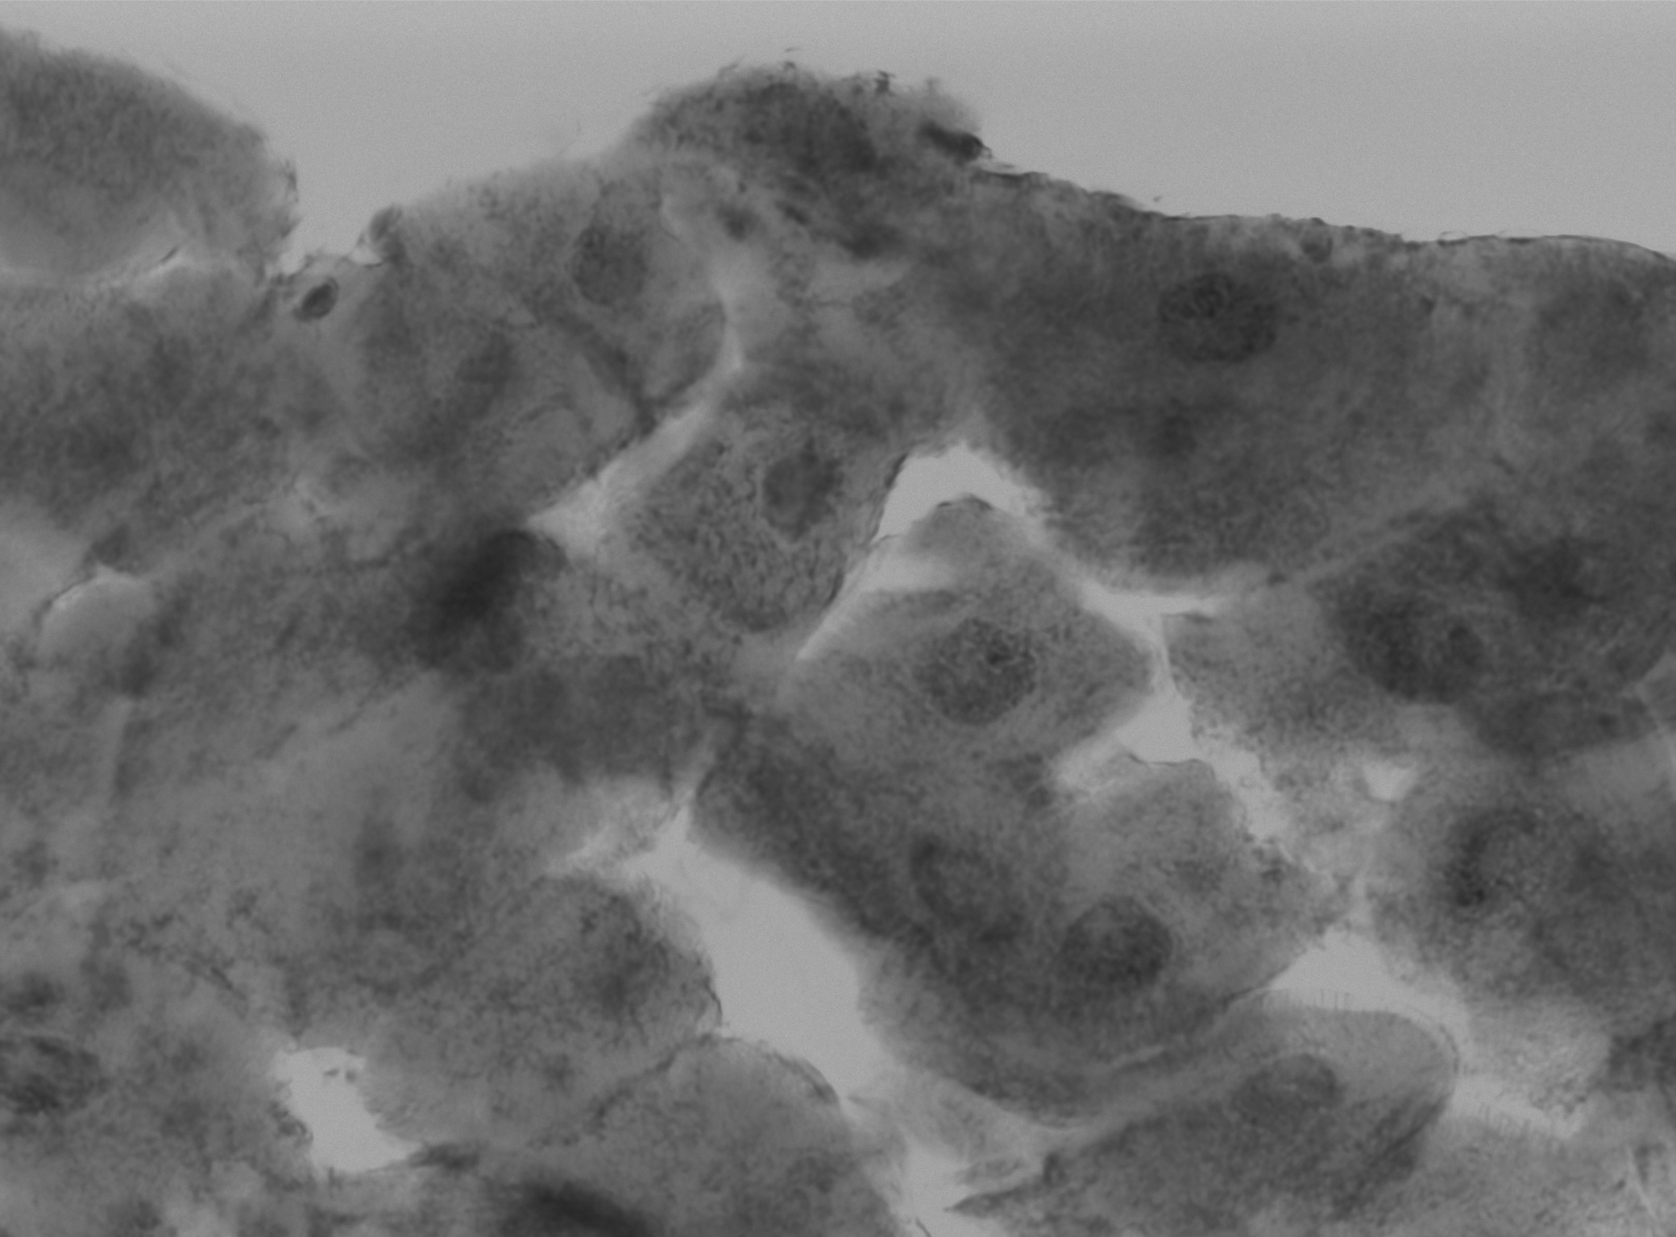
Questions
1. Describe the observed difference(s) between the structures of polytene chromosomes with and without heat shock treatment? (2 marks)
Polytene chromosomes that have undergone heat shock treatment exhibit strands with localized uncoiling, otherwise known as puffs. This indicates an increase in genetic activity where RNA is produced by genes involved in highly active transcription of DNA.
2. Give three biological processes or phenomena’s that were discovered through the study of polytene chromosomes? (3 marks)
Polytene chromsomes were found to be a good representational model of the interphase of chromosomes and the analysis of organization, replication and transcription at the cytological level has become possible because of this.This is because the production of polytene chromosomes is by successive replications of homologous pairs that remain synapsed (joined together) without separation or nuclear division, they remain in an extended interphase during the cell cycle.
It was found that the steroid hormone called ecdysone exerts its action through gene activation through studies of sequential puff formation in polytene chromosomes.
Lastly, heat shock treatments were discovered as a new occurrence of cellular stress response through studies on polytene chromosomes.
3. Why do you think that enzymes in salivary glands are produced more efficiently from polytene chromosomes rather than through normal chromosomes (i.e. in normal cells)? (2 marks)
As larva, fruit flies increase their size by ingesting large amounts of food. The salivary glands of the Drosophila sp. during the larval stage are thus large enough in order to provide a proper supply of enzymes for food digestion. They develop by increasing cell mass and volume rather than increasing cell number. This results in polyploidy with nuclei containing about a thousand copies of each chromosome.
4. Describe briefly why an increase in temperature at 37C induces puffing in polytene chromosomes? (3 marks)
An increase in temperature (this case being 37C), can result in the activation of certain genes within the polytene chromosomes. Since puffing is the phenomenon witnessed when high levels of gene activity (i.e./ RNA production by transcription) are occurring, a heat shock treatment involving exposure to a higher temperature induces a change in transcriptional activity within the polytene chromosomes and results in the uncoiling of strands (an indication of genetic activity).
- 5. Give two other factors that can also induce puffing? (2 marks)
The development of new puffs can be a result of two other factors such as genetic mutations or hormones.

