Save up to 50%*
Conceptual errors in preparing income statement
Case 1:
Roger Powers, founder and president of WindTech, Inc. was dismayed when presented with the following report. Despite better-than-expected sales the first quarter, the company’s ability to remain a going concern was now in doubt based on the high cost of operations. His company was organized at the beginning of the current year to produce and market a revolutionary new storage battery that captures and stores electricity generated by wind power. In addition, on April 3, the company’s finished goods warehouse was destroyed by a fire and all 8,000 unsold batteries were destroyed. These batteries represented 20% of the first quarter’s production. Although the company’s insurance policy states that the company will be reimbursed for the ‘cost‘of any finished batteries destroyed or stolen, the insurance adjuster is disputing the company’s claim of $226,000. The company’s somewhat inexperienced accountant determined the amount of the claim as follows:
Total Costs for the quarter/Batteries produced during the quarter = $1,130,000/40,000 units = $28.25/unit
$28.25 x 8,000 batteries = $226,000
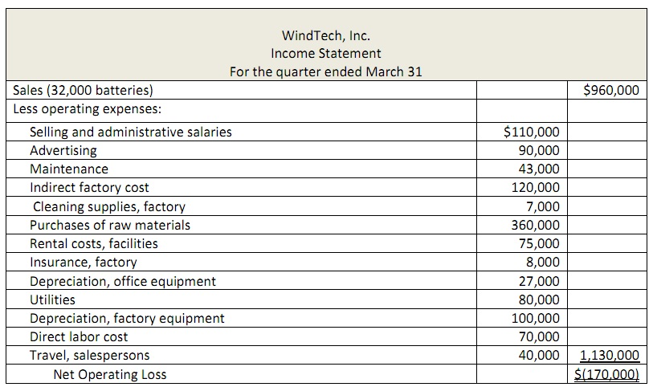
The following additional information concerning the company’s activities during the quarter is available:
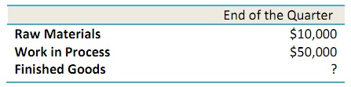
Eighty percent of the rental cost for facilities and 90% of the utilities cost relate to manufacturing operations. The remaining amounts relate to selling and administrative activities.
a) Describe the conceptual errors, if any, made in preparing the income statement above.
b) Prepare a schedule of cost of goods manufactured for the first quarter.
c) Prepare a corrected income statement for the first quarter. Show how cost of goods sold is computed.
d) Do you agree that the insurance company owes WindTech $226,000? Explain your answer.

