Digestive System:

3 general functions of the digestive system:

- Digestion is the mechanical and chemical breakdown of foods and the resulting absorption of nutrients by cells.
- Mechanical digestion breaks large pieces of food into smaller ones without altering their chemical composition.
- Chemical digestion breaks food into simpler chemicals, which get absorbed into the body for further use.
- The digestive system consists of the alimentary canal, which extends from the mouth to the anus, and several accessory organs, which secrete substances into the canal, used in digestion.
- Process food for energy as a source of materials for growth and repair.

Alimentary Canal: consists of the mouth, pharynx, esophagus, stomach, small intestine, large intestine, rectum, and anus; the accessory organs include the salivary gland, liver, gallbladder, and pancreas.
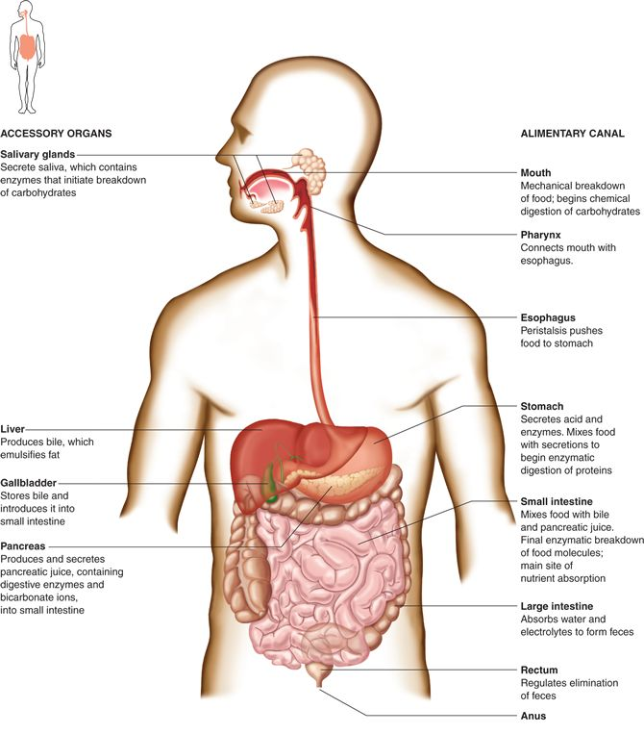
Structure of the wall of Alimentary Canal:
tube of smooth muscle, 9m long, inside epithelial surface exposed to environment.

Four layered structure:
- Mucosa (mucus membrane) lining cells secrete mucus and digestive enzymes. Carries out secretion and absorption of nutrients.
- Submucosa (nourish surrounding tissue) has blood vessels, lymphatic vessels, carry away the absorbed materials.
- Muscular Layer ( movement of the tube) consists of smooth muscle tissue.
- Serosa (serous layer) the outer covering moistens and lubricates the outer surface so organs are able to move freely against one and other.

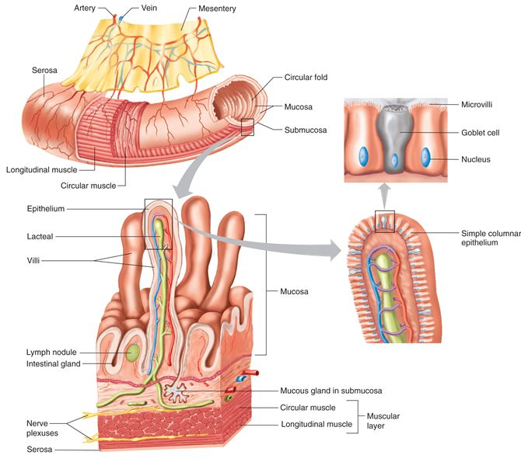

Movements:

Mixing movements like those in the stomach. When the stomach is full waves of muscular contractions along its walls mixes food with digestive juices.
Propelling movements like peristalsis pushing the food along.

Mouth:
- Teeth, which break up food for mechanical digestion.
- Tongue, which mixes and shapes food into a ball to aid in swallowing.
- Salivary glands produce enzyme amylase to help break down starch.
- Function of the mouth: mechanical digestion: breaks up food and mixes it with saliva, chemical digestion: amylase hydrolyzes starch into the disaccharide maltose.

Components of Saliva:
- Fluid that moistens particles, helps bind them, and begins the chemical digestion of carbohydrates(starch and glycogen).
- Saliva also dissolves food to help taste them, and cleanses mouth and teeth.
- Serous cells produce a watery saliva that has the digestive enzyme amylase.
- Mucus cells secrete thick liquid which helps bind food particles and lubricate them to help swallow.

Major Salivary Glands:
- Parotid gland- the largest, lie inferior ear to ear, secrete clear watery fluid that is rich in salivary amylase.
- Submandibular- located on the floor of the mouth on the mandible bone (in the middle of the 3 glands). Equally serous and mucus secretions.
- Sublingual- in the very front of the mouth, mostly mucus secretions, thick and stringy secretions.

Pharynx:
- Common passage way for food and air, splits into the trachea(air) and food(esophagus)
- Epiglottis is a flat of elastic cartilage. This closes over the trachea when you swallow directing food into the esophagus.

Esophagus:
- Wall of the tube has two layers of smooth muscle.
- Pushes food into the stomach using peristalsis.

- The sphincter controls the movement of food through the tube.

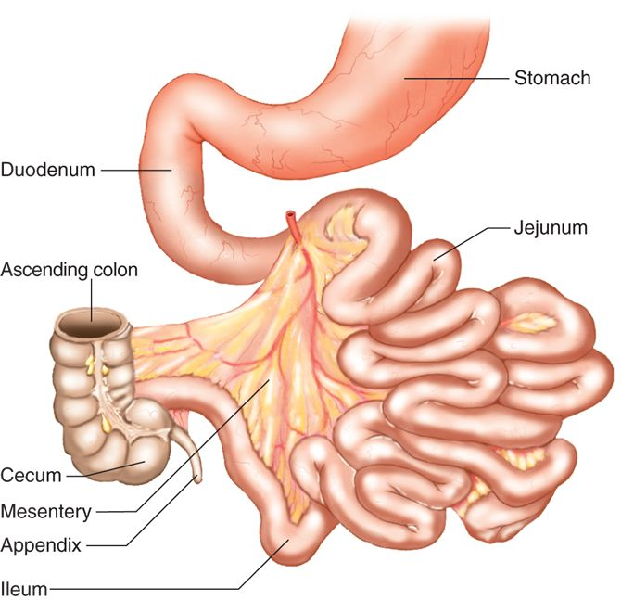

Stomach:
- A muscular sac with an extra third layer of muscle.
- Inner surface is wrinkled
- Gastric glands in epithelium secrete gastric juice.
- Sphincters control the flow in and out.
- Mixes food with gastric secretions by peristalsis.
- Stores mixture.
- Gastric glands produce hydrochloric acid, which activates enzyme pepsin.
- Pepsin hydrolyzes proteins into short polypeptides. Pepsin also produces mucus to protect the surface of the stomach so it doesn’t digest itself.

Chyme:
- The acidic mixture of partially digested food.
- Slowly delivered through sphincter into duodenum (1st section of small intestine)
- Taste and small receptors and food stretching the stomach wall stimulate the stomach muscles to contract.

Chemical Digestion:
- Liver: produces bile which emulsifies large fat globules into fat droplets. Bile is released into the duodenum. This increases surface area for enzyme action.
- Liver: stores glygocen in response to insulin, breaks down glycogen to glucose, converts non-CHO’s into glucose, protein metabolism, stores iron and vitamins A,D,B12, destroys damaged RBC, detoxifies substances like alcohol and drugs.
- Bile: secreted from hepatic cells in the liver, bile contains water, salts, pigments, cholesterol, electrolytes. The salts are the only part that have digestive function.
- Bile salts: salts aid digestive enzymes by affecting fat globules, breaks the fat into smaller droplets, lipase can better digest, enhances absorption of fatty acids and vitamins.
- Gall bladder: stores and concentrates bile. Gets released from cystic duct and hapetic duct which then merge to form bile duct, also guarded by the hepatopancreatic sphincter.

Pancreas:
- secretes pancreatic juice from the hepatopancreatic sphincter into the duodenum.
- Contains enzymes that digest CHO, fats, nucleic acids, proteins.
- Pancreatic amylase- CHO digestive enzyme splits starch or glycogen into disaccharides.
- Pancreatic lipase- fat digesting enzyme
- Nucleases- enzymes that break down nucleic acids.
- Trypsin, chymotrypsin, carboxypeptidase- protein splitting enzyme.

Small Intestine:

- 6 m long tube, receives chyme from the stomach, bile from the liver and gallbladder, pancreatic juice.
- 3 parts of the small intestine are the duodenum, jejunum, and the ileum.
- Lined with intestinal villi throughout its length (mostly in jejenum & duodenum)
- Contains nerve fibers, lymphatic and blood capillaries.
- Most absorption occurs in the small intestine.
- Mixing movements carry on in the small intestine (segmentation)- small ring like contractions cut the chyme ( semifluid mass of partially digested food that passes from the stomach to the small intestine) into segments and mix it back and forth.
- Chyme travels slowly taking from 3-10 hours to travel its length.
- If walls of the small intestine become irritated than a peristaltic rush will push food right into the large intestines cecum, not allowing water or electrolytes to be absorbed, causing dehydration or diarrhea.

Function of small intestine:
- Moves mixture of digestive enzymes and partially digested food along by peristalsis.
- Completes chemical digestion of nutrients into monomer units.
- Absorbs monomers into the body.
- Absorbs water.
Structure of small intestine:
- Smooth muscle in the wall.
- Inner surface is folded and covered with villi
- These finger like projections increase surface area for absorbtion of nutrient monomers.
- The villus absorbs nutrient monomers.

Digestive enzymes of the small intestine:
- Peptidases which split peptides into their amino acid monomers.
- Sucrose, maltase, lactase which split disaccharides sucrose, lactose and maltose into their monosaccharide’s glucose, fructose, and galactose
- Intestinal lipase splits fats into fatty acids and glycerol.
- Goblet cells and intestinal glands secrete these products when chyme provides stimulation.

Large Intestine:
- 1.5 meters long, 5 cm wide.
- Smooth muscle in the wall, contracts slowly to allow absorbtion of water, contains no villus.
- Sphincter controls entrance of undigested material and waste from the small intestine.
- Cecum the 1st section
- Appendix extends from cecum, has NO function.
- Rectum stores feces before elimination
- Anus 2 sphincters, 1 involuntary and 1 voluntary to control the exit of feces.

Function of the large intestine:
- Absorbs water and ions
- Forms feces from undigested material (cellulose) and other waste.
- Bacterial zoo makes vitamin K and several B vitamins.

Checklist:

Salivary Reflex- when a person sees, smells, tastes, or even thinks about appealing food, parasympathetic nerve impulses elicit the secretion of a large volume of watery saliva.

Products created by gastric pit cells- Chief cells secrete digestive enzymes(pepsin), parietal cells secrete a solution containing hydrochloric acid(which activates pepsin to breakdown protein). All together the mucous cells(secrete alkaline that coats the stomachs surface to keep it from digesting itself), chief cells, and parietal cells form gastric juice.
3 stimuli that effect gastric juice secretion-

1.when a person smells food, or when food is entering the stomach, the parasympathetic impulses on the vagus nerves to stimulate the release of acetylcholine, which stimulates gastric glands to secrete an abundant of gastric juice.

2. Parasympathetic impulses also stimulate gastrin which increases the secretory activity of gastric glands.

3. As food moves into the small intestine acid triggers sympathetic nerve impulses that inhibit gastric juice secretion. Fats and proteins cause the intestinal wall to release the peptide hormone cholecystokinin which decreases gastric secretions as the small intestine fills with food.

Structure of the liver (incl blood supply)-

- Fibrous capsule encloses the liver.
- Connective tissue (coronary ligament) divides the organ into left(smaller) and right(larger) lobes.
- Each lobe is separated into many hepatic lobules- the livers functional units.
- Vascular channels (hepatic senusoids) run throughout the liver to nourish the hepatic cells.
- Blood from the digestive tract which is carried through the hepatic portal vein bring newly absorbed nutrients into the sinusoids, and nourishes the hepatic cells.
- Large phagocytic kupffer cells are fixed into the inner linings of the hepatic sinusoids- they remove bacteria- blood passes through these sinusoids into the central veins of the hepatic lobules and exits the liver via hepatic vein.
- Within heptatic lobules are many fine bile canaliculi which carry secretions from hetpatic cells to bile ductules.
- Ductules join to become larger bile ducts hepatic ducts common heptatic duct … which brings bile from the gallbladder and liver into the duodenum.

Mastication: the mouth mechanically breaking up solid particles into smaller pieces and mixing them with saliva.

Peristalsis: rhythmic waves of muscular contraction in the walls of certain tubual organs. Helps to push food down the alimentary canal.

Churning: Stomach mixes balls of food together.

Segmental movements: constrictions in the small intestine to mix foods with digestive juices and helps to increase the rate of absorption.

Defecation reflex: holding a deep breath and contracting the abdominal wall muscles. (Helps to move feces through the large intestine to the rectum).

Describe deglutition (the swallowing reflex):

- the buccal phase occurs voluntarily in the mouth when the tounge forces the bolus of food toward the pharynx.
- The pharyngeal phase occurs involuntarily when food enters the pharynx, as follows :
- The epiglottis folds down as the larynx rises, opening to the trachea is covered, and food can pass only into the esophagus.

- the esophageal phase occurs involuntarily in the esophagus. The sphincter normally closed, now opens to allow food to pass when the larynx rises during swallowing, when food enters esophagus the esophageal sphincter opens and allows food to pass into the stomach.

Regulation of Pancreatic Activity:
Role of cholecystokinin- causes pancreatic juice to be secreted which has a high concentration of digestive enzymes.

Secretin- stimulates secretion of pancreatic juice that has a high concentration of bicarbonate ions.

Vagus nerve- parasympathetic impulses sent by vagus nerve stimulate gastric juice secretion and causes the pancreas to release digestive enzymes.

Villi:

- These structures are most numerous in the duodenum and the proximal jejunum.
- Increase surface area and aid in absorption of digestive products.
- Contain blood capillaries, lymphatic capillary, nerve fibers.
- Blood vessels carry away the absorbed nutrients.

Metabolism: the combined chemical reactions in cells that use to release energy.
Anabolism: synthesis of larger molecules from smaller ones.
Catabolism: break down of large molecules.

