- Marketing Communications
  - The coordination and integration of all promotion tools and sources within an organization to maximize the impact on consumers and other end-users at minimal costs

  - Sender
    - Company behind the message
  - Encoder
    - Taking the central message and turning it into some form of communication
  - Transmission devices
    - Channel or medium delivering the message
      - What we control, such as television, newspaper
  - Decoding
    - Message reaching consumer or receivers senses
  - Receiver
    - Decoding the message as the sender intended it
  - Feedback
    - Response to message
      - Can be a purchase, inquiry, research
  - Noise
    - Anything that distorts or disrupts the message in the communication process
    - Can occur at any stage
    - Anything that takes away from receiving the intended message
  - Clutter
    - Most common form of noise
    - As consumers we are exposed to hundreds of marketing messages each day

- Integrated Marketing Communications
  - 4 p’s
    - Product
    - Place
    - Promotion
    - Price
  - Promotion
    - Include but not limited too
      - Advertising
      - Digital marketing
      - Direct marketing
      - Sales promotion
      - Public relations
  - Growth of IMC
    - Increased accountability
      - Results linked to actions
      - Audience adoption of new forms of media
        - Modern technology (ex. YouTube videos)
        - Challenge becomes finding ways to reach consumers who are increasingly sophisticated at blocking out traditional advertising messages but who can be reached through new technologies
        - Marketing communications now means finding ways to engage with and interact with consumers and take advantage of modern technology
      - Increased competition
        - Consumers wants both low prices and high quality
        - Manufacturers and retailers must work together
        - Brand parity
          - No preference between brands
          - Same set of attributes between products
          - Purchase decisions mostly rely on price, availability or specific promotion deal
      - Economic pressures
      - Efforts lead by CEOs
        - Companies shifting expenditures from traditional to new, alternative media (creativity)
      - Younger consumers
        - Less likely to watch TV
        - Engaged in technology-based interactions
    - Information Technology
      - Instant communications
      - Old fashioned methods of R&D are slow, costly and unreliable
        - Purchase-behavior predicitons are now more precise due to the development of Universal product code (UPC)

- IMC Industry
  - A key to any successful campaign is a coordination of many positions working together (front line staff)
  - MC Agencies
    - Can take many different forms
      - Some are full service performing many different functions
      - Others are more specialized
        - Such as niche agencies
          - Ex. Only buying media, sales promotion or on a particular target market
          - Advertising, media service, direct marketing agencies
          - Consumer and trade promotion specialists
          - Public relations firms
      - These agencies offer
        - Strategic planning and research
        - Search engine optimization
        - Sales promotion
        - Direct marketing
        - On-line/interactive marketing
        - Website or graphic design
    - Different roles within the agencies
      - Account services
        - Most common place for grads
        - Strategy development or project management
        - Link between the client and the resources of the agency
        - Determines the needs to be accomplished within the agency and marshals the resources to get it done
      - Account planning
        - Less common in Canada
        - Researching role
        - Formal & informal research to determine strategic direction in which will be pursued by an agency
      - Creative
        - Role visualized by outsiders
        - Turns the idea into action through “communication vehicles”
      - Media managers
        - When and where to place the marketing message
        - Help achieve the planning and buying of media that will place the message in front of the audience at the right time
      - Production managers
        - Hands-on role of bringing the ideas from the creative and media departments to life
        - Roles include everything from graphic design, to producer who coordinates, to printer manager who manages production
        - Manage from sender to receiver (communication process)
  - In-house vs. advertising agency
    - Decision variables
      - Size of the account
      - Media budget
      - Objectivity (vs. bias)
      - Product complexity
      - Creative ability
    - Steps
      - Set goals
        - Provide a sense of direction
      - Define selection criteria
        - Reduce bias that may enter into the decision
          - Such as emotion and other feelings
        - Size
          - Large firm hiring small firms may be overwhelming for small firms
          - Small firm hiring large firms may result in small firm feeling insignificant
      - Request references
        - Agencies provide list of best customers for references
        - Background checks
      - The pitch
        - Time consuming and costly for agencies
        - Only worth time and effort if there is a decent chance at getting accepted
        - Shootout
          - How each agency would deal with specific issues that arise as a campaign is prepare
          - Helps companies understand the issues at stake
      - Selection of agency
        - Chemistry is critical
Agencies should
  - Be process-driven because a good process is better than a good relationship
  - Be committed
  - Be more selective in pitching
  - Be understanding
  - Be engaged

Clients should
- Be stable so agencies know expectations
- Be motivating to excite agency to perform at high levels of creativity
- Be evaluative so agencies understand feedback needed to improve but also when things go well
- Be realistic

- Communicating across cultures
  - Goal is to coordinate marketing efforts (internationally)
  - Greater challenge due to national and cultural difference
  - Regional considerations in with respect to culture and media in Canada also must be considered
  - Standardization versus adaptation
  - Think globally, but act locally

- Branding, Positioning and the Integrated Marketing Communications Plan

- Branding
  - Assigning a name, phrase, design symbols or a combination of these to a product, service or a group of complimentary products
- Brand identity
  - summarizes what the company stands for and the position the company has established
- Brand Equity
  - Certain assets that add to the value assigned to the product
  - Customer is aware of the brand and holds a positive opinion towards it
- Measuring Brand Equity
  - Can be difficult
  - Brand metrics measure return on branding investment (ROI) (likelihood of purchase)
  - Measures
    - Attitudinal measures
      - Awareness
      - Recall
      - Recognition
- Brand Value – customer perspective
  - Provides quality assurance in purchase decision
  - Reduces search time in purchase decisions
  - Provides psychological reinforcement and social acceptance of purchases
- Brand Value – company perspective
  - Extension of positive customer feelings towards new products
  - Ability to charge higher price or fee
  - Long-term consumer loyalty
  - Able to attract quality employees
  - Positive word of mouth endorsements
- Developing Brand Value
  - From introduction to post-purchase behavior
    - 5 dimensions
      - brand awareness
      - associations customers make with brands
      - attitudes customer have about the brand performance
      - brand attachment by the customer
      - brand activity – how do customers use the brand
- Types of brands
  - Family brands
    - Group of brand sold under one name
    - Transfer associations
  - Brand extension
    - Use of an established brand name on product or services not related to the core brand
    - New good or service
  - Flanker brand
    - Development of a new brand sold in the same category as another product
    - New brand within current category
    - Procter & Gamble
  - Co-branding
    - Offering of two or more brand in a single marketing offer
      - Ingredient branding
        - Placement of one brand with another brand
        - Intel processors in HP computers
      - Cooperative branding
        - Joint venture of two or more brand into a new product or service
        - WestJet Mastercard (redeem airmiles)
      - Complementary branding
        - The marketing of two brands together for co-consumption
        - McDonalds in Walmarts
  - Private brands
    - Proprietary brands marketed by an organization and sold within the organization’s outlets
    - Changes in private brands
      - Quality improvement
      - Lower prices
      - Higher store loyalty
      - Lower loyalty for manufacturer brands
      - Increase in advertising of private brands
      - Increase in quality of private brand in-store displays
    - Combatting private labels
      - Focus on core brands
      - Increase advertising
      - Introduce new products
      - Focus on in-store selling, packaging
      - Use alternative methods of marketing

- Categories of Corporate Names
  - Overt names
    - Reveals what the company does
  - Implied names
    - Contains recognizable words or words that convey what a company does
  - Conceptual names
    - Capture the essence of what a company offers
  - Iconoclastic names
    - Represent something unique, different and memorable
      - Rubbermaid
- Positioning
  - Process of creating a perception in the consumer’s mind regarding the nature of the company and its products relative to competitors
  - A product’s position is based on 2 elements
    - The products standing relative to the competition
    - How the product is perceived by customers
- Positioning Strategies
  - Attributes
    - Product trait or characteristic that sets it apart from other products
    - Commercial on quality over other products
  - Competitors
    - Used to establish position
    - Contrasting the company’s product with others
    - Mac vs PC
  - Use or application
    - Involves creating a memorable set of uses for a product
    - Arm & Hammer baking soda for deodorizer in the fridge
  - Price-quality relationship
    - Hallmark cards “only want to send the very best”
    - Others want to market low price
    - Walmart “Rollback” prices messaging to consumers
  - Product user
    - Distinguishes a brand clearly specifying who might use it
    - GMC for people who work with their trucks
      - Image of toughness and strength
  - Product class
    - Sometimes firms seek to position themselves in a certain product class
    - Products can be forced into new product classes
      - Orange juice “breakfast drink” to “anytime healthy” drink
  - Cultural symbol
    - Can be difficult
    - If successful, can become a strong competitive advantage
      - Playboy
      - Glamour magazine
      - Cosmopolitan magazine
- Maintaining a Brands Image
  - Consistence is key
- Rejuvenating a Brand
  - May be necessary if firm has encouraged negative publicity
    - McDonalds
    - Livestrong
- Repositioning a Brand
  - May be necessary when brands target market has shrunk or firm can no longer meet customer expectations
- Components of a brand
  - Has both tangible and intangible elements
  - Contact points
    - Consumers getting hands on a new product
    - Can be beyond marketers control
      - Consumer observation
  - Often intangible elements such as associated services may be key in building consumer loyalty towards a brand
  - Pleasant shopping environment may have significant impact on a consumers assessment of brand
    - Apple store
  - Other invisible or intangible elements may include how and where products are made
    - Fare trade product
- Marketing Communications and Brand Equity
  - Marketing communications is a key factor in the development of a strong brand
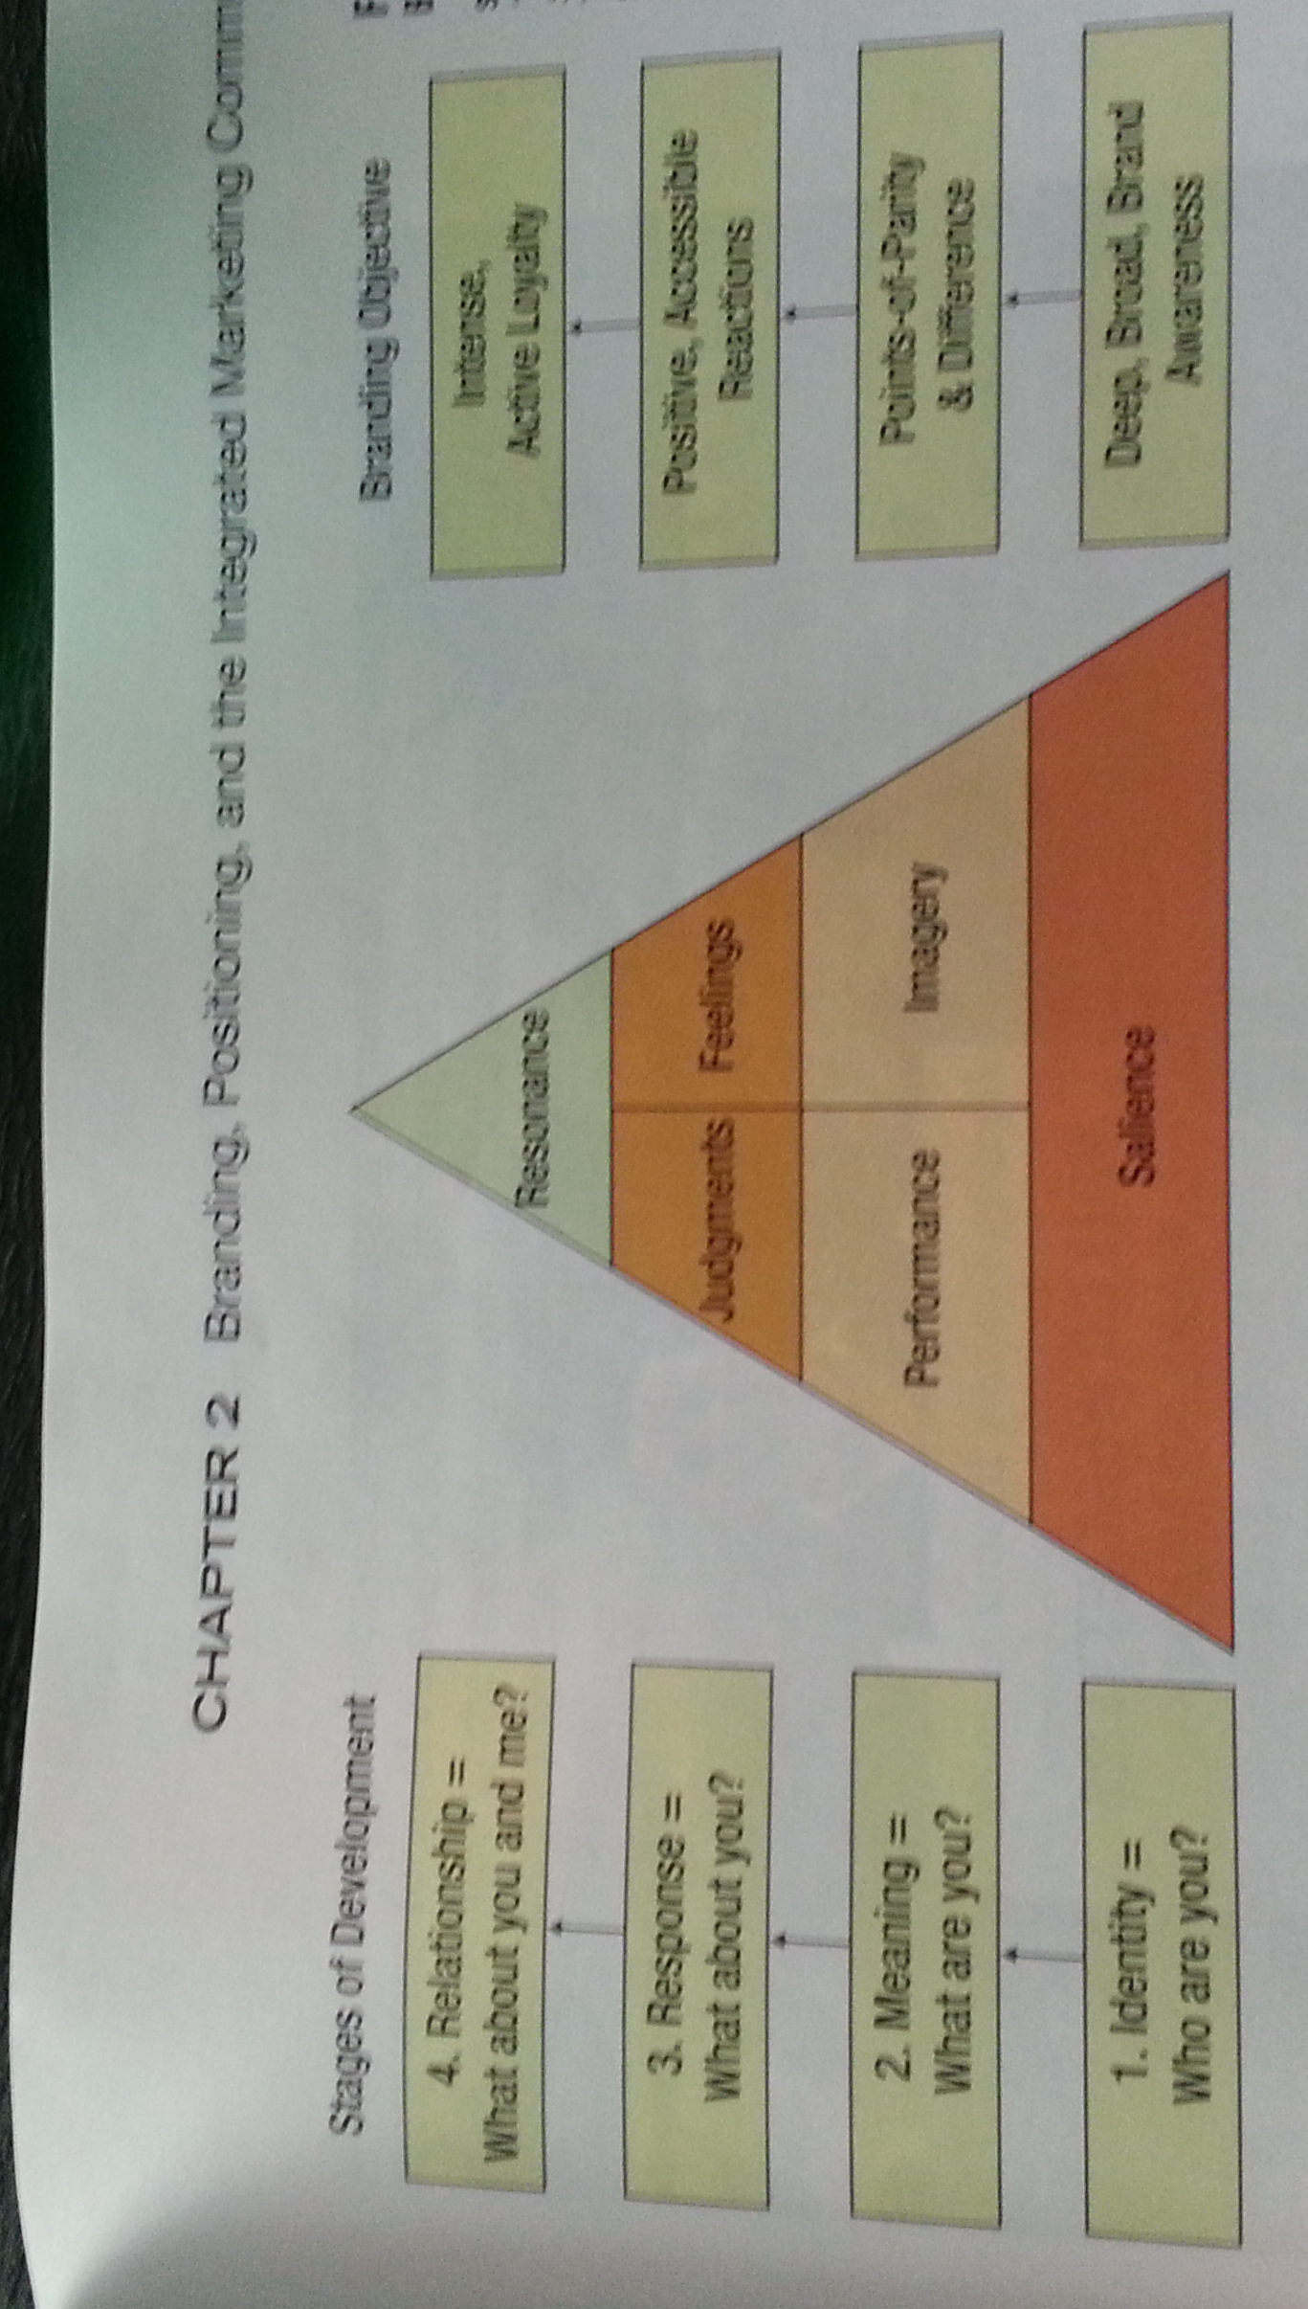
  - Brand equity exists because of the perceptions, feelings and attitude that customers have toward the brand
  - Objective is to have resonance between a brand and a customer who can lead to a close relationship (fight off substitutes, etc)
  - Marketing communications must strive to create brand salience for the customer

  - Resonance
    - Customer relationship & loyalty
    - Psychological bond
  - Salience
    - Customer knowing how product will satisfy their needs
    - Brand meaning

Consists of both performance-related attributes related to functional needs and the abstract social or psychological needs of the customer

Once established, objective is building brand responses
        - Generated after customer examines in-store
        - Two categories
          - Judgement
            - Attributes
          - Feelings
            - Feel when consuming
              - Coke – excitement
              - Hallmark – warmth
- The IMC Plan
- Key for Building Project
  - Marketing communications is grounded in the overall marketing plan of the firm
  - IMC plan must work toward the same overall objectives as other elements in the marketing plan
    - More than just the marketing department (CEOs + other depts)
  - Set on specific metrics (ROI)
  - Multiple sections and processes
  - Includes following components (building blocks)
    - Situation analysis
    - Competitive analysis
    - Customer research
    - Marketing objectives
  - Includes crucial elements
    - IMC objectives
    - Target audiences
    - Budget
    - Communication tools to be used
      - Based on goals and considerations
    - Methods to evaluate and control implemented plan
- International Implications
  - Achieving a balance
    - Adaptation vs. standardization
    - Standardization reduces costs
      - One brand name
        - Adaption can vary its name by country or region
    - Shrinking world leads to standardization
    - High profile, high involvement – global brand
    - Low-involvement products – local brand
    - Packaging and labeling issues can be complex
    - Image and positing issues

- Buyer Behavior

- Need of recognition
- Information search
- Evaluation of alternatives
- Purchase decision
- Post-purchase evaluation

- Consumer purchasing decision-making process
  - Need recognition
    - Needs
    - Could be due to exposure or purchase
    - Derived demand
      - Generated by the production and sale of some other good or service
      - Supply and demand of a good forcing domino effect
        - Ex. Car and steel to make the car
  - Information search
    - Internal vs. external
      - Internal search, using mental recall of products that might satisfy the need
        - Often individual recalls how the need was met in the past
        - Could exclude examination of other brands if need wasn’t previously met (eliminates negative brands)
        - User wants to organize group of brands to consider from
          - Key objective is to be apart of that group and stand out as superior
      - External search, evaluating other alternatives to mental knowledge of certain brands (expansion)
        - Can be gathered from a variety of sources
          - Friends, relatives, media, online, advertisements
        - Time spent on external search depends on
          - Ability
            - The more you know, the more you want to find out
          - Motivation
            - Level of involvement
            - Need of cognition
              - Personality characteristic and individual displays when he or she engages in and enjoys mental activies
              - More cognition, more information needed
            - Level of shopping enthusiasm
          - Cost vs. benefit
            - Actual cost of good or service
            - Subjective costs such as time spent and anxiety over choosing
            - Opportunity cost of search for information
            - Higher perceived benefits leads to tendency to search
          - Knowledge of product

  - Evaluation of alternatives
    - Evoked set
      - Consists of brands in which he or she considers in a purchasing decision
    - Inept set
      - Consists of brands that customer is aware of but are not considered because they elicit negative feelings
    - Inert set
      - Consists of brands that customer is aware of but has neither positive or negative feelings associated with the brand
      - Usually ignored for evoked set of brands
    - Multi-attribute approach
      - Attitude towards brand determined by
        - Brands performance on product or brand attributes
        - Importance of each attribute to the customer
          - Performance of a brand on a particular attribute
          - Performance of a competing brand on a particular attribute
          - Influence the importance of an attribute
          - Introduction of new attributes
      - Role of social influences
        - Doctors, spokesmen
        - Referent groups
          - Associative
            - Consumer wishes to belong to
            - Identifies with group being advertised
          - Dissociative
            - Powerful mechanism
            - Mac vs. pc
    - Affect referral
      - Consumers choose brands they like the best or the one with which they have developed emotional connections
      - Reasons being
        - No need to evaluate alternatives
        - Already found brand using multi-attribute approach
        - Emotional connection to brand
    - Alternative evaluation in business decision-making process
      - Formalized for business in 3 levels
        - Initial screening of proposals
        - Vendor audit
        - Share vendor audit information
  - Purchase decision
    - Importance is keeping customer long-term
    - Not always the point at which consumers buy the product
    - Important that purchase experience is consistent with brand experience that is promise throughout previous stages of decision-making process
  - Post-purchase decision
    - Consumers seek to reduce cognitive dissonance
    - In business decision making, follow-up service is a good idea

Buyer & Consumer Values
  - Implicit in our attitude and values
    - Lead to judgment that guide behavior (purchase decisions)
    - Values formed during childhood
      - Can change over time due to life experiences
      - Life, freedom, inner peace, happiness, love, security, self-fulfillment, personal accomplishment, etc.
- Roles within Consumer Buying Process
  - Users
    - Who will use the product
  - Buyers
    - Who will makes the purchase decision
  - Influencers
    - Who shapes purchase decision by providing or influencing the criteria utilized in evaluating alternatives
  - Deciders
    - Who decides whether or not something will be purchases and which product or service will be chosen
  - Gatekeepers
    - Who controls flow of information to others in the purchase process

- Buying center
  - Group of individuals making a purchase decision on behalf of a business
  - Factors that affect
    - Roles and perceived roles
      - Socially constructed, how they intend their role into the buying process
      - Feeling more important, more active in decision
    - Personality features
      - What type of person they are, that affects a purchase
      - Aggressive “know-it-all” doesn’t always benefit
    - Levels of cognitive involvement
      - Higher levels of cognitive capacity lead to wanting more information before making a purchase decision
    - Attitudes towards risk
      - Vendors are buying because it gives less risk
      - Risk avoidance leads buyers to stay with current vendors instead of changing
    - Levels of power
      - Derived from position within organization
      - Different purchase decisions for different levels of employment
    - Motivational levels
      - Dependent on goals
      - More motivated, more involvement

- Dual-channel marketing
  - Single strategy
    - Firms selling virtually the same goods or services to both consumers and businesses
    - Same communication message
    - Spin off sales
      - Individuals who buy a product at work often have positive experience and as a result purchase the product later on for personal use
  - Dual
    - When there is a difference between channels
      - Different communication messages
      - Create different brands
      - Use multiple channels or different channels
      - Synergies
        - Arise from increase brand identity and equity
          - Blackberry
- Trends in consumer buying environment
  - Age complexity
    - Children bombarded with advertisements
    - Adults growing old trying to “stay” young
  - Gender complexity
    - Equality of men and women in business & at home
  - Individualism
    - Specific tastes of individuals makes it tough to market specific needs
      - Nike lets you design custom-made shoes online then order them
  - Health emphasis
    - Healthy lifestyle
    - Idea of being healthy and eating healthy
  - Active buying lifestyles
    - Demand for free time is on the rise due to busy schedules
    - Results in increase of sales of convenience items
  - Cocooning
    - Expenditures on houses and other convenience items for a person to enjoy while alone
    - Shopping from home advertisements on the rise
  - Changes in family units
    - Change in purchase patterns with divorce rates rising
    - Forces cocooning
  - Pleasure pursuits
    - Personal enjoyment due to stress and busy lifestyles
    - Indulgencies “worth-it”
  - Environment
    - Green products
    - What’s best for our world
    - Forcing new trends by which marketers must:
      - Monitor consumer environment for changes
      - Create goods and services that are compatible with the changes
      - Design marketing messages that reflect the changes
- International Implications
  - Cultural assimilators
    - Are often used to assist with transitions between different countries
    - Understanding purchasing process is critical
    - Strong brand is important as well as gender boundaries
- Promotions Opportunity Analysis
  - The process marketers use to identify target audiences for an organization’s message and the communications strategies needed to reach these audience
  - Must accomplish 2 objectives
    - Determine which promotional objectives exist for the company
    - Identify the characteristics of each target market, to better understand how to reach that target audience
- Communication Market Analysis
  - Process of discovering the organizations strength and weaknesses in the area of marketing communications and combining that information with an analysis of the opportunities and threats present in the firm’s external environment (SWOT)
- Conduct a communication market analysis
  - Competitors
    - Identify major competitors
    - Identify communication strategies and tactics of each competitor (see who you are up against)
      - Advertisements, websites, customers, public info
  - Opportunities (space to play in market)
    - Questions…
      - Are there customers that the competition is ignoring?
      - Which markets are heavily saturated?
      - Are the benefits of our goods and services being clearly articulated
      - Are there opportunities to build relationships using a slightly different marketing approach?
  - Target markets (segmentation)
    - Questions…
      - What benefits does each target market want from the product
      - How can each target market be reached?
      - What appeals best for each target market?
      - What needs of the target market are not being met by a competing firm?
      - What is the demographic and psychographic makeup of each target market?
- Market Segmentation
  - Process of identifying specific purchasing groups based on their needs, attitudes and interests
  - Advantages
    - Identify company strengths and weaknesses
    - Locate opportunities
    - Match firm’s expertise with most lucrative markets
    - Focus budget on specific segment (Find best ROI market)
    - Base market on
      - Demographics
        - Gender, age, income
      - Psychographics
        - Persons activities, interests and opinions
      - Generations
        - Common preferences
      - Geographic
        - Location
      - Benefits
        - Advantages consumers receive from a product rather than the characteristics of consumers themselves
        - Can be used with demographic and psychographic
      - Usage
        - Focusing on long-term customers (customer service)
- Establish communication objectives
- 4 Criteria used to define objectives (Purchasing process ch.3)
  - Specific target audience
  - Specific tasks
  - Specific changes
  - Specific time

Create a communication budget

Budgets are based on
  - Communication objectives
  - Marketing objectives
  - Budgets vary from consumer to B-to-B markets
    - Percentage of sales
    - Meet-the-competition
    - What we can afford
    - Objective and task
    - Payout planning
      - Revenues out grow expenditures over a period of time
      - Quantitative models
        - Trade promotions 30%
        - Consumer promotions 25%
        - Advertising 40%
        - Other 5%
  - Unrealistic assumption to assume direct relationship between advertising and sales
    - Influences
      - Objectives of the communication
      - Threshold effects
      - Carryover effects
      - Wearout effects
      - Decay effect
      - Random events

- Creative Strategy
- - Creative Brief
  - Who are we talking to?
  - What is the objective?
  - What is the one thing we’re trying to tell them?
  - Why should they believe us?
  - Where and when are we telling them?
- Marketing Communications Theory
  - Three primary theoretical frameworks used to evaluate the creative development process
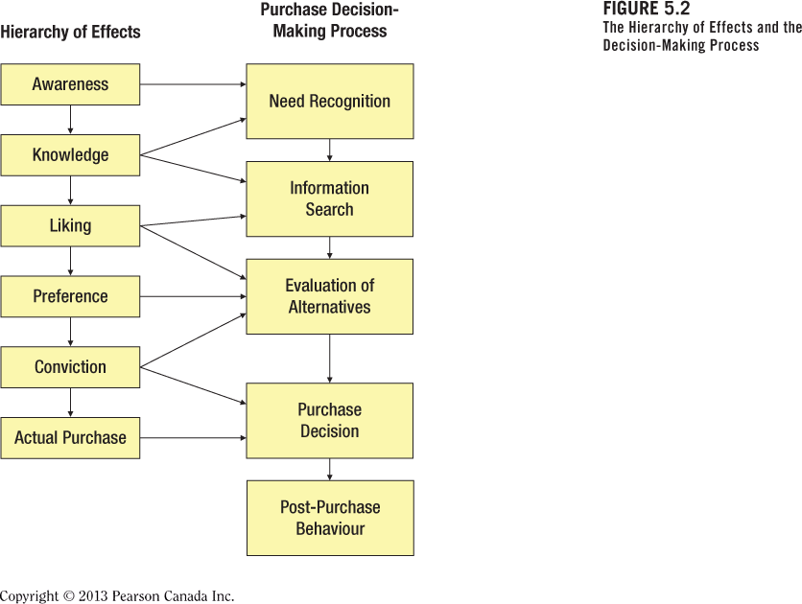
    - Hierarchy of effects model
    - Potential weakness: cannot explain all types of buying situations
      - Impulse buying
    - Means-end chain model
      - Suggests that marketing communication should contain a message=means that leads the consumer to a desired end state
      - End states=include personal value (below)
      - Means-end Conceptualization of Components for Advertising Strategy (MECCAS)
        - Products attributes
        - Consumer benefits
        - Leverage points
          - Feature of the ad that leads the viewer to transform the advertising message into a personal value
          - Must build a pathway that connects a products benefits with the potential buyer’s value system
            - Ex. (corona & beach)
        - Personal values
          - Comfortable life, equality, excitement, freedom, pleasure, security, wisdom etc.
        - Message tactics
        - Ex.

    - Elaboration likelihood model
      - Explains how likely a person is to spend time thinking deeply (elaborating) about any specific piece of marketing communication
      - Premise is that marketing communication influences audiences based on how much the audience thinks about the message
        - Central route
          - Ad is what audience is looking for
        - Peripheral route
          - Cues that consumer can remember even though they do not need the product right now
            - Endorsement athletes
        - Low-involvement persuasion
          - Not interested what-so-ever due to dislikes or not in need of recognition
- Types of Marketing Communication Appeals
- Appeal is the approach used to achieve objectives for the message
  - Can have both rational and emotional appeals
    - Rational appeals
      - Price
      - Performance
      - Scarcity
        - Limited use or availability
      - Print media is well suited
      - Well suited for complex and high involvement products
    - Emotional appeals
      - Fear
      - Humour
        - High recall
      - Sex
        - Break through clutter
        - Reduces brand recall
      - Based on
        - Consumers ignore most ads
        - Rational ads go unnoticed
        - Emotional ads can capture attention
          - Views by creative as key to developing brand loyalty
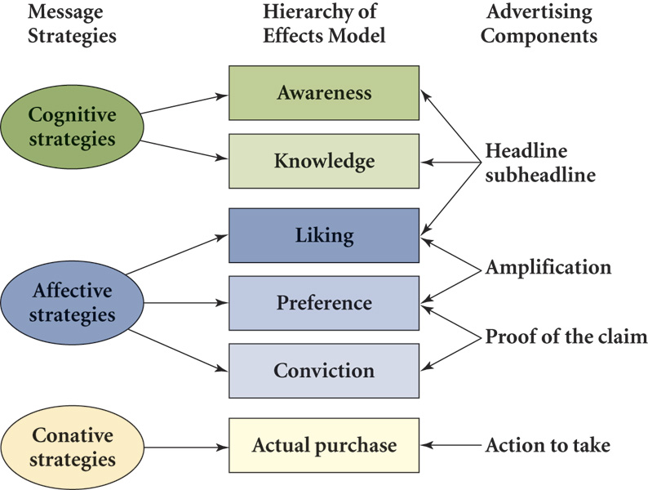
- Creative Tactics

- Message Tactics
  - Cognitive message tactic
    - Presentation of rational arguments or pieces of information to consumers designed to stimulate cognitive processing
      - Generic messages
        - Direct presentations of product attributes without claim to superiority
      - Preemptive messages
        - Claim superiority based on a products specific attributes or benefit
      - Unique selling proposition
        - Explicit claim of superiority that can be supported or substantiated in some manner
      - Hyperbole
        - Untestable claims based upon attributes or benefits such as being a “nations favourite”
      - Comparative messages
        - Comparing product to that of a competitors
  - Affective tactics
    - Invoke feelings or emotions and match those feelings with the good, service or company
    - Such messages are prepared in order to enhance the likeability of the product, recall of the appeal, or comprehension of the message
  - Conative tactics
    - Designed to lead more directly to some type of consumer response
    - Used in the development of sales promotions such as coupons or internet orders
- Executional Frameworks
  - Manner in which an appeal tactic is presented
    - Slice-of-life
      - Every day problems
    - Animation
      - Increased due to computer graphics technology
      - Visual representation
    - Dramatization
      - Higher level of excitement
      - Providing problem along with its solution
    - Testimonial
      - Successful in b2b
      - Message with positive experience of a product
    - Authoritative
      - Used to show superiority over other brands
      - Doctor, dentist, athlete, other professional
      - Involved cognitive processing
    - Demonstration
      - Shows how product works
      - Enhance believability through media such as television
    - Fantasy
      - Lift audience away from reality to show a make-believe experience
        - Ex. Sex appeal
    - Informative
      - Present information to evidence in a straightforward manner
        - Radio ads, verbal communication, etc.

Creating marketing communications
  - Print-based marketing communications production
    - Photography
    - Illustration
    - Studio development
    - Printing
    - Delivery
  - Broadcast-based marketing communication production
    - Pre-production
    - Production
    - Post-production

- Advertising
- Advertising media objectives
  - Element of marketing communications mix
  - Key tool in delivering messages to audiences
  - Different media play different roles and have their own specific advantages
- Components of a media plan
  - Marketing analysis
  - Advertising analysis
  - Media strategy
  - Media schedule
  - Justification and summary
- Advertising terminology
  - Reach
    - Number in target exposed
    - Typically 4-week period
  - Frequency
    - Average number of exposures
  - Opportunities to see (OTS)
    - Cumulative exposures
    - Placements x frequency
  - Gross rating points (GRPs)
    - Measures impact on intensity of media plan
    - Vehicle rating x OTS
  - Costs
    - Cost per thousand (CPM)
    - CPM allows for cost comparisons
  - Rating and Cost per rating point (CPRP)
    - Ratings measure percent of target market exposed by medium
    - CPRP allows for comparison across media
    - Cost of media buy / vehicles rating
    - Weighted CPM
  - Impressions
    - Gross impressions – total audience exposed to ad
  - Continuity
    - Continuous campaign
    - Pulsating campaign
  - Effective reach
    - Percentage of an audience that must be exposed to a particular message to achieve a specific objective
      - Never the same!
  - Effective frequency
    - Number of times a target audience must be exposed to a message to achieve a particular objective

- Achieving advertising objectives
  - Recency theory
    - One exposure may be enough
    - Effective the closer to a purchase
    - States hat consumer use selective retention when they consider ads
    - Advertising is waste of money when intended market is not reached
  - Three-exposure hypothesis
    - Intrusion value
      - Ability of media or an advertisement to intrude upon a viewer without his or her voluntary attention
    - Based on the assumption that it takes a minimum of three exposures for an ad to be effective
    - Number of media used is important (variability)
- Media planning
  - Focus on consumer behavior
  - Create plans that reflect the purchase process (ch.3)
  - Influence consumer in the marketplace
  - Study media choices
  - Listening and viewing habits
- Media buying
  - After media is chosen, media buyer
    - Is responsible for buying the space and negotiating rates, times and schedules for the ads
    - Works closely with media planner in the design of an advertising campaign
- Effective media purchase factors
  - Quality of media choices
  - Creativity in developing the media plan
  - Agency culture and track record
  - Good data analysis
  - Relationship between media buyer and sales representative
- Media schedule
  - Continuous
    - Advertising runs steadily with little variation over the campaign period
      - Full cycle
    - Spot ad
      - One time placement
    - Pulsating
      - Combines fighting and continuous scheduling by using a low advertising level all year round and heavy advertising during peak selling periods
    - Fighting
      - Intermittent and irregular periods of advertising, alternating with shorter periods or no advertising at all
        - Ex. Seasonal winter tires

Media selection factors
  - Reasons as to why certain media are selected
    - Organizational objecitves
    - Target markets
    - Costs
    - Message theme
    - Constraints (legal)
    - Product/service considerations

