Interprofessional Communication (Health-Care Relationships)

- Professional—Patient Relationships
Barrier to effective communication:
- Role Uncertainty
  - Hesitation; only express physical concerns
  - Reinforces traditional communication
- Responsibility Conflicts
  - Two factors: responsibility for disease and responsibility for cure
- Power Differences
  - Leary’s Model
  - HCP=dominant, Patient=submissive
- Unshared Meanings
  - Person-minded, not word-minded
  - Paraphrase; use many communicating methods

- Professional—Professional Relationships
Barriers to effective communication:
- Role Stress
  - Role conflict; Role overload
- Lack of Interprofessional understanding
- Autonomy Struggles
  - Scope of practice (governing laws)
  - Ability to access facilities
  - Ability to rain reimbursement
- Professional—Family Member Relationships
Barriers to effective communication:
- Limited contact with professionals
- Limited access to information
  - Privileged – available to family but not yet to patient
  - Filtered – family receives after patient or third party
- Patient—Family Member Relationships
Barriers to effective communication:
- Disruption of family member roles
  - Role Adaptation:
    - Ambiguity: too loose
    - Rigidity: too constricted
- Closed Communication Patterns
  - Perpetuated by family rules, protectiveness
  - Define rules; rules need discarding?: new rules needed?

Small Group Communication

Small vs. Large Groups

Small Groups:
- Close relationships
- Full participation
- Shared goals

Large Groups:
- Greater pool of talent and experience available for solving problems
- Shared effort (strength in numbers)

Optimum Number for Effectiveness

5-7 Members is the optimum.

Content & Process:
- Content receives more attention
- Process is usually what determines whether a group works effectively or not

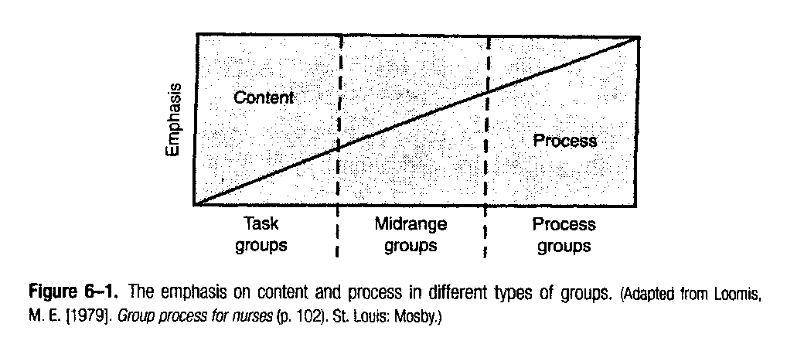
Types of Groups

Factors Which Influence Small Groups
- Goals
- Norms
- Cohesiveness
- Leader Behaivour
- Member Behaivour

1) Goals:
- Implicit: not stated; ex. Discussing patient care
- Explicit: stated; ex. To make decisions about equipment for the hospital pharmacy
- Individual Goals: the needs of each group member
- Group Goals: shared by group members

2) Norms:
- Code of conduct (acceptable behaviour)
  - Established by group to ensure consistent behaivour
- Overt Norms: verbally agreed upon rules that are generally known to all members
- Covert norms: not usually verbally acknowledged, but known nonetheless

3) Cohesiveness:
- Attraction of the group to its members
- Sense of team spirit
- Willingness to coordinate efforts

Features of a highly cohesive group?
- Members are more likely to talk; increased participation
- Members can exert influence on each other
- Greater member satisfaction
- More production

4) Leader Behaivour:
What type of leadership?
- Firm but not rigid is best
- Not beneficial: rigid, overly directive, low member participation, incessant talking
Behaviours for a Leader:
- Caring: kindness, warmth, openness
- Emotional stimulation: expression of feelings
- Meaning-Attribution: providing explanation to help members understand a situation or why they are acting or feeling a certain way
- Executive Function: norms, rules, time & procedures

5) Member Behaivour/Roles:
- Group Task Roles:
  - Contribute to ability of the group to perform its task
- Group-Building and Maintenance Roles:
  - Contribute to group cohesiveness; relationship aspect of group
- Individual Roles:
  - Use to satisfy a member’s own needs/not helpful to group tasks
Communication Networks

- Flow of Communication between group members.
- Sociogram: 1) Who talks to whom 2) How often
  - Line = verbal interaction between members
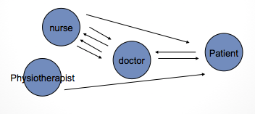
  - Arrow = who sent the message

Phases of a Group

5 Stages:

- Orientation: “do I belong here?”
- Conflict: control issues
- Cohesion: establishing unity
- Working: time, energy, depth in disclosure
- Termination: closure

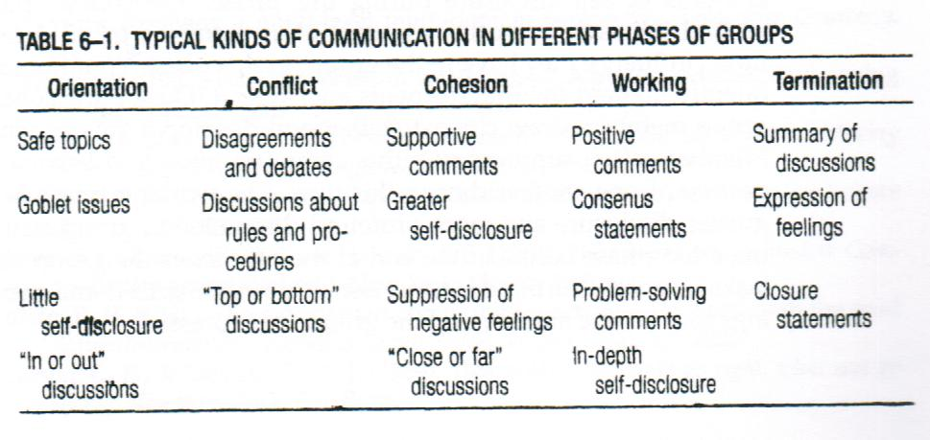
Developmental sequence of phases, similar for most groups; content & duration of phase vary with the kind of group and the group task

Intercultural Communication

Canadian Diversity:

May 15, 2001
- 5.4 million (18.4% total population) born outside of Canada
- 13.4% (4 million) are visible minorities

Visible Minorities born in Canada: similar trends in US
- 65% Japanese
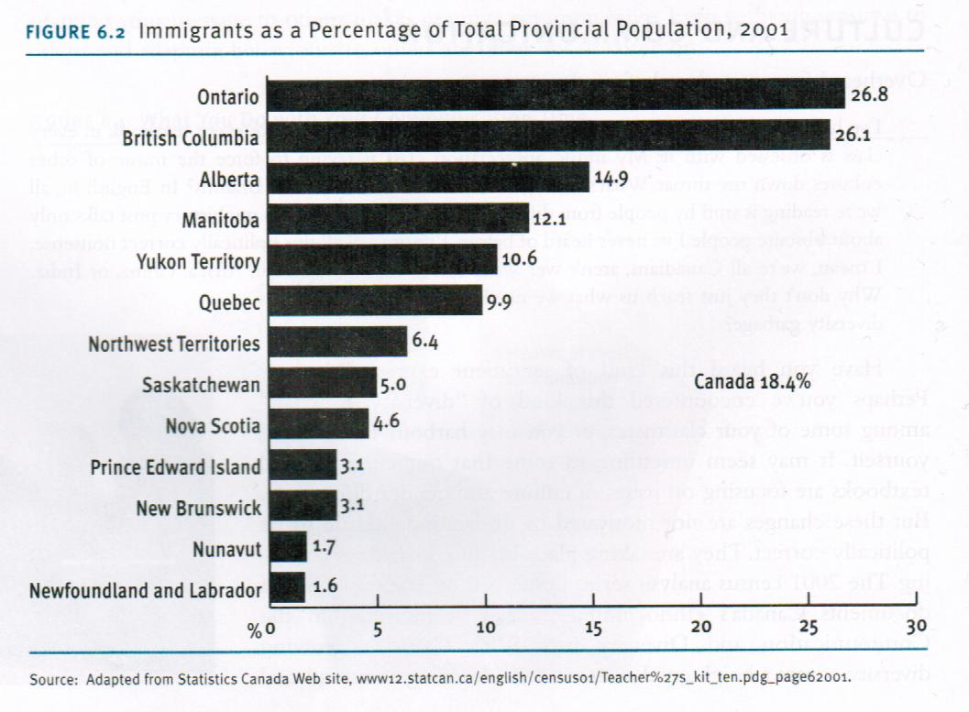
- 45% Blacks
- 29% South Asians
- 25% Chinese
- 21% Arab

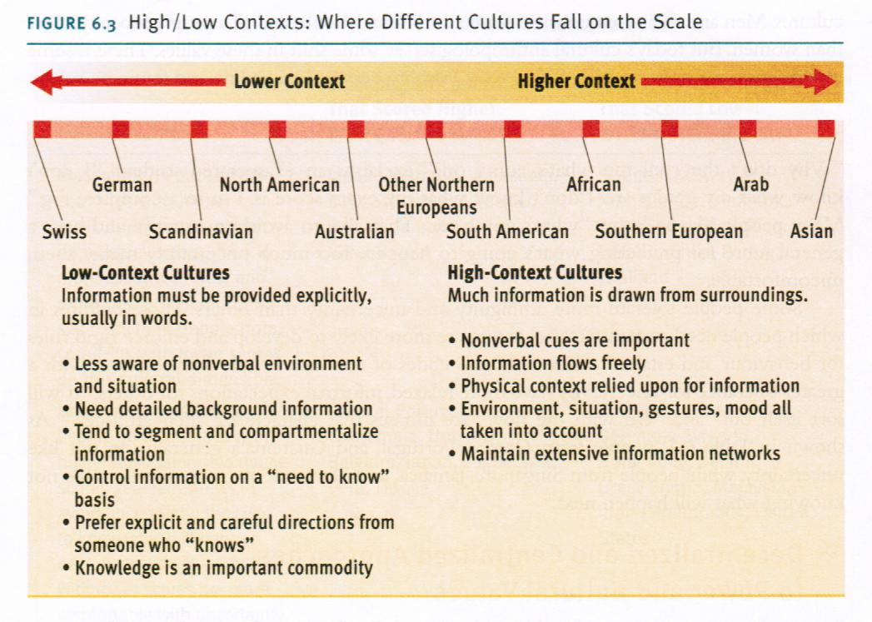

Cultural Values

Masculine and Feminine:
- Masculine: achievement, heroism, material wealth, and traditional sex roles
  - Japan, Australia, Venezuela, Italy, Switzerland, Mexico
- Feminine: relationships, caring for less fortunate, overall quality of life, and less traditional sex roles
  - Sweden, Norway, Denmark, Chile, Portugal, Thailand

Uncertainty and Certainty:
- Certainty: do not like ambiguity; value feeling secure
  - Greece, Portugal, Belgium, Japan, Peru, France
- Uncertainty: comfortable with ambiguity and less info
  - Singapore, Jamaica, Great Britain, India, Hong Kong, USA

Decentralized and Centralized Power:
- Centralized: power in hands of smaller number of people
  - Malaysia, panama, Philippines, Mexico, Arab countries, India
- Decentralized: favour equality and even distribution of power in government and organizations
    - Austria, Israel, New Zealand, Norway, Finland, Denmark

Individualistic and Collectivist:
- Individualistic: accomplishment of individual achievement
  - Canada, US, Great Britain, Italy, Sweden, France
- Collectivist: group and team collaboration
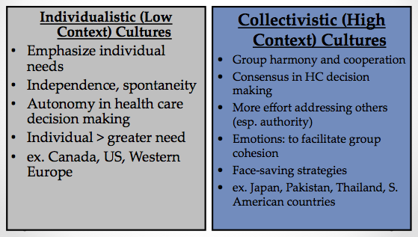
  - Ecuador, Venezuela, Columbia, Indonesia, Pakistan, Taiwan, South Korea

Individual vs. Collectivist Cultures

Barriers to Bridging Differences and Adapting to Others

- Assuming Superiority: ethnocentrism
- Assuming Similarity
- Stereotyping and prejudice
- Different communication cods: language, nonverbal cues

Adapting to Others Who Are Different From You

Develop Knowledge
- Seek Information
- Listen and ask questions
- Tolerate ambiguity
- Develop Mindfulness: self-talk, mindful
- Become other oriented: social decentering, empathy

Improving Intercultural Communication

- Recognize and reduce ethnocentrism
  - Self-awareness
- Be Mindful
  - Unconsciously incompetent
  - Consciously Incompetent
  - Consciously competent
  - Unconsciously competent
- Face Fears
  - Your well-being, well-being of others
- Avoid Over Attribution
  - Tendency caused by person’s cultural identification
  - View person as a spokesperson for given group
- Identify uncertainty and ambiguity
  - Active listening and perception checking (seek feedback)
- Recognize Differences
  - Between you and culturally-different people: values, beliefs
  - Within the culturally-different group: one but not the same
- Recognizing meaning differences in verbal and nonverbal messages
  - Use straightforward language and speak slowly and clearly
- Adjust your communication
  - Accommodate different system of symbols and communication styles
- Recognize culture shock
  - Common psychological reaction

Dimensions of Cultural Differences

- Materialism vs. concern for others
- Formality vs. Informality
- Acceptance of power and authority
- Individualism vs. collectivism
- Urgent vs. casual time orientation
- High context vs. low context
- Work vs. leisure orientation

Barriers to Effective Intercultural Communication
- Perceptual Expectations
- Stereotypes, prejudice, and discrimination
- Ethnocentrism
- Different norms and codes of conduct: micro inequities

Understanding Culture: Key Concepts

Enculturation: learning the ways of your culture through the teaching of family, peers, schools, faith-based organizations, government, media, etc.

Prejudice: making a judgment about others based on previous decisions or experiences

Ethnocentrism: Evaluating the values, beliefs, & behaviours of your own culture as better than those of other cultures

Acculturation: When a person’s culture is modified through direct contact with or exposure to another culture

Improving Intercultural Communication and Fostering Understanding

- Develop cultural sensitivity and cultural intelligence
- Focus on individuals rather than groups
- Respect all cultures
- Value cultural differences
- Minimize cultural bloopers

How Do You Overcome Cross-Cultural Communication Barriers?

- Be alert to cultural differences in customs and behaviours
- Use straightforward language: speak slowly and clearly
- When appropriate, speak in the language of the people from the other culture
- Observe cultural differences in etiquette
- Be sensitive to differences in nonverbal communication
- Do not be diverted by style, accent, grammar, or personal appearance
- Listen for understanding, not agreement
- Be attentive to differences in appearance

Effects of Cultural Barriers

- ^ Hospital re-admissions
- ^ Possibility of errors
- Decrease patient satisfaction
- Decrease understanding of condition
- Decrease access to mental health and counseling
- Decrease representation of minorities in clinical and health research
- Decrease staff satisfaction and effectiveness
- ^ Risk of liability
- ^ Health costs
- Decrease compliance
- Decrease adequate management of chronic illnesses
- Decrease quality of care
- Decrease informed consent

Traditional vs. Culturally Competent Approach to Care

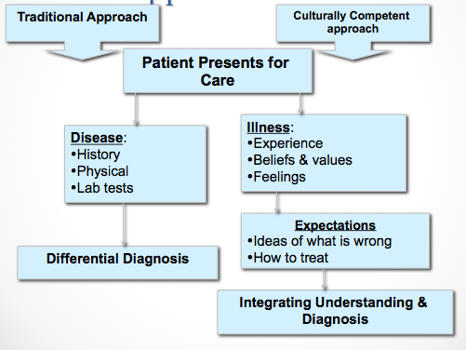

Conflict, Ethics, & Communication

Conflict

Why so much Conflict Exists

- Competition for limited resources (rewards)
- Personality Clashes (interdependence, struggle)
- Aggressive personalities: bullying
- Culturally diverse teams and factional groups (perceived incompatibility)
- Micro inequities
- Harassment: sexual harassment
- Competing life (work, family) demands

The Good and Bad Sides of Conflict

- Positive sides of interpersonal conflict:
  - Talents and abilities emerge
  - Needs satisfaction = good feelings
  - Unity (after conflict)
  - Reduces likelihood of premature agreement and poor decisions (group think)
- Negative sides of interpersonal conflict:
  - Poor well-being
  - Wasted resources (money, time, energy)
  - Emotional costs and fatigue
  - Self-interests, dominates all
  - Can lead to violence at workplace

2 Types of Conflict

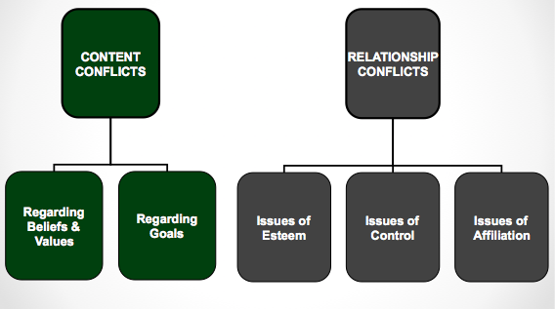

Conflict on Content Level:
- Conflict regarding values and beliefs
  - Religious, cultural, professional, etc.
- Conflict regarding goals
  - Procedural: the “how”; substantive: the “what”

Conflict on the Relational Level:
- Issues of Esteem: worth, respect, etc.
- Issues of Control: power struggles
- Issues of Affiliation: inclusion, affection

Levels of Conflict:

- Personal Conflict
- Interpersonal Conflict
- Intragroup Conflict
- Intergroup Conflict

What is Interpersonal Conflict?

Defined: disagreement between or among connected individuals
- Content Conflict cs. Relationship conflicts
- Online Conflict

Characteristics of Interpersonal Conflict

- Negatives and Positives
- Culture and Gender
- Conflict Styles have consequences
  - Competing: I win, you lose
  - Avoiding: I lose, you lose
  - Accommodating: I lose, you win
  - Compromising: I win and lose, you win and lose
  - Collaborating: I win, you win

Steps in Win-Win Problem Solving

- Identify your problem and unmet needs
- Make a date
- Describe your problem and needs
- Partner checks back
- Solicit partner’s needs
- Check your understanding of partner’s needs
- Negotiate a solutions
  - Identify and define the conflict
  - Generate a number of possible solutions
  - Evaluate the alternative solutions
  - Decide on the best solution
- Follow up on the solution

Ways to Manage Conflict

- Avoidance (nonnegotiation) and fighting actively
- Force and talk
- Defensiveness vs supportiveness
  - Evaluation, Control
  - Strategy: manipulation vs. spontaneity
  - Neutrality, superiority
  - Certainty: closed-mindedness vs. provisionalism
- Face-detracting and face-enhancing
- Blame and empathy
- Silencers and facilitating open expression
- Gunnysacking and present focus
- Fighting below and above the belt: belittling
- Verbal aggressiveness and argumentativeness
  - Objectivity, avoid attacking, avoid interrupting, express interest, avoid being overemotional, allow for face-saving

Techniques for Resolving Conflicts with Others

- Confrontation and problem-solving (win-win)
- Disarm the opposition
- Cognitive restructuring
- Appeal to a third party
- Negotiation and bargaining tactics
  - Create positive negotiation and climate
  - Allow room for compromise but be reasonable
  - Focus on interests, not positions
  - Make a last and final offer
  - Allow for face-saving
- Use a mediator
  - Formal method to address conflict; objective third party
  - The ultimate goal: finding a solution that both sides can agree to while still maintaining their goals

A Model for Resolving Conflicts: 5 Steps
- Define the conflict
  - Define both content and relationship issues (in specific terms)
  - Empathize
  - Avoid Mindreading
- Examine possible solutions
- Test a solution
- Evaluate the solution
- Accept or reject the solution
  - Accept: out
  - Reject: back to steps 1, 2, or 3

Styles of Expressing Conflict
- Non-assertion
- Direct Aggression
- Passive Aggression
- Indirect communication
- Assertion

Developing Assertiveness

Assertive: clearly and honestly stating what you think or how you feel in a forthright manner, without being abusive, abrasive, or obnoxious

Nonassertive: not overtly participating in sharing their thoughts, not letting their feelings be known

Aggressive: overbearing, step on others to get what they want in a situation

- Becoming more assertive and less shy
- How can you become more assertive in social situations?
  - Set a goal
  - Appear warm and friendly—use of body language
  - Conduct anonymous conversations
  - Greet strangers
  - Practice being decisive

Characteristics of an Assertive Message

- Behavioral description: non-judgmental
- The interpretation of the other person’s behavior: perception checking
- A description of your feelings
- A description of the consequences (3)
  - You the speaker
  - The person being addressed
  - Others
- A Statement of your intentions (3)
  - Your stance on an issue/ b. requests of others/ c. descriptions of how you plan to act in the future
Ethics

Health Care Ethics:

Health care dilemma: Conflict that requires careful consideration of all possible solutions to identify the one that balances the interests of all involved

Ethics:
- Set of moral principles that serve as a guiding, philosophy for behaviour
- Code of ethics, in each health care profession
- Functions: education, policy, consultation (deal with facts and emotional issues)

4 Ethical Principles:
- Autonomy: client makes the decisions
- Beneficence: professional decides what is best for patient (paternalism)
- Nonmaleficience: to do no harm (Hippocratic oath)
- Justice: resources distributed responsibly

Autonomy:
- Self-determination
- Built on trust, respect, truthfulness, sharing, and confidentiality
- Adult, sound mind, written consent
- The following needs to be addressed:
  - Language: appropriate (lay terms and in primary language)
  - All risks and benefits must be outlined
  - Any and all alternatives must be discussed
  - Client must sign statement that indicates understanding and acceptance of treatment

Informed Consent

- How much information is enough?
  - Impossible to provide information in all of its detail
  - Do patients truly understand “pros and cons” from a medical perspective?
- Information overkill = more stress to patients (?)
  - Did patient feel pressured to make a decision
- HCP must address the unique conditions of each patient
- Family members can be gatekeepers

Beneficience and Nonmaleficience:
- To do good and to provide benefit; do no harm
- If harm is unavoidable, it must be minimized
- Benefits must outweigh the risks
Justice:
- Ethical obligation to be fair
- Rights-based, legal, and distributive

Approaches to Truth Telling

Patient and Professional Relationship

- Strict Paternalism
- Blatant deception by the HCP for the patient’s best interest

- Benevolent Deception
- HCP withholds some (not all) of the truth from the patient

- Contractual Honesty
- HCP discloses as much info as the patient desires

- Unmitigated Honesty
- HCP tells all, even if patient does not want to hear the truth

Therapeutic Communication

Existential Factors: learning from others, life

Altruism: when one realizes they can assist another despite their own difficulties

Corrective Recapitulation: transference

Catharsis: learning to express (release) feelings

Universality: the human condition (hope, unity)

Health Care Professional focuses on:

- The patient’s most important concern
- The patient’s perception
- Facilitating the expression of emotions
- Guiding towards a course of action
- Management of illness, coping with crisis

Therapeutic Factors:
Control:
- Perception individuals have about how they are connected to others
- Includes the degree to which they feel able to influence the nature and development of relationships
- Complementary and symmetrical
- Restore control to patient when HCP shares control

Trust:
- We trust when we see people act in a positive, consistent, reliable manner
- HCP needs to be competent, sincere, and caring
- Trust = patient feels valued as a person
- Recognize the mistake of ‘thinging’
  - Ex. the heart specialist, the MS clinic: hip replacement on Ward B

Confirmation:
- Uncovering meaning in life
- How one chooses to respond to life (ex. man search for meaning)
- Patients desire the feeling of acceptance
- Cyclical process of disconfirming communication:
- HCP disconfirmed
- HCP less attentive to client
- HCP disconfirms client
- Client feels disconfirmed
- Client is less responsive to HCP
- Client disconfirms HCP
- Back to stage 1

Empathy:
- Feeling ‘with’ the client, while not losing objectivity
- Patients are empowered and have positive perceptions of health care experience
- Associated with better outcomes (assists with coping & resilience)

Barriers to Empathy:
- HCP: inexperience, lack of motivation (caring), distractions, fatigue (burnout)
- Patient: lack of openness, fear and rejection: inability to communicate through words (ex. language barrier)

Self-Disclosure

What factors influence self-disclosure?
- Who are you
- Your culture
- Your gender
- Your listeners the dyadic effect
- Your topic

Rewards of Self-Disclosure

- Self-Knowledge
- Self-acceptance: a more positive self-concept

- Communication and Relationship Effectiveness

- Physiological Health

Dangers of Self-Disclosure

- Personal Risks (ex. rejection by family and friends-ostracizing)
- Relationships Risks Decreased Trust
- Professional Risks

Guidelines for Self-Disclosure

- What is the motivation behind the self-disclosure
- How appropriate is the self-disclosure, and in what atmosphere is it occurring
- Is there reciprocal disclosure: is the other person also disclosing
- Will self-disclosure impose burdens

Guidelines for Facilitating and Responding to Disclosures

- Practice the skills of effective and active listening: empathetic, open-minded, understanding of feelings
- Support the discloser: practice affirmation
- Be willing to reciprocate with disclosure
- Maintain confidentiality of the disclosures

Increasing Listening Effectiveness

Empathy and Objective Listening
- View other as being equal
- Empathy: ability to put yourself in the position of the other person
- An attitude, a skill
- Understanding thoughts and feelings, as opposed to a “reflection”

Nonjudgmental and Critical Listening
- With an open mind (question your own assumptions, listen for facts)
- Be more tentative about what we think we know
- Don’t be afraid of being wrong
- Be aware of leveling

Surface and Depth Listening
- Most messages have more than one level of meaning (ex. Do you like my shirt?): literal and hidden
- Meaningful contact = awareness of the multiple levels of meaning
- Content vs. Relational aspect of message (use nonverbal cues)
- What is being said, why is it being said

Interviewing

Phases in the Interview Process

Preparation:
- Planning for the first meeting
- Self awareness of strengths and limitations

Initiation:
- First contact; establishing therapeutic climate
- Clarification of the interview’s purpose
- Formulating a contract and establishing mutual goals

Exploration:
- Clients’ determination of their problems, and subsequent management of their feelings
- Development of coping skills

Termination:
- Must plan for the interview’s closure
- Summarization of issues and accomplishments
- Discussion of the termination, and how it makes the client feel

Communication Techniques in Interviews

Questions—Silence—Restatement—Reflection—Clarification—Interpretation

Questions:
- Open: intend to facilitate disclosure
- Time consuming; stimulates discussion; more complex answers
- How, what, describe, explain
- Ex. tell me about your son’s problems in school

- Closed: for clarification and facts
- Does not allow for explanation of emotions; limits response (yes/no)
- Who, where, when
- Ex. was work stressful today?
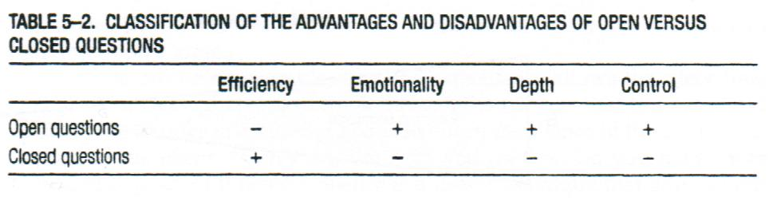
Silence:

- Encourages client disclosure
- Allow the clinician to collect thoughts
- Difficulty of giving expression
- Appropriate & therapeutic (avoid overuse)

Restatement (Paraphrasing):
- “What” (content) is being said
- Without adding personal thoughts/feelings
  - “I hear you saying”, “It sounds like”, etc.
- Shows “active listening” and acts as feedback
- Confirming and validating client

Reflection (of Feeling):
- “How” things are expressed
- More difficult than restatement; requires picking out the emotional aspect
  - Helps the client to handle their feelings
- Use to check accuracy of understanding
  - HCP correctly understood patient’s concerns?
- Do not use too soon or too frequently

Clarification:
- From broad to more focused topics
- Helps clinician determine what issue is the most pressing
- Allows for better understanding of client’s thoughts and feelings
- May require closed-ended questions and client to provide specific examples

Interpretation:

- Clinician offers: explanation, new frame of reference, or way of looking at things
- Designed to connect meaning to a feeling
- Client should have control over accepting or rejecting the clinician’s interpretation
- Suggestions for effective interpretation:
  - Use same language as the client
  - Prelude you are offering ideas; as for feedback
Using the Narrative Model

Hear Client Stories Listen for strengths/assets Re-Story Action and Change

**Contrast with illness-centered medicine

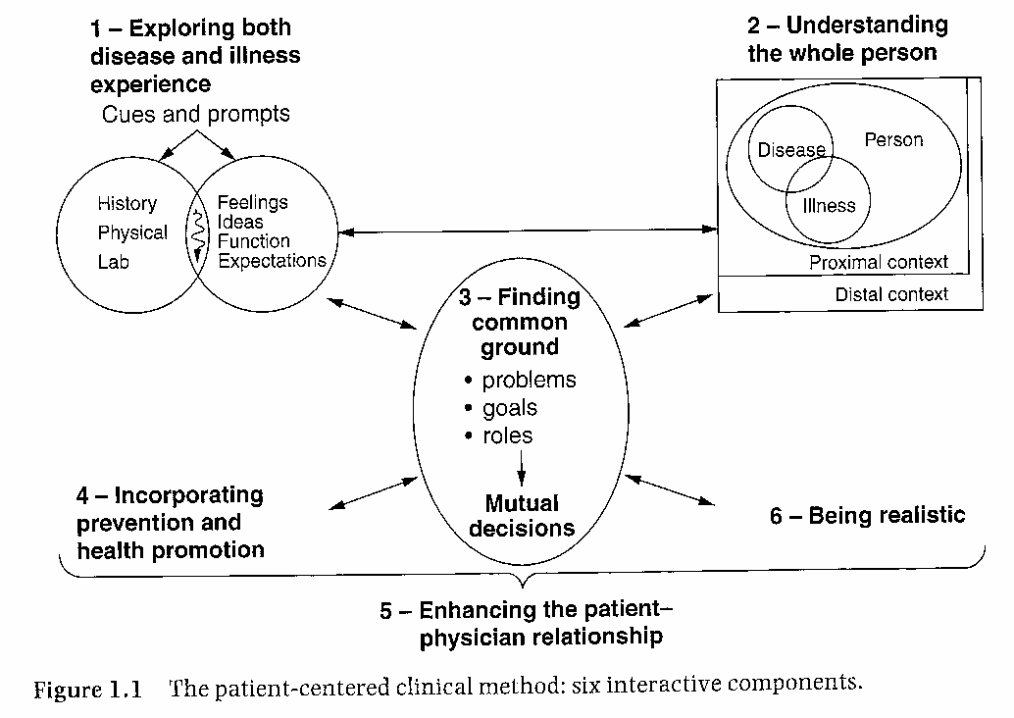

The Nature and Types of Interviews

- Information-Gathering
- Appraisal
- Problem-Solving
- Persuasion
- Job

Interview Structure

- Opening
- Body—Asking Questions
  - Questions Types:
    - Open, closed, probing, and hypothetical questions
  - Questioning Sequences:
    - Funnel Sequence
    - Inverted Funnel Sequence
- Conclusion

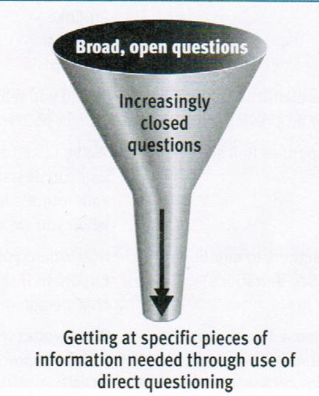
The Funnel Sequence:

Ex.
- Why do you find communication interesting?
- What is your primary interest in the study of communication?
- How long have you studied intercultural communication?
- Why do you think intercultural communication theory is useful?
- What would you do to test intercultural communication theory?

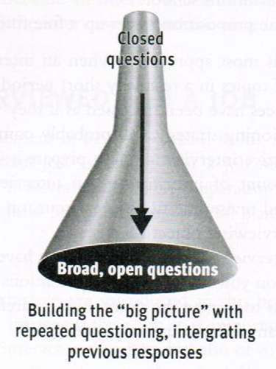
The Inverted Funnel Sequence:

Ex.
- Do you believe that your supervisor wants to fire you?
- What makes you think you will be fired soon?
- What do you think caused this problem?
- How has the problem developed?
- How would you describe the working climate in your department?

Undergoing a Job Interview

- Be aware of your skills and abilities
- Preparation of your resume
  - Personal information, career objectives, education, experience, honours and special accomplishments, select optional information, and references
- Identification and anticipation of your employer’s needs
- Listening, responding, and asking appropriate questions
- Following up after the interview

Undergoing an Information-Gathering Interview
- Prepare for the interview
- Listen effectively
- Respond appropriately
Responsibility of the Interviewer
- Awareness of biases and prejudices
- Adapting to an interviewee’s behaviour
- Dealing wisely with sensitive content
- Listening effectively
- Recording information
- Asking appropriate questions

Summary: Principles of Interviewing
- Awareness of your communication with yourself and others
- Effective use and interpretation of verbal message
- Effective use and interpretation of nonverbal messages
- Listening and responding thoughtfully to others
- Appropriately adapting messages to others

Gender, Aging, and Communication

Gender and Communication

- The importance of gender in culture
  - Sex-based expectations and conditioning from birth
  - Results on development as adults: relationships, careers, etc.

- Why vs. How
  - Instrumental orientation: men; expressive orientation; women
  - Content (verbal) and relational (nonverbal) dimensions

- Women tend to disclose more than men
  - Especially in same-sex dyads
  - Women tend to disclose more intimate information than men
  - Equal in negative disclosures
  - Women tend to increase the depth of disclosure as relationship becomes more intimate (not so for men)

- Listening and Fender (as a function of socialization)
  - When talking: men lecture (superior) and women listen (non-expert)
  - Women: “people-oriented” listening style (rapport)
  - Men: tend to interrupt more, “time-oriented listening style
  - Both genders communicate in similar fashion to their gender counterparts
  - Men: display of knowledge and expertise = respect
  - Women: seek to be liked; express interest and sends more cues than men
  - Women: more nonverbal cues when listening (ex. more eye contact), less pure silence; proximity and body posture
- Gender Differences in Communication Style
  - Women prefer to use communication for rapport building
  - Men prefer to use talk to preserve independence and status (via knowledge and skill)
  - Women want empathy, not solutions
  - Men prefer to solve problems alone but women prefer to discuss their problems with another person
  - Men tend to be more directive and less apologetic; women more apologetic and polite
  - When facing differences: men more intimidating
  - Attention to accomplishments and hogging recognition
  - Interruption used differently
  - Women tend to use more gentle expletives (“oh dear” vs. “fuck!”)

- Gender and Conflict Style (due to socialization)
  - Women more likely to use indirect strategies, instead of confronting conflict head-on (harmony)
  - Men more likely to use direct aggression
  - Relational content: men more-likely to withdraw if uncomfortable or do not get their way (hypothesis: women get more by “complaining”?)
    - “Demand-withdraw” dynamic
  - Men: aggression can be part of friendship
  - Women: more-likely logical reasoning and bargaining than aggression during competition
  - Men: more co-operative with other women than other men
  - Differences are less pronounced, as sex-role stereotyping diminishing in our current society

Ageism

- External Ageism: discrimination on basis of age
  - Assumptions about capacity
  - Removes decision-making process
  - Ignores person’s wishes
  - Treats persona as a child

- Internal Ageism:
  - “Self-adopted ageism is the idea that I cannot do that at my age. For many seniors, the personal definition of what I am capable of may be one of the biggest barriers to overcome”

Aging Populations

Society needs to:
- Develop and foster new attitudes
- Materials & Services, sensitive to needs
- Keep up with evolution of population

Communication Approach to Aging

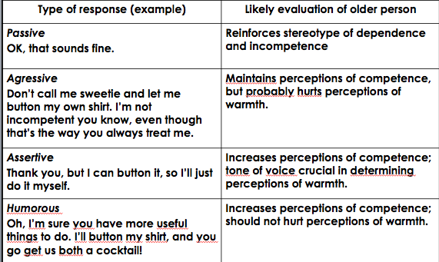
Why is communication central to figuring out the role of older people in society?

- Reflects & shapes understanding of aging
- Perceptions of aging
- Shapes experience of aging
- What messages do people receive as they age?
- Age-group memberships fundamentally important to our sense of “self”
- Our social identity
- Age-group memberships influence communication phenomena
- Styles and content of communication

There you go sweetie. You just sit there and I’ll button your shirt for you!
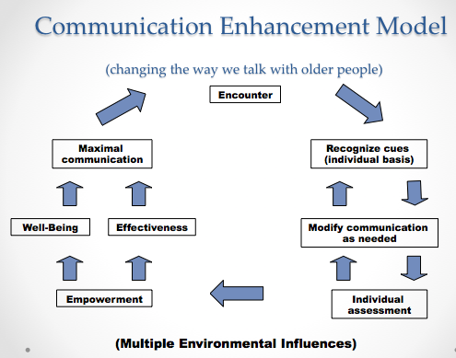

Health Promotion Messaging

A look at 3 Communication Theories:

Activation Model (Sensation Seeking Targeting)
- Stimulation and sensation seeking
- Messages with high sensation value (creative, intense, explicit, etc.)
- Sex and drug use and other high risk behaviours

Extended Parallel Process Model (EPPM)
- Fear appeal and scare tactics
- Threat appraisal: severity and susceptibility
- Efficacy appraisal: self-efficacy (confidence) and response efficacy (make a difference? : both need to be high for fear appeal to work

Fisher’s Narrative Theory
- People are storytellers
- Involves personal story, history, culture
- Truthfulness and consistency

