ADM 2320 Exam
Chapter 9
Dove Example
- Brand extension from soap bar to multiple personal care areas
- Brand image always associated with moisture / mildness
- Brand promise: mildness and moisturization
Complexity of Products
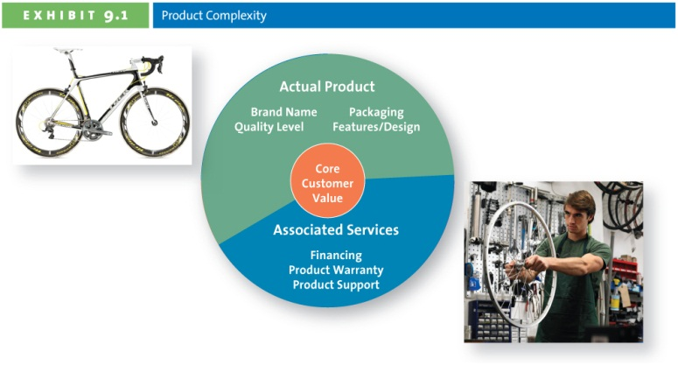
What Makes a Brand?

Value of Branding for the Customer and the Marketer
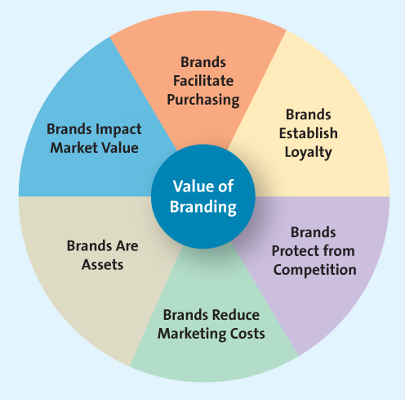

Branding Overview
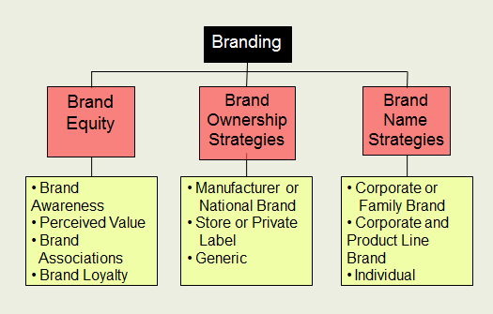
Brand equity is an important concept that can both help and hinder. For example, customers dislike some brands because of the firm’s actions or their negative perceptions. Nike has been the target of many labour activists, which causes some consumers to refuse to purchase or wear Nike products. Mattel’s brand equity was hurt when it recalled over 19 million toys because of lethal magnets and lead paint.
Brand Loyalty
- Consumers are often less sensitive to price
- Marketing costs are much lower
- Firm insulated from the competition
Brand Ownership
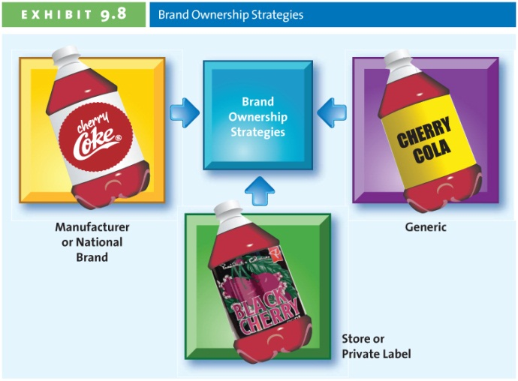
Brand Ownership
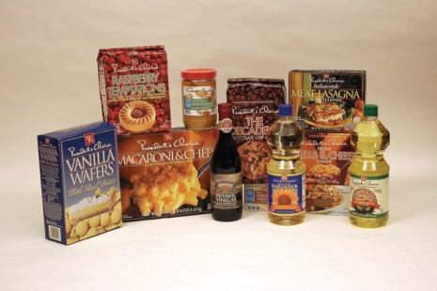
Brand Name Strategies
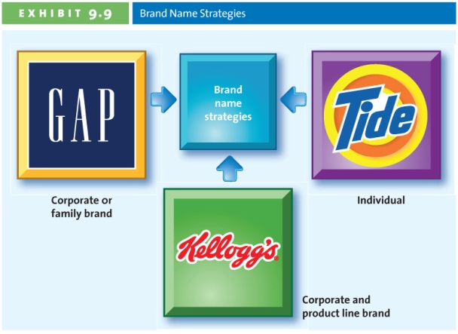
Branding exists on multiple levels, and firms choose strategically how to brand their products. The names they assign their products reflect this strategic choice. Marriott gives its individual brands unique names, all tied together by the phrase “by Marriott,” like Fairfield Inns by Marriott.
Choosing a Brand Name: Desirable Qualities
- Suggest benefits and qualities
- Easy to pronounce recognize & remember
- Capable of registration & legal protection
- Translated easily
Brand Extension
Benefits of brand extension
- Well established name
- Brand known for high quality
- Lower marketing costs
- Synergy among products
- Boost sales of the core brand

Brand Dilution
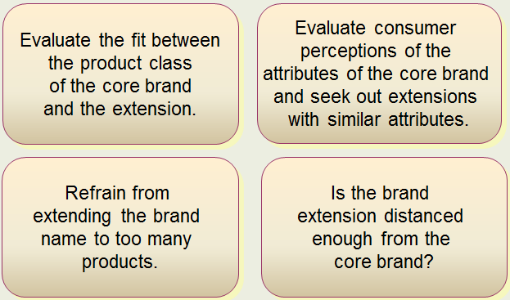
Cobranding
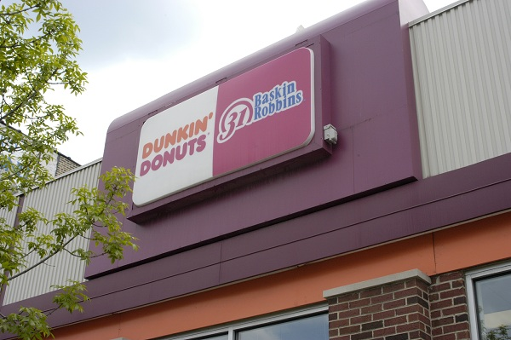
Packaging
Although often overlooked as a marketing tool, packaging helps determine the success of a product. The chapter covers many new packaging innovations including FlexCan, Daily Gloss, smart lids, Labatt blue, aseptic drink bottles, and snack and seal as seen in the ad above. In some instances, such as Coca-Cola or Aunt Jemima Maple Syrup, the package has become synonymous with the brand.
Even small firms benefit from good packaging and labeling. Quaker Coffee’s packaging conveys its value proposition to the marketplace. Its labels communicate roast qualities and bakery labels state “baked fresh.” Sales increased 400% as a result of the redesigned packaging.
Product Labeling
Label information is determined by regulations, and labeling rules vary from country to country. Certain terms convey specific meanings, such as “natural,” “organic,” “made in Canada,” and products must meet specific tests before placing such terms on their label.
Chapter 10
The Service Product Continuum
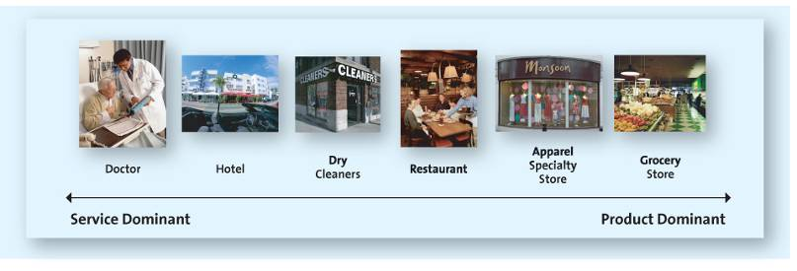
Services Marketing Differs from Product Marketing
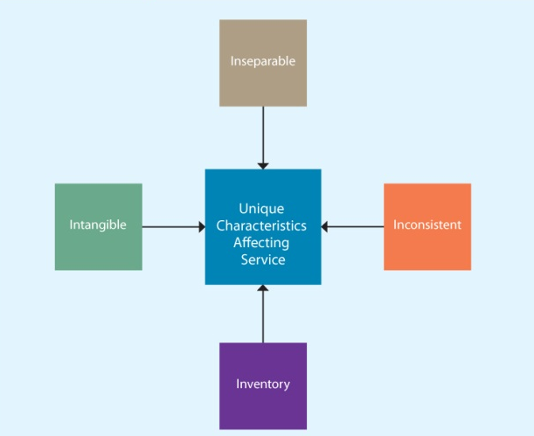
Intangible
- Requires using cues to aid customers
- Atmosphere is important to convey value
- Images are used to convey benefit of value
- Consumers use cues to judge the service quality of dentists, including the quality of the furnishings, whether magazines are current, and diplomas on the wall.
Inseparable Production and Consumption
- Production and consumption are simultaneous
- Little opportunity to test a service before use
- Lower risk by offering guarantees or warranties
- When staying at a hotel, you can’t test it out before you stay. Some hotels offer satisfaction guarantees to lower risk.
Inconsistent
- Technology
- Training
- Automation
- Attitude
Adding Convenience through self-Checkout Machines
- Increasing use of self-checkout machines
- Consumers enjoy faster checkout
- Retailers save on labour and training costs
- In many industries, consumers have taken roles in the final production process; ATMs, self-service gas stations, and self-service restaurants all shift labour to the consumer, and yet many consumers consider these technologies actually improve customer service. Technology can reduce inconsistency of service delivery.
Inventory
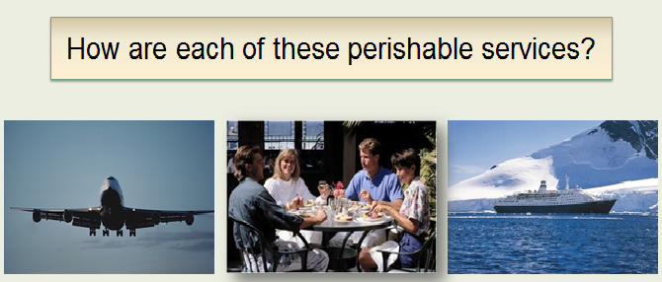
Each of the pictured services are perishable, because as soon as the plane/ship departs, the date ends, or the meal is served, there is no possibility of changing. Unsold seats or rooms are lost revenue.
Providing Great Service: The Gaps Model
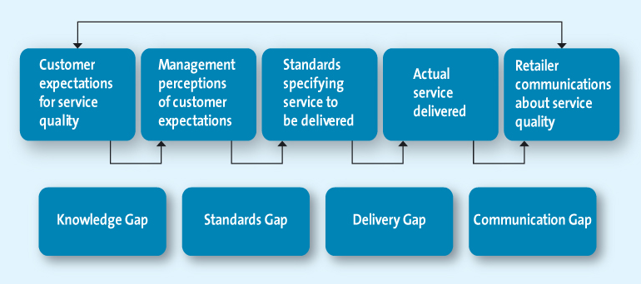
The Knowledge Gap: Knowing What Customers Want
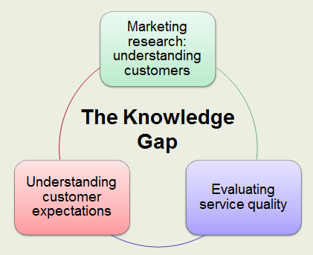
Understanding Customer Expectations
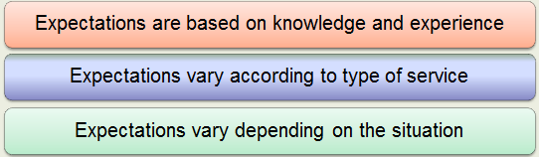
Evaluating Service Quality
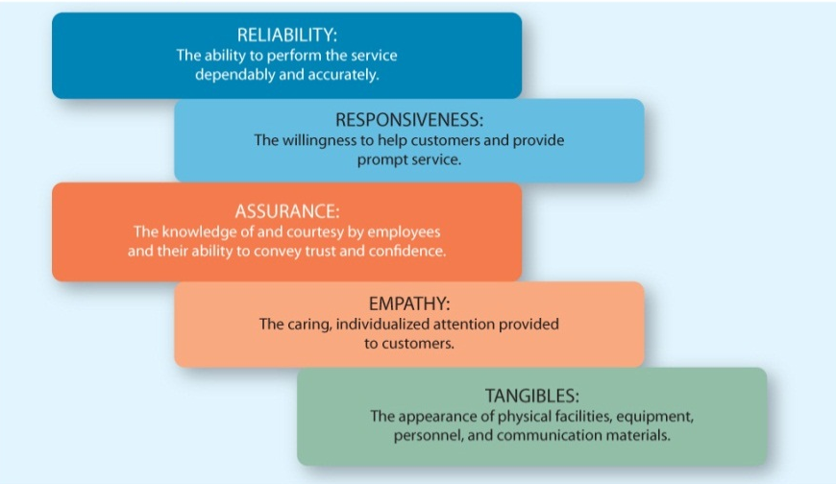
Zone of Tolerance
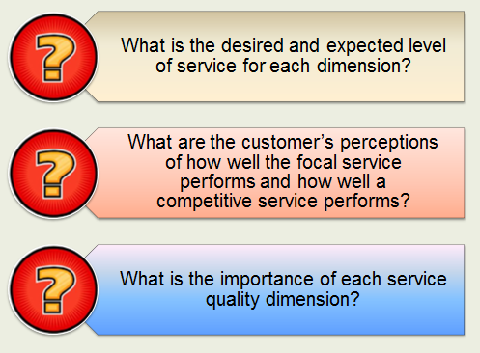
Consumers often have a range of acceptable outcomes. Think of a hotel room: You prefer a king bed but will accept two queen beds; you will not, however, accept a room without towels or a lumpy mattress. Therefore, you have defined your zone of tolerance for hotels.
The Standards Gap: Setting Service Standards
- Setting standards for quality
- Developing systems to ensure high-quality service

Quality service requires constant investments in training and monitoring. Similar to any other strategic element, service quality flows from the top down. Rewards and incentives must be in place to support service quality commitments.
The Delivery Gap: Delivering Service Quality
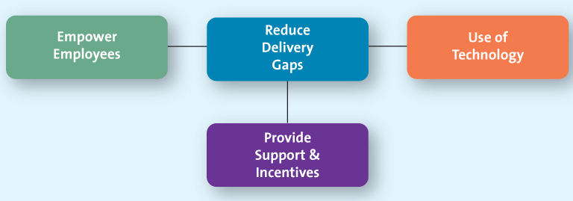
Providing Support and Incentives
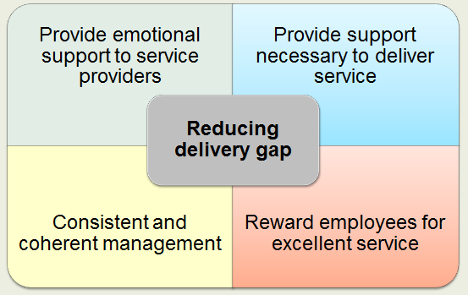
If the firm has just a paper commitment to service quality, it will not happen. Systems must support the service providers and allow them to do their job and exceed customer expectations.
The Communications Gap: Communicating the Service Promise
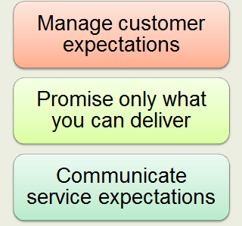
Many people have never stayed in a five-star hotel, but they know what level of service quality they expect. Often, such expectations develop in response to the promises made in promotional materials provided by the firm.
Many firms over promise and under deliver; Southwest Airlines attributes its success to under promising and over delivering instead.
Service Recovery
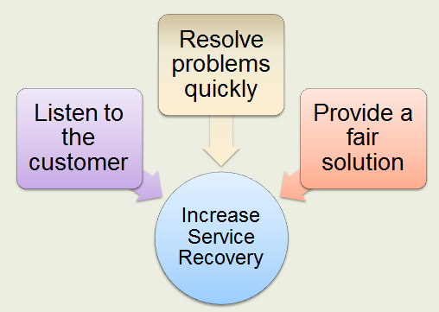
Finding a Fair Solution
- Distributive fairness
- Procedural fairness
- Even if they eventually receive a solution that seems fair, when consumers must work hard to achieve it, their low procedural fairness perceptions may cause them to believe that they are being punished for receiving bad service.
Resolving Problems Quickly
- The longer it takes to resolve service failure the more irritated the customers
- It is in the firms best interest to solve problems quickly
- By compounding a service failure with long delays in correcting it, the firm creates a hostile customer.

Chapter 11
The 5 Cs of Pricing
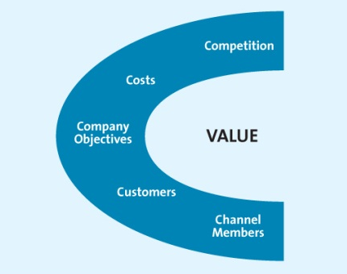
1st C: Company Objectives
- Profit Orientation
Maximize profits
Target return pricing
Target profit pricing
- Sales Orientation
- Competitor Orientation
- Customer Orientation
- Each firm has a specific orientation in the marketplace that dominates its pricing strategy.
- Profit: firms do not use value as a consideration but rather focus on generating a set level of profit from each sale.
- Sales: Focus on increasing sales, More concerned with overall market share, Does not always imply low setting low prices
- Competitor: Value is not part of this pricing strategy. This strategy is particularly common among smaller firms that lack knowledge or experience in setting prices. Non-market leader firms also use it to signal they are similar to the market leader.
- Customer: Focus on customer expectations by matching prices to customer expectations
- A recent study indicates that a variety of retailers sell one-carat diamonds, but consumers pay vastly different prices at Costco versus Tiffany’s. The diamonds are a commodity; they must meet the same standards and are rated the same.

2nd C: Customers
Price elasticity of demand
- Elastic (price sensitive)
- Inelastic (price insensitive)
- Consumers less sensitive to price increases for necessities

Elasticity
Affected by
- Cross-price elasticity
- Substitution effect
- Income effect

3rd C: Costs
- Variable Costs
- Vary with production volume
- Fixed Costs
- Unaffected by production volume
- Total Cost
- Sum of variable and fixed costs

Break Even Analysis and Decision Making
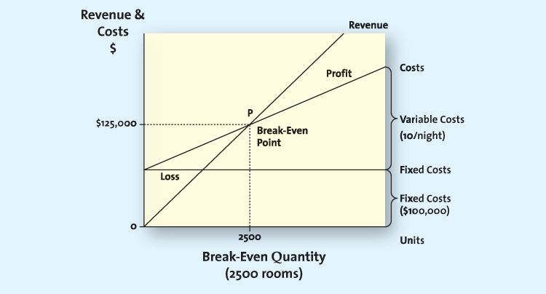
4th C: Competition
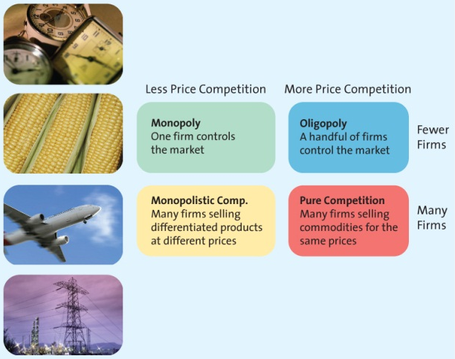
Monopoly: Hydroelectric power in most provinces, Microsoft operating system and Office suite.
Monopolisitic: many firms competing for customers, e.g. toys
Oligopolistic: Cable TV firms such as Rogers or Shaw
Pure: Most frequently purchased consumer goods such as soft drinks
This you tube ad is for a $5 foot long commercial for Subway - has this ad motivated you to visit subway?

5th C: Channel Members
- Manufacturers, wholesalers and retailers can have different perspectives on pricing strategies
- Manufactures must protect against grey market transactions
Other Influences on Pricing
The Internet
- Increased price sensitivity
- Growth of online auctions
Economic Factors
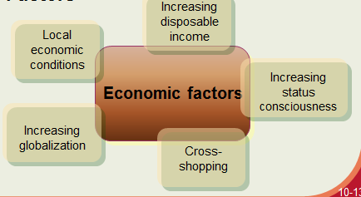
Pricing Strategies
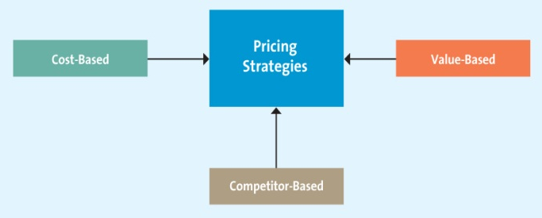
Pricing Strategies: 1. Cost-Based Methods
- Cost-base pricing methods start with cost
- All costs calculated on a per unit basis
- Assumes costs don’t vary for different levels of production
Pricing Strategies: 2. Competitor-Based Methods
- Set prices to signal information of how product compares with competitors
- Premium pricing
Pricing Strategies: 3. Value-Based Methods
- Setting prices that focus on the overall value of the product
- Consumer perceptions
Sellers need to determine consumer value perceptions.
- Improvement value method – Determine the price that could be charged for a new laptop. Suppose the key features were – weight of the laptop, processing speed, hard drive capacity and battery life. The improvement value of the new laptop on these four features can be calculated and the benefits weighted to determine a price.
- Cost of ownership method - Installing solar panels on a home is costly, but the savings over the life of the panels make the cost much lower than traditional electric power. Governments offer incentives that lower the initial investment, in hopes that more homeowners will switch to using solar power.
New Product Pricing Strategies
- Market Penetration Pricing
- Price skimming
Psychological Factors Affecting Pricing Strategies
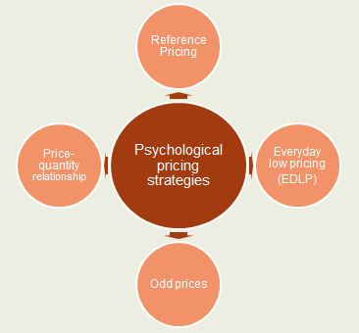
Business to Business Pricing Tactics and Discounts
- Seasonal Discounts
- Cash Discounts
- Allowances
- Quantity discounts
- Uniform delivered vs. geographic pricing

Consumer Pricing Tactics
- Price lining
- Price bundling
- Leader pricing
Consumer Price Reductions
- Markdowns
An integral component of high/low pricing strategy
Enable retailers to get rid of slow moving or obsolete merchandise
Used to generate store traffic
- Coupons (Retailer handles) and Rebates (Manufacturer issues)
Consumers use a lot of coupons to buy cereal, but the high value (generally $.75 or more) of the coupons costs cereal firms a lot of money. When they tried to eliminate coupons and lower the everyday price, consumers wanted the coupons back.
With redemption rates for coupons falling, many firms are beginning to wonder if it is time to end the practice altogether. How should firms respond when couponing no longer seems to work to increase sales?
- Quantity discounts for consumers
Size discount
The more you buy the cheaper the unit cost
- Seasonal discounts
Encourage consumers to use goods and services year around
B2B consumers are encouraged to buy early, but for consumers, seasonal discounts also encourage them to buy after the season so sellers can get rid of leftover merchandise

Legal and Ethical Aspects of Pricing
- Deceptive/Illegal - Loss leader pricing, Bait and switch
- Predatory - Prices set low with the intent to drive competitor out of business
- Price Discrimination - Price discrimination in a B2B setting isn’t always illegal. It is legal to give quantity discounts, to meet competition, and in barter situations. Why are quantity discounts legal? Because it costs less on a per unit basis to sell to customers that buy larger quantities
- Price Fixing - Note that MSRPs are a form of vertical price fixing; the manufacturer sets the price, and wherever the consumer shops, the price will be the same. However, some retailers argue that this form of price fixing prevents them from passing lower costs on to consumers.

Chapter 12
Distribution Channels, Supply Chain and Logistics are Related
- Distribution channel
- Supply chain management
- Logistics management
You may find the distinction between distribution channels and logistics management confusing because of their close relationship. Remember that the distribution channel consists of institutions, whereas logistics refer to activities among and within institutions. However, both are part of supply chain management.
Supply chain: focus on the sequence of firms required to create and deliver goods to the final consumer
Logistics Management: focus on the flow of raw materials & finished goods from point of origin to final consumption
Distribution Channels: focus on the companies that transfer the ownership of goods from the producer to consumers at the point of consumption

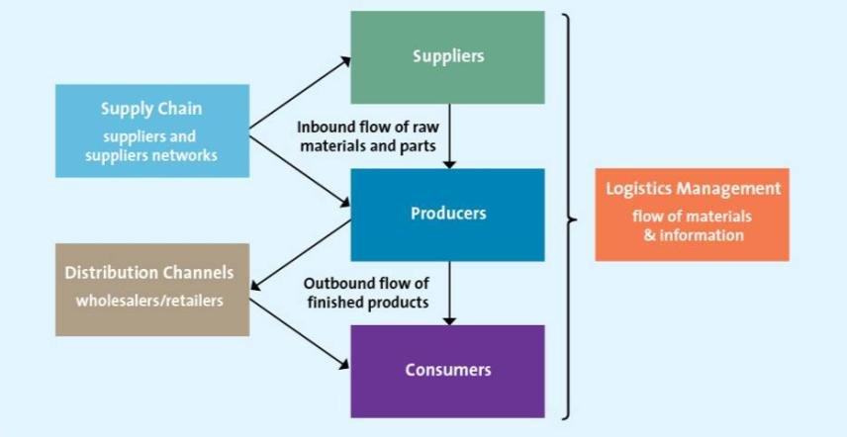
Functions Performed by Intermediaries
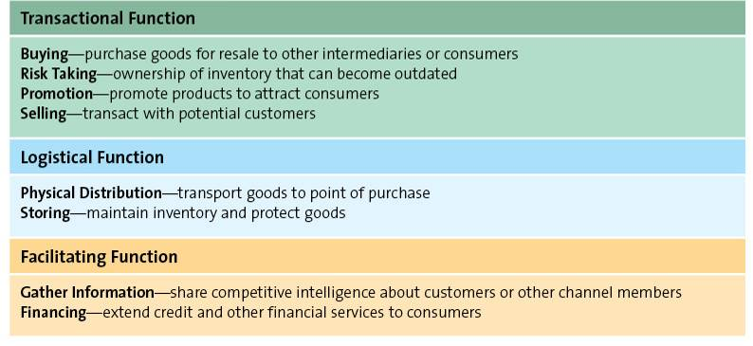
Distribution channels perform a variety of transactional, logistical and facilitating functions. One important role played by intermediaries is to reduce the number of marketplace contacts, resulting in more efficient systems. Intermediaries also match the requirements of individual consumers to the goods that manufacturers produce, handle physical distribution and storage of goods making them available for customers to purchase, facilitate searches by both buyers and sellers, and standardize exchange transactions. While channel functions may shift from one intermediary or channel member to another, it’s important to recognize that they cannot be eliminated.
Distribution Channel Structure: Direct & Indirect
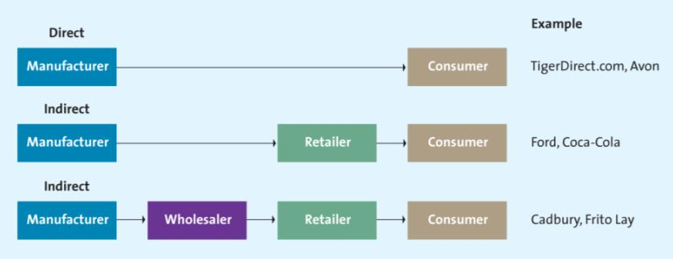
Distribution Channel Structure: Multichannel
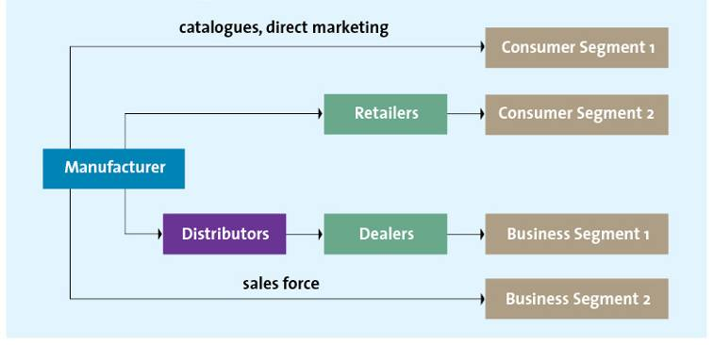
Distribution Intensity
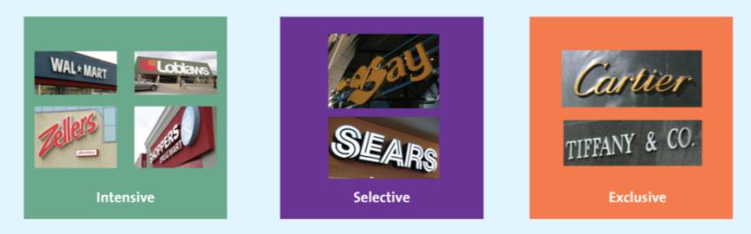
Types of Vertical Marketing Systems
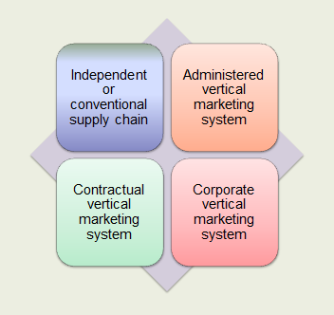
Supply Chain Management
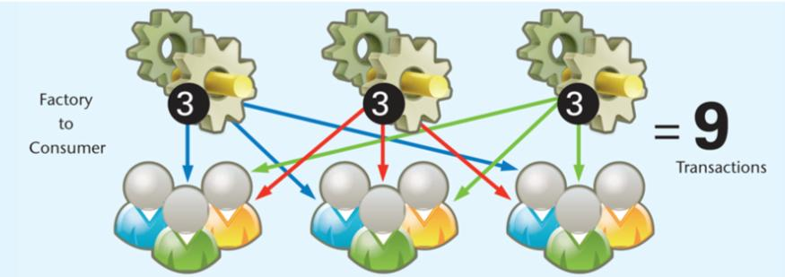
Supply Chains Add Value
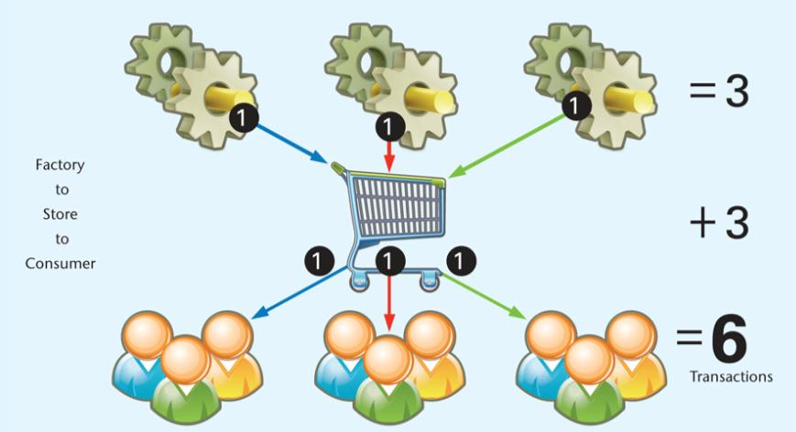

Supply Chains Streamline Distribution
- Reduce number of transactions
- Increase value for consumers
- More efficient and effective

Supply Chain Management Affects Marketing
- Fulfilling delivery promises
- Meeting customer expectations
- Reliant on an efficient supply chain

Logistics: Making Information Flow
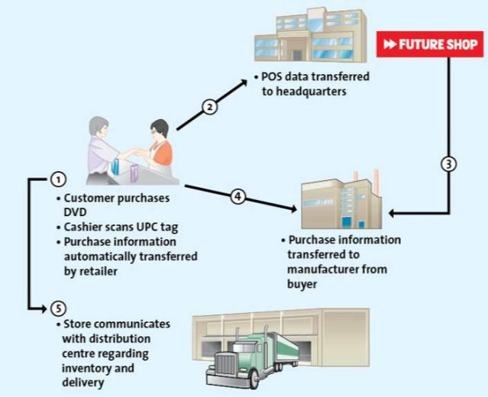
Electronic Data Interchange

- Advanced shipping notice
- Intranet
- Extranet

Managing Supply Chains Through Strategic Relationships
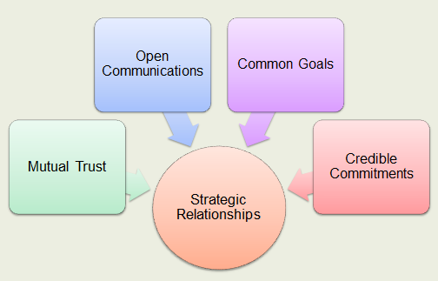
The Distribution Centre
- Management of inbound transportation
- Receiving and checking using UPC and RFID
- Storing and Cross-Docking
- Getting Merchandise Floor Ready
- Preparing to ship
- Shipping to store
Making Merchandise Flow
- Inbound Transportation
- Receiving and Checking
- Storing and Cross-Docking
Inbound Transportation - Dispatcher coordinates deliveries, Manufacturer may pay transportation expenses or retailers negotiate directly with trucking companies and pay expenses.
Receiving and Checking - After goods arrive at their destination, the recipient must account for them. RFID has the potential of tracking merchandise throughout the supply chain. Items wouldn’t have to be physically checked. A distribution centre or a store could know exactly where and how many of an item it has because each item has an RFID tag. Some are concerned, however, about consumer privacy—being able to track a consumer that is wearing apparel with and RFID tag.
Storing and Cross-Docking - One of the most important functions of the supply chain is to hold merchandise until the next link in the chain is ready for it. But many firms strive to hold merchandise a minimum amount of time because holding merchandise in a distribution centre is expensive and the merchandise is not available for sale. So cross-docking distribution centres are part of just-in-time delivery systems.
Receiving and Checking
- Receiving
  - Arrival receipt
- Checking
  - Undamaged
  - Ordered = received
- Radio Frequency Distribution (RFID) Tags
  - Container computer chips
Making Merchandise Flow
- Getting Merchandise Floor Ready
- Shipping Merchandise to Stores
- Inventory Management (JIT Systems)

Getting Merchandise Floor Ready – Many firms now require that manufacturers ship floor-ready merchandise, which shifts the burden of ticketing and marketing to the manufacturer. Ask students: What cost implications do these requirements have for manufacturers and retailers?
Shipping Merchandise to Stores – Technology facilitates shipments to stores by tracking item sales and thus triggering replacement orders.
Answer: Manufacturers can plan their production schedules. Retailers get more accurate forecasts. Customers get the merchandise they want, when they want it.
Inventory Management (JIT Systems) - Because they use smaller but more frequent shipments, JIT systems reduce stock-out situations which in turn increases customer satisfaction.

Benefits of JIT Systems
- Reduced lead time
- Increased product availability and lower inventory investment

Chapter 13
Choosing Retail Partners
Channel Structure: degree of vertical integration, manufacturer’s brand, power of manufacturer and retailer
Customer Expectations: how manufacturers determine which retailers would be best for consumers and where consumers expect to find certain products
Channel Member Characteristics: Larger firms often find that by performing the channel functions themselves, they can gain more control, be more efficient, and save money.
Distribution Intensity

Types of Retailers
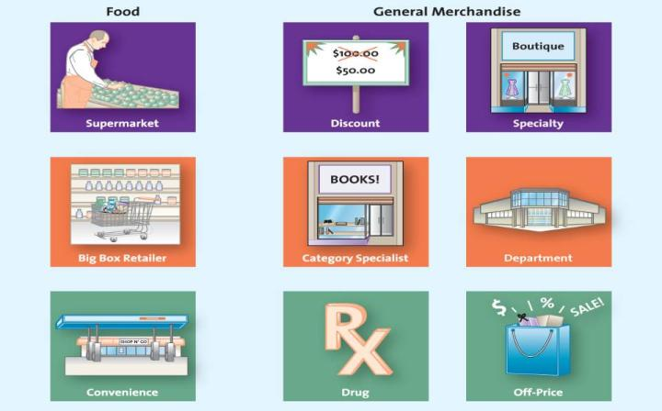
General Merchandise Retailers
- Department Stores
  - Broad variety and deep assortment
- Full-line Discount
  - Broad variety at low prices
- Specialty
  - Limited merchandise with service in small store
- Drugstores
  - Specialty for pharmaceutical and heath
- Category Specialist
  - Discount with narrow but deep assortment
- Extreme value
  - Full line, limited, very low prices
- Off-Price
  - Inconsistent assortment of brand name at low prices

Finding the Right Niche
Specialty stores need to serve the segment of consumer beyond what bigger retailers provide. How do you fill that niche?
The Wheel of Retailing
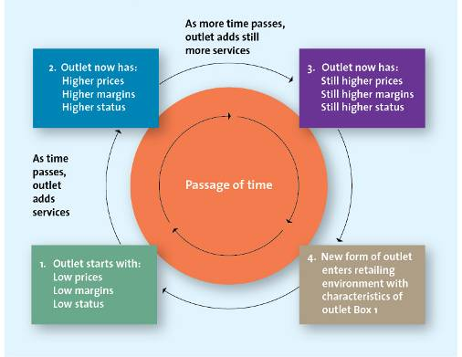
Channels for Selling to Consumers
- Store Channel
- Kiosk Channel
- Catalogue Channel
- Internet Channel

Benefits of Stores for Consumers
- Browsing
- Touching and Feeling
- Personal Service
- Cash and Credit
- Entertainment and Social Interaction
- Instant Gratification
- Risk Reduction

Benefits of the Internet and Multichannel Retailing
- Deeper and Broader Selection
- Personalization
- Gain Insights into Consumer Shopping Behavior
- Increase Customer Satisfaction and Loyalty
- Expand Market Presence

Shopping over the Internet provides the convenience offered by catalogs and other nonstory formats. However, the Internet, compared with store and catalogue channels, also has the potential to offer a greater selection of products and more personalized information about products and services in a relatively short amount of time. It also offers sellers the unique opportunity to collect information about how consumers shop—information that they can use to improve the shopping experience across all channels.
The Internet has radically altered the retail marketplace. Many traditional bricks-and-mortar retailers create synergy between online and traditional retailing. Multi-channel customers buy more than single channel customers.
Chapter 14
Communicating with Consumers: The Communication Process
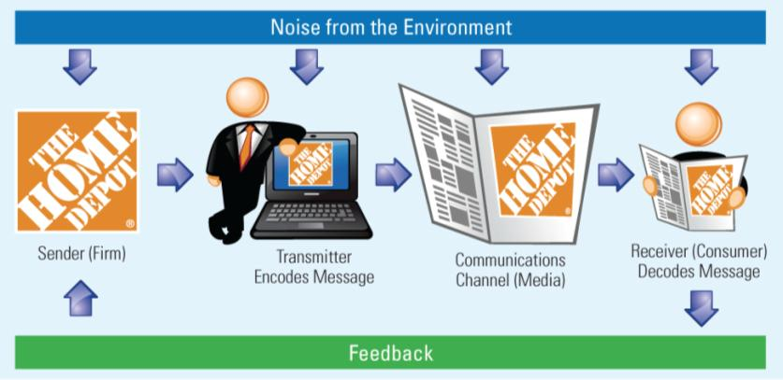
Integrated Marketing Communication Tools
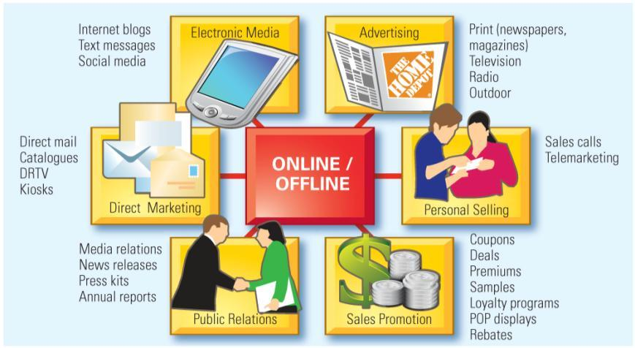
The goal of IMC is to ensure all the various marketing mix elements work together to deliver a consistent message. Therefore, IMC takes the best of each communications medium and combines it to achieve the most effective marketing communications campaign possible. There are six key IMC tools, most of which can be used in both online and offline environments. Each tool can range from being passive to very interactive. To get the right message to the right audience through the right tool and medium, an IMC planner must understand how each medium communicates and how to combine it with other media to generate the most impact.
Advertising
- Most visible element of IMC
- Extremely effective at creating awareness and generating interest

Personal Selling
- Some products require the help of a salesperson
- More expensive than other forms of promotion
- Salespeople can add significant value, which makes the expense
worth it

Sales Promotions
- Can be aimed at both end user consumers or channel members
- Used in conjunction with other forms of IMC
- Can be used for both short-term and long-term objectives

Direct Marketing
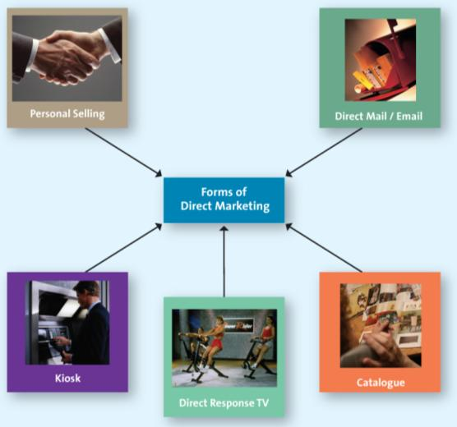
Online Marketing
- Websites
- Blogs
- Social Media

The Internet has radically altered the retail marketplace. Many traditional bricks-and-mortar retailers create synergy between online and traditional retailing. Multi-channel customers buy more than single channel customers.
Social media is media content distributed through social interactions. Three major online facilitators of social media are YouTube, Facebook, and Twitter.
Public Relations (PR)
- “Free” media attention
- Importance of PR has grown as cost of other media has increased
- Consumers becoming more skeptical about marketing, PR becoming more important

PR Toolkit
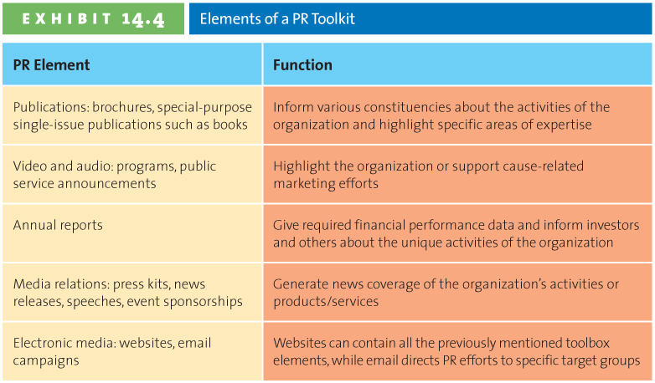
Steps in Planning an IMC Campaign
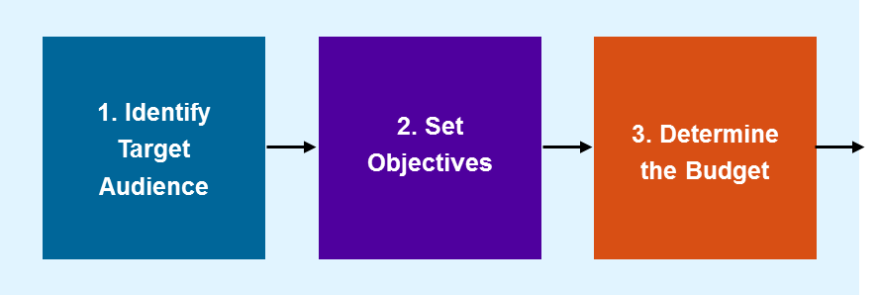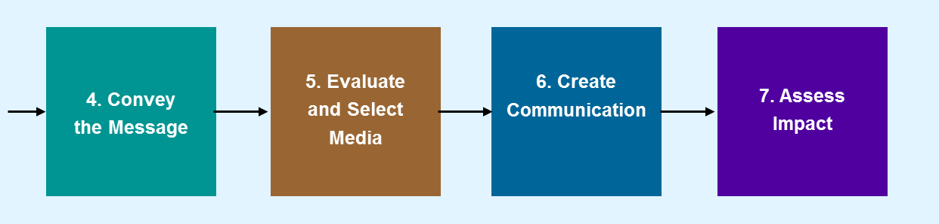
1. Identify Target Audience
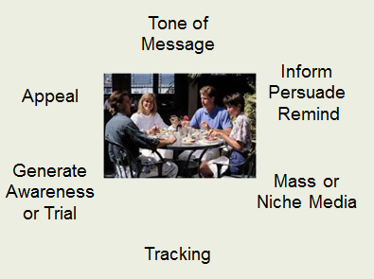
2. Set Objectives
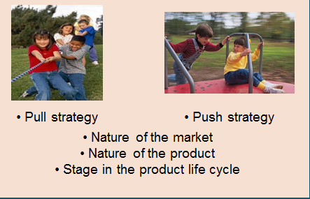
3. Determine Budget
- Considerations
  - Role that advertising plays in their attempt to meet their overall promotional objectives
  - Expenditures vary over the course of the Product Life Cycle
  - Nature of the market and the product influence the size of the budget

Budgeting Methods

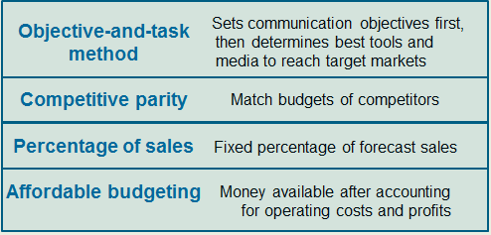
4. Convey the Message
Unique selling proposition
Boost Mobile….Where you at?
Nokia….. Connecting People

The Appeal
- Rational appeal
- Emotional appeal
Appeals depend on the target audience, chosen media, and type of product/service. Each appeal persuades in different ways. Whereas rational appeals are more cognitive and persuade using rational thought, emotional appeals persuade by triggering an emotional response rather than offering rational arguments.
How do the two Kleenex ads vary in their type of appeal and how well does each match the product? Which would make you purchase Kleenex?
Informational appeals are more cognitive and persuade using rational thought.
Emotional appeals persuade by triggering an emotional response rather than offering rational arguments.
5. Evaluate and Select Media
- Media planning
- Media mix
- Media buy

The ability of any one media outlet to reach a mass audience is declining due to the fragmentation of media and the proliferation of new media outlets. This trend represents a double-edged sword, because fragmenting media have also allowed for very fine targeting in media buys.
Mass and Niche Media
Mass media reach large anonymous audience
Niche media reach a smaller more targeted audience

Choosing the Right Medium
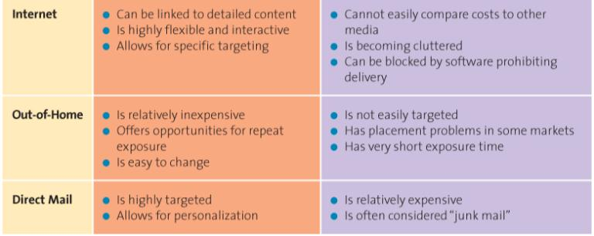
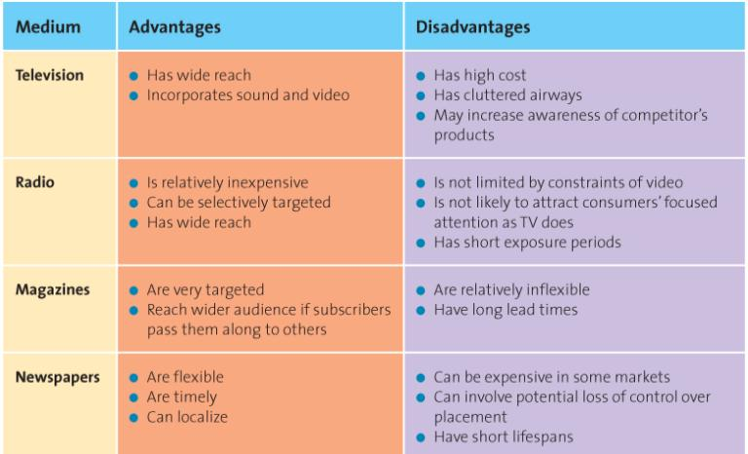

Determine the Advertising Schedule
- Continuous
- Pulsing
- Flighting

6. Create Communications
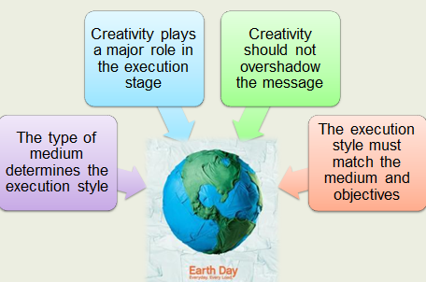
7. Assess Impact Using Marketing Metrics
- Pretesting
- Tracking
- Protesting

Results: Measuring IMC Success
- Understand desired outcome at outset
- Short-term or long-term
- Should be explicitly defined and measured

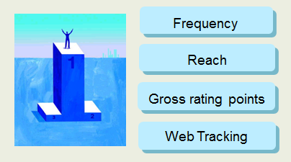
Chapter 15
The AIDA Model
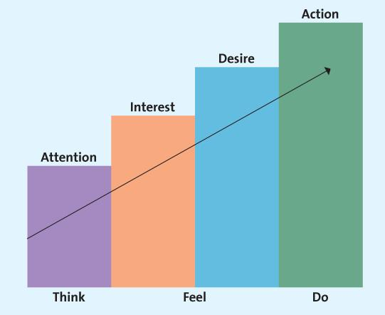
The AIDA model provides a basis for understanding how marketing communications works. Consumers move through a readiness continuum. At each stage they need information to help them progress to the next stage. The objective of some IMC campaigns may primarily be to generate awareness (e.g. new technology such as BluRay) while other campaigns aim to have consumers buy a new product (e.g. iPod Touch.) Each IMC tool can be used to move consumers through a buyer readiness continuum in different ways. For example, advertising may do a good job of creating awareness and even knowledge for a company that offers marketing consulting services but it may require a call from a sales person at that company to convince a small business, new start-up venture or entrepreneur to enlist the services of that consulting company.
Lagged Effect
- Advertising does not always have an immediate impact
- Multiple exposures are often necessary
- Difficult to determine which exposure led to purchase

Sometimes consumers don’t act immediately after receiving a marketing communication because of the lagged effect —a delayed response to a marketing communication campaign.
Advertising
- Paid message
- Delivered through media
- Must have identable source
- Designed to persuade
Many things people call advertising are not advertising at all. Word-of-mouth “advertising,” according to the definition, fails to meet several elements.
Advertising Objectives
- Inform
- Persuade
- Remind

Informative Advertising
Early in the PLC, firms use informative advertising to educate consumers about the product/service.
Persuasive Advertising
- Generally occurs in the growth and early maturity stages of the PLC when competition is most intense
- In the later stage of the PLC may be used to reposition an established brand

Reminder Advertising
- After the products have gained market acceptance
- Top-of-the-mind-awareness
Reminder advertising is communication used to remind or prompt repurchases, especially for products that have gained market acceptance and are in the maturity stage of their life cycle.
Focus of Advertisements
- Institutional advertisements
- Product-focused advertisements
The “Got Milk” campaign generates demand for the entire milk category; an advertisement for a single brand of milk tries to generate selective demand for that particular brand. The two are not mutually exclusive; when Coca-Cola introduced Diet Coke, it created both industry wide demand for diet soda and product specific demand for Diet Coke.
Companies like Exxon-Mobil advertise their commitment to the environment, not their products, to inform, persuade, and remind consumers of positive thoughts about the company, which can prompt the purchase of products and services.
Regulatory and Ethical Issues
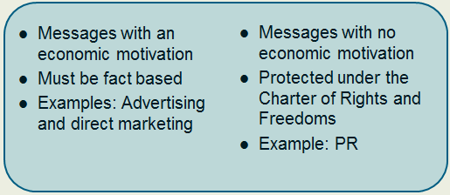
Puffery

Sales Promotions
- Can be targeted at either the end user consumers or channel members
- Can be used in either push or pull strategies

Remind students that as advertising has decreased as a portion of total marketing communications budgets, sales promotions have increased. Promotions can be used to stimulate sales by either the end user consumers or to stimulate channel members to sell more of a given product/service. If focused on the end user, the promotion is using a “pull strategy.” If focused on channel members , it is using a “push strategy.”
Types of Consumer Sales Promotion
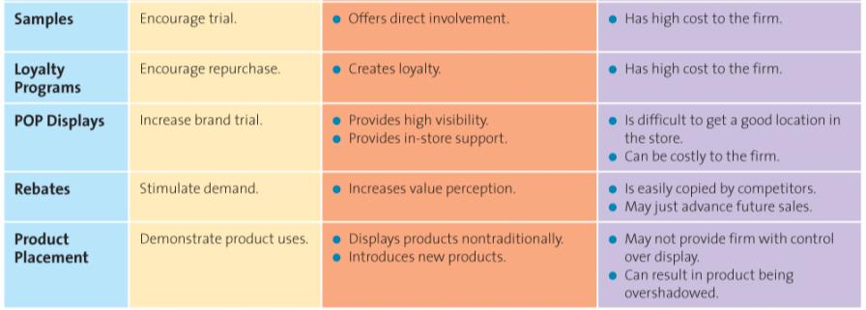
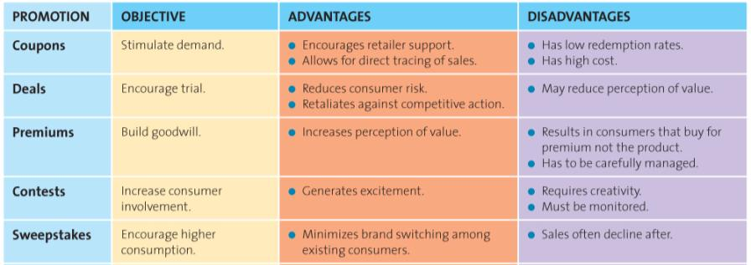

Using Sales Promotion Tools
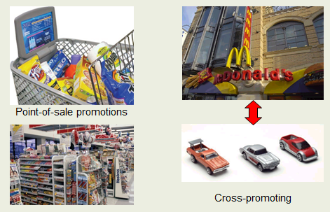
Types of Trade Sales Promotion
- Discounts and Allowances
- Co-operative Advertising
- Salesforce Training

Evaluating Sales Promotions using Marketing Metrics
- Realized margin
- Cost of additional inventory
- Potential increase in sales
- Long-term impact
- Potential loss from switches from more profitable items
- Additional sales by customers

The Scope and Nature of Personal Selling
- Internet
- Telephone
- Face-to-face
- Teleconference

Professional Selling as a Career
- People love the lifestyle
- There is a lot of flexibility
- There is a lot of variety in
the job
- Can be very lucrative, among the highest–paying careers for college graduates
- Very visible to management, good for promotions

Personal Selling and Marketing Strategy
- Can customize the message for a specific buyer
- Assists in creating strong supply chain relationships
- Increased customer loyalty through relationship selling
- Gather research input from customers
- Crucial to the success of CRM

The Value Added by Personal Selling
- Salespeople educate and provide advice
- Salespeople save time and simplify buying
The Personal Selling Process
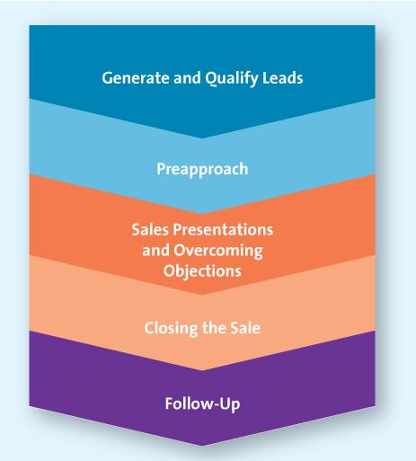
Step One: Generate and Qualify Leads
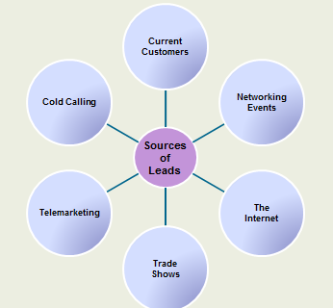
Step Two: Preapproach
- Extends the qualification procedure
- Set goals for what is to be accomplished

Step Three: Sales Presentation and Overcoming Objections

- The Presentation
- Handling Objections

Step Four: Closing the Sale

- Getting the order
- Often most stressful part of sales process
- A “no” one day may be the foundation for a “yes” another

Step Five: Follow-Up

- Five Service Quality Dimensions
  - Reliability
  - Responsiveness
  - Assurance
  - Empathy
  - Tangibles

Impact of Technology on Personal Selling
- Instant access to their customers
- Access to customer research and information
- Training programs are more effective, easier to operate, less expensive
- Less time on order tracking

Managing the Sales Force
- Sales force structure
  - Company sales force vs. manufacturer’s reps
- Recruiting and selecting salespeople
- Sales training
- Motivating and compensating salespeople
- Evaluating salespeople

Chapter 16

Assessing global markets (PEST)
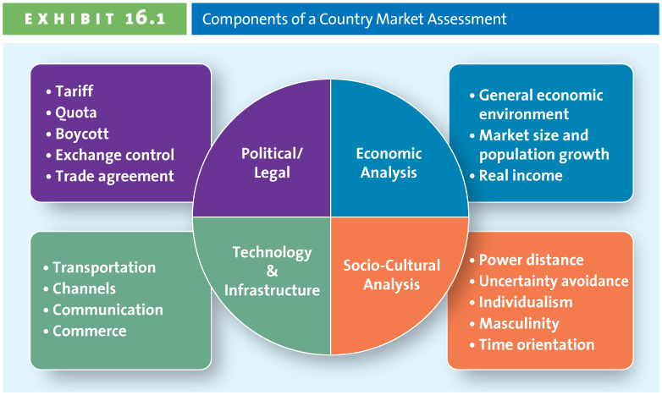
Any entry into a new market, especially into a new country, requires careful planning. A formal market assessment prevents firms from making costly mistakes.
Political-legal environment: Do any legal restrictions complicate entering the market?
Economic environment: What is the state of the nation’s economic health?
Social-cultural environment: How do cultural factors affect business opportunities?
Technological environment: To what degree are technological innovations used by consumers in the market?

Analyzing the Political/Legal Environment
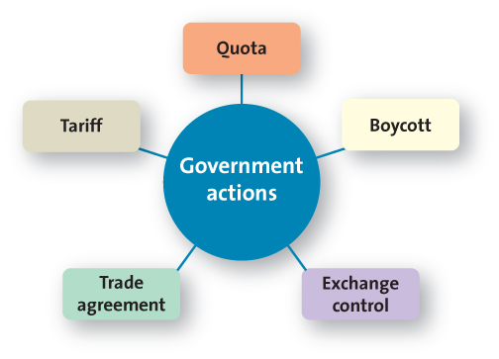
Tariff and Quotas
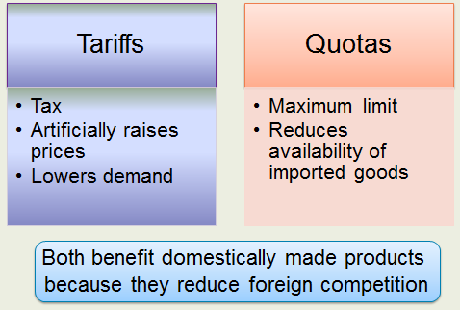
Trade negotiations often revolve around reducing or eliminating tariffs, quotas, or similar impediments to trade. Discuss the recent trade battles between the United States and foreign agriculture producers (e.g., sugar, corn). Many foreign producers accuse the United States of limiting market access through unfair tariffs and quotas, whereas the United States insists that it must protect United States agriculture.
Boycott
- Dissatisfied global consumers
- Voiced dissatisfaction with U.S. war policy
- Avoidance of U.S. products and services
- How do firms respond to these actions?
Exchange Control
- Exchange rate
- Countertrade
The Central Bank of a country generally regulates its currency. Many countries try to keep their markets attractive to foreign investors while simultaneously making their goods attractive to foreign buyers through exchange control.

General Agreement on Tariffs and Trade (GATT)
World Trade Organization (WTO)
Trade Agreements
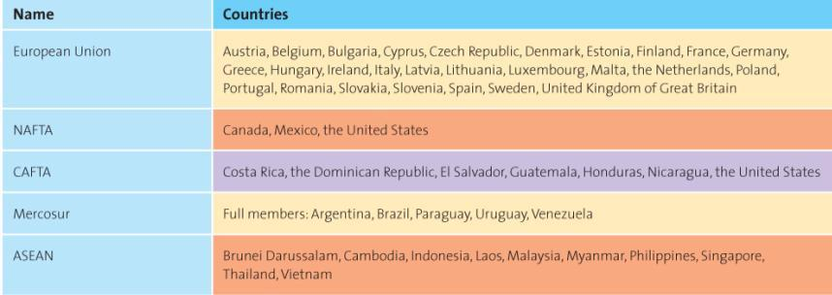
The European Union (EU)
- Monetary and Trade Union
- Euro (not in the UK)
- Membership consists of Western & Eastern European countries
- Turkey most recent petitioner

Analyzing the Economic Environment
A three-part economic analysis indicates whether the country market offers the firm an attractive target.
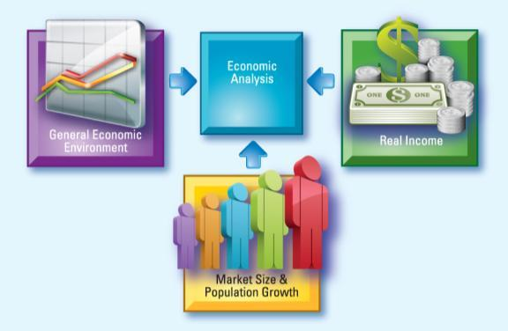

Economic Analysis General Economic Environment
- Gross domestic product
- Gross national income
- Purchasing power parity
- Human development index
Each of these standardized measures allow for comparisons across countries. The use of each depends on specific circumstances. Many reports now feature GNI rather than GDP, because it includes the economic impact of firms that earn income from their global operations, unlike GDP, which dramatically undercounts the impact of those activities on the economy of the firms’ home markets.
Purchasing Power Parity
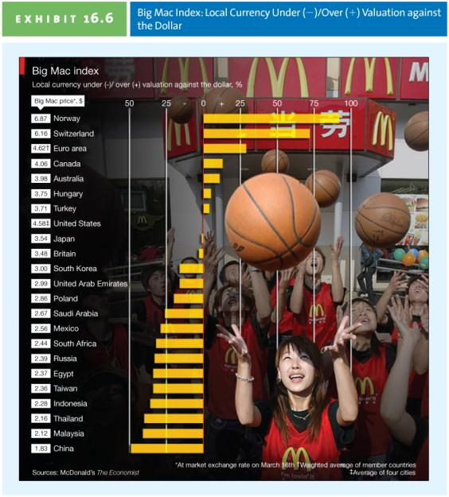
Global Human Development Index
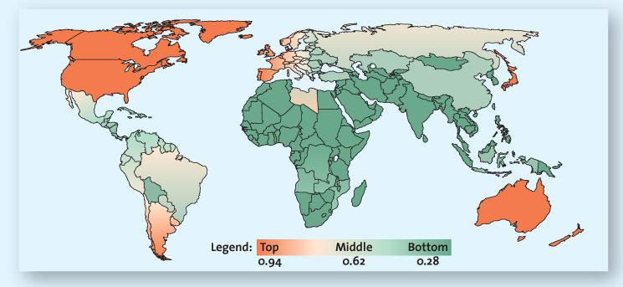
The HDI goes beyond traditional economic measures and considers people’s ability to afford subsistence. Many Western nations score close to 1, whereas many African nations earn the lowest scores in the world.
The NationMaster link shows the most recent Economy Statistics for the Human Development Index by country.
Evaluating Market Size and Population Growth Rate
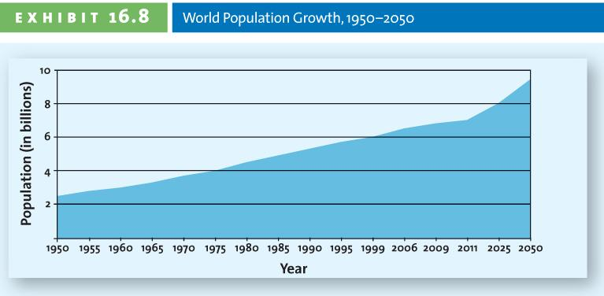
The population of Canada is over 34 million people. Although that may seem like a large number, other countries are growing at much faster rates. Some Western nations face serious population shortages and will have to rely on immigration to maintain their employment levels.
Evaluating Real Income
Firms can make adjustments to an existing product or change the price to meet the unique needs of a particular country market.
Successful firms make their products accessible to average buyers, which in many countries means offering products in smaller portions that make them affordable. Two thirds of the Chinese population earns less than $25 a month so P&G repackaged its Head & Shoulders shampoo in single-use packets to make it affordable and allowing Head & Shoulders to become the top-selling shampoo in China.
Analyzing Sociocultural Factors
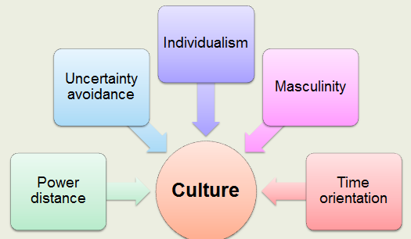
Country Clusters
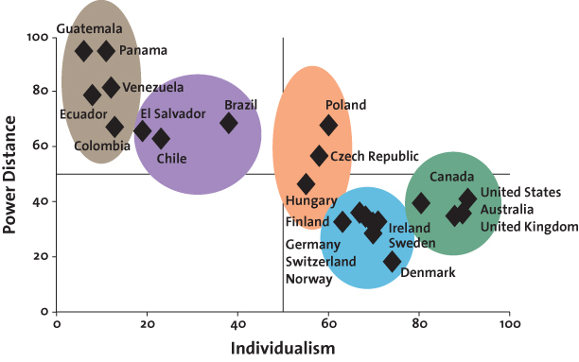
Hofstede’s cultural dimensions offer an effective understanding of the subtle elements of a culture. Taken together, these dimensions enable marketers to group countries together according to their similarity on these dimensions and therefore engage in more efficient planning.
Analyzing Infrastructure and Technological Capabilities
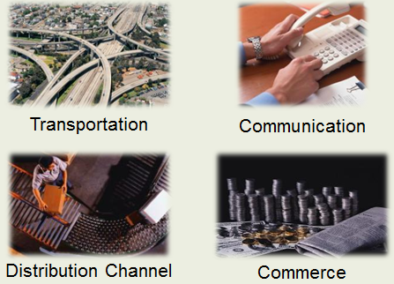
A firm’s ability to conduct business in a particular country is in large measure determined by that country’s infrastructure.
Choosing a Global Entry Strategy
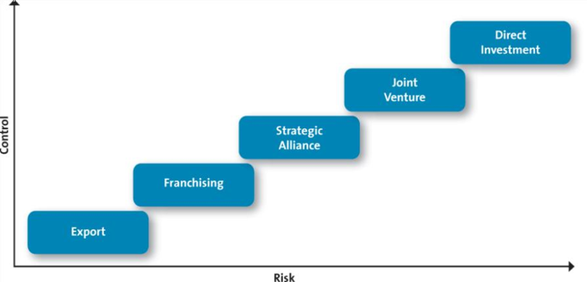
Choosing a Global Marketing Strategy: Target Market (STP)
- Cultural nuances
- Subcultures
- View of product and consumer role
- Different positioning
- Adaptation
- Single positioning strategy

The Global Marketing Mix: Product or Service Strategies
- Sell the same product or service in both the home country market and host country
- Sell a product or service similar to that sold in home country but include minor adaptations
- Sell totally new products or services

Global Marketing Mix: Pricing Strategies
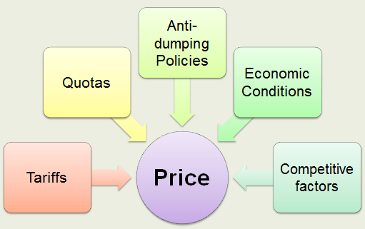
Global Marketing Mix: Global Distribution Strategies
- Some global channels are very long and complex.
- Consumer shop local small local stores.
- Suppliers must be creative in delivering to these outlets.

Delivering products to local retailers can be incredibly difficult and frustrating. Infrastructure issues often prevent traditional distribution methods and require creative adjustments. Global firms must find distribution strategies that enable them to reach even really remote markets. For instance, Avon sells and delivers cosmetics to customers using canoes. This example could also prompt an ethical discussion on whether or not firms should be marketing hedonic products or services to consumers with very little disposable income. This YouTube ad (always check before class) is for FedEx and shows how it international distribution can be difficult for many companies.
Global Marketing Mix: Global Communication Strategies
- Literacy levels vary by country
- Firms choose whether to adapt to language differences
- Cultural and religious differences also matter

