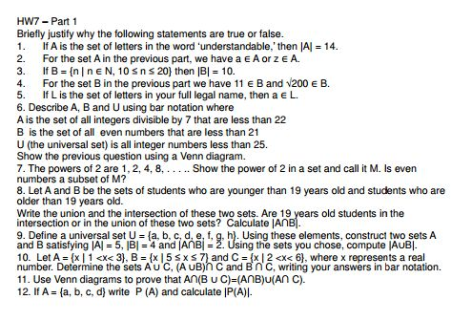

- True. |A| is used to show the cardinality of A which includes all the elements of a set, which in this case is 14 letters.
- False. a is an element of Set a, however, z does not belong in this set.
- False. There are 11 elements in this set as it contains elements from 10 to 20 including 10 and 20. While the cardinality indicates 10 elements in the set, which makes it false.
- True. Both elements do occur in the set, 11 and squareroot of 200.
- True. My name is Nitharsana, and a does belong in this set, L.
- A = {x | x is all integers divisible by 7 < 22} A = {7, 14, 21}
b. B = {x | x is an even number < 21} B= {2,4,6,8,10,12,14,16,18,20}
c. U= {x < 25} U={1,2,3,4,5,6,7,8,9,10,11,12,13,14,15,16,17,18,19,20,21,22,23,24}
B
2 4 6 8 10 12 16 18 20
A
7 21 14
U
1 3 5 9 11 13
15 17 19 22
23 24 25

- M= { (1) (2)(2)···(2) = 2^|A| }
M={ 1, 2, 4, 8…}
No, even numbers are not a subset of M because there is a one occurring as the first element, however in further powers of 2, it would be all even numbers.

- A UB = {1, 2, 3, 4, 5, 6, 7, 8, 9, 10, 11, 12, 13, 14, 15, 16, 17, 18, 19, 20, 21, 22, 23, 24, 25…}
A n B = {19} 19 year olds are found in the intersection of these sets.

- U = {a, b, c, d, e, f, g, h}

|A| = 5 A={a, b, c, d, e}
|B| = 4 B={a,b,c,d}
|AnB| = 2 |AnB|= {a,b}
|AUB|={a,b,c,d,e}

- AUC= {2, 3, 4,5}

(AUB)nC = {5}
AUB={2,5,6,7}
C={3,4,5}

BnC={5}
B={5,6,7}
C={3,4,5}
C 3 4

5

B 6 7
A 2
U

- A={a,b,c,d}
P (A) = { {a,b,c}, {a,b,d}, {b,c,d}, { c,d,a}, {a,b},{a,c},{a,d},{b,c},{b,d},{c,d} ,{a},{b},{c},{d}, A, φ }
|P (A)|= 16
Chapter 9
9.4
a) S={male, female}
b) S= { 0, ∞}
c) S= {O+,O-,A+,A-,B+,B-,AB+,AB-}
d) S= {0, ∞}
e) S= {

9.8
a) P (A) = 0.01 Fat content greater than 4 grams make up the event A .
b) P (B) = 0.99 Fat content less than 5 grams make up the event B.
c) P (A or B) = 1
The outcomes that make up event A or B is all the fat content greater than 4 grams and all the fat content less than 5 grams.

9.12
a) This probability model demonstrates an example of a continuous model because the number of hours varies for students which could take any infinite positive value.

b) This probability model demonstrates an example of a discrete model because the sample space is made up of discrete outcomes and only takes certain values, in this case being TV was on most the time, some of the time, a little bit of the time, or never.

9.16
a) Patients experienced a complication from DVT= 42:1518
Risks = 0.0277:1 Odds=7:246
These values compare as the risk and odds are quite close as 7 in 246 humans can experience DVT complications and the risks of it occurring is 2.77%.

b) In comparison to a large population these numbers appear to be fairly small. Although, these numbers may be fairly small Pfizer should try to reduce such numbers through further research. Proportions and numerical values displayed in decimals proportions are more visual to comprehend.

9.20
Discrete

9.32
a) Satisfies the rules of probability
b) It does satisfy the rules of probability as the outcomes do not equal to 1.
c) Satisfies the rules of probability.

9.36
a) A woman using a contraceptive method which relies on woman only is 67.2%
b) A contraceptive method require the man only is 13.2%
c) A contraceptive method involving a male partner in some way is 19.6%

9.40
a) Discrete because eye colors can only take certain descriptive values.
b) P(X > 4)= 0.19
c) Eye color is at most 2.
P(X < 2)= 0.34
P(X<2 )= 0.05

9.44
a) P(0.5<Y<1.3)= 0.4
h=0.5

b) P(Y> 0.8)= 1.7
h=0.5

