What is geology?
- Ancient Greek “ge” = Eearth
- “Logos” = “reasoning”, to speak
- It’s the science that studies earth (history, evolution, composition, internal/external components and processes.

Why study geology?
Because geology is all around us (landscape and resources)
- construction materials
- petroleum products
- water
- natural disasters (explain/predict)

Section 1.1
From Big Bang to Earth as we know it today

1) Big Bang (13.7 Ga)
2) Formation of nuclei ( approx.. 3 mins following B.B)
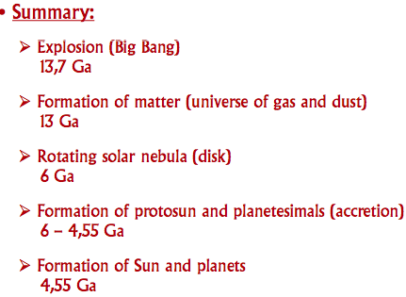
*Quarks > neuclei of H + He (protons only)
3) Formation of atoms (700 000 years after the B.B)
*Expansion of universe -> lowering of T*c
*Electrons attached to nuclei of H and He
*Universe = sop of gas and dusts (matter)
4) Formation of the stars / galaxies (approx. 200 Ma after B.B)
*Matter coalesces to form clumps, which collapse to form stars + galaxies
5) Diffuse mass of gas and dust: solar nebula (6 Ga)
*Rotating -> formed a gaseous and dusty disk
6) Formation of the protosun
*Accretion of matter at the centre of the nebula (or disk)
* Warming up of the centre of the nebula (increase in T *c and P)
* Nuclear fusion (multiple nuclei join to form a heavier one = release of energy)
7) Formation of planetesimals) = small solid bodies
* Accretion of matter in the disk
* Gradual cooling of the disk
8) Accretion of planetstimals continues
9 Birt of sun ( approx.. 4,55 Ga)
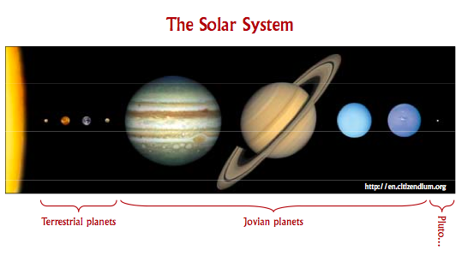
10) Formation of planets ( same ^)
* Final accretion of interplanetary debris
* Terrestrial vs. jovian planets

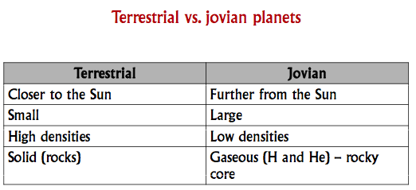
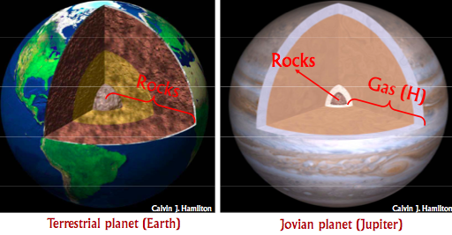
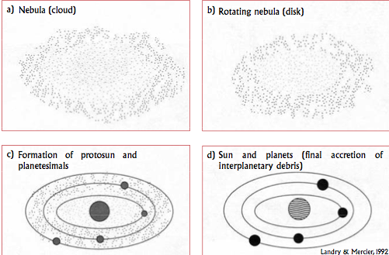

Differential of the Earth

Nowadays the Earth’s interior is composed of different layers

Two models:
- Homogeneous accretion
- Heterogeneous accretion

Homogeneous accretion
- Accretion of non-differentiated matter
- Later differentiation * based on:
- Density of materials
- Other chemical properties

* The Earth was initially molten

Heterogeneous accretion
- Sequential accretion of planetesimals of differing compositions:
1) metallic iron and oxides
2) dense silicates
3) light silicates
4) atmosphere (volatile-rich planetestimals ex: water, ammonia and methane)

Possibly a combination of both a and b

