ANP 1105 B – Human Anatomy and Physiology I- Final Exam
Contents
4.3 Blood Vessels and Hemodynamics 1
4.3.1 STructure of the Walls and Arteries of Veins 1
4.3.2 Three Types of Arterial Vessels 2
4.3.3 microcirculation and the three types of capillaries 2
4.3.4 Structure and Functions of veinous system 2
4.3.5 Blood Flow, Blood Pressure, Resistance, Peripheral Resistance 3
4.3.6 Changes in blood pressure as it moves throughout circulatory system 3
4.3.7 Factors that effect resistance 3
2.20 Systolic and Diastolic Arterial Pressure, pulse Pressure, Mean Arterial Pressure 4
4.3.9 Blood Pressure in Capillary Beds 4
4.3.10 BLood Pressure in tersms of Cardiac Output and Peripheral resistance 5
4.3.11 Neural and Chemical (hormonal) regulation of Blood pressure 6
Vasomotor tone and Vasomotor Centre 6
Baroreceptor initiated reflexes: 7
Chemoreceptor intiated Reflexes 7
Influence of HigHer Brain centres 7
Hormonal and short Term Regulation of Blood Pressure 8
4.3.12 Role of Kidneys in long term regulation of blood pressure 9
4.3.13 Mechanisms of autoregulation wrt local blood flow 9
2.27 Explain the forces that act to influence capillary exchange 10
Capillary Exchange Mechanisms 11
Lymphatic System (CH 20) 12
5.1 Structure and Function of the Vessels and Organs of the Lymphatic System 12
lymph capillaries 12
Lymph nodes 12
Lymphoid Cells 12
Lymphoid Tissue 13
Lymph Nodes 13
Other Lymphoid Organs 13
Spleen 13
Thymus 14
Tonsils 14
Aggregates of Lymphoid NoDules 14
5.2 Origin of Lymph and it’s transport 15
Lymph Transport 15
THe Respiratory System (CH.22) 16
INTRODUCTION 16
6.1 Structure of the components of the conduction and Respiratory Zones 16
1.Nose 16
REspiratory mucosa 17
2. Paranasal sinues 18
3. Pharynx 18
3c) Laryngopharynx 19
4. Larynx 19
5. Trachea 20
The Bronchial Tree 20
6.2 Gross Anatomy & Structure of the Lungs and the pleural cavities 22
Physiology of the REspiratory System 23
6.3 Intrapulmonary, intrapleural and Transpleural Pressure 23
Intrapulmonary Pressure (P_{pul}) 23
Intrapleural pressure (P_{ip}) 23
6.4 Roles of the Diaphragm and accessory msucles during inspiration and expiration 24
Quiet Inspiration 24
Quiet Expiration 24
Deep/Forced inspiration 24
Deep/Forced Expiration 24
6.5 Three Factors that influence pulmonary ventilation 25
6.5.1 REsistance 25
6.5.2 Alveolar Surface Tension 25
6.5.3 Lung Compliance 26
6.6 Lung volumes and Capacities 26
1. REspiratory Volumes: 26
2. Respiratory Capacities 26
6.7 Dead Space 27
AVR (Alveolar VEntilation) 27
6.8 mechanisms Underlying Some of the Non-respiratory air movements 28
6.9 Dalton’s Law in terms of the Composition of atmospheric and alveolar air 28
6.11 Three factors that influence the exchange of oxygen and of carbon dioxide at the level of the lungs (external respiration) 29
1. pP Gradients and GAs Solubilities 29
2. Structural Characteristics of Respiratory Membrane 29
3. Ventilation-perfusion Coupling 30
6.12 Partial Pressure Gradients Drive Oxygen And Carbon Dioxide Movements in tissues (Internal REspiration) 30
6.13 Transport of Oxygen in BLood 31
6.14 OXygen-hemoglobin dissociation curve 31
6.15 CArbon Dioxide Transport in thE Blood 32
6.17 Carbon Dioxide Levels and Ph 33
6.18 Respiration Control By Nervous System 34
Ventral Respiratory Group (vRG) 34
6.20 Influence of PCO₂. PO₂& arterial PH on respiration rate 34
CO₂ (and pH): 34
Influence of PO₂ 35
6.19 Heuring breuer Reflex, Hypothalamus, Cortex 35
Hering Breuer Reflex (Inflation Reflex) 35
Hypothalamus 36
Cortical Controls 36
Some Consequences 36
Arterial pH: 36
In summary: 36
6.21 Discuss The mechanisms controlling respiration durng intense exercise 37
Exam: 38

4.3 Blood Vessels and Hemodynamics

4.3.1 STructure of the Walls and Arteries of Veins
arteries » arterioles » capillaries » venules » veins
• arteries carry blood away from the heart
• veins carry blood toward the heart
• only capillaries directly serve cells
Structure of Blood Vessel Walls (except the thinnest vessels)
- Tunica intima:
  - innermost layer (intimate contact with blood)
  - Single layer of endothelial cells,
- Tunica media:
  - Composed of smooth muscle and elastic fibers, arteries and arterioles are capable of regulating their diameters, ease or constricts flow of blood depending on need
- Tunica adventitia (externa):
  - outer wrapping on veins and arteries, composed of collagen

Artery = thicker wall, Also has elastic tissue, required to stretch because of systolic pressure
Vein= doesn’t have elastic tissue, deals with diastolic pressure, has valves to prevent backflow of blood, important in our lower limbs
Vasa vasorum: delivers oxygen and draining oxygen poor blood to particular tissues
Capillaries: consist of single layer of flat endothelial cells, and basement membrane, promote exchange so we want thin of a wall as possible.

4.3.2 Three Types of Arterial Vessels
- Elastic (Conducting) Arteries
  - High volume, high pressure, requires strechiness, most elastin tissue in their walls
  - Recoil effect of the elasticity, another propulsion to keep pushing the blood
- Muscular (Distributing) Arteries
  - Deliver blood to specific organs
  - Control where blood goes
    - Smooth muscle vs. elastin:
- Arterioles:
  - No need for elastic tissue

4.3.3 microcirculation and the three types of capillaries
- Continuous capillaries
  - : places where we want to protect the surrounding tissue, limited passage of solutes
  - Uninterrupted linings
- Fenestrated Capillaries
  - Found where we need transpo of things, tissues like small intestine, endocrine organs etc.), intermediate level of passage
- Sinusoidal capillaries (leaky capillaries)
  - Large intercellular clefts for passage of proteins and RBC’s (ex. Red bone marrow)
  - Also fenestrated

microcirculation = flow of blood from an arteriole to a venule through a capillary bed
(i) vascular shunt = metarteriole + thoroughfare channel (central pathway used when we don’t need to profuse the entire capillary bed.
(ii) true capillaries = actual exchange vessels (10-100/bed)
• precapillary sphincter surrounds root of each true capillary, when contracted closes off and forces blood to go through the throughfare channel
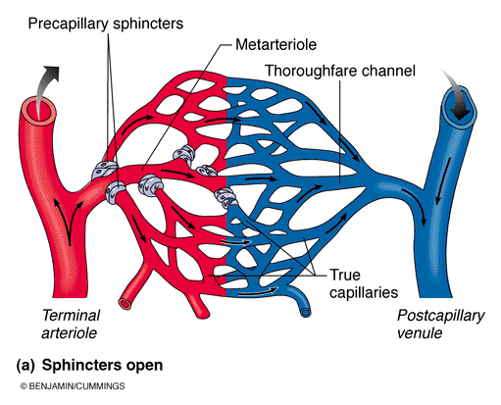

4.3.4 Structure and Functions of veinous system
- Venules:
  - 8-100 um diam; post capillary venules = just endothelium + a few fibroblasts; larger venules have sparse tunica media & thin tunica adventitia
- Veins:
  - 3 tunics but walls thinner & lumens larger
  - relatively little elastin/smooth muscle in tunica media; tunica adventitia is heaviest layer
  - under resting conditions up to 65% of blood in veins at any one time = capacitance vessels or blood reservoir
    - Larger internal lumen, blood moving less fast under lower pressure, pooling
- What are two structural adaptations of veins that promote blood return?
  - Valves:
  - Larger Internal Diameter:
Skeletal muscles pushing on the outside also encourage movement of blood

4.3.5 Blood Flow, Blood Pressure, Resistance, Peripheral Resistance
- Blood Flow: Definition: movement of a volume blood past any area at a time
  - can be regulated independently for various tissues & organs
- Blood Pressure: force per unit area exerted on the wall of a blood vessel by its contained blood (mm Hg)
  - refers to systemic arterial blood pressure in the largest arteries near the heart (eg: average aortic bp = 90 mm Hg (mean arterial pressure)

  - Flow occurs in response to a pressure gradient!!! :
    - If there is no pressure gradient (i.e. pressure same at beginning of pathway and at end there is nothing to encourage the flow forward, we must be able to move to an area of lower pressure.

4.3.6 Changes in blood pressure as it moves throughout circulatory system
Blood Flow= 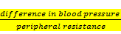 ( 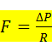 )
- Resistance is the major determinant of blood flow because a change in blood vessel radius increases resistance to the 4thpower
  - Ex. Halving diameter increases resistance by 2⁴ = 16x
- Arterioles can regulate their diameters
  - Ex. When you’re not using stomach, constrict arterioles in that area to encourage blood to other areas
We don’t have enough blood to profuse EVERY capillary blood, so we must distribute it properly

4.3.7 Factors that effect resistance
- Resistance: measures total of frictional forces that impede flow; flow & resistance are inversely related
  - resistance is influenced by: blood viscosity, vessel length/diameter
  - blood on the edges (rubbing against walls), slower than blood in the middle

Factors affecting Resistance
- a) blood viscosity: due to formed elements, plasma proteins, harder to push blood around
- b) total blood vessel length: more length = more resistance (e.g. extra adipose tissue, every pound has to be vascularized, ie greater workload on the heart)
- c) blood vessel diameter: can be regulated; fluid not touching walls moves faster
  - reduction of resistance in an area (vasodilation)
- 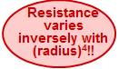Velocity of Blood Flow
- velocity ~ 1/total cross-sectional area
  - aorta: (2.5 cm²): 40-50 cm/sec
  - capillaries: (4500 cm²): ~0.03 cm/sec
  - vena cava: (8 cm²): 10-30 cm/sec

2.20 Systolic and Diastolic Arterial Pressure, pulse Pressure, Mean Arterial Pressure
- Pulse Pressure = systolic bp - diastolic bp
  - indicates vigor of contraction of ventricle
  - provides info on elasticity of aorta and major arteries (elastic arteries needed near beginning
  - diastolic pressure more important as we age—(i.e elasticity of arteries declining)
- Mean Arterial Pressure (MAP) = diastolic pressure + 1/3 pulse pressure
  - MAP is the pressure that propels blood to tissues during the cardiac cycle
  - not mean of systolic & diastolic pressures; diastole is longer than systole, heart spends more time in diastole
    - sample calculation: bp = 120/80 mm Hg: MAP = 80 + 40/3 = 93 mm Hg
(80 + (120-80)/3)= 93
  - » MAP & pulse pressure decrease with distance from heart; by end of arterial tree, blood flow is steady & pulse pressure has disappeared

4.3.9 Blood Pressure in Capillary Beds
- low pressure: 35 mm Hg at entry and 17 mm Hg by end
    - capillaries are fragile; high pressures would rupture them
    - most capillaries are extremely permeable; lots of exchange at low bp, high pressure gradient not needed
- loss in pressure due to net loss of water, exchange of nutrients and waste and due to the resistance to flow (capillaries are so small, RBC’s must travel one at a time)
Venous Blood Pressure
steady, changes very little during cardiac cycle (gradient only ~20 mm Hg)
Factors Aiding Venous Return:
- Respiratory pump: difference in pressure in thoracic cavity, inflation and deflation in lungs causes increase/decrease in abdominal pressure, therefore simple act of breathing helps pull blood up due to vacuum created by these pressure changes
- Muscular pump: contractions of skeletal muscle promoting pushing of blood

4.3.10 BLood Pressure in terms of Cardiac Output and Peripheral resistance
- homeostatic mechanisms in place to maintain adequate flow to tissues under a variety of circumstances
- main factors influencing blood pressure are: cardiac output (initial push out), peripheral resistance (pressure and elasticity, diameter of the tubing in system, confinement to pathway), blood volume
- blood pressure = cardiac output x peripheral resistance
- what determines CO??
    - HR (neural & hormonal factors)
    - SV (venous return, neural & hormonal factors)
What about peripheral resistance & blood volume??
Short-term regulation via nervous system changes peripheral resistance and CO
Long –term regulation alters blood volume via kidneys.

Pulse
- Pulse: pressure wave due to alternating expansion & recoil of elastic arteries
  - push surface artery against firm tissue (usu radial pulse)
  - also called pressure points (areas where we can apply pressure to stop bleeding)

Blood Pressure
Blood pressure:
• auscultatory method: brachial artery using sphygmomanometer
what are thesounds of Korotkoff?? : indicate different phases, ie points when small amounts of blood are spurting through the constricted artery
Cuff fully inflated (artery fully collapsed »» no flow)
cuff pressure lowered to < peak systolic pressure (momentary high velocity spurt) »» record cuff pressure as systolic bp
cuff pressure lowered to < diastolic pressure (continuous flow - sounds disappear) »» record cuff pressure as diastolic pressure

- normal adult, at rest: SP=110-140; DP=75-80
- influenced by age, gender, weight, race, stress, nutrition, mood, posture, fitness,. . .

4.3.11 Neural and Chemical (hormonal) regulation of Blood pressure
- 2 main goals:
  - alter blood distribution to respond to specific demands
  - maintain adequate MAP by altering blood vessel diameter
- usually reflex arcs involving baroreceptors, vasomotor centre of medulla, vascular smooth muscle
  - barocrecpetors: detect stretch on vessel, give info on bp (beginning parts of pathways large arteries)
  - vasomotor centre : baroreceptors send info to here, (found in medulla of brain stem), this centre regulates bp, vessel diameter, blood flow
  - smooth muscle: output to smooth muscle to either vasoconstrict or vasodilate

Vasomotor tone and Vasomotor Centre
• cluster of sympathetic neurons in medulla: part of cardiovascular centre
• vasomotor tone: constant input, especially to arterioles (NE)
• any increase in symp ns activity »» generalized vasoconstriction & rise in bp; decrease has reverse effect
• vasomotor centre responds to input from:
- baroreceptors (stretch receptors)
- chemoreceptors (CO₂, O₂, H⁺)
  - info on how blood is distributing nutrients, ions
  - H+ acidity level , too much = acidosis (blood pH)
- higher brain centres or hormones
  - cortical control
    - 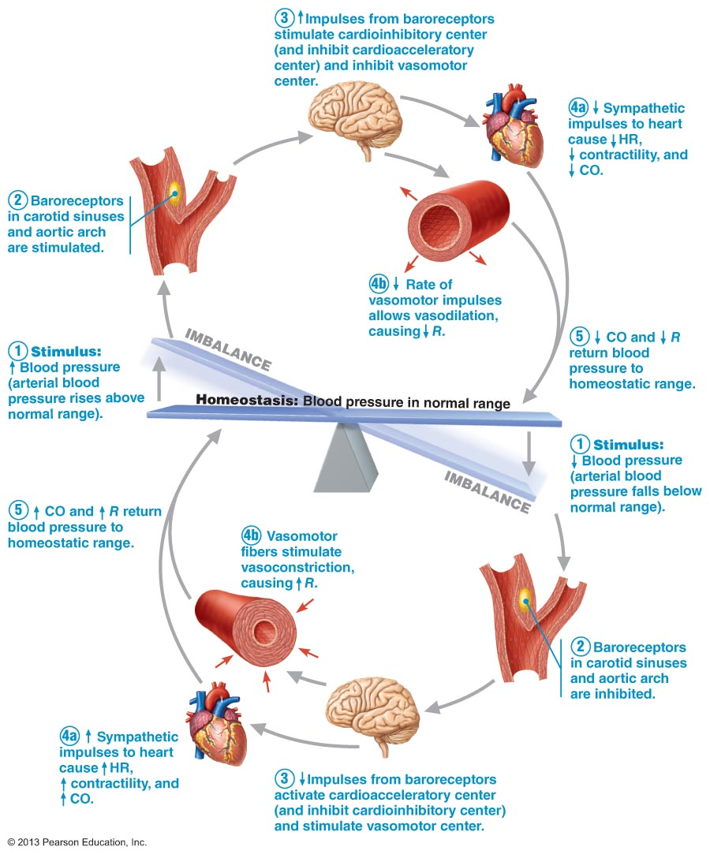anger will cause higher bp

Baroreceptor initiated reflexes:
• baroreceptors in carotid sinuses, aortic arch & other large arteries of neck & thorax
• increasing MAP stretches receptors; response (via vasomotor centre) is :
- dilation of arterioles
- venodilation to shift blood to venous reservoirs
- afferents also to cardiac centres to stimulate parasymp ns & inhibit symp ns, thereby decreasing heart rate & contractile force
• decreasing MAP initiates reflex vasoconstriction
GOAL: protect against short-term changes in bp (standing, bending); ineffective chronically (body adapts)

Chemoreceptor intiated Reflexes
- drop in O₂, pH or rise in CO₂: chemoreceptors in aortic arch & large arteries of neck to vasomotor centre »» reflex vasoconstriction (to move blood around faster, recycle CO2 and O2 faster, lower acidity)
- result is a rise in bp that speeds return of blood to heart & lungs

Influence of HigHer Brain centres
  - “fight-or-flight”, stress, exercise, . . »» cerebral cortex & hypothalamus get involved
  - Emotional responses (anger)

Hormonal and short Term Regulation of Blood Pressure
- Adrenal medulla hormones: NE/E & fight-or-flight
- vasoconstriction (except skeletal/cardiac muscle »» vasodilation)
- increases CO
- nicotine mimics effects of catecholamines (cigarette smoking, smokers tend to have higher bp due to interaction of nicotine that stimulates vasoconstriction)
- Atrial natriuretic peptide (ANP): (Na-triuretic= loss of sodium)produced by atria of heart
- causes blood volume & blood pressure to decrease
- generalized vasodilation
- Antidiuretic Hormone (ADH): source = hypothalamus/posterior pituitary)
- stimulates kidneys to conserve water (eg: severe hemorrhage) – long term effect
- if levels high, can potently cause vasoconstriction
- Angiotensin II: renin-angiotensin system; decreased renal perfusion
(a) intense vasoconstriction to increase systemic bp
(b) release of aldosterone, ADH
- Endothelium-derived factors:
(a) endothelin is a potent vasoconstrictor
(b) platelet-derived growth factor vasoconstrictor
(c) nitric oxide (NO) induces brief vasodilation
- Inflammatory chemicals:
eg: histamine, prostacyclin - released during inflammatory response; potent vasodilators
- Alcohol: inhibits ADH release, depresses vasomotor centre, promotes vasodilation (esp skin)
Short Term= local body responses, immediate vasoconstriction, vasodilation fix it temporarily
Long Term= generalized whole body responses, will correct problem, (i.e. changing blood volume by salt and water balancing by kidneys

4.3.12 Role of Kidneys in long term regulation of blood pressure
  - baroreceptors adapt to prolonged/ chronic high/low blood pressure
  - kidneys restore bp by adjusting blood volume
  - anything that changes blood volume will change blood pressure
  - if blood volume increased, kidneys excrete more of salt & water:
    - Direct Action: (indepent of hormones) increased blood volume/pressure = increased rate of filtrate formation → insufficient time to reclaim water → increased volume of urine (not able to pull back a lot of the salt and water)
    - Indirect Action:renin-angiotensin-aldosterone system
i) MAP decreases → kidney cells release renin → cascade of reactions (don’t need to know em) to yield angiotensin II (potent vasoconstrictor) → increased rate of renal perfusion (keep the kidneys functioning as well as possible, keep it well vascularized)
ii) angiotensin II stimulates secretion of aldosterone (adrenal cortex) → increases renal absorption of Na⁺& water
iii) also increased secretion of ADH (post pituitary) promotes water reabsorption
iv) triggers thirst sensation

4.3.13 Mechanisms of autoregulation wrt local blood flow
• blood flow to each organ regulated to meet needs
• resting vascular tone: in resting state, smooth muscles in walls of arterioles somewhat contracted (symp ns) »» can increase flow by vasodilation
immediate adjustments to changes in local conditions
Resistance varies 1/r⁴
• organs regulate individual blood flow by varying resistance of arterioles

Metabolic Controls (Local!) -Chemical
- Declining tissue levels of oxygen
- Increased levels of CO₂ , adenosine, H+, K+, heat, inflammatory chemicals (waste products)
- End result: immediate increased perfusion of “needy” tissues” to remove wastes via blood
Diagram:
Neural tissue does not change in blood pressure, pH, etc. Maintains static blood conditions
Improved delivery to skin to get rid of heat.

Active vs reactive hyperemia (occurs locally i.e. high altitudes causing lack of oxygen is not hyperemia)
- Active hyperemia: increased accumulation of waste products due to increased oxygen use, result of increased activity of tissues, stimulation of vasodilation
- Reactive hyperemia: dramatically increased blood flow into a tissue after the blood supply was temp. blocked ,(i.e. sitting in one position for long period of time), still generates waste products and uses oxygen, not able to get rid of waste products, as soon as we change position blood flow will increase in that area to get rid of waste product.

Myogenic Controls (Local!) -Physical
Sudden changes in body position ( i.e. headstand), to protect capillary beds we need to react by vasoconstricting to limit how much increased blood flow is going to an area, and then adjust again once u stand back up to make sure u have enough blood flow to ur head.
Maintain adequate blood flow due to body movement, gravity, changes in position.
• vascular smooth muscle responds to increased stretch with increased tone »» stretch is resisted »» vasoconstriction
• decreased stretch results in vasodilation
• result: tissue perfusion homeostasis so cells not deprived/capillaries not damaged
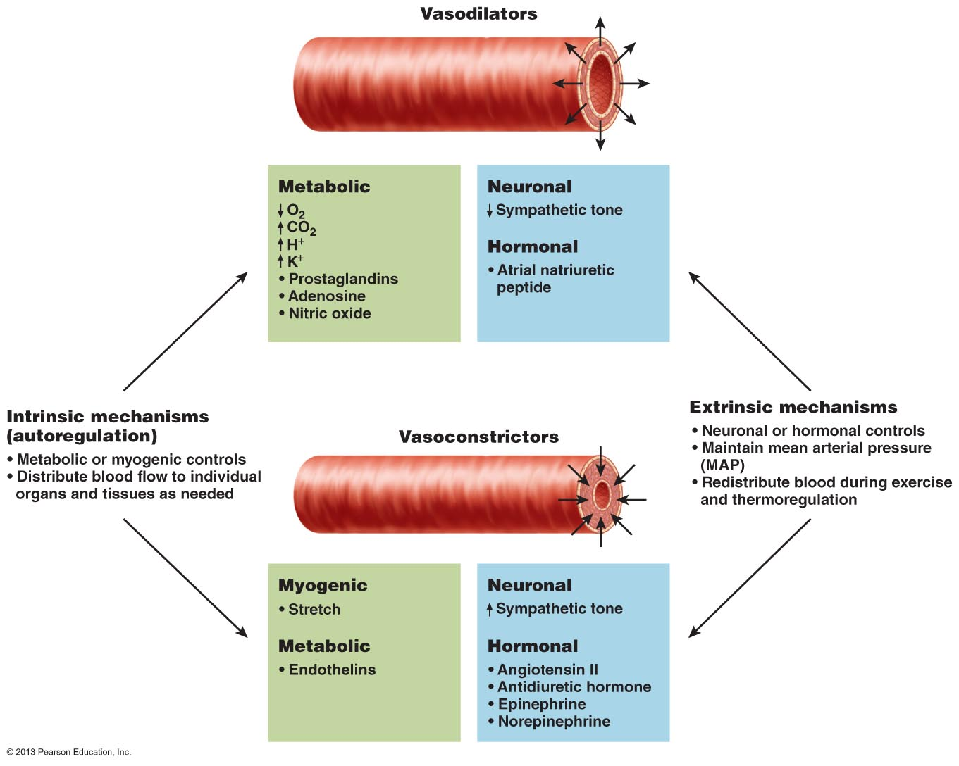

2.27 Explain the forces that act to influence capillary exchange
- 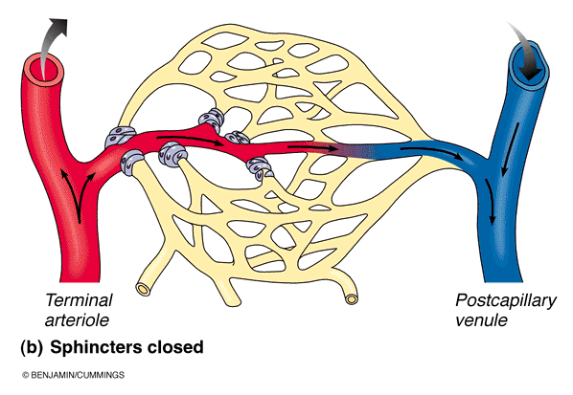capillaries: major point of communication between interstitial fluid & blood
  - most cells in body within 0.02 mm of a capillary »» diffusion works
  - capillary walls only 1 cell thick: mix of diffusional, osmotic & hydrostatic forces
- precapillary sphincter: cuff of smooth muscle at beginning of capillary; capillary walls themselves have no smooth muscle
- vasomotion: contraction and relaxation of precapillary sphincter
→ sporadic flow through each capillary

Capillary Exchange Mechanisms
- Vesicle Transport:
  - For relatively large, lipid-insoluble molecules
  - Shuttlingendocytosis, then exocytosis
  - Also antibody molecules from maternal to fetal circulation
- Diffusion
  - primary mechanism for dissolved solutes & gases - eg: O₂, CO₂, glucose
  - follow gradients
  - heat moves via convection down a thermal gradient
  - water-filled pores (Na+. K+, Cl-, glucose) or through bilayer (O₂, CO₂, urea)
  - pores <1% capillary SA; lipid-soluble substances have 100X more SA
- Bulk Flow
Hydrostatic pressure: fluid pushing against something, (c= inside capillary, if= insterstital fluid)
Colloid osmotic pressure (OP): solutes (i.e plasma proteins) holding water with it
Net Filtration Pressure (NFP): negative value meaning it is encouraging fluid to come back into that capillary, positive at arterial end meaning pushing fluid out, net is not equal, meaning we don’t get as much fluid as we push out

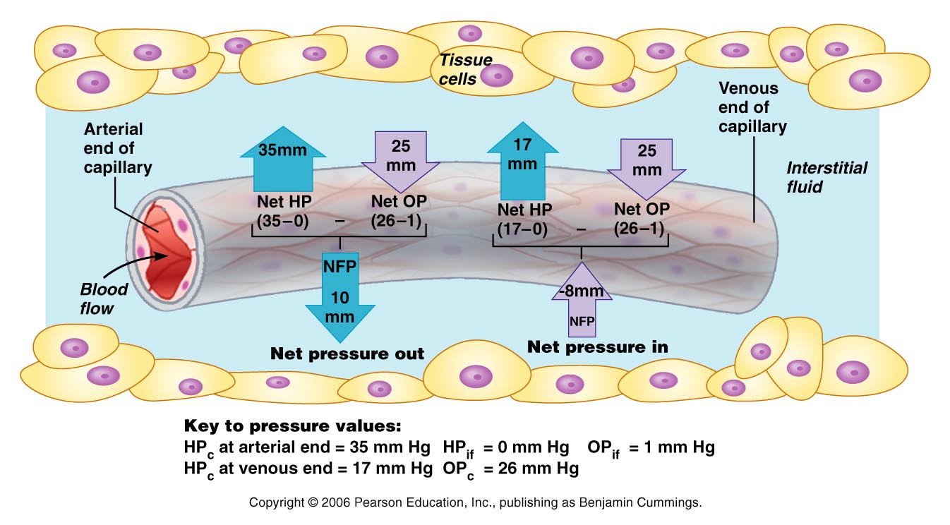
(i) increased arteriole pressure means increased filtration pressure = more fluid loss to tissues (edema— increased fluid loss to tissues)
Liver disease causes edemaliver makes plasma proteins, cannot hold fluid in bloodstream, no osmotic pressure, more fluid in tissues
(ii) hemmorhage favours reabsportion
Loss in blood pressure, therefore net pressure out is less, pulls back more than push out

Lymphatic System (CH 20)

5.1 Structure and Function of the Vessels and Organs of the Lymphatic System
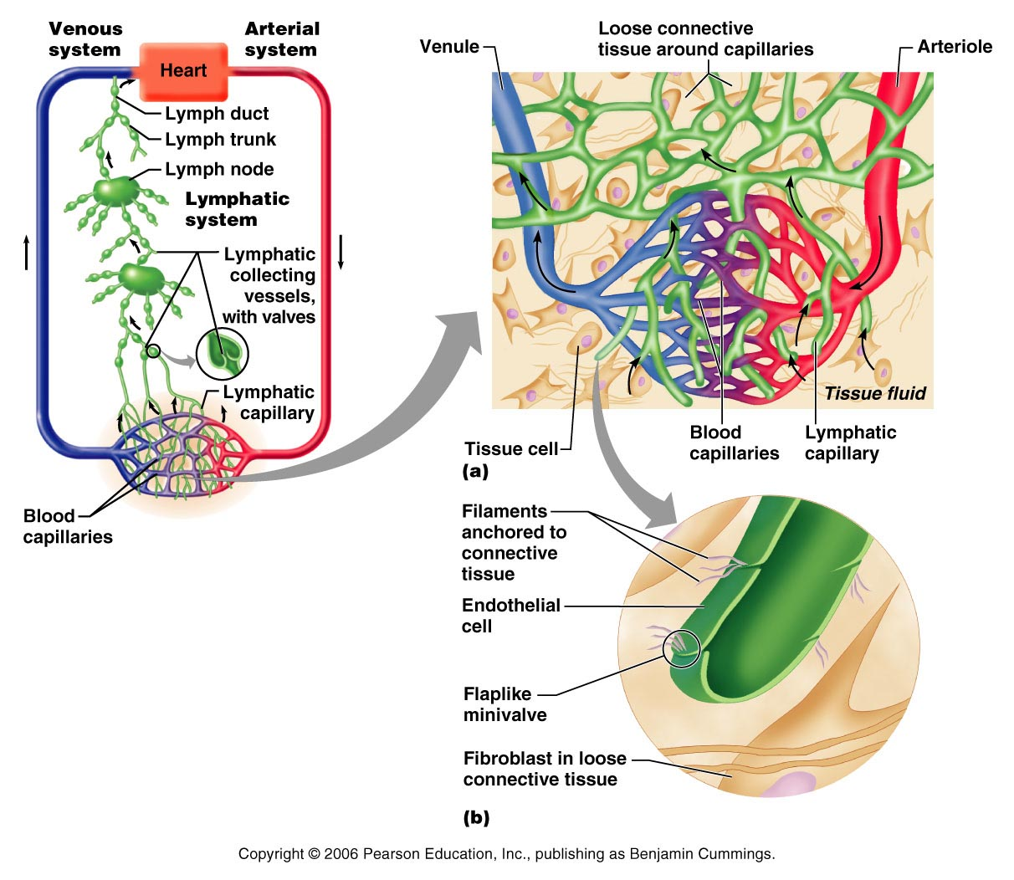Has some immune function, because the fluid leaving circulatory has potential to contain bacteria
Fluid collected is directly poured back into circulatory venous drainage
Called lacteals when found in GI (digestion)

lymph capillaries
Single layer of very thin endothelial cells, very permeable
Flap like minivalves between adjacent cells
When fluid pressure builds up in tissues (ex. edema), will create largen openings in flaps, allowing fluid collection from tissues into lymph capillaries

Lymph nodes
Fluid will be policed, scanned several times as it goes through lymph nodes:
Lymph Nodes
clustered along lymphatic vessels; larger clusters where lymphatic vessels converge (inguinal (thigh), axillary (armpit), cervical(throat) regions)
(i) filter lymph (macrophages; remove & destroy microorganisms)
(ii) activate immune system
- Very unequal division of labour between right thoracic duct and right lymphatic duct
- The rest of the body is handled by thoracic duct (entire lower body)
- Bumps = lymph nodes
- On the way to lymphatic capillaries, fluid passes through several lymph nodes (act as policing of lymphatic fluid)
- Right at junction of internal jugular and subclavian = entrance to right lymphatic duct into vein
- Clusters of lymph nodes in 3 places (neck, , )

Lymphoid Cells
- fight infectious microorganisms that have penetrated epithelial layer & are starting to proliferate in underlying loose CT
  - Lymphocytes: T-cells (manage immune response; some are soldiers)
    - T cells
      - Cell to cell attack, go out directly and kill other cells
    - & B-cells ( plasma cells – what are these?)
      - Stimulated during bacterial infection, differentiate into plasma cells
      - Plasma cells: specialized cells, subpopulation of B cells, activated to produce antibodies against bacteria
  - Macrophages: phagocytize foreign substances;, cleanup crew, removes debris
    - Displays found bacteria on cell membrane that it digests which
    - activates T-cells, causing them to destroy any remaining microorganisms

Lymphoid Tissue
- Reticular CT: all lymphoid organs except thymus; also in lamina propria of mucous membranes; macrophages reside in network; lymphocytes make temporary stopovers in between patrolling body
  - Houses and provides proliferation sites for lymphocytes
  - Ideal surveillance vantage point of lymphocytes and macrophages
- Lymphoid cells – 2 types of lymphocytes
- b-cells – when u have a bacterial infection, subpopulation of b-cells become activated to becomes plasma cells (very specialized cells that produce specific antibodies against particular types of microorganisms)
- T-cells – cell to cell attack, soldiers in immunes system, directly attack other cells
- Macrophages – garbage trucks, they clean up all the debris after we kill microorganisms and ensure debris doesn’t stay there
- Do so by phagocytes
- They will display part of the debris on their cell membrane to activate t-cells to gather there and kill any other foreign microorganisms that may still be there
- Lymphoid tissue – where the t and b cells can proliferate and form in order to create an army to go fight the harmful microorganisms

Lymph Nodes
- 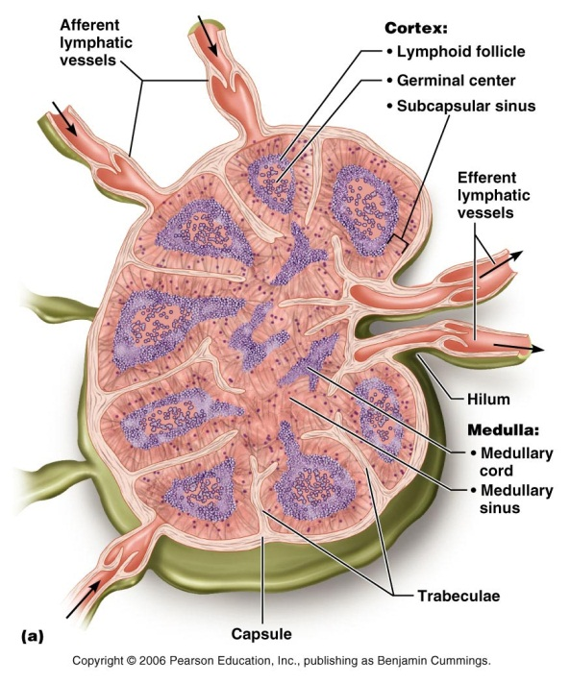discrete, encapsulated collections of diffuse lymphoid tissue + follicles
- ~2.5 cm long; divided into compartments by trabeculae
- Lymphatic fluid may travel through several lymph nodes
- Lymphatic vessels has valves similar to veins, to prevent back flow
Regions
- Cortex:
  - follicles with germinal centres – what happens here?
- Medulla:
  - Fluid flows towards here
  - medullary cords & large lymph sinuses
  - Note the one-way flow of traffic through each lymph node
- What is the significance of fewer efferent compared to afferent lymphatic vessels?
  - Slows down lymphatic fluid, allowing for more time to scan it

Other Lymphoid Organs
They are also composed of Reticular CT, but only the lymph nodes filter lymph fluid, other organs have only efferent lymphatics, not involved in policing lymph fluid

Spleen
Largest lymphoid organ; beneath diaphragm
    - site for lymphocyte proliferation; immune surveillance & response
    - blood cleansing
    - stores RBC products (iron) for recycling
    - RBC production in fetus (during fetal development)
    - stores blood platelets
• white pulp –the interior area (immunity); red pulp (other areas of spleen) ( associated with RBCs)
• capsule is thin – possible consequences: easily injured organ, although it is protected by ribcage, but once injured the capsule is not thick enough to provide adequate protection

Spleen not essential to life, can be removed if it is terminally damaged.

Thymus
- early years (used to mature our immune system)
- immunocompetence of T-lymphocytes (test to see if T-cells can recognize and differentiate self-antigens, recognize cells that are foreign or not,

- prominent in newborns; increases in size throughout childhood; then starts to atrophy (less active and shrinks around 10 years old)
- lymphocyte maturation - only lymphoid organ that does not directly fight antigens
- stroma consists of star-shaped thymocytes that secrete thymosin & thymopoietin (secretion of growth factors, supporting maturation of T-cells produced in the bone marrow, therefore well vascularized so blood can flow from marrow to here, and transport t-cells)
Mistakes in the thymus might cause autoimmune disease (T-cells not appropriately filtered and matured, now they attack bodies own cells)

Tonsils
- ring of lymphatic tissue at entrance to pharynx
- monitors air that we breath
- palatine tonsils: back of oral cavity, often the ones that get infected
- lingual tonsil: found on tongue
- pharyngeal tonsils (adenoids): located higher up near nasal cavity
- tubal tonsils: found near tubes draining in from ear canal

Aggregates of Lymphoid NoDules
MALT: mucosa associated lymphatic tissue, found under epithelial linings of walls of bronchi, areas of GI tract & genitourinary system (i.e any area that may interact or is exposed to exterior.
Consists of:
- Peyers patches: lymph nodule clusters (wall of ileum)
- Appendix: guard against digestive bacteria from going into rest of body

5.2 Origin of Lymph and it’s transport
- 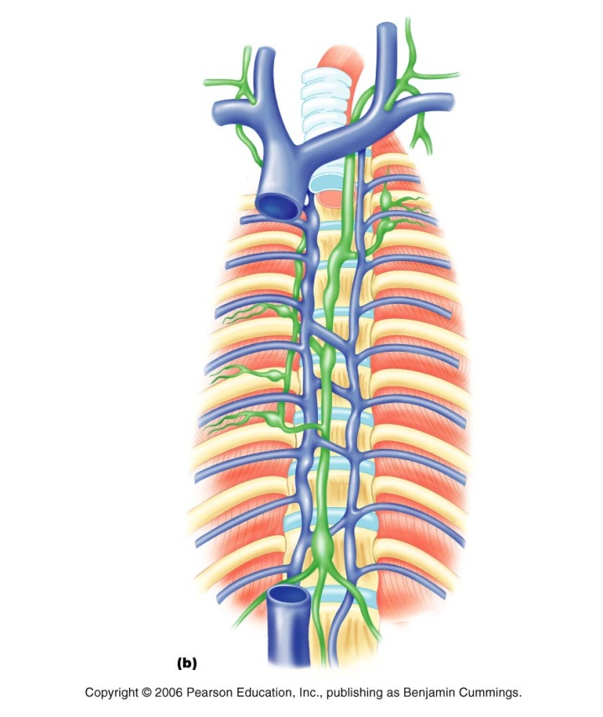lymphatic capillaries in inflamed tissues: leads to edema, causing drainage of fluid into lymphatic system
- lymph detours through lymph nodes before entering blood
- lacteals in intestinal villi: name for lymphatic capillaries in small intestine (small lymphatic vessel going up each villi, used for absorption of fats)
- lymphatic collecting vessels have same 3 tunics as veins, but are thinner-walled, more valves, more anastomoses—areas of junction, altering pathways
- lymphatic trunks: ( labeled on diagram) paired lumbar, bronchomediastinal, subclavian & jugular trunks; single intestinal trunk
1. Right lymphatic duct: lymph from rt upper arm, head, thorax
2. Thoracic duct: from lower limbs, intestinal trunk, lt thorax, upper limb/head

Lymph Transport
Jobs where u stand a lot will cause swelling of legs, feet
- no pump; same return aids as for veins (muscles, respiratory pressure changes, valves); also rhythmic contractions of smooth muscle in walls of lymphatic trunks & ducts
- system slow: ~3 L/day returned to blood; speed increased by local movement
- blockage/removal of lymphatics during surgery »» severe local edema; drainage restored by regrowth from remaining vessels
in picture: woman had breast cancer, breast area removed, therefore several lymph nodes removed in that axillary area, causing fluid accumulation in the forearm because no vessels and nodes to transport fluid, vessels will regrow, so eventually it will correct

THe Respiratory System (CH.22)

INTRODUCTION
• Major function of respiratory system is to supply O₂ and dispose of CO₂
• 4 distinct processes:
Lungs:
    - Pulmonary ventilation:(breathing) movement of air in and out of lungs (inspiration and expiration)
    - External respiration: exchange of gases between blood & air of alveoli (oxygen from lungs to tissues, and carbon dioxide from blood to lungs)
Cardiovascular System:
    - Transport of respiratory gases: role of blood in transport of gases between lungs & tissues of body (oxygen from lungs to tissues, carbon dioxide from tissue cells to lungs)
    - Internal respiration: at the level of the tissues, exchange of gases between blood in systemic capillaries and tissue cells (oxygen from blood to tissue cells, carbon dioxide from tissue cells to blood)
• First 2 functions handled by respiratory system; other two by CV system

6.1 Structure of the components of the conduction and Respiratory Zones
  - respiratory zone: (= site of gas exchange) »» composed of respiratory bronchioles, alveolar ducts & alveoli (microscopic)- air sacs of gas exchange
  - conducting zone: (passageways) »» nose, nasal cavity, pharynx, larynx, trachea, bronchi, bronchioles, terminal bronchioles (lead into respiratory zone)
  - as well as providing a passageway, conducting zone organs also cleanse, humidify & warm incoming air

1.Nose
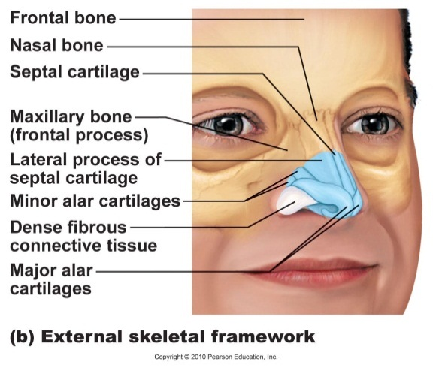Functions:
- airway for respiration
- moistens & warms incoming air
- filters & cleans inspired air
- resonating chamber for speech
- olfactory (smell) receptors
  - a lot of sense of taste is associated with smell, so sometimes meals don’t taste the same when one has cold
• structure of external nose: differences in nose size/shape due to differences in nasal cartilages

- 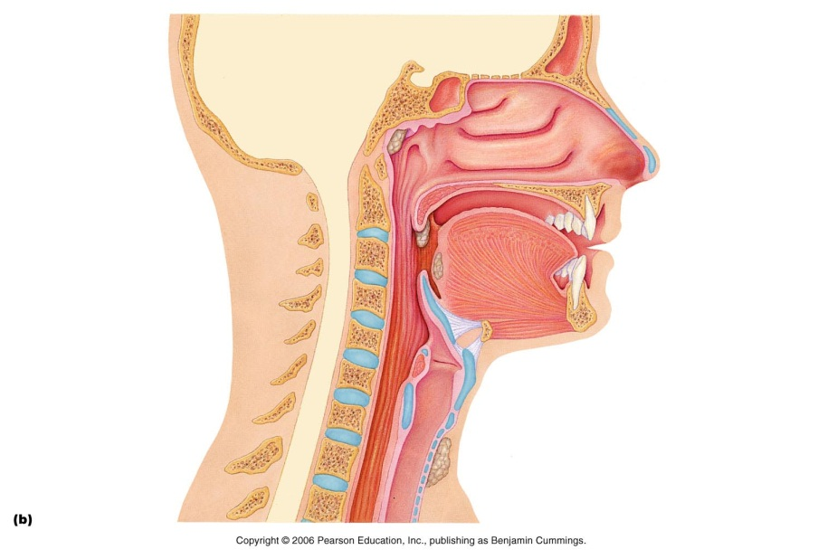air enters nasal cavity via external nares (nostrils) - divided by midline nasal septum (cartilage » bone); air then goes via internal nares to nasopharynx
- roof of nasal cavity formed by ethmoid & sphenoid bones of skull
- floor of nasal cavity formed by palate (anterior is hard; posterior is soft)
- vibrissae: fine hairs present inside nasal cavities
- nasal cavity lined by 2 types of mucosa
  - olfactory mucosa: found in the superior region, contains receptors for sense of smell
  - respiratory mucosa: see below
On diagram:
Base= tonsils, be able to label palinate and lingual tonsils
Hollow spaces= sinuses (frontal and sphenoid), air cavities in bone that help to lighten the skull, pressure changes in these cavities due to infection can cause headaches
Be able to label hard and soft palata, types of skull bone (ethmoid and sphenoid)

REspiratory mucosa
respiratory mucosa: pseudostratified ciliated columnar epithelium with goblet cells; lamina propria has mucous & serous glands (1 L/day sticky mucus containing lysozymeenzyme that destroys bacteria
• resp mucosa cilia move contaminated mucus posteriorly to pharynx
• cold air slows cilia activity and not moving mucus along → runny nose
• thin-walled veins under nasal epithelium role: warms incoming air as it flows across mucosal surface, cold air incites heavier engorgement of capillary beds, & nosebleeds are common due to the abundance and superficiality of the vessels.
• What are nasal conchae: 3 sets of bony projections into the lumen of the nasal cavities, easier to trap dust and debris,
• nasal mucosa richly supplied with sensory nerves irritants trigger sneeze reflex to get rid of debris

2. Paranasal sinues
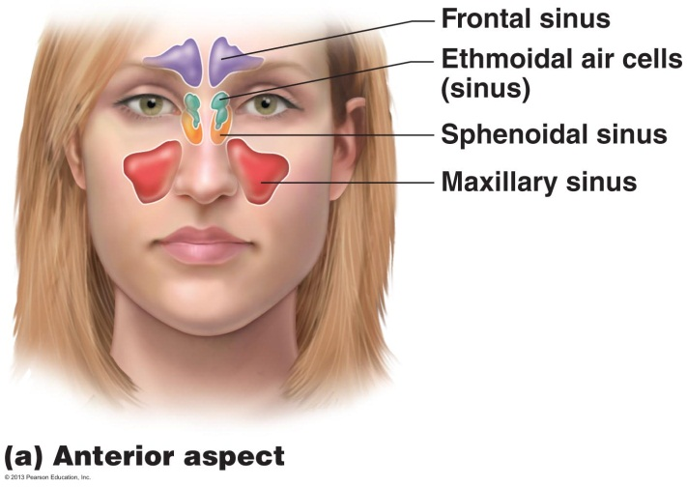Paranasal Sinuses
- surround nasal cavity
- frontal, sphenoid, ethmoid,maxillary bones
- lighten skull, produce mucus, also warm & moisten air
- sinus mucosa continuous with nasal mucosa »» spread of infections
- sinus headache: passageways connecting sinuses to nasal cavity blocked » air in sinus absorbed » partial vacuum

3. Pharynx
- common pathway for food and air, can only breathe OR swallow
- wall composed of skeletal muscle throughout ~13 cm length; mucosal lining varies

3a) Nasopharynx
  - only an air passageway
  - below sphenoid bone, above soft palate
  - what happens when swallowing:
    - uvula closes off and prevents food from entering nasal cavity
  - pseudostratified ciliated epithelium mucus propulsion
  - pharyngeal tonsils: located at the entry points of pharyngotympanic tubes
  - pharyngotympanic (auditory) tubes drain from middle ear
    - bug in throat area can therefore cause ear infection

3B) OroPharynx
Area of common passageway,
- fauces connects oral cavity with oropharynx, archway into the opropharynx
- from soft palate to epiglottis (air and food)
- epithelium becomes stratified squamousallows protection from scraping action of food against tissue, causing peeling, but stratification of this tissue allows several layers and regeneration.
- paired palatine tonsils + single lingual tonsil

3c) Laryngopharynx
  - also both food and air
  - stratified squamous
  - from epiglottis to larynx – then respiratory & GI pathways diverge
  - during swallowing, food has “right-of-way”

4. Larynx
  - ~5 cm (4th-6th cervical vertebrae)
  - attached to hyoid bone (above); continuous with trachea (below)
  - 3 functions:
      - open, 2-directional airway
      - switching: food vs air
      - voice production
9 cartilages in total (key ones listed below)
- thyroid cartilage: large, shield-shaped cartilage in front (puberty in males, testosterone stimulated growth in size, deepening of voice)
- arytenoid cartilages (2): lateral, pyramid-shaped, anchor vocal cords
- 9th cartilage is epiglottis: elastic cartilage, anchored to anterior rim of thyroid cartilage & extends up to base of tongue
- true vocal cords: white (avascular); vibrate in response to air movement up from lungs (what is the glottis: opening through which air travels, composed of both the true vocal chords and the opening between them, we breath in then allow air to slowly escape through passage and pass over cords to make sound)
- false vocal cords: above true vocal cords
  - Epithelial lining of upper versus lower larynx: upper stratified squamous , lower part and rest of tract = psuedostratified ciliated columnar epithelial, (trap dust and propel mucus in lungs)
  - Help in closing of glottis

Voice Production:
  - speech = intermittent release of expired air + opening & closing of glottis
  - length of vocal cords & size of glottis altered by action of laryngeal muscles that move arytenoid cartilages
  - male voice at puberty: vocal cords vibrate more slowly – why stimulates thickening of the vocal cords, thicker vocal cords vibrate more slowly as air passes over them
  - loudness of voice: force of air across vocal cords, increases volume of sound
  - laryngitis: inflammation of vocal cords ⇒ vibration impaired, cords irritated by infection or overuse
  - sphincter functions of vocal cords:
      - epiglottis closes respiratory tract during swallowing
      - Valsalva’s maneuver: What is thisclosing of glottis to promote defectation by increasing abdominal pressure
      - Heimlich maneuver: trying to expel air upwards through (common pathway) and dislodge object stuck, out through the mouth

5. Trachea
• 10-12 cm long; ~2.5 cm diameter; flexible, mobile
• pseudostratified ciliated columnar; cilia move mucus up to pharynx
smoking inhibits & then destroys cilia; only coughing to clear mucus
they kill off the pseudostratified tissue cilia, cilia no longer available to clear mucus
• submucosa is CT with seromucous glands
• outer adventitia reinforced internally by 16-20 C-shaped cartilaginous rings; keep airway open during pressure changes associated with breathing
Why C Shaped? Gives some space for the esophagus to stretch

The Bronchial Tree
- Conducting Zone Strucutres
• right primary bronchus is wider, shorter, more vertical than left
• air in bronchi is warm, cleansed of most impurities & humidified
• ~23 orders of branching air passages in lungs = bronchial or respiratory tree
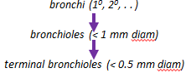

• changes in wall composition as one moves through tree:
a) cartilage: rings to plates to none (thinner and thinner)
b) epithelium: pseudostratified columnar to columnar to cuboidal; no cilia or mucous cells in bronchioles (to hard to propel mucus all the way back up)
c) smooth muscle:relative amount increases as passages become smaller, we need more relative muscle to make up the walls as we lose cartilage

- Respiratory Zone
- 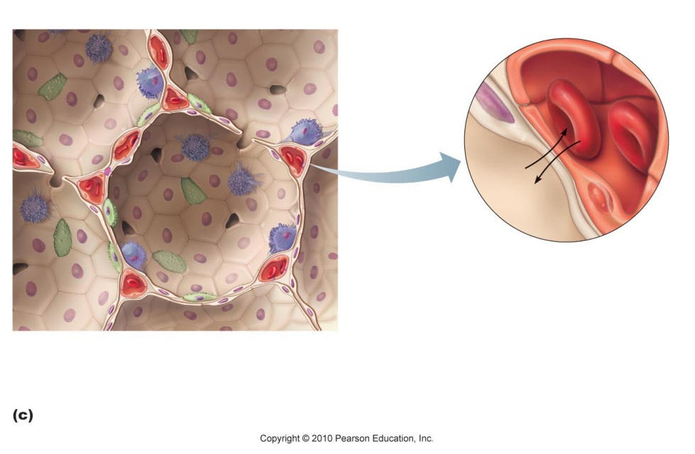terminal bronchioles branch into respiratory bronchioles
  - ~300 million alveoli = huge surface for gas exchange
  - Type 1 cells = Squamous cells that make up wall (beige)
  - Type 2 cells; secrete Surfactant: molecule that helps to keep alveoli open (green)
  - Type 3 cells: Macrophages: dust cells that are responsible for cleaning the inner face of each alveolus (blue)
  - Blood vessels (cross section) –(red)

respiratory membrane = alveolar wall + capillary wall + basal laminae
• respiratory membrane is an air-blood barrier; gas exchange by simple diffusion
• type II cells: scattered among type I cells; secrete surfactant
• other characteristics of lung alveoli:
(i) surrounded by fine elastic fibers
(ii) alveolar pores: allow equalization of air pressure throughout lung; alternate air routes if bronchi collapsed
(iii) alveolar macrophages = dust cells; inner alveolar surface; clear & swallow > 2 million dust cells/hour!

6.2 Gross Anatomy & Structure of the Lungs and the pleural cavities
  - paired lungs occupy entire thoracic cavity except mediastinum (occupied by heart)
  - each lung suspended in own pleural cavity; connected to mediastinum by vascular & bronchial attachments (= root)
  - costal surface = anterior, lateral & posterior lung surfaces in close contact with ribs
apex, base; also hilus »» blood vessels enter & leave lungs
1⁰ bronchus enters lungs
fissures: oblique, horizontal, left lung only has 1 oblique » septa subdivide each lung into 10 bronchopulmonary segments (CT divisions; own artery & vein), lung may appear as one large moving sac, but actually segmented,
pulmonary disease often segmental & can be treated that way, making it harder for disease to spread, only one segment affected and can be removed

- lobule: smallest subdivision that is visible by eye,
- lung : primarily air spaces; rest is elastic CT
Blood Supply & Innervation
- pulmonary arteries bring blood to be oxygenated
- pulmonary veins return oxygenated blood
- bronchial arteries provide systemic blood to lungs ⇒bronchial veins
- innervations primarily parasympathetic (restricting, when large air volume not needed) + some sympathetic (expanding, allowing more air volume in times of high activity)
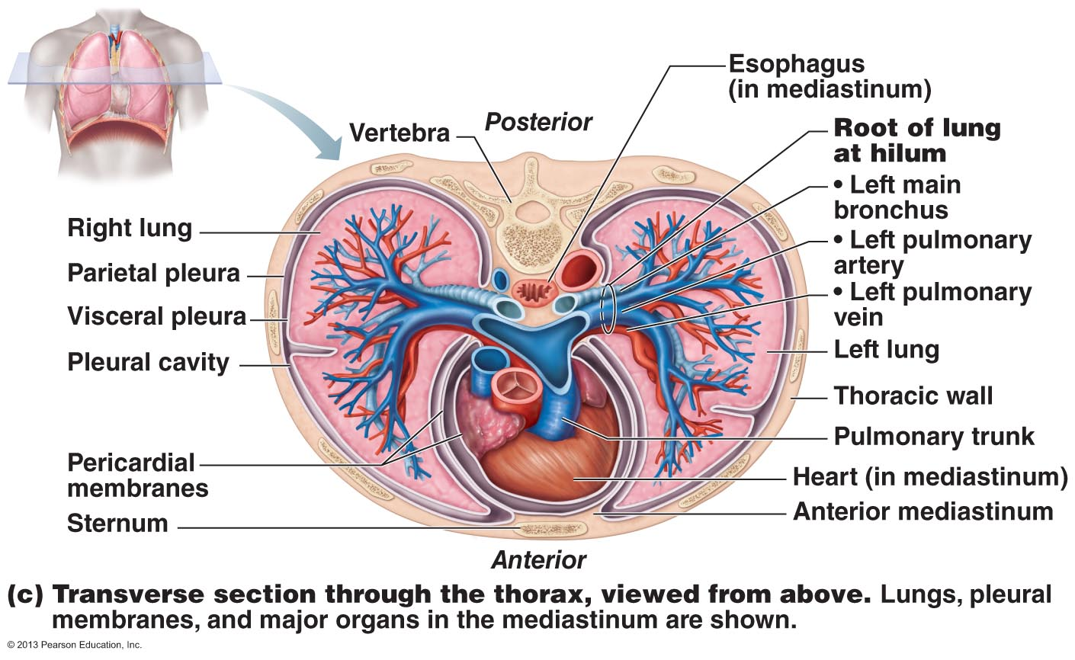

PLeura
• thin, double-layered (parietal & visceral) serosa
• pleural fluid: serous secretion that fills pleural cavity »» lungs slide easily during breathing; surface tension keeps pleurae from separating
• 3 chambers: central mediastinum + 2 lateral pleural compartments
• pleurisy: inflammation of pleurae, interferes with production of fluid, making it uncomfortable

Physiology of the REspiratory System

6.3 Intrapulmonary, intrapleural and Transpleural Pressure
- breathing (pulmonary ventilation)= inspiration + expiration
- P_{atm}=760mmHg @ sea level, pressure of air around body,
  - we describe respiratory pressure relative to atmospheric pressure:
    - eg. -4mmHg respiratory pressure= 760-4= 756mmHg

Intrapulmonary Pressure (P_{pul})
- pressure within alveoli of lungs (also called intra-alveolar pressure
- rises & falls with breathing but always eventually equalizes with atmospheric

Intrapleural pressure (P_{ip})
• pressure within pleural cavity
~4 mm Hg less than pressure in alveoli (less than atmospheric), ie always negative relative to intrapulmonary pressure
Interaction of 3 factors:
} contracts lungs
(i) natural tendency of lungs to recoil
(ii) surface tension of alveolar fluid
} enlarges lungs
(iii) surface tension of pleural fluid + elasticity of chest wall
• net result is negative intrapleural pressure, the adhesive force between the parietal and visceral pleurae due to the pleural fluid holds the two together.
- Any condition equalizing intrapleural pressure with intrapulmonary (or atmospheric) pressure causes immediate lung collapse (atelectasis)
- lungs in separate pleural cavities »» one can collapse & not the other
- transpleural pressure = intrapulmonary - intrapleural pressure

6.4 Roles of the Diaphragm and accessory msucles during inspiration and expiration
- diaphragm & intercostal muscles
  - increase volume of thoracic cavity » decrease pressure of gas inside » air rushes in through only opening (trachea)

Quiet Inspiration
(i) diaphragm contracts to increase height of thoracic cavity
(ii) intercostals contract to lift rib cage up & pull sternum forward to increase thorax diameter
• mm changes in each direction but overall increase in volume of about 0.5 L (the volume we inspire) and drop in intrapulmonary pressure of about 1 mm Hg
• air rushes in; inspiration ends when intra-pulmonary pressure = atmospheric pressure
• at same time, intrapleural pressure drops to about -6 mm Hg

Quiet Expiration
passive; depends more on elastic recoil of lungs than on muscle contraction
inspiratory muscles relax rib cage descends & lungs recoil thoracic & intrapulmonary volumes decrease alveoli compress/intrapulmonary pressure to +1 mm Hg gas out

Deep/Forced inspiration
accessory muscles (neck & chest) raise ribs more;extend back by straightening spine

Deep/Forced Expiration
(i) contract abdominal wall muscles: increase intra-abdominal pressure
(ii) depress rib cage

6.5 Three Factors that influence pulmonary ventilation

6.5.1 REsistance
Gas flow= pressure gradient/resistance
• resistance determined by diameters of conducting tubes
• usually insignificant in healthy individuals because:
(i) airway diameters at beginning are large
(ii) gas flow stops at terminal bronchioles (diffusion)
• greatest resistance at level of medium bronchi

Neural Influences on Diameter
Neural influences and chemical controls influence the smooth muscle of the bronchiolar walls
(i) parasympathetic (eg: inhaled irritants, histamine: constricts bronchioles)
- also occurs during acute asthma attack
(ii) sympathetic: dilates bronchioles (epinephrine)
- disease: eg: mucus, infectious material, solid tumours = sources of airway resistance

6.5.2 Alveolar Surface Tension
surface tension: at any gas/liquid boundary, molecules of liquid more strongly attracted to each other than to the gas »» tension at liquid surface
(a) liquid molecules drawn closer; reduce contact with dissimilar gas molecules
(b) resists any force to increase surface area
• water has a very high surface tension - water only in alveoli would cause collapse
• surfactant: detergent-like lipoprotein produced by type II cells; interferes with cohesiveness of water molecules »» less energy to overcome surface tension
Lipoprotein- has lipid rich areas(hydrophobic) and protein are(hydrophilic)
For Example:
Infant respiratory distress syndrome (IRDS): premature babies produce too little surfactant; alveoli must be re-inflated with every breath (positive pressure respirators, surfactant spray)

6.5.3 Lung Compliance
• ease with which lungs can be distended:
C_{L} = V_{L} / P_{pul} - P_{ip}
• the more a lung expands for a given increase intranspulmonary pressure, the greater its compliance
• depends on:
(a) distensibility of lung tissue
(b) alveolar surface tension
• compliance is diminished by any factor that:
(i) reduces natural resilience of lungs (eg: fibrosis)
(ii) increases surface tension of alveolar fluid
(iii) impairs flexibility of thoracic cage (ossification of costal cartilages with aging, the cartilage becomes bone)
• elasticity of lungs important for both inspiration & expiration

6.6 Lung volumes and Capacities

1. REspiratory Volumes:
below are shown normal values for healthy, 20 yr male (70 kg)
a) tidal volume: ~500 ml/breath; quiet breathing
b) inspiratory reserve volume: volume forcibly inspired after tidal volume
c) expiratory reserve volume: volume forcibly expired after tidal volume
d) residual volume: ~1200 ml remains in lungs even after forceful expiration (maintains alveolar patency)

2. Respiratory Capacities
always consist of 2 or more lung volumes
a) inspiratory capacity: air that can be inspired after tidal expiration(TV+IRV)
b) functional residual capacity: amount of air still in lungs after tidal expiration (RV +ERV)
c) vital capacity: total amount of exchangeable air (TV+IRV+ERV)
d) total lung capacity: sum of all lung volumes - can we measure this: No, we cannot completely expel ALL the air out of our lungs…residual volume remains

6.7 Dead Space
- Air that fills passageways-doesn’t participate in gas exchange (~150 ml or body weight in lb)
- 500 ml tidal volume = 150 ml dead space + 350 ml alveolar ventilation
- Note: if some alveoli no longer functional: total dead space = 150 ml + alveolar dead spaces
  - What happens to the relative contribution of dead space to lung ventilation if volume of air exchange/breath increases?:
    - Dead space is now a smaller proportion of the total tidal volume, becomes less of a factor as you take deeper breaths.

AVR (Alveolar VEntilation)
AVR is a better index of effective ventilation than minute ventilation rate
• takes into account volume of air wasted in dead space areas & measures flow of fresh gases in and out of alveoli/unit time
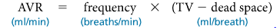
• if healthy: AVR = 12 x (500-150) = 4200 ml/min
• to increase AVR, better to increase volume of each inspiration rather than increase respiration rate - why??
Because anatomical dead space is constant in a particular individual, increasing the volume of each inspiration enhances AVR and gas exchange more than raising the respiratory rate. Look at table 22.2
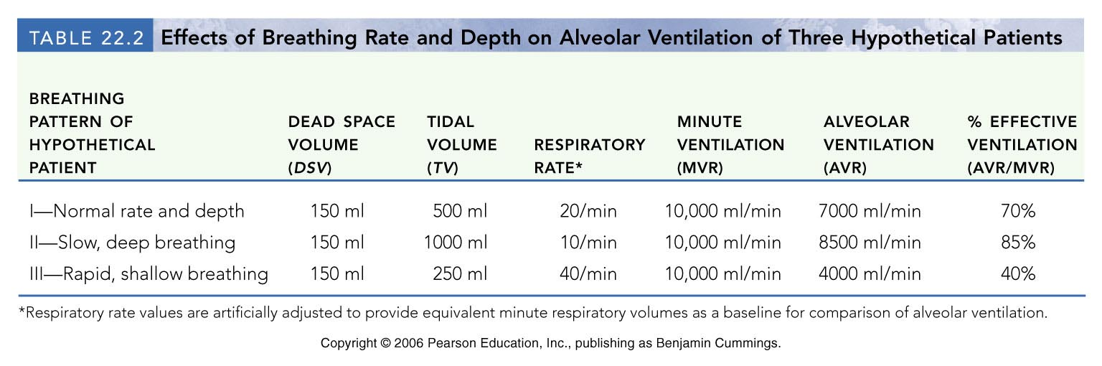

6.8 mechanisms Underlying Some of the Non-respiratory air movements
- hiccups: spasms of diaphragm; irritation of phrenic nervenerve that stimulates diaphragm during breathing; air hits vocal folds of closing glottis
- yawn: very deep inspiration that ventilates all alveoli; not believed to be triggered by oxygen or carbon dioxide levels in blood
- cough: blast of air shot out from lungs through briefly opened glottis – to dislodge foreign particles, mucus from lower respiratory tract
- sneeze: like a cough but air forced through nasal cavity to clear upper respiratory passageways

6.9 Dalton’s Law in terms of the Composition of atmospheric and alveolar air

Dalton’s Law of Partial Pressures:
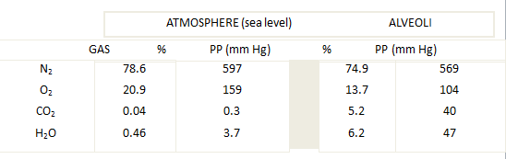• total pressure exerted by a mixture of gases = sum of pressures exerted by each gas (partial pressure) in mixture »» partial pressure of each gas directly proportional to its % in mixture

- high altitude: all partial pressures decrease in direct proportion
- below sea level: atmospheric pressure increases by 1 atmosphere (760 mm Hg) for every 33 feet down (in water); partial pressures increase accordingly

B. Composition of Alveolar Gas
- different from atmospheric (more CO₂, H₂O; less O₂)
  - these differences are because:
    - O₂ from air to blood & CO₂ from blood to air in lungs
    - conducting zone passageways have humidified the air
    - alveolar gas mixed with new “atmospheric” gas with every breath
  - increased depth of breathing increases alveolar PO₂& decreases PCO₂

6.11 Three factors that influence the exchange of oxygen and of carbon dioxide at the level of the lungs (external respiration)
• rate of exchange of O₂ and CO₂in lungs dependent on:
- PP gradients & gas solubilities
- structural characteristics of respiration membrane
  - accumulation of mucus, or thickening of this membrane creates a longer dstance for the gas to travel, causing difficulty in ventilation
- ventilation/perfusion coupling

1. pP Gradients and GAs Solubilities
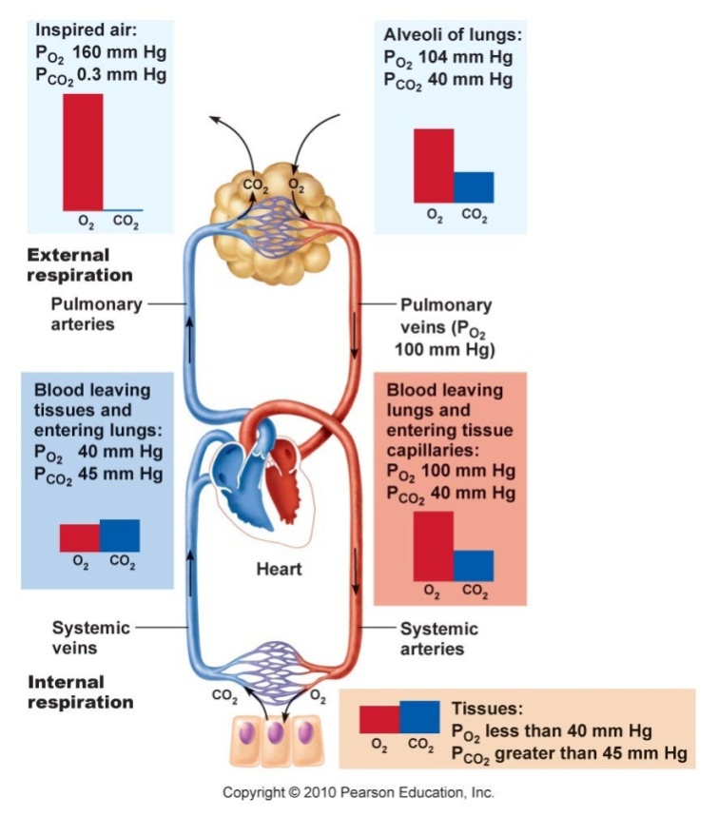• steep gradient for O₂ pick-up at lungs: ~104 mm Hg O2 vs ~40 mm Hg C02
• equilibrium (104 mm Hg on both sides of respiratory membrane) in ~0.25 sec (1/3 time RBC is in pulmonary capillary); What does this mean about level of oxygenation with a faster rate of blood flow: we cam still maintain adequate oxygenation even if blood flow increases to spend only 0.25 secs in pulmonary capillary, regular time is 0.75 s)
• CO₂ gradient much flatter: 40 mm Hg vs 45 mm Hg, it is still adequate to meet our needs
• equilibrium at 40 mm Hg & gradually expelled during expiration
note that equal amounts of CO₂ and O₂ exchanged (even though PP gradients very different) because CO₂ 20X more soluble in plasma & alveolar fluid than O₂!!

2. Structural Characteristics of Respiratory Membrane
- Thickness: 0.5-1 μm (healthy lungs); pneumonia »» fluid uptake, increasing thickness and decreasing rate of gas exchange
- Surface Area: huge (~140 m² if healthy, 40x SA of skin!); reduced markedly in emphysema, by tumors, mucus, inflammatory material

3. Ventilation-perfusion Coupling
Definition: We always try to match up how well we are perfusing an alveolus with how well that alveolus is being well ventilated, no point of a having high blood delivery to an alveolus to with low ventilation (no O2 to feed blood)
- = coupling between amount of gas reaching alveoli &blood flow in pulmonary capillaries; localautoregulation
- arteriole diameter based on PO₂: in alveoli where ventilation is poor, PO₂is low and arterioles constrict »» blood redirected to where PO₂is high (arterioles dilate)
- bronchiole diameter influenced by PCO₂: high alveolar PCO₂causes bronchioles to dilate »» CO₂ eliminated more rapidly; wherePCO₂low, bronchioles constrict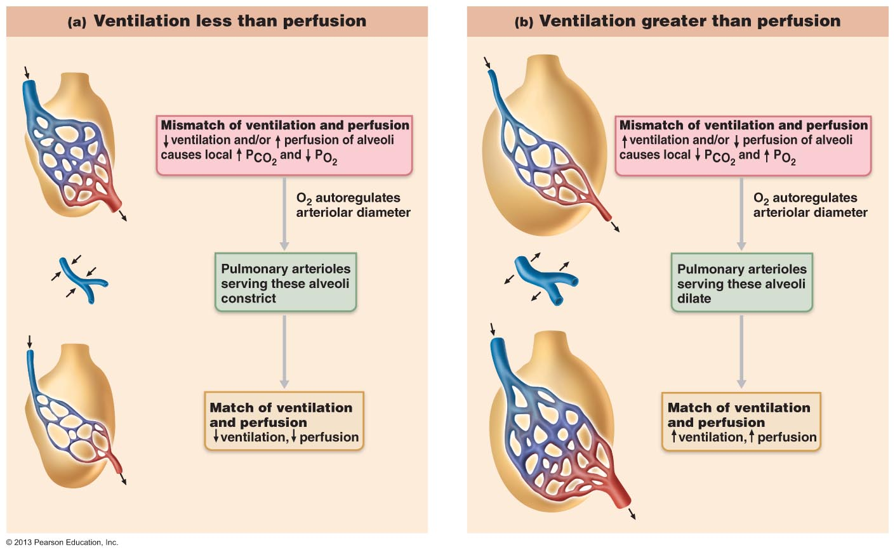

6.12 Partial Pressure Gradients Drive Oxygen And Carbon Dioxide Movements in tissues (Internal REspiration)
same sort of PP gradients at work, but in other direction
in tissues: PO₂ < 40 mm Hg (104 arterial) & PCO₂ > 45 mm Hg (40 arterial)
• exchanges occur & venous blood draining tissues has PO₂ of 40 mm Hg and PCO₂ of 45 mm Hg (like that entering lungs!)
External and internal respiration: diffusion driven by PP gradients!!

6.13 Transport of Oxygen in BLood
Oxygen Transport
- Carried in blood in 2 ways:
  - Bound to hemoglobin within RBC’s
  - Dissolved in plasma (~1.5%; O₂, poorly soluble water)
- Affinity of Hb for O2 depends on its level of saturation
- Fully saturated hemoglobin: 4 hemes have bound O₂
- Partially saturated: 1,2,3 hemes have bound O₂
- 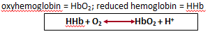
- Rate of O₂ binding/release depends on:
  - PO₂
  - temperature
  - blood pH
  - PCO₂
  - [BPG] in blood (bisphosphoglycerate)

6.14 OXygen-hemoglobin dissociation curve
- 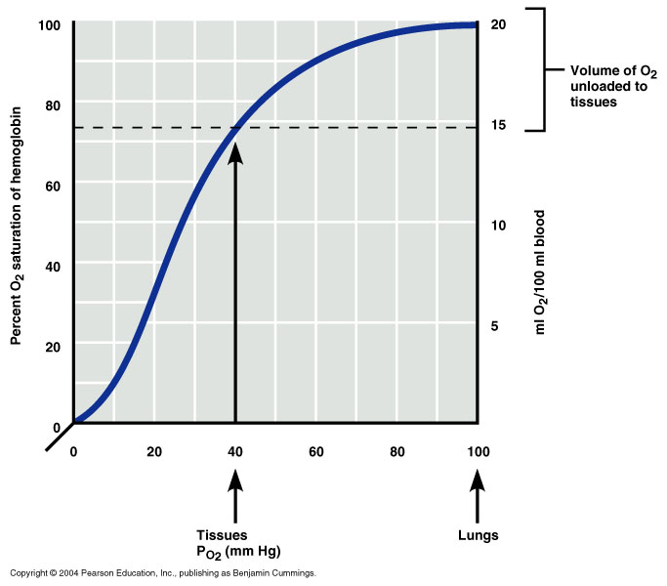steep slope at 10 to 50 mm Hg; plateaus at 70-100 mm Hg
- Hb in blood leaving lungs (PO₂=104 mm Hg) is 98% saturated
- at level of tissues (PO₂<40 mm Hg) Hb ~ 75% saturated (how many ml O₂/100 ml blood released: 15ml
- Hb almost completely saturated at PO₂ of 70 mm Hg; (significance wrt high altitude, cardiopulmonary disease: when you go up to high altitudes, there is less oxygen, ppl with cardiopulmonary disease ave trouble ventilating lungs but its not too bad because even if we go down to 40mmHg we can still get 75% of saturation)
- venous reserve: only 25% O₂ unloaded during first pass thru tissues; (significance in terms of vigorous exercise: the dotted line on the graph moves down (increase rate of unloading of oxygen at tissueslocal response to encourage Hb to unload a greater proportion of its oxygen.

Temperature, pH, PCO₂, BPG & Hb Saturation
• BPG: 2,3-biphosphoglycerate - produced by RBCs when they metabolize glucose anaerobically; binds reversibly to Hb
• influence Hb saturation by altering 3-D structure - modifying affinity for O₂:
a) an increase in temp, PCO₂, H⁺, BPG »» decreases affinity of Hb for O₂ (curve shifted to right) »» increases O₂ unloading from blood
b) decrease these factors increases Hb affinity for O₂ (curve shifted to left)

Makes sense because:
a) CO₂ highest at level of tissues
b) CO₂ release increased H⁺ content of blood
CO₂ + H₂O H₂CO₃ HCO₃⁻ + H⁺
Note: weakening of Hb-O₂ bond by acidosis is called the Bohr effect⇒ ensures that O₂ is released quickly where most needed
c) heat is a by-product of metabolic activity » temp affects Hb affinity for O₂: direct (RBC metabolism) and indirect (RBC synthesis of BPG)

6.15 CArbon Dioxide Transport in thE Blood
• normal active body cells produce ~200 ml CO₂/min = amount excreted by lungs/min
• transported in blood from tissues to lungs in 3 ways
    - Dissolved in plasma: 7-10%
    - Bound to Hb: 20-30%; carbaminohemoglobin; note that CO₂ binds to amino acids of Hb, not the heme part, so no competition for O₂ binding sites!
      - loading & unloading of CO₂ to and from Hb dependent on:
          - PCO₂: (low in lungs »» dissociates; high in tissues »» binds)
          - Hb saturation: HHb (tissues) –deoxyhemoglobin-binds more CO₂than HbO₂ (lungs) –
    - Haldane effect
      - HB has Greater ability to accommodate CO2 when O2 are not occupying the hemes
    - Bicarbonate ion in plasma:70%; conversion to H₂CO₃ (unstable) and then HCO₃⁻ + H^{+ ,}
      - occurs in RBCs (contain enzyme carbonic anhydrase), 1000x faster than in plasma
      - As CO₂ is converted and released along with H+, we get Bohr effect which encourages even more O₂ to release from Hb, which in turn will continue to push the Haldane effect
chloride shift: bicarbonate ions diffuse quickly to plasma; neg charge balanced by movement of Cl⁻ into RBCs
2. Process is reversed in the lungs:
CO₂…
1) Dissolved in plasma: moves out
2) Bound to Hb: released and moves out
3) Bicarbonate ion: back into RBC, back to CO₂ and H₂O and moves out

6.17 Carbon Dioxide Levels and Ph
CO₂ + H₂O H₂CO₃ HCO₃⁻ + H⁺
• H⁺: buffered by Hb or proteins in RBCs/plasma
• HCO₃⁻: diffuses into plasma »» alkaline reserve part of carbonic acid-bicarbonate buffer system
a) slow, shallow breathing »» CO₂ accumulates in blood »» carbonic acid accumulates and blood pH drops
b) rapid, deep breathing »» CO₂ flushed out of blood »» carbonic acid levels drop & blood pH rises
respiratory ventilation provides a fast-acting system to adjust blood pH and plays a major role in blood acid/base balance

6.18 Respiration Control By Nervous System
for control of breathing: neurons in medulla & pons
2 areas in medulla oblongata:
- ventral respiratory group (VRG): network in ventral brain stem- upper end of spinal cord to pons/medulla junction, the inspiratory centre, responsible for stimulating breathe in
- dorsal respiratory group (DRG): cluster of neurons located dorsally near root of cranial nerve IX

Ventral Respiratory Group (vRG)
pacesetting resp centre = inspiratory centre
via phrenic and intercostal nerves, stimulates contraction of diaphragm and external intercostal muscles respectively »» thorax expands ⇒inspiration
• then VRG becomes dormant »» passive expiration (muscles relax, lungs recoil)
• eupnea = 12-15 breaths/min (2 sec in/3 sec out)
• overdose of sleeping pills, morphine, alcohol »» complete suppression of VRG »» VRG stimulation gone, so no inspiration stimulus

6.20 Influence of PCO₂. PO₂& arterial PH on respiration rate
  - most important: changing levels of CO₂, O₂, H⁺
  - chemoreceptors:
    - bilaterally in medulla (central)
    - great vessels of neck (peripheral)

CO₂ (and pH):
  - most potent/closely controlled (arterial PCO₂+ 3 of 40 mm Hg)
  - peripheral receptors only weakly influenced by PCO₂; regulation is via medullary chemoreceptors
  - CO₂to cerebrospinal fluid »» hydrated to carbonic acid »» liberates H⁺ (CS fluid cannot buffer) »» pH of CS fluid drops, exciting central chemoreceptors »» increased rate & depth of breathing

hypercapnia = increased PCO₂
hyperventilation = increased rate/depth of breathing
• hyperventilation is self-limiting: ends when PCO₂ back to normal
Note that H+ is trigger for chemoreceptors (even tho initiated by increased CO₂); “. . . control of breathing during rest is aimed primarily at regulating [H+] in brain

Influence of PO₂
- arterial oxygen sensors in aortic bodies (aortic arch) & carotid bodies
- small changes just increase sensitivity of receptors to PCO₂
- need large drop in PO₂ (to < 60 mm Hg) before a major stimulus for increased ventilation (Hb saturated at PO₂> 60 mm Hg)
Clinical Application: : emphysema, chronic bronchitis: chronically elevated PCO₂ »» chemoreceptors become nonresponsive & PO₂ takes over
Hypoxic drive: lower availability of oxygen is now what is driving respirtation, instead of CO₂
Dorsal Respiratory Group (DRG)--*NOT ON EXAM
• DRG used to be thought of as the inspiratory centre – now VRG recognized to have that function
• role in integrating incoming information from peripheral stretch and chemoreceptors
• still not completely understood

6.19 Heuring breuer Reflex, Hypothalamus, Cortex

Hering Breuer Reflex (Inflation Reflex)
- stretch receptors in visceral pleurae & conducting passages stimulated when lungs inflate strongly
- send inhibitory impulses to medullary respiratory centres to terminate inspiration and allow expiration
- lungs recoil, stretch receptors become quiet; inspiration initiated again
  - reflex thought to be more protective (overstretching of lungs) than a feature of normal regulation because threshold in humans is very high

Hypothalamus
• involuntary: strong emotions/pain (eg gasp, breath-holding when angry,. . )

Cortical Controls
• instances of conscious control over rate/depth of breathing (eg: holding breath, deciding to take a deep breath)
• bypass medullary centres: direct signals from cerebral motor cortex to motor neurons that stimulate respiratory muscles
• when [CO₂] in blood too high, respiratory centres take over
We have an upper limit on how long we can hold our brath not because of lack of oxygen but due to build up of CO₂

Some Consequences
- Anxiety Attacks: hyperventilate involuntarilyhypocapniacerebral vessels constrict cerebral ischemiadizzy, faint (how to handle this breathe into bag, so person breathes in the CO₂ that he expels)
- Low PCO₂: respiration inhibited ((hypoventilation) »» can have periods of apnea ⇒ increased PCO₂ stimulates respiration

Arterial pH:
- • pH can alter breathing even if PCO₂& PO₂ are normal (eg: lactic acid, ketone bodies)
- • H⁺ diffuses poorly into CS fluid; effects of low pH mediated by increased PCO₂
- • increased respiration in response to blood pH via peripheral receptors located in aortic arch

In summary:
- (i) body’s need to get rid of CO₂ is driving factor
- (ii) normal conditions: low PO₂ just augments effect of high PCO₂& high PO₂ decreases effectiveness of PCO₂ stimulation
- (iii) PO₂< 60 mm Hg »» hypoxic drive via peripheral chemoreceptors
- (iv) arterial pH acts via peripheral receptors; no direct influence in central receptors

6.21 Discuss The mechanisms controlling respiration durng intense exercise
• geared to intensity & duration of exercise, maintanence of normal blood levels during intense activity
• tremendous increase in O₂ consumption & CO₂ production, ventilation increase of 10-20 fold
• respiratory changes not elicited by increased PCO₂/ decreased PO₂ or pH:
(i) ventilation increases abruptly, then gradual rise to steady state; post-exercise, decreases abruptly then gradual decline to pre-exercise levels
(ii) venous levels change, but arterial PO₂& PCO₂ remain ~constant
How does hyperpnea differ from hyperventilation???
- Hyperpnea: increased ventilation in response to metabolic needs
  - Unlike hyperventilation, respiratory changes in hyperpnea does not alter blood O₂ and CO₂ levels significantly
- Hyperventilation: excessive ventilation characterized by low P_{CO2} and alkalosis (rise in pH)

Our present understanding:
1) abrupt increase = psychic stimuli (anticipation) + cortical motor activation of skeletal muscles & respiratory centres + proprioceptors in moving muscles, tendons & joints stimulate respiratory centres
2) gradual increase to steady state: likely due to rate of CO₂ delivery to lungs
3) abrupt decline: shutting off of neural mechanisms
4) gradual decline to baseline: repayment of oxygen debt
Why is inhaling pure O₂ by football players to quickly replenish O₂-starved bodies not helpful??
The panting athlete is starved of oxygen, but not in the lungs, the shortage is in the muscles.
Respiration Rates:
Newborns 40-80/min
Infants ~30/min
5 years ~25/min
adults 12-18/min
old age >12-18/min

Exam:
15-20%, comes from 2 midterms, but questions not identical
New material:
Blood vessels, blood vessel anatomy
Lympatic system (1 lcture), respiratory system (4 lecturs)
Diagrams to label for lymphatic, respiratory and blood vessels,**no word bank provided

