Topic 1
Introduction and History

Life Expectancy:
Rank | Country | Years of Life
1 | Macau | 84.4
2 | Andorra | 82.5
3 | Japan | 82.1
4 | Singapore | 82.0
5 | San Marino | 82.0
6 | Hong Kong | 81.9
7 | Australia | 81.6
8 | Canada | 81.2
9 | France | 81.0
159 | World Average | 66.6
224 | Swaziland | 31.9

- The current life expectancy is higher now than at any other time in history
- Throughout the last 6000 years, the average lifespan was between 30 and 35 years and is also estimated to have been 30 to 35 years through the stone age
- Lifespan is only an educated guess
- As of 2009, the average life expectancy in Canada is 82 years old
- Over the last 150 years lifespan has been increasing
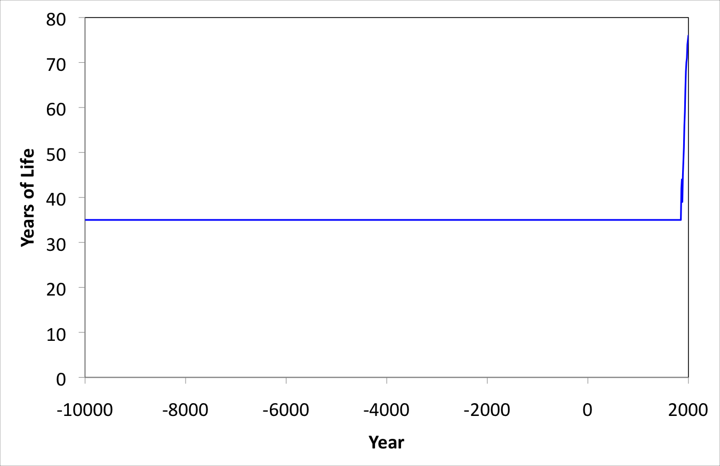
- Variations have been smoothed out but life expectancy is accurate
- Sudden increase at end of graph shows the last 150 years
- This data is obtained from the last 150 years in the United States
- In 1900 the life expectancy was approximately 44 years and the main causes of death were from infectious diseases such as pneumonia, tuberculosis, and influenza
- It was common for people to live their entire lives in poor health and were constantly sick with things such as parasites, lice, and chronic sores
- It was also more common to eat spoiled foods so many people were malnourished
- These conditions are still present in some countries
- Today the average life expectancy is 82 years and main causes of death are due to heart disease, cancer, stroke, lower respiratory infection, traffic incidents, and diabetes
- Infectious diseases leading to death are more rare today and death is more likely to be due to wear and tear
- The main reasons for improved health include:
  - Improved sanitation
  - Clean drinking water
  - Refrigeration
  - Vaccination
  - Antibiotics
- These improvements are often taken for granted
- Improved sanitation: Using a toilet is a recent sanitation advancement. People previously used outhouses and cesspits, and sewers previously involved open sections
- This poor sanitation is still common in third world countries
- People were also more commonly exposed to dead and dying bodies
- Safe water supply: Safe water is a recent development often taken for granted. People were unaware that nature didn’t make “pure” water, and that parasites and microorganisms could live in it
- People can become exposed to guinea worm via unsanitary drinking water
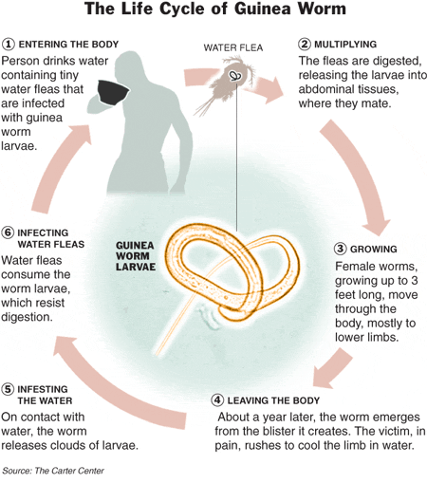
- A major advance for clean water was chlorination
- Chlorination kills microorganisms present in the water as well as preserves the water so it cant be reinfected by microorganisms
- Refrigeration: Food spoilage was extremely common before refrigeration. Icehouses were previously used to attempt to preserve food.
- Fridges also changed the way we eat and allowed for more well balanced meals.
- Pharmaceuticals improved health:
- Immunization or vaccinations were created to fix or avoid infectious diseases entirely
- The vaccines were very successful for viral diseases such as small pox
- Small pox was entirely eliminated in 1977 and only exists now in labs and as a biological weapon
- The small pox vaccination is no longer given, but before 1972 anyone who got it would have a clear vaccination scar
- Polio was also eradicated from North America in 1991
- Polio used to kill and paralyze thousands of people
- Currently there is less than 1000 cases worldwide and in 10 or 11 countries.
- A major eradication barrier is politics
- Antibiotics for bacterial infections:
- Many diseases can easily be cured via antibiotics
- The discovery of penicillin reduced maternal mortality significantly, and no longer made giving birth so dangerous
- 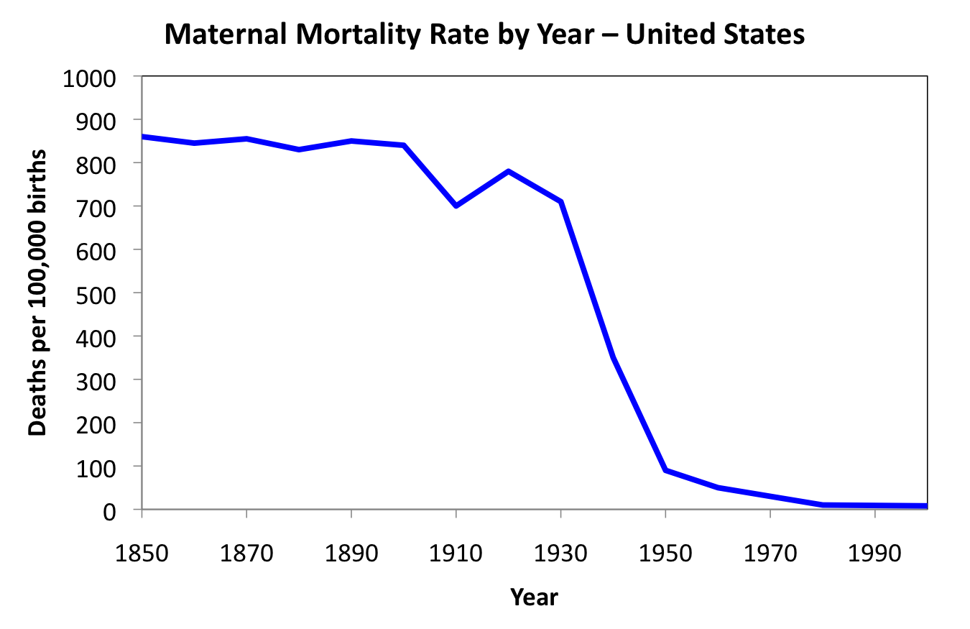
- The North American drug market has over $300 billion in prescription drugs and $25 billion in OTC drugs bought a year as of 2009
- The FDA rules the pharmaceutical industry, and things like Health Canada simply follow in its footsteps
United States | 49.1 %
Japan | 14.1 %
Germany | 7.7 %
France | 7.1 %
United Kingdom | 4.2 %
Canada | 3.8 %
Italy | 3.8 %
All Others | 10.3 %
- Canada’s drug market is insignificant

Types of Medical Treatment
- Surgical:
- Traditionally surgery was done by removing the affected body part as there were no anesthetics
- Since the development of anesthetics, surgery is now the modification of an affected body part
- Medicinal:
- Use of chemical compounds to treat disease
- Plants as source of drugs: Older drugs traditionally came from plants as plants are a huge source of poisons
- Plants are used as animals are not poisonous and all drugs are poisons, but not all poisons are drugs
- Early drugs were poisons but the different between a drug and a poison is the dose
- A drug produces desired beneficial biological effects
- A poison produces undesired harmful biological effects
- Typically low doses produce beneficial effects (drug), and high doses produce harmful effects (poison)
- Ex: 1-2 Tylenol every four hours provides a beneficial effect but exceeded 12 in one day produces a harmful effect
- In some cases however, low doses produce harmful effects (poison), and high doses produce beneficial effects (drug)
- Ex: Insulin and vitamins
- Another example of only the dose making the poison was a woman dying from drinking too much water and completely diluting her electrolytes

How were drugs discovered?
- Observation and experiment:
- People observed the effect of the drug
- Strong poisons given in low dose
- Best method if done right
- Philosophy:
- Cure arrived at by reasoning
- Based on belief
- Healing often connected with superstition, magic, religion
- Only as good as info it is based on
- Essentially made up
- 99% of cures were actually harmful
Drugs from observation and experiment:
- Used strong poisons which could be easily identified
- Low doses were used to be made into a drug
- Weak poisons could be used in large quantities in order to produce an effect
- Papyrus Ebers:
- Egyptian scroll describing hundreds of plants and uses in healing
- Some, such as opium, are still used today
- Hippocrates 460-370 BC:
- Hippocrates was the father of medicine
- Promotes experimental methods and rejection superstition and religion formed healing
- He was the first person to advocate experiments
- Discovered Ox liver was a use for night blindness because it contains vitamin A, and that poppy juice could be used to cure crying babies because it contains opiate
- Dioscorides 40-90 AD:
- De Materia Medica is a book featuring plants and their uses
- Identified opium for pain: Discovered opium (extracted from poppy seeds) is a narcotic painkiller, and a sedative. It was a drug in low doses but was discovered toxic in high doses and became a popular drug
- Identified cocaine as a stimulant: When extracted from coca leaves, could be used as a topical painkiller and a stimulant. Cocaine is still used in plastic surgeries
- Identified quinine as a malaria treatment: Obtained from Peruvian bark and cured malaria. At one time, was more valuable than cold. Originally the British Army drank quinine to prevent malaria in war, but since it was so bitter they made it into tonic water to make it easier to drink
Problems with Observation:
- Human brain searches for patterns even when they are not there
- Anecdotal evidence unreliable:
- Drug and effect may be coincidence
- Perceptions subject to placebo effects
- People lie
- Once “evidence” is available, hard to contradict:
- Many harmful remedies retained because of this
- Parent’s cold remedies. Ex: Once thought colds could be cured with a spread of flour milk and mustard powder. The mustard powder made the chest red and sweaty because it was an irritant and it was thought this was a sign of cure
- Apophenia:
- Seeing patterns or connections in random or meaningless data
- Correlation does not imply causation
- Pareidolia:
- Perceiving sounds or images as something else
- Ex: Seeing a face in a crater on Mars, a dog in a cloud, or Jesus’ face in a stain
- Anecdotal evidence is misleading:
- It relies on chance
- The medication and the cure may not be connected, and the poison and the harm may not be connected
- Need large number of data to conclude
- Ex: Tomatoes were once thought to be poisonous. Once the information is in the public realm it is hard to get out
- Ex: In North America bugs are not knowingly eaten, although they can be very nutritious and are easily digested. We are to afraid to eat them.
- Only experimental evidence is reliable. You must make a measurement, measure properly, and measure accurately
- Must rely on the statistical significance of data by collecting from large numbers of experiments and looking at averages and trends
Problems with Herbal Remedies:
- Poor control over the dose
- Plants produce variable amounts of active ingredients
- The variation in the amount of active ingredients can be based on size as well
- Variations in preparation and administration
- Ex: Flavor in foods. A carrot can have several different flavors based on how it is prepared. If a food is cooked or raw the active ingredient could be enhanced or destroyed
- No instructions: Information passed verbally can be imprecise and reproduced poorly. Instructions can be lost in translation and the cure can become useless
Philosophy to identify cures:
- Cure arrived at by reasoning
- Method requires good information. If something useful goes in it is more likely to provide an accurate cure. If garbage goes in, garbage will come out
- Healing often connected with superstition, magic, religion
- Hippocrates develops doctrine of humors:
- Hippocrates stated the earth was made of four elements, earth, air, fire, and water
- It was then thought since the universe is made of 4 elements, the body is made of 4 humors
- These humors were blood, phlegm, yellow bile, and black bile
- Blood and air were labeled cold, phlegm and water were labeled wet, yellow bile and fire were labeled hot, and finally black bile and earth were dry
- The four humors are normally in balance
- Too much or not enough of a humor causes disease
- Cure by re-balancing the humors
- Diagnose using the properties of the humors
- Fever associated with hot and dry can be cured using cold and wet (based on water and air)
- Bloodletting:
- Was made to re-balance the blood humor
- Thought that illness could be cured by removing blood by different ways such as distinctive cuts, and leaches
- Bloodletting often caused infection or removal of too much blood causing death
- Rebalance with emetics and purges:
- Thought humors could be rebalanced by emetics and purges
- Emetics make you throw up
- Purges empty your lower bowel
- Both of which are unpleasant and essentially useless
- Doctrine of humors was crap:
- Based on incorrect idea and was made up
- Treatments developed using it were harmful and painful:
  - Bloodletting
  - Purges
  - Fasting
  - Special foods
- Cant get a correct cure based on false information
- Doctrine of Signatures:
- Created by Jakob Bohme, shoemaker and philosopher (1575-1624)
- God left clues to tell us how to use things
- Disease and cure were linked
- This approach is/was used by almost all cultures
- Examples:
- Walnuts look like brains therefore eating walnuts is good for brain health
- Boneset stems grow through the leafs therefore they are good for bone health
- Thought that Sharks don’t get cancer since they only have cartilage and we have bones. Shark cartilage was used to treat cancer however it was based on imagination and we ignored that sharks do in fact get cancer
- Breath mints have chlorophyll because they were thought to give you fresh breath. This is because of this linkage:
- Fresh breath is from parsley, parsley is green, chlorophyll is also green, therefore chlorophyll gives you fresh breath
- Clorets gum gets their name from this theory when really chlorophyll is the very last and least ingredient in the gum
- Mandrake roots look like people therefore it was believed it could be used to cure a demonic possession
- It was thought that when it was pulled out it screamed and the scream could turn you to stone so the mandrake root was harvested using a dog
- This ensured the magic is preserved
- The rhino horn was thought to be a phallic symbol and was used in Chinese medicine as an aphrodisiac
- Mercury is a heavy metal was therefore drank as it was thought it pushed all the toxins out of you
- An avocado looks like a uterus therefore it must be good for uterine health
- Doctrine of signatures was also false:
- Most remedies developed this way were harmful
- At best were harmless
- Denied the patient proper treatment
- Lack of rationality or evidence
- Based on appearance or location
- Required imagination to see connections
- Lifespan didn’t progress until after philosophy was no longer used, and observation was more commonly used over the last 150 years

Surgery
- Some things couldn’t be helped with medicine and require surgery
- In more primitive ages, there was no anesthetic
- For this reason surgery involved only amputation, and had to be done quickly
- Most people usually died
- Amputation was learned through trial and error and less people died after it was discovered that the amputation should be done using a V-shaped incision so that the flaps could sewn back together and there would be less blood loss
- Sir Humphry Davy discovers nitrous oxide:
- Nitrous oxide left people awake but relaxed
- Still felt the pain
- Now used a propellant in things like whipped cream and can be used as a cheap high
- William T.G Morton and ether 1846:
- Ether was the first thing found to induce unconsciousness
- Allowed for more complicated procedures
- Discovered by a dentist
- First used to remove a neck tumor
- Anesthetics made modern surgery possible
- Before anesthetics amputation was the only option and less than 30% survived surgery
- 70% died due to their little knowledge of infection
- Surgeons used dirty clothes and dirty tools from one patient to the next
- Joseph Lister discovered phenol was an antiseptic
- Louis Pasteur made a link between the bacteria and diseases
- Lister took this idea to surgery and used phenol (previously a sewage disinfectant) in a sprayer to disinfect
- A carbolic acid sprayer was used and it was sprayed over the patient in a mist
- The vapor killed the bacteria and after this point it dramatically increased survival rate
- It was later discovered that phenol had a toxic long term effect
- Since the patient was only exposed to it for an hour in surgery it did not matter, but doctors would did several surgery’s everyday were at risk
- Risks outweighed the benefits
- People later tried to use a carbolic smoke ball to clean homes but this was also harmful
- Listerine, named after Lister contained phenol and was used for household cleaning, and dandruff but todays Listerine mouthwash no longer contains phenol
- Antisepsis brought to Canada by Thomas Roddick 1877:
- It was later discovered that simply washing hands, practicing in a clean room with clean tools, and using gloves was much safer
- Everyone also wore white because it was easier to see dirt
Problems with Drugs in the 1800’s
- No regulation
- Industrialization created big markets
- Lots of opportunity for fraud
- All these problems had/have always existed, but there was a dramatic increase in the 19th century
- Science and Fraud:
- The emergence of science made people trust claims using words such as “scientifically proven” and “patented”
- There was a rise of ads for medication
- The emergence of science made it easier to identify fraud. Before science, there was no way to know
- 1862 – First analysis of sugar/alcohol manipulation in wine
- 1873 – First analysis of morphine content in opium
- 1874 – First experiments on the effects of pesticides on humans
- Experiments on humans were common until WW2.
- Experiments were previously acceptable until the lines were crossed by Germans and rules were changed
- Rise in Patent Medications in the Late 1800’s:
- Patent medication essentially means nothing about the medication works to actually cure an illness
- Example: Soothing syrup for coughs contained opium soothed you and made you feel better as it contained opium but had no actual effect on the illness.
- This was also done with alcohol
- They made a claim that they could cure anything and to customers, it felt that way
- William J.A Bailey makes Radithor:
- Radithor was radioactive spring water based on the scientific observation that cancer cells die under radiation
- Twisted around to make people believe it could cure anything
- Water was sold as a mental enhancer
- Board of Food and Drug Inspection:
- Formed in 1907
- Due to several deaths from drugs it was required that companies list all ingredients on their label
- The beginning of the FDA recognizing there was actually harmful medication
- Didn’t required regulation of therapeutic claims or safety tested
- Patent medications are still sold today:
- The Massengill company sold the antibiotic sulfanilamide as a powder
- They made a lot of money on the powder but wanted to expand market by selling to children since they get sick frequently
- Sulfanilamide however tasted bad so it was made into a liquid and flavored so kids would drink it
- It was made in a liquid by dissolving it in diethyline glycol and water
- They labeled it an elixir
- The company didn’t realize that diethyline glycol was a poison (anti-freeze)
- Someone from the company took the drug and realize and sent a final message to the AMA: “Please wire collect by Western Union suggestion for an antidote”
- They tried to get the company to take the drug down but they didn’t want to since they did in fact list the ingredients
- The drug eventually was taken down since it was claimed to be an elixir where really an elixir is a substance dissolved in ethanol and their drug wasn’t
- The government recovered 234 of the 240 gallons sold but 107 died and 260 left disabled
- The FDA was then created
- Food and Drug Administration:
- Ensured the safety of drugs
- Animal testing was now required (safety only)
- Clinical trials were done to follow safety in humans
- Directions for proper use were required on the label
- Created in 1932
- Testing is now done by the company and results are sent back to the FDA
- Problems still occur in places where laws aren’t as strict
- Thalidomide:
- Thalidomide was the next disaster
- Developed as a sedative – 1957
- Very few side effects
- By 1962, thalidomide recognized as a teratogen
- Lead to birth defects
- Never marketed in the U.S., only in Europe
- Teratogenicity was discovered before FDA approval was given
- Thalidomide was initially tested in rats
- Rats however reabsorb babies there are a problem with so the problem was not seen until tested in humans
- The lab animal was poorly chosen
- Modern safety standards:
- Safety testing done in at least 2 species
- At least one must be a primate since they’re similar to humans
- Must show that the drug is bioavailable
- Gets into body (enters bloodstream)
- Must use relevant doses
Genetically Engineered Drugs
- Replaces animal experiments
- Done between the 1970’s and 1980’s
- Used to have to do most safety screening on animals
- Now it can be done in test tubes
- Genetic engineering facilitates drug discovery:
- We can now picture what happens when a drug enters the body on a molecular level using genetically engineered materials
- We can determine which protein sequence a drug reacts with
- Previously most insulin was gotten via animals like horses, pigs, and dogs which caused problems over time
- Today most insulin is genetically engineered
- Genetically engineered drugs created a decline in typical drugs such as aspirin
Drug discovery today:
- Each new drugs costs more than $800,000,000 to develop
- From idea to market requires 8 years
- High risk, high profit
- Sources of drugs today:
- Biologic (genetically engineered): 14%
- Vaccine: 4%
- Natural product (opium, coke): 5%
- Semi-synthetic: 23%
- Synthetic (most drugs): 54%
- Extracts form plants and animals are no longer as prevalent
- Drugs designed by computers are the future as they can see how a drug interacts in the body
- Drugs are found by random screening, essentially tral and error
- Test labs have millions of compounds which they test as every new disease comes along
- There is however a high failure rate for new drugs:
- Less than 1 in 10 drugs survive clinical trials and reach market
- More than 10,000 compounds are tested to find each new drug
- Process requires 8 to 12 years
- Each new drug costs $800,000,000 (nearly 1 billion) to bring to market

