DESC 200 NOTES
Chapter 2
Understanding your computer
Computers Are Data
Processing Devices
Strictly defined, a computer is a data processing device that performs four major functions:
- It gathers data (or allows users to input data).
- It processes that data into information.
- It outputs data or information.
- It stores data and information.
Data vs. Information
- Data is a representation of a fact, figure, or idea. Data can be a number, a word, a picture, or even a recording of sound. For example, the number 6125553297 and the names Derek and Washington are pieces of data.
- Information is data that has been organized or presented in a meaningful fashion. When your computer provides you with a contact listing that indicates Derek Washington can be reached by phone at (612) 555-3297, the data mentioned earlier suddenly becomes useful — that is, it becomes information.
How do computers interact with data and information?
Computers are excellent at processing (manipulating, calculating, or organizing) data into information.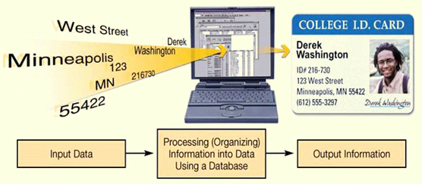

Bits and Bytes: The Language of Computers
- Bit
- In order to process data into information, computers need to work in a language they understand. This language, called binary language, consists of just two digits: 0 and 1.
- Everything a computer does is broken down into a series of 0s and 1s. Each 0 and 1 is a binary digit, or bit for short.
- Byte
- Eight binary digits (or bits) combine to create 1 byte.
- In computers, each letter of the alphabet, each number, and each special character (such as the @ sign) consists of a unique combination of 8 bits, or a string of eight 0s and 1s.

So, for example, in binary language, the letter K is represented as 01001011.
How Much Is a Byte?
Not only are bits and bytes used as the language that tells the computer what to do, they are also what the computer uses to represent the data and information it inputs and outputs. Word processing files, digital pictures, and even software are represented inside a computer as a series of bits and bytes. These files and applications can be quite large, containing thousands or millions of bytes.
- Kilobytes, megabytes, and gigabytes are therefore simply amounts of bytes.
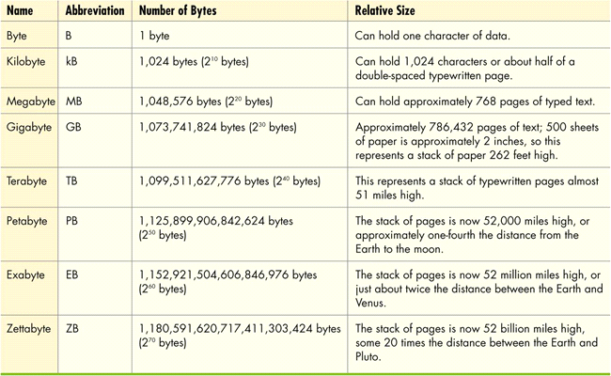

Computer Hardware
- Hardware: Any part of the computer you can touch.
- Hardware components consist of the system unit and peripheral devices, such as monitors and printers that are connected to the computer.
- Other hardware devices, such as routers, help a computer communicate with other computers to facilitate sharing documents and other resources.
- Together, the system unit and peripheral devices perform four main functions: they enable the computer to input data, process that data, and output and store the data and information.
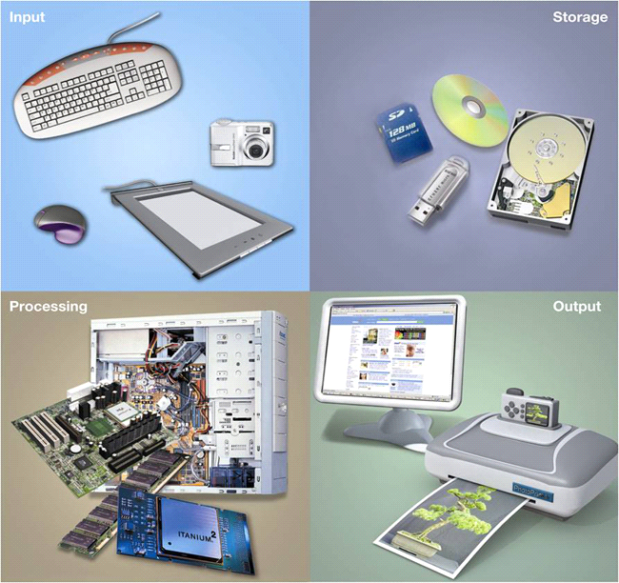
Computer Software
A computer without software is a shell full of hardware components that can’t do anything.
- Software is the set of computer programs that enables the hardware to perform different tasks.
- There are two broad categories of software: application software and system software.
- Application software is the set of programs you use on a computer to help you carry out tasks such as writing a research paper. If you’ve ever typed a document, created a spreadsheet, or edited a digital photo, for example, you’ve used a form of application software.
- System software is the set of programs that enables your computer’s hardware devices and application software to work together. The most common type of system software is the operating system (OS). It is the program that controls the way in which your computer system functions. It manages the hardware of the computer system, such as the monitor and the printer. The operating system also provides a means by which users can interact with the computer.

Types of Computers
There are two basic designs of computers: portable and stationary.
- Basic computer designs
- Portable
- Notebook computers: (or laptop computer) is a portable computer that is powered by batteries (or a handy electrical outlet) and has a keyboard, a monitor, and other devices integrated into a single compact case.
- Netbooks: small, lightweight notebook computer that is generally 7 to 10 inches wide and has a longer battery life than a notebook computer.
- Tablet PCs: similar to a notebook but features a touch sensitive screen that can swivel and fold flat. Users input data and commands on a tablet PC through a special pen called a stylus or with their fingers.
- Stationary
- Desktop computers: intended for use at a single location, and therefore, is stationary. Desktop computers consist of a separate case that houses the main components of the computer plus peripheral devices.
A peripheral device is a component, such as a monitor (screen) or keyboard,that is connected to the computer.
An all-in-one computer houses not just the computer’s processor and memory but also the monitor.

Are there other types of computers besides desktop and notebook computers?
Will probably not use these but still important.
- Mainframe: Large, expensive computer that supports hundreds of users simultaneously. Mainframes are often used in insurance companies, for example, where many people are working on similar operations (such as claims processing) all at once.
- Supercomputer: Performs complex calculations rapidly. Supercomputers are used in situations in which complex models requiring intensive mathematical calculations are needed (such as weather forecasting or atomic energy research). The main difference between a supercomputer and a mainframe is that supercomputers are designed to execute a few programs as quickly as possible, whereas mainframes are designed to handle many programs running at the same time but at a slower pace.
- Embedded computer: Self-contained computer performing dedicated functions. They have their own programming and typically do not receive input from you or interact with other systems. It resides in another device, like a car or the electronic thermostat in a home.

Each part of a computer’s hardware has a specific purpose that coordinates with one of the functions of the computer- input, processing, output, or storage.
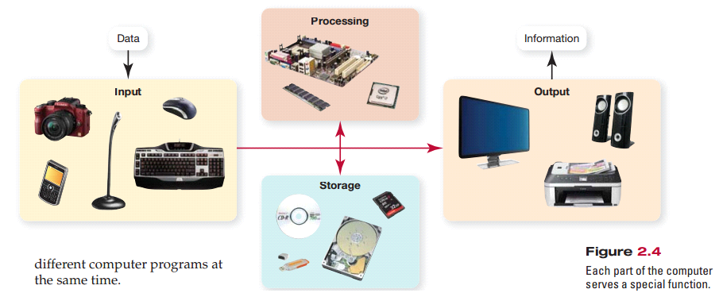
Input Devices
- An input device enables you to enter data (text, images and sounds) and instructions (user responses and commands) into the computer.
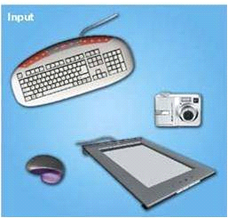
- The most common input devices are the keyboard and the mouse.
- You use keyboards to enter typed data and commands, whereas you use the mouse to enter user responses and commands.
- There are other input devices as well:
- Microphone: input sounds
- Scanner: inputs nondigital text
- digital camera: inputs digital images
- stylus: devices that look like skinny pens but have no ink. It is used to tap commands or draw on a screen.

Keyboards

- The QWERTY layout is standard on most PCs.
- The DVORAK keyboard is an alternative keyboard layout that puts the most commonly used letters in the English language on “home keys”, which are the keys in the middle row of the keyboard. The DVORAK keyboard’s design reduces the distance your fingers travel for most keystrokes, increasing typing speed.
- Enhanced keyboard features include number, function, and navigation keys.
- Notebook keys have alternate functions when used in conjunction with the F (function) keys. 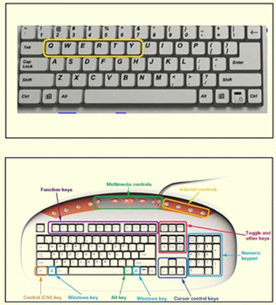
How do notebook keyboards differ?
To save space and weight, some of the smaller notebooks (laptops) have fewer keys. To retain the same functionality as the standard keyboard, many keys have alternate functions. For example, some letter keys function as number keys when they are pressed in combination with the function (Fn) key.

Specialty Keyboards
Virtual laser keyboard | Configurable keyboard
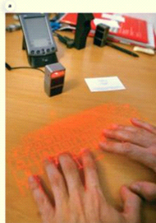 | 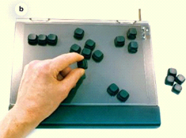

Flexible keyboards are a terrific alternative if you want a full-sized keyboard for your notebook. You can roll one up, fit it in your backpack, and plug it into the USB port when you need to use it.
The virtual laser keyboard is about the size of a cellular phone. It projects the image of a keyboard on any surface, and sensors detect the motion of your fingers as you “type” on a desk or other flat surface. Data is transmitted via Bluetooth technology, which is a wireless transmission standard that facilitates the connection of electronic computing devices such as cell phones, smartphones, and computers to peripheral devices such as keyboards and headsets.

Knowing how to use special keys will help improve efficiency:
Numeric keypad allows one to enter numbers quickly.
Function keys act as shortcut keys you press to perform special tasks.
The control key is used in combination with other keys to perform shortcuts and special tasks.
The Alt key works with other keys to execute additional shortcuts and special tasks.
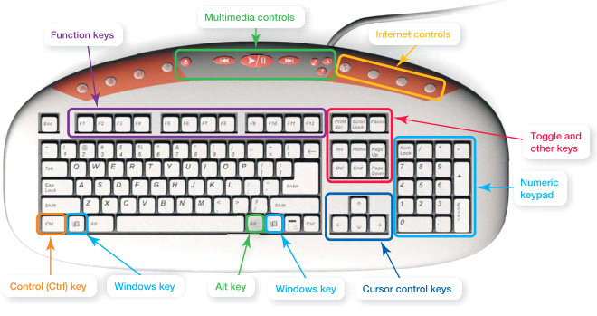
Some keyboards also include multimedia and internet keys or buttons that enable you to open a web browser, view email, access Help features, or control your CD/DVD player.
A cursor control key is also known as an arrow key because each one is represented by an arrow on standard keyboards. The arrow keys move the cursor one space at a time in a document: up, down, left or right.
Above the arrow keys, you’ll find Page Up (PGUP) and Page Down (PGDN) keys that move the cursor up or down one full page or even to the documents beginning (Home), or to the end of a line of text or document (End). The Delete (Del) key allows you to delete characters, and the insert key allows you to insert or overwrite characters within a document.
The insert key is considered a TOGGLE KEY because its function changes between one of two options each time you press it. When toggled on, the insert key inserts new text within a line of existing text. When toggled off, it replaces (or overwrites) existing characters with new characters as you type. Other toggle keys include Num Lock and Caps Lock.
Wireless keyboards send data to the computer using a form of wireless technology that uses radio frequency (RF).
Mice

- Optical mouse: (picture c)—uses an internal sensor or laser to detect the mouse’s movement. The sensor sends signals to the computer, telling it where to move the pointer on the screen. Preferable because there are fewer parts so less cleaning and less chances of parts breaking down.
- Needs no mouse pad
- Does not need cleaning
- Trackball (picture b)—has the rollerball on top or on the side of the mouse, and you move the ball with your fingers, allowing the mouse to remain stationary and easier on wrists.
- Easier on wrists
- Stays stationary on desk
- Wireless mouse
- Sends data to the computer by radio or light waves.
- If you have both a wireless mouse and keyboard, they can share the same RF receiver.
- Integrated pointing device
- Touchpad
- Trackpoint
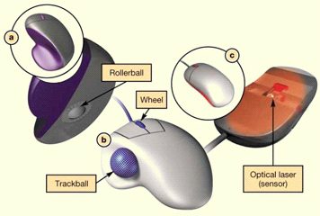

Do notebook computers include a mouse?
Most notebooks have an integrated pointing device such as a touch pad, a small, touch sensitive area at the base of the keyboard. Other notebooks incorporate a trackpoint device, a small joystick-like nub that allows you to move the cursor with the tip of your finger.
New Mouse Features

- Magnifier: Pulls up a magnification box that you can drag around the screen to enhance the viewing of hard-to-read images. This feature can be used by people with visual disabilities.
- Customizable buttons: Extra buttons on the mouse can be programmed to perform the functions you use most often to help you speed through tasks.
- Web Search: Allows you to quickly highlight a word or phrase and then press the search button (on the mouse) to start a Web search.
- File storage: Includes a wireless USB receiver that contains flash memory to store ofr back up your files (for example, a USB drive).

Other Input Devices

- Game controllers: They have buttons and miniature pointing devices that provide input to the computer.
- Joystick and steering wheels: deliver data in both directions. They translate movements to the computer and translate its responses into forces on your hands, creating a richer simulated experience.
- Touch screens: a display screen that responds to commands initiated by a touch with a finger or a stylus.
- Digital pens (stylus & tablet)

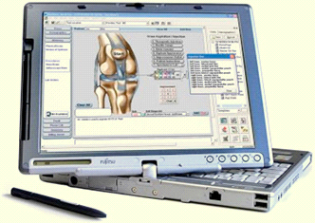

Image Input
How to input digital images into my computer?
- Digital cameras, camcorders, and cell phones are common devices for capturing pictures and video, and all of the, are considered input devices. Used in settings away from a computer to capture images and video for later downloading to the computer. They either connect to a computer with a data cable or transmit the data wirelessly.
- Pictures
- Video
- Scanners: works similarly to a photocopy machine but instead if generating the image on paper, they create a digital image which can be printed, saved or stored.
- Webcams: a small camera that sits on top of a computer monitor (connected by a cable) or is built into a notebook computer. They make it possible to transmit live video over the web.
- Used for Live video

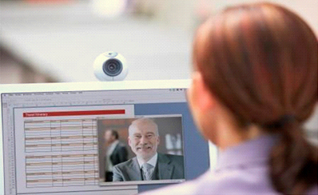
Sound Input
Why would I want to input sound to my computer?
Opens up possibilities: you can chat with freinds or colleaugues instead of using a phone. Inputting sound to your computer requires equipping it with a microphone or mic, a device that allows you to capture sound waves and transfer them to digital format on the computer.
Microphones are used for:
-Podcasts
-Videoconferencing
-Internet phone calls
-Speech recognition
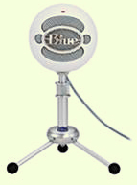
Different types of microphones:
Desktop microphones, which have an attached base that allows them to sit on a flat surface
Unidirectional microphones, pick up sound from only one direction.
Omnidirectional microphones pick up sounds from all directions at once.
Clip-on micophones( also called lavalier microphones), for presentations etc.
Close-talk microphones whichare usually attached to a headset, facilitate using speech recognition software, videoconferencing or making phone calls. It allows you to listen as well.
Input Devices for the
Physically Challenged
Visually impaired users can input data:
-from voice recognition
-by using large keyboards (for those whose visual limitations are less severe)
-by using touch-screen keyboards(easier to input for some individuals, displayed as graphics on a computer

Individuals who can only use one hand use the Maltron keyboard.
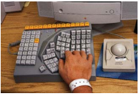

Users with severe motor control problems who may have difficulty with pointing devices can use:
-special trackballs designed and manipulated for one-finger use that can be mounted anywhere
-head-mounted pointing devices, when arm motion is severely restrained. This involves a camera mounted on the monitor and a device attached to the head. When the user moves his head the cursor moves . To click can be manipulated by a movement of the feet or hands or a device that goes into the mouth and senses when the user blows.
Output Devices
Output devices enable you to send processed data out of your computer. This can take the form of:
-text
-pictures (graphics)
-sounds (audio)
-video
One common output device is:
-a monitor(or display screen), which displays text, graphics and video as soft copies (copies you can see only on-screen)
-a printer, which creates tangible or hard copies of text and graphics

Speakers and earphones (or earbuds) are the output devices for sound.
Output devices make:
-Soft copies (video, sounds, control signals)
-Hard copies (print)

Monitor Types
LCD: Liquid crystal display( also called a flat-panel monitor)
Flat panel
Light and energy efficient
Newer LCD monitors that use LED: Light-emitting diode
More energy efficient than LCD monitors
Better color accuracy and thinner panels
LCD monitors have replaced the CRT(cathode ray tube monitors): CRT monitors are difficult to find because they have become Legacy technology which means that they are computing devices that use techniques, parts and methods from an earlier time that are no longer popular.
How do monitors work?
LCD Monitor Features
-Monitor Screens are grids made up of millions of tiny dots called pixels.
-Each pixel is composed of 3 sub-pixels: red, blue, and green (and sometimes yellow on some of the newer monitors).
-Liquid crystal is sandwiched between two transparent layers to form images.
LCD monitors are made up of two or more sheets of material filled with liquid crystal solution. The fluorescent panel at the back generates light waves. When electric current passes through the liquid crystal solution, the crystals move around and either block or let the fluorescent light pass through. This causes the image to form on the screen.
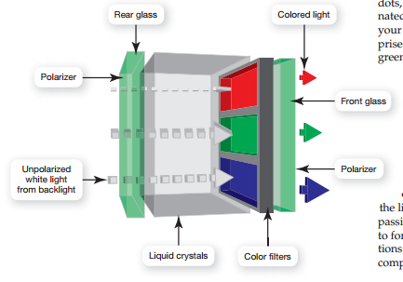
LCD Quality Factors
Aspect ratio: The width-to-height proportion of a monitor. Usually 4:3 but some are 16:10
Resolution: The most important factor to consider when choosing an LCD monitor is resolution, or clearness or sharpness of the image. The screen resolution reflects the number of pixels on the screen. An LCD monitor may have a native (or maximum) resolution of 1,600 x 1,200, meaning it contains 1,600 vertical columns with 1,200 pixels in each column. The higher the resolution, the sharper and clearer the image will be.
Contrast ratio: A measure of the difference in light intensity between the brightest white and the darkest black that the monitor can produce. If the contrast ratio is too low, colors tend to fade when you adjust the brightness to a high or low setting. A contrast ratio between 400:1 and 1,000:1 is preferable
Viewing angle: How far you can move to the side of (or above or below) the monitor before the image quality degrades to unacceptable levels. For monitors that measure 17 inches or more, a viewing angle of at least 150 degrees is usually recommended.
Brightness: A measure of the greatest amount of light showing when the monitor is displaying pure white. Measured as candelas per square meter (cd/m2) or nits, A brightness level of 300cd/m2 or greater is recommended.
Response time: The time it takes for a pixel to change color. The lower the response time, the clearer moving images will appear.

Is a bigger screen size always better?
In general, the larger the panel, the larger number of pixels it can display.
Screen Size
21-inch monitor
1680 × 1050 pixels
19-inch monitor
1440 × 900 pixels
1280 × 1024 pixels
HD-DVDs and Blu-ray movies
Require at least 1920 × 1080 pixels

projector, a device that can project images from your computer onto a wall or viewing screen.
Printers
Both the inkjet and laser printers are considered non-impact printers which spray ink or uses laser beams to transer marks onto paper. Today, nonimpact printers have replaced impact printers almost entirely. An impact printer has tiny hammerlike keys that strike the paper through an inked ribbon, making marks on the paper.
Inkjet printers
Spray tiny drops of ink onto page, produce high-quality color printouts quickly
and quietly.
Laser printers
Use laser beams and static electricity to deliver toner(similar to ink) to page. Heat is used to fuse the toner to the page, making the image permanent., faster printing speed, dont need inkjets
All-in-one printers: a device that combines the funtions of a printer, scanner, fax, and coppier in one machine
Plotters:produce oversize pictures that require the drawing of precise and continuous lines such as maps or detiled images. Provides a computer controlled pen that provides a greater level of precision.
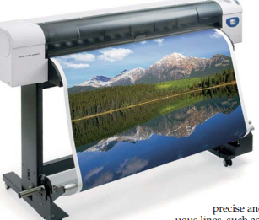

Thermal printers: the either work by melting wax based ink onto paper(a process called thermal wax transfer printing) or by burning dots onto specially coated paper (a process called direct thermal printing). Used in stores to print receipts and in airports for electronic ticketing and other places.
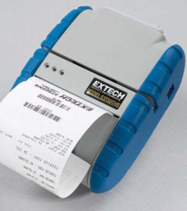

Choosing a Printer
Speed (ppm): A printer’s speed determines how many pages it can print per minute (called pages per minute, or ppm). Printing speeds range from 8 to 38 ppm for both laser and inkjet printers.
Resolution (dpi): A printer’s resolution (or printed image clarity) is measured in dots per inch (dpi). The higher the dpi, the greater the level of detail and quality of the image. For general-purpose printing, 1200 dpi is sufficient; for printing photos, 4800 dpi is better.
Color output: Some printers come with a single ink cartridge for all colors; others have two ink cartridges, one for black and one for color. The best setup is to have individual ink cartridges for each color, so you can replace only the specific color cartridge that is empty.
Use and cost: If you will be printing mostly black-and-white, text-based documents or will be sharing your printer with others, a black-and-white laser printer is best because of its printing speed and overall economies for volume printing. If you’re planning to print color photos and graphics, an inkjet printer or color laser printer is a must, even though the cost per page will be higher. ALSO, keep in mind the printers duty cycle which is a manufacturers figure that refers to how long a machine can keep operating before it needs a rest, or what percentage of the time its designed to be in use.
Cost of consumables: You should investigate carefully the cost of consumables (printer cartridges and paper) for any printer you are considering purchasing.

Nonimpact Printers
Inkjet printer:
-work by spraying tiny drops of ink onto paper
-less expensive device
-print high-quality color images cost effectively
Most inkjet printers use drop-on-demand technology in which the ink is "demanded" and then "dropped" onto the paper. Two different processes use drop on demand technology: thermal bubble and piezoelectric. The difference between the two is how the ink is heated.
Thermal bubble process: ink is heated in a way that it expands(like a bubble) and leaves the cartridge reservoir through a small nozzle.
Piezoelectric process: each ink nozzle contains a crystal at the back of the ink reservoir that receives an electrical charge, causing the ink to vibrate and drop out of the nozzle.
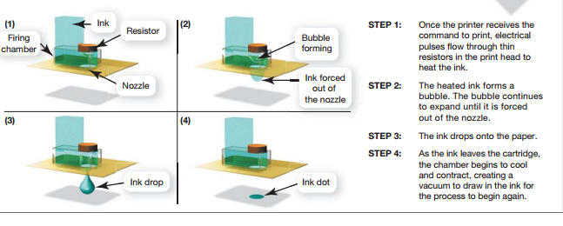

Laser Printer
-often preferred for their quick and quiet production and high-quality printouts
-more expensive device
-over the long run, for high-volume printing, laser printers are more economical than inkjets (they cost less per printed black-and-white page) when you include the price of ink and special paper in the overall cost.
-recently, the prices have fallen, making them competitive with high-end inkjet printers.
Inside is a big metal cylinder(also called a drum) that is charged with static electricity. The printer sends signals to the laser, telling it to "uncharge" selected spots on the charged cylinder. These spots correspond to characters and images in the document you wish to print. Toner, a fine powder(used instead of liquid ink) is only attracted to the areas of the drum that are not charged.
Sound output:
What are the output devices for sound?
A speaker is an output device for sound.
Subwoofers:Special speakers that produce only low bass sounds
Surround sound speaker: system of speakers and audio processing that envelops the listener in a full 360 degree field of sound.
The Motherboard
The motherboard is the main circuit board that contains the central electronic components of the computer, including the computer's processor(brain), its memory, and the many circuit boards that help the computer function.
On a desktop, the motherboard is located in the system unit. A system unit is the metal or plastic case that also houses the power source and all the storage devices.
What's on the motherboard?
A motherboard is the main circuit that contains the set of chips that powers the system,including the central processing unit(CPU). The motherboard also houses ROM, RAM and chache, the chips that provide the short term memory for the computer. It also includes slots for expansion cards(or adapter cards), which are circuit boards that provide additional functionality. Typical expansion cards found in the unit are the sound and video cards.
Sound card: provides a connection for the speakers and microphone.
Video card: provides a connection for the monitor.
Modem card: provides the computer with a connection to the internet via a traditional phone line
Network interface car(NIC): enbales computer to connect with other computers or to a cable modem to facilitate a high speed internet connection.
Attached directly to the motherboard are the:
-CPU
-RAM
-Expansion cards and slots
-Built-in components
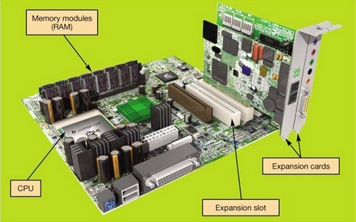

What exactly is RAM?
RAM: Random Access Memory (RAM) is the place in a computer where the programs and data the computer is currently using are stored. RAM is located on the motherboard . RAM is a series of small cards(called memory cards or memory modules plugged into slots on the motherboard.
RAM is a temporary or volatile storage location. It is considered the computers temporary memory whereas the hard drive is the computers permanent memory.
ROM: Read Only Memory holds all the instructions the computer needs to start up when the computer is powered on. This is also located on the motherboard. The instructions stores on ROM are permanent, making ROM a nonvolatile storage location.
Processing:
What is the CPU?
The central processing system is sometimes referred to as the “brains” of the computer because it controls all the functions performed by the computer’s other components and processes all the commands issued to it by software instructions.
Processor speed is measured in units of hertz(Hz)- Stands for Machine cycles per second. Can perform billions of tasks per second without error, making them extremely powerful components.
Machine cycle is the process of the CPU getting the data or instructions from the RAM and decoding the instructions into something the computer can understand.
Current systems run at speeds measured in gigahertz (GHz).
What else determines processor performance?
CPU performance also is affected by other factors. One factor is the number of cores, or processing paths a processor has. Now, processors can have up to even eight different pths, allowing them to process more than one instruction at a time. For example, a virus protection software and the operating system are always running behind the scenes but they can have their own processors freeing up the other processor to run other applications such as itunes or web browser.
With their dual core processors, Intel CPUs can work in parallel, processing two seperate programs at the same time instead of switching back and forth between them.
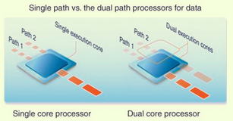

Storing Data and Information:
Each of the permanent storage devices is located in your desktop in a space called drive bay.
There are two kinds of drive bays- internal and external.
Internal hard drive: Usually holds all permanently stored programs and data. (Cannot be seen or accessed from the outside)
External drive bays: Can be seen and accessed from the outside. They house CD and DVD drives and are covered by a faceplate.
You may sometimes see a PC that has a bay for a floppy disk drive, which reads and writes to easily transportable floppy disks that hold a limited amount of data. A zip disk drive resembles the floppy disk but can carry much more data(up to 750MB). They are both legacy technologies.
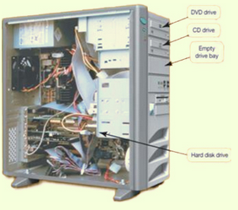

Which storage device holds the most data?
Hard Drive: Your computer’s primary device for permanent storage of software and documents. It is a non-volatile storage device, meaning it holds the data and instructions your computer needs, even after the computer is powered off. Since it holds all the data, it is protected in the system unit.
External hard drive is essentially like an internal hard drive but it was made portable(small and light weight) with a protective case. Often used to back up data that is contained on an internal hard drive in case of a problem.
Optical drive: can be read from and maybe even write to CDs, DVDs or Blu ray discs. Data is saved to a compact disc(CD), digital video disc(DVD), or Blu ray disc (BD) as tiny pits that are burned on the cd by a high speed laser.
Flash drive or jump drive, or USB drive or thumb drive is a way of storing portable data.
Flash memory cards:let you transfer digital data between your computer and devices such as digital cameras, PDAs, smartphones, video cameras and printers.
-Slide into slots in the system
Solid state (SSD) hard drives does not have any spinning platters or motors, so they are more efficient, run with no noise, emit very little heat and require very little power.

Connecting Peripherals to the Computer:
Port: A place through which a peripheral device attaches to the computer so that data can be exchanged between it and the operating system.
What is the most common way to connect deviced to a computer?
A universal serial bus(USB) port is now the most common port type used to connect input and output devices to the computer.
Types of ports:
-USB
-Serial port: sends data one bit(piece of data) at a time. Often used to connect modems to the computer.
-Parallel port: could send data between devices in groups of bits, much faster than the traditional serial ports. Often used to connect printers to computers.
-Audio and video
-FireWire
Connectivity port: Can give you access to networks and the internet or enable your computer to function as a fax machine.
-Ethernet port: transfer data at speeds up to 1000 Mbps. can use it to connect your computer to a digital subscriber line(DSL) or cable modem or network.
-Modem port: uses traditional telephone signal to connect to the internet over a phone line.
-HDMI(high defintion multimedia interface): compact audio-video interface that carries both high defintion video and digital audio on one cable.
Adding Ports
Can add special Expansion cards. If your compiter for example only has USB 2.0 ports, but you would like to upgrade to the new USB 3.0 ports you can install expansion cards to provide additional ports.
-New port standards
Expansion hubs: connects to one port to provide adiitonal new ports.
-Enable several devices to be connected to a port
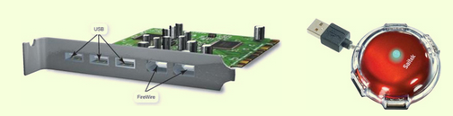
Power Controls
Power-on button on the front panel: although you use this button to turn on your system, you do NOT want to use it to turn off your system. You turn off the power by clicking on a shutdown icon on the desktop.
Cold boot: powering on your computer from a fully turned off state
Other options:
Sleep mode: all the documents, applications and data you were using are stored in RAM, from which they are quickly accessible upon restarting your computer.
Hibernation: another power-saving mode that stores your data in memory and saves it to your computer's hard disk
Warm boot: restarting the system while its powered on.
If you’re using Windows 7, you can restart the computer when you click the right arrow button next to the lock button on the Start menu. This is called a warm boot. You might need to perform a warm boot if the operating system or other software application stops responding or if you have installed new programs.
Safety Guidelines:
In terms of computing, ergonomics refers to how you set up your computer and other equipment to minimize your risk of injury or discomfort.
The following are some guidelines that can help you avoid discomfort, eyestrain, or injuries while you’re working at your computer:
Position your monitor correctly. This should be at least 25 inches from your eyes and at eye level or so that it is at an angle 15 to 20 degrees below your line of sight.
Purchase an adjustable chair. Adjust the height of your chair so that your feet touch the floor. The chair should include back support.
Assume a proper position while typing. Your wrists should be flat with respect to the keyboard, and your forearms should be parallel to the floor. Specially designed ergonomic keyboards and wrist rests can help you achieve the proper position for your wrists.
Take breaks from computer tasks.
Ensure that the lighting is adequate.
These are steps to make sure the ergonomics of the computer environment are well set up.
Input Device examples:
Keyboard
Mouse
Microphone
Digital Camera
Stylus
Output Device Examples:
Monitor
Speakers
Printer
Summary Questions
What exactly is a computer and what are its four main functions?
What is the difference between data and information?
What are bits and bytes and how are they measured?
What devices do you use to get data into the computer?
What devices do you use to get information out of the computer?
What’s on the motherboard?
Where are information and programs stored?
How are devices connected to the computer?
How do you set up your computer to avoid strain and injury?

