Mechanisms
- Organic reactions happen when electrons move
  - Easiest to understand by organic mechanisms
- 3 general concepts (know)
  - Work with functional groups
    - Don’t worry about how the molecule looks, worry about the functional group
    - Functional group are locations on a molecule that react
      - Reaction = function
  - Use arrows to show bonds formation
  - Use arrows to show bonds breaking
  - Use arrows to show charge formation
- Identifying functional groups
  - Heteroatom
  - Unsaturation (double bond or higher)
  - Atom that carries a charge
- Hydrocarbon part does not react
  - Scaffolding that holds functional group
  - Hydrocarbon can be abbreviated as “R”
  - Just focus on the functional group
- Bond formation
  - Arrows show e⁻ movement
- Always show e⁻ pairs with negative charges
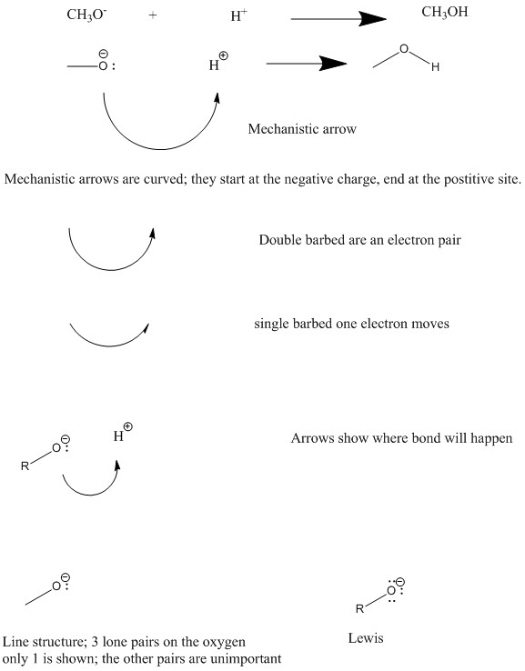
Can also show bonds breaking
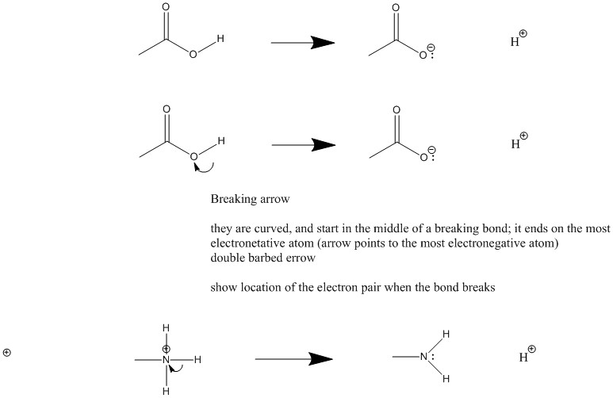
- When a double barbed arrow points to an atom, the atom gains electrons and becomes 1 unit more negative
  - Arrow points at more electronegative, unless it already has a (full) negative charge
- Atom that a doubly barbed arrow starts at (points away from) loses electrons and becomes one unit more positive
Combine Bond forming and breaking
- Memory method
OH⁻ + HCl ?
OH⁻ + HCl H₂O + Cl⁻
- Mechanistic way
OH⁻ + H-Cl H₂O
δ⁺ δ⁻
Arrow points to the most electronegative ion (negative delta)
Acids and bases
- Review
  - pKa
  - pKb
  - Ka
  - Kb
  - Conjugate acid and conjugate base
  - Bronstead and Lewis
- Estimating acid and base strength
  - Strong acids produce weak conjugate bases
  - Weak acids have a strong conjugate base
  - A⁻ is the atom in the acid that holds the negative charge
  - Easiest to predict acidity by comparing charged molecules
- 4 factors that control acid strength
  - Increases in elecronegativity increases strength of acidity (HA)
    - Apply this across the periodic table
    - You look at the atom that carries the charge
    - Oxygen is to the right of N in periodic table, and is more electronegative
    - Negative charge is more stable on oxygen
      - CH₃O is a WEAKER BASE
      - CH₃OH is a stronger acid
  - Increasing the size of A⁻ atom increases acidity
    - Size trumps electronegativity
    - Bigger atoms distribute charge over large volume
      - Stabilized by reduced electron repulsion, and makes the conjugate base more stable

    - Sulphur is lower in periodic table, and it is therefore larger
      - Charge is more spread over the bigger volume for CH₃S⁻
      - CH₃S⁻ is more stable
    - CH₃S⁻ is a weak base
    - CH₃SH is the stronger acid
    - Only the atom that carries the charge counts
- Acid strength increases from left to right (electronegativity), acid strength increases down the periodic table (size)
- Increased acidity by inductive effects
    - F is very electronegative
    - CF₃ group is electron withdrawing group
    - Electron withdrawing group = EWG
    - EWG increases electron attracting power of oxygen
    - CF₃ group pulls electrons towards it, reducing the amount of negative charge on oxygen, making the conjugate base more stable
      - Stablizing effect
      - Inducing smaller negative charge on oxygen
    - CF₃O⁻ is the weakest base (most stable)
    - CF₃OH is the strongest acid
- Resonance increases acidity
- Has effect of dispersing charge
- Stabilizes charged molecules
- Negative charge stabilized by resonance
- Charge can be shared between oxygen molecules
- π bond switches molecules
[]⁻
- resonance forms
- arrow indicates resonance
[]⁻
Hybrid (there should be deltas with negatives next to the oxygens)
- negative is spread over several atoms, and it is stabilizing
- CH₃COO⁻ is the weakest base
- CH₃COOH is the strongest acid
Resonance
- Some compounds represented by more than 1 structure
  - Differ by location of electrons
- Slow method
  - Count electrons
    - Number of atom times number of electrons for that atom
    - Make double bonds to reduce charge
  - EACH IS A RESONANCE FORM AND CONTRIBUTES TO THE OVERAL STRUCTURE
    - This leads to a hybrid which is a combination of all 3
    - Combine to make hybrid
(oxygen should have a delta negative)
    - Not all resonance forms are equal
    - More stable forms contribute more
- In general, the best resonance forms have the following characteristics
    - Stuff at the top of the list beats stuff at the bottom
- Full octets on all atoms
- Fewest formal charges
- Negative charge on electronegative atoms
- Positive charge on electropositive atoms
- Max separation similar charges (+,+ or -,-)
- Min separation opposite charges (+,-)
When constructing resonance forms
- Do not break single bonds
  - You may break double bonds
- Do not exceed atom valance
  - (no more than 8 electrons for the 1st row)
  - Exceptions are S and P
Good contributes more, bad contributes less (if at all)
Good
- Full octets on all atoms
  - Everything has 8
- Only have one charge
  - Fewest charges possible
Good
- Full octets on all atoms
- Only one has charge
  - Fewest charges possible
Bad
- Carbon atom lacks an octet
  - This structure has a problem with it
- There are also three charges
  - Lots of charge is also bad
- In this example the “Good” structures contribute
- The bad form does not contribute
  - It is so bad it is insignificant
- Insignificant resonance form
  - Useful, but do not contribute to the structure of the molecule
  - Are useful to construct other resonance forms
- Determining structure significance
  - Forms that have more than 2 charges in a system are usually insignificant
  - Distribution of negative and positive charges
    - Okay to have negative and positive, as long as negative is on the most electronegative atom
Notes on resonance
- Broken double bonds only significant when heteroatoms are involved
Resonance and arrows
- Resonance involves π-bonds
  - You look at what is beside the π-bond
      - IN ORDER
    - Lone pair
    - Atom that lacks octet
    - Unpaired electron
    - Charge (+ or -)
    - Another π-bond
- Do the easy stuff first
  - Start by looking for heteroatoms
    - They tell you where to start
- DO NOT DRAW ELECTRONS ON RESONANCE STRUCTURE
  - They go all over the place
Turbo method
- Look for easy +/-
- Keep track of electrons
  - Negative charges usually involve a lone pair
    - DRAW THE PAIR (especially on midterms)
- Negative charges push electrons
- Positive charges pull electrons
- If you already have a negative, don’t start by breaking the bond
  - Creates three charges
- Remember, resonance involves π-bonds only, it does not touch sigma, bonds
- In the case of a positive charge, a double bond is broken, pulled towards it
pKa chart
- Low pka = strong acid
- High pka = strong conjugate base
- Acids in this table protonate conjugate bases below it
  - Protonate = to give an H+
- Bases in this table deprotonate conjugate acids above
  - Deprotonate = remove an H+
- Low numbers push towards high numbers
- Using pKa to determine equilibrium position
Aldehydes and Ketones
- Contain carboxyl group
  - O = C
- C = O bond has 1 pi bond, and one sigma bond
  - Remember π -bonds are weak
- All reactions involve the π-bond
- Oxygen is more electronegative than carbon
  - Electrons in bonds are attracted towards oxygen
  - This can be described using resonance
Carbonyl (carbon atom connect to an oxygen via double bond)
- σ bond
- Pi bond
- Pi bonds are weaker and chemistry of carboxyl involves pi bonds
- C = O
  - Oxygen is electronegative and attracts electrons and becomes delta⁻
  - The carbon is less electronegative and loses electrons and becomes delta⁺
- You can use resonance to analyze their reactivity
- Electrophiles
  - React at a delta negative
  - positive
- Nucleophile
  - Reacts at a delta positive
  - negative
- This functional group reacts with nucleophiles Nu:⁻
  - They are an electron pair donor
- Workup
  - Phase in which organic molecules become more neutral
  - Neutralize charge through adding a positive or negative
  - Usually involves the movements of H⁺
    - Adding or removing a proton (H⁺)
  - This is usually an acid/base reaction
- Over the arrow notation
  - Writing the reagent or solvent over the arrow of the equation
    - Ex. the H⁺
  - This focuses on the organic material
    - The organic material is not as important
- This is showing a nucleophile electrophile reaction
- This is both a nucleophile/electrophile and an acid/base reaction
  - Both fundamentally the same thing
- When a reaction involves H⁺ you have acid/base
  - Happens with the electrophile is H⁺
- Once we have completed the reaction, we carry out a workup
  - Converts into an alcohol
- Overall we add the H₂ across the double bond
- This is a reduction
  - Adding electrons reduces
  - [H]
    - Indicates reduction process
- In the case of oxidation
  - Removal of electrons oxidizes
  - [O]
    - Indicates oxidation
Cyanohydrins
- CN_ is a good nucleophile electron pair donor
- Carbon caries the negative charge and donates the electron pair
- Usually add acid to a mixture of NaCN and carbonyl
Add Complexity
- Don’t panic
  - Look for stuff you know
- Cyanohydrins = cyanide attached to a carbon attached to an oxygen
Cyanohydrin
- Reversible in the presence of a base
- Cyanide leaves with a pair of electrons
Leaving group
- A substance that leaves a molecule with a pair of electrons
- Capable of stabilizing a negative charge
- Generally weak bases
    - They are the best leaving groups
  - Halogens
    - Cl, Br, I
  - Br is connect to carbon, it is the leaving group, it takes an electron
  - Intermediate has the charge on carbon, but the charge needs to be on the oxygen; the electrons get shared between the two, giving both octets
Organometallic reagents
  - Carbon + metal
- Formation of C – C bonds
- Metals include
  - Mg
  - Li
  - Na
  - K
Grignard reagents
  - The metal is always magnesium (Mg)
  - Easily produced and highly reactive
  - Halogen reaction with magnesium
  - Oxidation state of magnesium changes to +2
- Essentially have
  - A carbon with a pair of electrons
  - MgBr with a positive charge
- Special properties
  - Grignards are very strong bases
  - pKa > 45
  - Reacts violently with any heteroatom attached to a hydrogen
- Must prepare and use grignards away from OH, NH, and SH groups
  - H₂O
- In absence of acidic H⁺ get neucleopilic displacement
- Still has an oxygen magnesium bond (still organometalic)
- Workup
  - Use an acid
- Sticky solid is the pre-workup product

- Can react grignards with different types of functional groups
Organolithiums
- Formed in a similar way to grignards
- Very strong bases
  - pKa > 45
- in special cases it can remove a hydrogen atom from a carbon to create new carbon-carbon bonds
- Butyllitium
  - Superstrong base
  - BuLi
  - Will remove a hydrogen from basically everything
Acetylides
pKa and hybridization
- s- orbitals are lower energy than p
  - Electrons in “s” orbitals import lower energy than p
- Hybrid orbitals with more S character stabilize negative charges better
  - sp is better than sp² is better than sp³
Hydrates and Hemiacetal formation
- Hydrates (H₂O)
- Hemiacetyl (HOR)
- H₂O adds reversibly to carbonyl group
  - Acid/base catalyst
- OH is neither consumed or replaced
  - Speeds up the reaction
- Acid catalyst 1st add H⁺ to something
- Creates positive charge
  - Activates carbonyl group
- Abridged, remember arrows show the movement of electrons
- H⁺ from HA is a catalyst
  - It is not consumed
- Base accelerates reaction by activating nucleophile
  - Nu-H Nu:
    - Nu: is a better electron donor
- Acid accelerates reaction by activating electrophile
  - Oxygen pulls electrons better, and is a better electron receptor
- Do not mix charges, you only have positive (acid) and negative (base)
  - Cannot mix both
- Mechanisms of acid/base do the same thing only start differently
Intramolecular reactions
- Within same molecule
- Inter molecular means different molecules
- Hemi acetyl
- You can form a ring in an intramolecular reaction. It is the same reaction, only the only difference is the functional groups are attached via R
would have been created with attached
Hydrate and hemiacetate formation is reversible
Reactions of imines are similar
- Pattern of reactivity will be the same
- Nitrogen is less electronegative than oxygen
  - Contribution of the charged resonance structure is less
- Imines are less stable than carbonyl
- Imines require an activation with a weak nucleophile
  - Primarily react with an acid
  - Less reactive acid is better
  - NaBH₄ will destroy it
(replace one H on nitrogen with a C)
Molecular orbitals and carbonyl reactivity
- Explain reactivity with resonance
- Using molecular orbitals you can also analyze the molecule
  - Double bond is both sigma and pi bonds
    - Sigma
      - sp²
    - Pi
      - P
- Sigma is closer to oxygen
  - Electrons closer to oxygen
  - O contributes more to the structure
- C is closer in energy to the antibonding orbital
- Sigma is a symmetrical
  - Larger near oxygen
  - More electrons near the oxygen
    - Makes it delta-
    - Makes carbon delta+
- Pi bond lobes on carbon are much larger on O
- Pi* bond lobes are bigger on carbon
- Also leads to delta- on O and delta+ on C
  - There is a greater probability to find electrons on oxygen
Combining sigma and pi,
- We can predict the way molecules will react
- When a nucleophile reacts with a carbonyl it must donate electron pair into an empty orbital
  - Picks the lowest energy orbital that is empty
      - LUMO = lowest unoccupied molecular orbital
        - Receives electrons from nucleophile
    - Pi* orbital is the lowest energy orbital
    - This electron addition causes the orbital to become an antibonding orbital and the bond is broken
  - Carbon is more likely to be empty, so it is added there
    - Larger pi* on C is where it goes
Alkenes
- Pi bonds act as a neucleophile
- Depending on the substitution pattern, you can get different products
- The double bond can act as a nuecleophile on either side
- When this molecule reacts with acid, the most satble carbocation is formed
  - This leads to the major product of the reaction
    - Formed in the largest percentage
- Positive on the most substituted carbon atom
  - Markovinkaov product
  - Product in which the heteroatom goes the most substituted position
    - Most attached carbons
- Carbocation stability (C⁺)
  - Positive charges are stabalized by substitution (carbons) at charge site
- Substitution
sustitution | Symbol | Stability
methyl | CH₃⁺ (Me) | Least
Primary | CH₃CH₂⁺ (1⁰)
Secondary | CH(CH₃)₂⁺ (2⁰)
Tertiary | C(CH₃)₃⁺ (3⁰) | most

- Alkyl groups are electron donors
  - More alkyl groups means more charge reduction
  - It isn’t the carbons, it is the bonds attached to the carbons
- Hyperconjugation
  - The C-H and C-C sigma bonds on the alkyl groups donate electrons into empty p orbital on C⁺
  - sp³ tetrahedral lines up with the empty p on a trigonal C⁺ atom
  - Donation of electrons from C-H and C-C bonds into the C⁺ reduces the effective charge and increases stability
  - More alkyl groups means more time electrons are in the p-orbital of C⁺ stabalizing the charge/entire molecule

Double Double bonds

Addition of water across double bonds (via acid)

Different ways to remove a hydrogen
Sulfuric acid can make sulphates
- These can be converted into an alcohol
The direct addition of H₂O to a double bond is uncommon in labs
- Requires heat and pressure
- Is equilibrium
- Get rearrangements
Rearrangments
- Same atoms, new bonds
- Avoided by oxymercuration

