Chapter 7—The Pre-approach: Planning your sales call & presentation

Strategic customer sales and planning
- Planning is often called the pre-approach
- Strategic—customers most important goals and problems
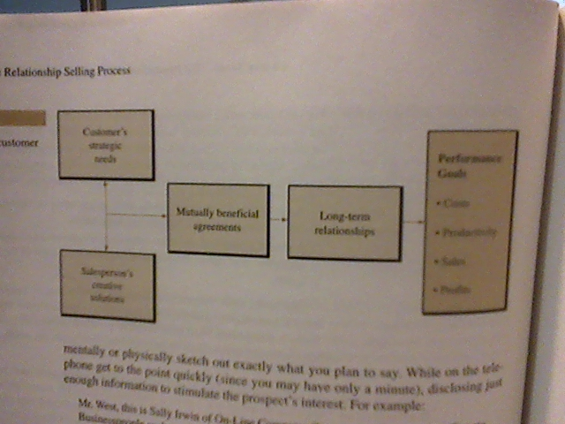
- Strategic customer relationship—formal relationship that involves joint pursuit of mutual goals
Creative solutions
Mutually beneficial agreements
Customer Relationship model
Exhibit 7-2

Planning the sales call
Builds self confidence
Develops an atmosphere of goodwill
Creates professionalism
Increases sales
- Sales Planning
- Determining the sales call objective
- Reviewing the customer profile
- Developing a customer benefit plan
- Developing individual sales presentation

Determining sales call objective
Pre-call objective
- If call is successful, what should happen
Focus and flexibility
Making the objective specific
- Specific
- Measureable
- Achievable
- Relevant
- Time bounded
Sampling of sales call objective
Moving toward your objective

Getting the appointment
The telephone
- Establish your objectives
- Prepare your opening statement
- Briefly outline your message
- Ask for what you want
- Prepare for objections
- Inquire about the prospect needs
- Confirm info
- Thank prospect
- Provide a reminder
Believe in yourself
Develop friendship with prospect firm
Call at the right time on the right person
Don’t waste time waiting

Call reluctance
Not wanting to contact a person at some point EXHIBIT 7-5
- Yielder
- Over-preparer
- Emotionally unemanicpated
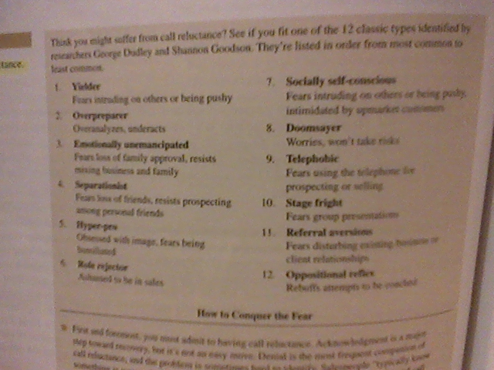
- Separationist
- Hyper-pro
- Role rejecter
- Socially self conscious
- Doomsayer
- Telephobic
- Stage freight
- Referral aversion
- Opposition reflex

Developing customer profile
CRM

Developing a Customer Benefit Plan
- Contains the nucleus of info used in your sales presentation
- Select the FAB of your product/service
- Develop marketing plan
- Develop business proposition
- Develop suggested purchase order based on customer benefit plan

Developing a sales presentation
- Planning the sales presentation involves developing steps 3-9
- Approach
- Fully discuss your product/service
- Present your marketing plan
- Explain you business proposition
- Suggest purchase order
- Close
- Exit

Prospects mental steps
- Attention
- Interest
- Desire
- Conviction
- Purchase

Sales presentation methods
- Salesperson to buyer
- Salesperson to buyer group
- Sales team to buyer team
- Conference selling
- Seminar selling

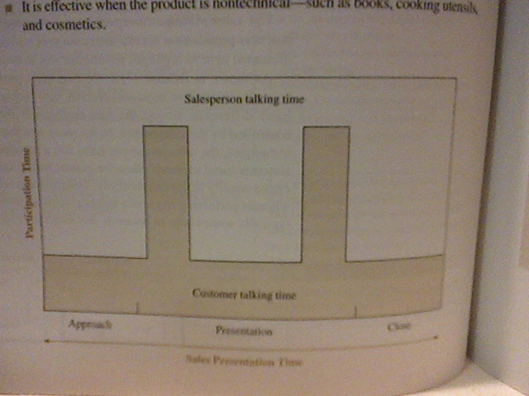
Memorized sales presentation
- Prospect needs can be simulated by direct exposure
- Needs have already been stimulated because prospect has seeked out product
EXHIBIT 7-13

Formula presentation
- Persuasive selling presentation
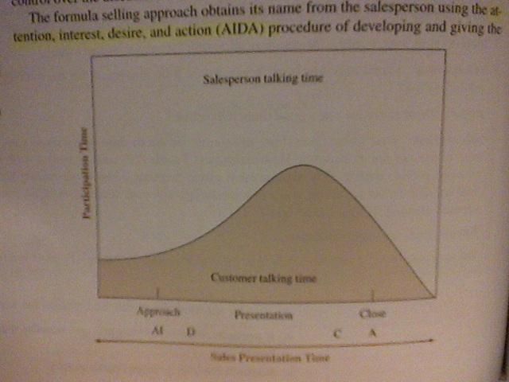
- Assumed that similar prospects in similar situation can be approach with similar presentations
- Attention, interest, desire, action (AIDA)
- Effective for current customers & prospects who are well known (business wise)
EXHIBIT 7-15

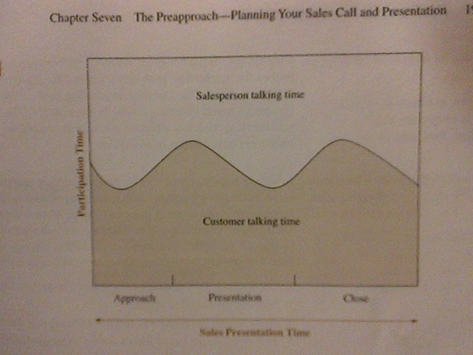
Interactive need satisfaction presentation
- Flexible
- free flowing
- interactive
EXHIBIT 7-18

Problem solution presentation
- Convincing prospect to allow the salesperson to conduct the analysis
- Making the actual analysis
- Agreeing on the problem
- Preparing the proposal for a solution
- Preparing sales presentation
- Making presentation

Group presentation
- Give proper intro
- Est credibility
- Provide an account list
- State you competitive advantages
- Give quality assurances and qualifications
- Cater to the groups behaviour style
- Get the group involved
- The proposal
  - Document that ranges from 1 page to notebook with data and info for solution to problems
- Avoid prices
- Summarize benefits

Negotiate
Phases of negotiations
- Planning
- Meeting
- Studying
  - Must have
  - Should have
  - Would be nice to have
- proposing

