Chapter 6—prospecting: the lifeblood of selling
- Prospecting
- Preapproach
- Approach
- Presentation
- Trial close
- Determine objections
- Meet objections
- Trial close
- Close
- Follow up

Before Sales presentation
- Prospecting
- Obtaining an appointment
- Preapproach planning

Prospecting
Why prospect?
- To develop new customers and increase sales
- Replace customers lost each year
- Leads—names of individuals who may need a salespersons product
EXHIBIT 6-3
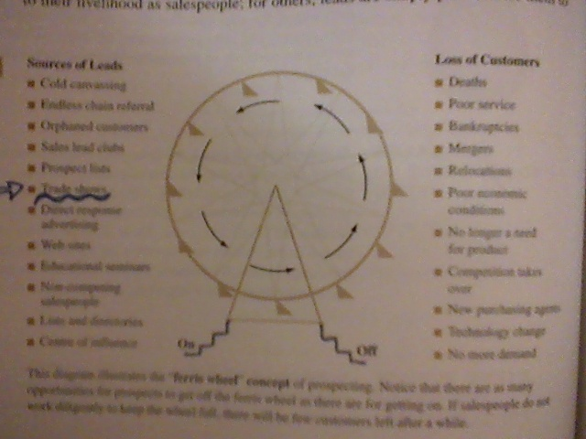
- First determine if a person or organization has the potential to buy
- Qualified prospects
  - Money to buy
  - Authority to buy
  - Desire to buy

How to qualify a prospect
- MAD
- Motives
- Means
- Opportunity
- Where to find prospects
- Planning a prospecting strategy
- Prospecting methods
  - Lists and directories
  - Develop lists of prospects
  - Endless chain referral
    - Cold calling
  - Orphaned customers
    - Sales people leave their jobs for other jobs
  - Sales lead clubs
  - Become an expert—get published
  - Public exhibitions
    - Trade shows, special gatherings
  - Center of influence
    - Finding people in an area who are willing to cooperate in helping to find prospects
  - Direct mail
  - Telephone and telemarketeing
  - Oberservation
    - Watching what is happening in their area
  - Networking
    - Focus on center of influence people
    - Talk about their business
    - Open ended questions
    - Business cards
    - Ask for leads
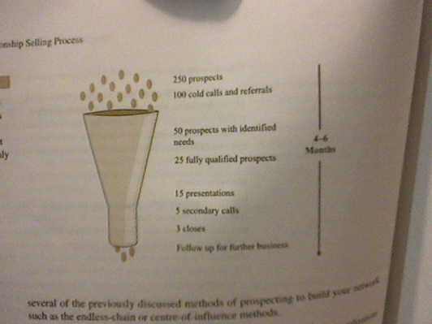
    - Handwritten thankyous
    - Stay on your contacts mind
    - Send leads
Exhibit 6-6

Referrals
Objections
Prospect pool
- Leads
- Customers
- Orphans
- Referrals

Referral Cycle
Provides guidelines for a salesperson to ask for leads
- Preapproach
- Presentation
- Product delivery
- Service and follow up
- Parallel referral sale—people sell the product and sell the prospect on providing referrals
- Don’t mistreat referrals
- Track referrals

