Chapter 4—Communication for successful selling: how to build relationships

Communication: it takes two
- Transmitting verbal and nonverbal info between buyers and seller
- Paralanguage

Salesperson-buyer communication process
- Source
- Encoding process
- Message
- Medium
- Decoding process
- Receiver
- Feedback
- Noise
EXHIBIT 4-1
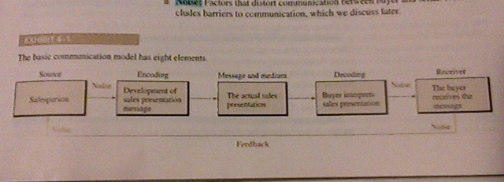

Nonverbal communication
Physical space
- Territorial space—refers to the preferred distance between humans
- Intimate—0 to 50cm
  - Close friends and loved ones
- Personal—0.5 to 1.5
  - Closest zone a stranger or business person is normally allowed
- Social—1.5 to 3.5
  - Sales presentations
- Public—over 3.5
  - Large sales presentations
- Space threats
- Space invasion
Appearance
Handshake
Body language
- Acceptance signals
- Caution signals
- Disagreement signals

Barriers to Communicate
- Differences in perception
- Buyer does not recognize a need
- Selling pressure
- Info overload
- Disorganized sales presentation
- Distractions
- Poor listening
- Not adapting to buyers style

Persuasive communication
- Means the ability to change a person’s beliefs posion or course of action
- Probing—asking Q’s to determine a buyers attitude
- Empathy—ability to identify and understand anther persons feelings
- KISS—keep it simple salesperson

Communication style
Audio
Visual
Kinesthetic

Netiquette for sales presentation
- Enhances the effectiveness of emails
- Subject line
- Message body
- Signature

Listening key to unlocking buyers needs
Listen to the buyers thoughts feelings and words
- Listen for what is NOT said
3 levels of listening
- Marginal listening—first and lowest level, involves lowest level of concentration, easily distracted
- Evaluative listener—hears what prospect is saying but no effort to understand
- Active listener—see other persons point to view
Attitude makes a difference
- Enthusiasm
- Credibility
Evidence statements make you believable
- Substantiate claims made by the sales person
- Proof statements

