Chapter 3—Preparation for Relationship Selling

Why people buy—The black box approach
- The prospect internalizes or considers this information before deciding whether to purchase
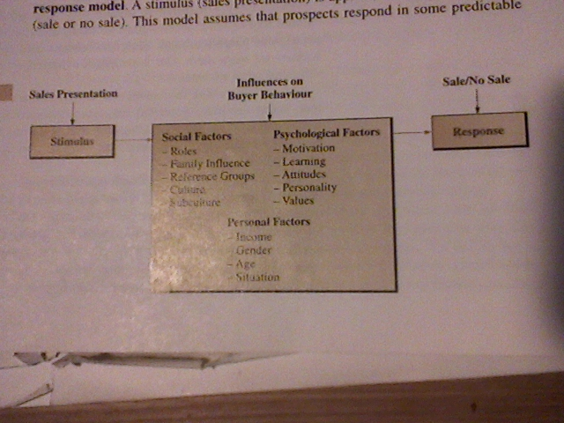
Stimulus response model EXHIBIT 3-1

Psychological Influences on Buying
Motivation to buy must be present
- Needs—requirements of human life
- Wants—not required to sustain life
- Buy to satisfy the needs and wants of others
Awareness of Needs: Some Buyers are Unsure
- Some buyers are not fully aware of their needs
Economic Needs: The Best Value for the Money
- The buyers need to purchase the most satisfying product for the money.
- Economic needs includes: price, quality, service, convience of buying

Social influences on buying
Reference Groups
- Girl buys sweater thinking what will friends think
Roles
- Who is user? Who is buyer? Decider? Influencer?
Learning
- Own memory
- Either good or bad

Your buyers perception
- Perception—is process by which a person selects organizes and interprets info
- Selective exposure—info that is forgotten due to difficulty of retaining lots of info
- Selective distortion—altering of info
- Selective retention—remembering info that supports view or belief

Attitudes and beliefs
- Attitudes—learned predispositions towards something
  - Attitudes shaped by past
- Beliefs—state of mind in which trust or confidence is placed in something or someone
- Most difficultcreating or changing people’s learned beliefs and attitudes

Consider the buyers personality
- Personality—can be viewed as the individuals distinguished character traits attitudes or habits
Self Concept
- The real self—people as they actually are
- Self image—how people see themselves
- Ideal self—what people would like to be
- Looking glass self—how people think others regard them

Face to face with your business buyer
Personality typing
- Thinking
- Intuiting
- Feeling
- Sensing
EXHIBIT 3-5

Adapt your presentation to the Buyers style
The thinker style
- High value on logic, ideas and systemic inquiry
The Intuitor style
- High value on ideas innovation concepts theory and long range thinking
The Feeler style
- High value on being people oriented and sensitive to peoples needs
The Senser Style
- High value on action

Social Style theory
Amiables
- Strong need to feel recognized and valued in the negotiating partnership
Drivers
- Results oriented and focus primarily on the bottom line
Analytical
- Explores all methodology for a fair economical outcome
Expressive
- Status approvals are important

Difficult Customers
- Angry people
- Complainers
- Know it alls
- Silent types
- Indecisive prospects
- Greedy customers

Viewing buyers as a decision maker
Need arousal
- This is triggered by the salesperson
- Can be psychological, social, economical, safety, ego, self actualization
  - Mazlow
Collection of info
- Visit stores
- Talk to salesperson
Info evaluation
- Determines what will be purchased
  - Then purchase decision made
- Process includes rating preferences
  - Price quality etc
Purchase Decision
- Attitudes of significant others
- Perceived risk of buying product
- Uncontrollable circumstances
- Salespersons action after decision has been reached
Post purchase
- Purchase satisfaction—comes from receiving benefits expected
- Cognitive dissonance—can cause tension over whether the right decision was made
- Lower CD
  - Show buyer how to use
  - Be realistic
  - Reinforce buyers decision
  - Follow up

Classifying buying situations
EXHIBIT 3-9
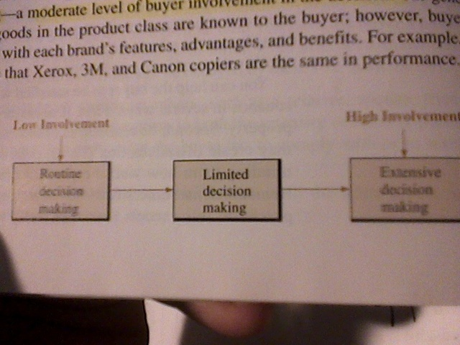
Routine
- People give little time or thought
- Low involvement
Limited
- Unfamiliar with product or brand
- Moderate level of involvement
Extensive
- Unfamiliar with specific brand or product
- Most time and money invested

B2B buying situations
- Straight rebuy
- Modified rebuy
- New buy
- Users
- Gatekeepers—controlling flow of info
- Influencers
- Deciders
- Buyers

