Sampling Distribution
16 November, 2011
7:08 PM

  - Assumptions for sampling proportions
    - Independence Assumption: The sampled values must be independent of each other.
Randomization Condition: Subjects should have been randomly chosen.
10% Condition: The sample size, n, must be no larger than 10% of the population.
Success/Failure Condition: The sample size must be big enough so that both the number of “successes,” np, and the number of “failures,” nq, are expected to be at least 10.

  - Sample Mean
    - 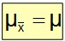

  - 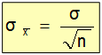

  - 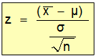

  - 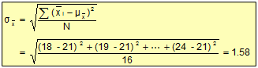
  - When calculating the SD for sample the only difference is the lower portion is N-1 and not N
  - Central Limit Theorem
    - Even if a population is not normal, sample means from the population will be approximately normal as long as the sample size is large enough (N > 30)
    - For fairly symmetric distributions, n > 15(follow a symmetric distribution but not entirely symmetrical.)

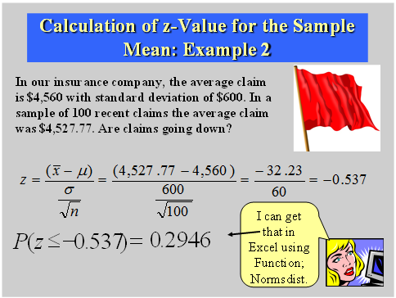
    - Use z-score because we are looking for whether claims are decreasing therefore if it is less that 0.05 then it is not going down but if the probability is going down then it will be above 0.05, therefore we are looking for the probability that is below 4527.77
- No they are not going down as the probability is above 5% at 29.46%, therefore there is not unusual getting a sample mean of 4527.77 and this is normal.

  - Sampling Distribution (CLT) Assumptions:
Independence Assumption: The sampled values must be independent of each other.
Randomization Condition: Subjects should have been randomly chosen.
10% Condition: The sample size, n, must be no larger than 10% of the population. If sample size is greater than 10% of population then MUST use the Finite population correction
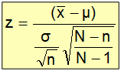
Large Sample Condition: The sample size must be large particularly for very skewed population distributions.
  - 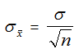
    - Normal population
    - Sample mean is normally distributed
  - 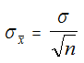
    - Any population
    - Sample mean is approximately normally distributed, for large samples (n>30)
  - T-distribution (Looks like normal accept the ends of the curve is raised up by (1,5,25) if u have above 25 degrees of freedom it will be the on same as normal distribution) (see slide 48 on sampling distribution) Degree of Freedom is: n-1
    - When we don’t know the SD for the RV, X is computed as before, only substituting s for the unknown σ.
    - When SD of X is based on estimate s instead of true σ then SD referred to as:
Standard error:
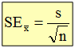
and we use t-distributions for sample mean distributions
  - As the freedom increases the t-distribution approaches normal
  - Assumptions
    - Sample should represent a random sample
    - Data are drawn from a normal distribution, though we can relax the condition, insisting on roughly normal distribution instead
    - If sample size large (n>30) one can use the t-methods regardless of the distribution for X.
  - T-values
    - 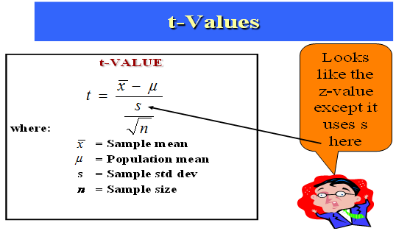

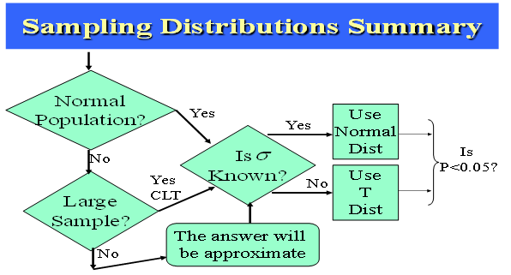

  - When population is normally distributed then sample mean is normally distributed
  - If population is normal then don't care about sample size but if it is skewed then we need a population of about 30
  - When Standard deviation of population is not known then the sample distribution follows an t distribution

