ADM 2320—Marketing Course Notes

Ch.1: Overview of Marketing

Marketing: marketing is a set of business practices designed to plan for and present an organization’s products or services in ways that build effective customer relationships.
- Marketers ResponsibilityMarketers must address the ethical implications of their actions on society in general
Value: The fundamental purpose of marketing is to create value for both the firm and customer. Value is in essence what you get for what you give up.
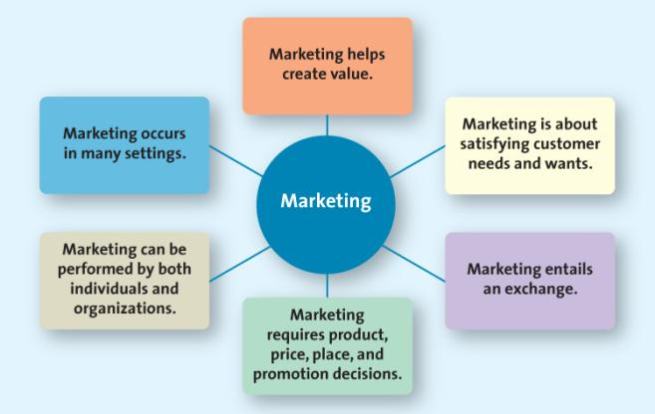
- Value is perception (our perception of apple computers for ex)
Marketing Plan: a written document composed of an analysis of the current marketing situation, opportunities and threats for the firm, marketing objectives and strategy specified in terms of the four Ps.

Marketing’s 6 Core Aspects
*We need to know these 6 Aspects
1. Satisfy Customer Needs and Wants
- Begins with understanding their needs/wants
- Developing products and services
- Want=the particular way in which a person chooses to satisfy a need, which is hsaped by a persons knowledge, culture and personality.
- Need= what we need to survive (we need food, we want McDonalds)
2. Marketing Entails Exchange
- The exchange can occur between any 2 parties.
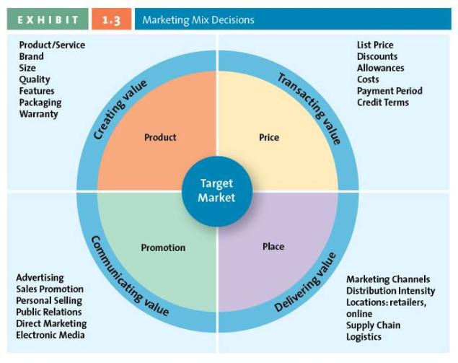
- Not simply a buyer and seller exchanging money for a good or service
- Can be an exchange of information for convenience.
3. Marketing Requires Product, Price, Place, and Promotion Decisions
The four Ps is also called the marketing mix and they are the controllable set of activities that a firm uses to respond to the wants of its target markets.
- Product: creating value goods, services, ideas
  - Goods= something you can physically touch (roots clothing, beer, KD)
  - Services= intangible customer benefits that are produced. Getting money from an ATM, beauty treatments, entertainment are examples
  - Ideas= thoughts, opinions, philosophies, mothers against drunk driving for ex
- Price: is everything the buyer gives up in exchange for the product. Is NOT always money.
  - Can be in the form of:
    - Time
    - Money
    - Energy
- Place: all activities necessary to get the product to the right customer when that customer wants it.
  - Place decisions are concerned with developing an efficient system for merchandise to be distributed in the right quantities, to the right location, and at the right time, in the most efficient way.
  - Supply chain management is the field that examines these activities
  - Where would you find this product in the store?
  - Marketing Channels Distribution Strategy: how does a company get the product to the right customer when and where they want it?
- Promotion: the communication activities of marketing.
  - Includes advertising, promoting, sales marketing, ect.
  - Used to inform, persuade and remind potential buyers
  - Used to influence their opinions or elicit a response
4. Marketing can be performed by both individuals and organizations.
- B2C(business to consumer) the process of which businesses sell to consumers
- B2B (business to business) the process of selling merchandise or services from one business to another
- C2C (consumer to consumer) the process in which consumers sell to other consumers (ex: kijiji, ebay)
Social media: the use of internet tools to easily and quickly create and share content to foster dialogue, social relationships and personal identities.

5. Marketing Occurs in Many Settings
- Both profit and non-profit.
- Developing economies
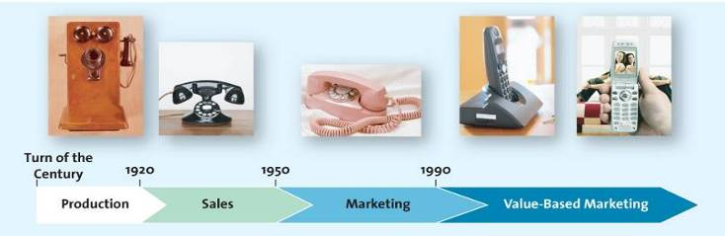
- Entire industries
6. Marketing helps create Value
Marketing has evolved from an activity designed simply to produce and sell products to an integral business function aimed at creating value for customers and the company’s shareholders. There are 4 different marketing orientations- product, sales, market and value based orientation.
- Product oriented era
  - These companies focus on developing & distributing products with little concern with customer needs.
- Sales oriented era
  - View marketing as a selling function where companies try to sell as many of their products as possible rather than focus on making products customers really want.
  - These companies rely heavily on personal selling and advertising to attract customers.
- Market oriented era
  - Focus on consumer wants/needs then develops the product. More on wants and needs
  - “the customer is king”
- Value-based marketing era
  - Focus on wants/needs while still remaining profitable.
  - Value: reflects the relationship of benefits to costs, or what the consumer gets for what he or she gives.
* The last 2 eras change into wants/needs, where as the first 3 is just to make it and people will either want it or not. Now it is seeing what people want, then building it. These days, you need to collaborate about consumers needs and want before the product because you are spending a lot of money. We are now Value based marketing era.

Value-Based Marketing
- Firms must offer customers something in excess of that being offered by the competitors
- Firms must understand how each aspect of their product/service creates value for customers
- * The goal is to find the most desirable balance between providing benefits to customers and minimizing costs.
  - It costs to develop, and we need to balance this with profit.
- Definition: focuses on providing customers with benefits that far exceed the cost (money, time, effort) of acquiring and using a product or service while providing a reasonable return to the firm.

How Firms Compete on the Basis of Value
- Constantly changing consumer perceptions
- Firms must constantly monitor the marketplace in order to create value

Sharing Information
- Why is sharing and coordinating information such a critical success factor for any firm?

Becoming Value Driven: Balancing Benefits and Cost
- Understand key benefits
- Focus on key benefits
- Eliminate cost of less strategic benefits
- You can’t satisfy the requirements of every single person. What can you do to satisfy but still be profitable? This is what you need to ask yourself.

Becoming Value Driven: Building Relationships with Customers
- Take a long term view of customer relationships
- Use data to assist in maintaining the relationship
  - It is cheaper to keep a customer than finding a new one. You want them to keep coming back…
- Transactional Relationship: regards the buyer-seller relationship as a series of individual transactions, so anything that happened before or after the transaction is of little importance.
- Relational Relationship: a method of building a relationship based on the philosophy that buyers and sellers should develop a long-term relationship
- Customer relationship management (CRM): a business philosophy and set of strategies, programs and systems that focus on identifying and building loyalty among the firms most valued customers.

Why is Marketing Important?
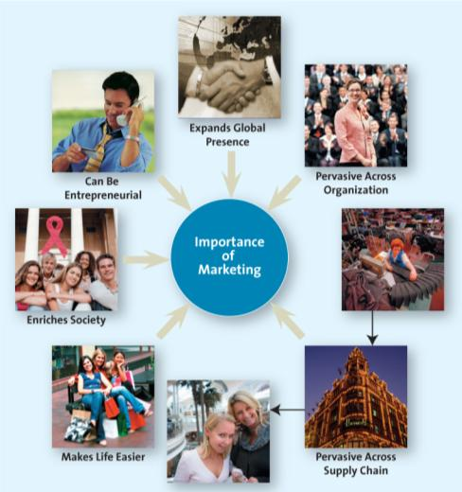

Expands Global Presence
Pervasive across organizations
Pervasive across supply chain
Makes life easier
Enriches society
Can be entrepreneurial

Supply Chain: the group of firms and set of techniques and approaches firms use to make and deliver a given set of goods and services.

Ch. 2- Strategic Marketing Planning

Marketing Planning Process: a set of steps a marketer goes through to develop a marketing plan

Levels of Strategic Planning
1) Corporate Level
- Scope is the entire firm
- Long term duration (5 years)
- Strategic focus is on defining the companies mission, set company’s goals and establish the business portfolio
2) Strategic business unit (SBU)/ Division Planning
- Single SBU within the firm
- Medium to long term (3-5 years)
- Strategic focus is to set goals and establish portfolio of products for the business unit
3) Functional Planning
- Scope is product portfolio, single product, brand or market
- Short to medium term (1-3 years)
- Strategic focus is develop marketing plans for specific products, brands or markets

In addition to corporate and functional level strategic planning, large companies that operate several business lines may see each of their strategic business units (SBUs) develop strategic plans for their products and the markets they serve. An SBU is a division of the company that can be managed somewhat independently from other divisions since it markets a specific set of products to a clearly defined group of customers.

The Marketing Plan
The marketing plan is a written document composed of an analysis of the current marketing situation, opportunities and threats for the firm, marketing objectives ands strategy specified in terms of the four Ps, action programs, and projected income statements. You don't always have to go through the whole plan.
- Three major phases in the marketing plan:
  - Planning Phase
    - Where marketing executives and other top managers define the mission and objectives of the business, and evaluate the situation by assessing how various players (both inside and outside organization), affect the firms potential for success
  - Implementation Phase
    - Where marketing managers identify and evaluate different opportunities by engaging in a process called segmentation, targeting and positioning. They then develop and implement the marketing mix by using the four Ps.
  - Control Phase
    - The part of the strategic marketing planning process when managers evaluate the performance of the marketing strategy and take any necessary corrective actions.
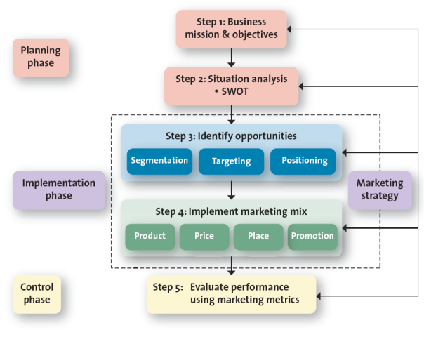

Step 1: Defining the Mission & Objectives
- Mission Statement: A broad description of an organization/firms objectives and the scope of activities it plans to undertake
  - What type of business are we in?
  - What do we need to do to accomplish our goals and objectives?
  - Examples: Starbucks, petro Canada, McDonalds, Google(this is a good ex), Microsoft
  - What is the importance of a mission statement to marketing?
  - What is the importance of marketing to a mission statement?
- The mission statement gives focus to the activities of the company. We are trying to achieve this, whereas marketing is a public demonstration of how a company is meeting its mission

Step 2: Conduct Situation Analysis Using SWOT
- Analyzes the internal and external environments , and is designed to help the firm determine areas in which it is strong and can compete effectively and areas where it is weak and vulnerable to competitive attacks.
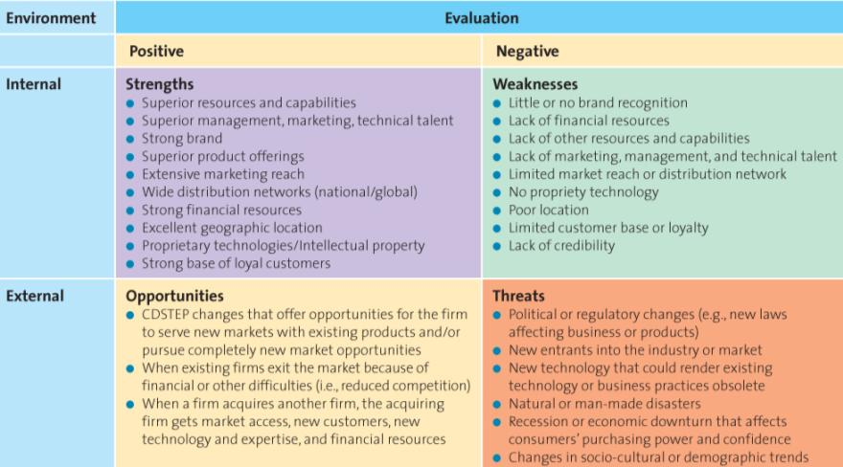
In class activity:
Develop a SWOT analysis for the Telfer School of Management:
- What are its strengths/ weaknesses (internal)?
Strength: bilingualism/ location, triple crown
Weakness: lack of space/buildings,
- What are its opportunities and threats (external)?
Opportunities: Multicultural, location
Threat: Algonquin/Carleton that offer Business programs

Step 3: Identify and Evaluating Opportunities using STP
This process is used to identify and evaluate opportunities for increasing sales and profits.
- Segmentation
  - Market Segment: a group of consumers who respond similarly to a firms marketing efforts.
  - Marketing Segmentation: The process of dividing the market into distinct groups of customers, each groups having similar needs, wants or characteristics, who might appreciate products or services geared especially for them in similar ways
  - Location, season, time slot, demographics, culture, religion, gender, age, social staus, ect.
- Targeting
  - The process of evaluating the attractiveness of various segments and then deciding which to pursue as a market .
  - This involves measuring attractiveness of segment
  - You have to do segmentation before targeting*
  - Ex: Lays Potato chips makes cheesy Doritos for a teen segment and makes its Lay’s wasabi and curry potato chips for Asian-Canadians.
- Positioning
  - Market Positioning: involves the process of defining the marketing mix variables so that target customers have a clear, distinct, desirable understanding of what the product does or represents in comparison with competing products.
  - The place the product or services occupies in the customers mind with regard to the mind
  - How a firm wants to be positioned in those segments it has decided to pursue
  - This involves defining the marketing mix variables (4PS—product, price, place, promotion)

Step 4: Implement Marketing Mix and Allocate Resources

This step is when marketers implement the marketing mix (4 ps)
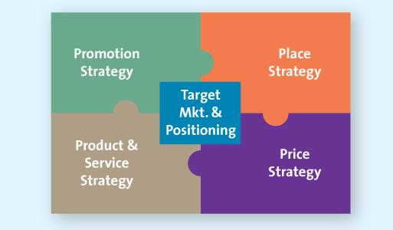
- Price and Value For Money
  - Price should be based on the value the customer perceives
  - We pay a certain price (doesn’t have to be money) for something.
- Place and Value Delivery
  - Product must be readily accessible—How?
  - Direct vs Indirect:
    - Manufacturer consumer
    - Manufacturer retailer consumer
    - Manufacturer wholesaler retailer consumer
- Intensity
    - Intensive (kraft, pepsi)
    - Exclusive (Rolex)
      - Exclusive people have the right to represent the manufacturer.
    - Selective (Seiko)
- Promotion and Value Communication
  - Television
  - Radio
  - Magazines
  - Sales force
  - New media

Step 5: Evaluate Performance and Make Adjustments
- You evaluate the results of the strategy and implementation program by using marketing metrics.
  - A metric is a measuring system that quantifies a trend, dynamic, or characteristic.
- “ The BCG Matrix” (One of the most popular portfolio analysis methods)
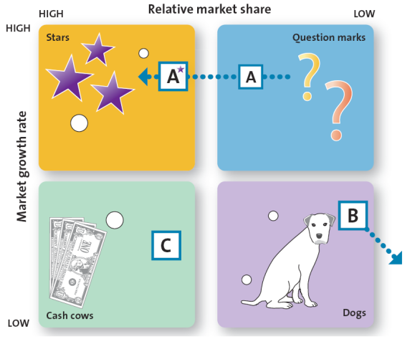

Horizontal: Relative Market Share
- a measure of the products strength in a particular market (defined as the sales of the focal
product divided by sales achieved by the largest firm in the industry)

Vertical: Market Growth Rate
- the annual rate of growth of the specific market in which the product competes

Stars: occur in high-growth markets and are high market share products. Stars often require heavy resource investment in such things as promotions and new production facilities.
Cash Cows: low growth markets but are high-market share products. These markets have already received heavy investments to develop their high market share, they have excess resources that can be spun off to those products that need it. Ex: Brand C uses its excess resources to fund products in the question mark quadrant.

Question Mark: Question marks appear in high growth markets but have relatively slow market shares. They are often most managerially intensive products in that they require significant resources to maintain and potentially increase their market share. Managers must decide whether to infuse question marks with resources generated by the cash cows, so that they can become starts, or withdraw resources, eventually phase out the products. Ex: Brand a, is currently a question mark, but by infusing it with resources, the firm hopes to turn into a star.

Dogs: are in low-growth markets and low market shares. Although they may generate enough resources to sustain themselves, dogs are not destined for stardom and should phase out unless they are needed to complement or boost the sales of another product.

Growth Strategies:

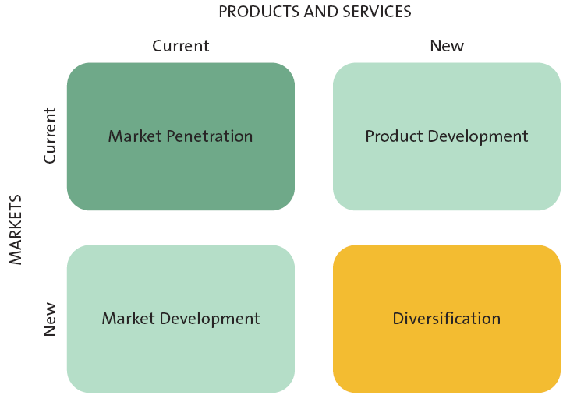
Market Penetration
- Uses the existing marketing mix (the 4 Ps) and focuses on existing customers
- Encourage current customers to patronize the firm OR
- Attract new customers from within the firm’s existing target market
- Ex: coupons is an example, or loyalty or reward programs

Market Development Strategy
- Employs the existing marketing offering to reach new market segments
- Ex: McDonalds in Japan, targeting certain ethnic groups

Product Development
- Offers a NEW product or service to the current target market
- Ex: Fairmont hotel wanted to migrate its existing customers to its website so it developed a website that simpies booking strategies, promotions during the booking process.
- Example: requires company to know customers to know what they want

Diversification
- Introduces a new product or service to a new market segment
- Related and unrelated diversification
- Ex: Fairmont joining with delta hotels to target new customers.

January 18th 2013
“ Online Marketing Strategies” Video Films on Demand( Library WEBSITE: Films on Demand)
Marketing: the processes by which products, services and values are exchanges to fulfill needs and want. Can include advertising promotion and sales.
It was the emerge of the Internet that changed marketing in the 1990s. Viral marketing is easy and cheap (Facebook, cheaper). Online facilitates the communication channels and the messages/good will behind it doesn't change. Nothing comes easy.
Businesses are no longer limited to geography with online marketing strategy
How can consumers get information?? Search engine (Google for ex).
Search engine optimization (SEO): choosing targeting keywords related to web searches. Optimization makes pages readable and emphases topics related to content.
-SEO is critical: it is tweaking the site so it comes out in the top 10 results in Google.
Pay Per Click: main pay per click is Google. Every time someone clicks on your advertisements you get paid.
Viral Marketing: snow ball effect. It usually fails, viral marketing usually happens by accident, can be a good thing or bad. Viral marketing was very popular with Hotmail.
Social media optimization is the process of optimizing a company’s social profile on the web. (facebook, linktem, twitter, blogs)

Midterm: Compare online marketing to traditional marketing
There is not a whole lot of different in the 4 P’s whether it is online or offline. They both use the 4 P’s.

Sustainable Competitive Advantage
Sustainable Competitive Advantage: something the firm can persistently do better than its competitors that is not easily copied and thus can be maintained over a long period of time.

- What exactly is sustainable competitive advantage?*
  - This is what every company dreams of. To have a sustainable competitive advantage. It is a key component.
  - A long-term competitive advantage that is not easily duplicable or easily surpassed by the competition.
  - What distinguishes you from the competition in the minds of your customers.
  - A very secure advantage, its sustainable, it's been developed over the long term, not easily duplicated and easily understood by your competitors *
    - He gave picture of McDonald, Tim Hortons, Starbucks, Jaguar, Rolex and asked if they had sustainable competitive advantage?
      - All of these have sustainable advantage.
- Where is it visible?
- How is it developed?

Sustainable Competitive Advantage Attributes
- Pedigree
- Exclusivity
- Immediate recognition
- Loyal customers
- Controlling the supply chain
- Strong brand
- Unique positioning
- Excellence in location

4 Key Strategies in Developing Sustainable Competitive Advantage
Customer Excellence:
- Retaining loyal customers
- Customer Service
Operational Excellence:
- Efficient operations Excellent supply chain management
- Supply chain management: the manufacturer doesn't always sell directly to the customers. It is the distribution channel. Good operational excellence manages the supply chain
- Committed employees are needed
Product Excellence:
- A strong brand
- Unique positioning in the marketplace
- High perceived value
Locational Excellence:
- The three most important things in retailing are: location, location, location.
- you need to have a location that will fit your product.
- Can you buy a Rolex in Walmart? No.. can you buy one in a strip mall?.. no. You need high end locations

In Class Team Exercise: Think of a company your team feels has a sustainable competitive advantage (one that we have not considered). Each team will briefly present its chosen company and defend why it has a sustainable competitive advantage

Apple Company.
Logo: everyone recognizes the apple symbol.
What distinguishes apple from other competitors is their great customer service (genius bar for example) & value of product you are paying for (even though it is more expensive than other companies)
Has been around for a Long period of time and keeps growing with new technologies and are ahead of other technology companies with technologies (paying with the phone)
Loyal customers: once you get an apple product, usually they go back and get more.
Location: apple stores in large malls , and other retailers sell their products but usually you go ot the apple store for their knwoeldge and good customer service. ONLINE ACCESS & FREE SHIPPING
*they will be able to stay this way for a long period of time.

WalMart
Lululemon
Google—two teams did this. Think of their ethics.. is it okay if they are this large?

Team Exercise: COULD BE AN EXAM QUESTON*
- Develop a marketing plan for a new tablet computer offering by a new company…
  - Mission statement
  - SWOT
    - Strength: good management team, good tech engineering’s
    - Weaknesses: stronger financing needed
    - Opportunities: market share
    - Threat: existing companies
  - STP:
    - Segmentation (how would u do this)?
      - If we are using age demographics, between 20-35
    - Targeting (how and who)
      - In the segment, it will be students
    - Positioning (how do you want consumers to think about you and your product)
      - This is the best deal and value for their money is an example
  - Marketing Matrix
    - Product and value
      - What is the product, how is the value perceived
    - Price and value
      - Do consumers get what they pay for?
    - Place and value
      - How will we get it there, and does this add value (online, come on campus and distribute)
    - Promotion and value communication
      - How will we promote… online? Magazine?
  - Evaluate performance
    - When its all said and done, how will we know that its working

Ch. 3—Analyzing the Marketing Environment

- At the heart of the marketing environment is the consumer. These are the people who buy your stuff therefore important.
- Consumers are influenced by many things:
- Actions of the company
- Actions of the company’s competition
- Corporate partners in the supply chain
Actions of the Competition
- Pricing
- Advertising
- Ethics
- Social responsibility
- Depiction by the press
- Quality assurance
Actions of the Company
- Pricing
- Advertising
- Ethics
- Social Responsibility
- Depiction by the press
- Quality Assurance

- The actions of the company and actions of the competitions are the same thing. If actions of competition is better, then the consumer will go to the competition. It can either be good or bad. It doesn't take much to loose what you’ve built up.
- How actually are consumers influenced by these things?
- What does the manufactured retail price really mean?

Actions of Corporate Partners in the Supply Chain
How are consumers directly influenced by partners in the supply chain?
- Quality
- Reliability
- Timeliness
- Conflict
- Ethics
- Social Responsibility
- Relationships with other partners (competing goods?)

A Marketing Environment Analysis Framework
Have to understand these and arguments for or against each micro and macro.
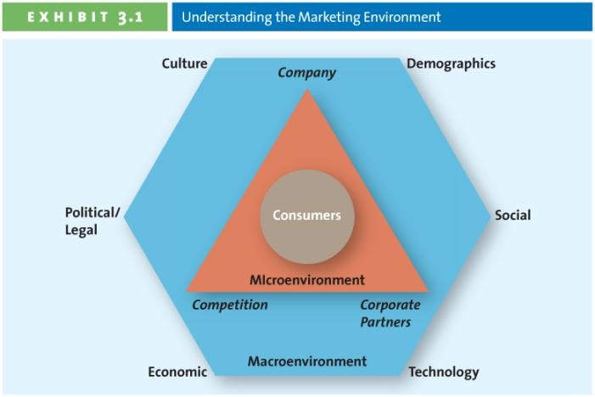

The Microenvironment
– affect the company directly
- Factors affecting consumer’s microenvironment Company (i.e. its capabilities), its competition and its corporate partners

Successfully Leveraging Company Capabilities
- Core competency
- What does the company have? (design of product, manufacturing services, ect)
- Existing knowledge, facilities, patents, ect
APPLIED TO
- New markets, new products, ect

Question: What are the core competencies of Rolex?
- The manufacture, distribution and promotion of their brand.
- All of these give the companies a sustainable competitive advantage that is profitable.

Competitors
- Identify and analyze direct and indirect competitors
  - Should we compete with these people? If so, in what markets and in what environment.
- Greater competition means more choices for consumers, which influences their buying decisions.
- Know strengths and weaknesses
- Competitive Intelligence (CI) is used by companies to collect and synthesize information about their position with respect to their rivals. It allows companies to anticipate change rather than just reacting to them.
- Sending an employee to a competitive store to check merchandise, prices, traffic
- Interviewing customers, suppliers, partners, former employees (you need to be careful for ethical situations and be very cautious)
- Other more sophisticated methods.
- Secondary research: your getting information from another source (websites, journals).

Corporate Partners
- Firms are part of alliances therefore you cannot work alone anymore. You need to make a “seamless system”.
- Align with competitors, suppliers, ect
- Example of corporate partners: Just in Time Delivery Systems (JIT)
  - From Factory to retailer

Macroenvrionmental Factors – “CDSTEP “
- Outside the control of marketing managers—you cannot influence them.
– Affect consumer indirectly and the company directly
In addition to understanding the company itself, the competitors and their corporate partenrs, marketers must also understand the macroenvronmental facors that operate in the external environment. (Culture, demographics, social trends, technological advances, economic situation and political/legal environment)
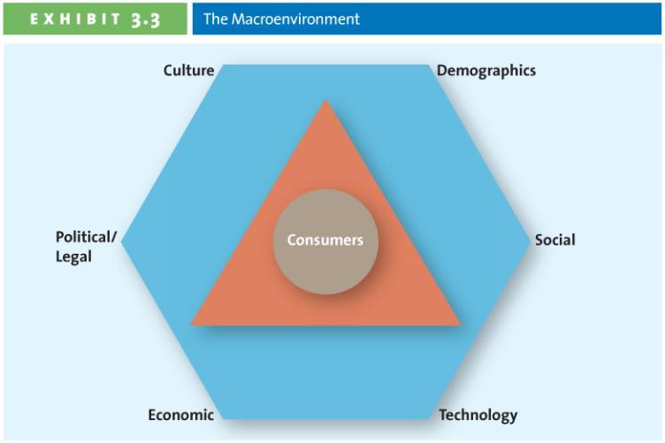

Culture
- Culture,
- Country Culture (visible differences)— entails easy to spot visible nuances to a country, such as dress, symbols, ceremonies, language, colours, and food preferences
- Regional Subcultures—the region in which people live in a particular country affects the way they react to different cultural rituals.
- What is culture?
  - Shared meanings, beliefs, morals, values and customs of a group of people
  - Transmitted by words, literature, and institutions; passed down from generation to generation and learned over time.

- Hofstede: A Multiple Dimension Models of National Culture
    - Power Distance: how a society deals with the fact that people are unequal in a social and status sense.
      - A low rating characterizes societies that stress equality and opportunity
    - Uncertainty Avoidance: how society copes with uncertainty and deals with risk
      - A low rating characterizes societies that are more accepting of ambiguity, less rule-oriented, take more risks and more readily accept change
    - Individualism—Collectivism: the relative closeness of the relationship between one person and others
      - Collectivism emphasizes a tight social framework in which people expect others in groups of which they are a part to look after them and protect them.
    - Masculinity—Feminity: the sexuality of roles in society and the degree to which society allows overlap between the roles of men and women
    - Long term vs Short term orientation
      - A new addition to Hofsteds

USA | JAPAN
- Low power distance: prefer that power is shared equally  - Low uncertainty avoidance: deviating from the norm is acceptable  - High individualism: an individualistic society with emphasis on the individual  - A masculine society: aggressive, competitive, gender based roles | - High power distance: accept unequal sharing of power  - High uncertainty avoidance: deviating from the norm is unacceptable  - Low individualism: a collectivist society with emphasis on groups  - A masculine society: aggressive, competitive, gender based roles

- National Culture Differences
  - * What might the differences mean for marketing?
    - Different marketing mix (4Ps)
    - Different marketing strategy
    - Different timelines
    - Different micro and Macroenvrionmental factors

Demographics
- “ The characteristic of human populations and segments especially those used to identify consumer markets”
- Provides an easily understood snapshot of the typical consumer in a specific target market.
- Age Demographics: General Cohorts
  - Tweens (9-12) spend money mainly on food, drinks, electronics, games, music, cellphones, clothes
  - Generation Y generational cohort of ages 13-31; the biggest cohort since the original postwar baby boom
  - Gen X people between 36-47. First generation where both parents worked.
  - Baby Boomers people born after WWII between 48-66
  - Seniors 65 and up
- “Generation Gap”
  - Does this mean anything to you? What does it mean to marketing?
  - How do you experience this gap between your generation and that of your parents?
- Income
  - Median income of Canadian families in 2008 was 63900.
  - Over 80% are considered middle and upper class.
  - Purchasing Power is tied to income
    - Upper Class ( 45% of Cdn. Households) and family income in more than 70K
    - Middle Class (38% of Cdn. Households) and family income is 30-70K
    - Working Class (almost 15% of Cdn. Households) and income is 20-30 K
    - Under Class (just under 15% of Cdn. Households ) and income is less than 20K
- Education
  - Education is related to income, which determines spending power.
- Gender
  - Male/Female roles have been shifting and marketing has changed to reflect these shifts.

Social Trends
- Greener Consumers
  - Customers who appreciate the efforts of companies to supply them with environmentally friendly merchandise
  - The body shop (don't test on animals), TOMS, organic food. Would you pay a premium for these things?
- Privacy Concerns
  - Loss of privacy
  - Identify theft
  - Do not call or email
  - How secure do you think our information is??
- Time-Poor Society
  - In the majority of families, most parents work
  - Consumers have many more choices regarding leisure time but this time has dimished.
  - Many consumers multitask.
  - Technology will help this (blackberries, iPhone, computers)

Technological Advantages
- Technology has impacted every aspect of marketing:
  - New products
  - New forms of communication
  - New Retail channels

Economic Situation
- Foreign currency fluctuations combined with inflation and interest rates affect the firms ability to market goods and services
- Cannot influence tax, currently fluctuation, inflation.
- Inflation: refers to the persistent increase in the prices of goods and services
- Interest rates: represent the cost of borrowing money

Political/ Regulatory Environment
- Competition Act
- Consumer Packaging and Labeling Act
- Food and Drugs Act
- Access to Information Act
- Patent Act North American Free Trade Agreement (NAFTA)

A Team Exercise: Time-poor consumers have adopted various approaches to “buy” themselves more time such as (a) voluntarily simplifying their complex lives, (b) using new technologies for greater empowerment and control, (c) using their time productively when travelling or commuting and (d) multitasking. Identify and describe one product or service that consumers use to implement each of these strategies (one product for each strategy)

Video: How Secure your Information Is (Insurance)
- Credit scoring is what many insurance companies say they use to set their rates. Do they actually use these techniques?
- 300 is the least healthy- 900 is the most healthy and is good predictor for future credit claims.
- How much can a credit score affect your premium?
- People who have never made a claim are being charged much more each month. Single dad and man who is unemployed in Chatham. They called cooperatives and they say its because of their credit score.
- 87% of people have no idea that their credit affects their rate of insurance. The better credit you have, the less you pay. If you loose your job then it would double—this isn’t fair.
- Insurance should be about affordability and availability and not their credit rating.
- When people are unemployed they are almost “ not wanted” … and therefore their charges are increased.
- Segmentation is happening by the insurance companies to get them off their insurance company so they go to another company.. they are looking for people just with secure jobs.
- You click a box on the computer during filling out a questionnaire with cooperatives.. where does it go? This was an example of how marketing and technological adventures are combined.
- The enabling effect of IT.

Ch. 4—Marketing Research

Each Team: Come up with 1 example of a product or service you feel is misrepresented to consumers in terms of the marketing mix (4Ps) NUTELLA (full of sugar) –they make it seem like it makes a well-balanced breakfast food.

Marketing Research: Consists of a set of techniques and principles for systematically collecting, recording, analyzing and interpreting data that can aid decision makers involved in marketing goods, services or ideas.

The Marketing Research Process
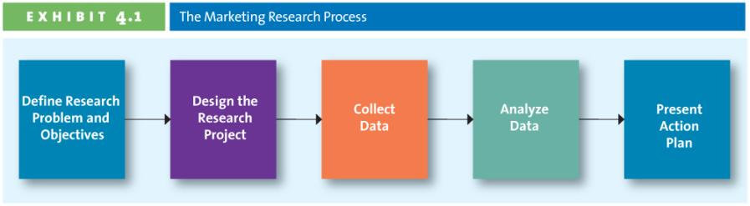
1. Defining the Objectives and Research Needs
- What information is needed to answer specific research questions?
- How should that information be obtained?

2. Designing the Research Project
- Type of data & Type of Research
- How are you going to get this data (primary, secondary or both)

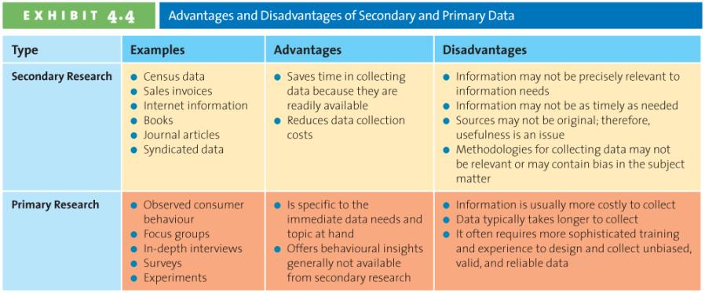

The power of primary research: when you do surveys and brand new information, this is very powerful therefore very advantageous.

Collecting Primary Data: Research Study must be Reliable and Valid
- Reliability is the extent you will get the same result if the study is repeated under identical situations
- Validity is the extent to which the study actually measures what it is supposed to measure

Team Exercise:
- Suppose your local Rolex dealer appears to be loosing customers
- Each team is to provide:
  - One research question that primary data can answer
  - One question that secondary data can answer

3. Data Collection Methods
- Exploratory Research Methods
  - Attempts to understand phenomena
  - Ex: observation, in-depth interview, focus group, social media
- Conclusive Research Methods
  - Wants to verify—examples are experiments, survey, scanner and panel
  - Can either be descriptive or experimental
    - Descriptive: “do you like nutella”,
    - Experimental: “how likely are you to go out and buy nutella now that you know the nutrition facts”.

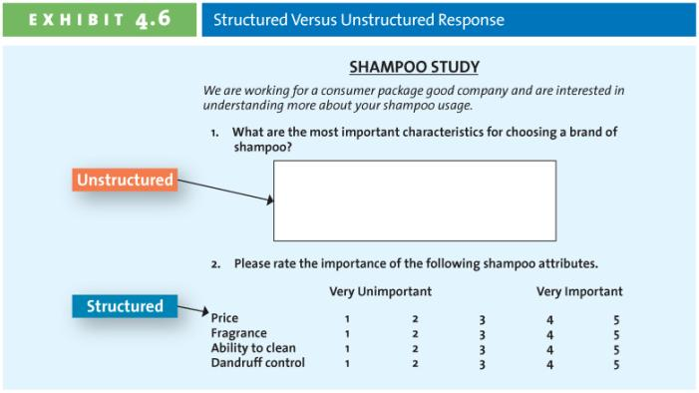
Unstructured: write your answer in box
Structured: rate your opinions.

What’s the better way?
-- Structured because its simple

What not to do when designing a questionnaire:
- Do you dye your hair?
  - This could offend an elderly.
- DO you believe that mechanical watches are better than quartz watches
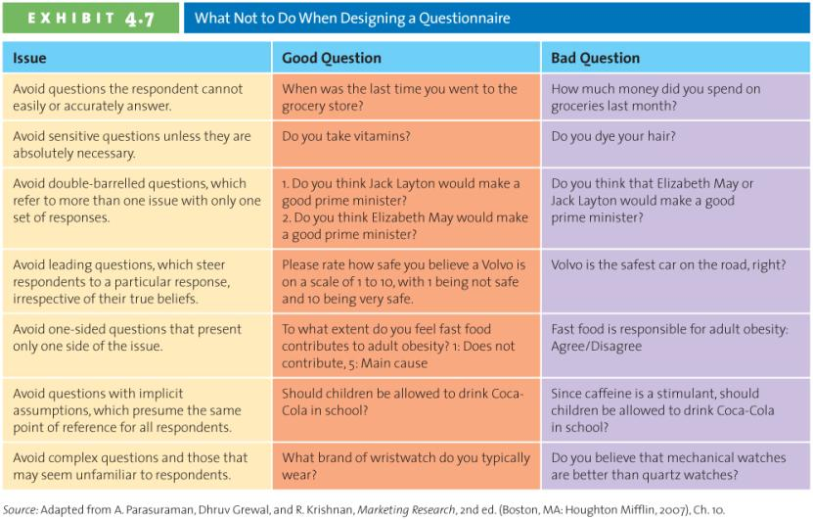

Web Surveying
- Response rates are relatively high (Why?)
- Respondents may lie less? (Why?)
- It is inexpensive
- Results are processed and received quickly.

Experimental Research
Scanner Research
- Scanner data informs a pile of research that the computer can get (what was purchased, when it was purchased, ect)
- Sales volumes on the day you bought this. Therefore how secure is your information out there?

Panel Research—Group of consumers and survey or sales receipts (what are they buying or not buying)

4. Analyzing Data
- Converting data into information to explain, predict and/or evaluate a particular situation.
- Data VS Information

5. Presenting Results
- Executive Summary
- Body
- Conclusions
- Limitations
- Supplements
  - Tables, figures, appendices

The Ethics of Using Customer Information
- Bottom Line: Marketing research should be used only to produce unbiased, factual information. Is this actually happening?
- Code of Standards and Ethics for Survey Research

Video: Data Mining: an overview
- Digging in the data to find “gold”.
- Using math procedures behind the decision making of business. As organization are making large collections of data, and data mining came to be to analyze data more strategically
- Data Mining is new, but comes from data analysis, which has been around forever.
- What has changed is the amount of data out there.
- What is the use of data mining? Monitoring consumer purchasing habits, traffic signaling, flow in retail outlets/banks, gaining insight for the purpose to identity taxation fraud, optimizing service industry, protecting the community
- Steps Staging: storing raw data, Integration, Access
- The uses of Data Mining: your credit card transactions—show preferences based on historical data of where you spend.
  - Forensics and crime strategies
  - Risk assessment: modeling worst case scenarios and making sure you have money set aside
  - Identifying fraud
  - Environmental Science: data is being collected across the country
  - Sports: to make athletics healthier/more athletic
  - Road Systems: making sure the roads flow for traffic, ect.
- Your phone is a big source of data (telephone, text, online, apps, ect)
- Challenges of big data: ability to collect data into one slice, because there is so many sources its hard to centralize this data.

The process of data mining:
- Manage the huge amounts of available data.
- “Hadoop” enables large amounts of data to be processed properly.
- Path analysis: understanding at the transaction level (not only financial, its also how people click through website pages for example).
- Predictive Modeling: understanding what differentiated some people from another group of people who didn't take out data.
- Major Elements of Data Mining:
  - Collecting Data: Internal systems and sources
  - Transform the data: analysis/ integration
  - Modeling techniques: application software, neural networks, regression, segmentation
  - Deploy the data: IT systems and databases or reports.

**How secure is your information**

Ch.5- Consumer Behaviour

The Consumer Decision Process:
- Need Recognition
  - Functional Needs: all about the performance about the product
    - Ex: a scuba diver has a functional need (100$ watch)
  - Psychological Needs: personal gratification of what you purchase
    - Ex: a scuba diver has a psychological need (10000$ watch)
- Information Search
  - Internal Search For Information
    - A buyers own memory and knowledge about the product
    - Just stick to what you know about a brand
    - When would you rely just on this search mechanism?
      - habitual products (things you buy all the time)
  - External Search for Information
    - Information outside the buyer’s personal knowledge base to help make the buying decision:
      - Friends, family, commercial media, magazines, TV, internet, social media

Both Internal & External Search:

- Factors Affecting Consumer’s Search Process: Perceived Benefits vs Perceived Costs
How much control you have over your environment
  - Internal Locus of Control= more search activities
    - “ I control things, I am the master”
  - External Locus of Control= Fate, external factors= why bother
    - “ I cannot control anything, it will just be fate therefore why would I worry about it”
- *know these*Actual vs perceived risk:
    - Performance risk, financial risk, social risk, physiological risk, psychological risk.
    - Social Risk: the fears that consumers suffer when they worry others might not regard their purchases positively. “You paid HOW much for that?!”
    - Physiological Risk: this refers to the fear of an actual harm should the product not perform properly
    - Psychological Risk: the risks associated with the way people will feel if the product doesn't convey the right image

- Factors Affecting Consumer’s Search Process:
- Type of Product or Service
- Specialty goods/services
- Convenience goods/services
- Shopping goods/ services

- Alternative Evaluation
  - Evaluate Criteria
    - How do consumers begin to evaluate different alternatives, and what important attributes and criteria do they use?
  - Determinant Attributes: products or services that is important to buyers and on which competing brands are perceived to differ.
    - Decision Heuristics: mental shortcuts that we use to narrow down decision:
      - Price (you can afford it or not)
      - Brand
      - Product Presentation

- Post-Purchase Evaluation
  - Post purchase: Dissonance:
    - Firms attempt to reduce dissonance by reinforcing the decision
    - Thank you letters, congratulations letters, quality ratings

Factors Influencing the Consumer Decision Process
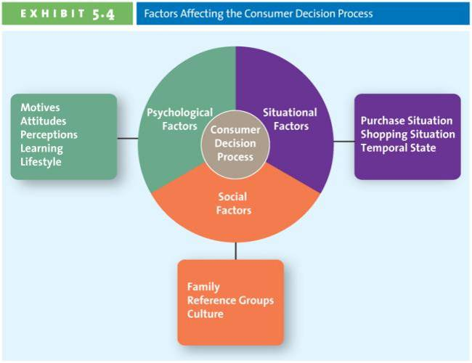

Psychological Factors: Motives
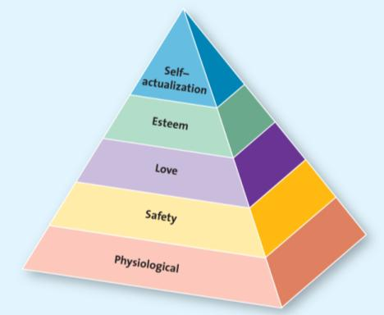

Psychological Factors: Attitude (3 components)
- Behavioral (the actions we undertake with regard to the issue at hand)
- Cognitive (reflects what we believe to be true)
- Affective (what we feel about the issue at hand)

Psychological Factors: Learning
- Affects both attitudes and perceptions
- Affected by social experiences

Psychological Factors: Perception
- The processes by which we select, organize, and interpret information to form a meaningful picture of the world.
- There are 4 components: LOOK UP

Social Factors: Family
- Decision makers
- Influencers

Social Factors: Reference Groups
- Groups: family, friends, coworkers, famous people
- Provide: Information, rewards, self-image

Social Factors: Culture
Situational Factors:
- Purchase Situation Customers predisposed to purchase certain products or services because of some underlying psychological trait or social factor (thriftiness)
- Shopping store atmosphere, salesperson, crowding, promotions, in-store demonstrations, packaging
- Temporal State our state of mind at any particular time can alter our preconceived motions of what we are going to purchase.

Involvement and Consumer Buying Decisions
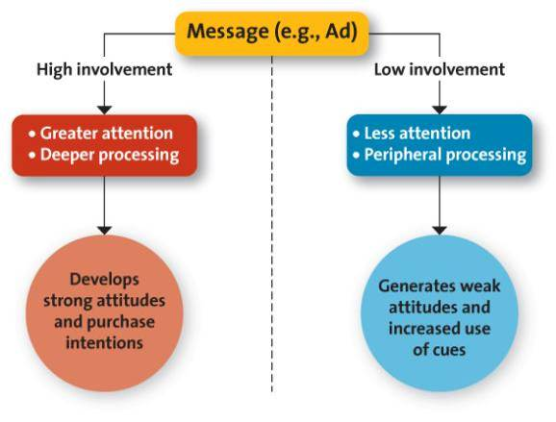

Films on Demand: Ted Talks Idea Diffusion
Sliced Bread: for the first 15 years after sliced bread was invented, no one bought it. Not until Wonder came along, and marketed sliced break, then people started buying it.
The century of sliced diffusion: TV and mass media made it easy to spread ideas (The TV industrial Complex)
Buy ads, get more distribution, sell more products, and then make a product and repeat again

Now they are not using TV Industrial Complex as much anymore.
Choices vs time= he is saying to just ignore stuff….. if you are driving down the road and see a cow, you just continue going.. no one is going to pull over and go “ WOW”. However, if the cow was purple, then you’d notice it. * The thing that decides what gets done, purchased, or built, is the question “ IS IT REMARKABLE”—this means “ worth making a remark about”

The top selling DVDs change every week—this is an example because it is new and different for a small amount of time, then it changes.
Don't market the middle men anymore, market to the early adaptors using the TV industrial Complex because they like listening, and they are obsessed. Then they will spread to the rest of the curve….
You have to determine what people really want.
1. design rules now
2. the riskiest thing you can do is be safe…. * Safe is risky * the safe thing to do, is be remarkable.
3. being very good is boring… its average…. You don't want this because no one will notice it.

Ch. 6- Business-to-Business Marketing

B2B Marketing
- The process of buying and selling goods or services to be used in the production of other goods or services, for consumption by the buying organization, or for resale by wholesalers and retailers.
- B2B marketing involves manufactures, wholesalers, retailers, and service firms that market goods and services to other businesses, but not directly to the ultimate consumer.

Question: Key distinctions between B2B and B2C—who is the end user?

B2B Markets
- Resellers
- Institutions
- Government
- Manufacturers

1. Manufacturers or Producers
- Buy raw materials, components or parts
- Manufacture their own goods
2. Resellers
- Manufacturer Reseller Retailer
- Can combine input from many manufacturers, its not necessarily just one.

3. Institutions
- Schools, museums, religious organizations
- When U of O buys tables, and desks, they don't buy them from Staples, they buy them from Manufacturers, AKA B to B

4. Government
- Canadian Government spends 240$ billion buying goods & services
- Provincial and local governments also make significant purchases
- Firms specialize in selling to government
- Canadian government contracts are posted on Business Access Canada website

Characteristics of Business Markets

Differences between Business & Consumer Markets

Market Characteristics
- Demand for business products is derived
- Driven from B to C markets.
- Fewer customers, more geographically concentrated, and orders are larger
- Demand is more inelastic, fluctuates more, and more frequently
Product Characteristics
- Products are more technical in nature, purchased based on specifications
- Mainly raw and semi-finished goods
- Heavy emphasis on delivery time, technical assistance, after sale service, financing
Buying Process Characteristics
- Buying decisions more complex
- Competitive bidding, negotiated pricing, complex financial arrangements
- Qualified, professional buyers - more formalised buying process
- Buying criteria and objective specified
- Multiple participants in purchase decisions
- Reciprocal arrangements common
- Close long-term relationships
- Online buying common
Marketing Mix Characteristics
- Direct selling and physical distribution often essential
- Advertising more technical, promotions emphasize personal selling
- Price often negotiated, inelastic, affected by trade/quantity discounts

Business-to-Business Buying Process
Need Recognition Product Specification RFP Process Proposal Analysis & Supplier Selection Order Specification Vendor/Performance Assessment

Stage 1: Need Recognition
- Can be generated internally or externally
- Sources for recognizing new needs:
  - Suppliers
  - Salespeople
  - Competitors
Stage 2: Product Specifications
- After recognizing the need, the organization considers alternative solutions and comes up with potential specifications that suppliers might use to develop their proposals to supply the product can be done collaboratively with suppliers
Stage 3: RFP Process (Request for Proposal)
- A process through which buying organizations invite alternative suppliers to bid on supplying their required components
Stage 4: Proposal Analysis, Vendor Negotiation and Selection
- Often several vendors are negotiating against each other
- Considerations other than price play a role in final selection
- You select who is going to buy the product.
Stage 5: Order Specification
- Firm places the order
- The exact details of the purchase are specified
- All terms are detailed including payment
Stage 6: Vendor Analysis
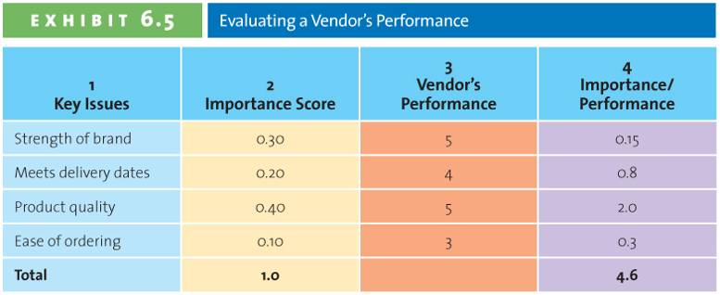

Factors Affecting the Buying Process
We need to know the process of B to b, differentiate B to C and know the factors affecting the buying process and apply them to an example.
- The buying center
  - The Initiator: the person who first suggests buying a product or service.
  - The Influencer: the person who influences the buying center
  - The Decider: the person who makes the final decision
  - The Buyer: handles paperwork
  - The User: uses the product
  - The gatekeeper: control access to decision maker or influencers of who will buy the product.
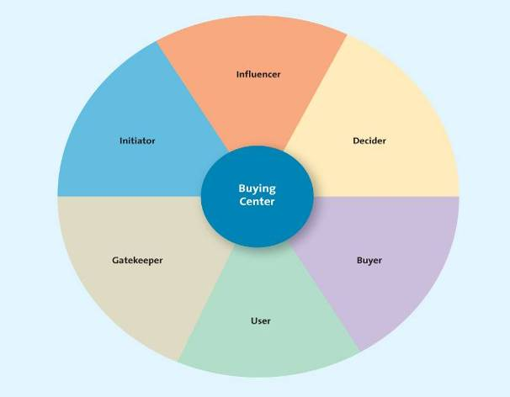
Team Exercise:
-Suppose Telfer is considering the purchase of a new textbook for its Introductory Management course...
-Who would you see in each of the six different buying roles and why?
- The decision to buy the book from manufacturer to get into the bookstore… this is B to B
- Then for the book to become available for students to buy…. This is B to C

The Initiator:
- Salespeople from different publisher to talk about how they can sell us their book
- Students or anyone who is a stakeholder (or has an interest)
The Influencer:
- Professors
- The section coordinator
- The director of undergraduate program
The Decider
- The director of undergraduate program
The Buyer:
- The bookstore
The User
- Students
The Gate Keeper
- If the director or undergrad program is the decider, then the professor is the gatekeeper.
- Its almost shared

- Organizational Culture
  - A set of assumptions or an ideology shared by members in an organization
    - Used by people to identify how things work and what is important in that organization
  - A system of shared meaning, held by organizational members, that distinguishes the organization from other organizations.
  - Common Features:
    - Distinction between one organization and another
    - A sense of identity for organizational members
    - A commitment to something larger than self interest
    - A standard recognized and honoured willingly by employees
    - The driving force behind the successful operation of the organization
  - Strong Organizational Culture
    - Shared values, beliefs, attitudes, rites, rituals, ceremonies
    - Strong unifying philosophy
Memorize these when backing up your answer*
    - Trusted and trusting leaders
    - Openx communication/access to top management
    - Emphasis on people
    - Sense of accomplishment/belonging
    - Satisfaction with rewards, performance and efforts
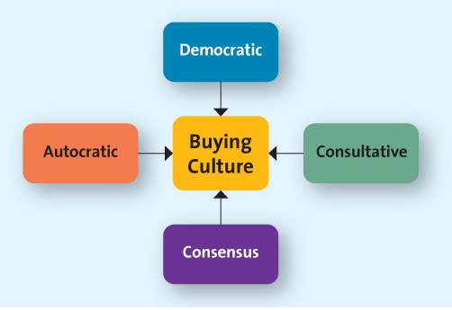
Know these *
Team Exercise: What style of organizational buying culture would you expect to find in each of these organizations?
Top 3 Picks for Strongest Culture and Briefly Why?
- Microsoft
- Canadian Forces
- Walmart

Some Organizations
- Jaguar
- Canadian Forces JTF
- Subway
- Walmart
- Holt Renfrew

- MicroSoft
- MacDonalds
- Canadian Coast Guard
- PetroCanada

- Buying Situations
  - New Buy
    - Purchasing for the 1st time
    - Likely to be quite involved
    - The buying center will probably use all 6 steps in the buying process
  - Straight Rebuy
    - Buying additional units or products that have been previously purchased
    - Most B2B purchases fall into this category *
  - Modified Rebuy
    - Purchasing a similar product but changing specifications
    - Current vendors have an advantage

Ch.7—Segmentation, Targeting and Positioning
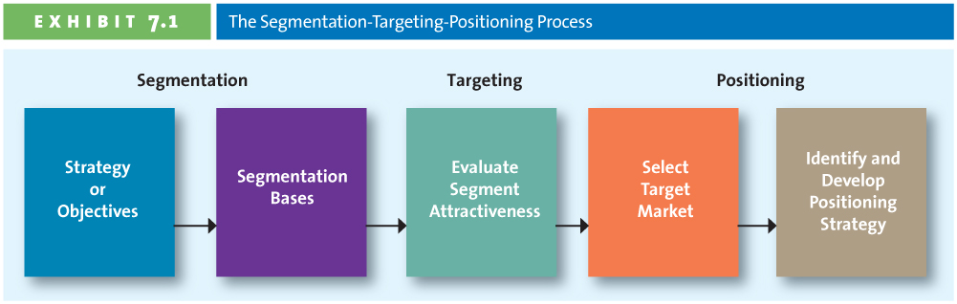
Step 1: Establish Overall Strategy of Objectives
- Consistent with mission statement
- Derived from mission and current state

Step 2: Profile Segments
- Geographic country, province, city, uran, rural, climate, region, continent
- Demographic age, gender, income, education, occupation, ethnic background, religion, family life cycle
- Psychographic lifestyles, values, personality, self-concept
- Behavioural benefits sought, usage rates, user status, loyalty

Geographic Segmentation
- Divided market into separate geographic units
- Countries, regions, provinces, cities, neighborhoods, climate
- Develop appropriate marketing programs.

Demographic Segmentation
- Most common method
- Divided market into groups:
  - Gender, age, ethnic group, family lifestyle, income, household type, other (occupation, education, religion)
- Be careful of stereotyping

Psychographic Segmentation
- How consumers describe themselves:
  - Self-values
    - Life goals that drive how a person lives his/her life, overriding desires
    - Self respect, self of belonging
  - Self-Concept
    - The image people have of themselves
    - Ex: are you fun loving, studious
  - Lifestyle
    - The way we live to achieve overall goals
    - Ex: healthy, balanced life.
VALS Framework Matrix in textbook* Pg.221 Matrix
- Recommend where they are in this framework.. are they innovators, achievers, strivers, survivor
Behavioural Segmentation
- Benefit Sought
- User Status—are you a current user, ex user, new user
- Usage Rate—do you use it a lot?
- Loyalty—its much more expensive to find new customers than to service your existing

Step 3: Evaluate Segment Attractiveness
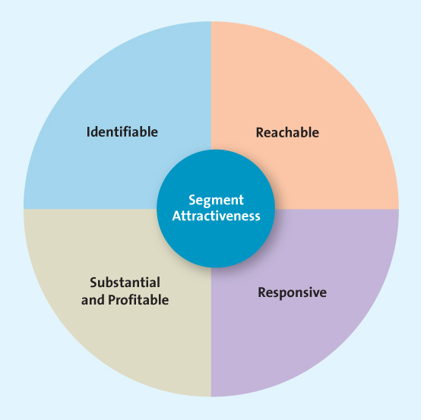
- Identifiable
  - Who is in their market?
  - Are the segments unique?
  - Does each segment require a unique marketing mix?
- Reachable
  - Know the product exists
  - Understand what it can do
  - Recognize how to buy
- Responsive
  - Customers must:
    - React similarly and positively to firm’s offering
    - Move toward the firms products/ services
    - Accept the firm’s value proposition

- Substantive and Profitable
  - Size matters
  - Too small and segment is insignfiacnt, not profitable
  - Growth potential equally important

Step 4: Selecting a Target Market
- The key factor is the marketers ability to pursue the target segment

Segmentation Strategy
- Mass or undifferentiated—everyone is considered a potential user of the product
- Differentiated—several market segments with a different offering in each
- Concentrated—focus is on single, primary target market
- Micromarketing (One-to-One)—tailoring a product to suit an individual customer’s wants or needs

Step 5: Identify and Develop Positioning Strategy
Positioning Methods:
- Value—the relationship of price to quality. Different consumers= different value
- Product Attributions—focus on the attributes that are more important, vary market to market.
- Benefits & Symbolism—can you identify the symbol of the company?
- Competition—Direct vs Indirect
  - Position against a specific competitor
  - Position against an entire product classification
- Market Leadership

Video:
Segmenting: to divide market into chunks. Make homogenous (all the same characteristics)
1. Define characteristics of the targeted market. ( common characteristics are—demographics, usage level, geographics, benefits sought)
Lifestyle= psychographics (how the person behaves)

Implicityly—your better (Wheeley cheese is cheaper)
Explicitly—mentioning another competitor. (wheeley cheese is better than block cheese)

Segmenting: a process of dividing markets into segments
Targeting:
Position: process of refining your product image in the eye of consumer.

Ch. 8—Developing New Products
A new product: new to the world but also involves innovation
Innovation:

Drivers of Innovation
- WHY DO FIRMS CREATE NEW PRODUCTS?
  - Changing Customer Needs
  - Market Saturation: when market is saturated, then you have to do something about it
  - Managing Risk through Diversity
  - Fashion Cycles

Diffusion of Innovation or Consumer Adoption Cycle
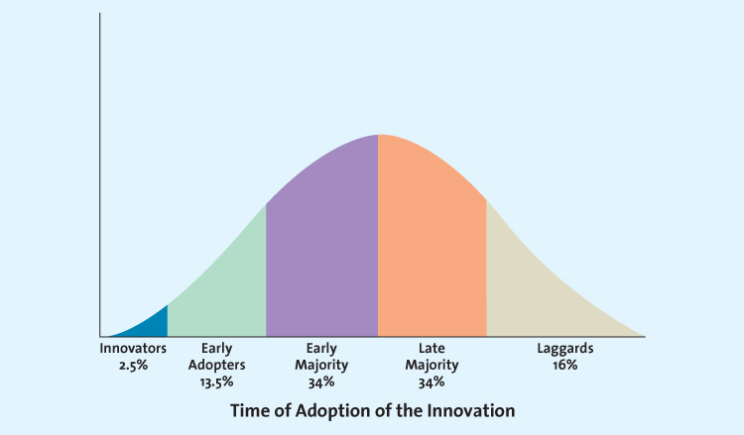
Innovators: research it and then buy in
Early Majority
Late Majority
Laggards

How Firms Develop New Products

- Idea Generation ( development of viable new product ideas)
- Sources of ideas:
  - Internal R&D
    - Typically by large firms
    - High product development costs
    - Often the source of technological products
    - Often the source of breakthrough products
  - Licensing
    - Firms purchase the rights of technology or ideas from other research-intensive firms
    - Biotechnology firms are research intensive but typically lack the resources and expertise to do their own marketing
  - Brainstorming
    - Groups work together to generate ideas
    - No idea can be immediately dismissed
  - Competitors Products
    - Reverse Engineering: taking a competitor’s product apart, analyzing it, and creating a superior product (that does not infringe on patents)
  - Consumer Input
    - As much as 85% of new business to business products come from customers
    - Lead users modify existing products according to their own specific needs
- Concept Testing
- Concept is a brief written description of the product
- Customers’ reactions determine whether or not it goes forward
- Triggers the marketing research process
- Product Development
  - Prototype
  - Alpha Testing
  - Beta Testing
- Market Testing
- Premarket tests
  - Customers exposed
  - Customer surveyed
  - Firm makes decision
- Test Marketing
  - Mini product launch
  - More expensive than premarket tests
  - Market demand is estimated
- Product Launch
- The most critical step
  - Confirms target market
  - Decides on how the product will be positioned
  - Finalizes the marketing mix
    - Promotion
    - Place
    - Price
    - Timing
- Evaluation of Results
- Satisfaction of technical requirements
- Customer acceptance
- Satisfaction of the firms financial requirements

Why do new Products Fail
- Too small target market
- Poor design
- Low product quality
- Incorrect positioning
- Wrong price strategy
- Poor marketing communication
- Competition
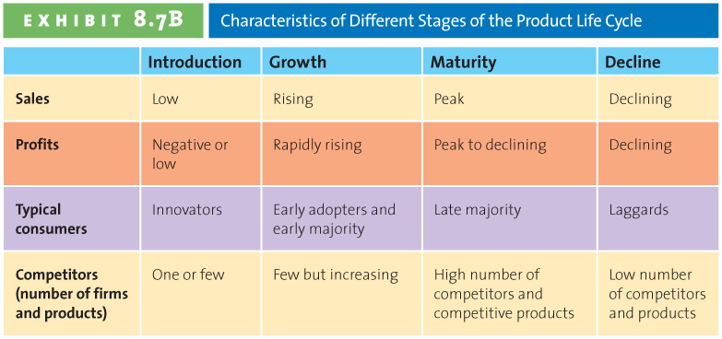
Product Life Cycle
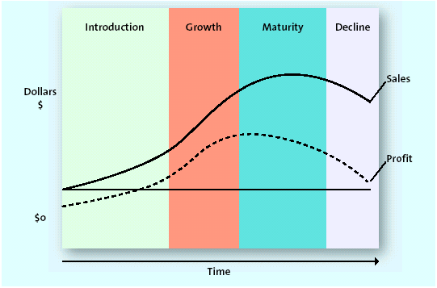

Variations on product life cycle curve
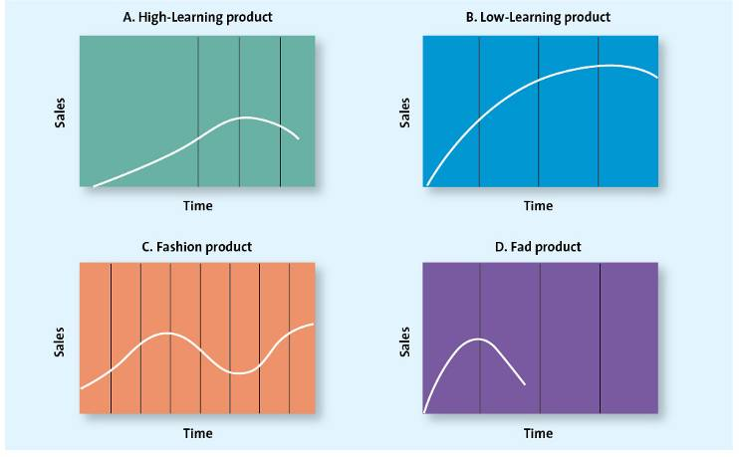
Team Exercise:
Each team pick 2 products and identify where you think this product lies in the product life cycle (and why)

Ch. 9—Product, Branding, and Packaging Decisions

Complexity of Products
Core Customer Value: in the middle
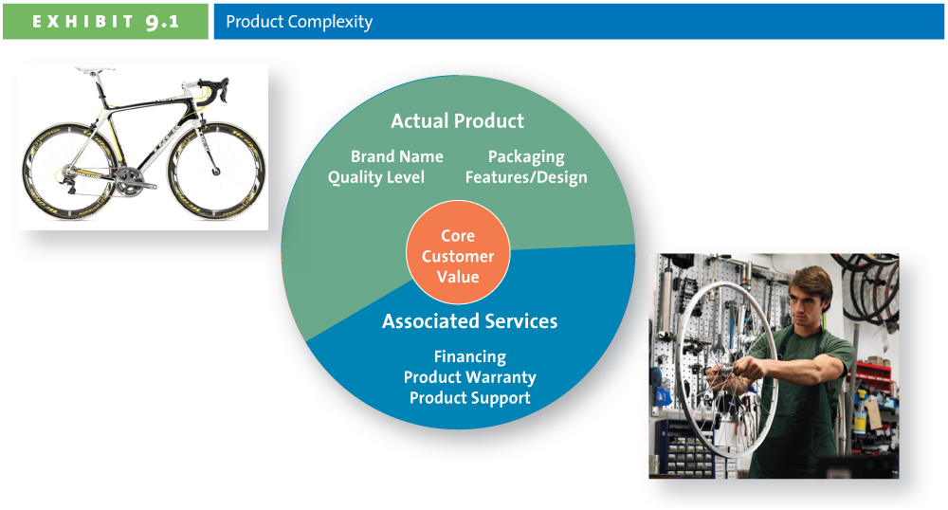

Types of Products
- Specialty—consumers show a strong preference and will spend considerable efforts to search for the best suppliers
  - Ex: luxury cars
- Shopping – consumers will spend a fair amount of time comparing alternatives
  - Ex: appliances
- Convenience—consumer is not willing to spend any efforts to evaluate prior to purchase
  - Ex: bread
- Unsought—products that consumers do not normally think of buying or do not know about
  - Ex: new to the world products

Product Mix and Product Line Decisions
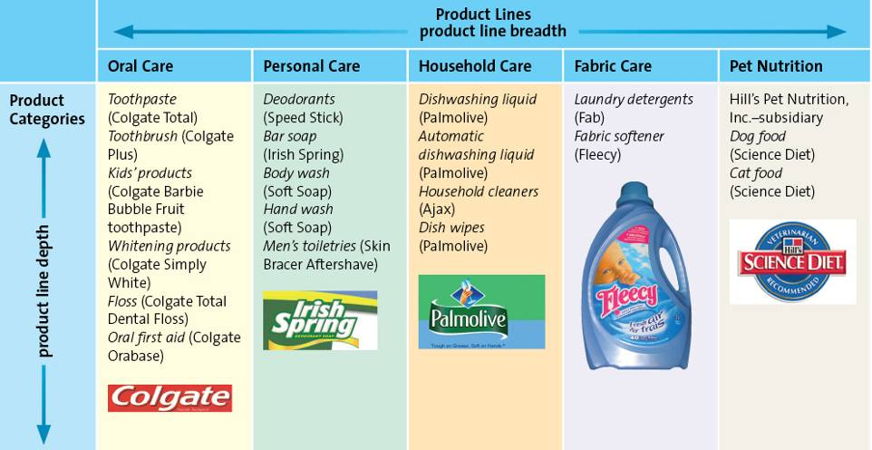

Breadth: number of product lines
Depth: number of categories within a product line

Change Product Mix Breadth
- Increase breadth
  - New product line
- Decrease Breadth
  - Dropping a product line
Change in Product Mix Depth
- Increase Depth
  - Band-Aid now has over 40 products to heal cuts
- Decrease Depth
  - McCormick spices eliminated dozens of products each year

Branding
- A brand can use: Name, Logo symbols, characters, slogans, jingles and even distinctive packages
- Brands can be identified through many associations. Such as jingles, characters, slogans, URLs, logos and symbols.

Value of Branding for the Customer and the Marketer
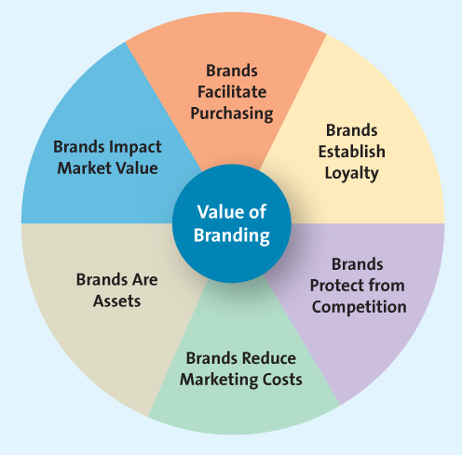

Branding Overview
- Brand Equity: brand awareness, perceived value, brand association, brand loyalty
- Brand Ownership Strategies: manufacturer or national brand, store or private label, generic
- Brand Name Strategies: corporate or family brand, corporate and product line brand, individual

Brand Equity: Awareness
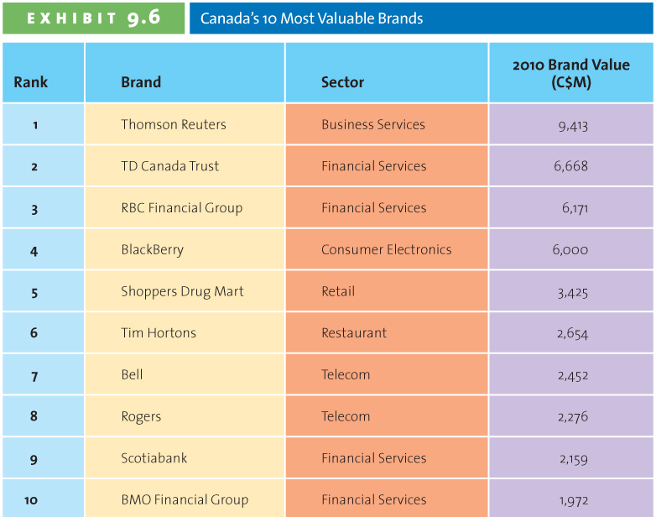

Brand Equity: Perceived Value

Brand Equity: Brand Loyalty
- Consumers are often less sensitive to price
- Marketing costs are much lower
- Firm insulated from the competition
- Occurs when consumers buy same brand and services over time, without going to competition (always buying a BMW)
    - Brand loyalty provides the firm with high value. State Farm has built their brand equity by having loyal customers.
    - To further illustrate brand loyalty, ask students: would you leave a store if your particular brand were not in stock? When you order a Sprite in a restaurant and the server asks, “Is 7-Up okay?” do you say no?

Choosing a Brand Name: Desirable Qualities * EXAM * He will give us 4 brands, pick one and go through this process
- Suggest benefits and qualities
- Easy to pronounce, recognize and remember
- Capable or registration and legal protection
- Translated easily

Brand Extension
Benefits of brand extension
- Well established name
- Brand known for high quality
- Lower marketing costs
- Synergy among products
- Boost sales of the core brand

Brand Dilution
- Evaluate the fit between the product class of the core brand and its extension
- Evaluate consumer perceptions of the attributes of the core brand and seek out extensions with similar attributes
- Refrain from extending the brand name to too many products
- Is the brand extension distanced enough from core brand?
Cobranding
Marketing 2 or more brands together in the same package of promotion. It benefits each company.
- Example: chapters and starbucks, pizza hut and taco bell, tide and febreeze,

Brand Licensing: one firm allows the other to use its for some fee
- Lacoste
  - Founded in 1933 by David
Lacoste
  - Still sold in stores today
- Harley Davidson
  - ConAgra recently introduced Harley Davidson Beef Jerky into the $2.7 billion per year beef snack category
  - The product will be sold in convenience stores and in Harley Davidson dealerships
- Canadian Tire/Nascar
  - official automotive retailer of NASCAR in Canada
Packaging:

