BU:415
Intro to Management Information Systems (Fall Term: 2013)
Professor Hari Stirbet
Chapter 1: Components of an Information System
Diamond-E: E is the environment. Whatever happens in the environment will have an effect on your business and change strategy. Management preference will have an effect on which direction they want the company to go. Resources are the next component. What recourses are available to you? This will impact strategy. This includes, capital, and HR.

Anything that happens in a hotel is an IS. Structure, people, processes, and technology. They have a staff and hierarchy. In term of people: desk clerks, chefs, cleaning crew, waiters, bellhop, and elevator hand. It has all the components to be an information system.

Information Technology Component
- Hardware
  - Computer or cell phone
- Software
  - Microsoft office
- Telecommunications Equipment
  - Internet

Process Component
- The series of steps necessary to complete a business activity
- Examples
  - Check in at a hotel
  - Credit approval rating
  - Materials receiving at a warehouse
- There are multiple ways to perform an activity: Every process is designed

People Component
- Those individuals or groups directly involved in the information system
  - End users
  - Managers
- Their needs are a critical concern in designing and implementing a new information system
- Depending on where you are in the structure (hierarchy) you'll have different needs from the information system. Lower managers schedule, and higher managers get business intelligence and create strategies based on this.

Structure Component
- The organizational structure component (structure for short) encompasses:
  - Organizational design
    - Hierarchy, decentralized, loose coupling
  - Reporting configuration
  - The organizational relationships

System Effects: Components Working Together
- The four components of an Information System are Interdependent
- Changes in one component may affect all others
- Success is based on the proper interaction of IT with the other components.
- Change is the hardest thing to impose on an organization. Need to do it carefully

Information Systems and Organizational Change

- First order change: Automate
  - Only affects the technical subsystem
  - Easier to envision, justify, and manage
  - Affects only technology and process

- Second: Informate
  - Affect the people component
  - Thus provides more of a challenge to implementation
  - Affects people, technology and process

- Third: Transform
  - Affects organizational structures
  - Seeks to transform how the organization operates
  - Requires significant managerial and executives involvement
  - Changes structure, people, technology, and process

Implications
- IT should not be the start of your information system design process
  - Strategy may be inspired by IT

Chapter 2: Strategy & Technology
Sustainable Competitive Advantage – Financial performance that consistently outperforms industry average
Operational Effectiveness – performing the same tasks better than rivals perform them
Fast Follower Problem – exists when savvy rivals watch a pioneer’s efforts, learn from their successes and missteps, then enter the market quickly with a comparable or superior product at a lower cost before the first mover can dominate
Strategic Positioning – performing different tasks than rivals, or the same tasks in a different way
Inventory Turns – inventory turnover – number of times inventory is sold or used during the course of a year; a higher figure means that a firm is selling products quickly
Straddling – attempts to occupy more than one position, while failing to match the benefits of a more efficient, singularly focused rival
Resource-based View of Competitive Advantage – the strategic thinking approach suggesting that if a firm is to maintain sustainable competitive advantage, it must control an exploitable resource, or set of resources, that have four critical characteristics; these resources must be (1) valuable, (2) rare, (3) imperfectly imitable, and (4) nonsubstitutable
Dense Wave Division Multiplexing (DWDM) – a technology that increases the transmission capacity and speed of fiber-optic cable; transmissions using fiber are accomplished by transmitting light inside “glass” cables - in DWDM, the light inside fiber is split into different wavelengths in a way similar to how a prism splits light into different colours
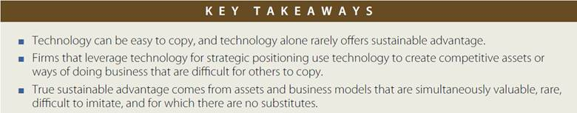
Imitation-Resistant Value Chain – a way of doing business that competitors struggle to replicate and that frequently involves technology in a key enabling role
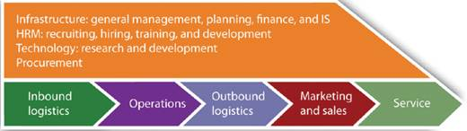
Value Chain – the set of activities through which a product or service is created and delivered to customers
Brand – the symbolic embodiment of all the information connected with a product or service
Viral Marketing – leveraging consumers to promote a product or service
Scale Advantage – advantages related to size
Economies of Scale – when costs can be spread across increasing units of production or in serving multiple customers; businesses that have favorable economies of scale are sometimes referred to as being highly scalable
Switching Costs – the cost a consumer incurs when moving from one product to another; it can involve actual money spent as well as investments in time, any data loss, and so forth
Sources of switching costs: learning costs, information/data, financial/contractual commitment, search costs, loyalty programs
Network Effects/Externalities – when the value of a product or service increases as its number of users expands
Distribution Channels – the path through which products or services get to customers
Affiliates – third parties that promote a product or service, typically in exchange for a cut of any sales
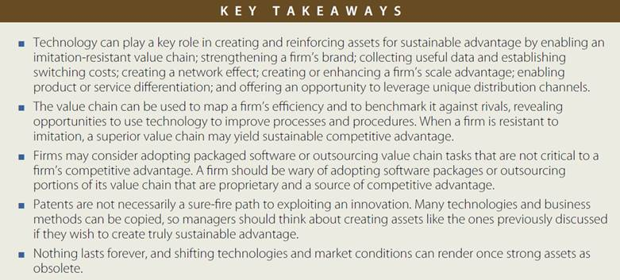
Porter’s Five Forces – Industry/Competitive Analysis – A framework considering the interplay between
(1) the intensity of rivalry among existing competitors
(2) the threat of new entrants
(3) the threat of substitute goods or services
(4) the bargaining power of buyers
(5) the bargaining power of suppliers
Price Transparency – the degree to which complete information is available
Information Asymmetry –a decision situation where one party has more or better information than its counterparty
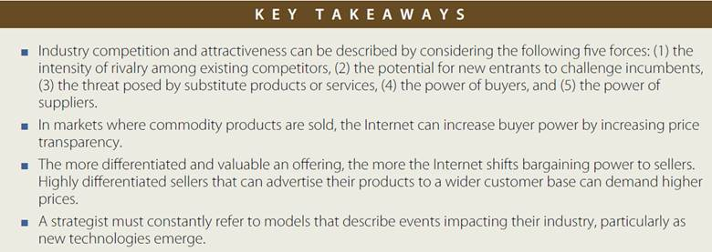

Chapter 3: Zara: Fast Fashion from Savvy Systems
Contract Manufacturing – outsourcing production to third-party firms
- firms that use contract manufacturers don’t own the plants or directly employ the workers who produce the requested goods
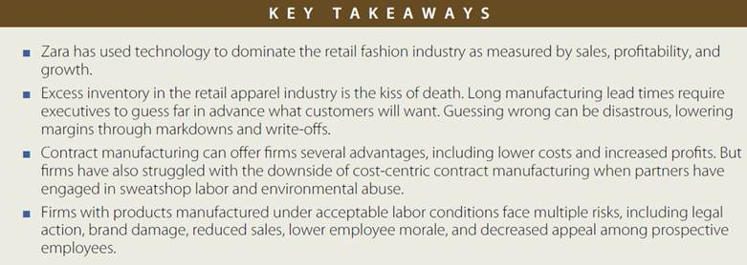
Personal Digital Assistants (PDAs) – handheld computing devices meant largely for mobile use outside an office setting; PDAs have now been integrated into other mobile device classes, such as smartphones and tablets
Point-of-Sale (POS) Systems – transaction processing systems that capture customer purchases
- cash registers and store checkout systems are examples of point-of-sale systems
- these systems are critical for capturing sales data and are usually linked to inventory systems to subtract out any sold items
Vertical Integration – when a single firm owns several layers in its value chain
Value Chain – the set of activities through which a product or service is created and delivered to customers
Logistics – coordinating and enabling the flow of goods, people, information, and other resources among locations
Radio Frequency Identification (RFID) Tags – small chip-based tags that wirelessly emit a unique identifying code for the item that they are attached to; think of RFID systems as a next-generation bar code
Information System (IS) – an integrated solution that combines five components: hardware, software, data, procedures and the people who interact with and are impacted by the system
Return on Investment (ROI) – the amount earned from an expenditure

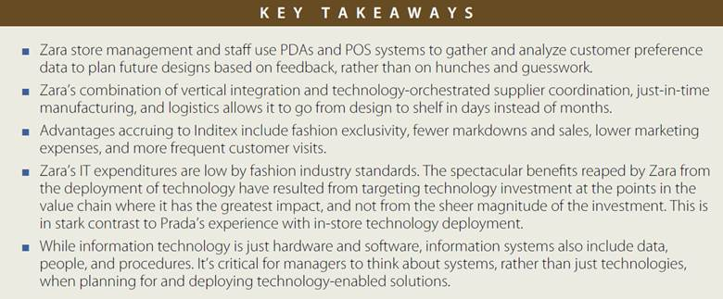
Operations – the organizational activities that are required to produce goods or services
- operations activities can involves the development, execution, control, maintenance, and improvement of an organization’s service and manufacturing procedures
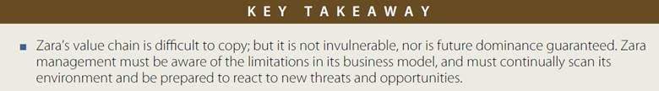

Chapter 4: Netflix: The Making of an E-Commerce Giant
Initial Public Stock Offering (IPO) – the first time a firm sells stock to the public
Pure Play – a firm that focuses on a specific product, service, or business model
- an Internet pure play is a firm that only operates through the Internet channel
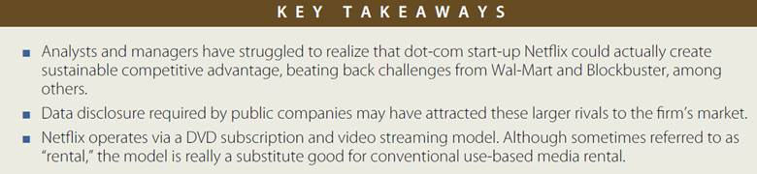
Long Tail – refers to an extremely large selection of content or products
- the long tail is a phenomenon whereby firms can make money by offering a near-limitless selection
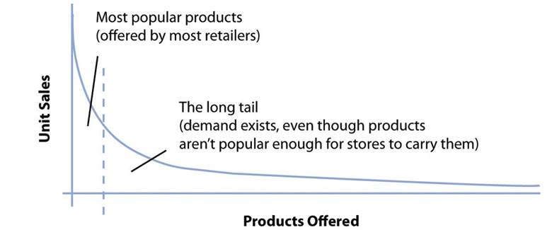
The long tail works because the cost of production and distribution drop to a point where it becomes economically viable to offer a huge selection; for Netflix, the cost to stock and ship an obscure foreign film is the same as sending out the latest blockbuster. The long tail gives the firm a selection advantage that traditional stores cannot match.
Collaborative Filtering – a classification of software that monitors trends among customers and uses this data to personalize an individual customer’s experience
Churn Rate – the rate at which customers leave a product or service
Crowdsourcing – the act of taking a job traditionally performed by a designated agent and outsourcing it to an undefined, generally large, group of people in the form of an open call
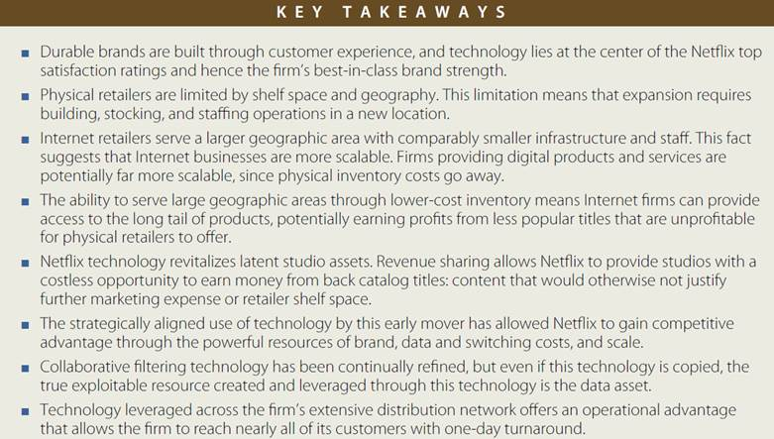
Atoms to Bits - The idea that many media products are sold in containers (physical products, or atoms)
for bits (the ones and zeros that make up a video file, song, or layout of a book). As the Internet offers fast wireless delivery to TVs, music players, book readers, and other devices, the “atoms” of the container aren’t necessary. Physical inventory is eliminated, offering great cost savings.
Windowing – industry practice whereby content, usually a motion picture, is available to a given distribution channel for a specified time period or “window,” usually under a different revenue model
(e.g. ticket sale, purchase, license fee)
Marginal Cost – the cost associated with each additional unit produced
Disintermediation – removing an organization from a firm’s distribution channel
- disintermediation collapses the path between supplier and customer
Bandwidth Caps – a limit, imposed by the ISP on the total amount of traffic that a given subscriber can consume (usually per each billing cycle)
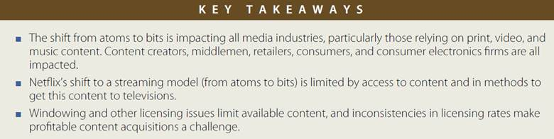
Chapter 5: Moore’s Law
Moore’s Law – chip performance per dollar doubles every eighteen months
Microprocessor – the part of the computer that executes the instructions of a computer program
Random-Access Memory – the fast, chip-based volatile storage in a computing device
Volatile Memory – storage (such as RAM chips) that is wiped clean when power is cut off from a device
Nonvolatile Memory – storage that retains data even when powered down (flash memory, hard disk)
Flash Memory – non-volatile, chip-based storage, often used in mobile phones, cameras, and MP3 players; slower than conventional RAM but holds its charge even when the power goes out
Solid State Electronics – semiconductor-based devices; often suffer fewer failures and require less energy than mechanical counterparts because they have no moving parts
- RAM, flash memory and microprocessors are solid state drives but hard drives are not
Semiconductor – a substance such as silicon dioxide used inside most computer chips that is capable of enabling as well as inhibiting the flow of electricity
Optical Fiber Line – a high-speed glass or plastic-lined networking cable used in telecommunications
Price Elasticity – the rate at which the demand for a product or service fluctuates with price change
- highly elastic goods/services see demand spike as prices drop
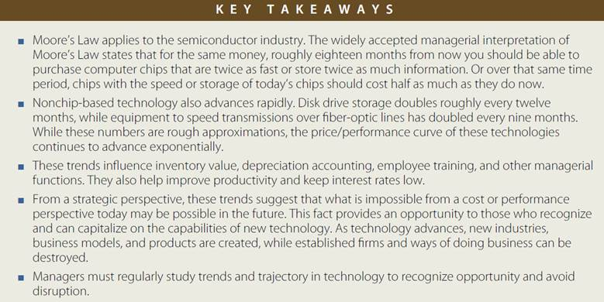

Fabs – semiconductor fabrication facilities; the multibillion dollar plants used to manufacture semiconductors
Silicon Wafer – a thin, circular slice of material used to create semiconductor devices
- hundreds of chips may be etched on a single wafer, where they are eventually cut out for individual packaging
Multicore Microprocessors – microprocessors with two or more calculating processor cores on the same piece of silicon
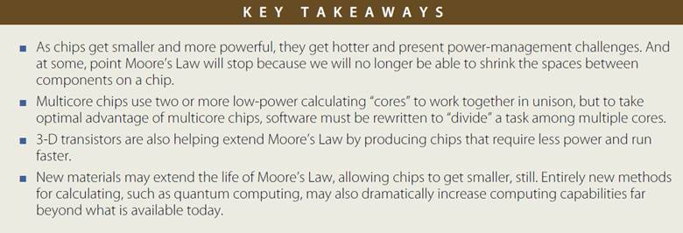
Supercomputers – computers that are among the fastest of any in the world at the time of their introduction
Massively Parallel – computers designed with many microprocessors that work together, simultaneously, to solve problems
Grid Computing – a type of computing that uses special software to enable several computers to work together on a common problem as if they were a massively parallel supercomputer
Software as a Service (SaaS) – a form of cloud computing where a firm subscribes to a third-party software and receives a service that is delivered online
Cloud Computing – replacing computing resources – either an organization’s or individual’s hardware or software – with services provided over the Internet
Server Farm – a massive network of computer servers running software to coordinate their collective use; server farms provide the infrastructure backbone to SaaS and hardware cloud efforts

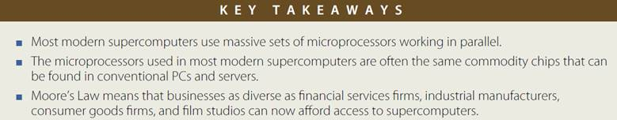

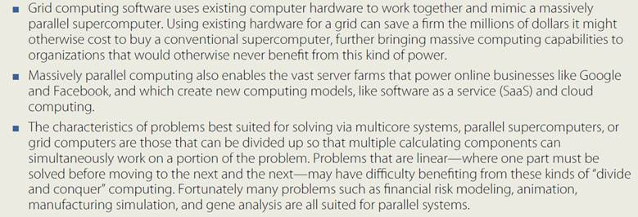

E-Waste – discarded, often obsolete technology; also known as electronic waste
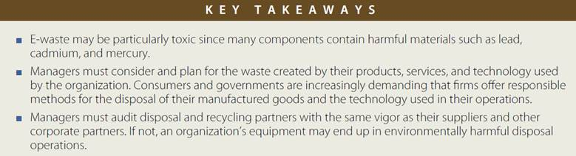

Chapter 6: Understanding Network Effects
Network Effects/Externalities – when the value of a product or service increases as its number of users expands
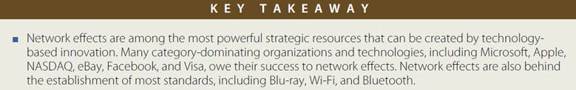
Staying Power – the long-term viability of a product or service
Switching Costs – the cost a consumer incurs when moving from one product to another
- it can involve actual money spent as well as investments in time, any data loss, and so forth
Total Cost of Ownership (TCO) – an economic measure of the full cost of owning a product
- direct costs plus indirect costs such as training, support and maintenance
Complementary Benefits – products or services that add additional value to the primary product or service that makes up a network
Platforms – products and services that allow for the development and integration of software products and other complementary goods
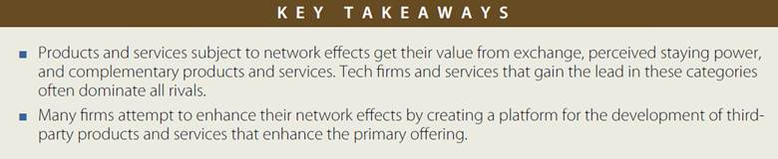
One-Sided Market – a market that derives most of its value from a single class of users (e.g. instant messaging)
Same-Side Exchange Benefit – benefits derived by interaction among members of a single class of participant (e.g. the exchange value when increasing numbers of IM users gain the ability to message each other)
Two-Sided Market – network markets comprised of two distinct categories of participant, both of which that are needed to deliver value for the network to work (e.g. video game console owners and developers of video games)
Cross-Side Exchange Benefit – when an increase in the number of users on one side of the market
(e.g. console owners) creates a rise in the other side (software developers)
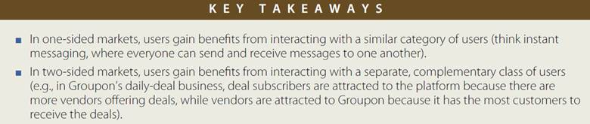
Monopoly - a market where there are many buyers but only one dominant seller
Oligopoly – a market dominated by a small number of powerful sellers
Technological Leapfrogging – competing by offering a new technology that is so superior to existing offerings that the value overcomes the total resistance that older technologies might enjoy via exchange, switching cost, and complementary benefits
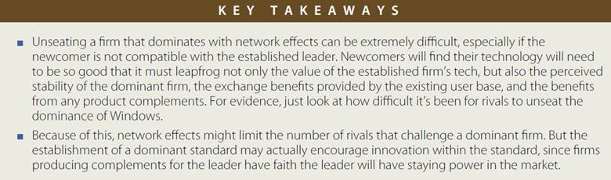
Blue Ocean Strategy – an approach where firms seek to create and compete in uncontested “blue ocean” market spaces, rather than competing in spaces and ways that have attracted many, similar rivals
Convergence – when two or more markets, once considered distinctly separate, begin to offer features and capabilities; e.g. the markets for mobile phones and media players are converging
Envelopment – when one market attempts to conquer a new market by making it a subset, component, or feature of its primary offering
Backward Compatibility – the ability to take advantage of complementary products developed for a prior generation of technology
Adaptor – a product that allows a firm to tap into the complementary products, data, or user base of another product or service
The Osborne Effect – when a firm preannounces a forthcoming product or service and experiences a sharp and detrimental drop in sales of current offerings as users wait for the new item
Congestion Effects – when increasing numbers of users lower the value of a product or service


