Chapter 13 Physicians, Their Practices, and the Market for Physician Services

13.1 The Physician Services Sector
Institutional Background
  - Expenditure on physician services
  - Physician treatment decisions influence utilization and expenditures on hospital-based services, drugs, home care, and many other services
- Physician behaviour is essential to achieving an efficient and equitable allocation of health care resources
  - Access to GP and specialist care
    - Family/general practitioners working fewer hours
  - Primary care – first point of access to the full range of health care services
  - Specialists as independent practices with the right to admit patients to hospitals
  - Fee for service and alternative forms of payment – salary, capitation, blended funding formulae, and other methods
Clinical payment programs | Definition
Fee-for-service | In a fee-for-service system, physicians bill for each individual service provided.
Alternative payment | Alternative payment programs are arrangements to pay physicians directly by methods other  than fee-for-service.
- Salary | A compensation method by which physicians are paid based on annual scales.
- Blended | Physicians are compensated through fee-for-service along with some other form of remuneration.
- Capitation | A model of compensation in which physician practices are paid a fixed sum of money for each patient rostered with the practice. Capitation may fund a range of services, including prevention and medical care.
- Sessional | Payments on an hourly or daily basis. Used by some jurisdictions to fund services such as, but not limited to, hospital emergency departments, psychiatry clinics and clinics in rural areas.
- Emergency and on call | Programs provide amounts of funding to groups of physicians who agree to provide on-call services to hospitals.
- Contract | Provides negotiated funding for physicians providing defined services to a defined  population; the compensation arrangement usually specifies services to be provided or time commitments.
- Other | e.g., Northern and under-serviced areas; block funding; psychiatry etc.
Regulation of Physicians and Their Practices
  - Rationale for regulation
    - regulation is motivated by asymmetry of information, attendant market power and scope for inefficient outcomes
    - balance counter-acting welfare effects:
1) raising quality and facilitating the physician-patient agency relationship
2) inhibiting competition and engendering inefficiency
  - Physician self-regulation
    - Asymmetry of information between physicians and regulators
    - Royal College of Physicians and Surgeons, Royal College of Family physicians
  - Regulation of entry, advertising and fees
    - Seventeen accredited medical schools with tightly controlled training slots, licensing of foreign trained doctors
    - Scope of practices/medical acts
    - No extra billing
the practice by a physician of charging a fee greater than the public reimbursement, requiring the patient to pay the difference between the two

Market for physician services
- Most primary care markets are local with family doctors competing for patients
- Specialists in large cities draw patients from large catchment areas through referrals or based in hospitals
- Competition among physicians emphasizes the non-price dimensions of care – style of practice, range of services offered, perceived quality, hours of operation
- Alternative providers - -physician assistants, nurse practitioners

13.2 Modeling the Physician Practice and Physician Behaviour
Developed within the household production framework
  - Physician preferences: what is in the physician objective function?
U=U(C,L,E)
where C=consommation,
L=leisure,
E=ethics (physician’s professional ethics – provide appropiate, good-quality care, do no harm, etc)
  - Physician gets dis-utility from providing a level of care other than the one the physician judges to be most appropriate

  - The production function for medical services (the practice): combining various inputs to produce physician services
M= M(A,I),
where M =quantity of care provided,
A =physician labour, and
I=other inputs
  - Constraints:
O + F_{M}M – P_{I}I – P_{C}C = 0
where O = non-practice income
F_{M} = the fee received for providing a unit of medical care
P_{I} = the price of a unit of non-physician input
P_{C} = the price of a unit of consumption
    - Financial – total expenditure do not exceed total amount of income
    - Time – total hours L+A=24
  - The choice problem for a utility-maximizing physician – level of consumption, leisure, other inputs, and medical care

Physician Responses to Fee Changes (McGuire and Pauly)
  - Purpose: to analyze the impact of fee changes the service provision by physicians
  - Basic set-up of model: utility function, production, constraints, and so forth
    - Backward bending labour supply (and possibly, service supply) function
  - Key results
    - The impact of a fee change cannot be determined from theory alone
    - Two counter-acting effects:
      - impact on labour supply
      - impact on disutility of inducement
    - when relative fees change across two services, impact depends on the relative share of activity accounted for by the service whose fee has changed

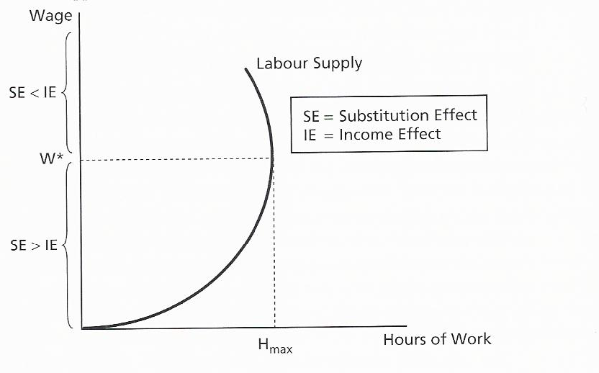
Backward-bending labour supply curve

Physician Labour Supply and the Production of Medical Services
  - Key question: how do changes in aspects of a practice influence the amount of time physicians work, how physicians combine their effort with other inputs, and the amount of services provided.
    - Changes in non-practice income
    - Changes in consumer prices
    - Changes in fees and the price of inputs
    - Empirical evidence on these questions

