Chapter 10 Private Insurance

10.1 Moral Hazard
Ex Ante Moral Hazard: Insurance-induced changes in behaviour that alter the probability that an insured event occurs
- A larger concern for insurance that covers material possessions than it is in health insurance, because of pain and suffering not compensated by insurance
Ex Post Moral Hazard: Insurance-induced changes in behaviour that alter the insured loss after the insured event occurs
- It means consuming more or higher-priced care than you would if you did not have health insurance
- A larger concern in the health sectors

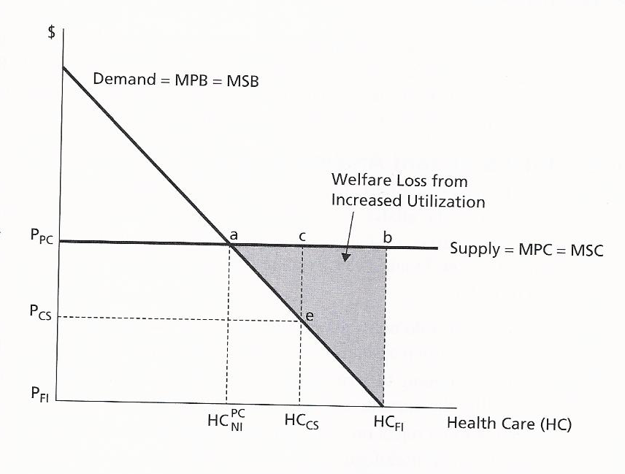
Standard Analysis of Moral Hazard

  - Based on M. Pauly’s seminal paper – treating health care as a standard commodity
- Because insurance induces inefficient over-consumption of health care, insurance causes large welfare losses in the market for health care services
  - Assumes perfectly competitive markets, no externalities, no income effects, demand curve accurately represents the benefit of health care, so all of the insurance-induced increases in health care consumption are welfare-decreasing
  - This analysis led some to conclude that full insurance coverage that provides care free of charge can never be optimal, so cost-sharing or partial insurance is a policy solution to moral hazard

Figure Analysis
- In the market equilibrium with no insurance, the price of health care will be P_{pc} and individuals will pay the full cost, consuming ${HC}_{NI}^{PC}$ health care, which is the socially efficient amount.
because there is no externalities, ot other sources of market failure
- If there is full insurance coverage that lowers the price of health care to zero (P_{FI}), the demand for health care will increase to H_{FI}. Insurance increases health care consumption by the amount (H_{FI} - ${HC}_{NI}^{PC}$)
- Because the demand curve is assumed to accurately reflect the marginal social benefit of care to individuals, the increased benefit derived from additional health care utilization is the trangle below the demand curve between the two levels of consumption (a, H_{FI}, ${HC}_{NI}^{PC}$)
- The increased cost of producing the additional care is the area under the supply curve, the rectangle (a, b, H_{FI}, ${HC}_{NI}^{PC}$). The insurance-induced increase in utilization generates a welfare loss equal to (a, b, H_{FI})

Critiques of the Standard Analysis of Moral Hazard (book)
- Modifying Assumption Within the Standard
- Asymmetry of Information, Moral Hazard, and Welfare Loss
- Ethical Objections to Willingness to Pay as a Measure of Benefit

  - Even within the standard welfare economic framework, incorporating imperfect markets, positive consumption externalities and positive income effects reduces the implied welfare losses from insurance-induced increases in utilization (i.e., moral hazard)
  - In the presence of informational asymmetry, does the normative interpretation of the demand curve as representing social benefit hold up? – with informational asymmetry, observed utilization may not accurately reflect either individual preferences or an accurate understanding of the benefits of health care
  - Ethical objections to willingness-to-pay as the appropriate measure of benefit

Combating Moral Hazard from the Supply-side
- Gatekeeper model – A delivery model in which the primary care provider regulates access to specialist and diagnostic services, which patients are not permitted to access directly
- People must first pass through the ‘gate’ of the primary care provider
- When people access to higher levels of care should be based on professional judgments of need
- Managed care - A delivery model that monitors and controls the provision of care in an effort to reduce moral hazard and increase quality by regulating the choices of providers and patients
- Managed care is characterized by the following
- Lower cost-sharing requirements than non-managed-care plans
- Limited patient choice of providers
- Limited access to certain services expect with explicit approval of the managed care plan
- Retrospective review of provider utilization patterns
- Capacity control – Supply-side policies in systems that are publicly financed, rely less on micro-management of clinical practice and more on aggregate, system-level capacity constraints
- Supply-side financial incentives – Aligning the financial incentives for good medical practice through careful design of the funding mechanisms by which insurers pay providers, better balancing the incentives for over and under use of care
10.2 Risk Selection
Risk Class – individuals classified by an insurance agency as having the same risk (based on observable characteristics) and who are, therefore, each charged the same premium
Risk Selection – the phenomenon whereby an insurer’s risk pool systematically attracts individuals of either below-average or above-average risk status given the premiums charged
Adverse Risk Selection – when an insurance pool systematically attracts individuals of above-average risk status within a risk class
- Process of adverse selection
- Nature of market failure caused by adverse selection
- informational asymmetry prevents the insurer from charging risk-adjusted, individual-specific premium, leading to no exchange
- Policies to combat adverse selection
- better risk adjustment or better definitions of risk pools to prevent adverse selection
(adverse selection can occur when people within a risk class have different levels of risk)
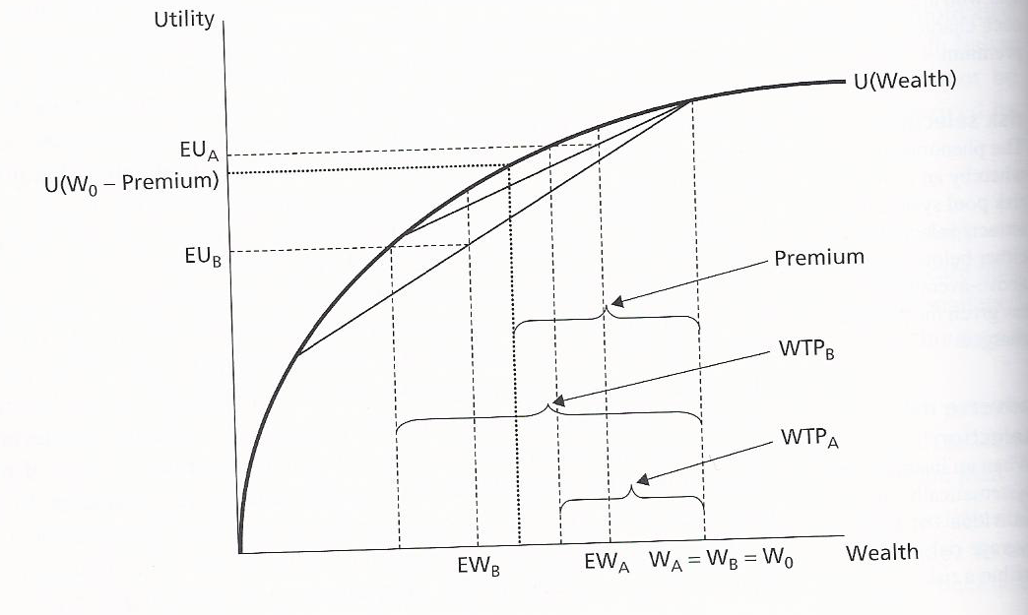

Favourable Risk Selection – when an insurance pool systematically attracts individuals of below-average risk status within a risk class (also called as cream-skimming or cherry picking)
- Cream –skimming arises form the actions of an insurer and has two causes
- Cream-skimming by exploiting and informational advantage
an insurer may be able access a person’s risk status better than the individual.
- Cream-skimming through strategic policy design
it can strategically design and market insurance policies that induce individuals to sort themselves according to their risk status.
- Nature of the market failure caused by cream-skimming
the real resources insurers expend to cream-skim constitute social waste
it can break risk pools in ways that harm social welfare
- Policies to combat cream-skimming – universal public insurance

10.3 Economies of Scale
economies of scale – a situation in which the average cost of production falls as output rises over most of the relevant range of production in the industry

