Chapter 8 The Demand for Health Care

8.1 Need, Demand, and Utilization
utilization – the amount of health care that is consumed

- Health care need depends on individuals’ health status and availability of services, but does not depend on their preferences
- Health care demand, the expression of a desire to obtain a health care good or service given its price, does depend on individual preferences and resources
- Health care utilization is the amount of health care actually consumed
- Important to Distinguish Need, Demand and Utilization
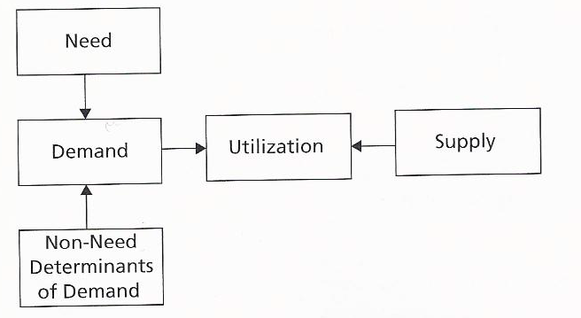

  - The three are distinct but causally related
  - Utilization is the only one that is directly observable

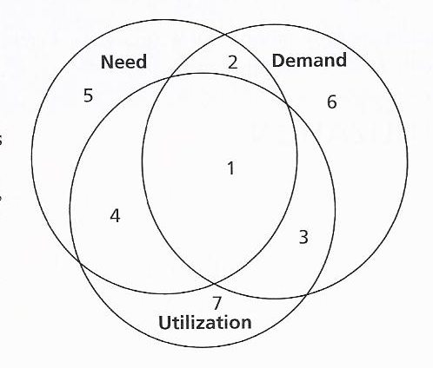

- The objective for the system is for needs to be expressed as demands and met by the utilization of care
- Systematic departures from this represent some of the major challenges facing health care systems

Category 1 - represents the health care bulls-eye --- services that are needed, demanded, and utilized
Category 2 – includes services that bedevil many public health care systems today: services that are needed and demanded but not utilized due to a supply or other constraint
Category 3 – includes services that are demanded and utilized but not needed
Category 4 – includes needed utilization that is not demanded
Category 5 – includes needed care that is neither demanded nor utilized
Category 6 – includes services that are demanded but neither needed nor utilized
Category 7 – includes services that are utilized but neither needed nor demanded

8.2 Demands for Health Care within the Standard Economic Framework
Standard demand framework is the starting point for analyzing demand or health care - in pursuit of well-being

Demand_{HC} = F(preferences, price_{HC}, price_{sub}, price_{comp}, income, health status, provider)
Where
Demand_{HC} = demand for health care
Preferences = preferences over health, health care, and other goods and services
price_{HC} =prices of health care
price_{sub} = prices of substitutes
price_{comp} = prices of complements
income = individual or household income
health status = health status of the individual
provider = the individual’s provider

    - Preference, prices and income are all perfectly standard determinants
    - The presence of health in the demand function reflect the derived nature of demand for health care
    - The presence of “provider” reflect the potential for provider influence because of asymmetry of information

Preferences - over health, over health care, other goods and services, and toward risk
Risk attitude – the extent to which a person likes or dislikes risk. A person who likes to take risks is risk loving; a person who does not like to take risks is risk averse; a person who is indifferent is risk neutral

Price of health care - money price, non-monetary costs
    - Challenge of empirically determining the impact of price on demand in the presence of insurance that makes price endogenous
    - Important role of non-monetary costs, such as time, when money price is low

Prices of substitutes and complements
- The lower the price for a substitute service, the smaller will be the demand for a particular health care service
- Psychotherapy of comparable quality

Income/Wealth
- Primary determinant of the ability to pay for health care
- The time cost of obtaining care increases with an individual’s income
- Low individual income-elasticity (0.2~0.6) vs relatively high aggregate elasticity (1.0)

8.3 Informational Asymmetry and the Demand for Health Care
- Information Asymmetry gives Physicians Market Power: Potential for Supplier-induced Demand
  - Definition of supplier-induced demand
    - The ability of physicians to shift the demand curve (for better or for worse)
    - Systematic exploitation of market power by physicians for their own financial interest in response to market conditions or health care policies
    - Welfare implication: Role of agency and the effectiveness of a service obtained
– Would the patient have demanded the service if he or she had the same information as the physician?
- Did the service contribute positively to the patient’s health status?
- The Challenges of empirically measuring supplier-induced demand
  - Definitions rest on unobservable phenomena, e.g., provider motive
  - Difficult to identify predictions consistent with supplier-induced demand but not consistent with the standard model
  - Challenges of capturing all phenomena of interest given data limitations
- Roemer’s law - A bed built is a bed filled, which reflects the fact that in the presence of full insurance, capacity often defines the level of utilization

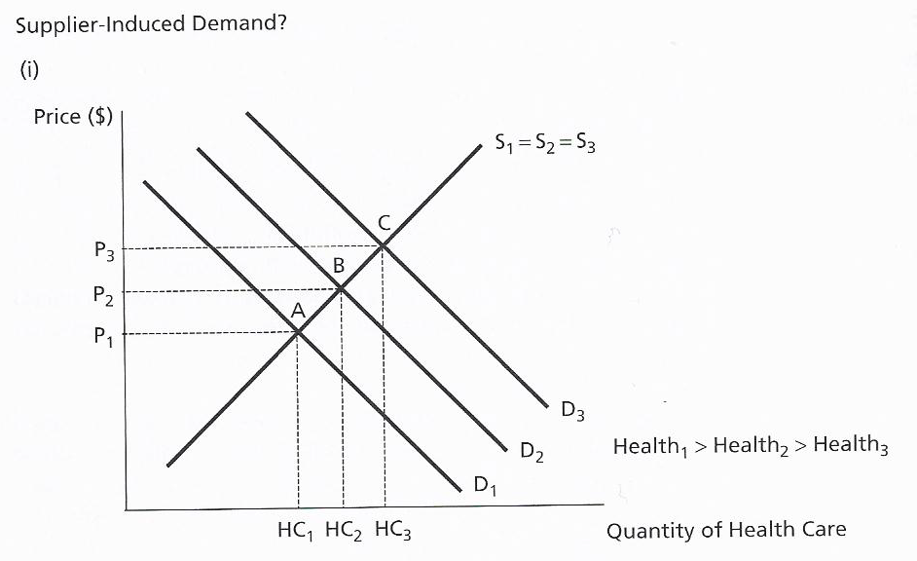
Different levels of health status cause demand for health care differ across three countries.

Generating the observed positive correlation between utilization per capita and physician supply (A, B, C)

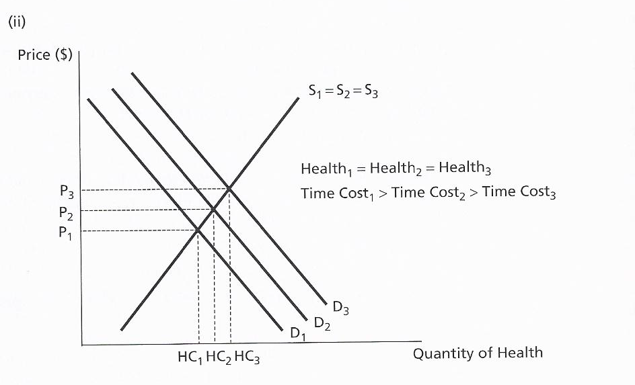

The “availability effect” would shift the demand curve outward, resulting in a positive correlation between physician supply and utilization per capita through a mechanism other than supplier-induced demand.

Implications of Supplier-Induced Demand
- Supplier-induced demand and positive economic analysis
  - Predictions of the impact of many types of policies, including physician supply policies, payment policies and patient cost-sharing, may be mis-leading unless the possibility of supplier-induced demand is taken into account
- Asymmetry of Information and the Normative Interpretation of the Demand Curve
  - Asymmetry of information undermines consumer sovereignty and the normative interpretation of the demand curve, even if one accepts in principle willingness-to-pay as a measure of value
  - Undermines standard approach to assessing insurance-induced changes in health care consumption in response to price changes

