Chapter 7 the Nature of Health Care as an Economic Commodity

7.1 What is Health Care
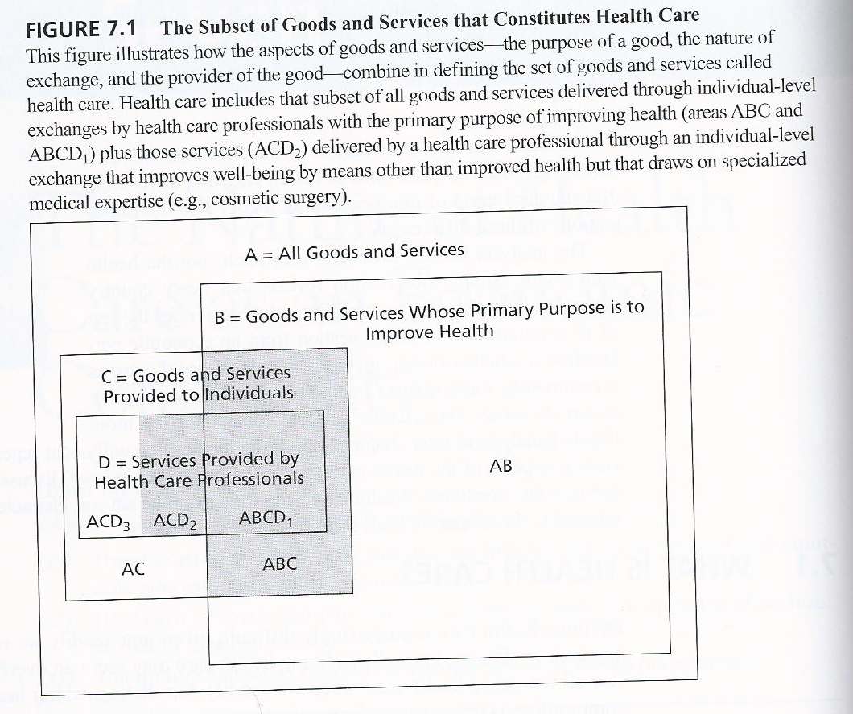
For examples:
- A radio broadcast – A, not B, C, D
- A radio – C, not B or D
- A guardrail along a highway – B, bot C or D

- ABC – purpose is health improvement and they are sold through individual exchange but not by a health professional (aspirin sold in a grocery store)
- ABCD₁ - purpose is health improvement and they are provided to an individual by a health professional (appendectomies)
- ACD₂ – provided to individual by health professionals utilizing specialized professional expertise, but they are not intended to improve health (cosmetic surgery)

7.2 Characteristics of Health Care as an Economic Commodity
5 Characteristics (economic analysis)
- Derived demand for health care
- Externalities
- Information asymmetry between providers and patients
- Uncertainty regarding both the need for and effectiveness of health care
- The vulnerability of individuals at the time they consume health care

Derived Demand for Health Care
Utility U = u(H(Z,HC), HC, X),
Where U=utility,
H=health status,
H( )=health production function,
Z=non-health goods, services and activities,
HC=health care goods and services
X=all other consumption
- Health care affects the utility both directly and indirectly
- The demand for health care derives from the demand for health

Assessing the Efficiency of Health Care Consumption
- A person benefits from health care only if it improves his or her health; improved health is a necessary condition for a person to benefit from health care consumption.
- Production relationship between health care and health provides scope for using supply-side notions of efficiency to assess efficiency in health care consumption

Need for Health Care
- Economists generally skeptical of concept of need in economic analysis
- Production relationship provides a basis for a conception of need
- A necessary condition is expected positive marginal benefit from use of a service
- Unlike other goods for which claims of need are made: health care is characterized often by very limited substitutability between health care and other goods; health care itself is often unpleasant

Externalities
Physical (selfish) Externality
- a health-related externality in which even purely selfish person cares about others’ consumption of health care because such care reduces the chances that a communicable disease is spread
- reduce the chance that a communicable disease is spread
Care Externality
- a health-related externality that arises when a person cares about the health status of others and, consequently, their consumption of needed health care
- a person cares about the health of others and, consequently, their consumption of needed health care

Informational Asymmetry Between Providers and Patients
- Concern about two questions ‘what is wrong with me?’& ‘what should I do?’
- The information required for efficient decisions (the marginal benefit of care just equals the marginal cost)
- Information regarding the expected impact that a health care service will have on health (physician knowledge)
- Information regarding the values to the individual of that improvement (patient knowledge)
- The information challenge
- Learning by gathering information => technical nature of knowledge
- Learning through experience => counterfactual problem – the difficulty in knowing what the outcome would have been had an alternative course of action been pursued
- Policies to address asymmetry of information
- Professional licensure
- Physician agency
- Information asymmetry and market power
- Informational asymmetry a source of market power for physicians
- Asymmetry of information and economic analysis
- Positive economic analysis assume that the supply and demand sides of a market are independent
- Assumption that consumers are well informed is crucial for normatively interpreting the area under a demand curve as a measure of social benefit.

Uncertainty
- At the individual level, because the uncertainty, thereby creating demand for health care insurance.

Vulnerability to the Integrity of a Person
  - Can compromise ability to make rational decisions in times of need for care
  - Heightens concern for fairness and ethical standards in care process and in allocation of resources

7.3 Is Health Care Different?
- Each characteristics shared by at least one other good, but constellation of characteristics unique
- Policy-making in a second-best world
- Second –best => a situation in which it is not possible to correct all sources of market failure and in which correcting a single source may make matters worse
- Not all health care is alike: need to assess analytically relevant characteristics when analyzing specific sets of services (e.g., physician services and drugs)

