Chapter 5 Individual-Level Demand for and Production of Health

5.1 The Health Capital Model
Household Captial Framework
- individuals combine market-purchased goods and their own time to produce the goods, services and activities that provide utility
- time is a commodity, so time costs drive much observed behaviour

Health Capital Model – an economic model of the individual-level demand for and production of health over a lifetime, based on the assumption that health can be analyzed as a durable capital good

the Grossman Health Capital Model
- Assume that health is just one of many goods that provide utility and that, within bounds, people are willing to trade off health against other things that also utility
- People desire health for 3resons
- Good health provides direct benefits and enables them to undertake activities that provide utility (consumption benefits)
- Good health enables them to work more days in the labour market and earn a higher income, which allows them to purchase more goods and services (investment benefits)
- Good health enables them to live longer, enjoying the benefits of their activities and consumption for more years
- Assume people care about two things
- Health: provides direct consumption benefit and investment benefit (allows a person to work more hours to earn income)
- Final Consumption Goods (e.g., entertainment, travel)
- Depreciation rate of health capital
- The amount by which health diminishes each period if an individual does not invest in maintaining health

Investment demand for health – an individual’s demand for health capital that derives benefits (due to increased time available for work) associated with improved health
- the assumption that the direct benefit of health is zero
- Marginal Cost of Health Capital = Monetary Cost + Depreciation Rate

Derived Demand for Health Care
- The demand for health care derives from the demand for health
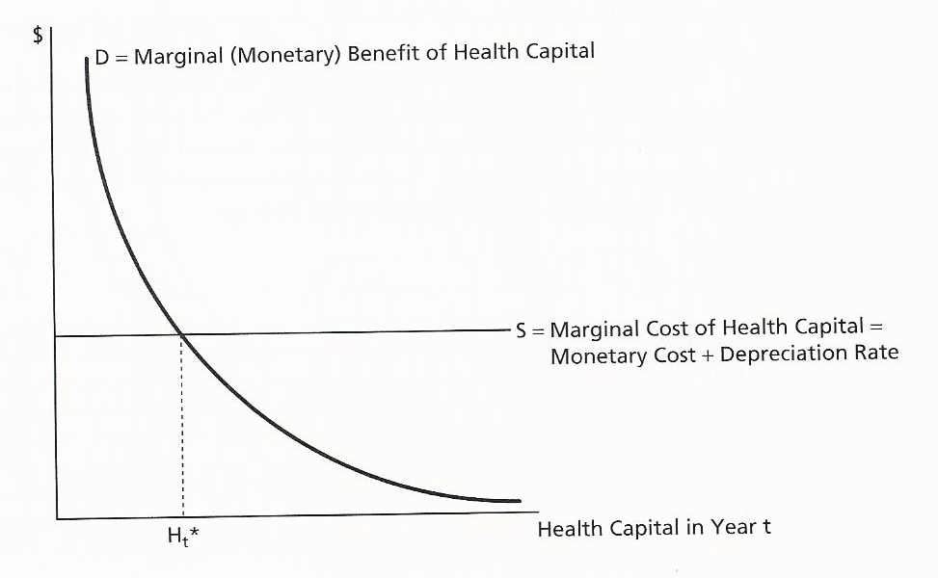

Optimal Level of Health Capital
- The optimal level of health capital in the period t is that level at which the marginal benefit of a unit of health capital equals the marginal cost of health capital.

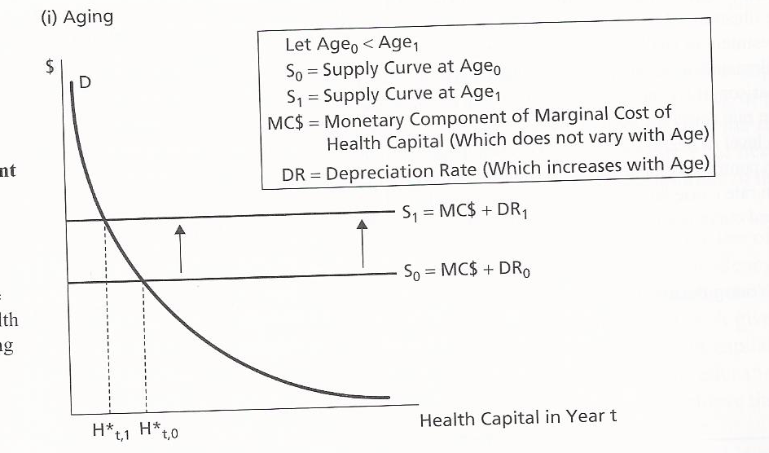
Aging and the Optimal Level of Health
- Because of older people need more health care, this causes the supply curve to ship upward

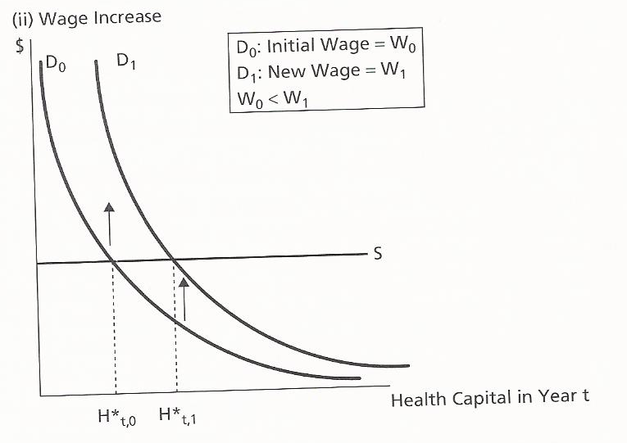
Wage rate and the optimal level of health
- The impact of an increase in wage rate on the demand for health
1. higher wage rate increase the value of time spent working, demand upward and optimal level of health capital
2. higher wage rate increases the opportunity cost of time spent producing health, inducing a person to substitute health care for their own time to achieve a given level of health
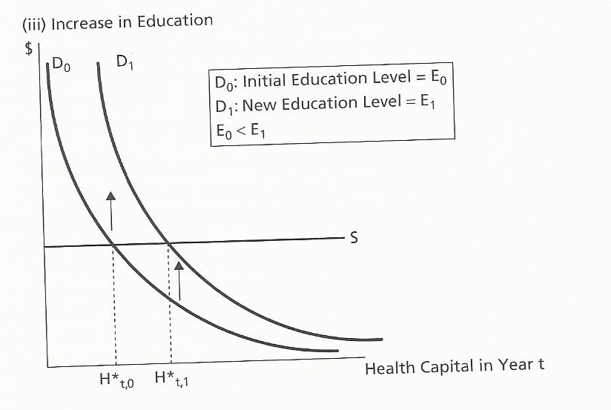
Education and the optimal level of health
- A high level of eductionhigher productivity return on a given investmentdemand curve shifts up and increasing the optimal level of health

Consumption Demand for Health
- An individual’s demand for health capital that derives from the nonmonetary, direct utility benefits associated with improved health

Rate of time preference – how much an individual values health today compared to the time
- Aging and the optimal level of health capital
- People with a high rate of time preference prefer current health to future health, so the optimal level of health capital will fall more rapidly as they age
- Wage Rate and the optimal level of health capital
- Depends on whether the production of health is more time or more health-care intensive
- Education and the optimal level of health capital
- Ambiguous, depends on production of health and final consumption goods
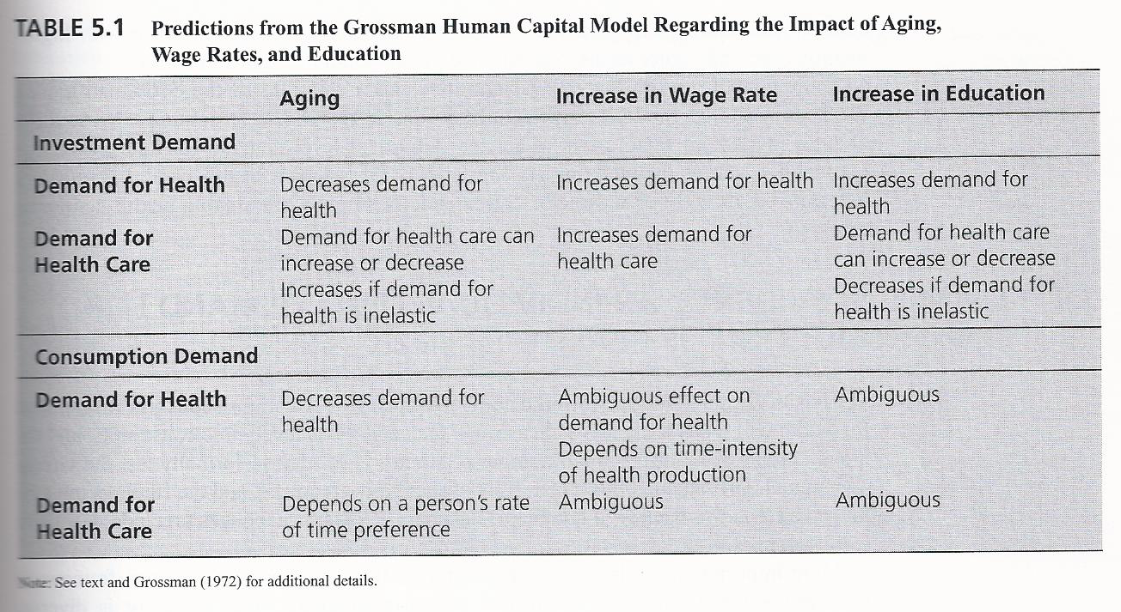
Strengths & Weakness of the Health Human Capital Model

5.3 Health-Related Behaviours
Body Mass Index – a person’s weight in kilograms divided by the square of their height in meters (BMI=kg/m²)
BMI<20 underweight
20≤BMI≤24.9 normal,
25≤BMI≤29.9 overweight
30≤BMI≤34.9 moderately obese
35≤BMI≤39.9 severely obese
BMI≥40 extremely obese

Causes of the Obesity Epidemic
Hypothesis 1: Primal Tastes – potential role of evolution in our food tastes
Hypothesis 2: Increased Women’s Labour Force Participation – less time for food preparation at home
Hypothesis 3: Changing Prices for Food and Meals
- food has gradually become relatively less expensive, especially energy-dense, high-calorie foods
- Effects of technology on both money and time costs

