$50.a) θ=\frac{arc length}{radius}$
= $\frac{6}{4}$
= $\frac{3}{2}$
= 1.5 radians

b)
2
6

c) A radian is the ratio between the arc length and the radius of a circle. The circumference, which is one full revolution of the circe is 2$π$. Half the circle in radians is $\frac{2π}{2}$, which is $π$radians. 180$°$ is half a circle which is equivalent to the radian measure of $π$ (half a circle).
3/3
51. a)i) 10$°$
= 10 [$\frac{π}{180°}]$
= $\frac{π}{18}$ radians
ii) 225$°$
= 225 [$\frac{π}{180°}]$
= $\frac{5π}{4}$ radians good 2/2

b) i) $\frac{π}{5}$ 78/80 98%
=$\frac{180°}{5}$
= 36$°$
ii) $\frac{11π}{6}$
= $\frac{11(180°)}{6}$
= 330$°$ nice 2/2

52. a) sin $\frac{2π}{3}$
= sin [$\frac{π}{3}]$
= $\frac{√3}{2}$
b) cos $\frac{7π}{6}$
= - cos [$\frac{π}{6}]$
=$\frac{-√3}{2}$

e) sec $\frac{7π}{6}$
= - cos [$\frac{π}{6}]$
= $\frac{-√3}{2}$
= $\frac{-2}{√3}$
c) sin $\frac{5π}{4}$
= - sin [$\frac{π}{4}]$
= $\frac{-1}{√2}$
d) tan $\frac{4π}{3}$
= tan [$\frac{π}{3}]$
= $√3$ good 5/5
$53. a) y=sinθ$

Period = 2$π$
¼ wave = $\frac{π}{2}$
Amplitude = 1
Graphs starts at (0,0)

b) Graphs starts at (0,1) nice 5/5

54.
Period = 8
¼ wave = 2
Amplitude = 5
Domain = $\left\{x | xϵR\right\}$
Range = $\left\{y | -2≤y≤8\right\}$ 5/5
55.a)

55. a) Amplitude: 3.2
Period: 9 it’s 12.
¼ wave: 2.3
*approximation based on scatter plot

55.b) The natural gas used in the summer would not be zero, because just as in winter , there is demand for natural gas to cool the house instead of heat.
Ok 4/5

56. a) Period: $π$
Key Questions Lesson 13
Amplitude: 3
Phase Shift: $\frac{π}{4}$ units to the right

b) 5 Criticial points:
[$\frac{π}{4}$,4] , [$\frac{π}{2}, 1]$, [$\frac{3π}{4}$, -2], [$\frac{4π}{4}, 1], [\frac{5π}{4}, 4]$

c) *Done on Graphing paper
¼ wave: $\frac{π}{4}$
starting point: ($\frac{π}{4}, 4)$

57. $y=16\sin\left[\frac{π}{6}\left(t-3\right)\right]+20$ very nice 4/4

58. a)Done On Graphing Paper*

b) $y=-4\cos\left[\frac{π}{2}t\right]+1.5$ amplitude is 1. Very close. 3/4

Excellent $6/6$

56.c)
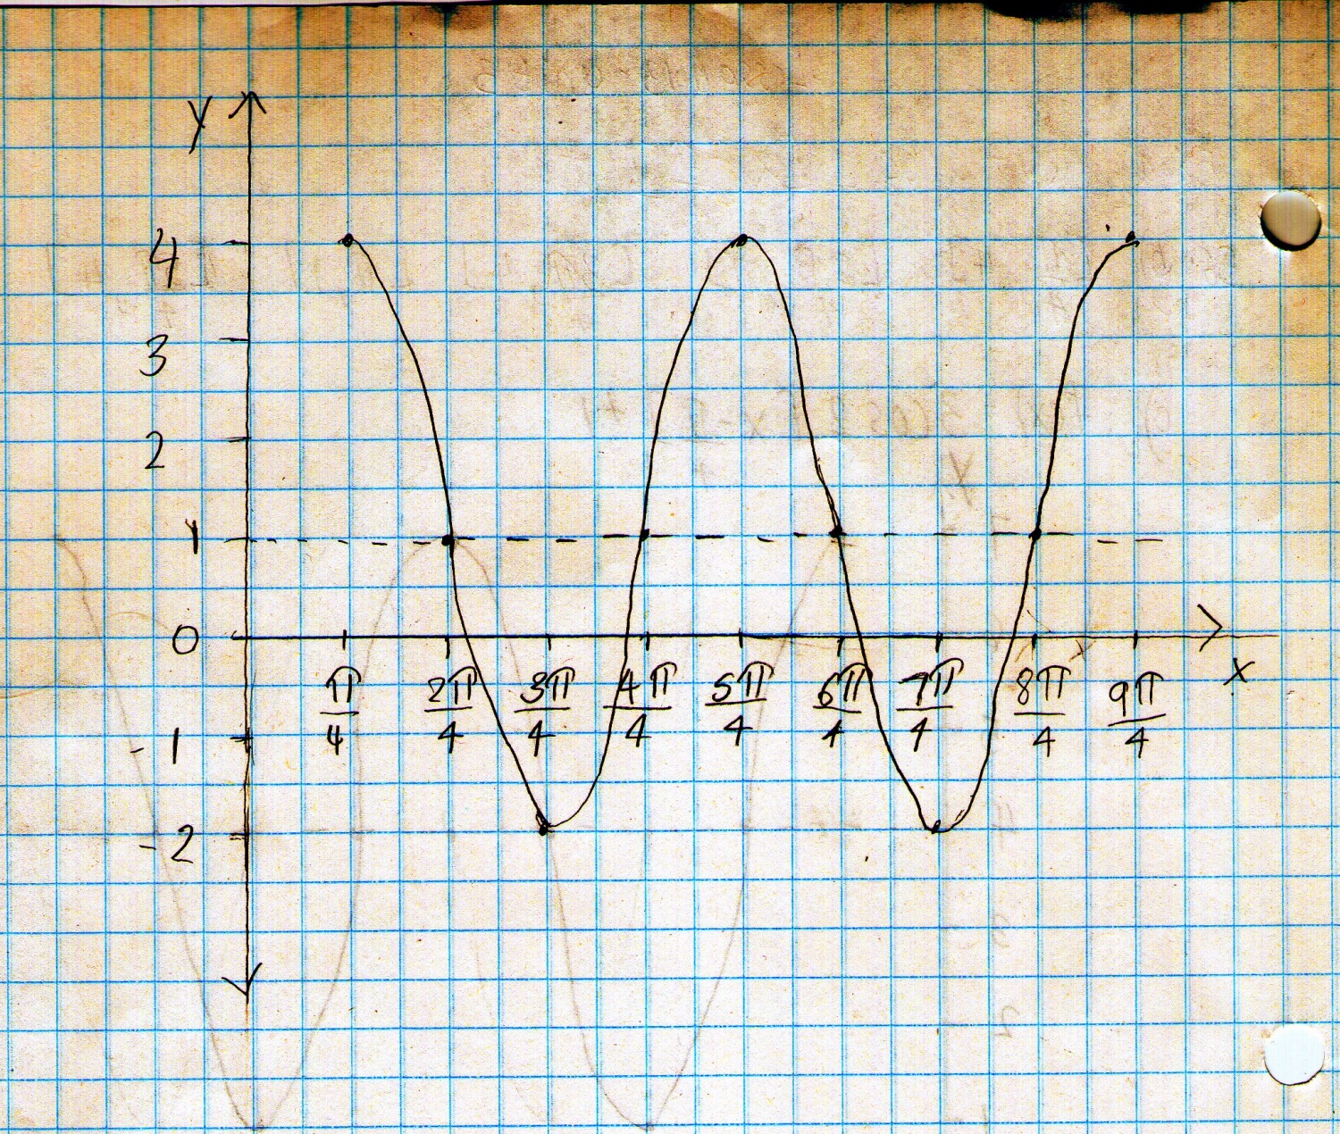

Good 3/3

Nice 3/3

59. Sin[$\frac{5π}{12}]$
Key Questions Lesson 14
=Sin[$\frac{π }{4}$+$\frac{π}{6}]$
=Sin$\frac{π}{4}$cos$\frac{π}{6}$ + cos$\frac{π}{4}$sin$\frac{π}{6}$
=($\frac{1}{\sqrt{2}})( \frac{\sqrt{3}}{2}$) +($\frac{1}{\sqrt{2}})(\frac{1}{2})$
=$\frac{\sqrt{3}}{2\sqrt{2}}+\frac{1}{2\sqrt{2}}$
=$\frac{\sqrt{3}+1}{2\sqrt{2}}$ great 5/5

60. a) $cos$($π-x)$ = $-cosx$
R.S=$-cosx$
L.S= $cos$($π-x)$
= $cosπcosx+sinπsin\frac{3π}{2}$
= $-1(cosx)+0(sinx)$
= $-cosx$
$∴$ L.S = R.S
3/3
b) $cos⁡[\frac{3π}{2}+x]$ = $sinx$
R.S= $sinx$

L.S= $cos\frac{3π}{2}cosx-\sin{xsin\frac{3π}{2}}$
= $0\left(cosx\right)-sinx\left(-1\right)$
= $sinx$good 3/3
$∴$ L.S = R.S

c) $sinxcosxtanx=1-cos^{2}x$
R.S = $1-cos^{2}x$
= $\sin^{2}x$
L.S= $sinxcosx$
= $sinxcosx$ $[\frac{sinx}{cosx}]$
= $\frac{\sin^{2}xcosx}{cosx}$
= $\sin^{2}x$
$∴$ L.S = R.S
Good 3/3

61.a) $cosθ+sinθtanθ$ $= \frac{1}{cosθ}$
Key Questions Lesson 15
L.S= $cosθ+sinθ$ $[\frac{sinθ}{cosθ}$]
R.S= $\frac{1}{cosθ}$
= $cosθ+$ $\frac{sin^{2}θ}{cosθ}$
= $\frac{cos^{2}θ+sin^{2}θ}{cosθ}$
= $\frac{1}{cosθ}$
$∴$ L.S = R.S good 3/3

b) $tanθ$= $\frac{1-cos2θ}{sin2θ}$
R.S= $\frac{1-cos2θ}{sin2θ}$
= $\frac{1-(1-2sin^{2}θ)}{2sinθcosθ}$
= $\frac{1-1+2sin^{2}θ}{2sinθcosθ}$
= $\frac{sinθ}{cosθ}$
L.S= $tanθ$
$$=\frac{sinθ}{cosθ}$$

Good 5/5
$∴$ L.S = R.S

62. a) $2\cos^{2}x+3cosx-2=0$
($2cosx-1)(cosx+2)=0$
$2cosx-1=0$
$$Cosx+2=0$$
$$Cosx=-2$$

$∴$No solution
$Cosx$ = $\frac{1}{2}$
$x=$ $\frac{π}{3}$, $\frac{5π}{3}$ yes, 4/4

b) $sinx=cos2x$
$sinx=1-2\sin^{2}x$
$2\sin^{2}x+sinx-1=$0
$$\left(2\sin{x}-1\right)\left(sinx+1\right)=0$$

Sinx=-1 x= 3π2Sinx=-1 x= 3π22sinx-1=0
$Sinx$ = $\frac{1}{2}$
$x$= $\frac{π}{6}, \frac{5π}{6}$
Nice 5/5

c) $sinx=\sqrt{3}cosx$
$\frac{sinx}{cosx}=$ $\frac{\sqrt{3}cosx}{cosx}$
$$tanx= \sqrt{3}$$

$∴x= \frac{π}{3}, \frac{54π}{3}$ 2/2

d) The graphs are not the same; therefore they are not equal to each other. Ok 1/1

