

Faculty of Engineering
GNG 1106: Fundamentals of Engineering Computation
Assignment 1 Report: Geometric Shapes

By:
For:
Due:

Problem Identification and Statement

A program is to be developed that helps high school students investigate, and compute various properties for four geometric shapes. These shapes are the square, circle, cylinder, and sphere. The properties to be computed, respectively, are: perimeter and area; circumference and area; surface and volume; surface area and volume. (Although the problem requests the square as a shape to be investigated, the square is a special case of a rectangle where all sides are the same, therefore “square” will herein be referred to as rectangle.)

The program must provide the user with the ability to select from a list the shape to be investigated, and to select which property to be computed. After these selections are made the program must prompt the user for all the required information for the property chosen, compute the property value, and finally display its value.

Although not explicitly necessary, the use of looping was implemented thereby allowing the user to continue selecting shapes and properties indefinitely until the program is terminated.

Gathering of Information and Input Output Description

To compute the properties selected by the user, the formulas for these properties must be known, they are as follows:

Rectangle:

Perimeter = 2(a+b), where a and b are the side lengths of the rectangle.
Area = a*b

Circle:

Circumference = 2*π*r, where r is the radius of the circle.
Area = π*r²

Cylinder:

Surface area = 2*π*r*h, where r is the radius of the base and h is the height of the cylinder.
Volume = π*r²*h

Sphere:

Surface area = 4*π*r², where r is the radius of the sphere.
Volume = (3/4)*π*r³

The input parameters which as listed above are a,b,r, and h, depending on the shape, will be entered by the user. These are then processed by the program and the result is printed on the screen.
Test Cases and Algorithm Design

Test Case 1: Rectangle Perimeter

Perimeter = 2(a+b), a = 5, b= 5
Perimeter = 2(5+5)
Perimeter = 20

Test Case 2: Circle Circumference

Circumference = 2*π*r, r = 2
Circumference = 2*π*2
Circumference = 12.566

Test Case 3: Circle Area

Area = π*r², r = 3
Area = π*(3)²
Area = 28.274

Test Case 4: Cylinder Surface Area

Surface area = 2*π*r*h, r = 2, h = 2
Surface area = 2*π*2*2
Surface area = 25.132

Test Case 5: Sphere Volume

Volume = (3/4)*π*r³, r = 5
Volume = (3/4)*π*(5)³
Volume = 294.524

Begin:
Declare floating point variables for: radius, diameter, circumference, perimeter, side_a, side_b, height, volume

Declare integer variables for use in shape selection/looping: main_loop, rectangle_loop, circle_loop, cylinder_loop, sphere_loop

Set main_loop to 0

Print welcome screen and instruction text

While main_loop is anything but integers 1 through 5 inclusive

Print instructions to select shape by selecting and integer form 1 to 5
Read value in to main_loop

Case of main_loop

Condition 1: Rectangle

Set rectangle_loop to 0
Clear screen
Print rectangle information and instructions
Print “a=”
Read value in to side_a
Print “b=”
Read value in to side_b
Print property selection options, perimeter, area

While rectangle_loop is anything but integers 1,2

Read value in to rectangle_loop

Case of rectangle_loop

Condition 1: Perimeter

Perimeter = 2*(side_a+side_b)
Print value of perimeter
Break

Condition 2: Area

Area = side_a*side_b
Print value of area
Break

Condition Default: Invalid selection

Print instructions to choose 1 or 2
Break

End Case of rectangle_loop

Pause
Clear screen
Set main_loop to 0 to exit rectangle_loop and return to main_loop
Break

Condition 2: Circle

Set circle_loop to 0
Clear screen
Print circle information and instructions
Print “radius=”
Read value in to radius
Print property selection options, circumference, area

While circle_loop is anything but integers 1,2

Read value in to circle_loop

Case of circle_loop

Condition 1: Circumference

Circumference = 2*π*radius
Print value of circumference
Break

Condition 2: Area

Area = π*(radius)²
Print value of area
Break

Condition Default: Invalid selection

Print instructions to choose 1 or 2
Break

End Case of circle_loop

Pause
Clear screen
Set main_loop to 0 to exit circle_loop and return to main_loop
Break

Condition 3: Cylinder

Set cylinder_loop to 0
Clear screen
Print cylinder information and instructions
Print “radius=”
Read value in to radius
Print “height=”
Read value in to height
Print property selection options, surface area, volume

While cylinder_loop is anything but integers 1,2

Read value in to cylinder_loop

Case of cylinder_loop

Condition 1: Surface area

Surface area= 2*π*radius*height
Print value of surface area
Break

Condition 2: Volume

Volume = π*(radius)²*height
Print value of volume
Break

Condition Default: Invalid selection

Print instructions to choose 1 or 2
Break

End Case of cylinder_loop

Pause
Clear screen
Set main_loop to 0 to exit cylinder_loop and return to main_loop
Break

Condition 4: Sphere

Set sphere_loop to 0
Clear screen
Print sphere information and instructions
Print “radius=”
Read value in to radius
Print property selection options, surface area, volume

While sphere_loop is anything but integers 1,2

Read value in to sphere_loop

Case of sphere_loop

Condition 1: Surface area

Surface area= 4*π*(radius)²
Print value of surface area
Break

Condition 2: Volume

Volume = (3/4)*π*(radius)³
Print value of volume
Break

Condition Default: Invalid selection

Print instructions to choose 1 or 2
Break

End Case of sphere_loop

Pause
Clear screen
Set main_loop to 0 to exit sphere _loop and return to main_loop
Break

Condition 5: Exit

Clear screen
Print Goodbye
Break

Condition: Default

Clear screen
Print instructions to choose an integer from 1 to 5
Break

Pause

Return 0

Implementation

/********************************************/
/* */
/* September 30, 2013. */
/* Filename: assignment1.GNG1106.7489069 */
/* This program performs various operations */
/* for shapes whose parameters are input */
/********************************************/
#include <stdlib.h>
#include <stdio.h>
#include <math.h>
#define PI 3.141593

int main() //main program
{
float rad, diam, area, circum, perim, side_a, side_b, height, volume; //Float and integer declarations. Multiple variables with descriptive names were
int select_main, select_rect, select_circ, select_cylndr, select_sphere; //used for readability, as opposed to using one or two variables for the calculations.

select_main = 0;

printf("Welcome! This program helps you learn more about rectangles, circles, cylinders and spheres:" //Welcome screen
"by providing descriptions and calculating parameters such as circumference, area, and volume.\n\n");

while(select_main<1 || select_main>5) //Loops while select_main value is anything other than 1,2,3,4 or 5. This allows the user to make indefinite shape selections,
{ //and avoids ending the program when an erroneous number is selected.

printf("Please enter the number corresponding to the shape you would like to investigate or press 5 to terminate program:\n"
"\n\t1.Rectangle\n\t2.Circle\n\t3.Cylinder\n\t4.Sphere\n\n\t5.Done\n\nYour selection is: ");
scanf("%d", &select_main);

switch(select_main) //Shape selection, cases 1 through 4 each relating to a shape, with 5 ending the program. The arithmetic operations are also performed in each case.
{
case(1): //Rectangle
{
select_rect = 0;
system("cls"); //This command clears the screen. Unfortunately it appears to be unique to Windows. For POSIX use "system(clear);"
printf("You have selected the Rectangle. A rectangle is a polygon with four sides, and four right angles."
"A rectangle with four sides of equal length is a square. Please input sidelengths a and b, followed "
"by the number corresponding to the operation you would like to perform.\n\n");
printf("a = ");
scanf("%f", &side_a);
printf("\nb = ");
scanf("%f", &side_b);
printf("\n1.Perimiter\n2.Area\n\nYour selection is: ");

while(select_rect<1 || select_rect>2) //Loops while select_rect value is anything other than 1,2. Avoids complications when erroneous integers are entered
{
scanf("%d", &select_rect); //Reads case selection. 1 for perimeter, 2 for area.

switch(select_rect)
{
case(1):
{
perim = 2*(side_a+side_b);
printf("\nThe perimeter of a rectangle with side lengths %f and %f is: %f\n", side_a, side_b, perim);
break;
}
case(2):
{
area = side_a*side_b;
printf("\nThe area of a rectangle with side lengths %f and %f is: %f\n", side_a, side_b, area);
break;
}
default:

printf("Please chose 1 for perimeter or 2 for area.\n");
break;
}
}

}
system("PAUSE");
system("cls");
select_main = 0; //Returns to main loop for shape selection after break
break;

case(2): //Circle
{
select_circ = 0;
system("cls"); //This command clears the screen. Unfortunately it appears to be unique to Windows. For POSIX use "system(clear);"
printf("You have selected the Circle. A circle is the set of all points in a plane that are equidistant from a central point."
" The distance between any point and this central point is called the 'radius'. Please input a radius length, followed"
" by the number corresponding to the operation you would like to perform.\n\n");
printf("radius = ");
scanf("%f", &rad);
printf("\n1.Circumference\n2.Area\n\nYour selection is: ");

while(select_circ<1 || select_circ>2) //Loops while select_rect value is anything other than 1,2. Avoids complications when erroneous integers are entered
{
scanf("%d", &select_circ); //Reads case selection. 1 for circumference, 2 for area.

switch(select_circ)
{
case(1):
{
circum = 2*PI*rad;
printf("\nThe circumference of a circle with radius %f is: %f\n", rad, circum);
break;
}
case(2):
{
area = PI*pow(rad,2);
printf("\nThe area of a circle with radius %f is: %f\n", rad, area);
break;
}
default:

printf("Please chose 1 for circumference or 2 for area.\n");
break;
}
}
}

system("PAUSE");
system("cls");
select_main = 0; //Returns to main loop for shape selection after break
break;

case(3): //Cylinder
{
select_cylndr = 0;
system("cls"); //This command clears the screen. Unfortunately it appears to be unique to Windows. For POSIX use "system(clear);"
printf("You have selected the Cylinder. A cylinder is a basic curvilinear shape that is enclosed by the set of all points"
" that are equidistant from a central point for a certain length(radius), along an axis, and two planes perpendicular"
" to said axis. Please input a radius length and a height, followed by the number corresponding to the operation"
" you would like to perform.\n\n");
printf("radius = ");
scanf("%f", &rad);
printf("height = ");
scanf("%f", &height);
printf("\n1.Surface Area\n2.Volume\n\nYour selection is: ");

while(select_cylndr<1 || select_cylndr>2) //Loops while select_rect value is anything other than 1,2. Avoids complications when erroneous integers are entered
{
scanf("%d", &select_cylndr); //Reads case selection. 1 for area, 2 for volume.

switch(select_cylndr)
{
case(1):
{
area = 2*(PI*rad*height);
printf("\nThe surface area of a cylinder with radius %f and height %f is: %f\n", rad, height, area);
break;
}
case(2):
{
volume = PI*pow(rad,2)*height;
printf("\nThe volume of a cylinder with radius %f and height %f is: %f\n", rad, height, volume);
break;
}
default:

printf("Please chose 1 for surface area or 2 for volume.\n");
break;
}
}
}

system("PAUSE");
system("cls");
select_main = 0; //Returns to main loop for shape selection after break
break;

case(4): //Sphere
{
select_sphere = 0;
system("cls"); //This command clears the screen. Unfortunately it appears to be unique to Windows. For POSIX use "system(clear);"
printf("You have selected the Sphere. A Sphere is a circular object in 3-dimensional space that is perfectly round."
" Just as a circle is the set of all points that are equidistant from a central point for a certain radius in 2 dimensions,"
" the same is true for a sphere but in 3 dimensions. The radius for a given sphere is the same as its 2-dimensional analogue."
" Please enter a value for the radius, followed by the number corresponding to the operation you would like to perform.\n\n");
printf("radius = ");
scanf("%f", &rad);
printf("\n1.Surface Area\n2.Volume\n\nYour selection is: ");

while(select_sphere<1 || select_sphere>2) //Loops while select_rect value is anything other than 1,2. Avoids complications when erroneous integers are entered
{
scanf("%d", &select_sphere); //Reads case selection. 1 for surface area, 2 for volume.

switch(select_sphere)
{
case(1):
{
area = 4*(PI*pow(rad,2));
printf("\nThe surface area of a sphere with radius %f is: %f\n", rad, area);
break;
}
case(2):
{
volume = 0.75*(PI*pow(rad,3));
printf("\nThe volume of a sphere with radius %f is: %f\n", rad, volume);
break;
}
default:

printf("Please chose 1 for surface area or 2 for volume.\n");
break;
}
}
}

system("PAUSE");
system("cls");
select_main = 0; //Returns to main loop for shape selection after break
break;

case(5): //Exit
{

system("cls"); //Unfortunately this command appears to be unique to Windows. For POSIX use "system(clear);"
printf("\n**Thanks! Goodbye.**\n");
break;

}

default:

system("cls");
printf("**Please choose an integer from 1 to 5!**\n\n");
break;

}
}

system("PAUSE");
return 0;
}

Software testing and Verification

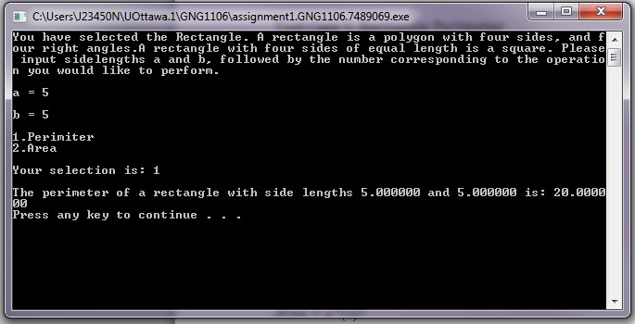
Test Case 1: Rectangle Perimeter

Test Case 2: Circle Circumference
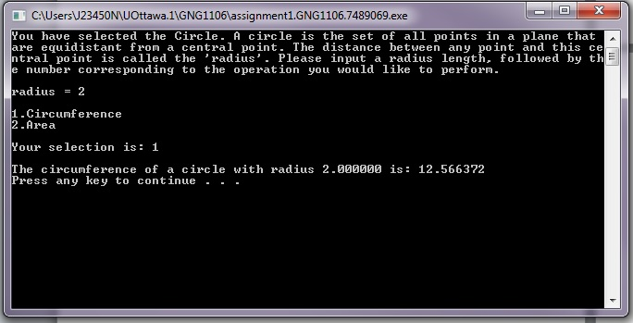

Test Case 3: Circle Area

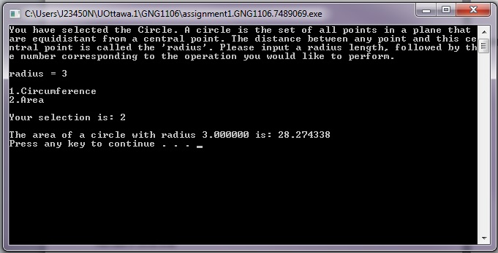
Test Case 4: Cylinder Surface Area

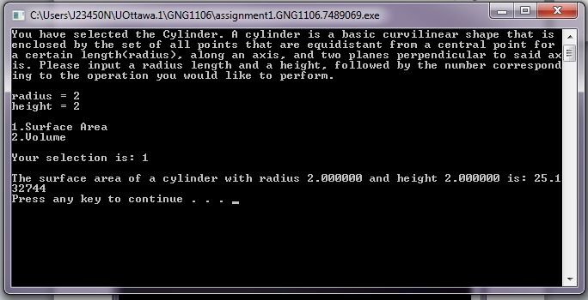

Test Case 5: Sphere Volume

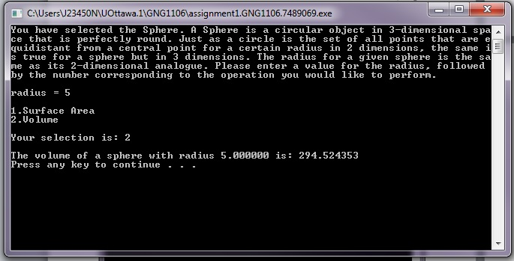
Given the nature of the program, there are two most test cases that are relevant to its operation. One is the main_loop case 5, which terminates the program, and the other is the case where main_loop is fed an incorrect integer.

Test Case 6: Terminating the program

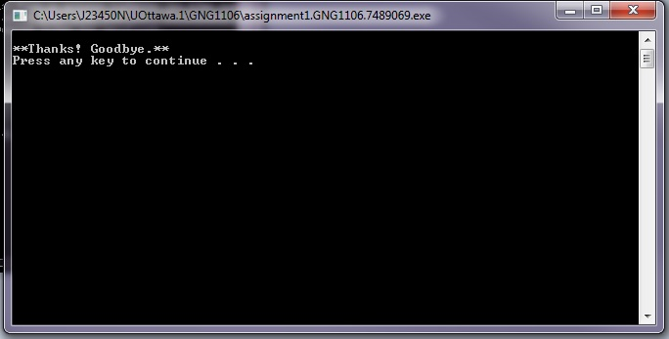

Test Case 7: Entering an invalid integer

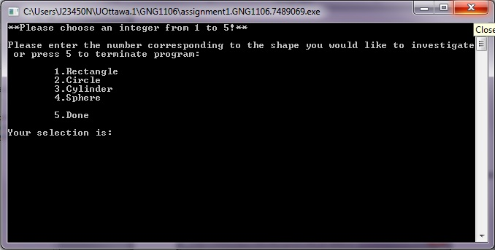

End Notes

As noted in the program comments, the “system(clr)” is understood to be exclusive to windows, and therefore may not run properly in a POSIX environment. No alternatives appeared to be in the libraries provided with codeblocks, conio.h and curses.h in particular. Also, the program does indeed break when a non-integer character is entered for any of the scanf functions. This is not easily avoidable and was deemed outside the scope of this assignment. One solution may have been to use the ceiling, floor, or round functions to round a float to the nearest integer, but this makes the input inconsistent and only solves the problem for floats; characters still break it.

