Introduction to Business Management
Text Book
Chapter 7

- Management: The process of achieving organizational goals through people and other resources both effectively and efficiently.
- Managers Role: To combine human and technical resources in the best way possible to achieve the company’s goals.
- The Management Hierarchy

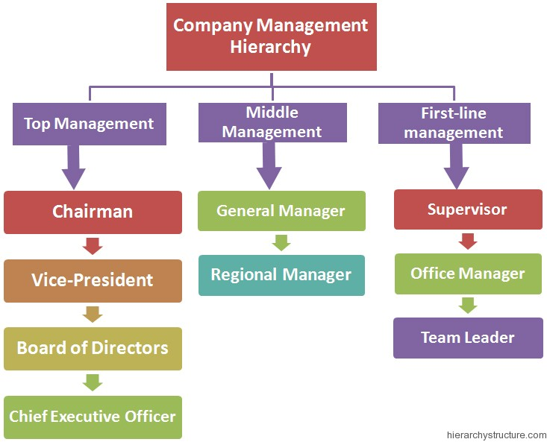
- Top Manager: Spend most of their time developing long range plans for their organizations. Deciding whether to introduce new products, purchase other companies, or enter new geographical markets.
- Middle Managers: They develop detailed plans and procedures to carry out the firm’s strategic plans. They essentially focus on the products being sold and on the customers who will buy the products and lead to the profit growth intended by the CEO.
- Supervisory Management: They work directly with the employees who produce and sell he firm’s goods and services. They carry put middle managers’ plans by motivating workers to accomplish daily, weekly & monthly goals.

3 Management Skills

- Technical Skills: are the manager’s ability to understand and use the techniques, knowledge tools and equipment of a specific department or area of study. (Very important for first line managers)
- Human Skills: Interpersonal skills that help managers to work effectively with people. They include ones ability to communicate, motivate and lead employees to complete their tasks.
- Conceptual Skills: help managers see the organization as a single unit as well as being able to see the big picture by acquiring, analyzing and interpreting information.

4 Functions of Management (P.L.O.C or P.D.O.C)

- Planning: the process of looking forward to future events and deciding on the course of action for achieving organizational goals.
- Directing (Leading): Guiding and motivating employees to accomplish organizational goals.
- Organizing: the process of blending human and material resources through a formal structure of tasks and authority; arranging work, dividing work, etc.
- Controlling: the function of accessing an organizations performance against its goals.

- Vision: the ability to perceive marketplace needs and what an organization must do to satisfy them.

4 Categories of Planning

Strategic Planning: The most far-reaching level of planning. It is the process of deciding on the primary objectives of an organization and then taking action and setting aside resources to achieve those objectives.

Tactical Planning: Carrying out the activities set out in strategic plans. They guide the current and short term activities required to carry out the overall strategies.

Operational Planning: sets the detailed standard that helps out tactical plans. It involves choosing specific work targets and assigning employees and teams to carry out plans.
Contingency Planning: Is essentially viewed as a back up plan, which helps firms resume operations as quickly and smoothly as possible after a crisis.

Mission Statement: A written description of an organization’s overall business purpose and aims.

Swot Analysis: Asses the factors that can help a company grow or cause it to fail. It is a tool that is often used in this part of strategic planning.
Strength: Weaknesess:
Leverage Problems
Opportunities: Threats:

Objectives: set targets so hat managers can plan for the organizations hoped-for performance.

The basic goal of developing a strategy is competitive differntiation – the unique mix of a company’s abililties and resouces that set it apart from its competitors.

Implemetning Strategy

Lecture

Efficiency: the amount of resources incurred to produce goods and services (doing things right)

Effectiveness: how well an organization is doing in meeting its goals (doing the right things)

Manager: the person responsible for supervising resources to achieve goals.

P.L.O.C

Organizing
- Structuring workplace to achieve goals
- Mobilize resources, arranging work
- Creates organizational structure
- A formal system of relations

Controlling

Steps
- Set performance standards, monitor performance, compare actual with standards, make corrections
- Also allows managers to measure themselves in 3 other areas

Steps in the Planning Process

Define mission
Assess competitive position (swot analysis)
Set objectives (what are the goals that you are trying to achieve which must be specific, measurable, agreed upon, realistic, timely,)
Create strategies for Differentiation to action (what makes you different as an organization)
Strategy to action
Evaluate and refine

IN THE MIDDLE (Feedback)

The Leadership Function

- Leadership – the ability to direct or inspire people to reach goals or inspire people to reach goals
- Involves influence and/or power
- Various traits to leaders…
- Various styles of leadership
- Autocratic – centered on boss
- Democratic – employee involvement, empowerment
- Free-rein – minimal supervision

Corporate Culture

- A system of shared meaning (values, behaviors, etc.) that determines how employees act
- Distinguishes one organization from another
- Is the ‘glue’ that bonds an organization
- “The way we do things around here”
- When change occurs it creates a much larger effect based on corporate culture.

