Training & Development: Exam Study - Content

Final exam content
- Section A: 5 definitions (out of 10 each worth 5 marks) = 25 marks
- Section 2: choice do 1 of 2 - Short Answer questions = 10 marks
- Section 3: Mini-Cases (like in text) - No choice 2 cases = 10 + 15 = 25 marks

Content

INSTRUCTIONAL SYSTEMS DESIGN MODEL (ISD)
- Scientific model of the training and development process, that consists of a needs analysis, training design and delivery, and training evaluation
- Needs analysis shows whether training is needed and what gaps there are that need to be filled
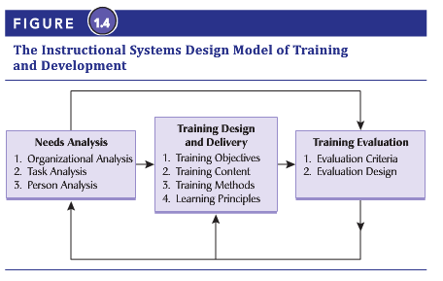
- Purpose of training is improve performance and organizational effectiveness

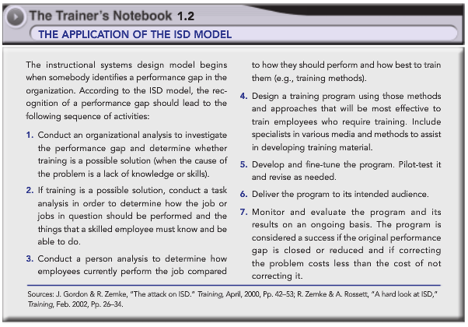

Learning Styles
- Using all four styles is best
- Importance of learning cycle; see chart
- All four steps in learning cycle should be part of learning experience
- Learning modes
  - Thinking (AC)
    - Gather information by thinking about issues, concepts and ideas
  - Feeling (CE)
    - Direct experience and involvement
  - Watching (RO)
    - Observe and reflect, different point of view
  - Doing (AE)
    - Doing something for practical value
- Implications for training
  - People differ on how they learn
  - Training programs should be designed with each learning mode as part of a sequence of learning experience
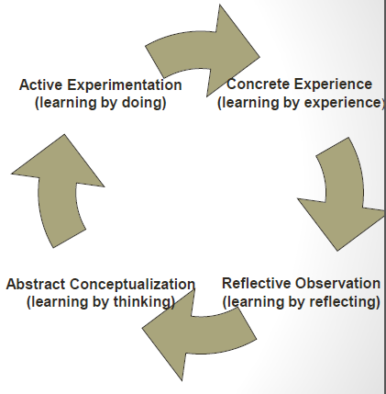

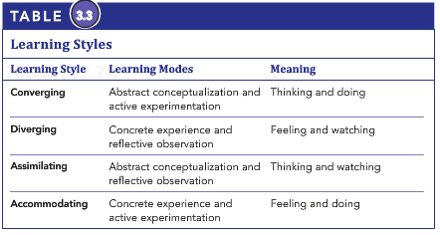

Adult Learning Theory
- Adults need to know why they learn
- It has to be meaningful
- They need opportunity to practice
  - Massed versus Distributed Training
    - Refers to how the segments of a training program are divided and whether the training is conducted in a single session (massed) or is divided into several sessions with breaks or rest periods between them (distributed)
  - Whole versus Part Learning
    - Refers to whether the training method is learned and practiced at one time or one part at a time
  - Overlearning
    - Continued practice even after trainees have mastered a task so that the behaviour becomes automatic
    - Automaticity
    - The performance of a skill to the point at which little attention from the brain is required to respond correctly
- They need feedback
- Adults learn through observation, experience, and interaction with others
- Andragogy
  - An adult-oriented approach to learning that takes into account the differences between adult and child learners
- Design and instruction of training should be joint responsibility of trainer and trainee
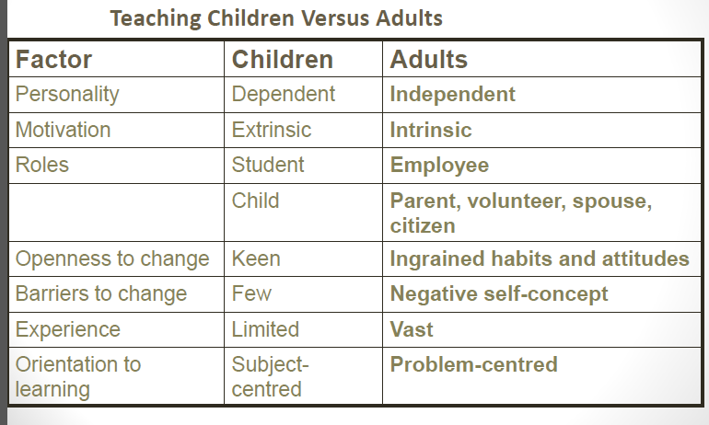
- Adults should provide input about training they receive

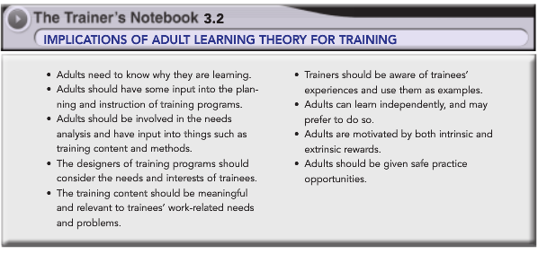

Model of Training Effectiveness
- Highlights the linkages between training and learning and between learning and individual performance and organizational effectiveness.
- Things that influence learning and retention is cognitive ability, job attitudes, self-efficacy, training motivation and personality characteristics
- After learning and retaining the content from the training the trainee must transfer that into individual behaviour and performance which is called transfer of training
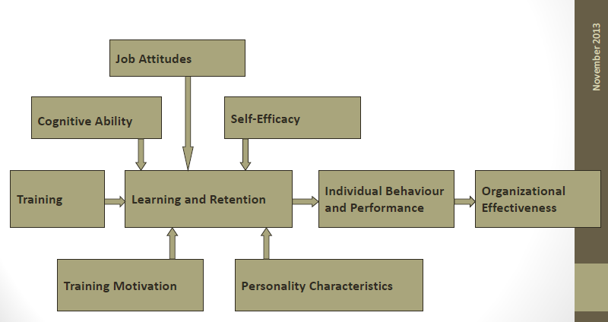
- The last step is how individual behaviour and performance have an effect on organizational effectiveness

The Needs Assessment Process
- Step 1
  - Concern
    - Listed under reasons or “pressure points” in diagram
- Step 2
  - Importance
    - Training manager must be aware of strategic orientation
    - Cost implications
    - If it is important concern, than should be able to demonstrate that correcting problem will increase productivity or client satisfaction
- Step 3
  - Consult stakeholders
    - Support from key players/stakeholders are important to have at the beginning of an needs analysis
    - Top management should understand rationale for training
    - Training analysts must obtain why the needs analysis is being done and who will be involved
    - All stakeholders must buy into the needs analysis to ensure data collection will result in accurate information and they are committed to success of the program
  - Step 4
    - Data collection
      - Documentation of the concern through collection of information from three levels of analysis
        - Organizational
          - Provides information about strategies and context and finds out where the training is needed in the organization
          - Involves strategy, environment, resources, and context
          - Indicates training needs and probability of success
          - Must align with organization’s strategy
            - Show type and amount of training needed
          - Training and development embedded in the external environment
            - Environment is dynamic and uncertain
              - New technology, competitors, recessions, and trade agreements
            - Training programs often direct result of government regulations (safety)
            - Also can be from organizations attempt to establish a niche market (new technology, etc.)
          - Must make sure the organization has the resources (money, time, and expertise) to design and deliver a training program
            - Training programs also require materials, equipment, and facilities
            - Determines if training is more cost effective or if another solution would be cheaper
          - Must be aware of the organizational context which refers to the organizational climate and training transfer climate
            - Organizational climate is collective attitudes towards work, supervision, company goals, policy, and procedures
            - Training transfer climate is whether the climate facilitates or inhibits the application of training on the job
            - Looking at the culture is important too, which is the shared beliefs amongst employees
            - Organizations should adopt a continuous learning culture where employees feel like learning and skill acquisition are a part of their job responsibility and that it is important to the work
            - These cultures and climates are important because if they are not strong than there is no point of training
        - Task
          - Provides information about tasks and relevant knowledge, skills, and abilities needed to perform the job
          - 6 steps in task analysis
            - 1. Identify the target jobs.
            - 2. Obtain a job description.
            - 3. Develop rating scales to rate the importance of each task and the frequency with which it is performed.
            - 4. Survey a sample of job incumbents.
            - 5. Analyze and interpret the information.
            - 6. Provide feedback on the results.
          - Cognitive task analysis
            - Focuses on understanding the mental processes and skills required for a job
            - Better for complex jobs
            - Looks at things like decision making, problem solving, etc. that aren’t directly observable
            - Best methods of this is interviews and observation
          - Team task analysis
            - Looks at team-based competencies associated with tasks
              - Communication, interaction, and coordination of tasks
            - Looks at interdependencies of a job and cognitive skills needed to interact in a team
            - Best methods are group interviews, review of existing information, observation, questionnaires, examining past events
        - Person
          - Provides information about an employee’s level of performance and finds out who needs to be trained
          - 3 step process
            - 1. Define the desired performance.
              - Standard or acceptable level of performance
              - Proficiency assessment – what competencies are needed to complete job
            - 2. Determine the gap between desired and actual performance.
              - Comparison is made from performance appraisals, work samples, observations, self-assessments, and formal tests
            - 3. Identify the obstacles to effective performance.
              - Many reasons for gaps and solutions for each type identified in “barriers to effective performance”
                - Include lack of knowledge, skills, motivation
                - Counterproductive system
                - Group norms
  - Outcomes
    - Good list is within diagram
    - Development of measures for training evaluation
    - Where the training is needed
    - Design and delivery of training
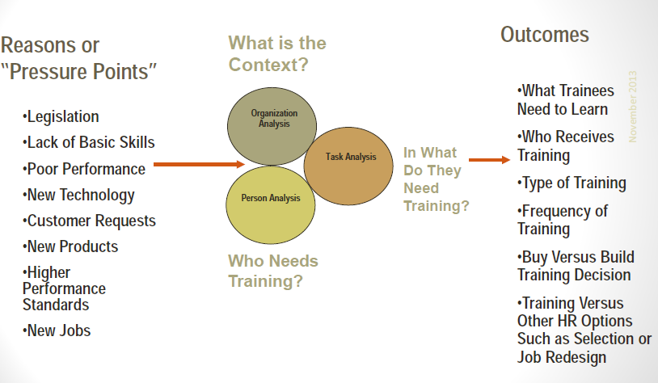

Barriers to Effective Performance
- only the first two (lack of knowledge and skills) suggest a training solution
- a flowchart of decision making is used to find best solutions to this
  - first step is to decide if the problem or gap is worth pursing (time and money)
  - try some quick fixes
    - clarify expectations and standards
    - setting goals
    - provide necessary resources
    - provide performance feedback
  - if can’t be quick fixed, must find source of problem by doing an analysis
    - Is desired performance being punished? If so remove
    - Is poor performance being removed? If so remove
    - Performance consequence used effectively? If not rearrange consequences
      - Can use contingency management
        - bad behaviour has negative consequences, which is not repeated by employee
        - good behaviour has good consequence, which is repeated by employee
        - similar to conditioning theory
  - if that doesn’t solve it, must look at skill deficiency
    - must see if employee could do the job if their life depended on it
    - if they can than training is not needed
    - if they can’t do it than look at other methods before training
      - lower expectations
      - simplify task
      - transfer employee
      - remove obstacles
        - lack of authority
        - bad tools/tech
        - conflicting responsibility
        - work overload
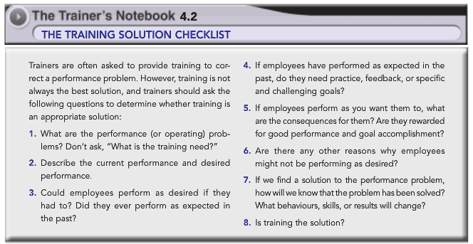
    - if there is no potential for the employee to change their skill deficiency, than remove them, if there is some potential than do training

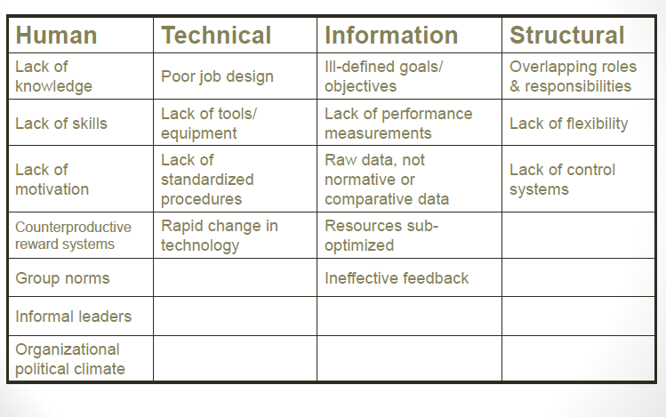

Determining if Training is the Best Solution
- Must look at all the barriers and the flowchart of decision making
- Performance is important and could be costly from lost productivity
- Employees don’t know how to perform effectively
- Employees received little to no training
- Employees can’t demonstrate correct knowledge/behaviour
- Performance expectations are clear and no obstacles to performance
- Positive consequences for good performance, while poor performance is not rewarded
- Employees receive timely, relevant, accurate, constructive, and specific feedback about their performance (a feedback issue)
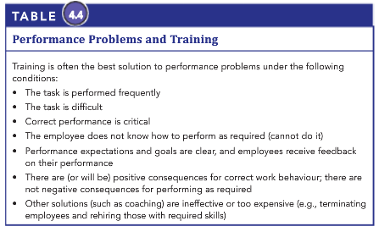
- Other solutions like job transfer or redesign are more expensive than training

Gagne-Briggs: Nine events of Instruction
- Gain attention
  - Trainee engagement
  - Present a thought-provoking problem
  - Getting them interested and motivated, trainees should know why training is important
- Describe objectives
  - Must communicate what they will learn, what to expect, and what they will accomplish
  - Should know how they would apply on the job
  - Might provide a demonstration of desired behaviour
  - Helps trainees focus on what they need to learn and to think about goals
- Stimulate recall of prior knowledge
  - Show relation of what they know with what they are about to learn
  - Let trainees discuss what they already know about training material
  - Trainer might provide framework to help trainees learn
- Present the material to be learned
  - Logical and consistent manner
  - Trainer asks questions at various points during training and ask trainees to provide examples of own experience
- Provide guidance to learning
  - Direction on how best to learn material
  - Using relevant examples, asking questions, and discussions to help trainees toward main learning points
- Elicit performance practice
  - Opportunity to practice and apply material
  - Trainers provide enough time for this
- Provide informative feedback
  - Trainees should receive feedback on their performance
  - Essential for trainees to know and understand what they did right, what they did wrong, and how to correct it
  - Leave them with understanding of what they did well and what they need to improve on
- Assess performance
  - Test trainees on their learning during and after training
  - Formal test or informal question/answer
  - Make sure trainees learn the material before moving on
- Enhance retention and transfer
  - Trainees must know how learning is applied to the job
  - Trainers show how the learning applies to the work situations
  - Ask trainees when they would use it at work helps
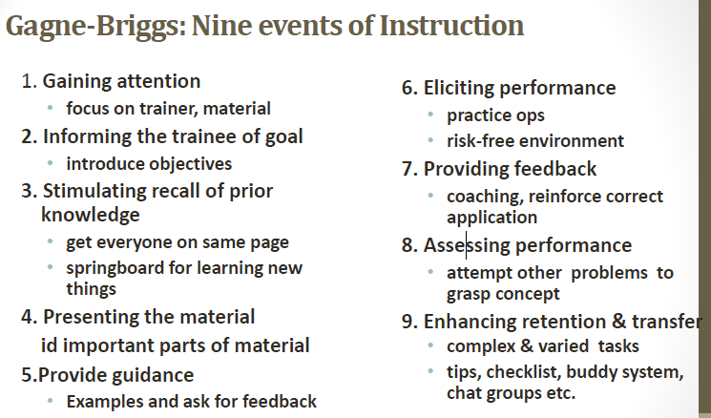
- CLOSE PROGRAM – conclude it, show a successful completion

Self-Directed Learning
- Process in which individuals take initiative and responsibility for learning and manage their own learning experiences
- Seek out necessary resources to engage in learning
- Assess their own needs, and evaluate effectiveness of meeting needs
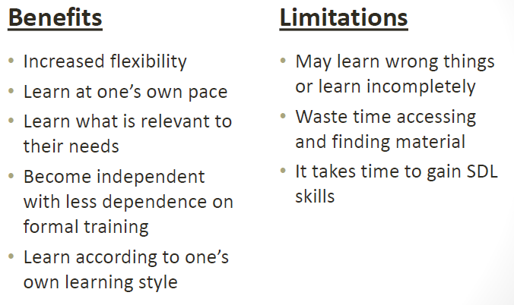
- Allows access to training materials when they want to, at their own pace, and in sequence they prefer

Different types of training sessions
- Skipped for now – must look at the slides because can’t find in textbook
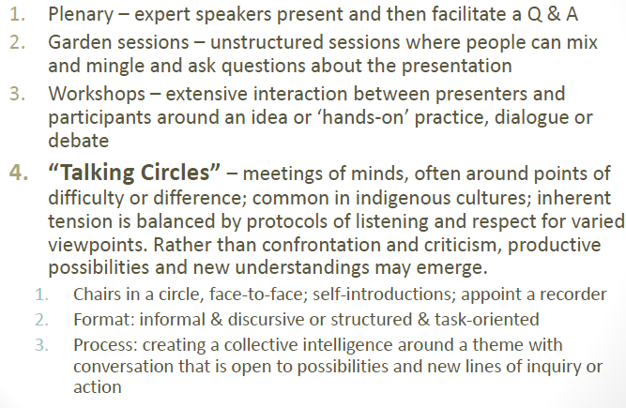

The Transfer System
- All factors in the person, training, and organization that influence transfer of learning to job performance
- Important predictors of transfer of training
- The LTSI can be used to diagnose transfer system; identify barriers and type of intervention to overcome problem
- Benefits is that it recognizes importance of systematic approach
- There is no one strategy to improve transfer of training, multiple strategies should be used
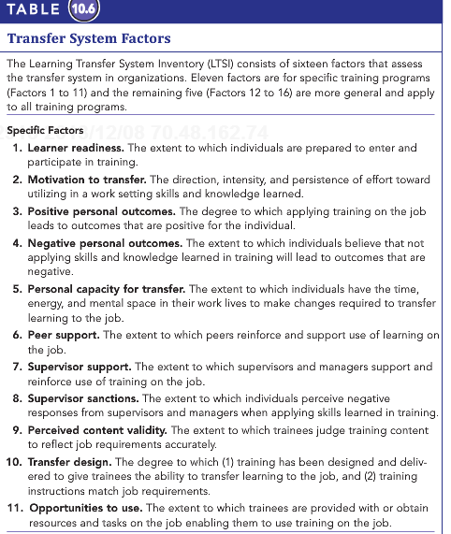
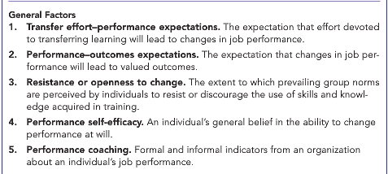

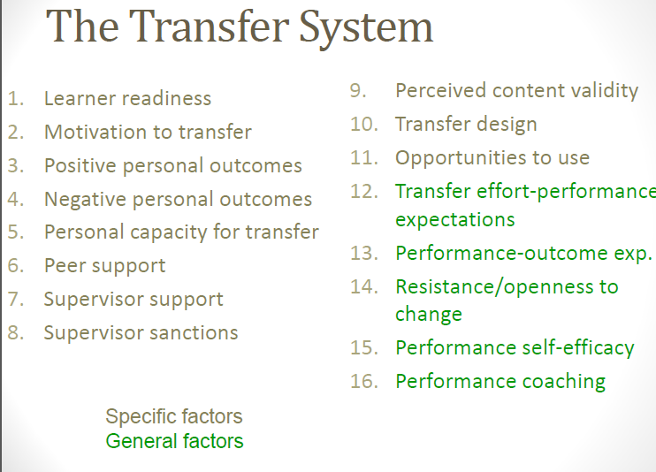

MODEL OF TRAINING EFFECTIVENESS
- Trainee characteristics have direct effect on learning and retention
- Learning and retention have direct effect on individual performance
- Individual performance has a direct effect on organizational effectiveness
- Now can add that work environment and trainee characteristics to link up with individual behaviour and performance
- Also training design has direct link to learning and retention and individual performance
- Vertical transfer is the linkage between individual level training outcomes and organizational effectiveness
  - Relationship is not one-to-one
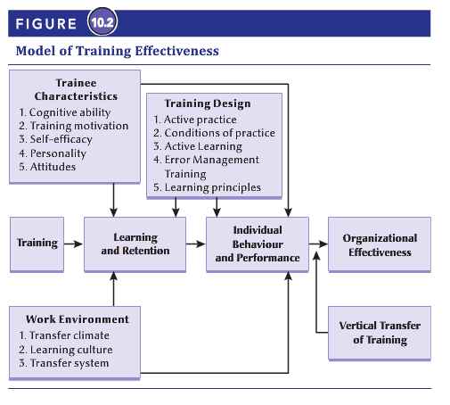
  - A change in improvement of employee performance (horizontal transfer) is necessary for vertical transfer, but not sufficient (other factors involved)

Data for Evaluation
- Reactions
  - Typically done by questionnaires
  - Affective reactions
    - Likes and dislikes of the program
  - Utility reactions
    - Perceived usefulness of a training program
    - Indicate to some degree whether transfer is likely or not
  - Immediate post-training questionnaires are the best
- Learning
  - Declarative learning
    - Acquisition of facts and information
    - Minor effect on behaviour
    - Easy to administer; multiple-choice, short answer, etc.
  - Procedural learning
    - Organization of facts and information into a smooth behavioural sequence
    - Largely effect behaviour including transfer of training
    - Harder to administer; simulations, demonstrations, etc.
  - Learning tests can provide legal defense to show training was done
- Behaviour
  - Display of newly learned skills
  - 3 basic approaches
    - Self-reports
      - Easy and practical
      - Individuals reports if they used what they learned on the job
      - Accuracy is problematic – people might lie
    - Observations
      - Supervisors/trainers/clients/co-workers observe if application of learning is done
      - More reliable and useful if observer has extensive contact
    - Production indicators
      - Assessed through productivity records such as sales or absenteeism
      - Measures impact of training
      - Can provide precise data
      - Not always the best because other factors might be in play
- Motivation
  - Training motivation and motivation to transfer
  - Use expectancy theory
    - Valence
      - Attractiveness of outcomes
    - Instrumentalities
      - Positive/negative consequence
    - Expectancies
      - Probability of transfer resulting in successful performance
- Self-efficacy
  - Trainees belief in their ability to perform behaviours
  - Assess confidence in doing tasks
- Perceived and/or anticipated support
  - Perceived support
    - Degree in which trainee reports receiving support in transfer of skills
  - Anticipated support
    - Degree in which trainee expects to be supported in attempt to transfer of skills
- Organizational perceptions
  - Perception of transfer climate and learning culture
  - 8 cues to trigger reactions that encourage/discourage transfer
    - The eight scales include goal cues, social cues, task and structural cues, positive feedback, negative feedback, punishment, no feedback, and self-control.
- Organizational results
  - Effects on training to the organization
  - Testing causality requires experimental designs that are hard to implement
  - Hard data
    - Results assessed objectively
    - Hard to obtain sometimes
  - Soft data
    - Results assessed subjectively
  - Difficult to assess impact of training directly
  - Return on expectations
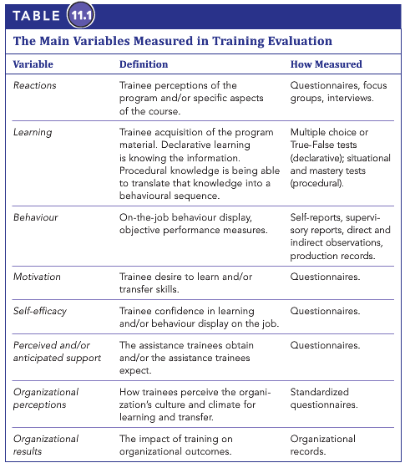
    - Measurement of a training programs ability to meet managerial expectations

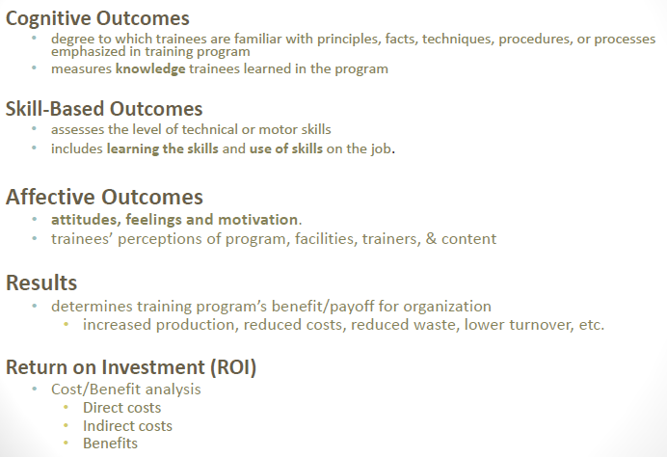

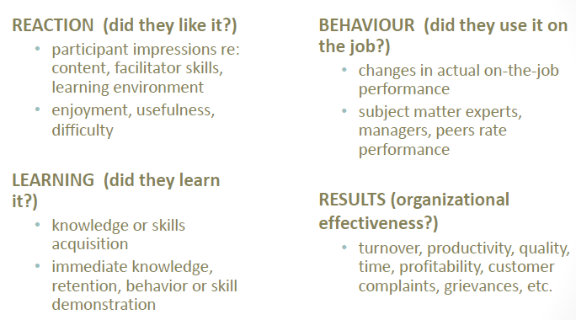

Methods of Management Development
- Informational
  - Helping managers adapt principles and techniques in conformity requires effort on the learner which requires motivation
  - Managers operate in fluid and varied environments and each manager develops their own way of applying principles learned
- Experiential learning
  - Provides motivational benefits, extensive hands on practice to build procedural knowledge, contributes to managerial self-efficacy
- Emphasis on each vary across programs
- 3 approaches
  - Management education programs
    - Acquisition of a broad range of managerial knowledge and general conceptual abilities
    - Colleges/universities (MBA)
  - Management training programs
    - Programs designed to develop specific managerial skills (communication, decision making)
    - Classrooms, seminars, and workshops
    - In house or third-party
    - Off-the-job / electronic available
  - On-the-job management development
    - Programs designed to provide managers with learning experiences on the job
    - Job rotation
      - Exposing an individual to different areas and experiences throughout organization
    - Coaching
      - One-on-one individualized learning experience in which knowledgeable person is called upon to help another person develop insights and techniques relevant to the job
    - Mentor
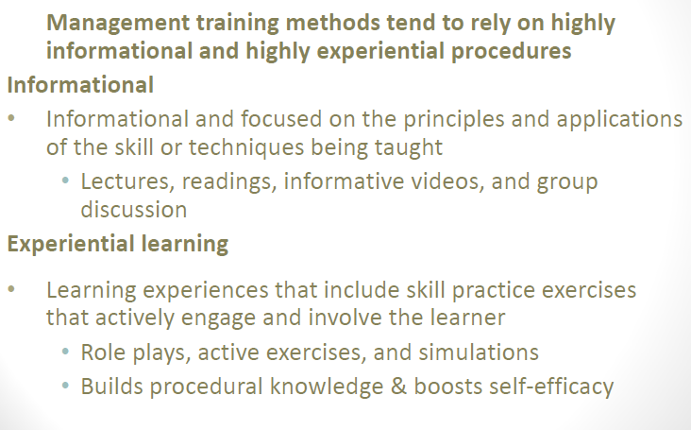
      - Help less experienced managers gain insight on managerial problems and difficulties with which they are confronted with

Some additional topics that may be covered

Chapter 1

Benefits of T&D
Benefits of Organizations
- Strategy
  - Insures employees have skills/knowledge to achieve strategy
  - Becomes a strategic activity that operates in concert with other programs and activities, once training linked to strategy
- Effectiveness
  - Trained employees can do more and better work, make fewer errors, require less supervision, have more positive attitudes and have lower rates of attrition
  - Also produce higher quality products and services
- Employee Recruitment and Retention
  - Considered an effective tool for attracting and retaining top talent, especially those under 30 who view career growth and development more important than salary.

Benefits to Employees
- Intrinsic Benefits
  - Benefit by acquiring new knowledge and skills that enable them to perform their jobs better.
  - Leads to positive effect on job behaviour, job performance, greater self-confidence and self-efficacy.
  - Seek out opportunities to exploit new training.
- Extrinsic Benefits
  - Higher earning as a result of increased knowledge and skills, improved marketability greater security of employment, and enhanced opportunity of promotion and advancement

Benefits to Society
- Educated and Skilled Population
- Economy and Standard of Living

Chapter 2

Knowledge Management

- The creation, collection, storage, distribution, and application of complied “know-what” and “know-how”

Knowledge Acquisition
- Environmental Scanning
  - Establishing internal and external connections and relationships in order to acquire and share information and knowledge.
- Formal Learning
  - Involves activities and events that are planned and designed by the organization with explicit goals and objectives
- Informal Learning
  - Learning that occurs naturally as part of work and is not planned or designed by the organization
- Communities of Practice
  - Groups of people with common interests and concerns who meet regularly to share experiences and knowledge, learn from each other, and identify new approaches for working and solving problems

Knowledge Interpretation
- Learning occurs when employees form their views of the organization and it’s environment
- Views are called Mental Modules
  - Deeply ingrained assumptions, generalizations, or images that influence how we understand the world and how we take action.

Knowledge Dissemination
- Companies must design systems or ways of sharing knowledge so that others can improve their work practices.
- ICTs (information and communication technologies)
- Intranets

Knowledge Retention
- As much intellectual capital can be tacit knowledge, companies need to build tools to quickly compile, store and retrieve this knowledge.

Chapter 3/4

Stages of Learning – ACT THEORY (Anderson Character of Thought)
- Declarative Knowledge
  - Learning knowledge, facts and information
- Knowledge Compilation
  - Integrating tasks into sequences to simplify and streamline tasks
- Procedural Knowledge
  - The learner has mastered the task and performance is automatic and habitual

Learning styles
The diverger uses concrete experience and reflective observation. A diverger tends to be interested in people, culture, and the arts.

An assimilator uses abstract conceptualization and also reflective observation. An assimilator is good at inductive reasoning, creating theoretical models, and combining disparate observations into an integrated explanation.

A converger uses abstract conceptualization and active experimentation, and prefers dealing with technical tasks rather than interpersonal issues.

An accommodator uses concrete experience and active experimentation, and is good at implementing decisions, carrying out plans, and getting involved in new experiences.
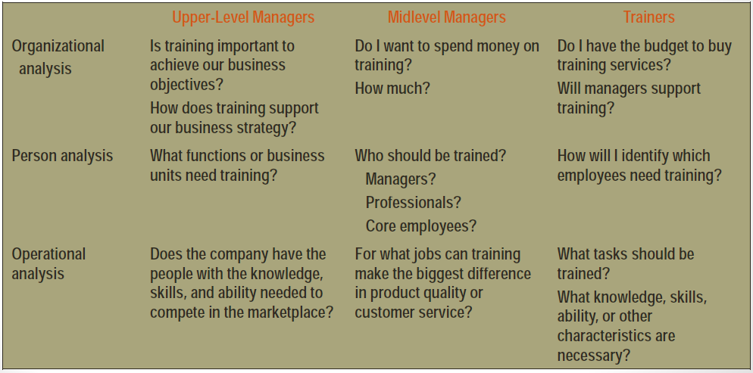

Chapter 5/6

Training objectives should include five key elements of the desired outcomes:
1. Who is to perform the desired behaviour?
2. What is the actual behaviour?
3. Where is the behaviour to be demonstrated?
4. When is the behaviour to be demonstrated?
5. What is the standard by which the behaviour will be judged?

Off-the-Job Instructional Methods

- Lecture
- Discussion
- Audio-visual methods
- Case study
- Case incident
- Behaviour modeling
- Role play
- Games
- Simulations
- Action learning

Action learning
- Learner develops skills through responsible involvement in a real, complex, and stressful problem
- Goals are to involve and challenge trainee
- Involves identifying real problems, developing solutions, testing them in real world and evaluating consequences
- Changes trainees from passive information receivers to problem solvers
- Incorporates more adult learning principles than other methods
Role play
- Trainees practice new behaviours in a safe environment
- Focus on doing and experiencing
- Useful for acquiring interpersonal skills, human relations skills, and changing attitudes
- Three phases: development, enactment, debriefing
- Debriefing is most important phase and should take 2-3X longer than enactment

What is blended learning?
•Blended learning integrates seemingly opposite approaches, such as formal and informal learning, face-to-face and online experiences, directed paths and reliance on self-direction, and digital references and collegial connections, in order to achieve individual and organizational goals.

•From the executive’s perspective, blended learning is about improving performance and achieving business objectives as employees spend more time where they are most needed—at work. From the employees’ perspective, blending allows them to answer questions and meet needs at a time and place of their choosing.

Chapter7/8

On the job training

Apprenticeship Programs
- Societal values influencing youth and parents to select other occupations
- Opportunity to attract wider demographic into apprenticeship labour pool
- Employer reluctance to offer apprenticeship programs and rely on existing labour market to meet their needs
- Role of HR and Training professionals important in championing apprenticeships as effective recruitment and retention strategy
- Target economically depressed regions and high unemployment areas
- tie UI to re-training?
Mentoring
- Method in which a senior member of an organization takes a personal interest in the career of a junior member
  - Mentor: provides coaching and counseling to a junior employee (the protégé)
  - Formalized mentoring programs are emerging in organizations
  - Focus is narrower than coaching: career development of “junior” employees
  - Participation is generally voluntary
  - Career support
    - Mentoring activities that include coaching, sponsorships, exposure, visibility, protection and the provision of challenging assignments
  - Psychological support
    - Mentoring activities that include being a friend who listens and counsels, who accepts and provides feedback, and a role model for success
Off-the Job Training Methods
- Advantages
  - Trainers can use a wide variety of methods, can tailor to needs of trainees
  - Trainer is able to control the training environment
  - A large number of trainees can be trained at one. (ie. In a lecture)
- Disadvantages
  - Can be much more costly
  - Training takes place in different environment than where trainees will have to able the training

On-the Job Training Methods
- Advantages
  - Cost is much lower, given no need for training facilities, travel, accommodation, etc.
  - Greater likelihood of application of training, as occurs in work environment
- Disadvantages
  - Work environment is full of distractions
  - Trainee might be called to do work or solve problems
  - Potential to damage expensive equipment
  - Disruption of service or slowdown in production
  - Can compromise safety
Chapter 9

The Trainees
- Who should attend a training program?
- Money and cost will be wasted if the wrong people attend, performance problems will likely continue if those in need of training do not attend
- Four decisions need to be made when selecting participants
  - Who can benefit from the training?
  - What programs are required by law or by government edict?
    - Ie. Health and safety, sexual harassment
  - Should the training be compulsory or voluntary?
    - If voluntary, some employees in need of training will not go
    - If required for a group, training should be compulsory
  - Should the participants be segregated by level in the organization, or should two or more levels be included in the same class?
    - Depends on organizational culture and rapport that exists between different levels
    - Will employees feel comfortable if higher levels are present
Implementing the Training Program
- Learning Climate
- Pre-arrival Factors
  - Things done prior to create positive environment (giving objectives or deliverables)
- Greeting Participants
- Learning Facilitating
  - Creating the environment through ambient conditions
- Trainer’s Style and Behaviour

Chapter 10

Transfer of Training
- Refers to generalization of knowledge and skills learned in training on the job and maintenance of acquired knowledge and skills over time
  - Two conditions:
    - Generalization
      - The use or application of learned material to the job
    - Maintenance
      - The use or application of learned material to the job over a period of time
- Types of transfer of training:
  - Near
    - Applying new learning to situations that are very similar to those in which training occurred
  - Far
    - Applying new learning to situations that are novel or different from those in which training occurred
  - Horizontal
    - Transfer across different setting or contexts at the same level
  - Vertical
    - Transfer from trainee level to organizational level or impact on organizational outcomes

Training Design
- Learning principles can be incorporated into the design of a training program to increase the transfer of training
- Identical Elements
  - Providing trainees with training experiences and conditions that closely resemble those in the actual work environment
- General Principles
  - Teaching trainees the general rules and theoretical principles that underlie the use and application of particular skills
- Stimulus Variability
  - Providing trainees with a variety of training stimuli and experiences, such as multiple examples of a concept, or practice experiences in a variety of situations
Transfer of Training Interventions
- Relapse Prevention
  - An intervention that instructs trainees to anticipate transfer obstacles and high-risk situation in the work environment and to develop coping skills and strategies to overcome them
- Self-Management
  - A post-training transfer intervention that teaches trainees to manage their transfer behaviour
- Goal-Setting
  - An intervention that instructs trainees about the goal-setting process and how to set specific goals for the use of trained skills on the job
The Work Environment
- Characteristics of the work environment can influence transfer of training prior, during, and after training
- Pre-training environment
  - Management actions prior to a training program send signals and messages about the importance of training
- Post-training environment
  - Factors can encourage, discourage, or prevent employees from applying new knowledge or skills on the job
- Training transfer climate
  - Characteristics in the work environment that can either facilitate or inhibit application of training on the job
- Learning Climate
  - A culture in which members of an organization believe that knowledge and skill acquisition are part of their job responsibilities and that learning is an important part of work life in the organization
Chapter 11

What is Training Evaluation?
- Process to assess the value - the worthiness - of training programs to employees and to organizations
- Assesses value by analyzing data collected from trainees, supervisors and other familiar with the trainees and their job context
- The more sophisticated the design, the more complete the information, the better the conclusions, and the greater the confidence with which they can be stated
- Cost-tradeoff is involved as in some cases, less sophisticated may be quite suitable
- Currently most training evaluation is simply reaction based

Some Reasons for Evaluating

•Solved the problem & met objectives
•Strengths/weaknesses of program
•Credibility and funding
•Approval for budgets
•Justify the need for training
•Program improvement
•ID employees likely to benefit most
•Professionalism
•Reinforce expected results
•Professional development for trainers

Types of Training Evaluation
- May be distinguished from one another by the data gathered and analyzed, the overall purpose
- The data collected
  - Most common rely on trainee perceptions at conclusion of training
  - Growing emphasis that assesses the psychological forces that operate during the training and impact outcome measures such as learning and behaviour changes
  - Information on the work environment that trainees return to can be useful as well (ie. Measures on training transfer climate and learning culture)
- The purpose of the evaluation
  - Formative Evaluations
    - Data about various aspects of the training program
  - Summative Evaluations
    - Data about the worthiness or effectiveness of the training program
  - Descriptive Evaluations
    - Data that describes the trainee once they have finished training
  - Causal Evaluations
    - Data to determine if training caused the post-training behaviours
Models of Training Evaluation
- Kirkpatrick’s Hierarchical Model
  - Oldest, best known, most frequently used
  - Level 1: Trainees report positive reactions to the training programs
  - Level 2: Trainees learn the material
  - Level 3: Trainees apply what they learned on the job
  - Level 4: Training yields results, changes in performance
  - Level 5: Training causes organizational success
  - Each level has a casual effect on the level above

Data Collection Designs in Training Evaluation
- The manner with which the data collection is organized and how the data will be analyzed
- All data collection designs compare the trained person to something
- Non-experimental designs:
  - Comparison is made to a standard and not to another group of (untrained) people
- Experimental designs:
  - Trained group is compared to another group that does not receive the training and when the assignment of people to the training group and the non-training group is random
- Quasi-experimental designs:
  - Trained group is compared to another group that does not receive the training, but when the assignment of people to the training group and the non-training group is not random.
Chapter 12

Management Development vs. Employee Training
Differences:
•Managers work mainly through other people
•Training design techniques tend to be different
•Managerial personalities must be taken into account
•Management development is a longitudinal process
•Unique strategic significance of developing managers

Is Management Development Important?
- Per capita training expenditures are greater for managers than any other category of employee
- Corporate expenditures on management development are estimated annually to be in the billions
- A manager’s role is pivotal in organizations

Models of Management Skill Development
- The basic blueprint that identifies the components to be included in the development of programs
- Skill Assessment
  - Identifies the skill level, strengths, weaknesses before development
- Skill Learning
  - Learning the required principles and behaviours that form the core of the intervention is central to the program
- Skill Practice
  - Serves 3 purposes
    - Practice reinforces learning
    - Enhances trainee’s self-efficacy
    - Activities are more active, and maintain trainee’s interest
- Skill Application (Transfer)
- Transfer process of applying new behaviour and skills to the workplace

Chapter 15

Outsourcing T&D
- Using an external supplier to provide training and development programs and services
- 57% of HR and training professionals outsource at least some portion of T&D
- In Canada, 52% of total training investment is outsourced
  - Directly to outside trainers
  - Indirectly to tuition reimbursement to outside providers

The Ethics of Training & Development
- Ethics: involves systematic thinking about moral consequences of one’s actions and decisions on various stakeholders
- Stakeholders: persons inside or outside the organization who might be affected by one’s actions and decisions
  - Many organizations, such as the Canadian Society for Training and Development, have codes of ethics that set standards of practice and professionalism for members

Trends in Training and Development
- Just-in-time learning:
  - Capability to provide learning and training opportunities when they are needed and where they are needed
  - Training on demand
  - Accelerates pace of learning
  - New technologies helpful in achieving this
  - Scenario-based
  - (See Training Today 15.1)
- Rapid e-learning
  - Software that allows firms to develop e-learning more quickly at a lower price than conventional e-learning development tools
- Learning Management Systems (LMS)
  - Software that tracks and manages training activities in an organization
- Lifelong Learning
  - An approach to learning that recognizes that learning takes place throughout a person’s life and involves all aspects of one’s life

