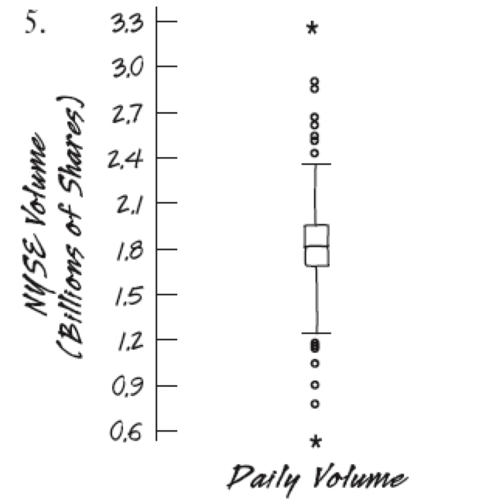
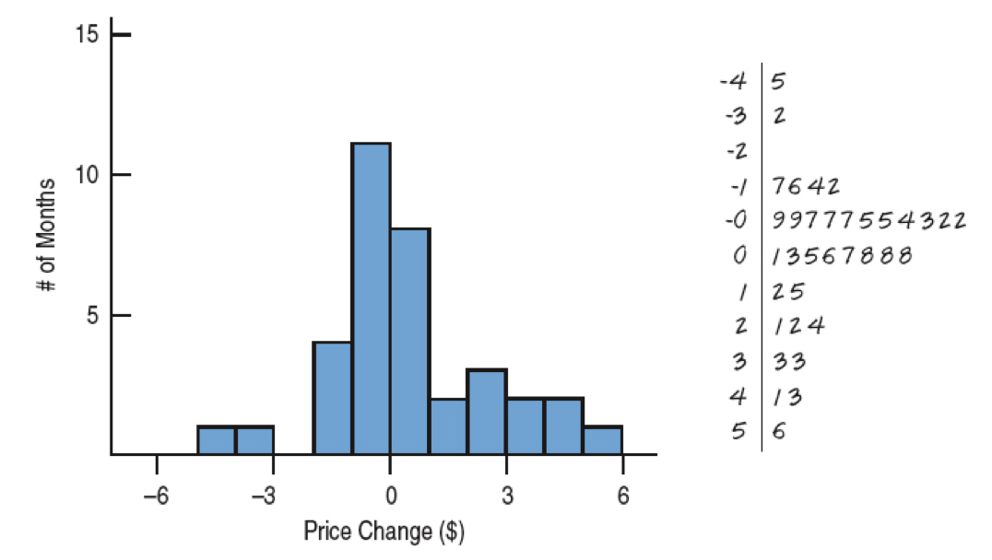
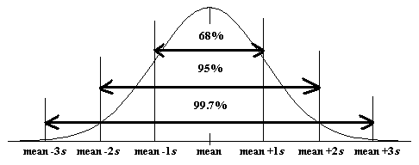
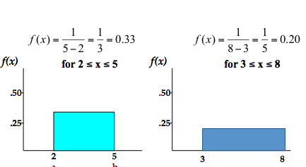
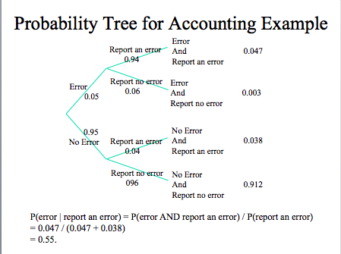
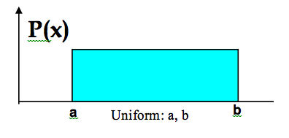
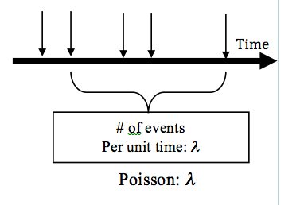
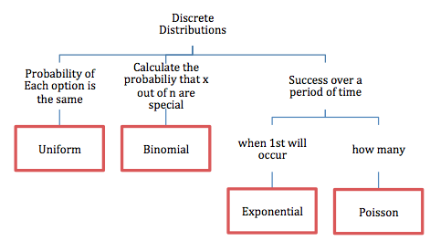
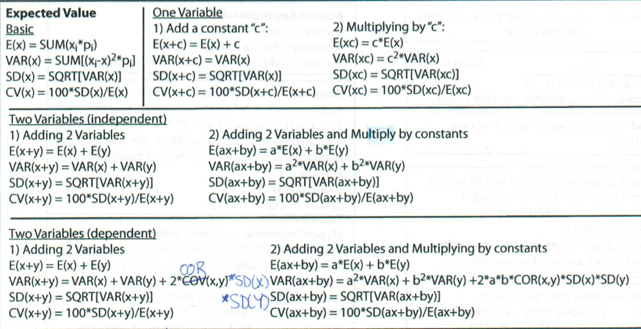
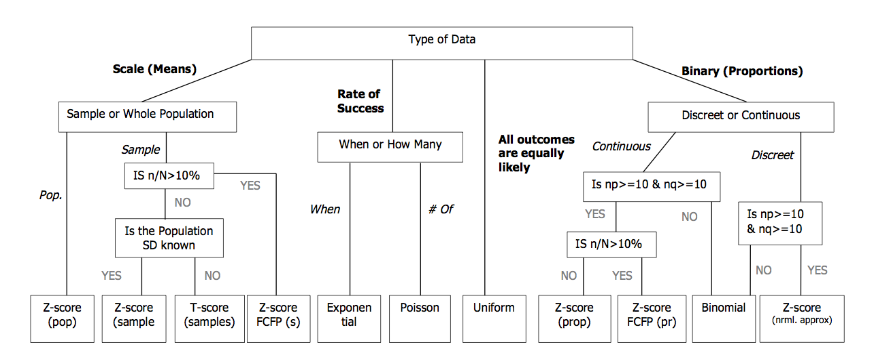
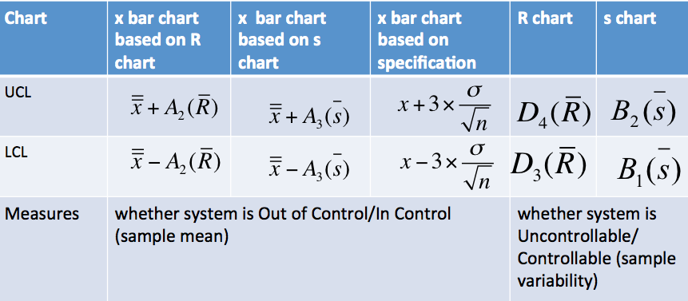
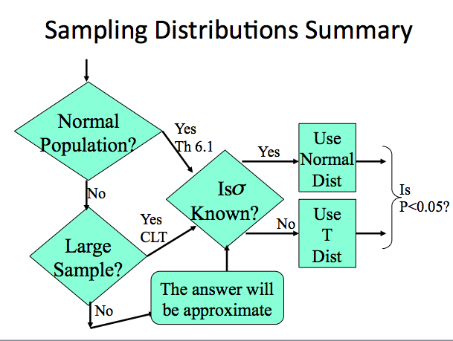
Populations, Samples, Sampling Methods

Sample ->[used to calculate]->Statistic->[used to estimate]->Parameter->[tells us about]->Population

Statistical Sampling
(SRS)Simple Random Sampling: every possible sample of a specified size has an equal chance of being selected
Stratified Random Sampling: pop. is divided into subgroups called strata, each item only belongs to one strata
SRS on each stratum, results are combined in the end (within stratum should be alike, strata should be differienciable)
Cluster Sampling: pop. is divided into clusters that act as mini populations (clusters are alike, within cluster varies)
Systematic Random Sampling: sequencing the population, then starting at a random point, select every kth item

RANDOMIZATION IS KEY

What goes wrong?
Non-Statistical Sampling Techniques:
-Methods of sampling using influence, judgement, oother non-chance processes
Response Bias:
-Non Response Bias
-individuals who don’t respond have common characteristics
-Voluntary Response Bias
-individuals with strongest feelings are more likely to respond
Convenience Sampling: selects based on accessibility and ease

RED
If P is <0.05 of >0.95 raise a RED flag
Event cannot just occur by chance; there must be a change or problem (something is off)
Describing Data Using Numerical Measures
Mean: Average Median: Middle Mode: Most Frequent Population VS Sample
Mean where N= size of population n= sample size
Percentiles: *median is 50th percentile
-Put the Data in order
-Multiply number of data points(n) by percentage
-Round up, if integer take the average of n & n+1
-Point nth is your percentile
Quartiles: *median=2nd quartile Variance
divides data set into 4 equal groups (25%ile,50%ile,75%ile)

Variability: Range, IQR, Var, SD, Coeffivient of Var
Range = Max- Min
IQR = Third Quartile- First Quartile
Five Number Summary: Max, Q3, Median, Q1, Min Standard Deviation
Box-Plots:
-“Box” is Q1, Median, Q3
-Fence is 1.5 IQR above & below box (max and min if within)
-Add any outliers Coefficient of Variation (Ratio of SD to the mean)
Standardization: (Computing z-score to standardize sample mean)

Descriptive Statistics

Simpsons Paradox: when %ages are inappropriately combined
Categorical Data ->Bar Charts, Pie Charts, Contingency Tables
Quantitative Data: Histograms, Stem & Leaf Diagrams
Histograms: width=(largest value-smallest value)/# of classes
Stem & Leaf: Stem= 1st digit, Leaves= 2nd digit

Scatterplots, Correlation, Causality

Scatterplots: can rep. relationships between two variables [look for Direction, Form, Strength, Unusual Features]
Correlation Coefficient Correlation Between RV’s
*Correlation measures the extent of the LINEAR relationship
Causality:
-Don’t confuse correlation with causation (two things are correlated doesn’t mean one causes the other
Continuous Distributions: Uniform and Normal Distribution, Normal Approximation to Binomial

Probability Density Function: the P distribution of a continuous random variable is represented by a probability density function
Uniform Distribution

Normal Distribution
Standard Normal Distribution: normal dist. with mean = 0 & SD = 1
1.Draw a picture 2.Find z value 3.Look from z table
Standard Normal Z Value
x= point on horiz. axis z=# of SD from mean

Normal Approximation to Binomial
Use when binomial has a large n (if np>10 and n(1-p)>10) [USE SD OF BINOMIAL]
Correction for Continuity for numerator of z-score calc. : [if <= or > add 0.5] [if>= or < subtract 0.5]
FPFC (when n>10% of pop.) multiply denominator by: Sqrt[(N-n)/(N-1)]
Discrete Distributions: Binomial, Geometric & Poisson, Exponential Distributions

Bernoulli Trials:
1.Has only two outcomes “SUCCESS” or “FAILURE”
2.Assume INDEPENDENCE
3.Probability of success remains CONSTANT
Binomial Formula Binomial Mean & Standard Deviation
n= sample size x= # of successes p= probability of success q= 1-p
Geometric Distribution (Similar to Binomial)
*Probability that x is the first success after x-1 trials *EV= how many trials before success

Poisson Formula Poisson Mean & Standard Deviation
x= -# of successes λ= expected # of successes in a segment t
*If time segment is different then for given λ, λ for calculation is λt (where t is the new time segment)
Exponential Distribution [CONTINUOUS DIST]

EMPERICAL RULE
c
c
-average error rate P(error) = 0.05.
-P(report an error | no error) = 0.04.
(false positive)
-P(report an error | error) = 0.94,
-P(report no error | error) = 0.06,
(false negative).

What is the probability that there really is an error, P(error | report an error)?
Bayes Rule because it fits our two criteria.

-We know P(report an error | error) = 0.94 and would like to know P(error | report an error).

-We have an initial estimate, P(error), and would like to update it to, P(error | report an error).

Random Variables, Distribution Functions Expected Value & Variance

Random Variable: variable assigns a numerical value to each outcome of a random trial
Discrete Random Variable: can only assume a countable number of values
Continuous Random Variable: can assume any value on a continuum, can assume uncountable number of values

Expected Value of Random Variables Variance and Standard Deviation of Discrete Random Variables

-Don’t add standard deviations -Add variances -Do NOT subtract Variances: Var(x-y) = Var(x) + Var(y)
Probability Trees, Bayes Theorem

Bayes Theorem Probability Trees
Data Types. Rules of Probability. Joint, Marginal, Conditional Probability. Independence.

5 W’s : Who, What. When, Where, Why
Data Types:
-Qualitative: (Categorical)
-Quantitative:
-Discrete (counted items) [Binomial, Poisson]
-Continuous (Measured Characteristics) [Z-score, Expon., Uniform, Normal (approximation)]
Time Series Data (over time) vs Cross Sectional Data (fixed point in time)
Rules of Probability:
Trial -> Event. Sample Space = Collection of all possible events of a trial
- 0<= P <= 1
- P(Sample Space) = 1
- P(x) = 1 – P(!=x)
Four Types of Probability:
-MARGINAL “Straight”: P(X)
-JOINT “AND”: P(X AND Y)
P(X AND Y) =P(X)*P(Y) -> independent
P(X AND Y) = P(X)*P(Y|X) -> dependent
Events are INDEPENDENT if P(X|Y) = P(X) or P(Y|X) = P(Y)
-UNION “OR”: P(X OR Y)
P(X OR Y) = P(X) + P(Y) -> for disjoint events only (events x and y cannot occur together)
P(X OR Y) = P(X) + P(Y) – P(X AND Y)
-CONDITIONAL PROBABILITY “GIVEN”: P(X|Y)
P(X|Y) = P(X AND Y) / P(Y)
Bayes Theorem, getting P(X|Y) using P(Y|X) (in W2)

Uncontrollable/Out of Control
Uncontrollable:
-R Chart problems
-Range is behaving badly
-Whole process needs changing
Out of Control:
-X-Bar Chart problems
-Average is behaving badly
-Way process is being controlled needs changing
Quality Control

Common cause variation: is the variation in the output that is naturally occurring and expected (uncontrollable)
Special cause variation: is the variation in the output of a process that is abnormal & has an assignable cause (out of control)
Total Process Variation:
Common Cause + Special Cause

Process Control
-Process control charts are about maintaining the status quo
Subgroup: sample of items selected from a process

Statistical Process Control Charts
Creating x-bar & R-charts
-Calculate subgroup means & ranges
-Compute the average of the subgroup means & the range value
-Prepare graphs of the subgroup means & ranges as a line chart
-Compute the upper and lower control limits

X-bar Control Chart
Average of Subgroup Means UCL LCL
R Chart
Average of Ranges UCL LCL
Where n = subgroup size A_{2,} D₃, D₄ =Shewhart factor for subgroup size n
S Chart: Similar to R Chart, but uses standard deviation of samples instead of ranges
Process is uncontrollable/out of control when:
-One point is outside control limits
-9 points in a row above (or below) the centerline
-6 points in a row increasing (decreasing)
-14 points in a row alternating up/down

Sampling Distribution for Proportions/Mean, Central Limit Theorem, Unknown Population SD

Sampling Distribution: a distribution of the possible values of a statistic for a given sample size selected from a population (“imaginary”)
THE NARROWER THE SAMPLING DIST., THE MORE ACCURATE THE ESTIMATE

Assumptions & Conditions
-Independence Assumption
-Randomization Condition
-10% condition: n should be no greater than 10% of the pop
-Success/Failure Condition: n must be big enough that np & nq are at least 10
-Large Sample Condition: sample size must be large, esp. for a skewed population dist. N>30 “large enough” [CLT]

For Proportions *assume independence, two outcomes: success or failure – proportion of success
Sample proportion = p̂ True proportion = p
Mean Standard Deviation Z-Value
For the Mean *average of averages
Mean Standard Deviation Z-Value
Central Limit Theorem: as the sample size gets large enough, the sampling dist. Becomes almost normal, regardless of shape of pop.

Large Sample Sizes, AKA Small Populations *when n> 10% of N
USE FPFC (when n>10% of pop.) multiply denominator by: Sqrt[(N-n)/(N-1)]

Unknown Standard Deviation
T-Value where s= sample std dev.
Degrees of Freedom
Higher degree of freedom
-> larger sample size, closer to SD
FOR THIS COURSE: n-1

