What is psychology?

Definition of psychology (mind, brain, behavior)
- The science of behavior (what we do) and mental processes (sensations, perceptions, dreams, thoughts, beliefs and feelings) that occur within the brain.
  - Ultimate Goal => Understand human behavior
  - The mind and the brain is ultimately the same thing. You cannot have the mind without the brain. The brain is the organ, all the hormones and chemicals, it is a structure. The psychological awareness of the brain/thinking is the mind. The function is the mind.
  - Why do we do the things we do?

Past Conceptions of Abnormal Behavior

Ancient Societies: The Stone Age

Theory
- Deviance and the supernatural (mysticism)

Treatment
- Exorcism (the attempted expulsion of an “evil” spirit)
- Trephination (an operation removing a circular section of the bone of the skull)
  - Various of reasons why these procedures happened. Some thought it was to release an evil spirit, others thought it was a real medical surgery. To relieve pressure from migraines or war injuries.

Ancient Egypt

Theory
- “Wandering Uterus”. Women becoming very anxious, suffering from paralysis, blindness, deafness. They were suffering because the uterus would become detached, they thought of it like an animal, wandering around her body looking for food. It could attach itself to the woman’s heart.

Treatment
- They’d use smelling salts to looer the animal back to it’s proper place. They thought women were “hysterical”. They thought women semen on it’s own was poisonous and would cause hysteria. It occurred mostly in virgins and widows. Afterwards they started advertising vibrators.

Psychology’s Roots

Prescientific Psychology
- Is the mind connected to the body or distinct?
- Are ideas inborn or is the mind a blank slate filled by experience?
- Nature vs Nurture
- Nativism vs Empiricism
  - The real question is now is it more nature or nurture?

The Rise of Psychology as a Science

Philosophical roots of psychology:

Descartes (1596-1650): Dualism
  - You can actually will the body to do something…

Hobbes (1588-1679): Materialism
  - The mind the body is all based on physical laws. Even consciousness is due to laws of nature.

Locke (1632-1704):Empiricism (tabula Rosa)
  - Even knowledge is sensory thoughts. Everything is materialistic. Tabula Rosa means we are born with a blank slate. With the proper nature you could mold a person.

Biological Roots of Psychology:

Muller (1801-1858): doctrine of specific nerve energies

Flourens (1774-1867): experimental ablation
  - Taking out parts of the brain (of animals) and seeing what it would destroy. They would take a certain part of the brain out and the animal wouldn’t be able to walk or see or fly, etc.

Broca (1824-1880): localization of language
  - The brain is lateralized. Damage to the left hemisphere will cause damage to the right side of the body. If you had a stroke in the left hemisphere you may not be able to produce speech and be paralyzed on the right hand side.

Helmholtz(1821-1894): located the mind within the brain (RTs)
  - He studied the reaction times (RT) of the brain. Measure how fast people could calculate something or process complex information. People can respond to things in different amounts of time. This now means psychology is a science.

Weber(1795-1878): Psychophysics
  - Tries to relate physical stimuli and mental phenomena. Full of natural and physical laws.

Parts of the Brain
- Frontal Lobe
  - Judgment, logic, motor, planning, executive functions; are all things that could be affected if the frontal lobe is damaged.
- Parietal Lobe
  - Receives sensory input for touch and body position.
- Occipital Lobe
  - Receives information from the visual fields.
- Temporal Lobe
  - The part of the brain that deals with hearing. Addition hearing. If your temporal lobe is damaged you might experience deafness and loss of memory.

Lateralization of Function
- Left Side
- Right Side

Current Fields of Psychology
- Biological
  - Physiological
  - Psychophysiology
  - Behavior genetics
- Clinical
  - Behavior analysis
  - Personality
  - Neuropsychology
- Cognitive Psychology
  - Emphasizes internal mental processes
- Social
- Developmental psychology
  - Social/mental development of children
- Cross-cultural
- Evolutionary
  - The gradual development of something

What is a “paradigm”?
- A cognitive set
  - Interpret information
- A way of thinking about something
  - A worldview underlying the theories and methodology of a particular subject.
- It determines what evidence you seek and how you interpret it

Major Paradigms in the Development of Psychology

Structuralism: Wundt, Titchner
  - What is the structure of the mind? Trying to come up with the basics structures of the mind.
- Wilhelm Wundt
  - Added two key elements to make psychology a science
    - Carefully measured observations
    - Experiments
  - Opened the first psychology lab at the university of Liepzig
- Titchener
  - Aimed to determine the basic elements, or the structure, of conscious mental experience.
  - Thought that consciousness could be reduced to its basic elements.
  - Introspection

Functionalism: Darwin, James
  - Functionalism focused on how behavioral processes function how they enable organism to adapt, survive and flourish
  - Study of the mind is function of behavior, not the individual parts

Gestalt Psychology: Wertheimer School
  - Individuals perceive objects and patterns as whole units, and therefore the whole perceived is more than the sum of its parts
  - Developed as a direct response to Structuralism
  - Mind is not the sum of its parts, it’s bigger than that
  - Must look at organized wholes (ex. Song, painting, insight)
  - Gestalt = unified form (Holistic)

Behaviorism: John B. Watson
  - Studied behavior that was observable and measurable and there, objective and scientific
  - Reward vs punishment
  - When you reinforce an action, it’s actually rewarding. When you ignore or withhold rights, you are punishing.
  - E.L. Thorndike: Law of Effect
    - Responses that lead to “satisfying” consequences are more likely to be repeated than responses that lead to “unsatisfying” consequences.
  - Subject should be behavior, not the mind (S-R psychology)
  - Goal is to understand environmental conditions that cause behavior
  - Unobservable events not of interest (thoughts, feelings, beliefs)

The Psychodynamic Perspective: Freud
  - A school of thought united by a concern with the dynamics or interaction of forces lying deep within the mind.
  - The depth Hypothesis:
    - Almost all mental activity takes place unconsciously
  - Interpretation
    - Revealing the hidden, intrapsychic motives (when something traumatic as a child happened and you can remember it, doesn’t mean that it won’t cause actions later on in life
  - The Id:
    - Pleasure principle
  - The Ego:
    - Reality Principle
  - The Superego
    - The “conscience”
    - Morality principle
    - Defense mechanisms

Humanism Psychology: Abraham Maslow & Carl Rogers
  - This subfield focuses on the uniqueness of human beings and their capacity for choice, growth, and psychological health.
  - The perspective purports that human beings are innately good
  - Humanists developed theories and treatments to help people to feel accepted and to reach their full potential

Cognitive Psychology
  - Often uses information-processing approach to study mental processes such as memory, problem solving, reasoning, language and other forms of cognition.
  - It recaptured the field’s early interest in mental processes and made them legitimate topics for scientific study
  - Puts the O in S-R

A New Biological Revolution is Energizing Research
  - Brain Chemistry
  - The Human Genome
  - Watch the Working Brain

The Neuropsychological perspective

The Brain
  - Structures, neurochemistry and genes
  - Biological reductionism (reduce problems to their smallest parts)
  - Very popular now; high tech (Zeitgeist)

The Big Issue in Psych: Nature vs. Nurture
  - To what extent are our traits already in place at birth (nature)? And to what extent do our traits develop in response to our environment/experience (nurture)?

Three Levels of Analysis

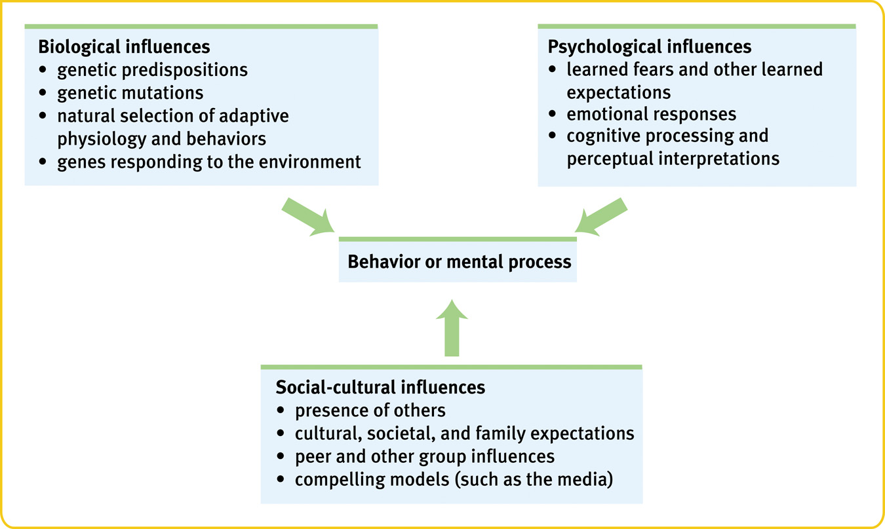

Psychiatry:
  - A branch of medicine dealing with psychological disorders
  - Practiced by physicians who sometimes use medical (for example, drug) treatments as well as psychotherapy

Outline
- The need for psychological science
- How do psychologists ask and answer questions
- Statistical reasoning in everyday life

The Need for Psychological Science
- Our mind operates one two levels – conscious and unconscious – with the larger part operating behind the sense
- Three phenomena – hindsight bias, judgmental overconfidence and our tendency to perceive patterns in random events.
- Hindsight bias – the tendency to believe, after learning an outcome, that one would have foreseen it.
- A lot of the time humans are more confident in knowing the answer, then they are actually correct.
- Wallace Stevens – “rage for order” – we are prone to perceive patterns. We tend to find random sequences often don’t look that random
- These can all lead us to overestimate our intuition
- Critical thinking – thinking that does not blindly accept arguments and conclusions. Rather, it examines assumptions, discerns hidden values, evaluates evidence and assesses conclusions.
- The scientific attitude combines (1) curiosity about the world around us, (2) skepticism toward various claims and ideas, (3) humility about one’s own understanding. Evaluating evidence, assessing conclusions, and examining our own assumptions are essential parts of critical thinking.

How Do Psychologists ask and answer questions

The Scientific Method In Psychology Main Issues
- Theory – an explanation using an integrated set of principles that organizes observations and predicts behaviors or events.
- Hypothesis – a testable prediction, often implied by a theory
- Goals
  - Description
  - Explanation
  - Prediction
  - Control
- Identifying the problem
  - What question do you want to pursue?
  - Hypotheses vs. Theories
    - An hypothesis is a statement of what you think should happen in your experiment.
    - A theory is a set of integrated statements that organizes/predicts results and is more encompassing than an hypothesis
    - Operational definition
- Research methods
  - The Research Process
  - 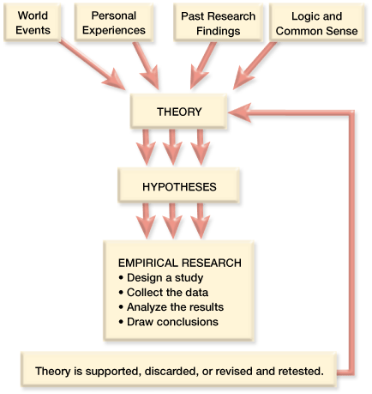
  - Descriptive studies
    - Case Study
      - Psychologists study one or more individuals in great depth in the hope of revealing universal principles
      - Individual cases can suggest fruitful idea. What’s true of all of us can be glimpsed in any one of us, But to discern the general truths that cover individual cases, we must answer questions with other research methods.
    - Naturalistic Observation
      - Observing and recording behavior in naturally occurring situations without trying to manipulate and control the situation
      - This study does not explain behavior, it describes it.
    - Survey
      - A technique for ascertaining the self-reported attitudes or behaviors of a particular group, usually by questioning a representative, random sample of the group.
      - Population – all the cases in a group being studied, from which samples may be drawn.
      - Random Sample – a sample that fairly represents a population because each member has an equal chance of inclusion.
  - Correlation studies
    - A descriptive study that looks for a consistent relation between two phenomena [Variables occur naturally]
    - Correlation – a measure of the extent to which two factors vary together, and thus of how well either factor predicts the other
    - Correlation Coefficient
      - A statistical measure of how strongly two variables are related to one another
      - A correlation can range from -1.0 to +1.0 . Number indicates strength and sign indicates direction.
    - Graphing Correlations: The Scatter Plot – a graphed cluster of dots, each of which represents the values of two variables. The slope of the points suggests the direction of the relationship between the two variables. The amount of scatter suggests the strength of the correlation (little scatter indicates high correlation).
      - How to construct a scatter plot
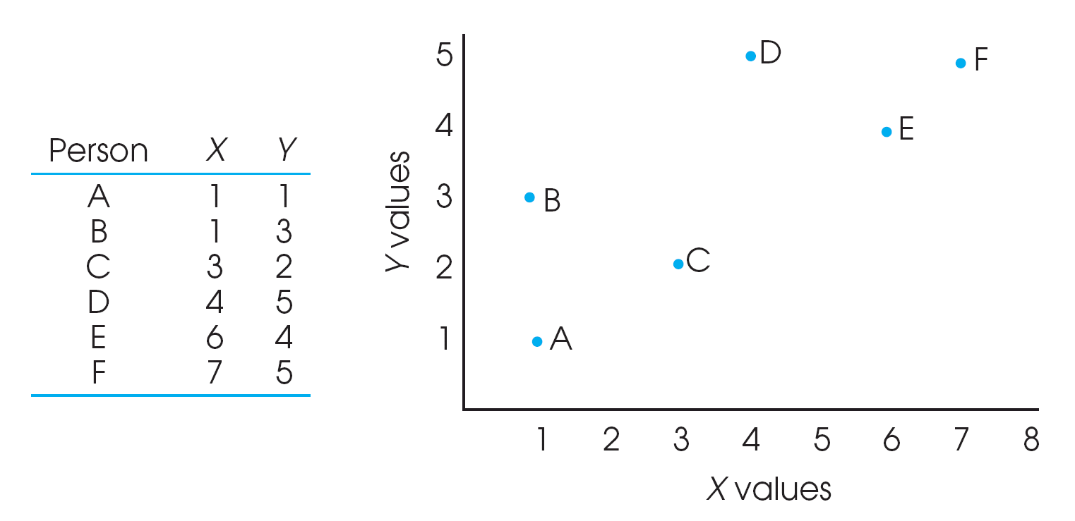
- Draw 2 axes and label both variables
- Mark the axes using the full range of values
- Plot by placing a dot that corresponds to each person’s pair of scores
  - *note that the scatterplot allows you to see the relation between X and Y. Providing a visual description
- A correlation is negative if two sets of scores relate inversely, one set going up as the other goes down.

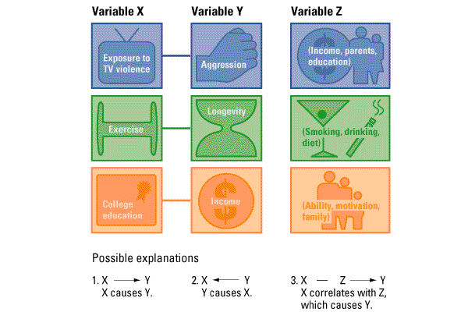

    - Naturally Occurring
      - Start with 2 variables, (X,Y) where X and Y are correlated:

-X may cause Y

-Y may cause X

-Z may cause X and Y
      - Correlations show relational patterns, not causes.

  - Evaluating the findings
  - Keeping the enterprise ethical
  - Experiments
    - Experiment – a research method in which an investigator manipulates one or more factors (independent variables) to observe the effect on some behavior or mental process (the dependent variable). By random assignment of participants, the experimenter aims to control other relevant factors.

-Experiment Variables
    - Independent Variable: A variable that an experimenter manipulates
    - Dependent Variable: “the outcome factor”. A variable that an experimenter predicts will be affected by manipulations of the individual variable.
    - Confound Variable: a factor other than the independent variable that might produce an effect in an experiment.
- Correlational vs. Experimental Studies

Correlational Studies
    - Cannot infer causation
    - Can only state that there is a relation between the variables of interest
    - May be due to a third unknown variable

Experimental Studies
    - Can infer a causal relation between the two variables of interest
    - May be due to a third unknown variable

-Experimental Method Concerns Overview
    - Selection bias
    - Confounding variables
    - Experimenter/participate bias
    - Placebo effect
    - Reliability & Validity
- Methods of Control
  - Experimental Group: A group that is exposed to the treatment, that is, to one version of the independent variable
  - Control Group: the group that is NOT exposed to the treatment; contrasts with the experimental group and serves as a comparison for evaluating the effect of the treatment.
  - Random Assignment: Assigning subjects randomly to the different groups in the experiment by chance, thus minimizing preexisting differences between those assigned to the different groups
- Designing an experiment

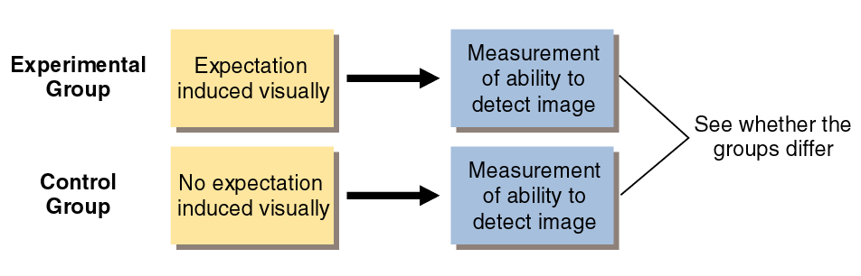
- Conducting an experiment

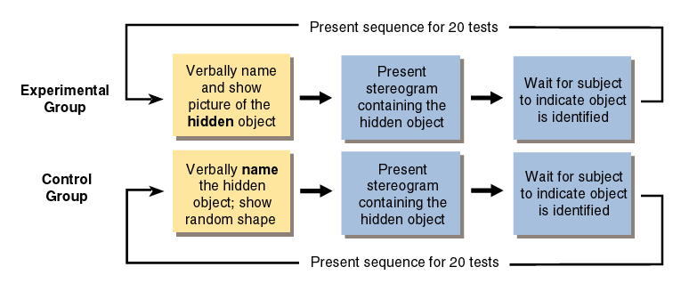
- Random Assignment
  - In order for experiments to have experimental and control groups composed of subjects similar in characteristics that may effect their results, random assignment should be used.
  - Each individual participating in the study has the same probability as any other of being assigned to a given group.
- Confounding of Variables
  - We must control our independent variables
  - Sometimes an unexpected variable is also introduced
  - An inadvertent alteration of more than one variable during an experiment is called a confound.
- Experiment Effects Demand Characteristics
  - Unintended changes in subjects behavior due to cues inadvertently given by the experimenter
  - Social desirability: response set
  - Strategies for preventing experimenter effects include single and double-blind studies
- Minimizing the Effects of Expectations
  - Single-Blind Procedure: The subject is unaware
  - Double-Blind Procedure: Both the subject and the experimenter are kept unaware as to which treatment is being administrated
  - Placebo: A substance that looks like a drug or other active substance but is actually on inert or inactive substance
  - Placebo Effect: results caused by expectations alone; any effect on behavior caused by the administration of an inert substance or condition, which the recipient assumes an active agent.
- Performing an Experiment
  - Reliability of Measurements: The repeatability of a measurement or will you get the same result twice?
  - Validity of Measurements: The extent to which a test measures or predicts what it is supposed to.
- Generalization
  - Can you apply your results to the population from which you took your sample from?
  - What does your experiment mean in the real world?
- Recap
  - A variable is anything can vary (infant nutrition, intelligence, TV exposure – anything within the bounds of what is feasible and ethical). Experiments aim to manipulate an independent variable, measure the dependent variable, and allow random assignment to control all other variables. An experiment has at least two different conditions: an experimental condition and a control condition. Random assignment works to equate the groups before any treatment effects occur. In this way an experiment tests the effect of at least one independent variable (what we manipulate) on at least one dependent variable (the outcome we measure).
- Ethics
  - Research with Human Participants
    - Requires compliance with the following principles:
    - Informed consent

an ethical principle that research participants be told enough to enable them to choose whether they wish to participate
    - Confidentiality

to keep their information private
    - Minimal Risk

to protect them from harm/discomfort
    - Debriefing

the post experimental explanation of a study, including its purpose and any deceptions, to its participants.
  - Research with Animals

-As animals cannot give informed consent, we must comply with the following principles
    - Is this an important research topic?
    - Have we minimized harm to the animal?
    - Are the animals receiving the best possible care?
    - Are the animals being treated humanely?

- Understanding Research Results
  - Descriptive Statistics

What are the results?
  - Measures of Central tendency
    - Mean: the arithmetic average of a distribution, obtained by adding the scores and then dividing by the number of scores
    - Median: the middle score in a distribution; half the scores are above it and half are below it.
    - Mode: the most frequently occurring score(s) in a distribution
  - Measures of Variability
    - Variance
    - Standard deviation: a computed measure of how much scores vary around the mean score.
  - Inferential Statistics
    - Statistical procedures that allow researchers to draw inferences about the statistical meaning of a study’s results
    - The most commonly used inferential statistics are significance tests
  - Are the results significant?
    - Statistical analyses: the way in which we determine statistical significance
    - Statistical significance: the probability that an observed relation or difference between 2 or more variables is not due to chance.

(Alpha levels 5% -- p< .05 or p> .05)

Main Points

The Nervous System

Neurotransmission

Study of the Brain (Methods)

Major structures of the brain
  - Subcortical Structures and Function
  - Organization of the Cortex

Biology, Behavior and the Brain
- Phrenology – theory by Franz Gall, studying bumps on the head could reveal a person’s mental abilities and character traits. Phrenology succeeded in focusing attention to the localization of function – the idea that various brain regions have particular functions.
- Biological Perspective – concerned with the links between biology and behavior. Includes psychologists working in neuroscience, behavior genetics and evolutionary psychology. These researchers may call themselves behavioral neuroscientists, neuropsychologists, behavior geneticists, physiological psychologists, or biopsychologists.

The Nervous System
- The Central Nervous System(CNS) is the brain and the spinal cord. The CNS makes decisions for the body.
- The Peripheral Nervous System (PNS) is “the rest” of the nervous system. It gathers and sends info to and from the rest of the body.
  - Peripheral nervous system has two different types.

Automatic (controls self-regulated action of internal organs and glands).
    - Sympathetic (arousing)
    - Parasympathetic (calming)

Somatic (controls voluntary movements of skeletal muscles).

Neurons and Neuronal Communication:

The Structure of a Neuron

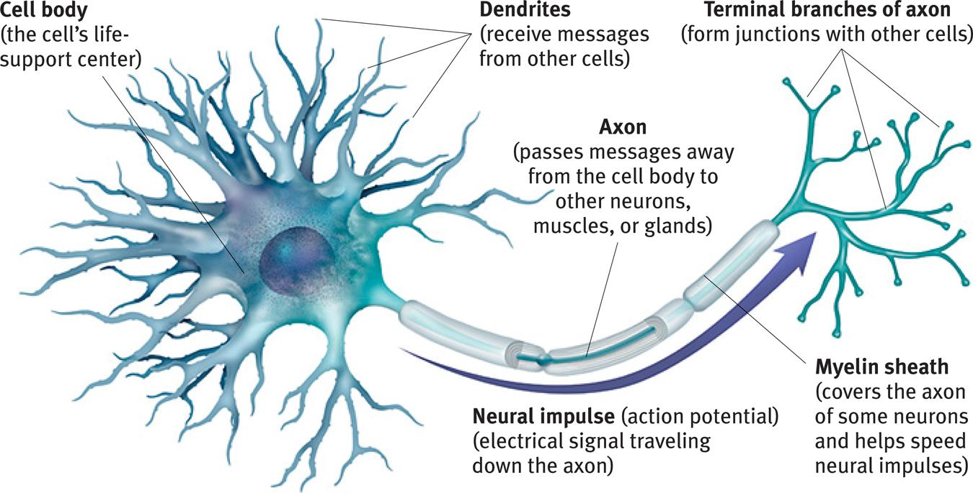
- Neurons are a nerve cell; the basic building block of the nervous system
- Each neuron consists of a cell body and its branching fibers
- The bushy dendrite fibers receive information and conduct it toward the cell body.
- From there, the cell’s lengthy axon fiber passes the message through its terminal branches to other neurons or to muscles or glands.

*Dendrites listen, axons speak.
- Axons may project several feet through the body and some are encased with myelin sheath
- Myelin sheath is a layer of fatty tissue that insulates them and speeds their impulses
- If myelin sheath degenerates, multiple sclerosis results: communication to muscles slow, with eventual loss of all muscle control.

*There are billions of neurons throughout the body.
- The Firing of a Neuron
- Resting Potential – positive-outside/negative-inside
  - This is the cell at rest (-70 millivolts)
  - Depolarization occurs and it goes from -70 to a positive state
- Ion channels (open/close) and ion transporters regulate (pump) the number of ions inside and outside the axon.
- When a neuron fires, the first section of the axon opens it’s gates and positively charged sodium ions flood through the cell membrane. This depolarizes that axon section, causing another axon channel to open and then another, each tripping the next.
- Neurons transmit messages when stimulated by signals from our senses or when triggered by chemical reactions from neighboring neurons.
- A neuron fires an impulse called the action potential – a brief electrical charge that travels down its axon.
- Threshold – the level of stimulation required to trigger a neural impulse.
- Neuron’s reaction is an all or none response. They either fire or they don’t.
- A strong stimulus (a slap) can trigger more neurons to fire, and to fire more often, but it does not affect the action potential’s strength or speed.

Neural Transmission (Synapse)
- The meeting point between neurons is called a synapse
- When an action potential reaches the knoblike terminals at an axon’s end, it triggers the release of chemical messengers, called neurotransmitters.
- When released by the sending neuron, neurotransmitters travel across the synapse and bind to receptor sites on the receiving neuron, thereby influencing whether that neuron will generate a neural impulse.
- This is what happens in the synaptic gap. Neurons send neurotransmitters to one another across this tiny space between one neuron’s terminal branch and the next neuron’s dendrite. In reuptake, a sending neuron reabsorbs the extra transmitters.

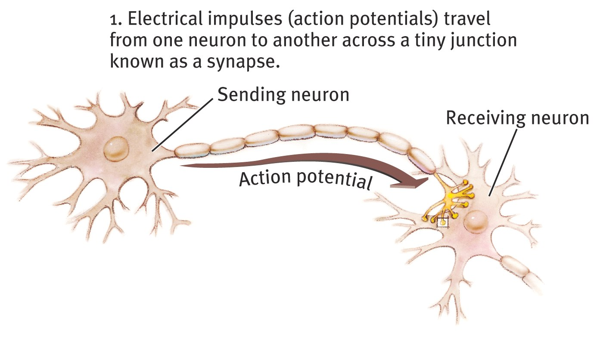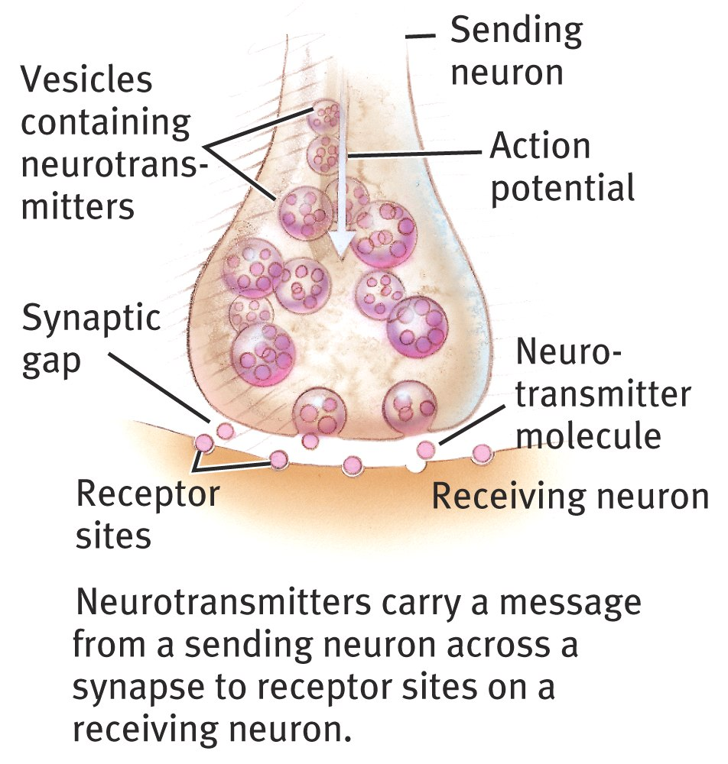

Major Neurons

[when leaving the CNS: Efferent vs. Afferent coming into the CNS]
- Sensory Neurons: Bring information to the central nervous system
- Interneurons: Associate sensory and motor activity in the central nervous system
- Motor Neurons: Send signals from the brain and spinal cord to muscles

Your spines interneurons trigger your hand to pull away from a fire before you can say “OUCH!” – This is an example of a reflex action.

Reuptake
- Neurotransmitters in the synapse are reabsorbed into the sending neurons through the process of reuptake. This process applies the brakes on neurotransmitter action.

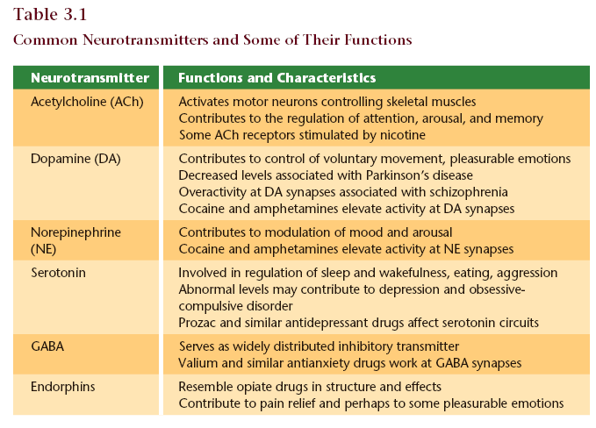
  - Serotonin pathways
    - Networks of neurons that communicate with serotonin help regulate mood
  - Dopamine pathways
    - Networks of neurons that communicate with dopamine are involved in focusing attention and controlling movement

Neurotransmitters & Drugs
- Specific neurotransmitters work at specific synapses – Lock and Key mechanism
- Agonist – mimics neurotransmitter action
  - This agonist molecule excites. It is similar enough in structure to the neurotransmitter
  - Fills the receptor site and activates it, acting like the neurotransmitter
- Antagonist – opposes action of a neurotransmitter
  - Fills the lock so that the neurotransmitter cannot get in and activate the receptor site

Methods of Studying the Brain

EEG (electroencephalogram)
  - Is an amplified read-out of the waves of electrical activity that sweep across the brain’s surface. These waves are measured by electrodes places on the scalp.

CT (computed tomography) Scan
  - A series of x-ray photographs taken from different angles and combined by computer into a composite representation of a slice through the body; also called CAT scan

PET (positron emission tomography) Scan
  - A visual display of brain activity that detects where a radioactive form of glucose goes while the brain performs a given task

MRI (magnetic resonance imaging)
  - A technique that uses magnetic fields and radio waves to produce computer-generated images that distinguish among different types of soft tissue; allows us to see structures within the brain

Controls of Behavior
- The Cerebral Cortex
  - The intricate fabric of interconnected neural cells that cover the cerebral hemispheres. It is the body’s ultimate control and information processing center.

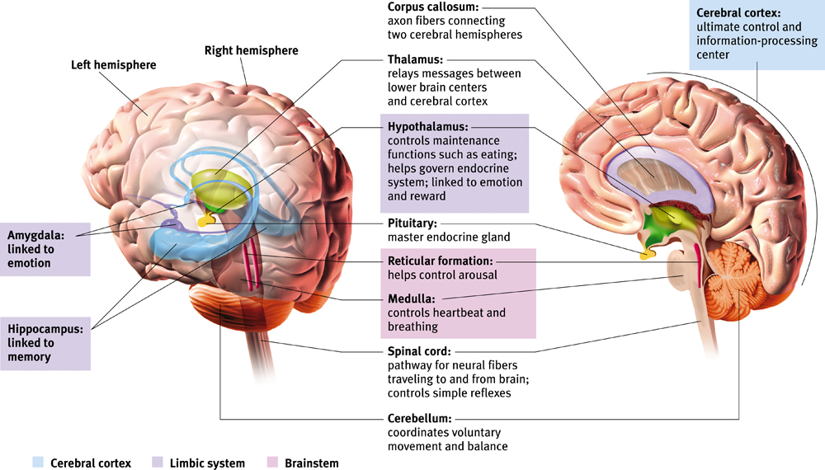
- The Limbic System

This neural system sits between the brain’s older parts and its cerebral hemispheres. The limbic system’s hypothalamus controls the nearby pituitary gland.
  - Hypothalamus:
    - This small but important structure helps keep the body’s internal environment in a steady state.
    - An important link the command chain governing bodily maintenance.
    - Influencing hunger, thirst, body temperature, sexual behavior.
  - Amygdala: two lima-bean-sized neural clusters in the limbic system; linked to emotion.
    - Linked to aggression and fear
  - Hippocampus
    - Processes conscious memories.
    - Loss or damage to the hippocampus can cause loss of the ability to form new memories of facts/events.

- Lobes of the Brain

Frontal Lobe
  - Speaking
  - Muscle movements
  - Making plans/judgments
  - Motor skills

Occipital Lobe
  - Receives visual information

Parietal Lobe
  - Receives sensory for touch and body position

Temporal Lobe
  - Auditory/hearing
  - each receiving information primarily from the opposite ear

Specialization & Integration
- Hearing words – auditory cortex and Wernicke’s area
- Seeing words – visual cortex and angular gyrus
- Speaking words – Broca’s area and motor cortex

Hemispheric Asymmetry

Left hemisphere Right hemisphere

Thoughts and logic Feelings and intuition

Details – “trees” Big picture – “forest”

Language: words and definitions Language: tone, inflection,

Linear and literal context

Calculation Inferences and associations

Pieces and details Perception

Wholes, including the self

Split-Brain Patients
- “Split” = surgery in which the connection between the brain hemispheres (corpus callosum) is cut in order to end sever full-brain seizures.

Divided Consciousness
- When looking at a word (for example) and the word is separated by a dot and then the word disappears (the word HE-ART) you see the word “art” and you can say “art” and you can point with your left hand to the word “he”.

Sensory Processing
- Vision
- Audition
- Gustation
- Olfaction
- The Somatosenses

- Transduction: Process by which sensory receptors convert energy into neural impulses
- Sensory receptors detect and respond to various stimuli (modality specific)
- Anatomical & Temporal Coding

Psychophysics: Measuring Sensation

Absolute Threshold
- The different between not being able to perceive a stimulus and being able to just barely perceive it.
- The minimum amount of sensory stimulation that can be detected 50% of the time.

- Sensory: A single candle flame from 30 miles on a dark, clear night
- Hearing: The tick of a watch from 20 feet in total quiet
- Smell: 1 drop of perfume in a 6-room apartment
- Touch: The wing of a bee on your check, dropped from 1cm
- Taste: 1 tsp. of sugar in 2 gallons of water

*anything subliminal is below the level of threshold

Signal Detection Theory
  - A psychophysical theory that divides the detection of a sensory signal into a sensory process and a decision process.

Difference Threshold
- The ability to detect the smallest increase or decrease in a physical stimulus that is required to produce the “just noticeable difference” (JND) in sensation that is detectable 50% of the time.
- Weber’s Law: to perceive as different, two stimuli must differ by a constant minimum percentage
  - light intensity – 8%
  - weight – 2%
  - tone frequency – 0.3%
- Sensory adaption: diminished sensitivity as a consequence of constant stimulation

Vision

Electromagnetic Energy
  - When you look at something with colour, what hits your eyes are not particles of colour but pulses of electromagnetic energy that your visual system perceives as a certain colour.
  - What we see as visible light is but a thin slice of the whole spectrum of electromagnetic energy, ranging from imperceptibly short gamma waves to the long waves of radio transmission

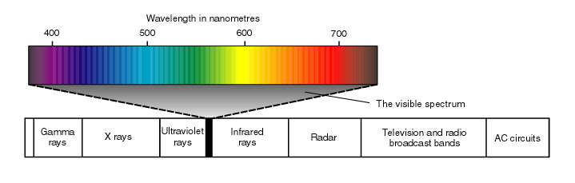
  - Two physical characteristics of light help to determine our sensory experience of them. Light’s wavelength – the distance from the peak of one wave of light to the peak of the next – determines its hue (the colour we experience, such as the tulip’s red petals or green leaves). Intensity, the amount of energy in light waves (determined by a wave’s amplitude, or height), influences brightness.

The Eye and its Function

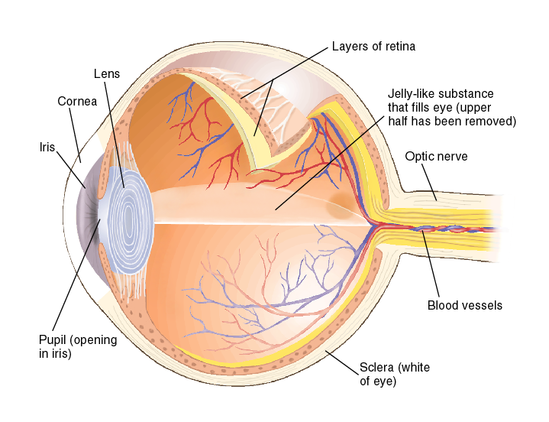
Light rays (from a candle) enters the eye through the cornea then passes through the pupil and lens. The curvature and thickness of the lens change to bring nearby or distant objects into focus on the retina. Rays from the top of the candle strike the bottom of the retina and those from the left side of the candle strike the right side of the retina. The candle’s image on the retina thus appears upside-down and reversed.

An Eye on the World
- Retina
  - Neural tissue lining the back of the eyeball’s interior, which contains the receptors for vision
- Rods
  - Visual receptors that respond to B&W; dim light
- Cones
  - Visual receptors involved in colour vision. Most humans have three types of cones (red, blue, green)

Receptors in the Human Eye

 | Cones | Rods
Number | 6 million | 120 million
Location in Retina | Center | Periphery
Sensitivity in dim light | Low | High
Color sensitive | Yes | No
Detail sensitive | Yes | No

The Retina
- Light sensitive inner surface of the eye, containing the receptor rods and cones plus layers of neurons that begin the processing of visual information
  - Light entering the eye triggers photochemical reaction in rods and cones at back of retina.
  - Chemical reaction in turn activates bipolar cells.
  - Bipolar cells then activate the ganglion cells, the axons of which converge to form the optic nerve. The nerve transmits information to the visual cortex in the brain’s occipital lobe.

Trichromatic Theory

-Young (1802) & Von Helmholtz (1852) both proposed that the eye detects three primary colours only. (red, blue, green)

-All other colour are made by combining these three colours

Opponent Process Theory
- A theory of colour vision which holds that pairs of colours are opposing or antagonistic
- Certain ganglion cells increase firing rate to signal one colour, and decrease to signal the opposing colour
- So colour based on neural excitation – inhibition
  - Red—Green
    - Red: red-green ganglion cell is excited
    - Green: red-green ganglion cell is inhibited
  - Yellow—Blue
    - Yellow: yellow-blue ganglion cell is excited
    - Blue: yellow-blue ganglion cell is inhibited
- Because certain cells are inhibited by a colour, they have a burst of activity when it is removed.
- Visual phenomenon called an afterimage

Defects in Colour Vision
- Protanopia: Red cones filled with green photo-pigment
- Deuteranopia: Green cones filled with red photo-pigment
- Tritanopia: Lack of blue cones

Audition

Cochlea: a coiled, bony, fluid-filled tube in the inner ear; sound waves traveling through the cochlear fluid trigger nerve impulses.

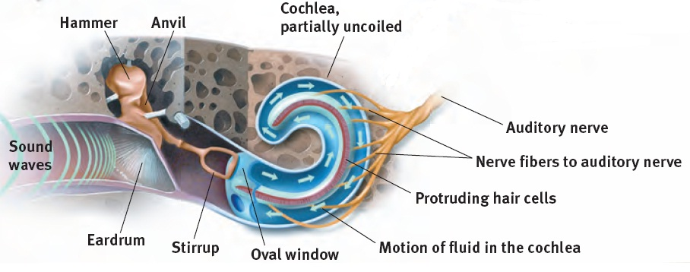
The Middle & Inner Ear
- Conduction Hearing Loss: when the middle ear isn’t conducting sound well to the cochlea
- Sensorineural Hearing Loss: when the receptor cells aren’t sending messages through the auditory nerves

Preventing Hearing Loss
  - Exposure to sounds that are too loud to talk over can cause damage to the inner ear, especially the hair cells
  - Structures of the middle and inner ear can also be damaged by disease
  - Prevention methods include limiting exposure to noises over 85 decibels and treating ear infections

Theories of Hearing

Place Theory: Each individual pitch is determined by the particular place along the basilar membrane that vibrates the most (Middle-High Freq.)

Frequency Theory: The hair cell receptors vibrate the same number of times per second as the sounds that reach them (Lo Freq.)

Auditory Localization
- Sounds from different directions are not identical as they arrive at left and right ears
  - Loudness
  - Timing
  - Wave Phase
- The brain calculates a sound’s location by using these differences.

Detecting and Localizing Sounds:

Relative Loudness:

High frequency won't vibrate as much as low frequency

Gustation & Olfaction

Five Qualities of Taste
- Sweet: energy source
- Sour: potential toxic acid
- Umami: (savoriness) proteins to grow and repair tissue
- Bitter: potential poisons
- Salty: sodium essential to physiological processes

Receptors and the Sensory Pathway
- Smell and taste work together for a person to taste “flavor”

Olfaction: The Sense of Scents
- Airborne chemical molecules enter the nose and circulate through the nasal cavity.
  - Vapors can also enter through the mouth and pass into nasal cavity.
- 5 million receptors on the roof of the nasal cavity detect these molecules.

Smell and Memories
- The brain region for smell (in red) is closely connected with the brain regions involved with memory (limbic system). That is why strong memories are made through the sense of smell.

The Somatosenses

The Skin Senses
- Pressure
  - Stroking adjacent pressure spots creates a tickle
  - Repeated gentle stroking of a pain spot creates an itchy sensation
- Warmth
  - Stimulating nearby cold and warm spots produces the sensations of hot [warmth+cold = HOT]
- Cold
  - Touching adjacent cold and pressure spots triggers a sense of wetness, which you can experience by touching dry, cold metal. [warmth+cold = HOT]
- Pain
  - Pain is your body’s way of telling you something is wrong
  - The rare people born without the ability to feel pain may experience severe injury or even die before early adulthood

The Vestibular Sense
- The sense of the body movement, position, including the sense of balance.

Biological Factors in Pain Perception

Gate-Control Theory
- This theory hypothesizes that the spinal cord contains a neurological “gate” that blocks pain signals or allows them to pass on to the brain.

The “gate” is opened by the activity of pain signals travelling up the small nerve fibers and is closed by activity in larger fibers or by information coming from the brain. Stimulating large nerve fibers in the spinal cord through acupuncture, massage or electrical stimulation seems to close that gate.

Endorphins
- These hormones can be released by the body, to reduce pain perception.

Perceptual set:
- a mental predisposition to perceive one thing and not another (ex. Seeing the young woman before the old witch, vice versa)
- Perceptual set can affect our sight, hearing, taste and smell
- Involves top-down processing, our perceptual set influences our interpretation of stimuli based on our experiences, assumptions and expectations

Context Effect
- Because of the context in a phrase, we may hear something that was never actually said.
- Same goes for the other senses
- A given stimulus may trigger radically different perceptions

Emotion and Motivation
- Perceptions can also be influenced by emotions and motivation
- For example; sad music can make us hear words like mourning instead of morning, it can also make us believe a target to be farther away to those throwing a heavy object rather than a light one.
- Motives also matter – desired objects, such as water bottle when thirsty, seem closer.

Sensation & Perception Processes

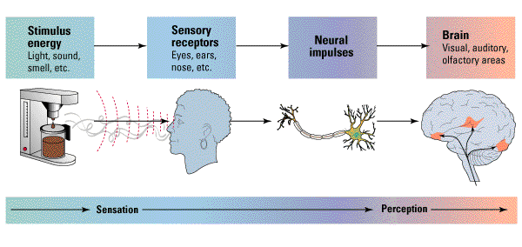

The Visual System is not a Camera
- Much visual processing is done in the brain
  - Some cortical cells respond to lines in specific orientations (ex. Horizontal)
  - Other cells in the cortex respond to other shapes (ex. Bulls-eyes, spirals, faces)
- Feature-detectors
  - Cells in the visual cortex that are sensitive to specific features of the environment

Visual Information Processing
- Processing of several aspects of the stimulus simultaneously is called parallel processing. The brain divides a visual scene into subdivisions such as color, depth, form, movement, etc.

Visual Association Cortex
- Visual scene is broken into small “tiles”; information is analyzed in term of orientation, thickness of lines, colour, movement, etc.

Visual Organization
- When given a cluster of sensations, people tend to organize them into a gestalt, (form/whole).
- In perception, the whole may exceed the sum of its parts.
- We filter incoming information and construct perceptions.

Perception of Form
- Figure and Ground – the organization of the visual field into objects (the figures) that stand out from their surroundings (the ground).
  - Boundaries: edges formed by changes in brightness, color, texture.
  - Figure: perceived as a self-contained object
  - Ground: a formless background against which objects (figures) are seen.
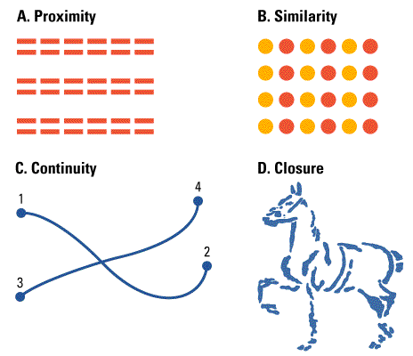
- Gestalt Laws of Grouping: the perceptual tendency to organize stimuli into coherent groups.
  - Right hemisphere is more for the big picture
  - Left hemisphere notices more of the detail
  - Proximity: we group nearby figures together. (Seeing 3 pair of lines in A)
  - Similarity: we group figures that are similar to each other. (seeing columns of orange and red dots in B)
  - Continuity: We perceive smooth, continuous patterns. (seeing lines that connect 1 to 2 and 3 to 4 in C)
  - Closure: We fill in gaps to create a complete whole. (Seeing a horse in D)
- Models of Pattern Perception
  - Templates: It is thought that all of us have a template for things – untrue.
  - Prototypes
    - Distinctive Features is what defines a prototype. This is based on certain features that have to be there. For example, to know what a mug is it has to have a certain shape, a handle, etc.

Depth and Distance Perception
- Depth perception: enables us to estimate an object’s distance from us.
- Visual Cliff: a laboratory device for testing depth perception in infants and young animals.
- Binocular Cues:
  - Visual cues to depth or distance that require the use of both eyes
  - Convergence: Turning inward of the eyes, which occurs when they focus on a nearby object
  - Retinal Disparity: The slight difference in lateral separation between two objects as seen by the left eye and the right eye

Monocular Cues for Depth/Distance (depth cues available to each eye separately)

-Retinal Image
- Size of the image on the retina is proportional to its distance from the retina
- An object moved twice as far away produces a retinal image half of what is was before
- Relative size
  - If we assume two objects are similar in size, most people perceive the one that casts the smaller retinal image is farther away.
- As the house moves farther away, the size of its image on the retina becomes increasingly smaller. But we see its size as constant because we use depth cues to determine that its distance from us, rather than its size, is changing.

-Linear Perspective
- Parallel lines appear to meet in the distance. The sharper the angle of convergence, the greater the perceived distance.
- Provides context
- Side lines seem to converge
- Top line seems farther away

-Texture

-Shading
- Shading produces a sense of depth consistent with our assumption that light comes from above. If you invert this illustration, the hollow will become a hill.

-Interposition
- If one object partially blocks our view of another, we perceive it as closer. The depth cues provided by interposition make this an impossible scene.

-Proximity to Horizontal (Elevation)

-Perceptual Constancies
- Shape/Form/Lightness/Colour Constancy
- Size Constancy

-Perceptual Illusions
- Ames Room’
- Moon Illusion – a picture of a moon on a sign would zip behind us, but the actual moon is too far for us to pass.

-Relative Motion
- When we are moving, we can tell which objects are farther away because it takes longer to pass them.
- This depth perception cue is often referred to as motion parallax. It is used by many animals that don’t have the benefit of binocular cues because their eyes are on the sides of their heads. It is called “relative motion”; when we are moving, the objects we pass can appear to be moving in the opposite direction, and the father objects don’t move as fast.

Motion Perception
- Our brain computes motion based partly on its assumption that shrinking objects are retreating and enlarging objects are approaching.
- Phi phenomenon – an illusion of movement created when two or more adjacent lights blink on and off in quick succession.

Consciousness Major Topics
- Consciousness as a social phenomenon
- Consciousness as a cognitive dissociation
  - Attention
  - Memory
- Consciousness as a neurological dissociation
  - Effects of brain damage
- Consciousness as altered states
  - Sleep & dreams

Consciousness as a Social Phenomenon “Communication”
- Is consciousness verbal communication? – no .
- Consciousness is our awareness of ourselves and our environment
- Reflection of mental processes (verbal awareness)
- Symbolic expressions of mental processes (nonverbal awareness)

Dual Processing: The Two Track Mind
- Dual processing – Perception, memory, thinking, language and attitudes all operate on two levels – a conscious, deliberate “high road” and an unconscious, automatic “low road”.
- Blindsight – a condition in which a person can respond to visual stimulus without consciously experiencing it.

Cognitive Dissociation Attention
- Limited capacity system
- Controlled and automatic processing
- Selective Attention: The cocktail-party phenomenon. We can follow a particular conversation even when other conversations are going on around us.
- Inattentional Blindness: refers to the inability to see an object or a person in our midst. Simons & Chabris (1999) showed that half of the observers failed to see the gorilla-suited assistant in a ball passing game.
- We often aren’t able to see something that should be obvious.
- Change Blindness: a form of inattentional blindness in which two-thirds of individuals giving directions failed to notice a change in the individual asking for directions.
- Semantic Priming Influence without Awareness:
  - Despite not being aware of the words that they “saw”, those exposed to positive words were happier and those exposed to negative words were sadder. This indicates that moods can be influenced without awareness.
- Selective Attention “tip of the iceberg”:
  - Sensory inhibition?
  - No, info does filter through
  - Where does the “lost” info go?
  - Explicit and Implicit Memory (tap 2 levels of “awareness”)
- “Split Memory” A dissociation of Memory processes
  - Explicit (declarative) memory: memory of facts and experiences that one can consciously know and “declare”.
  - Implicit (nondeclarative) memory: retention independent of conscious recollection.
  - HD vs ADS
  - Subcortical vs. cortical memory structures
  - Verbal vs. nonverbal

Consciousness and the Brain
- Visual Agnosia
- The Split-Brain Syndrome (corpus callosum)
- Hypnosis

Altered States: Sleep, Dreams & Hypnosis
- Circadian Cycles: The Biological Clock
  - Circadian cycles are those that last “about a day”.
  - Circadian rhythms are governed by an area of the hypothalamus called the suprachiasmatic nucleus (SCN)
  - Controls body temperature, metabolism, blood pressure, hormone levels and hunger.
  - Jet lag is the result of desynchronization of the circadian rhythm
  - Even if you lose sleep for a few days, you can’t just sleep 14 hours one night, it’s better to add an extra hour each night.
  - Circadian rhythms occur on a 24-hour cycle and include sleep and wakefulness. Termed our “biological clock”, it can be altered by artificial light.
  - Light triggers the suprachiasmatic nucleus to decrease (morning) melatonin from the pineal gland and increase (evening) it at nightfall.
- Sleep Stages
  - Measuring sleep: about every 90 minutes, we pass through a cycles of four distinct sleep stages.
  - Sleep and Dreams: Measuring sleep
    - Electrodes measure – eye movements
    - EMG measures – muscle tension
    - EEG measures – brain waves
    - A camera may also record body movements.
  - Falling asleep: waking beta waking alpha theta(NREM 1) (NREM 2) delta(NREM 3) REM. There are FOUR stages of sleep.
- REM Sleep
  - “Rapid Eye Movement”
  - REM called paradoxical sleep
    - Brain waves similar to waking state, but person is deeply asleep and unable to move
  - Most dreaming takes place during REM
- Sleep Disorders
  - Insomnia – difficulty falling or staying asleep
  - Narcolepsy – falling asleep uncontrollably
    - 1/2000 people
    - persistent daytime sleepiness & irresistible REM sleep attacks (but may not sleep well at night)
    - cataplexy (sudden loss of muscle tone while still awake), often triggered by laughter, anger, embarrassment, sex, exertion, talking to strangers.
    - Sleep paralysis when falling asleep or waking
    - Hypnagogic hallucinations (dreams while awake)
    - Begins in late teens/twenties
    - Associated with some neuron loss in basal forebrain and limbic areas in dogs and abnormality in a recently discovered transmitter (hypocretin/ orexin)
  - Sleep Apnea – reflexive gasping for air that awakens the sleeper
    - loss of oxygen while sleeping
    - brain forgets to breath while asleep
  - Nightmares – anxiety-arousing dreams – REM
  - Night Terrors – intense arousal and panic – NREM3
  - Somnambulism – sleepwalking – NREM3
- Dreams as Unconscious Wishes
  - Freud believed that dreams expressed wishes, so provide insight into the unconscious – he also traced dreams by analysis to erotic wishes
  - Manifest Content: conscious dream content that is remembered after awakening
  - Latent Content: the unconscious, censored meaning of a dream
- Dreams as a by-product of Mental Housekeeping
  - Unnecessary neural connections in the brain are eliminated and important ones are strengthened.
  - The brain divides new information into “wanted” and “unwanted.”
  - What we recall as dreams are only brief snippets from scanning and sorting that occurs during REM sleep.
- Dreams as Interpreted Brain Activity
  - Activation-synthesis theory
  - Dreaming results from cortical synthesis and interpretation of neural signals triggered by activity in the brain
  - Dreams result from the brain’s attempt to make a sense of random neural signals that fire during sleep
- Sleep Theories
  - Sleep protects: Sleeping in the darkness when predators loomed about kept our ancestors out of harm’s way.
  - Sleep helps us recover: Sleep helps restore and repair brain tissue.
  - Sleep helps us remember: Sleep restores and rebuilds our fading memories.
  - Sleep may play a role in the growth process: During sleep, the pituitary gland releases growth hormone. Older people release less of this hormone and sleep less.
  - Sleeps feeds creative thinking: dreams have inspired artistic, literary achievements.
- Hypnosis: A Suggestible State
  - The hypnotic state is not sleep
  - Hypnotic responsiveness depends more on the person being hypnotized than on the skill of the hypnotist
  - Hypnotized people can’t be forced to do things against their will
  - Feats performed under hypnosis can be performed by motivated people without hypnosis
  - Theories of hypnosis

Sociocognitive approach (Spanos, 1996)
    - Hypnotic behaviors are social actions that reflect what the hypnotized individual believes to be characteristic of a hypnotized trance (social)
    - The abilities, beliefs and expectations (cognitive)

Dissociation theories (Hilgard, 1991)
    - Hypnosis is a split in consciousness in which one part of the mind operates independently of the rest of the consciousness, or
    - During hypnosis, dissociation occurs between an executive control system in the brain (probably frontal lobes) and other brain systems involved in thinking and acting.
  - Hypnosis: A split consciousness?
    - Subjects held a hand in ice water and reported pain
    - Hypnotized subjects reported lower pain
    - Hypnotized subjects reported a “hidden observer” that was aware of the pain

Psychoactive Drugs

Psychoactive drugs are chemicals introduced into the body which alter perceptions, mood and other elements of conscious experience and are divided into three groups:

Depressants
  - Examples: alcohol, barbiturates, opiates.
  - Chemicals that reduce neural activity and other body functions.
  - Effects of Alcohol Use: Impact on functioning
    - Slow neural processing, reduced sympathetic nervous system activity and slower thought and physical reaction
    - Reduced memory formation, caused by disrupted REM sleep and reduced synapse formation
    - Impaired self-control, impaired judgment, self-monitoring, and inhibition; increased accidents and aggression.
  - Sedatives
    - Barbiturates:

-Powerful sedative drugs

Alleviate tension and bring about relaxation and sleep
    - Benzodiazepines (tranquilizers and nonbarbiturate sedatives)

-Used in treatment of anxiety disorders and stress-related physical disorders (role of GABA)
  - Narcotics
    - Opiates and Opioids:

-Induce relaxation and reverie

-Provide relief from anxiety and pain

-Ex. Opium, morphine, Heroin, Methadone.

Stimulants
  - These drugs intensify neural activity and bodily functions.
  - Some physical effects of stimulants: dilated pupils, increased breathing and heart rate, increased blood sugar, decreased appetite.
  - Examples: Caffeine, Nicotine, Amphetamines, Methamphetamines, Cocaine, Ecstasy.
  - Methamphetamine
    - triggers the sustained release of dopamine, sometimes leading to eight hours of euphoria and energy. Your brain will eventually stop producing dopamine by itself. You will start having Parkinson symptoms.
    - What happens next… irritability, insomnia, seizures, hypertension, violence, depression.
    - “meth” addiction can become all-consuming.
  - Cocaine
    - Blocks reuptake, and thus increases levels at the synapse of:
      - Dopamine (feels rewarding)
      - Serotonin (lifts mood)
      - Norepinephrine (provides energy)
    - Effect on consciousness: Euphoria, for at least 45 minutes.
  - Euphoria crashes into a state worse than before taking the drug, with agitation, depression, and pain.
  - Users develop tolerance; over time, withdrawal symptoms of cocaine use get worse, and users take more just to feel normal.
  - Cycles of overdose and withdrawal.
  - Effects on drugs on synaptic transmission: Cocaine and amphetamine prevent reuptake. Transmitter substance is not taken back by the terminal button; therefore, it effects on the receptor molecules are prolonged.
  - Ecstasy/MDMA (MethyleneDioxyMethAmphetamine)
    - Ecstasy is a synthetic stimulant that increases dopamine and greatly increases serotonin.
    - Effects on consciousness: euphoria, CNS stimulation, hallucinations and artificial feeling of social connectedness and intimacy
    - What happens next… In the short run, regretted behavior, dehydration, overheating and high blood pressure
    - Damages serotonin-producing neurons, causing permanently depressed mood
    - Disrupted sleep and circadian rhythm
    - Impaired memory

Hallucinogens
  - LSD (lysergic acid diethylamide)
    - LSD and similar drugs interfere with serotonin transmission
    - This causes hallucinations – images and other “sensations” that didn’t come in through the senses. (senses merge)
  - Marijuana/THC (delta-9-TetraHydroCannabinol)
    - Marijuana binds with brain cannabinoid receptors.
    - Effect on consciousness: amplifies sensations, disinhibits impulses, euphoric mood, lack of ability to sense satiety.
    - Impaired motor coordination, perceptual ability, and reaction time.
    - THC accumulates in the body, increasing the effects of next use. Stores in the fat cells for quite some time.
    - Over time, the brain shrinks in areas processing memory and emotion.
- Influences on Drug Use
  - The use of drugs is based on:

biological,
    - Genetic tendencies
    - Dopamine reward circuit

psychological and
    - Lacking sense of purpose
    - Significant stress
    - Psychological disorder, such as depression

social-cultural influences
    - Urban environment
    - Belonging to a drug-using cultural group
    - Peer influences

Summary: Desired & Negative Effects of Drugs
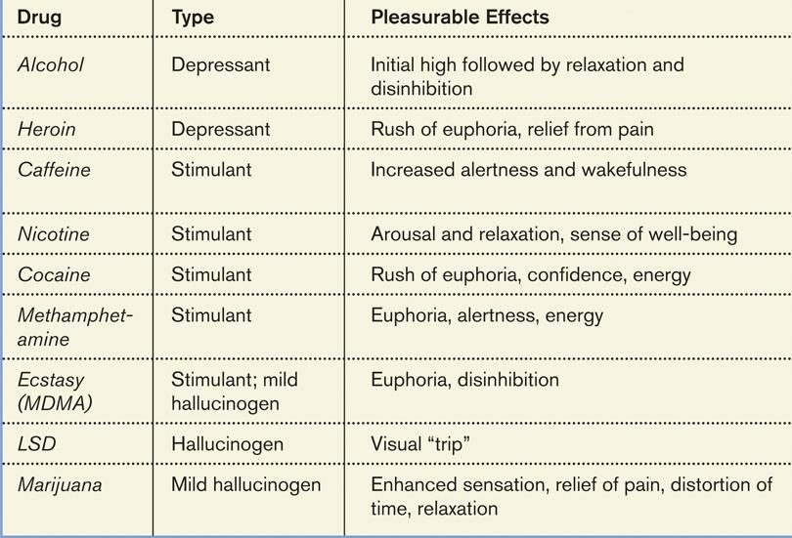

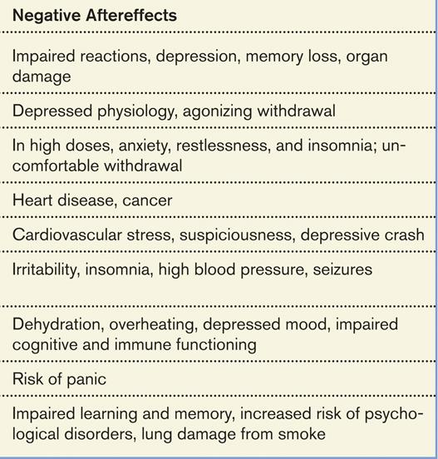

Main Points

Learning & Habituation

Classical Conditioning

Operant Conditioning

Conditioning of Complex Behaviors (Phobias)

Learning and Habituation

Learning: A relatively permanent change in behavior (or behavioral potential) due to experience. – the process of acquiring new and relatively enduring information or behaviors.

Behaviorism: Emphasizes the study of observable behavior and the role of the environment as a determinant of behavior. – by learning we are able to adapt to our environments.

Habituation: The simplest form of learning. Habituation is learning not to respond to an unimportant event that occurs repeatedly. (ex. The sound of an echoe)

Classical Conditioning

Pavlov’s Serendipitous Discovery
- By observing dogs during the digestion process, Pavlov formulated his theory of classical conditioning.
- He noticed the dog would start salivating as soon as the food was placed in front of him. He then put a shield so the dog couldn’t see the food coming, Pavlov would sound a tone right before he brought the dog the food. Eventually as soon as the dog heard the tone, he would start salivating – expecting the food. The tone is the neutral stimulus, the salivating is an unconditioned response, and the food is the unconditioned stimulus. However, because the salivation (UR) only occurs to the tone (NS) after the dog is conditioned (has learned) to this stimulus, him salivating is a conditioned response and the tone is now a conditioned stimulus.
- Classical Conditioning: The process by which a previously neutral stimulus acquires the capacity to elicit a response through association with a stimulus that already elicits a similar or related response.
- We learn to associate two stimuli and thus to anticipate events. (A stimulus is any event or situation that evokes a response)

Conditioning Terms
- Neutral Stimulus (NS): a stimulus that elicits no response before conditioning.
- Unconditional Stimulus (US): A stimulus that elicits a reflexive response in the absence of learning/a stimulus that unconditionally triggers a response. (this stimulus naturally triggers a response)
- Conditioned Stimulus (CS): An initially neutral stimulus that comes to elicit a conditioned response after being associated with an unconditioned stimulus. (starts off as a NS then after conditioning, becomes a learned stimulus)
- Unconditioned Response (UR): A reflexive response elicited by a stimulus in the absence of learning. (this is the initial and natural response that happens without any conditioning)
- Conditioned Response (CR): A response that is elicited by a conditioned stimulus; it occurs after the conditioned stimulus is associated with an unconditioned stimulus. (this is the response that occurs after a conditioned stimulus)

The Biological Significance of Classical Conditioning
- The ability to learn to recognize stimuli that predict the occurrence of an important event allows the learner to make the appropriate response faster and more effectively
- Stimuli that were previously unimportant acquire some of the properties of the important stimuli and can now modify behavior (taken economies)

Classical Condition in Advertising
- Many advertisers attempt to make their products conditioned stimuli that elicit pleasant emotional responses by pairing their products with attractive or popular people or sexual imagery.
- (CS) Products [ex. underwear] (US) Attractive person (CR+UR) Pleasant emotional response.

Basic Principles of Classical Conditioning
- Acquisition (CS-US pairings) the linking of a NS and a US so the NS becomes a CS.
  - Making the connection between the two things.
  - Stimulus Intensity
  - Timing on making a connection
  - A neutral stimulus that is consistently followed by an unconditioned stimulus will become a conditioned stimulus
  - Higher-order condition – a procedure in which the CS is paired with a new NS, creating a second (often weaker) CS. For example, an animal that has learned that a tone predicts food might then learn that a light predicts the tone and begin responding to the light alone.
  - During acquisition, the strength of the dog’s conditioned response (measured by the amount of salivation) increases rapidly and then levels off near its maximum.
- Extinction (CS alone)
  - The STOPPING of the conditioned response
  - The weakening and eventual disappearance of a learned response; in classical conditioning, it occurs when the conditioned stimulus is no longer paired with the unconditioned stimulus
  - Ex. Sounding a tone over and over again without giving the food after, will weaken and eventually diminish the conditioned response
  - During extinction, the CR declines erratically until it’s extinguished. After a “rest” period in which the dog is not exposed to the CS.
- Spontaneous Recovery (CS alone)
  - The re-emergence of a previously extinguished conditioned response after a delay.
  - A spontaneous recovery occurs, and the CS once again elicits a (weakened) CR. Repeated presentations of the CS alone re-extinguished the CR, but after another “rest” interval, a weaker spontaneous recovery occurs.
- Generalization and Discrimination
  - Generalization: The tendency to respond like-wise to stimuli similar to the CS.
  - Learning to Fear
    - In 1920, 9 month old Little Albert was not afraid of rats.
    - John B. Watson and Rosalie Rayner then clanged a steel bar every time a rat was presented to Albert.
    - Albert acquired a fear of rats, and generalized this fear to other soft and furry things.
    - Watson conditioned “Little Albert” to be afraid of white rats by pairing the neutral stimulus (rats) with an unconditioned stimulus (loud noise)
- Conditioned Emotional Responses
  - Phobias are probably an example of a conditional emotional response
  - Phobias are an unreasonable fear of specific objects or situations, learned through classical conditioning
- Discrimination: Responding only when a specific discriminative stimulus is present (no response to similar stimuli) – the ability to distinguish between a conditioned stimulus and other irrelevant stimuli.

Operant Conditioning – we to learn to associate a response (our behavior) and its consequence. Thus we learn to repeat acts followed by good results and avoid acts followed by bad results.

The Law of Effect
- Thorndike’s idea that the consequences of a behavior determines whether it is likely to be repeated or not
- Pleasant outcomes = higher probability
- Unpleasant outcomes = lower probability
- Associative Learning: Learning to associate a response with a consequence

Skinner and Operant Behavior
- Using Thorndike’s law of effect as a starting point, Skinner developed the Operant chamber, or the Skinner box, to study operant conditioning.
  - The Skinner Box had a rat inside a box who would tap a bar to release food. The food acted as a reward. This was Skinner’s concept of reinforcement (any event that strengthens a preceding response).

Reinforcement and Punishment
- Reinforcement: The process by which a stimulus or event strengthens or increases the probability of the response that it follows
- Positive Reinforcement: when a pleasant consequence follows a response, making the response more likely to occur again.
  - any stimulus that when presented after a response, strengthens the response.
  - Add a desirable stimulus – pet a dog that comes to you when you call its name
- Negative Reinforcement: when a response is followed by the removal of something unpleasant, making the response more likely to occur again. *not a punishment
  - Strengthens a response by removing or reducing something negative.
  - Removing an aversive stimulus
  - Fastening seatbelt to end loud beeping
- Primary Reinforcement reinforces and inherently reinforcing and typically satisfy a need. (getting food when hungry)
- Secondary Reinforcement: A stimulus with reinforcing properties through association with a primary reinforcement (the light coming on after pressing a button, indicating food is coming)
- Schedules of reinforcement:
  - Ratio (fixed): every so many – buy 5 coffees, get one free
  - Ratio (variable): after an unpredictable number – playing slots
  - Interval (fixed): every so often – discounted beers on Tuesday
  - Interval (variable): unpredictably often – checking for a FB response
- Punishment: The process by which a stimulus or event weakens or reduces the probability of the response that it follows
- Positive Punisher: When something unpleasant occurs after a behavior
  - Administer an aversive stimulus
  - Ex. Spraying a barking dog with water bottle, getting a ticket for speeding
- Negative Punisher: When something pleasant is removed after a behavior
  - Withdraw a rewarding stimulus
  - Ex. Taking away videos games from a boy, revoking driving privileges
- Primary Punisher: Something inherently punishing
- Secondary Punisher: A stimulus with punishing properties through association with a primary punisher
- Negative Side-Effects of Punishment
  - Risk of injury
  - Inducement of fear and hostility
  - Organisms learn only which response not to make
  - Punishment doesn’t teach the organism desirable responses
  - May be reinforcing behavior
- Positive vs Negative / Reinforcement vs Punishment
  - Positive – adds something
  - Negative – takes away something
  - Reinforcement – increases behavior
  - Punishment – decreases behavior
- Conditioned Emotional Response “Maintaining Phobias”

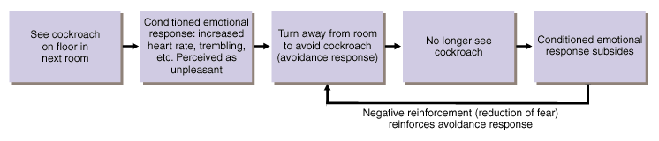
  - Acquisition: Phobias
    - Classical conditioning of a fear response. Many emotional responses that would otherwise be puzzling can be explained by classical conditioning. In the case of one woman’s bridge phobia, the fear originally elicited by her father’s scare tactics because a conditioned response to the stimulus of bridges.

Other Operant Procedures and Phenomena

Vicarious Learning: Learning through observation
  - Mirror Neurons: Neuroscientists discovered mirror neurons in the brain of animals and humans that are active during observational learning. Starting from an early age humans are able to imitate people around them.
  - Bandura’s Experiments
    - Bandura’s Bobo doll study (1961) indicated that individuals (children) learn through imitating others who receive rewards and punishments.
  - Applications of Observational Learning
    - Unfortunately, Bandura’s studies show that antisocial models (family, neighborhood or TV) may have antisocial effects.
  - Positive Observational Learning
    - Fortunately, pro-social (positive, helpful) models may have pro-social effects.

Shaping: a method of successive approximations
  - Shaping is the operant conditioning procedure in which reinforces guide behavior towards the desired target behavior through successive approximations.
  - Ex. A rat shaped to sniff mines. A manatee shaped to discriminate objects of different shapes, colour and sizes.

Schedules of Reinforcement:
  - Continuous Reinforcement: a reinforcement schedule in which a particular response is always reinforced.
  - Intermittent (Partial) Reinforcement: A reinforcement schedule in which a particular a response is sometimes reinforced
    - Ratio (fixed, variable)

Interval (fixed, variable)

Important Definitions on Memory
- Memory – the persistence of learning over time through the storage and retrieval of information
- Recall – a measure of memory in which the person must retrieve information learned earlier, as on a fill-in-the-blank test
- Recognition – a measure of memory in which the person need only identify items previously learned, as on a multiple choice test
- Relearning – a measure of memory that assesses the amount of time saved when learning material again

Memory Overview
- The Atkinson-Schiffrin (1968) three-stage model of memory includes:

Sensory input sensory memory short-term memory long-term memory
- Memory is found in each lobe of the brain: spatial memory, motor memory, etc.
- Sensory input: the memory that does not stay
- Sensory memory: The immediate, very brief recording of sensory information in the memory system
- Short term memory: activated memory that holds a few items briefly, such as seven digits of a phone number while dialing it, before the info is stored or forgotten
- Long term memory: relatively permanent and limitless storehouse of the memory system. Includes knowledge, skills and experiences
- Working memory: Focuses on conscious, active processing of incoming auditory and visual-spatial information, and of information retrieved from long-term memory

Studying Memory: Information Processing Models
- Encoding – The processing of information into the memory system – for example, by extracting meaning
- Storage – the retention of encoded information over time
- Retrieval – accessing information from storage [Ex. exam]

Sensory Memory: Fleeting Impressions
- Momentarily preserves images of sensory information
- Iconic: lasts only a fraction of a second (visual)
- Echoic: lasts about 3-4 seconds (auditory)
- Information that is not quickly passed to short-term memory decays rapidly

Short-Term Memory (STM)
- Involved in the retention of information for brief periods
- Has a capacity of 5 to 9 bits of information (7 +/- 2)
- Lasts about 20 seconds
- Capacity – The magical number seven, plus or minus two: some limits on our capacity for processing information. (George miller – 1956)

Limits of Working Memory
- Miller (1956) demonstrated that people on average could remember 7 +/- 2 pieces of information
- You can chunk these pieces of information
- There are time limits

How we encode
- Chunking – meaningful unit of information which may be composed of smaller units
- Rehearsal – Baddley’s loop

Primacy and Recency Effects
- Primacy Effect – is the tendency to remember initial information
- Recency Effect – is the tendency to recall later information

Serial Position Effect
- Recall of first and last items on a list is greater than recall of items in the middle of the list

Long-Term Memory: Final Destination
- Unlimited capacity/relatively permanent
- The memory systems involved in LTM:
  - Explicit/Implicit
  - Semantic/Episodic/Procedural

Explicit & Implicit Memory:
- Explicit – memories of facts and experiences that one can declare and consciously know
  - Facts, knowledge
- Implicit – retention independent of conscious recollection (non-declarative)
  - Skills and habits

More content of long term memory
- Semantic memories
  - General knowledge, including objective facts, rules, concepts
- Episodic memories
  - Personally experienced events and the contexts in which they occurred
- Procedural memories (nondeclarative)
  - Memories for performance of actions or skills
  - “knowing how”

Encoding Information into Long-Term Memory
- The Consolidation Hypothesis
  - Consolidation is the process by which information in short-term memory is transferred to long-term memory
  - Long-term potentiation – refers to synaptic enhancement after learning. And increase in neurotransmitter release or receptors on the receiving neuron indicates strengthening of synapses.
- Rehearsal
  - Maintenance Rehearsal – rate repetition of material in order to maintain its availability in memory
  - Elaborative Rehearsal – association of new information with already stored knowledge to make it memorable
  - Semantic categories is one way information is organized
- The Levels of Processing Hypothesis
  - Encoding information by processing meaning rather than simply the physical or surface features of a stimulus
  - Shallow – structural encoding: emphasizes the physical structure of the stimulus.
  - Intermediate – phonemic encoding: emphasizes what a word sounds like.
  - Deep – semantic encoding: emphasizes the meaning of verbal input.
- Improving Long-Term Memory
  - Mnemonic – is a system of conscious strategies/tricks designed to improve memory
    - ex. Never Eat Shredded Wheat – North, East, South, West.
  - Method of Loci – relating certain items to other things (stupid)
  - Peg-Words

The Biology of Memory

Forming a memory involves chemical/structural changes at the neuronal level.
- Short-term memory: changes within neurons temporarily alter the neuron’s ability to release transmitters
- Long-term memory: long-term potentiation or a long-lasting increase in the strength of synaptic responsiveness occurs

- Chapter Overview
- Motivation Concepts
- Hunger
- Sexual Motivation
- The Need to Belong
- Motivation at Work

Motivation Concepts
- Motivations are needs or desires that energizes and directs behavior. They arise from the interplay between nature (the bodily push) and nurture (the pulls from our thought processes and culture).
- An Instinct is a complex behavior that is rigidly patterned through a species and is unlearned.
- Four perspectives for viewing motivated behaviors:
  - Instinct theory – focuses on genetically predisposed behaviors. Now referred to as the Evolutionary perspective.
  - Drive-reduction theory – focuses on how our inner pushes and external pulls interact.
  - Arousal theory – focuses on finding the right level of stimulation.
  - Maslow’s Hierarchy of Needs – describes how some of our needs take priority over others.

Drives & Incentives
- Drive reduction theory – the idea that a physiological need creates an aroused state that drives the organism to reduce the need by, say, eating or drinking. When a physiological need increases, so does a psychological drive – an aroused/motivated state.
- The physiological aim of drive reduction is homeostasis – the maintenance of a steady internal state.
- Need drive drive-reducing behaviors
- We are pushed by our need to reduce drives and we are pulled by incentives – positive or negative environmental stimulus that motivates behavior.
- Human motivation aims not to eliminate arousal but to seek optimum level of arousal. Once all of biological needs are satisfied, we feel driven to experience stimulation and we hunger of information.

Hierarchy of Motives
- As humans we all start with physiological needs for air and water and food. Once these are met our priorities may shift to safety needs. Then to belongingness and love, and then esteem needs, then self-actualization needs, and the last one being self-transcendence needs.
- In poorer nations, financial satisfaction more strongly predicts feelings of well-being.
- In wealthy nations, home-life satisfaction is a better predictor.
- Self-esteem matters most in individualist nations, whose citizens tend to focus more on personal achievements than on family and community identity.

Hunger
- The need for food and water over powers everything.
- In a study done by Ancel Keys, he studied semi-starvation by cutting the food intake of 36 males in half. Their body weights dropped by 25% but the most dramatic effects were the psychological effects. They became food obsessed and lost interest in many other things.

The Physiology of Hunger
- Stomach contractions whenever feeling hungry.
- Glucose is the form of sugar that circulates in the blood and provides that major source of energy for body tissues. When it’s level is low, we feel hungry.
- Increases in the hormone insulin, diminish blood glucose, partly by converting it to stored fat. If you blood glucose level drops, you won’t consciously feel this change, but your brain with trigger a sense of hunger.
- Signals from your stomach, intestine and liver all signal your brain to motivate eating or not.
- One neural arc, arcuate nucleus, has a center that secretes appetite-stimulation hormones, and another center that secretes appetite-suppressing hormones.
- Ghrelin is a hunger-arousing hormone secreted by an empty stomach.
- Leptin & PPY both decrease hunger and orexin triggers hunger.
- A set point is an individual’s “weight thermostat”. When the body falls below this weight, an increase in hunger and a lowered metabolic rate may act to restore the lost weight.
- Some researchers have abandoned this idea and use the term setting point, to indicate the level at which a person’s weight settles in response to caloric intake and expenditure.
- Basal metabolic rate – the body’s resting rate of energy expenditure.

The Psychology of Hunger
- As time passes since we last ate, we anticipate eating again and start feeling hungry. (tested with amnesia patients)
- Carbohydrates help boost levels of the neurotransmitter serotonin, which has calming effects.
- Some tastes preferences are genetic and universal, others are conditioned.
- Culture also has effects on taste. We avoid unfamiliar foods.
- And out taste preferences are also adaptive. For example, spices used in hot climate recipes where food spoils more quickly, inhibit growth of bacteria. Pregnancy related nausea peak around the tenth week when the developing embryo is most vulnerable to toxins.

Situational Influences on Eating
- Situations can control out eating
- Social facilitation – we tend to eat more in the presence of others. Explaining why after a celebration, we may realize we have overeaten.
- Unit bias – this deals with portion sizes and how serving things in smaller bowls/plates we may eat less.
- Food variety – when there is less food to choose from, we will eat less.

Obesity
- There are obviously social effects of obesity.
- The physiological effects of obesity include;
  - Set point and metabolism – once we become fat, we require less food to maintain our weight than we did to attain it. Fat has a lower metabolic rate. You can change you set point over time, however it is easy to gain weight back if you lost it fast.
  - Genetic Factors – our genes can affect our weight
  - Food and activity factors – sleep loss can cause obesity. Levels of leptin fall and ghrelin rise. Social influence is another factor, people are more likely to become obese when a friend becomes obese.

Losing weight
- Begin only if you feel motivated and self-disciplined – this may turn into a career for a little while, so you must be able to stick it through
- Minimize exposure to tempting food cues
- Exercise
- Eat healthy foods
- Don’t starve all day and eat one big meal at night
- Beware of the binge

Eating Behavior
- Biological influences
  - Hypothalamic centers in the brain monitoring appetite
  - Appetite hormones
  - Stomach pangs
  - Weight set/settling point
  - Attraction to sweet and salty tastes
  - Adaptive wariness toward novel foods
- Psychological influences
  - Sight and smell of food
  - Variety foods available
  - Memory of time elapsed since last meal
  - Stress and mood
  - Food unit size
- Social-cultural influences
  - Culturally learned taste preferences
  - Responses to cultural preferences for appearance

Sexual Motivation
- Sexual motivation is nature’s clever way of making people procreate.

Physiology of Sex
- Sexual response cycle – has four stages.
  - Excitement phase – genital areas become engorged with blood
  - Plateau phase – excitement peaks as breathing, pulse and blood pressure rates continue to increase.
  - Orgasm – muscle contractions
  - Resolution phase – the male enters refractory period when he is incapable of an orgasm, this period for the female is a lot shorter.
- Sexual disorders
  - Problems that consistently impair sexual arousal or functioning.
  - Erectile dysfunction and premature ejaculation happen in men
  - Some women deal with orgasmic dysfunction
- Hormones and Sexual Behavior
  - The female becomes sexually receptive when secretion of the female hormone, estrogen, peak during ovulation.
  - Male hormone levels are more constant, and hormone injection does not so easily manipulate the sexual behavior of males animals.
  - In men, normal fluctuations in testosterone levels, have little effect on sexual drive. Fluctuations in male hormones are partly a response to sexual stimulation.
  - North America and China find that married fathers tend to have lower testosterone levels than do bachelors and married men without children.
  - Male sex-offenders take Depo-Provera, a drug that reduces testosterone levels to that of a pre-pubertal boy.
  - Biology is a necessary but not sufficient explanation of human and sexual behavior.

- Psychology of Sex
- Hunger responds to a need, sex is not in this sense a need. Both depend on internal physiological factors.
- Despite the shared biology that underlies sexual motivation, expressed reasons for having sex are widely ranged.
- External Stimuli
  - With repeated exposure, the emotional response to any erotic stimulus often habituates.
  - Women being sexually coerced and liking it, tend to increase viewer’s acceptance of the false idea that women enjoy rape and they tend to increase male viewers’ willingness to hurt women.
- Imagine Stimuli
  - The stimuli inside our heads can influence sexual arousal and desire.
  - Nearly all men and some 40 percent of women, dreams sometimes contain sexual imagery that leads to orgasm.

Sexual Motivation
- Biological influences
  - Sexual maturity
  - Sex hormones, especially testosterone
  - Sexual orientation
- Psychological Influences
  - Exposure to stimulating conditions
  - Sexual fantasies
- Social-cultural influences
  - Family and society values
  - Religious and personal values
  - Cultural expectation
  - Media

- Adolescent Sexuality
- Teen Pregnancy
  - Minimal communication about birth control
  - Guilt related sexual activity
  - Alcohol use
  - Mass media morns of unprotected promiscuity
- STI’s
  - Two-thirds of new infections occur in people under 25. Teen girls are especially vulnerable due to their not yet fully matured biological development and lower levels of protective antibodies.
- Adolescents who are more like to be abstinent usually have:
  - High intelligence
  - Religious engagement
  - Father presence
  - Participation in service learning programs

Sexual Orientation
- Sexual orientation – our enduring sexual attraction toward members of our own sex or the other sex.
  - 3% of men and 1 or 2 % of women.
- Sexual orientation is not an indicator of mental health.
- Origins of Sexual Orientation
  - Homosexual people appear more often in certain populations – poets, artists, musicians, etc.
  - Men who have older brothers are more likely to be gay – fraternal birth order effect.
  - With each pregnancy with a male fetus, the maternal antibodies may become stronger and may prevent the fetus’ brain from developing in a male-typical pattern.
- The brain and sexual orientation
  - One cell cluster was reliably larger in heterosexual males than in women and homosexual men.
  - Everything psychological is simultaneously biological.
  - The neuroanatomical correlates of male homosexuality differentiate very early postnatal if not prenatally.
  - Anterior commissure is lager in gay men than in straight men.
  - Gay men’s hypothalamus reacts as do straight women’s to the smell of sex-related hormones.
- Genes and Sexual Orientation
  - There is evidence that genetic influence can effect sexual orientation.
  - Shared sexual orientation is higher among identical twins that among fraternal twins.
  - Sexual attraction in fruit flies can be genetically manipulated
  - Male homosexuality often appears to be transmitted from the mother’s side of the family.
- Prenatal influences
  - Altered prenatal hormone exposure may lead to homosexuality in humans and other animals
  - Right handed men with several older biological brothers are more likely to be gay, possibly do to a maternal immune-system reaction.

The Need to Belong
- Separated from friends and family, isolated in prison, alone in a new place – most people don’t like being alone and isolated.
- This started way back in history when people got more hunting and gathering done in packs of people rather than by themselves.
- When our need for relatedness is satisfied in balance with two other basic psychological needs – autonomy (sense of personal control) and competence – the result is a deep sense of well being.
- Much of our social behavior therefore aims to increase our belonging – our social acceptance and inclusion.
- Like sexual motivation, which feeds both love and exploitation, the need to belong feeds both deep attachments and menacing threats.

The Pain of Ostracism
- To experience ostracism is to experience real pain.
- It elicits increased activity in brain areas, such as the anterior cingulate cortex, that also activate in response to physical pain.
- The pain-reliever acetaminophen lessens social as well as physical pain.
- Pain, whatever it’s source, focuses our attention and motivates corrective action.
- The pleasure of love in a natural pain killer.
- People who feel ostracized will become aggressive, and engage in self-defeating behaviors.

Social Networking
- Social networking tends to strengthen your relationships with people you already know, increase your self-disclosure, and reveal your true personality.

Motivation at Work
- Flow – a completely involved, focused state of consciousness, with diminished awareness of self and time, resulting from optimal engagement of one’s skills.

- Chapter Overview
- Cognition and Emotion
- Embodied Emotion
- Expressed Emotion
- Experienced Emotion

Cognition and Emotion
- Emotions are a mix of bodily arousal (heart pounding), expressive behaviors (quickened pace) and conscious experience (including thoughts and feelings).
- James-Lange Theory: Arousal Come Before Emotion
  - You feel sad because you cry, you get angry because you lash out, you are afraid because you tremble.
  - James and Lange believed that you felt an emotion after your bodily function took place.
- Cannon-Bard Theory: Arousal and Emotion Occur Simultaneously
  - Bard and Cannon concluded that our bodily responses and experiences emotions occur separately but simultaneously.
  - The emotion-triggering stimulus travels to the sympathetic nervous system, causing the body’s arousal. At the same time, it travels to the brain’s cortex, causing the awareness of emotion.
  - This theory has been challenged by people with severed spinal cords. Lower-spine injuries reported little change in their emotion’s intensity. Those with high-spinal injury reported changes. “Anger just doesn’t have the heat to it that it used to.”
  - But most researchers now agree that our emotions also involve cognition. (Whether we fear the man behind us on the dark street depends entirely on whether we interpret his actions as threatening or friendly).
- Schachter and Singer: Cognition Can Define Emotion
  - Schachter and singer believed that an emotional experience requires a conscious interpretation of arousal: our physical reactions and our thoughts together create an emotion.
  - In there two-factor theory, to experience emotion one must be physically aroused and cognitively label the arousal.
  - The spillover effect, is when you react to a situation a certain way because of the emotion you were feeling just before – feeling angry after a favorite team just lost the series and then taking part in a riot.
  - Arousal fuels emotion; cognition channels it.
- Zajonc, LeDoux and Lazarus: Cognition May Not Precede Emotion
  - (Zajonc) We have many emotional reactions apart from, or even before, out interpretation of a situation.
  - (LeDoux) Our emotional responses can follow two different brain pathways. Some emotions (especially more complex feelings like hatred and love) travel a “high road”. A stimulus following this path would travel by way of the thalamus to the brain’s cortex, where it would be analyzed and labeled before the command is sent out, via the amygdala (an emotion-control center) to respond.
  - Sometimes our emotions (such as more simple ones such as like, dislike, fear) take the “low road”, a neural shortcut that bypasses the cortex. A fear-provoking stimulus would travel by way of the thalamus directly to the amygdala. This shortcut enables a speedy emotional response before our intellect intervenes.
  - The amygdala sense more neural projections up to the cortex than it receives back, which makes it easier for our feelings to hijack our thinking to rule our feelings.
  - (Lazarus) Emotions arise when we appraise an event as harmless or dangerous, whether we truly know it is or not. For example, we appraise the sound of the rustling bushes as the presence of a threat, later we realize that it was “just the wind”.
  - As Lazarus, Schachter and Singer predicted highly emotional people are intense partly because of their interpretations. They may personalize events as being somehow directed at them and they may generalize their experiences by blowing single incidents out of proportion.

Embodied Emotion

Emotions and the ANS
- In a crisis, the sympathetic division of your automatic nervous system mobilizes your body for action, direction your adrenal glands to release the stress hormones epinephrine and norepinephrine. To provide energy, your liver pours extra sugar into blood stream and your respiration increases to help burn the sugar and supply needed oxygen. Lots of other physical things happen within the ANS.
- When the crisis passes, the parasympathetic division of you ANS gradually calms your body.

The Physiology of Emotions
- Different emotions do not have sharply distinct biological signatures. Nor do they engage sharply distinct brain regions.
- Insula, a neural center deep inside the brain, is activated when we experience various social emotions, such as lust, pride and disgust. In brain scans in lights up when people into something disgusting.
- Research has pinpointed some real, though subtle, distinct physiological and brain pattern distinctions among the emotions.
- Fear and joy, although they prompt similar increased heart rate, stimulate different facial muscles.
- Compared with observers watching angry faces, those watching fearful faces show more activity in their amygdala.
- When you experience negative emotions such as disgust, your right prefrontal cortex tends to be more active than the left. Depressions-prone people, and those with generally negative personalities, also how more right frontal activity.
- Positive moods tend to trigger more left frontal lobe activity. More positive people show more activity in the left frontal lobe.

Expressed Emotion

Detecting Emotion in Others
- Most of us read nonverbal cues well.
- We are especially good at detecting non-verbal threats
- A single angry face “pops out” faster than a single happy one.
- Physically abused children are much quicker than other children to spot the signals of anger
- Hard-to-control facial muscles reveal signs of emotions you may be trying to conceal
- Despite out brain’s emotion-detecting skill, we find it difficult to detect deceiving expressions
- Introverts tend to excel at reading others’ emotions, while extraverts are generally easier to read

Gender, Emotion and Nonverbal Behavior
- Women generally do surpass men at reading people’s emotional cues when given “thin slices” of behavior
- Emotionality is “more true of women”
- Women are also far more likely than men to describe themselves as empathetic
- Females are also more likely to express empathy, to cry and to report distress when observing someone in distress

Culture and Emotional Expression
- The meaning of gestures caries with the culture
- However facial expressions are generally the same throughout the world
- Musical expressions also cross cultures. ie. Happy music makes people happy
- Facial muscles speak a universal language
- People judge an angry face set in a frightening situation as afraid
- They would judge a fearful face set in a painful situation as pained
- Some cultures differ in how much emotion they express
- North Americans convey a lot of emotion through their mouth

The Effects of Facial Expressions
- William James believed that we can control emotions by going “through the outward movements” of any emotion we want to experience
- The facial feedback effect is the tendency of facial muscle states to trigger corresponding feelings such as fear, anger or happiness.
- By activating one of the smiling muscles by holding a pen in your teeth, you will find things more amusing.
- When smiling you will even more quickly understand that sentences that describe pleasant events.
- Your face does not just display your feelings but it also feeds your feelings
- After receiving Botox injections between the eyebrows, paralyzing the frowning muscles, 9 out of 10 depressed patients were no longer depressed anymore.
- Letting your face mimic the face of another, helps you empathize with their emotions

Experienced Emotion
- Carroll Izard isolated 10 basic emotions present in infancy: joy, interest-excitement, surprise, sadness, anger, disgust, contempt, fear, shame and guilt
- Pride and love are a couple more
- The ingredients of emotion include not only physiology and expressive behavior but also our conscious experience
- Any emotion is some combination of feeling good versus bad and of being aroused and energized or not
- On the valence and arousal dimensions, terrified is more frightened (more unpleasant and aroused) than afraid

Anger
- Chronic hostility is linked to heart disease
- Catharsis – emotional release. Releasing aggressive energy, through action or fantasy, relieves aggressive urges
- This is temporarily calming, doesn’t completely cleanse one’s rage. Expressing anger, can magnify that anger
- Forgiveness is usually what calms the body

Happiness
- Feel good, do good phenomenon – people’s tendency to be helpful when already in a good mood
- Doing good also promotes good feelings
- Subjective well-being – self-perceived happiness or satisfaction with life. Used along with measures of objective well-being to evaluate people’s quality of life
- Money can make a lot of people happier in the sense that you need money to feed your family and provide shelter. But after you’ve met all of these needs money does less to increase feelings of happiness.
- Experiencing luxury diminishes our savoring of life’s simpler pleasures
- Adaption-level phenomenon – our tendency to form judgments relative to a neutral level defined by our prior experiences
- Relative depreciation – the perception that one is worse off relative to those with whom one compares oneself

Predictors of Happiness
- Genes matter
- Personal history and culture
- Our genes, our outlook, recent experiences, happiness all seems to fluctuate around our “happiness set point”.

