1. Describe in general terms how enzymes can increase reaction rates.  2. Contrast the progress curve of an enzyme catalyzed reaction, as a function of change in free energy when reactants are converted to products, with that of an uncatalyzed chemical reaction.  3. Explain the relationship between enzyme concentration, substrate concentration and rate of product formation.  4. Compare competitive vs. allosteric enzyme inhibitions as a way of regulating enzyme activity.  5. List other factors affecting enzyme activity.  1. Compare genome structure and arrangement in bacterial cells versus eukaryote cells.  2. Discuss the diversity in genome sizes among organisms.  3. Describe the relationship between DNA structure and the Watson-Crick base pair rules (Chargaff’s rules).  4. Relate DNA stability to base-stacking and hydrogen bonding between bases (denaturation and renaturation  5. Identify the 5’ to 3’ polarity of DNA and RNA polymers  1. Label a schematic diagram of double stranded DNA to show the 3’ and 5’ ends, including the chemical group found at each 3’ and 5’ position.  2. Describe the process of polymerase chain reaction amplification of DNA including the role of each step.  3. List the components needed (in a test tube) to start a PCR amplification experiment.  4. Recognize the four deoxyribonucleotide triphosphates (dNTPs) used in DNA synthesis (dATP, dGTP, dCTP, dTTP)  5. Distinguish the 3’ and 5’ ends of individual DNA strand and Predict at which of these ends dNTPs will be added during DNA synthesis  6. Define DNA denaturation (“melting”) and renaturation (“annealing”), and explain what role these play in the replication of DNA.  7. Describe what is happening at each of the first 4 steps of a PCR experiment  8. Predict what primers would be needed to amplify a given piece of double stranded DNA.  9. Predict the products of an amplification reaction given locations of primers on a DNA.  10. Describe uses for the PCR reaction in biology and society.  1. Compare and contrast DNA replication in vitro (PCR) and in vivo (in cells)  2. Compare and contrast Origins of Replication in bacterial cells and eukaryotic cells.  3. Explain the logistics of the process of DNA replication including how the cell solves the problems of  - Separating the DNA strands  - Replication both strands simultaneously  - Primers and providing primers for the leading and the lagging strands during replication (DNA synthesis)  - Replicating the ends of the DNA  4. Distinguish between, and label the leading and the lagging strands of DNA in a replication fork during replication  5. Explain what an Okazaki fragment is and its role in replication.  6. Explain how the ends of the eukaryotic chromosomes are extended by telomerase, why this is necessary and important.  7. Describe the origin of mutations through errors in replication.  8. Describe mechanisms that cells have for correcting errors from replication (eg. proofreading by DNA Polymerase, mismatch repair), and why this is important for cells)  9. Describe how information flows from DNA to proteins in cells  10. Distinguish between the processes of replication, transcription, and translation  11. Distinguish between types of RNA molecules in cells and explain why single stranded RNA molecules can have secondary and tertiary structure.  12. Describe and Draw DNA sequence “landmarks” of genes that are important in information flow.  13. List the types of non-covalent interactions that enable interactions between DNA and DNA-binding proteins (eg. DNA Polymerase, helicase, primase, telormerase)  1. Distinguish between the processes of replication, transcription, and translation  2. Illustrate (explain with diagrams) the structure of transcription units in both bacteria and eukaryotes, clearly differentiating between regulatory and coding regions.  3. Explain what a promoter of a gene is, identify it on a transcription unit  4. Explain how a promoter is recognized by proteins involved in transcription.  5. Determine a consensus sequence from a simple data set.  6. Distinguish between the template strand and the non-template (coding) strand in DNA.  7. Describe the role of RNA polymerase in transcription, and initiation of transcription in the 5’ to 3’ direction.  8. Contrast the different types of RNA molecules: rRNA, tRNA, mRNA.  9. List the different RNA polymerases found in eukaryotes and identify the type of RNA polymerase that is involved in the transcription of mRNA.  10. List the various eukaryotic mRNA processing events – 5’-capping, splicing, and polyadenylation (polyA tails), and how these contribute to mRNA stability.  11. Compare and contrast the process of transcription of an operon in bacteria and a gene in eukaryotes.  12. Compare the general differences in gene expression between bacterial cells and eukaryotic cells.  1. List RNAs involved in the process of translation, and describe their roles.  2. Describe the features of the genetic code (“universal”, “redundant” and “non-overlapping”).  3. Explain the function of amino acyl tRNA synthetase enzymes and why they are described as “the translators” of the genetic information.  4. Explain what is meant by “wobble” in tRNA binding.  5. Describe the roles of the ribosome binding sites in bacteria, the initiation codon, and termination codons on a mRNA.  6. Describe in general terms the structure of a ribosome, including the RNA and protein components.  7. Describe the cycle of binding of the ribosomes and tRNA in protein synthesis and the directionality of translation.  8. Compare and contrast the steps of transcription and translation in bacterial to the parallel steps in eukaryotes.  9. Translate a stretch of DNA coding sequence into its polypeptide product and the non-template (coding) strand in DNA.  10. Explain the logic of the function and regulation of the mal operon relative to the availability of maltose.  11. Draw a correct representation of the mal operon that includes the genes, the promoter and operator regions, and the malT gene with its promoter.  12. Draw a correct representation of MalT bound to the control regions of the mal operon based on the presence and absence of maltose.  13. Predict the effects of mutations in the malT gene, the operator or other regulatory regions, the mal operon, on the amount of Mal enzymes produced.  14. Use the mal operon example to explain other examples of transcriptional regulation. | 1. They bring reactant molecules (substrates) together in specific orientation (ie.geometry)  They also lower the activation energy.  2.  3.  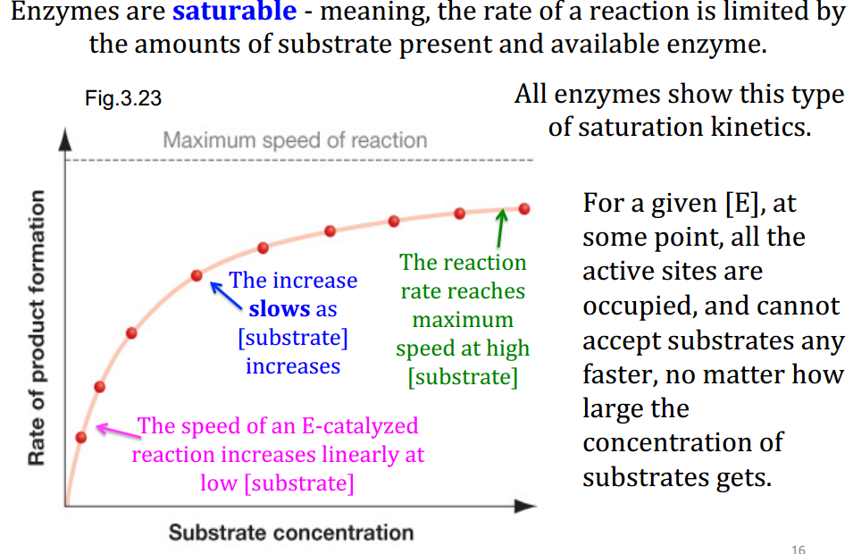  4. Competitive inhibition: catalysis is inhibited when a molecule that is similar in size and shape to a substrate binds to the active site.  Allosteric regulation: Regulatory molecules may bind at a location other than the active site. Binding event changes the shape of the enzyme in a way that makes the active site inaccessible.  5. – Reaction rates level off because all available enzyme molecules are being used.  - Temperature affects movement of the enzyme as well as the kinetic energy of the substrates. (movement of the substrates and enzyme)  - pH affects the makeup and change of a.a. side chains w/ carboxyl or amino groups, and the active site’s ability to participate in proton-transfer or electron transfer reactions. (enzyme’s shape and reactivity)  1. In prokaryotes the genome is often one circular fragment of double stranded DNA (called a circular chromosome). Bacterial cells only have one copy of the genome, hence they are haploid. In eukaryotes the genome is organized into separate linear chromosomes.  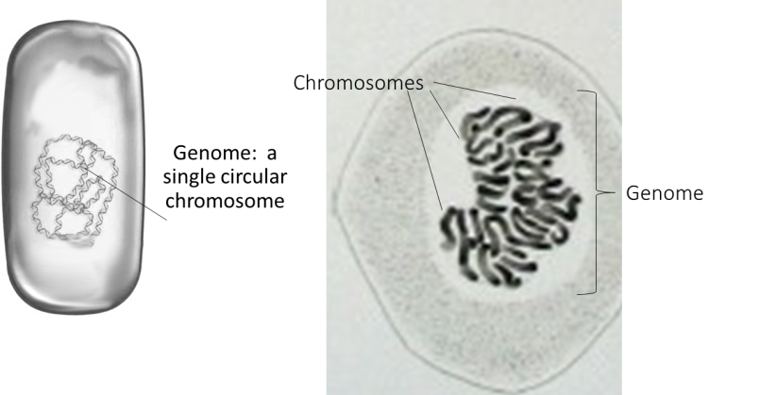  A comparison of the physical structure and appearance of a prokaryotic (left) and eukaryotic (right) genome.  2. Genomes of different species vary in size (the number of base pairs), the number of genes, and the percentage of genome sequence that is coding versus non-coding. Many genomes contain large repeating and non-coding DNA sequences in between genes.  3. Two strands of DNA are arranged side by side and running in opposite directions (one strand runs in the 5’ 3’ direction, other is oriented 3’ 5’ : antiparallel) Antiparallel strands twisted together to form a double helix, the coiled sugar–phosphate backbones ended up on the outside of the spiral and the nitrogenous bases on the inside.  4. In complementary base-pairing, the nitrogenous bases in the middle of the DNA helix also pack tightly on top of each other in a regular, flat pattern. This tight packing makes it possible for hydrophobic interactions to occur among bases on top of and below each other. These hydrophobic stacking interactions are what hold the DNA together, similar to the hydrophobic amino acids interacting in the core of a protein. The double-stranded DNA molecule as a whole is water soluble, because the sugar-phosphate backbones, which face the exterior of the molecule, are negatively charged and thus are hydrophilic.  - Hydrogen bonds form between G-C pairs and A-T pairs  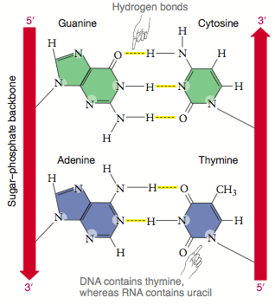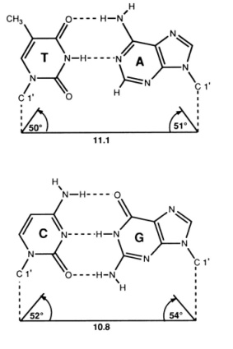  5.  1.  2. Step 1: Researcher creates a reaction mix containing a supply of the 4 dNTPs, a DNA sample that includes gene of interest, many copies of two primers, and Taq polymerase  Step 2: Reaction mix heated to 95°C => double-stranded template DNA denatures. (two DNA strands separate, forming single-stranded templates)  Step 3: Mixture cooled to 50°C-60°C => primers bond (anneal) to complementary portions if the single-stranded template DNA (this step is called primer annealing)  Step 4: Reaction mix heated to 72°C => Taq polymerase synthesizes the complementary DNA strand from dNTPs, starting at the primer (this step is called extension)  Step 5: Repeat Steps 2 through 4  Step 6: Continue repeating Steps 2 through 4 until the necessary number of copies is obtained.  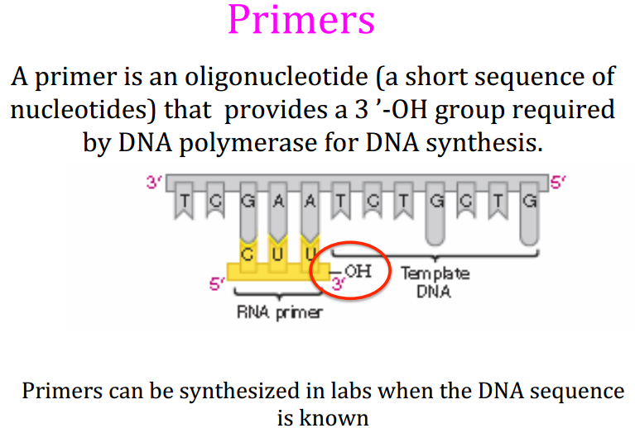  3.  4.  5.  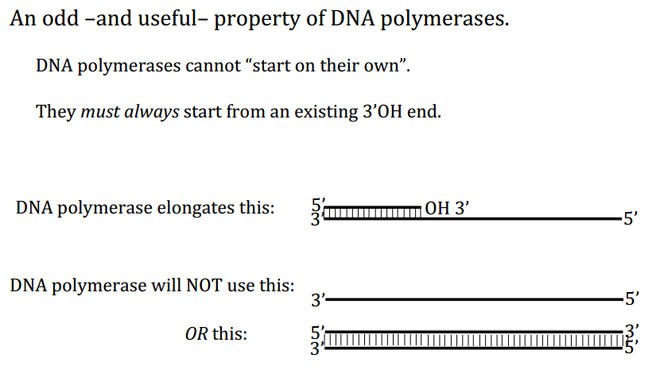  6. Refer to step 2 and 3  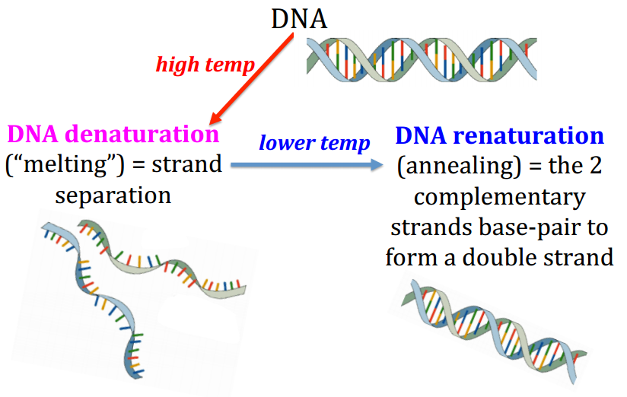  7. Refer to #2  8.  9.  10. – Researchers produced million of copies of the Neanderthal DNA fragment to analyze whether or not there was the same gene segment found in modern humans.  - Ecologists who check for mutations affecting organisms.  - Forensic biologists who to help solve crime (clone DNA from tiny drops of blood or hair)  - Genetic counselors advise pregnant couples on how likely their offspring are to suffer from inherited diseases.  1.  2. Replication bubble forms at a specific sequence of bases called DNA the origin of replication.  => Bacterial chromosomes have a single location where the replication process begins => single bubble forms  => Eukaryotes have multiple sites along each chromosome where DNA synthesis begins => multiple replication bubbles form  3. – Helicase breaks h-bonds btw deoxyribonucleotides =>two strands of DNA to separate =>proteins called single-strand DNA-binding proteins (SSBPs) attach to separate strands and prevent them from snapping back into double helix  - Coils and kinks in response to twisting forces do not occur because of proteins called topoismerases. Topoisomerase is an enzyme that cuts DNA, allows it to unwind, and rejoins it ahead of the advancing replication fork.  - Enzyme that makes the primer: primase. Primase is a type of RNA polymerase (an enzyme that catalyzes the polymerization of ribonucleotides into RNA). RNA polymerase do not require a primer; they can attach ribonucleotides directly by complementary base paring to single-stranded DNA, thus primase creates a primer for DNA synthesis.  4.  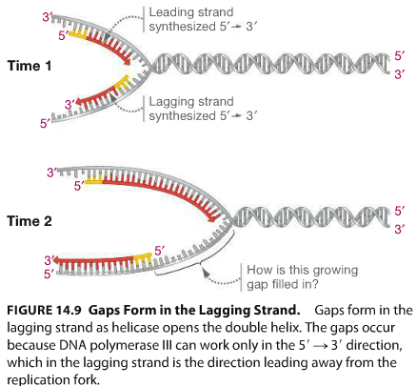  Leading strand (continuous strand): leads into the replication fork and is synthesized continuously.  Lagging strand (discontinuous strand): strand that is synthesized in the opposite direction of the replication fork.  -The synthesis of the lagging strand starts when primase synthesizes a short stretch of RNA that acts as a primer. DNA polymerase III then adds bases to the 3’ end of the primer. Enzyme moves away from replication fork, but behind it helicase continues to open the replication fork.  5. Okazaki fragment: short segment of DNA produced during replication of 5’-to-3’ template strand. Many Okazaki fragments make up the lagging strand in newly synthesized DNA  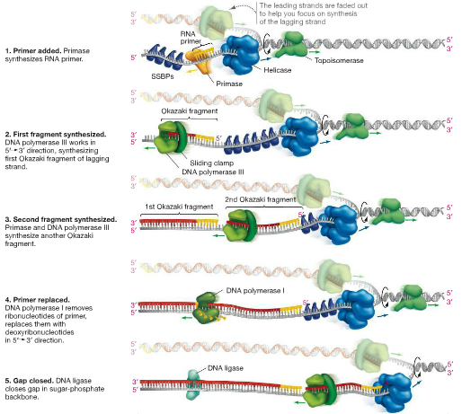  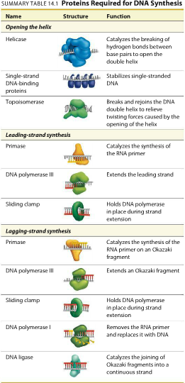  NOTE: DNA ligase (enzyme): catalyzes the formation of phosphodiester bond between the adjacent fragments (closes gaps)  Replisome: the multimolecular machine that copies DNA; includes DNA polymerase, helicase, primase, and other enzymes  6. telomerase: an enzyme that replicates the ends of chromosome (telomeres) by catalyzing DNA synthesis from an RNA template that is part of the enzyme. (not active in most types of cells)  Check figure 14.12 => Lagging strand is too short (not enough room for primase to add a new RNA primer)  How eukaryotes maintain the integrity of their linear chromosome:  1. Telomeres do not contain genes that code for products needed in the cell  2. Telomerase is involved in replicating telomeres  Telomeres consist of short stretches of bases that are repeated over and over. Telomerase catalyzes the synthesis of DNA from an RNA template. It carries an RNA molecule that acts as a built-in template, allowing telomerase to add DNA onto the end of a chromosome and prevent it from getting shorter.  Pg.293  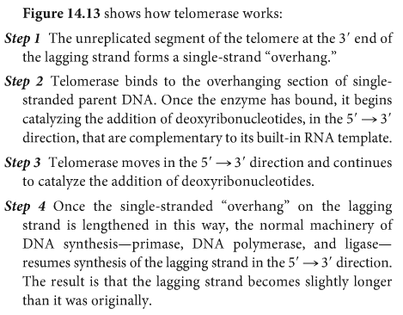  Telomere has a role in limiting the amount of time cells remain in an actively growing state.  7.  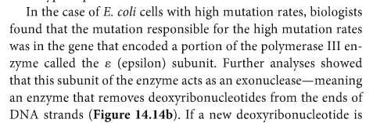  8. Proofreading:  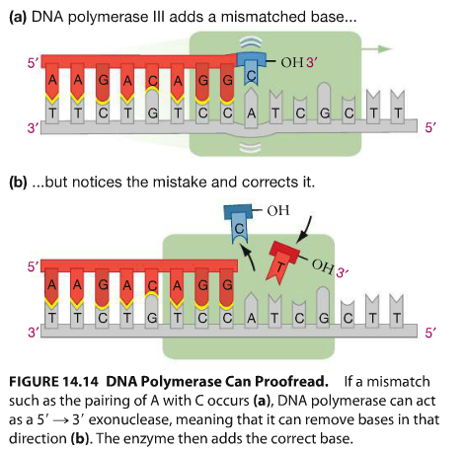  Mismatch repair: DNA polymerase leaves a mismatched pair behind in the newly synthesized strand, a battery of enzymes springs into action to correct the problem.  WHY IS THIS IMPORTANT?  9. mRNA carry info from DNA to the site of protein synthesis.  10. Replication:  Transcription: process of copying hereditary info in DNA to RNA  Translation: process of using the information in nucleic acids to synthesize proteins.  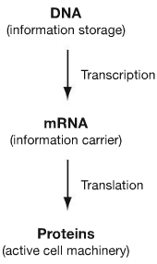  NOTE: According to the central dogma, an organism’s genotype is determined by the sequence of bases in its DNA, while its phenotype is a product of the proteins it produces.  11.  12.  13.  1. Replication:  Transcription: process of copying hereditary info in DNA to RNA  Translation: process of using the information in nucleic acids to synthesize proteins.  2.  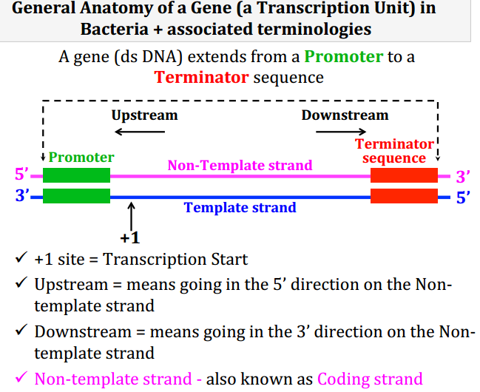  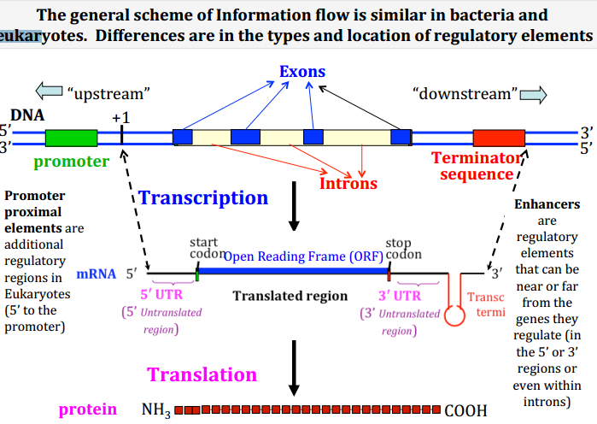  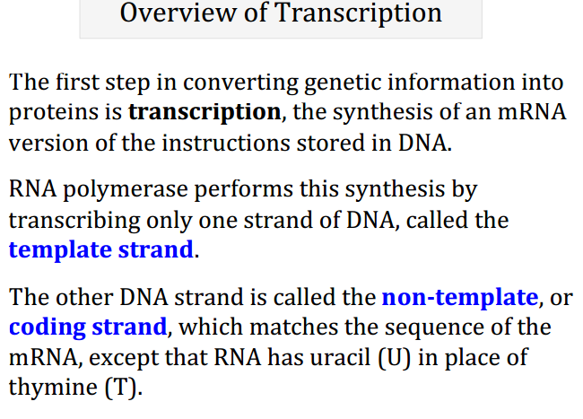  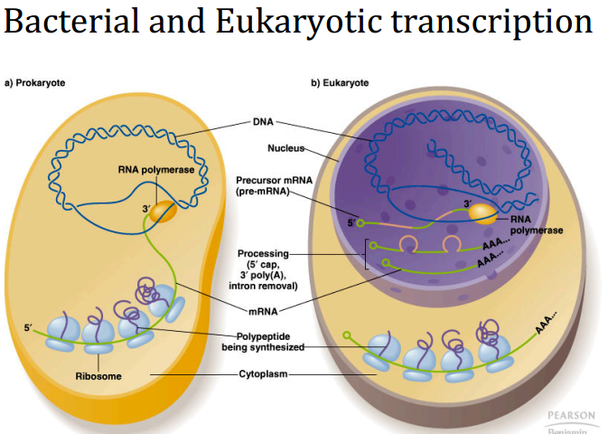  3. Promoter: a short nucleotide sequence in DNA that binds RNA polymerase, enabling transcription to begin  - section of DNA where transcription begins  Refer to #2  4. - (Bacteria) sigma appeared to be responsible for guiding RNA polymerase to specific locations where transcription begins (promoter)  5.  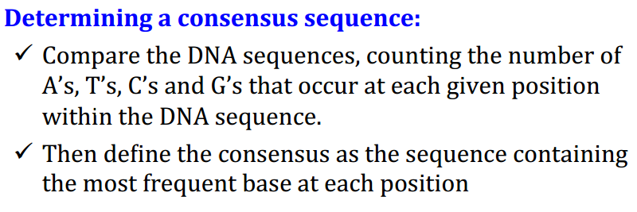  6.  7. Like DNA polymerases, RNA polymerase performs a template-directed synthesis in the 5’ to 3’ direction  => but they do not require a primer to transcription  - Sigma (protein subunit) must bund to the polymerase before transcription can begin  - Holoenzyme: formed by bacterial RNA polymerase and sigma  => core enzyme – contains active site for catalysis, and other required proteins  8. mRNA: an RNA molecule that carries encoded info, transcribed from DNA, that specifies the a.a. sequence of a polypeptide  tRNA: an RNA molecule that has an anticodon at one end and an amino acid binding site at the other. Each tRNA picks up a specific a.a. and binds to the corresponding codon in messenger RNA during translation.  rRNA: an RNA molecule that forms part of the structure of a ribosoe  9.  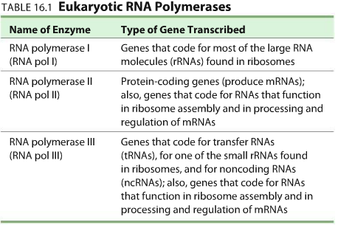  NOTE: promoters that were 40-50 base pairs long and had a particular section in common: a series of bases identical or similar to TATAAT => this six-base-pair sequence is known as the -10 box, b/c it is centered about 10 bases from the point where bacterial RNA polymerase starts transcription  Downstream: DNA that is located in the direction RNA polymerase moves during transcription  Upstream: DNA located in the opposite direction  -10 box centered 10 bases upstream from transcription site  Place where transcription begins is called +1 site  Sequence TTGACA centered 35 bases upstream from +1 site; -35 box  10. Splicing: The process by which introns are removed from primary RNA transcripts and the remaining exons are connected together.  => pre-mRNA; when molecule passes through intermediate changes (as splicing occurs)  => mature mRNA when molecules only contain exons  => catalyzed by complexes of proteins and specialized RNAs (called small nuclear RNAs (snRNAs); these protein-plus-RNA complexes are known as small nuclear ribonucleoproteins (snRNPs)  As soon as the 5’ end of the eukaryotic RNA emerges from RNA polymerase, enzymes add a structure called the 5’ cap.  An enzyme cleaves the 3’ end of most RNAs once transcription is complete, and another enzyme adds a long tow of adenine nucleotides (not encoded on the DNA template strand), known as poly(A) tail.  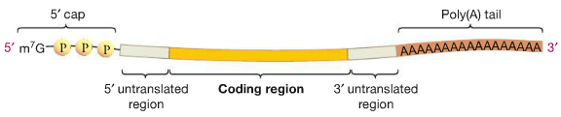  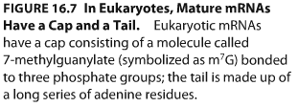  *With the addition of the cap and tail and completion of splicing, processing of the primary RNA transcript is complete => mature mRNA  Figure 16.7 shows coding region flanked by untranslated region; this will help stabilize the mature RNA and regulate its transition.  HOW DOES THIS CONTRIBUTE TO mRNA STABILITY?  NOTE: - Many amino acids are specified by more than one codon.  - Codons for the same a.a. tend to have the same nucleotides at the first and second positions but a different nucleotide at the third position.  - Codons are always written in the 5’ -> 3’ direction  - Anticodons are written in the 3’ -> 5’ direction  (inside a ribosome)  - protein synthesis occurs when the sequence of bases in an RNA message is translated into a sequence of amino acids in a polypeptide  - the conversion of each mRNA codon begins when the anticodon of aminoacyl tRNA binds to the codon  => conversion is complete when a peptide bond forms between the tRNA’s a.a. and the growing polypeptide chain  11.  12. Gene expression  1. Aminoacyl tRNA: a transfer RNA molecule that is covalently bound to an amino acid  2.  3. Aminoacyl tRNA synthetases catalyze the addition of a.a. to tRNAs  4. Many a.a. are specified by more than one codon. Codons for the same a.a. tend to hve same nucleotide for the first and second position but not for third position. Certain bases in the third position of tRNA anticodons can bind with bases in the third position of a codon in a way that does not match Watson-Crick base pairing => allow a limited flexibility, or “wobble”, in base pairing.  5. Start codon (usually AUG) is found near the 5’ end of all mRNAs and that is codes for the amino acid methionine (common for both bacteria and eukaryotes)  -signals that protein synthesis should begin at that point on mRNA molecule.  Ribosome binding site (Shine-Dalgarno sequence) : in a bacterial mRNA molecule, the sequence just (6 nucleotides) upstream of the start codon (AUG) to which a ribosome binds to initiate translation  Stop codon (termination codons; UAA, UAG, UGA)  6.  7.  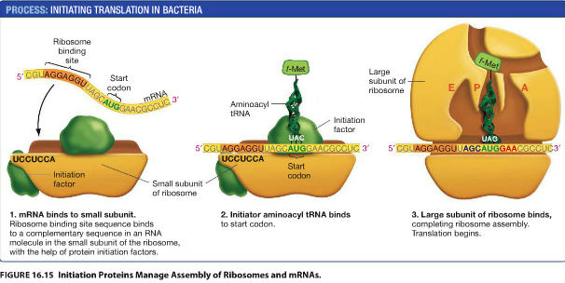  Check pg. 328 for info about translation  5’3’  8.  9.
  Bacteria  - single RNA polymerase  - (in DNA) a single promoter is often associated w/ several contiguous genes  - sigma binds to promoter  CHECK PG.359-360  CHECK PG. 321 FIGURE 16.2 | Eukaryote  - 3 distinct types of RNA polymerase- (in DNA) each gene generally has its own promoter  - many reuyotic promoters include a unique sequence called TATA box, centered about 30 bases upstream of transcription start site  - proteins called basal transcription factors bind to promoter region in DNA  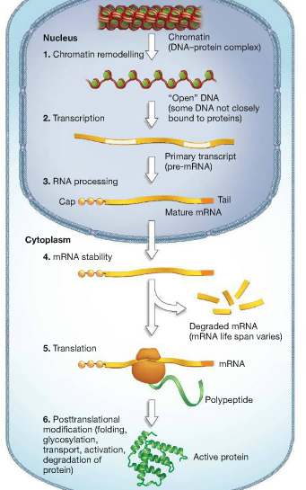
  Bacteria:  -presence of start codon (AUG) found near the 5’ end of all mRNAs and it codes for amino acid methionine  -takes place in cytosol | Eukaryotes:  -presence of start codon (AUG) found near the 5’ end of all mRNAs and it codes for amino acid methionine  - initiation factors bind to 5’ cap on mRNAs and guide it to ribosome  -initial amino acid is normal methionine  -takes place in cytosol although future membrane and export proteins are made by ribosomes on ER

