Name: …………………………………………….. Student # ………………………
46. Direct cell-cell communication is achieved by… GAP JUNCTIONS

47. Fast glycolytic skeletal fibers are usually involved in…
SHORT-TERM, RAPID, INTENSE MOVEMENTS
(WEIGHT-LIFTING, SPRINTING OR SIMILAR are acceptable)
48. Facilitated Diffusion always requires… CARRIER PROTEINS

49. For synaptic integration, when one or more presynaptic neurons transmit impulses in rapid-fire order this can result in what kind of summation?
TEMPORAL SUMMATION

50. In the middle panel, what is the tonicity of the solution that the blood cells are in?
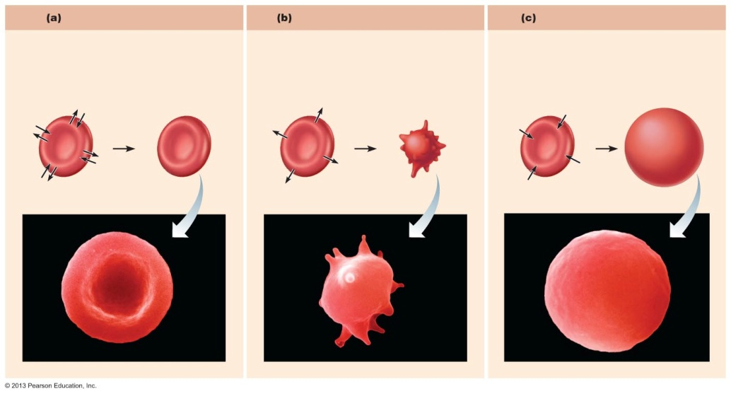 HYPERTONIC

Name: …………………………………………….. Student # ………………………
51. Name the component of the plasma membrane indicated by the lines.
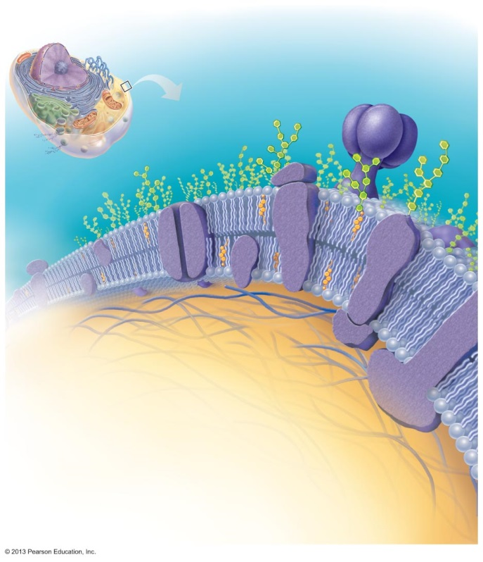
Extracellular fluid
Cytoplasm

INTEGRAL PROTEINS, INTEGRAL MEMBRANE PROTEINS

52. Using a maximum 5 words, label what is happening at Step 3. G-PROTEIN ACTIVATES ADENYLATE CYCLASE
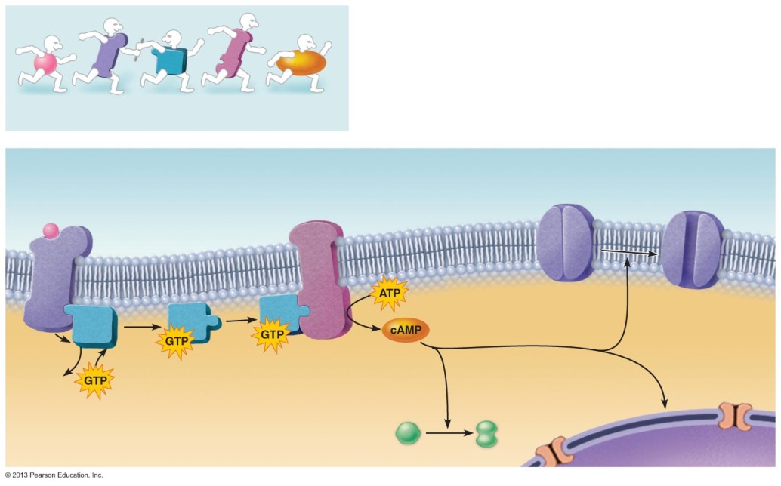

2nd messenger signaling
Receptor
GDP

Name: …………………………………………….. Student # ………………………
53. What phase of the Action Potential is #3? Which ion is critical? What direction does it move across the neuronal membrane? (3 marks) REPOLARIZATION, K+ (POTASSIUM), OUTWARD, OUT
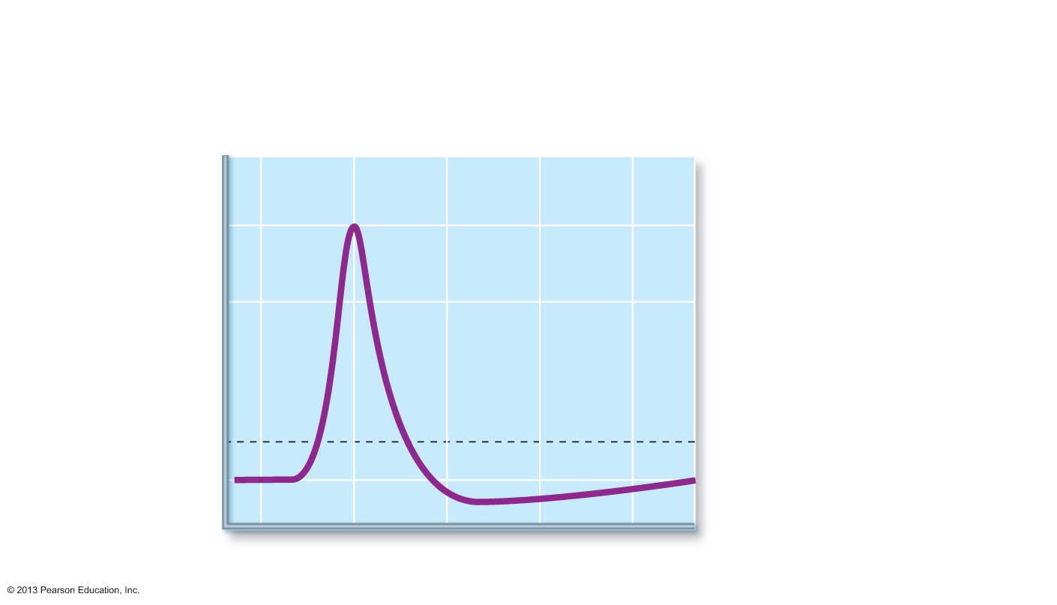
Active enzyme
Nucleus
3
2
1
Action
potential
Threshold
Time (ms)
Membrane potential (mV)
+30
0
–70
0
1
2
3
4
–55

1

2

3

54. When a nerve impulse reaches a neuromuscular junction, what kind of Ca²⁺ channels open?
VOLTAGE GATED Ca2+ (CALCIUM) CHANNELS.”Voltage-Gated” is sufficient

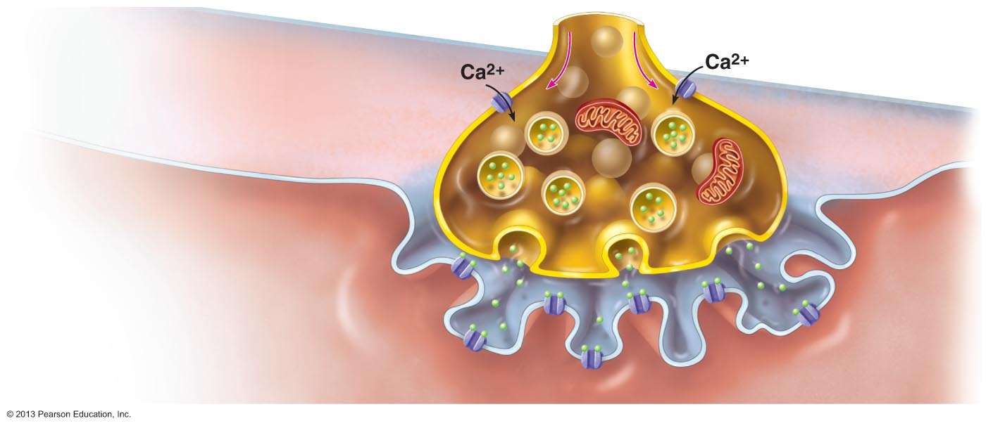
4

1
voltage at which the AP is triggered
Synaptic vesicle
containing ACh
Synaptic cleft

Name: …………………………………………….. Student # ………………………
54. Name the cell-type and two fiber types indicated in this general model of connective tissue (3marks)
“Fat cell” or “adipocyte” part marks for “lipid cell”. Top fiber=elastin or elastic, bottom fiber=collagen
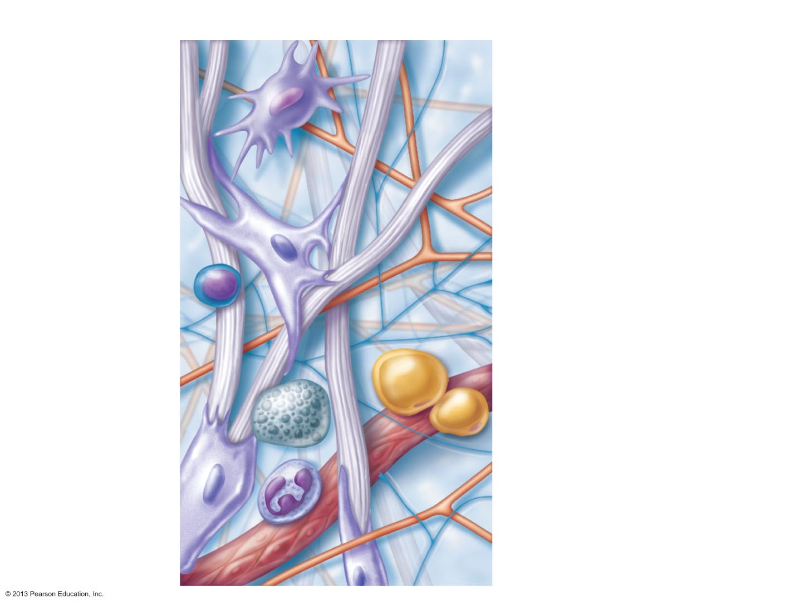
Axon terminal
of motor neuron
Fusing synaptic
Vesicles
ACh
Junctional
folds of
sarcolemma
Sarcoplasm of
muscle fiber

55. Name these two types of epithelia.
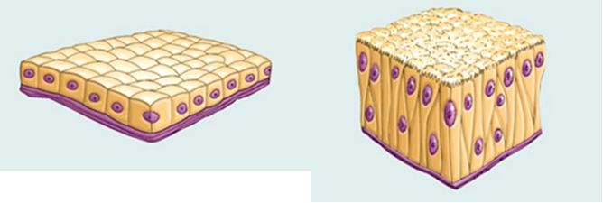
SIMPLE (0.5) CUBOIDAL (0.5) epithelia PSEUDOSTRATIFIED (0.5) COLUMNAR (0.5) epithelia
No penalty for reasonably close spelling mistakes

