Chapter 1

- Statistics is the science of collecting, organizing, presenting, analyzing, and interpreting data to assist in making more effective decisions
Types of Statistics
Descriptive Statistics
- Methods of organizing, summarizing, and presenting data in an informative way
  - Frequency distributions
  - Chart forms
  - Central tendency measures
  - Data clustering
Inferential Statistics
- The methods used to determine something about a population, based on a sample
  - A population is the entire set of individuals or objects of interest or the measurements obtained from all individuals or objects of interest
  - A sample is a portion, or part, of the population of interest.
Types of Variables
Qualitative
- The characteristic being studied is non-numeric
- EXAMPLES: Gender, religious affiliation, type of automobile owned, country of birth, eye color
Quantitative
- Information is reported numerically
- EXAMPLES: Balance in your chequing account, ages of company CEOs, life of a battery, number of children in a family
Quantitative Variables: Classifications

Discrete Variables
- Can only assume certain values and there are usually “gaps” between values
- EXAMPLES: number of bedrooms in a house, number of cars arriving at a shopping center, number of students in a statistics course section
Continuous Variables
- Can assume any value within a specified range
- EXAMPLES: tire pressure, weight of shipment of grain, amount of Raisin Bran in a box, duration of a flight
Summary of the Variable Types

Important Properties
- Mutually exclusive
  - A property of a set of categories such that an individual or object is included in only one category
- Exhaustive
  - A property of a set of categories such that each individual or object must appear in at least one category

Levels of Measurement
Nominal
- The variable of interest is divided into mutually exclusive categories or outcomes
- There is no natural order to the outcomes
- EXAMPLES: colours of M&Ms, gender
Ordinal
- Data classifications are represented by labels or names (high, medium, low) that are mutually exclusive
- Data classifications are ranked or ordered according to the particular trait they possess
- EXAMPLES: professor ratings, terrorist attack risk levels
Interval
- Data classifications are mutually exclusive and exhaustive
- Data classifications are ordered according to the amount of the characteristic they possess
- Equal differences in the characteristic are represented by equal differences in the measurements
- EXAMPLES: temperature, shoe size, IQ scores
Levels of Measurement: Summary of Major Characteristics
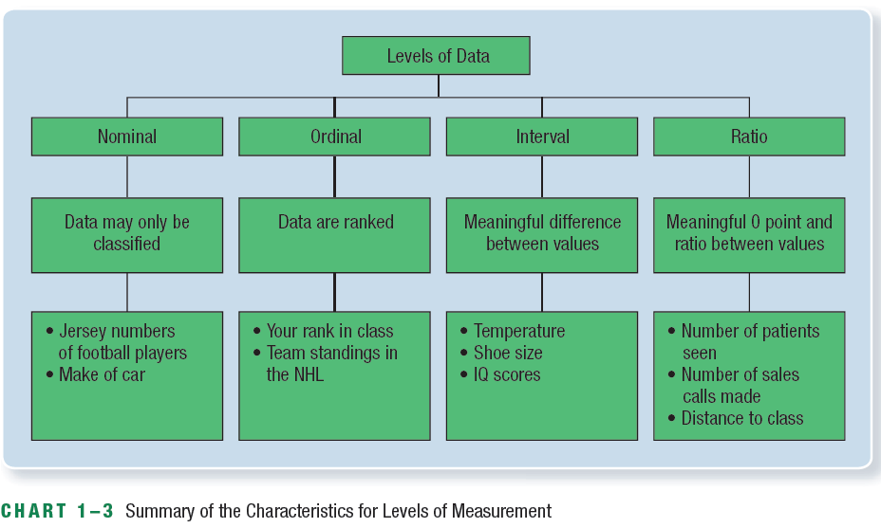
Ratio
- Data classifications are mutually exclusive and exhaustive
- Data classifications are ordered according to the amount of the characteristics they possess
- Equal differences in the characteristic are represented by equal differences in the numbers assigned to the classifications
- The zero point is the absence of the characteristic and the ratio between two numbers is meaningful
- EXAMPLES: wages, weight, height

Chapter 2

Frequency Distribution
A grouping of data into mutually exclusive classes showing the number of observations in each class
Relative Frequency Distribution
- Class frequencies can be converted to relative class frequencies to show the fraction of the total number of observations in each class
- A relative frequency captures the relationship between a class total and the total number of observations

Graphic Presentation of Data: Bar Charts
- The horizontal axis shows the variable of interest and the vertical axis the amount, number or fraction of each of the possible outcomes
- A distinguishing characteristic of a bar chart is that there is a distance or gap between the bars
- Can depict any of the levels of measurement—nominal, ordinal, interval, or ratio

Graphic Presentation of Data: Line Charts
- Effective for business data because we can show the change in a variable over time
- The variable is scaled along the vertical axis and time along the horizontal axis

Graphic Presentation of Data: Pie Charts
- Shows the percent or proportion that each class represents of the total number of frequencies

Relative Frequency Distribution
- A relative frequency distribution converts the frequency to a percent
- To convert a frequency distribution to a relative frequency distribution, each of the class frequencies is divided by the total number of observations

Graphic Presentation of a Frequency Distribution
- Three most common forms:
  - Histogram
- Very similar to the bar chart showing the distribution of qualitative data
- Classes are marked on the horizontal axis and the class frequencies on the vertical axis
- Quantitative data is usually measured using scales that are continuous, not discrete
- The horizontal axis represents all possible values, and the bars are drawn adjacent to each other
  - Frequency polygon
- Shows the shape of a distribution and is similar to a histogram
- Consists of line segments connecting the points formed by the intersections of the class midpoints and the class frequencies
- The midpoint of each class is scaled on the X-axis and the class frequencies on the Y-axis
- To complete the frequency polygon, midpoints are added to both ends of the X-axis to “anchor” the polygon at zero frequencies
3. Cumulative frequency polygon
- Also called an ogive
- There are two types
  - Less-than cumulative frequency distribution
  - More-than cumulative frequency distribution

A stem-and-leaf display is an alternative to a frequency distribution

Chapter 3
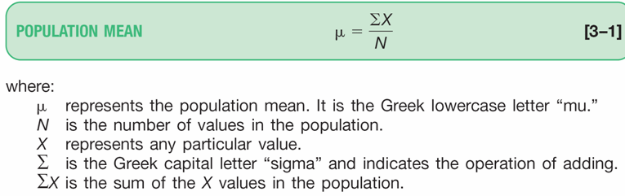
Numerical Descriptive Measures
- Measures of Location
  - Arithmetic Mean
  - Weighted Mean
  - Median
  - Mode
  - Geometric Mean
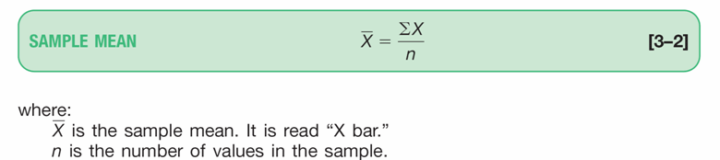
- Measures of Dispersion
  - Range
  - Mean Absolute Deviation
  - Variance
  - Standard Deviation
The Median
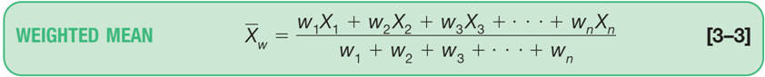
The median is the midpoint of the values after they have been ordered from the smallest to the largest
  - There are as many values above the median as below it in the data array
  - For an even set of values, the median will be the arithmetic
  - average of the two middle numbers
The Mode
- The mode is the value of the observation that appears most frequently
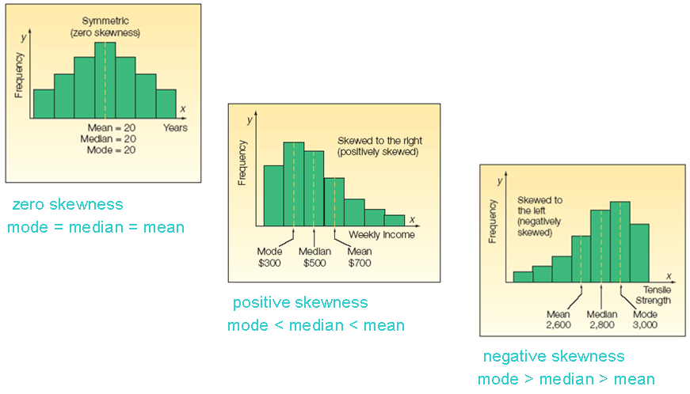
The Relative Positions of the Mean, Median and the Mode
Mean Deviation
- The mean deviation is the arithmetic mean of the absolute values of the deviations from the arithmetic mean
  - All values are used in the calculation
  - It is easy to understand because it is the average of the deviations from the mean
  - Major drawback is the use of absolute values
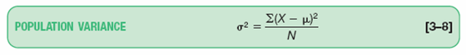
MD=∑│X-ẋ│/n

σ² is called sigma squared
μ is the arithmetic mean of the population
X is the value of an observation
N is the number of observations
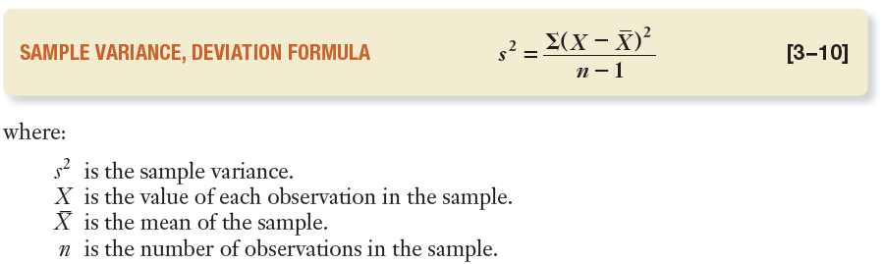

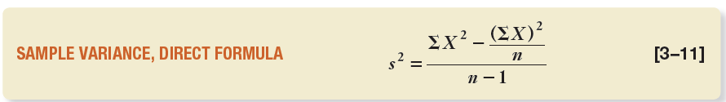

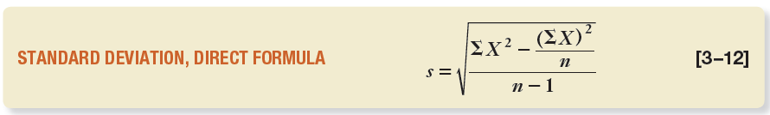

Chebyshev’s Theorem
- For any set of observations (sample or population), the proportion of the values that lie within k standard deviations of the mean is at least 1-1/k², where k is any constant greater than 1
- Allows us to determine the minimum proportion of the values that lie within a specified number of standard deviations of the mean
- Concerned with any set of values; that is the distribution of values can have any shape
The Empirical Rule
- For a symmetrical, bell-shaped frequency distribution:
  - Approximately 68 percent of the observations will lie within ±1 standard deviation of the mean
  - About 95 percent of the observations will lie within ±2 standard deviations of the mean
  - Practically all (99.7 percent) will lie within ±3 standard deviations of the mean
Relative Dispersion
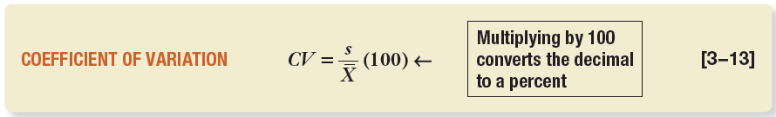
- In order to make a meaningful comparison of different measures, we need to convert each of these measures to a relative value—that is, a percent
- The coefficient of variation is the ratio of the standard deviation to the arithmetic mean, expressed as a percentage

Skewness
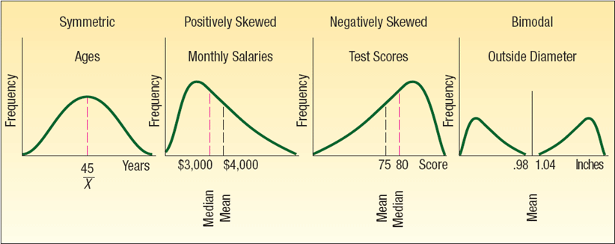

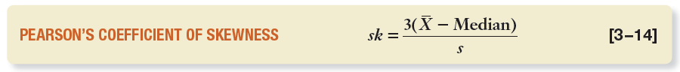

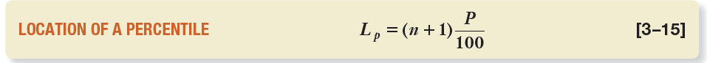

Box Plots
- A box plot is a graphical display, based on quartiles, that helps to picture a set of data
- Five pieces of data are needed to construct a box plot
  - Minimum value
  - First quartile
  - Median
  - Third quartile
  - Maximum value
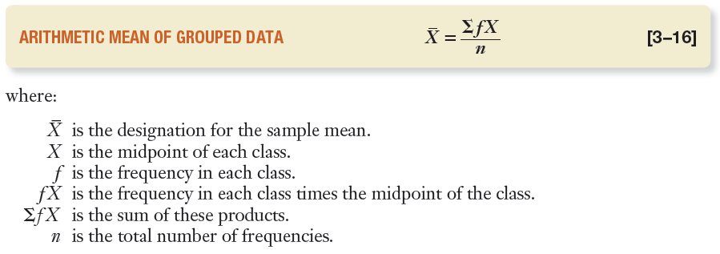

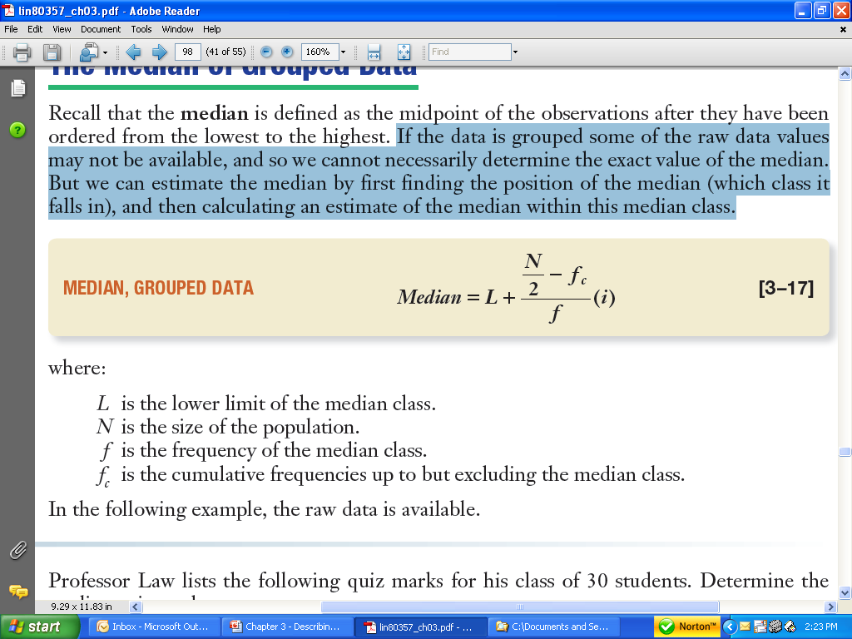

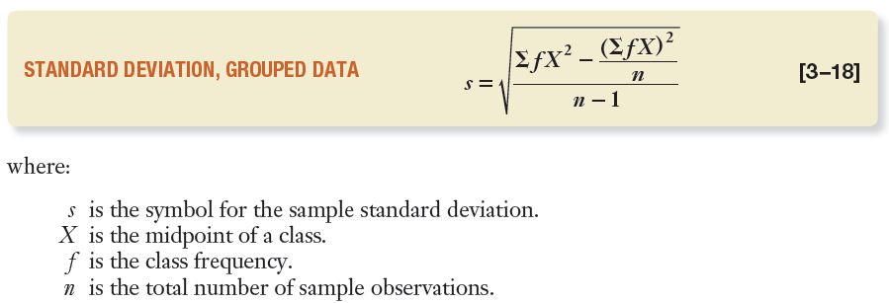

Chapter 4
Probability
- A probability is a measure of the likelihood that an event in the future will happen
  - It can only assume a value between 0 and 1
    - A value near zero means the event is not likely to happen
    - A value near one means it is likely
- Three approaches to assigning probabilities
  - Classical
  - Empirical
  - Subjective

1. Classical Probability
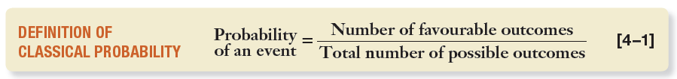

Terms:
- Events are mutually exclusive if occurrence of one event means that none of the other events can occur at the same time
- Events are collectively exhaustive if at least one of the events must occur when an experiment is conducted
- If the set of events is collectively exhaustive and the events are mutually exclusive, the sum of the probabilities equals 1
2. Empirical Probability
- The probability of an event happening is the fraction of the time similar events happened in the past
- Based on what is called the law of large numbers
  - Over a large number of trials, the empirical probability of an event will approach its true probability
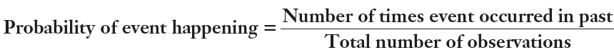

3. Subjective Probability
- The likelihood (probability) of a particular event happening that is assigned by an individual based on whatever information is available
- Illustrations of subjective probability are:
  - Estimating when the next provincial election will be
  - Estimating the likelihood you will be married before the age of 30
  - Estimating the chance of the Maple Leafs winning the Stanley Cup
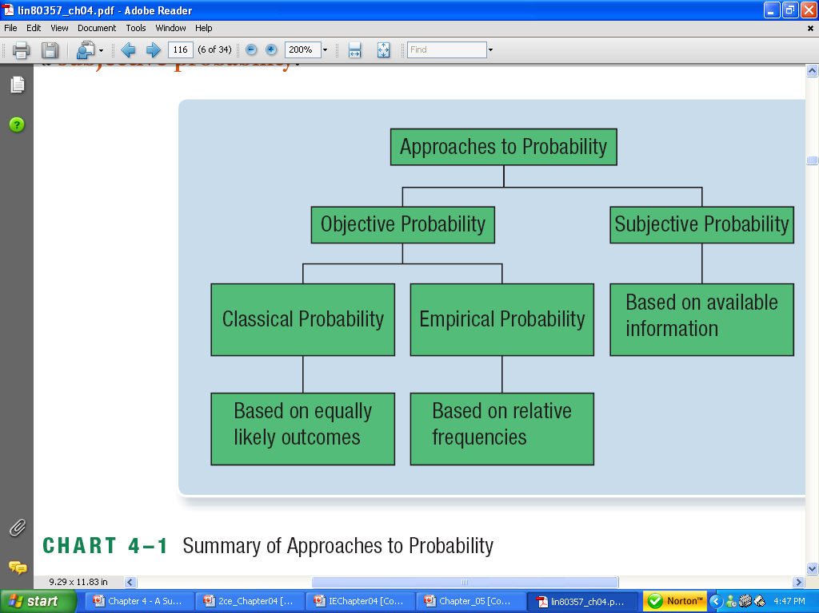

Principles of Counting
- There are three principles of counting the number of outcomes
  - The multiplication formula
  - Permutations
  - Combinations
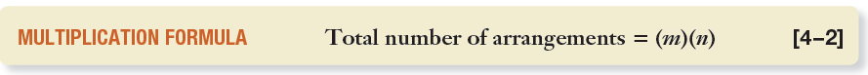

- If there are m ways of doing one thing and n ways of doing another thing, there are m x n ways of doing both
- For three events m, n, o:
  - The total number of arrangements = (m)(n)(o)
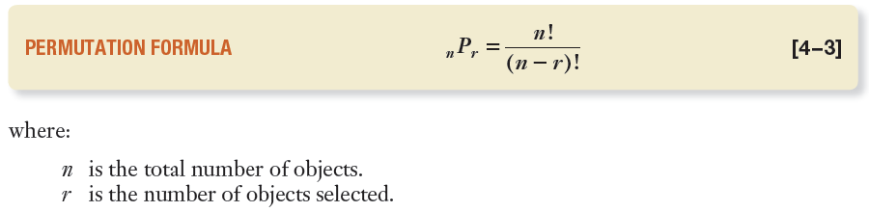

- Any arrangement of r objects selected from a single group of n possible objects
- The order of arrangement is important in a permutation
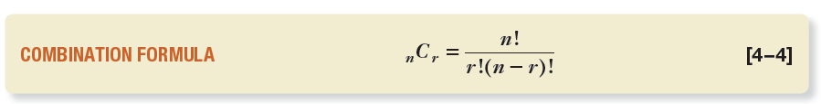
A combination is the number of ways to choose r objects from a group of n objects without regard to order

Rules for Computing Probabilities
- Special rule of addition
- General rule of addition
- Complement rule
- Special rule of multiplication
- General rule of multiplication
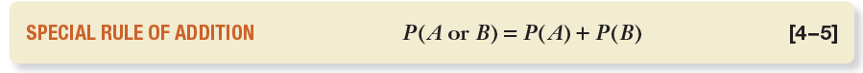
Special Rule of Addition
If two events A and B are mutually exclusive, the probability of one or the other events occurring equals the sum of their probabilities.
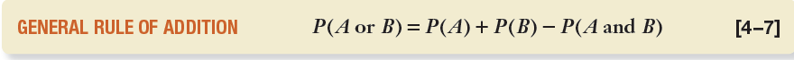
The General Rule of Addition
If A and B are two events that are not mutually exclusive
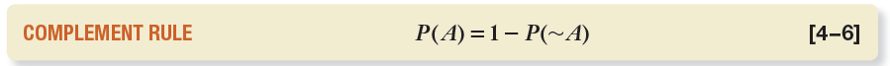
- Used to determine the probability of an event occurring by subtracting the probability of the event not occurring from 1
- Useful because sometimes it is easier to calculate the probability of an event happening by determining the probability of it not happening and subtracting the result from 1
- Notice that the events A and ~A are mutually exclusive and collectively exhaustive. Therefore, the probabilities of A and ~A sum to 1

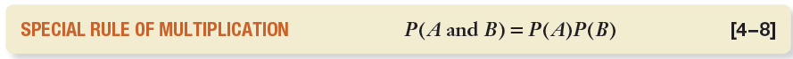
Special Rule of Multiplication
- The special rule of multiplication requires that two events, A and B, be independent
- Two events are independent if the occurrence of one does not alter the probability of the occurrence of the other event
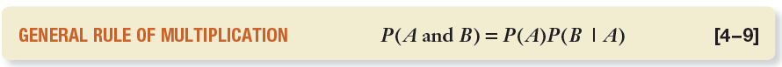
The General Rule of Multiplication
- Used to find the joint probability that two events will occur when the events are not independent (i.e. they are dependent)
- It states that for two events, A and B, the joint probability that both events will happen is found by multiplying the probability that event A will happen by the conditional probability of event B occurring given that A has occurred
Contingency Tables
- A table used to classify sample observations according to two or more identifiable characteristics
- Level of measurement can be nominal
- Makes it easy to figure out probabilities
- E.g. A survey of 150 adults classified each as to gender and the number of movies attended last month. Each respondent is classified according to two criteria—the number of movies attended and gender
Tree Diagrams
- The tree diagram is a graph that is helpful in organizing calculations that involve several stages
- Each segment in the tree is one stage of the problem
- The branches of a tree diagram are weighted by probabilities

Summary
- A probability is a value between 0 and 1 inclusive that represents the likelihood a particular event will happen
  - Probabilities involve experiments, outcomes, and events
- There are three definitions of probability including classical, empirical, and subjective
- Two events are mutually exclusive if by virtue of one event happening the other cannot happen
- Events are independent if the occurrence of one event does not affect the occurrence of another event
- There are three counting rules that are useful in determining the number of outcomes in an experiment, including the multiplication rule, permutations, and combinations
- The rules of addition refer to the union of events and include the general and special rule of addition, as well as the complement rule
- The rules of multiplication refer to the product of events and include the general and special rule of multiplication
  - A joint probability is the likelihood that two or more events will happen at the same time
- A conditional probability is the likelihood that an event will happen, given that another event has already happened

Chapter 5

Probability Distributions
- Gives the entire range of values that can occur based on an experiment
- Similar to a relative frequency distribution.
  - However, instead of describing the past, it describes how likely some future event is
- A probability distribution shows the possible outcomes of an experiment and the probability of each of these outcomes
Characteristics of a Probability Distribution
- The probability of a particular outcome is between 0 and 1 inclusive
- The outcomes are mutually exclusive events
- The list is exhaustive. The sum of the probabilities of the various events is equal to 1
Random Variables
- In any experiment of chance, the outcomes occur randomly
- A random variable is a variable whose value is determined by the outcome of a random experiment
Types of Random Variables
Discrete
- A variable that can assume only certain, clearly separated values
- Usually the result of counting something
- Examples:
  - The number of heads appearing when a coin is tossed three times
  - The number of students earning an A in this class
Continuous
- Can assume an infinite number of values within a given range
- It is usually the result of some type of measurement
- Examples:
  - The length of each song on the Best of the Beatles album
  - The height of each student in the class

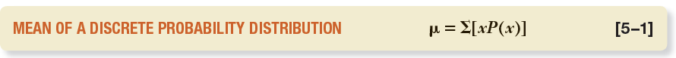
- The mean is a typical value used to represent the central location within a probability distribution
- It also is the long-run average value of the random variable
- The mean of a probability distribution is also referred to as its expected value
- It is a weighted average where the possible values are weighted by their corresponding probabilities of occurrence
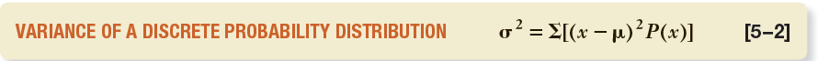
- Measures the amount of spread in a distribution
- The computational steps are:
  - Subtract the mean from each value, and square this difference
  - Multiply each squared difference by its probability
  - Sum the resulting products to arrive at the variance
- The standard deviation is found by taking the positive square root of the variance

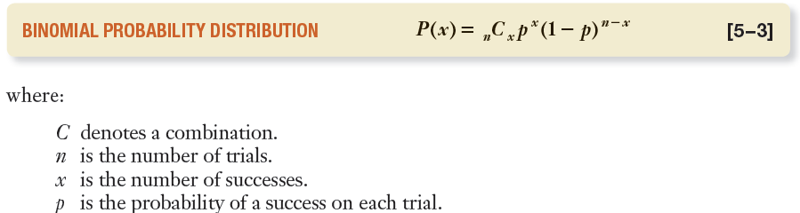
Characteristics of a Binomial Probability Distribution
  - An outcome on each trial of an experiment is classified into one of two mutually exclusive categories—a success or a failure
  - The random variable counts the number of successes in a fixed number of trials
  - The probability of success and failure stays the same for each trial
  - The trials are independent, meaning that the outcome of one trial does not affect the outcome of any other trial
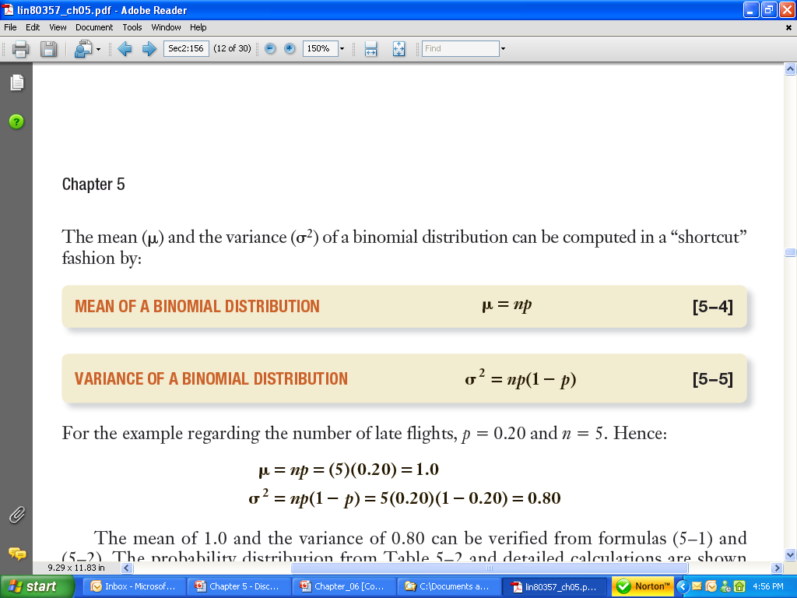

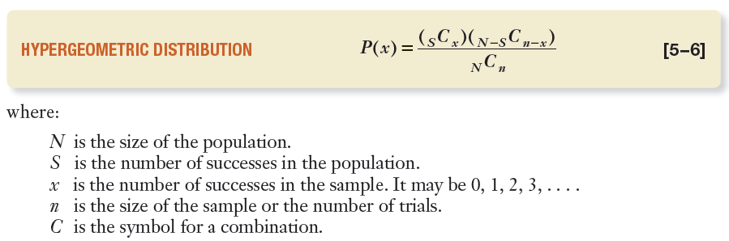
- If a sample is selected from a finite population without replacement
- And if the size of the sample n is more than 5 percent of the population N
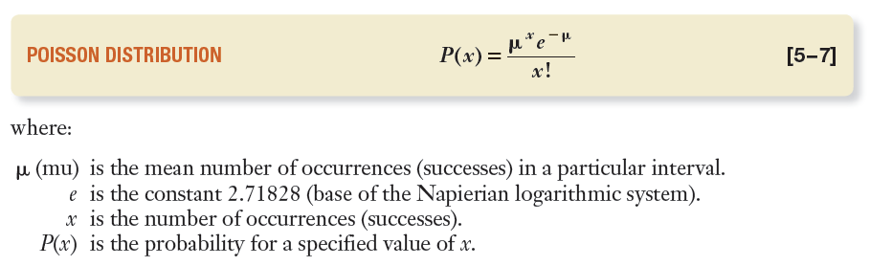
- Then the hypergeometric distribution is used to determine the probability of a specified number of successes or failures
- It is especially appropriate when the size of the population is small

- The Poisson probability distribution describes the number of times some event occurs during a specified interval. The interval may be time, distance, area, or volume
- Characteristics:
  - The random variable is the number of times some event occurs during a defined period
  - The probability of the event is proportional to the size of the interval
  - The intervals do not overlap and are independent
Chapter 6
Continuous Probability Distributions
- Usually results from measuring something
- Usually interested in information such as the percentage of data above or below a certain point; or the percentage of data in a certain range
- Important continuous probability distribution is the normal probability distribution
  - Describes the likelihood that a continuous random variable with an infinite number of possible values lies within a specified range
Normal Probability Distribution Characteristics
- It is bell-shaped and has a single peak at the center of the distribution
  - The arithmetic mean, median, and mode are equal
  - The total area under the curve is 1.00; half the area under the normal curve is to the right of this center point and the other half to the left of it
- It is symmetrical about the mean
- It is asymptotic: The curve gets closer and closer to the X-axis but never actually touches it
  - To put it another way, the tails of the curve extend indefinitely in both directions.
- The location of a normal distribution is determined by the mean(μ), the dispersion or spread of the distribution is determined by the standard deviation (σ)
The Standard Normal Distribution
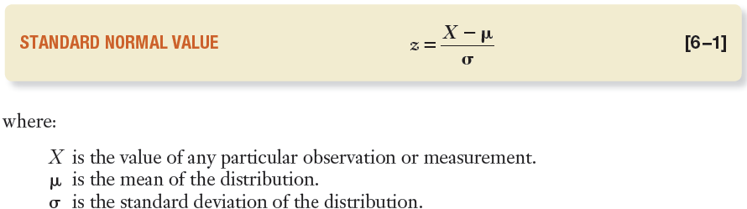
- The standard normal distribution is a normal distribution with a mean of 0 and a standard deviation of 1
- It is also called the z distribution
- A z-value is the signed distance between a selected value, designated X, and the population mean μ, divided by the population standard deviation, σ

The Empirical Rule
- For a symmetrical, bell-shaped frequency distribution:
  - Approximately 68 percent of the observations will lie within ±1 standard deviation of the mean
  - About 95 percent of the observations will lie within ±2 standard deviations of the mean
  - Practically all (99.7 percent) will lie within ±3 standard deviations of the mean
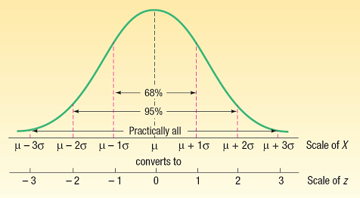

Summary of Normal Curve Applications
- To find the area between 0 and z (or -z), look up the probability directly in the table
- To find the area beyond z or (-z), locate the probability of z in the table and subtract that probability from 0.5000
- To find the area between two points on different sides of the mean, determine the z values and add the corresponding probabilities
- To find the area between two points on the same side of the mean, determine the z values and subtract the smaller probability from the larger
The Normal Approximation to the Binomial
- As n gets large, the binomial distribution gets time-consuming to use
- As n increases, a binomial distribution gets closer and closer to a normal distribution
The Normal Approximation to the Binomial – When To Use
- When np and n(1 - p) are both at least 5
- All binomial criteria are met:
  - There are only two mutually exclusive outcomes to an experiment: a “success” and a “failure”
  - The distribution results from counting the number of successes in a fixed number of trials
  - Each trial is independent
  - The probability, p, remains the same from trial to trial
The Continuity Correction Factor
- The value 0.5 subtracted or added, depending on the question, to a selected value when a discrete probability distribution is approximated by a continuous probability distribution
- Only four cases may arise. These cases are:
  - For the probability that at least X occur, use the area above (X - 0.5)
  - For the probability that more than X occur, use the area above (X + 0.5)
  - For the probability that X or fewer occur, use the area below (X + 0.5)
  - For the probability that fewer than X occur, use the area below (X - 0.5)

Chapter Summary

- The normal distribution is a continuous probability distribution with the following characteristics
  - It is bell-shaped and the mean, median, and mode are equal
  - It is symmetrical
  - It is asymptotic, meaning the curve approaches but never touches the X-axis
  - It is completely described by the mean and standard deviation
  - There is a family of normal distributions. Each time the mean or standard deviation changes, a new distribution is created
  - The area under a normal curve expresses the probability of an outcome
- The standard normal distribution is a particular normal distribution
  - It has a mean of 0 and a standard deviation of 1
  - By standardizing a normal distribution, we can report the distance from the mean in units of the standard deviation
- The normal distribution can approximate a binomial distribution under certain conditions

