DECEMBER EXAM – PHYSIOLOGY 1021

SMELL & TASTE

- Use chemoreception to sense the environment and move towards food sources
- Only 20% of the smells we perceive smell pleasant (warms us of harmful substances)
SMELL
Olfactory System
- Regarding the pathway to the CNS, this is the only system that has its info bypass the thalamus
- How is the smell stimulus transduced into a signal?
- Odorant molecules are dissolved by the mucus
- Dissolved odorant molecules bind to the odorant receptors at the primary olfactory neuron
- This binding triggers opening of Ca²⁺ and Na⁺ channels
- Generation of action potentials
- Release of neurotransmitters to secondary olfactory neuron
- The combo of signals coming from different olfactory sensory neurons creates the perception of different smells
- Olfactory Pathways in the Brain

Primary olfactory neurons
Olfactory Bulb
Synapse with secondary
olfactory neurons
Olfactory cortex
Limbic system

Cranial Nerve I

- Olfactory response is terminated in 4 ways
- Odorant molecules diffuse away
- Enzymes in the mucus can break these molecules down
- Desensitization of the receptor
- Adaptation

TASTE
- Combo of 5 sensations:
- Sour taste = H+
- Salty taste = Na+
- Sweet taste = nutritious food (organic molecules)
- Bitter taste = warning against possible toxic food
- How to differentiate between flavours?
- Each food activates a different combo of taste receptors
- The smell component helps
- The food experience: texture, temperature…
- Specific cells are connected to specific gustatory axons
Taste Buds
- Have about 2000-5000
- Formed by taste, support, and basal cells
- Non-neural epithelial cell, responsible for taste transduction
- ATP and Serotonin are neurotransmitters released by taste buds

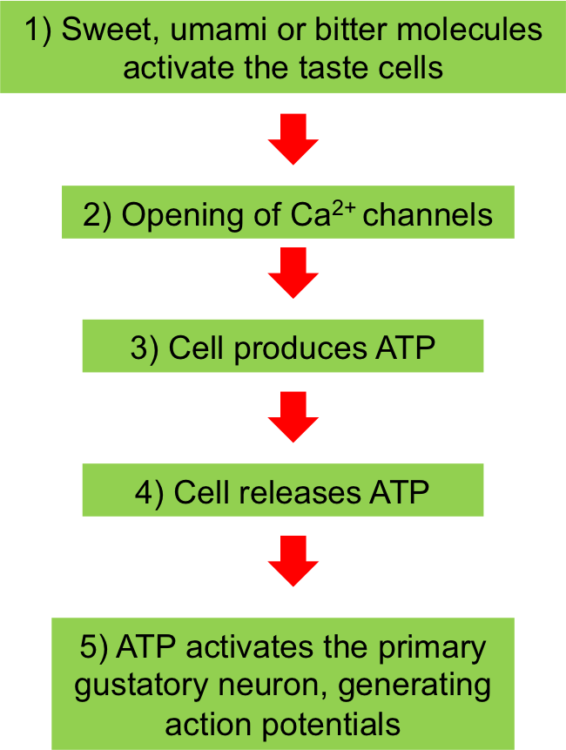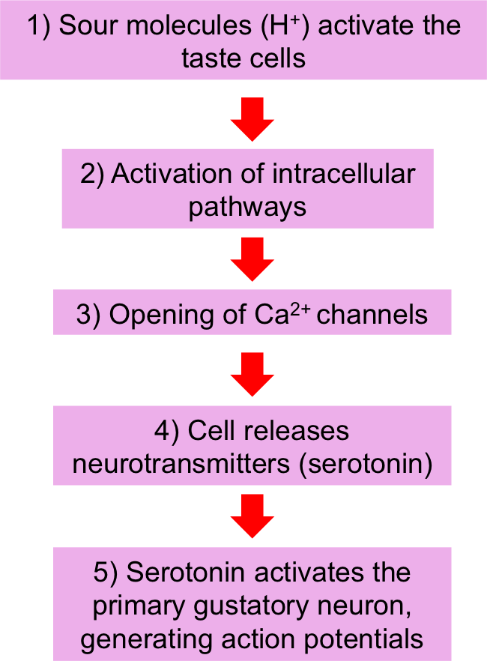

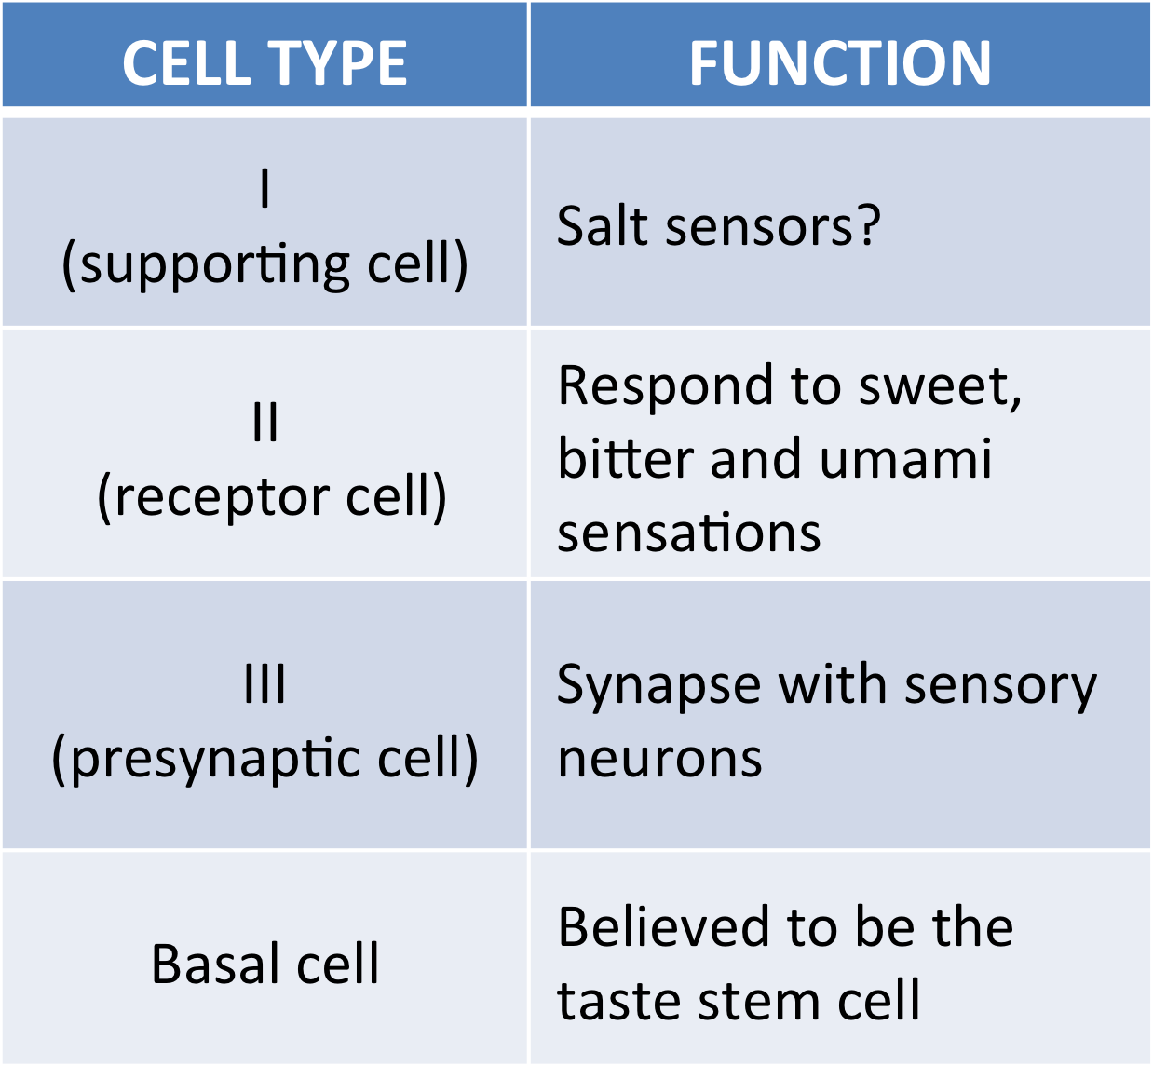

- Taste pathway to the brain
- ATP and Serotonin activate primary gustatory neurons
- Synapse with secondary sensory neurons at MEDULLA
- Signal arrives at THALAMUS
- Then is directed to a specific area of the GUSTATORY CORTEX

THE AUTONOMIC NERVOUS SYSTEM (ANS)
- Throughout neuroaxis –head is the hypothalamus
- Two divisions – PNS & SNS – usually antagonistic, but sometimes work in a cooperative or commentary manner
- Found EVERYWHERE…
- Pre-ganglionic – myelinated
- Post-ganglionic – non myelinated

PARASYMPATHEIC NERVOUS SYSTEM (PNS)
- Both pre- and post- ganglionic neurons release Ach
- Secro cord/Medulla oblongata
- Goes directly
- Long pre-ganglionic
- ‘Rest and digest’
- Relaxing
- High digestion
SYMPATHETIC NERVOUS SYSTEM (SNS)
- Preganglionic neurons releases ACH while post-ganglionic neuron releases NE
- Thoracic/Lumbar
- Neuron (ganglionic)
- Post neuron (post-ganglionic)…releases N: epinephrine
- Interacts a lot
- Releases Ach
- ‘Fight or flight’
- Low digestive

Different effects of organs (all others are just opposites)
- Salivary Glands – a and B2 (complimentary both produce salvia)
- PNS – watery secretion
- SNS – mucus, enzymes
- Arterioles…veins – a…B2 (No parasympathetic innervations)
- PNS – none
- SNS – Constricts…Dilates
- Urinary bladder…a and B2 (complementary)
- PNS – release of urine
- SNS – urinary retention
- Male and female sex organs…a (co-operative…erection > ejaculation)
- PNS – erection
- SNS – ejaculation (male)

The Motor Unit
- Group of skeletal muscle fibers and the somatic motor neuron that controls them
- Are the basic unit used for motor movement
- The neuron that leads to the muscle is the alpha motor neuron

Alpha Motor neuron: signals to contract, innervates extrafusal muscle fibers, always excitatory
Muscle Spindle: detects muscle length, and how that length changes…found in belly of muscles
Intrafusal Muscle Fiber: inner layer, signals info related to muscle to CNS
Extrafusal Muscle Fiber: normal contractile fibers, outer layer of muscles
1a afferent neuron: muscle spindles, sensory neurons send info to CNS, change in length
1b afferent neuron: Golgi tendon organ to CNS, responds to tension
Gamma Motor Neuron: from CNS…innervate intrafusal fibers (muscle spindles), control contraction (stretch) in muscle spindles

- To perform a movement we need to know:
- Which muscle to use > learned
- Length > muscle spindles > 1a afferent neuron
- Tension > Golgi tendon organ > 1b afferent neuron

- Golgi Tendon Organs ink the muscle and the tendon
- In series with tendon/muscle fibers
- Responsible for info about tension within muscle
- Increased traffic in brain
- Increases 1b traffic (AP)
- Increases 1a traffic (AP)
- During contraction 1a decreases, 1b increases
- During stretch they both increase
- Muscle Spindle
- In parallel with extrafusal muscle fibers
- Responsible for information about length and change in length of skeletal muscle
- Reflex Arc
- Receptor is the afferent neuron
- Synaptic contact in the spinal cord (CNS)
- Motor neuron effector

Reflexes and Reflex Arc
- Monosynaptic Reflex
- Stretch Reflex
- Polysynaptic Reflex
- Golgi tendon reflex (inverse stretch reflex)
- Alpha-gamma co-activation
- Simultaneous activation of skeletal muscle fiber (alpha motor neuron) and muscle spindle (gamma motor neuron) causing both to contract
- Increases sensitivity of the muscle spindle and maintains afferent information to CNS about muscle length
- Stretch Reflex
- Helps in compensation for additional loads
- Golgi Tendon Reflex
- Protective mechanism
- Crossed Extensor Reflex
- Helps body maintain its balance when it has been disrupted, result of a flexor reflex

- Motor Cortex
- Frontal lobe (precentral gyrus)
- The organization in the motor cortex is due to the cerebral representation of body areas having dense and small motor units
- Motor homunculus
- Somatopotically organized
- Corticospinal Tract
- Direct pathways to alpha motor neurons
- Lateral > Crossed > Used mainly for fin and gross motor movements (90%)
- Ventral > uncrossed > Used for gross motor movements (10%)
- Babinski Sign (reflex)
- Used to assess corticospinal tract damage
- Planning movement (frontal lobe)
- Ganglia and Sunstania Nigra (control valve of involuntary movements)
- The basal ganglia are primarily involved in action selection, that is, the decision and planning of which several possible behaviours to execute at a given time
- The basal ganglia and substania nigra exert an inhibitory influence on a number of motor systems, and that a release of this inhibition permits a motor system to become active
Reciprocal Innervation: contraction in a muscle is accompanied by a loss of tone or by relaxation in the antagonistic muscle.

Cerebellum:
- Major functions
- Motor movement coordination
- Timing of movement
- Programs of movement
- Balance (equilibrium)
- Muscle tone
Cerebellar Disease:
- Hypotonia – muscle ton decrease
- Dysarthria – cant talk well…slurs
- Ataxia – difficult with balance (lose it)
- Intension Tremor – shaking with movement
- Dysmertia – Inability to locate

Basal Ganglia:
- Controls cognition, movement coordination and voluntary movement
Damage effects:
- Athetosis
- Hemiballism
- Increased muscle tone – opp. of cerebellar
- Dyskinesia
- Resting Tremor – shaking at rest
Parkinson’s Disease…Cause: when neurons in substania nigra area of the brain die or become impaired
- Unblinking, mask-like face
- Resting tremor
- Rigidity
- Slowness and poverty of movement
- Trouble walking

Skeletal Muscle Physiology
- Whole muscle > Fascicle > Muscle cell/fiber > Myofibril > Myofilaments
- Skeletal muscle is striated
- Number of muscle cells depend on the size of the whole muscle
- Length of the muscle cells/fibers vary from 1mm to 12cm long
- Contain glycogen, lipids for energy and myoglobin to store oxygen
- Transverse tubules (T Tubules) - Transmit action potentials from the surface of the muscle cell to deep within the fibers
- Sarcoplasmic reticulum (SR) - Storage site of Ca2+ ions (facilitate myofilament contraction)
- Terminal Cisternae - Ends of the SR; interaction point for incoming action potentials; location of Ca2+ channels
- Sarcolemma - Surface membrane of muscle fibers
- Myofilaments – Thick and thin - Major components of the muscle contractile system

Thin Myofilaments
- G-Actin
- Globular protein
- Primary unit of thin myofilaments
- Attachment point for thick myofilament (myosin binding sites)
- Tropomyosin
- Two rod-shaped protein strands intertwined in a coil formation
- In relaxed state, protein strands cover myosin binding sites that are located on actin molecules
- Troponin
- Attached to actin and tropomyosin molecules
- In the relaxed state, troponin holds the tropomyosin strands over the myosin sites of actin
- When the muscle is activated, Ca2+ binds to troponin
- Troponin pulls tropomyosin away from myosin binding sites, allowing for attachment of thin and thick myofilaments
Thick Myofilaments
- Large bundle of myosin molecules
- Active unit in the sliding filament theory – undergoes physical change to carry out muscle contraction
- Each myosin molecule is made of two intertwined polypeptide chains
- Each myosin molecule has two functional units (heads). Each head has an ATP binding site (provides energy for contraction) and a binding site for actin (pulls on thin myofilament)
Sliding Filament Theory
- When myosin binds to actin a cross-bridge is formed
- Myosin then changes shape and a power-stroke occurs
- Actin slides past myosin
- Overall length of the sarcomere (Smallest functional unit of muscle cell) decreases
- BUT, length of the myofilaments does not change
Neuromuscular Junction (NMJ)
- Point of contact between the motor nerve and the muscle cell/fiber
- Amount of activation in a muscle is equivalent to the amount of activation in the nervous system (a-motor neurons)
- One action potential in an a-motor neuron will always lead to one action potential in a muscle cell

- AP on motor nerve depolarizes axon terminal
- VG Ca2+ channels open
- Ca2+ flows in, Ach is released
- Ach diffuses across synaptic cleft to end plate
- Ach binds to receptors, chemically gated channels open
- Sodium flows into muscle cell (and K+ flows out)
- Depolarization causes and End Plate Potential (EPP) – no AP yet
- EPP triggers VG Na+ channels to open triggering an AP
- AP propagates over sarcolemma
- Ach is broken down by Ach-ase into choline and acetate and taken back up into axon terminal to be recycled
Excitation Contraction Coupling (ECC)
- The purpose of generating an AP in a muscle is to trigger the release of calcium ions (stored in the SR) into the muscle cell environment
- AP generated at the plate of the muscle cell
- AP propagates over sarcolemma and down T-tubules
- Voltage sensors in T-tubule detects AP and changes shape
- Voltage sensor opens Ca2+ channels on lateral sac of SR
- Ca2+ binds to troponin causing tropomyosin to roll of myosin binding sites found on actin
- Myosin attaches to actin (cross-bridge formation) and power stroke occurs
- Actin Slides over myosin and muscle contracts (sliding filaments)
- Ca2+ is actively pumped back into SR by Ca2+ ATPase
- When Ca2+ is “removed”, tropomyosin covers myosin binding sites
- Muscle relaxes
Actin-myosin-ATP cycle
- Describes the physical changes that occur between thick and thin myofilaments during the muscle contraction process
- In order for contraction to occur, thick myofilaments must bind to thin myofilaments and pull on them
- This action is achieved by harnessing energy from the breakdown of ATP
- ATP is attached to myosin
- Myosin is not attached to actin
- ATP is hydrolyzed to ADP and Pi
- Energy transferred to myosin
- Myosin now has high affinity for actin
- Myosin head is repositioned
- ECC

- Pi is released
- Cross bridge movement (power stroke) is triggered
- Muscle contraction occurs (sliding filaments)
- ADP is released
- Cross bridges still formed
- Myosin still attached to Actin (cross bridge still formed)
- New molecule of ATP attaches to myosin
- Cross bridge breaks
- Cycle repeats
Rigor Mortis
- Permanent fusion of thick and thin myofilaments after death
- For them to separate it needs cross bridge dissociation
- ATP molecule has to bind to the myosin head
- After death the body does not produce anymore ATP because lack of oxygen
- Makes them stay attached until muscle decompose
Motor Unit
- A motor unit is a motor nerve plus all the muscle cells it contacts
- Small motor unit – one motor nerve and a small number of muscle cells
- Large motor unit – one motor nerve and a large number of muscle cells

Grading of Muscle Contraction
- An increase in the fore of a muscle contraction can be achieved by:
- Recruitment of motor units (MU)
- Summation of twitch contractions
- Recruitment of Motor Units
- As more MU are recruited, more muscle cells are activated and contract > the overall contractile force increases
- Summation of Twitch Contractions
- A muscle twitch is the muscle contraction in response to one action potential in the motor nerve
- As AP frequency is increased, each twitch has less time to relax before next one occurs
- Twitches start to stack up on one another causing a more forceful contraction
- Incomplete Tetanus: Still small time in between twitches
- Complete tetanus: maximal contraction, no time in between

CARIOVASCULAR PHYSIOLOGY

Functions of the CV System
- Homeostasis
- Transports oxygen and nutrients
- Removes CO2 and waste
- Regulates body temps and pH
- Transports and distributes hormones throughout the body
2 Major Circulatory Systems in the body
- Systemic Circulation
- Blood supply for most of the body – provides oxygen and nutrients to organs and tissues
- Allows for removal of CO2 and other waste products
- Arteries have high oxygen levels and low CO2 levels
- Veins have low oxygen levels and high CO2 levels
- Pulmonary Circulation
- Blood that travels to the lungs for gas exchange
- Allows for resupply of oxygen and removal of CO2 from blood
- Arteries have low oxygen levels and high CO2 level
- Veins have high oxygen levels and low CO2 levels
Blood Volume Distributions
- Total Blood Volume – approx. 5 litres
- Heart and Pulmonary Circulation – 15%
- Arteries and Arterioles of systemic (distribution vessels) – 10%
- Capillaries of the systemic circulation (exchange vessels) – 5%
- Veins of the systemic circulation (capacitance vessels) – 70%
Cardiovascular Anatomy
- Vena Cava – returns blood to the heart from venous braches of systemic circulation
- Pulmonary Veins – return blood to the heart from the venous branches of the pulmonary circulation
- Atria – entry point for blood returning to heart
- Ventricles – pump blood out of the heart into the circulation
- Tricuspid Valve – controls blood flow from the right atrium to the right ventricle
- Bicuspid Valve – controls blood flow from the left atrium to the left ventricle
- Pulmonary Artery – start of the pulmonary circulation
- Aorta – start of the systemic circulation
PATH OF BLOOD THROUGH THE HEART AND VESSELS
Pulmonary
R. Ventricle > Pulmonary Artery > P. Capillaries > P. Vein > L. Atrium
Systemic
L. Ventricle > Aorta > Systemic Arteries > Sys. Capillaries > Sys. Veins> Vena Cava > R. Atrium

CARDIAC FUNCTION
Myocardial Cells
- Contractile Cells
- Similar to skeletal muscle cells in terms of contractile function (think and think myofilaments, require Ca2++, etc.)
- Major differences: greater mitochondrial content (very active muscle group), intercalated discs (contain gap junctions)
- Nodal/Conducting Cells
- Specialized form of neuronal cell
- Cells in the SA node dictate the pace of the heart
- SA node cells are SELF-EXICTABLE…do not require external stimulus to fire AP

The SA node
- SELF-EXCITABLE
- Specialized group of cells in the upper wall of the right atrium, responsible for dictating the rate of contraction within the heart
- Has the fastest rate of spontaneous action potential generation in the heart
- Average resting HR of person is 70-BPM
- Pacemaker potential is the spontaneous increase in membrane potential towards the electrical threshold of the nodal cells
- Compared to other types of excitable cells, SA node cells have greater Na+ and Ca2+ permeability, lower K+ permeability
- Because of these differences, cells o not stay at rest. Instead, the movement of ions across the membrane though “leak channels” favours depolarization
- The cells of the SA node – do not have a resting membrane potential, an electrical threshold of -40mV, once the threshold is reached, an AP fires within the SA node
- Depolarization during an SA node action potential is caused by influx of Ca2+ through VG Ca2+ channels
- Repolarization during an SA node action potential is caused by efflux through VG K+ channels

Direction of AP/Blood flow
- AP in the atria start at the top of the chamber and progress downwards to the bottom
- As a result, the cardiomyocytes will contract top to bottom and blood will be forced downwards (into ventricles)
- AP in the ventricles start at the bottom of the chamber and progress upwards to the top
- As a result, the cardiomyocytes will contract bottom to top and blood will be forced upwards (into the pulmonary artery and aorta

Important structures in the heart
- Sinoatrial ode
- Generates spontaneous AP to dictate pace of the heart
- Atrioventricular ring
- Insulation between the top and bottom chambers of the heart
- Creates electrical separation between atria and ventricles
- Bundle of His
- Relays AP from AV node to the bottom of the ventricles
- Purkinje fibers
- Distribute AP signal throughout ventricular muscle

