Solutions to Lab Problems for Chapter 6

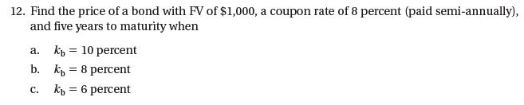12. Section: 6.2 Bond Valuation
Learning Objective: 6.2
Difficulty: Easy

Using a financial calculator:

A. N = 10; I/Y= 5; PMT = 40; FV = 1,000; CPT PV = –922.78

B. N = 10; I/Y= 4; PMT = 40; FV = 1,000; CPT PV = –1,000

C. N = 10; I/Y= 3; PMT = 40; FV = 1,000; CPT PV = –1,085.30

Clearly, the price of bonds is inversely related to the market yield.

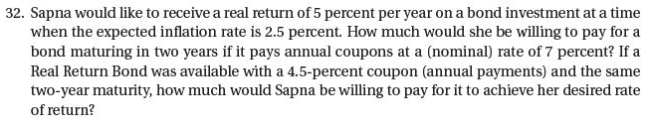
32. Section: 6.4 Interest Rate Determinants
Learning Objective: 6.4
Difficulty: Medium

For a bond paying a coupon in nominal terms, Sapna requires YTM = 5% + 2.5% = 7.5% (approximately). Thus, using a financial calculator we can find:
N = 2; I/Y = 7.5; PMT = 70; FV = 1,000; CPT PV = – 991.02

(Using the exact relationship, YTM = (1+0.05) × (1+0.025) –1= 7.625% and B = $988.80)

For the Real Return bond, Sapna requires YTM = 5%
N = 2; I/Y = 5; PMT = 45; FV = 1,000; PV = – 990.70

Notice that these prices are very similar because the “real” coupon rate plus the expected inflation, 4.5%+2.5% = 7% which is the “nominal” coupon rate.

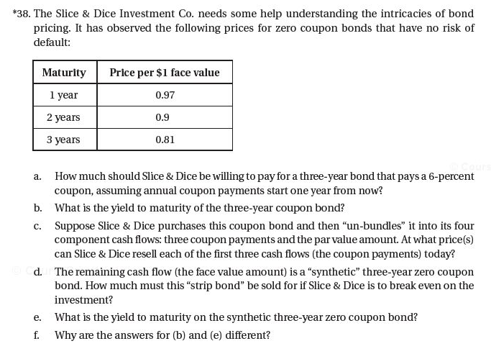38. Section: 6.2 Bond Valuation, 6.3 Bond Yields, and 6.5 Other Types of Bonds/Debt Instruments
Learning Objective: 6.2; 6.3; 6.5
Difficulty: Difficult

a. We do not have a yield to maturity figure with which to discount all the cash flows (coupons and face value). Therefore, we must use the market rates implied by the zero coupon bond prices for the appropriate time period. A one-year zero coupon bond will increase from $0.97 to $1 over one year, implying that 0.97×(1+r₁) = 1, or r₁=3.09%. Similarly, 0.90× (1+r₂)²=1 so that r₂=5.41%, and 0.81×(1+r₃)³=1 so that r₃=7.28%. These rates can be used to discount the three-year coupon bond’s cash flow. (Alternatively, we could use the zero coupon bond prices as given).

The difference in these results is due to rounding of the interest rate figures ($970.80 is the correct figure).

b. Using a financial calculator:
N = 3; PMT = 60; FV = 1,000; PV = -970.80; CPT I/Y = 7.115%

c. From part (a), the present values of the coupon payments are: $60×0.97=$58.20 (first coupon), $60×0.90=$54.00 (second coupon) and $60×0.81=$48.60 (third coupon). These are the fair values (market prices) of the coupons today.

d. To just break-even, the synthetic zero coupon bond would be sold for:
$970.80 – ($58.20 + $54.00 + $48.60) = $810.00. Notice that this is the present value of the face value of the bond: $1,000×0.81 = $810.00

e. $810.00× (1+YTM)³ = $1,000, therefore, YTM = (1,000/810)^{1/3}–1 = 7.277%
This is the same figure calculated in (a) as the three-year interest rate.

f. The YTM of a coupon-paying bond is an average value (weighted by the dollar amounts) of the yields on all the cash flows (coupons and face value). This average will be lower than the three-year interest rate because the yields are increasing for longer maturities (upward sloping term structure).

