Chapter 12: Measuring Attitude
Types of Primary Data: Only from the slides, not the book
Demographic / Socioeconomic characteristics
- Age, education, occupation, martial status, sex, income, social class.
- Used to know frequency of each group.
- Used to cross-classify the data to interpret consumers’ responses.
Psychological / Lifestyle characteristics
- Personality
- Normal patterns of behaviour exhibited by an individual – attributes, traits and mannerisms that distinguish one individual from another.
- Expected to lead to different choice or consumption behaviours but empirical evidence is mixed.
- Typically measured by standardized questionnaire.
- Psychographic analysis
- A technique that investigates how people live, what interests them and what they like to do.
- It is also called lifestyle analysis, since it relies on a number of statements about a person’s AIO – activities, interests and opinions.
Attitudes
- An individual’s overall evaluation of something (e.g., object, situation, or person).
- Four elements:
  - Action – buying, searching.
  - Target – product category, brand.
  - Context – retail store, online.
  - Time – when occurred.
- Majority of marketing research questions are designed to measure attitudes.
- Hypothesized that attitudes lead to behaviour.
- For pragmatic reasons, ask attitude questions rather than observe and interpret behaviour.
- Large capacity for diagnosis and explanation
- Cognitive component
  - Represents a person’s knowledge of an object.
  - Beliefs about the characteristics or attributes of the object.
- Affective component
  - Summarizes a person’s overall feelings toward an object, situation, or person.
Awareness / Knowledge
- Brand awareness
  - Communication effect derived from advertising exposures.
  - Recall and recognition of the brand.
- Advertising awareness
  - More a function and measure of cognitive and emotional processing of advertising.
  - Unaided recall
  - Aided recall
  - Recognition
Intentions
- Anticipated or planned future behaviour.
- Usually asked by a scaled question indicating the likelihood of buying a product.
- Proxy for actual behaviour, but accuracy is a concern
Motivation
- A need, a want, a drive, a wish, a desire, an impulse, or any inner state that energizes, activates, or moves and that directs or channels behaviour toward goals.
- Concept is used to assess why consumers behave.
- Tends to be more stable that actual behaviour.
Behaviour
- What respondents have done or are doing (e.g., purchase, use, consume).
- Occurs with specific circumstances, time, and involves one or more participants
Types of Scales
Non-comparative Scale*
*Rating Scale: requires respondents to estimate the magnitude of a characteristic or quality that a brand/store/object possess.
- A scaling technique in which each stimulus object is scaled independently of the others.
- Sometimes referred to as a metric scale.
- Major strength is that the scale only has interval properties.
- Major limitation is the absence of a common referent.
- Examples
- Category
- Respondents must indicate their ratings of an attribute or object by selecting the response category that best describes their position on the attribute or object
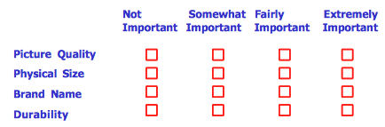
- Likert
- Requires respondent to indicate degree of agreement or disagreement with a variety of statements related to the attitude object.
- Scores on individual items are summed to give total score for respondents.
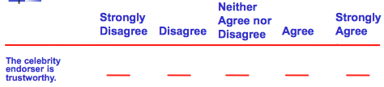
- Semantic Differential
- Respondents rate each attribute object on five or seven-point rating scales bounded by (bi)polar adjectives or phrases.
- Rating is indicated by marking the appropriate response
- Numbers can be used instead of spaces, known as a numerical scale.
- With bipolar scale, the midpoint is a neutral point.
- Pairs of objects or phrases must be meaningful in market being studied and often correspond to product/service attributes.
- Avoid "halo" effect by placing negative pole on either side.
- Category increments are treated as interval scales so group mean values can be computed for each object on each scale.
- May also be analyzed as a summated rating scale.
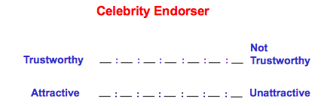

- Stapel
- Modification of semantic differential - uses one pole rather than two opposite poles.
- Respondents select a numerical response category.
- Only need one adjective and provides extra variance with ten-point scale versus seven.
- Concern of phrasing of one adjective positively, negatively or neutrally limits its acceptance.
-1 -2 -3 -4 -5 TRUSTWORTHY +1 +2 +3 +4 +5
- Graphic (Continuous) Rating
- Respondents indicate their rating of an attribute by placing a check at the appropriate point on a line that runs from one extreme of the attribute to the other.
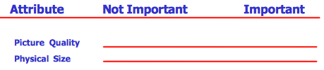
Comparative Scales:
- A scaling technique in which there is direct comparison of stimulus objects with one another.
- Sometimes referred to as non-metric scale.
- Major strength is that small differences between objects can be detected due to a common reference.
- Major limitation is that the scale has ordinal properties.
- Examples
- Paired Comparison (perceptual map)
- Brands to be rated are presented two at a time to assess similarity or preference.
- Each brand in the category is compared once to every other brand.
- Brands are rated on a given 10 points that are then divided between the two brands.
- Specialized software produce perceptual map to assist in positioning decisions.
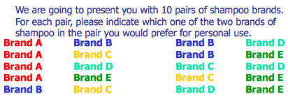
- Constant Sum
- Respondents allocate a fixed number of rating points among two or more attributes on some basis of importance or favourability.
- Often sort cards, but can also me rating task
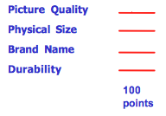
- Rank Order
- Respondents are presented with several objects simultaneously and asked to order or rank them according to some criterion. (ex: 1-10 from most liked to least liked)

Decisions to construct a scale
- Type of Scale
  - Monadic: asks respondents about single concept in isolation
  - Comparative Rating Scale: rate concept in comparison with benchmark
- Number of Items in a Scale
- Number of Scale Categories
  - Four, five, or seven response positions or categories? Or graphic scale with infinite amount?
- Balance of a Scale (even-odd)
  - Balanced: equal number of positive and negative categories; a neutral point or point of indifference is at the center
  - Unbalanced:
- Types of Poles Used in the Scale
- Strength of the Anchors
- Labeling of the Categories
  - Verbal? Numerical? Unlisted?
- Reverse Scaling
- Including “Don’t Know” Response Category

