Chapter 11: Measurement
What is to be measured?
Concepts:
- A generalized idea about a class of objects, attributes, occurrences, or processes
- Before measurement process can occur must identify concepts relevant to the process
Operational Definitions:
- Explanation that gives meaning to a concept by specifying the activities or operations necessary to measure it
- Conceptual Definition:
  - Verbal explanation of the meaning of a concept (construct). It defines what the concept is and what it is not
  - A construct is defined in terms of other constructs. An equation expressing their relationships is possible.
- Hypothetical Construct:
  - Concepts used in explaining theoretical models/theories.
  - Concepts that cannot be seen but are useful to model.
  - Examples
    - Attitudes
    - Personality
    - Intentions
Types of Measurement Scales
- Scale: any series of items that are arranged progressively according to value or magnitude; a series into which an item can be placed according to its quantification
- Nominal Scale: Categorical
  - Scale in which the numbers or letters are assigned to objects serve as labels for identification or classification
  - No necessary relationships among categories.
  - No ordering or spacing are implied.
  - Only possible arithmetic operation is a count of each category.
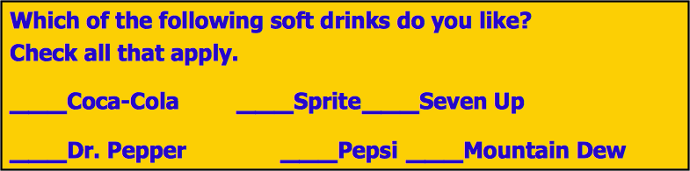
- Ordinal Scale: Categorical
  - Scale that arranges objects or alternatives according to their magnitude in an ordered relationship
  - Does each object have more or less of a variable than some other object?
  - Does not provide information on how much difference between objects.
  - Arithmetic operations are limited to statistics such as median or mode.
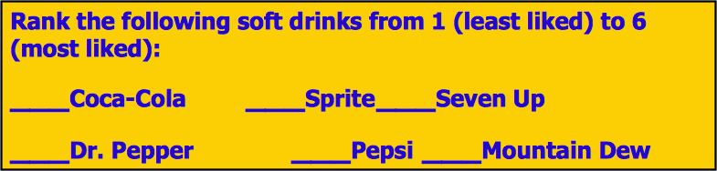
- Interval Scale: Continuous
  - A scale that both arranges objects according to their magnitudes and distinguishes their ordered arrangements in units of equal interval
  - Numbers are assigned to allow the comparison of the size of the differences among and between members.
  - Differences can be compared.
  - Entire range of statistical operations can be employed.
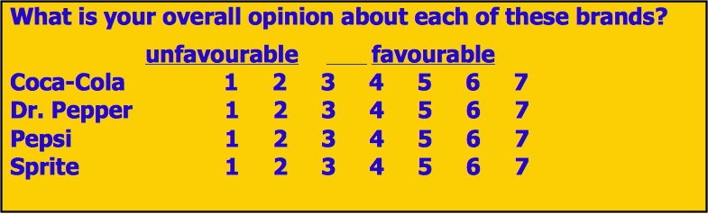
- Ratio Scale: Continuous
  - Scale that has an absolute rather than relative quantities and an absolute zero where the is an absence of a given attribute
  - Possible to say how many times greater or smaller one object is than another.
  - Magnitude scaling of attitudes has been calibrated through numeric estimation.
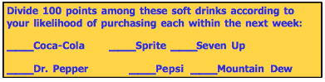
-
Ratio and interval scales have all the properties of nominal and ordinal scales.

Scale | Descriptive Statistics
Nominal | Frequency in each category  Percentage in each category  Mode
Ordinal | Median  Range  Percentile Ranking
Interval | Mean  Standard Deviation  Variance
Ratio | Geometric Mean  Coefficient of Variation
Index Measures:
- Attribute: a single characteristic or fundamental feature of an object, person, situation or issue
- Index (or composite) Measure: a composite measure of several variables used to measure a single concept; a multi-item instrument

Establishing the Validity of Measures:
- Systematic Error
  - Error in measurement that is also known as constant error since it affects the measurement in a constant way.
  - Examples
    - Type of question
    - Cultural factors
    - Personality
    - Research method
- Random Error
  - Error in measurement due to temporary aspects of the person or measurement situation and which affects the measurement in irregular ways.
  - Examples
    - Varying personal factors
    - Situational characteristics
    - Clarity of the measuring instrument
- Importance of Validity and Reliability
  - The extent to which
    - Differences in scores on a measuring instrument reflect true differences among individuals, groups, or situations in the characteristic that it seeks to measure.
    - True differences in the same individual, group, or situation from one occasion to another, rather than systematic or random errors.

Three Criteria for Good Measures
- Reliability:
  - Degree to which measures are free from random error and therefore yield consistent results
  - 2 underlying dimensions: repeatability & internal consistency
  - Test-retest method: administering the same scale or measure to the same respondents at two separate points in time to test for stability
  - Split-half method: a method for assessing internal consistency by checking results of one-half of a set of scaled items against the results from the other half
  - Equivalent Form method: a method that measures the correlation between alternative instruments, designed to be as equivalent as possible, administered to the same group of subjects
- Validity:
  - The ability of a scale to measure what was intended to be measured
- Establishing Validity:
  - Face (or content) validity: Professional agreement that a scale’s content logically appears to accurately reflect what was intended to be measured.
    - The adequacy with which the important aspects of the characteristic are captured by the measure.
  - Criterion validity: the ability of a measure to correlate with other standard measures of the same construct or established criterion
    - The usefulness of the measuring instrument as a predictor of some other characteristic or behaviour of the individual.
  - Construct validity: the ability of a measure to provide empirical evidence consistent with a theory based on the concepts
    - Assessment of how well the instrument captures the construct, concept, or trait it is supposed to be measuring
  - Discriminant Validity (extra)
    - A form of construct validity that represents the extent to which the measured construct is not associated with which the construct is related on theoretical grounds.

Sensitivity: a measurement instrument’s ability to accurately measure variability in stimuli or responses
Developing Measures:
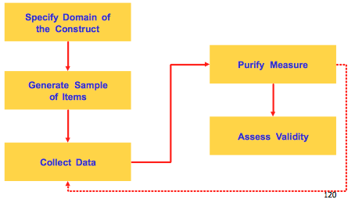
Establishing the Validity of Measures 

