Chapter 7: Survey Research: An Overview
The Nature of Surveys
Purpose
- Describe the characteristics of certain groups.
- Estimate the proportion of people in a specified population who behave in a certain way.
Respondent:
- The person who verbally answers an interviewers questions or provides answers to written questions
Survey:
- A method of collecting data in which information is gathered by communicating with a representative sample of people
Advantages:
- Quick, inexpensive, efficient, accurate means of assessing information about a population

Errors in Survey Research (Sampling Error)
Random Sampling Error:
- Statistical fluctuation that occurs because of chance variation in the elements selected for a sample
Sampling Error:
- Difference between the observed values of a variable and the long-run average with repeated measurement
Systematic Error (nonsampling error):
- Error resulting from some imperfect aspect of the research design that causes respondent error or from a mistake in the execution of the research
Sample Bias:
- A persistent tendency for the results of a sample to deviate in one direction from the true value of the population parameter

Respondent Error (Nonsampling error)
- A category of sample bias resulting from some respondent action or inaction such as nonresponse or response bias
Nonresponse Error:
- The statistical differences between a survey that includes only those who respond in a perfect survey that would also include those who failed to respond
- Nonrespondents: person who is not contacted or who refuses to cooperate in the research
- No contact: a person who is not at home or who is otherwise inaccessible on the first and second contact
- Refusal: a person who is unwilling to participate in a research project
- Self-selection Bias: a bias that occurs because people who feel strongly about a subject are more likely to respond to survey about questions than people who feel indifferent about it
- Diagnosing Nonresponse Error:
  - Contact a sample of non-respondents.
  - Compare respondent demographics against known demographics of population.
  - Conduct an analysis of late responders vs. early responders.
- Minimizing Nonresponse Errors:
  - Refusals
    - Hide the identification of the sponsor by using an independent research organization.
    - Get respondent to complete a small task to build rapport.
    - Use a follow-up contact at more convenient time.
    - Ensure interviewer quality with training.
    - Provide advance notice of survey arrival.
    - Communicate value of research and importance of respondent’s participation.
    - Guarantee anonymity.
    - Provide an incentive for participating
  - Not-at-homes
    - Have interviewers make advance appointments.
    - Call back at another time.
    - Use another data collection method.
  - Objective is improved response rate!
    - The number of completed interviews with responding units divided by the number of eligible responding units.
Response Bias (Error):
- A bias that occurs when respondents either consciously or unconsciously tend to answer questions with a certain slant that misrepresents the truth
- Deliberate Falsification
- Unconscious Misrepresentation
- Diagnosing Response Error:
  - Does the respondent understand the question?
  - Does the respondent know the answer to the question?
  - Is the respondent willing to provide the true answer?
  - Is the wording of the question or the situation in which it is asked likely to bias the response?
- Minimizing Response Error:
  - Match the background characteristics of interviewer and respondent as closely as possible.
  - Make sure interviewer instructions are clear and written.
  - Examine interviewer’s understanding of the study’s purposes and procedures.
  - Have interviewers complete the questionnaire and examine their replies.
  - Verify a sample of each interviewer’s work.
Types of Response Biases:
- Acquiescence bias
  - Individuals agree with all questions or concur with a particular position.
- Extremity bias
  - Individuals use extremes when answering questions.
- Interviewer bias:
  - Occurs because the presence of the interviewer influences respondents’ answers.
- Auspices bias:
  - Individuals are influenced by the organization conducting the study.
- Social desirability bias
  - Respondents’ desire, either conscious or unconscious, to gain prestige or appear in a different social role
- Courtesy bias
  - Respondent’s to respond positively to all questions.
- Uninformed response bias
  - Respondent answers questions without knowledge
- Inability to respond
  - Ignorance
  - Forget
  - Cannot formulate an adequate answer.
- Unwillingness to respond
  - Concern about invasion of privacy
  - Time pressure and fatigue
Administrative Error
- Error caused by the improper administration or execution of the research task
- Data Processing Error: occurs because of incorrect data entry, incorrect computer programming, or other procedural errors during data analysis
- Sample Selection Error: caused by improper sample design or sampling procedure execution
- Interviewer Error: mistakes made by interviewers failing to record survey responses correctly
- Interviewer cheating: filling in fake answers or falsifying questionnaires while working as an interviewer

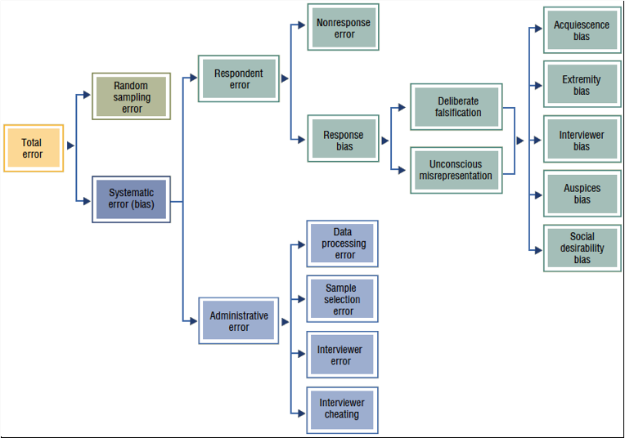

Classifying Survey Research Methods
Structured and Disguised Questions:
- Questionnaire:
  - Data collection form used for surveys is a questionnaire.
  - Content helps classify surveys in three ways.
    - Degree of Structure
    - Degree of disguise
    - Method of Administration (most are hybrid of these)
- Structured Questions: Fixed alternative questions
  - Question that imposes a limit on the number of allowable responses
- Unstructured Questions: Open ended questions
  - Questions that don’t restrict the respondents answers
- Disguised Question:
  - An indirect question that assumes the purpose of the study must be hidden from the respondent
  - Required when
    - Knowledge could bias responses.
    - A natural environment is preferred
  - Disguised methods require debriefing respondents.
    - Process of giving appropriate information to respondents after data has been collected using a disguise.
- Undisguised Question
  - Straightforward question that assumes the respondent is willing to answer
Temporal Classification:
- Most surveys are for individual research projects conducted only once, however other projects require multiple surveys over a long period of time, thus can be classified on a temporal basis
- Cross-Sectional Study
  - Study in which various segments of a population are sampled and data are collected at a single moment in time
- Longitudinal Study
  - Survey of respondents at different times, thus allowing analysis of response continuity and change over time
  - Tracking (cohort) Study: longitudinal study that uses successive samples to compare trends and identify changes in variables such as satisfaction, brand image, advertising awareness
  - Consumer Panel: longitudinal survey of the same sample of individuals or households to record their attitudes, behaviour or purchasing habits over time

