Chapter 3: Organizational and Ethical Issues in Marketing Research

Degree of Marketing Research Sophistication:
Research Sophistication:
- A stage in which managers have considerable experience in the proper use of research techniques
- 3 Levels:
  - Stage of intuitive decision making: ignorant about marketing research, depend on intuition/experience to obtain info informally
  - Stage of sophistication: marketing research becomes proactive force to identify decision makers information needs, recognize potential of research to improve decision making
  - Stage of development: believe that the result of research is the decision itself, not information on which to base a good decision

Organizational Structure of Marketing Research:
Marketing Research as a Staff Function:
- Must wait for management to request assistance, functions like an internal consulting organization
- Client: term often used by the research department to refer to line management for whom services are being performed
- Manager of customer quality research: a research staff person who specializes in conducting surveys to measure consumer’s satisfaction with product quality
The Director of Marketing Research as a Manager
- Director of marketing research: the person who plans, executes, and controls the marketing research function
- Faces several problems:
  - Skilled professionals would rather conduct research then manage people, they are hands-on researchers
  - Operating managers perceive managers as chief project directors and expect them to do the work, research management role is not recognized
  - Trouble delegating responsibility, fear the loss of control, “I can do it better myself”
  - Think staff is extension of themselves, extra arms and legs, causes problems because they can’t do everything themselves, may produce shoddy work or drive away employees
  - Full time leader is unnecessary since there is an array of equal projects that are each handled by project director
Sources of Conflict Between Marketing Management and Marketing Research
- Research that implies criticism: ex: manager wants survey and find he is being criticized in it, or manager informally projects 5% increase in sales, when really it should be 20%
- Money: managers see research as expenditure not investment, don’t understand the valuable contributions of research, while researchers contend that research is only as good as budget that is allocated
- Time; Emergency Research: if research programs aren’t systematically planned, marketing researchers will encounter emergency requests. Researchers asked to begin study after something goes wrong, rather than at an earlier stage, this produces unfavourable data and makes managers leery of all research projects
- Intuitive Decision Making: Managers want to make decisions informally, pride themselves on ability to reach decisions quickly and in an authoritative manner, don’t want research
- Future decision based on past experience: managers want to predict future, researchers only measure current/past events
- Pseudo-Research and Organizational Politics:
  - Pseudo-Research: activities that appear to be research but are conducted for the purposes of organizational politics rather than objective gathering of information. (Manager will still make the same decision regardless of what research says)
  - Most common is to justify decision that’s already made
  - Also used to pass on blame for failure to another area
Reducing the Conflict Between Management and Researchers
- Revolves around better communication so each grows to understands the others activities and needs
- Research Generalist: person who can serve as a communication link between management and the research specialist because he/she understands the needs of both parties
- Cross-Functional Teams:
  - Teams composed of individuals from various organizational departments such as engineering, production, finance, and marketing who share common purpose

Research Suppliers and Contractors
Research Supplier:
- Commercial marketing research service that conducts marketing research for clients. The marketing research supplier may be though of as a marketing research consulting company.
Syndicated Service:
- A marketing research supplier that provides standardized information for many clients
- Used when the project is too expensive to do on their own
Standardized Research Service:
- A research organization that has developed a unique methodology for investigation a specialty area, such as advertising effectiveness supplied by organizations at the request of individual clients

Customer Research:
- A marketing research study designed for an individual client and tailored to the client’s unique needs
Consideration in Hiring Supplies (make-or-buy debate)
- Expertise acquired from experience in similar situations, major reason to buy
- Lack of research supplier familiarity with the product/service or customers
- Urgency of decision and company’s own resources
- Economic factors
- Confidentiality
- High variability of research supplier performance

Ethical Issues in Marketing Research
Ethical Questions are Philosophical Questions
- No general agreement about the answers to the questions, however rights and obligations of individuals are guided by societal norms:
  - Codes of behaviour adopted by a group that suggest what a member of the group ought to do under a given circumstance
General Rights and Obligations of Concerned Parties:
- 3 Parties: Researcher, Client(user), Respondent (subject), interaction of the parties results in many ethical questions.
- Each part consciously or unconsciously expects certain behaviours from rights/obligations toward the other parties
- For each right there is corresponding obligation
- Ex: Researchers think they have a right to seek info, but subjects believe they have a right to privacy

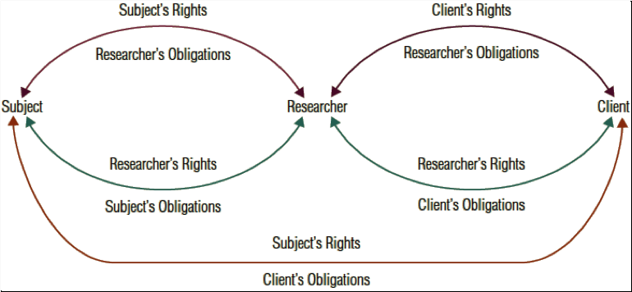
Rights and Obligations of the Respondent
- Informed Consent:
  - Notion that the individual understands the reason for the research and waives his or her right to privacy when he or she agrees to participate in the research study
- Obligation to be truthful
  - In exchange expects confidentiality (obligation on part of the researcher not to reveal the identity of the individual subject)
- Privacy
  - Involves the freedom to choose whether to comply with the investigators requests
  - Issue: is it an invasion of privacy if an interviewer calls someone during their favorite TV show?
  - Major issue of whether observed behaviour is public or private
- Deception
  - Creates false impressions by disguising purpose of the research, to avoid biased answers researcher lies to subjects
  - Deception is justified if:
    - No physical danger or psychological harm will result
    - Researcher informs them after of the deception
- Right to be Informed
  - All aspects of the research, including info on purpose and sponsorship
- Rights and obligations of the Researcher
  - General business ethics are the standard
  - Code of ethics:
    - Set of guidelines that states the standards and operating procedures for ethical practices by researchers
- The Purpose of Research is Research
  - Not allowed to misrepresent a sales tactic as market research
  - Use of schemes or misrepresenting the purpose as research to gain admission into a prospects home, office, or other establishments is unethical and hurts public as well as research agencies
- Misrepresentation of Research:
  - Can’t misrepresent the statistical accuracy of their data, nor overstate the significance of the results by altering the findings
- Protecting the Right to Confidentiality for both Subjects and Client
  - Client may want list of favourable industrial sales prospects generated from a research survey, researchers responsibility to ensure that the privacy and anonymity of the respondents are preserved
- Dissemination of Faulty Conclusions:
  - Cannot imply a scientific, factual, or statistical basis where none exist

Rights and obligations of the Client Sponsor (User)
- Ethical behaviour between the buyer and seller
- Open relationship with research suppliers
  - Client can encourage supplier to seek out the truth
- Open relationship with the interesting parties
  - Conclusions should be based on the data
  - Advocacy Research: research undertaken to support a specific claim in legal action

Privacy
- Cannot collect and distribute peoples personal information without their knowledge
- Privacy rights of subjects create privacy obligation of client

Commitment to research:
- Clients should only request proposals from research suppliers when they intend on conducting the entire research. Shouldn’t ask for a proposal to get the researchers opinion

