Biology 100A Final Exam
Independent Study and Lecture Outcomes
Lecture 12: Inheritance in Populations
Independent study Outcomes:
Strategy to distinguish between a phenotype that results from codominance relative to incomplete dominance
- Incomplete dominance: occurs when the effects of recessive alleles can be detected to some extent in heterozygotes
- MIXING
  - E.g. flower colour in snapdragons
    - true breeding red and white flower make pink
    - white and red appear in F2 generation 1:2:1 (red, pink, white)
  - eg. Sickle cell disease
    - homozygous individual have it
    - heterozygous individuals have sickle cell trait
  - hypercholesterolemia, tay sach’s are other examples
- Codominance: occurs when alleles have approximately equal effects in individuals, making two alleles equally detectable in heterozygotes.
- BOTH SHOW
  - E.g. M, MN, N blood types
    - L^{M}L^{M}- only M glycoprotein
    - L^{N}L^{N-}only N glycoprotein
    - L^{M}L^{N-} both glycoproteins
Characteristics that identify a pleiotropic allele
- Pleiotropy: single genes affect more than one character of an organism.
  - Eg. Sickle cell disease affects hemoglobin structure and function
    - Altered hemoglobin structure can cause numerous body functions; blood vessel blockage heart failure, abdominal pain, paralysis etc.
Conditions under which Hardy Weinberg Equilibrium is possible in a population.
- Hardy-Weinberg Principle: conditions under which a population of diploid organisms achieves genetic equilibrium , the point which neither allele frequencies nor genotype frequencies change in succeeding generations.
- HWE only possible under these conditions:
- No mutations are occurring
- The population is closed to migration from other populations
- The population is infinite in size
- All genotypes in the population survive and reproduce equally well
- Individuals in the population mate randomly with respect to genotypes
- If conditions met; allele frequencies of population for an identified gene locus will never change, and the genotype frequencies will stop changing after one generation.
- Microevolution will NOT occur

Lecture Outcomes:
general pathway of eukaryotic membrane protein production.
- DNA in nucleus (has black and brown alleles- heterozygote)
- Alleles transcribed and spliced, leave nucleus
- Ribosomes takes transcripts to ER
- Transcripts translated on ER, packaged into vesicles
- Vesicles go to golgi
- Packaged into new vesicles that send proteins to cell membrane
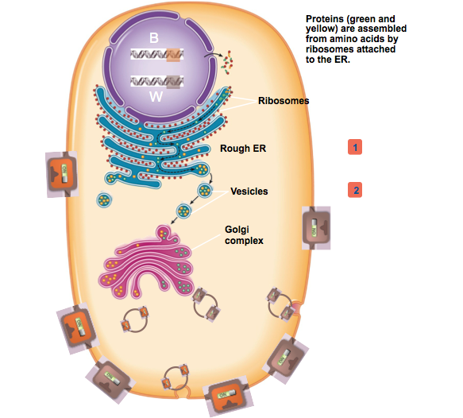
general physiology of skin/hair pigmentation.
- Pigment production results from melanin
  - Black melanin (eumelanin)
  - Red/yellow melanin (pheomelanin)
  - Brown is mixture of red and black melanin
- Melanin produced by melanocytes
  - Melanocytes pack melanin into melanosomes and export to skin cells/hair follicle cells for pigmentation
  - All cells can make red or black melanin, depends on cAMP levels
  - High cAMP levels in cell make black melanin
  - Low cAMP levels produce red melanin
  - Brown allele can make black and red, resulting in pig’s brown colour
characterisitics of dominant alleles.
- Dominance determines the phenotype of the organism
- Simple Dominance in Black and brown pigs
  - Black is dominant allele
  - Black x brown of F1 generation give all black (black is dominant trait)
  - F2 generation; 3black:1brown
- Dominance happens from interaction of gene products
- Dominance occur from expression of alleles; there is no interaction of alleles themselves
- An allele may not be dominant all the time; depends what allele it is paired with
  - Eg. Brown allele is recessive to black, but dominant to red
which allele in a heterozygote is dominant, given the biochemical mechanism of action of allele products.
- Membrane Receptor (MC1R) normally sits in membrane
  - Black allele is insensitive to hormone control, cyclic AMP levels always high- on at all time
  - Brown allele may sometimes be off
  - Red allele is always off; homozygotes always produce red melanin
  - Allele that is “on” all the time determines phenotype
factors that affect how allele frequencies change over time in a population.
- To know future allele frequencies we ONLY need to know starting allele frequencies
- Relative dominance doesn’t affect frequency
- Dominant allele is not necessarily most “fit” allele; frequencies will remain the same if they have same fitness
- Dominance vs. recessiveness, diploidy doesn’t drive changes in allele frequency
allele frequencies (p and q), given genotypic frequencies.
- Punnett squares can be used to predict allele frequencies in next generation (product rule)
- Genotype frequencies and allele frequencies will not be any different from previous generation in case below
- Recessive alleles don’t just ‘die out’, doesn’t affect evolution

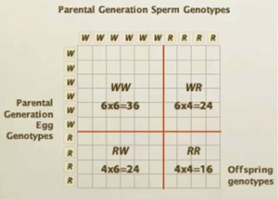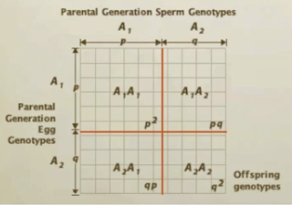
function of various MC1R alleles.*** SimUtext
- B MC1R- always on
- W MC1R

Lecture 13: Selection and Fitness
Independent Study Outcomes:
Meaning of deme, population, allele frequency, genotype frequency
- Population: group of sexually interbreeding or potentially interbreeding individuals.
- Deme: local population of organisms of one species that interbreed with one another and share a distinct gene pool.
  - Species may have many demes that do not exchange alleles
  - Selection could potentially isolate demes from one anoter
  - Populations of modern humans are demes
- Genotype frequencies: percentages of individuals possessing each genotype. (eg. p, pq, q)
- Allele frequencies: frequency of individual alleles. Does not depend upon dominance or recessiveness (genotype frequencies)
  - For a locus with two alleles:
    - P identifies frequency of one allele
    - Q identifies frequency of other
- Sum of 3 genotype frequencies=1
- Sum of 2 allele frequencies =1
- Null model: predict what you would see if a particular factor had no effect. Theoretical reference points against which observations can be evaluated.
Allele frequencies in a population, given the genotype frequencies
- Snap-dragon example:
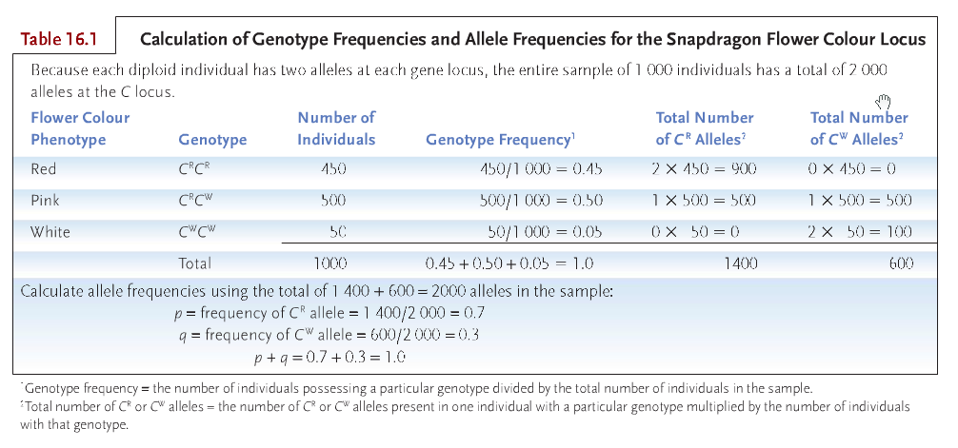

Genotype frequencies in the next generation, given the allele frequencies and assuming Hardy-Weinberg equilibrium
- In each parent, alleles segregate and end up in different gametes
- P²+2pq+q² predicts the genotype frequencies in the offspring generation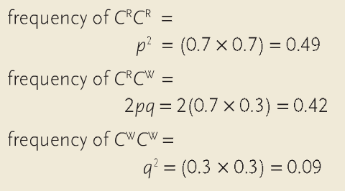
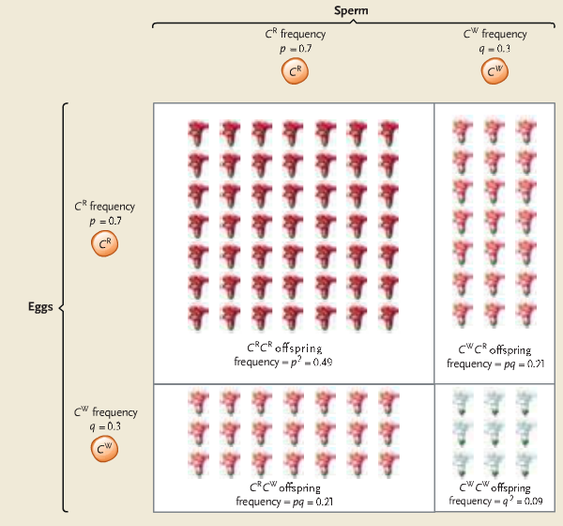
Assumptions of Hardy-Weinberg equilibrium
- Random mating in large populations
- Equilibrium allele frequencies
  - Traits don’t become blended therefore progressively diluted with each generation; remain in equilibrium
- Absence of gene flow into the population
- Genes have to be on separate chromosmes
- Has to be atleast two alleles

Lecture Outcomes:
conditions necessary for Hardy-Weinberg equilibrium
- large, random-mating populations
- Mutations are rare enough to be ignored
- Absence of immigration or emigration
- No selection operates on population genotypes and phenotypes have equal frequencies
- THEN we can use the allele frequencies to calculate genotype frequencies.
- F(A₁A₁)= p²
- F(A₁A₂) = 2pq
- F(A₂A₂) = q²

whether a population is in HWE, given observed genotype or phenotype frequencies
- Use observed phenotype or genotype frequencies to calculate allele frequencies.
- Use product rule to calculate expected genotype frequencies (under HWE)
- Compare observed vs expected genotype frequencies: is the population in HWE? (calculate expected using p, q)
- If population in HWE, then expected ratios of genotype
  - P² 2pq q²
- p≠q to be in HWE

Hardy-Weinberg is a “null” model
- to recognize evolution, we need to know what a non-evolving population looks like
- If genotype frequencies can be predicted from allele frequencies, population is in Hardy-Weinberg equilibrium (HWE) at this locus. Allele frequencies will not change while this is true; evolution is not happening
- If not in HWE, one or more assumptions of HWE are violated. The population may be evolving.
effect of selection on changes in allele frequency
- Not all genotypes have the same fitness
  - Eg. If black pigs were more susceptible to wolves, with time, their allele frequency will decrease
- If selection pressure is weak, evolution proceeds slowly
- If selection pressure is strong, evolution proceeds more quickly

relative vs absolute fitness
- For each genotype we can estimate (based on lifetime reproductive success, survival…) its
- Average absolute fitness (W): ratio between the number of individuals with that genotype after selection to those before selection. Calculated for a single generation
  - Eg. Units of offspring, or length of life
  - Must us same measure of absolute fitness for al genotypes
- Average relative fitness (w): average number of surviving progeny of a particular genotype compared with average number of surviving progeny of competing genotypes after a single generation
  - Allows to predict evolution

how to calculate relative fitness
- Fittest genotype has w=1
- All others have relative fitness w= W/W_{max} (between 0 and 1)

how to quantify strength of selection
- The greater the difference in w, the stronger the selection, the faster evolution will proceed
relationship between dominance/recessiveness of alleles and response to selection.
- Dominance/recessiveness in itself is not enough to change allele frequencies
- Dominance interacting with selection pressure can change allele frequencies
- Selection against a dominant allele can “weed out” entire genotype
- Selection against recessive allele can “hide” in genotype of dominant organisms
- Intro of new beneficial dominant allele; the frequency will never go to 1
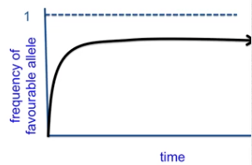
- Intro of new beneficial recessive allele; frequency can get to 1
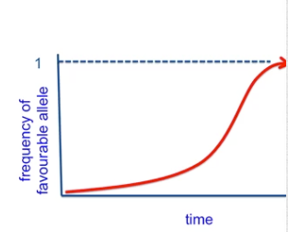

- Recessive allele over extended period of time can completely outcompete non-Favoured dominant allele.
- Hardly any genetic disorders associated with dominant alleles, most associated with recessive, because natural selection would automatically weed out dominant

effect of heterozygote advantage on genetic variation
- Both alleles are maintained in the population at equal frequencies
- Almost always you can say a population outside of HWE is evolving, however in the case of heterozygotes, allele frequencies not changing, but technically not in HWE
- Weird situation: selection, without evolution
why the amount of genetic variation in a population is important
- Genetic variation is the raw material for evolution and adaptation to environmental change
- Inbreeding depression: offspring of close relatives tend to have low fitness. Likely to get deleterious recessive alleles.
- Genetic variation in terms of the LONG TERM: evolution, and SHORT TERM: for success of individual

different types of selection (stabilizing, directional) and their effect on genetic variation
- Most traits exhibit quantitative distribution: individuals differ in small, incremental ways (i.e. body size)
- Qualitative variation: variation is two more discrete forms. Intermediates absent (gives rise to polymorphism)
- Stabilizing selection: mean values stays where it is, selection favours intermediate forms. (most common form of selection)
- Individuals of extreme phenotypes more likely to die
- Individuals in center of selection more likely to survive
- E.g. human birthrates
  - Extremely small, or large babies less likely to survive than babies with average mass

- Directional Selection: favours phenotypes on one end of spectrum. Shift in mean value of distribution.
- E.g. in birds, the males with long tales will be more successful in selecting a mate than those with average or small
- Selection will favour the males with the long tale eventually

Lecture 14: Selection vs. Other Evolutionary Forces
Independent Study Outcomes:
difference between Batesian and Mullerian mimicry/how the population frequency of a mimic phenotype may affect its fitness
- Batesian Mimicry: palatable species that mimic distasteful models are protected against predators.
  - Benefits the individual
  - More frequent mimic: less frequent model means greater chance of predator attack
  - Less frequent mimic: model, greater chance mimic is protected
- Mullerian Mimicry: mimicry between different species; enables predators to learn a single warning pattern that applies to all potential but distasteful prey.
  - Benefits both species
  - Rare warning patterns offer little protection; predator has little chance to learn distastefulness
  - Distinctive patterns offer greater protection at higher densities
why the same phenotype may be selected against in one environment but have a selective advantage in a different environment
- Spatial and temporal organization of environment may affect extent to which polymorphism is depended upon as adaptive strategy
- Coarse-grained environments: different individuals in population exposed to different experiences promotes greater genetic polymorphism
- Fine-grained environments: all individuals experience few environmental differences
- Industrial Melanism: change that occurred in industrial areas of England where air pollution darkened vegetation because of coal smoke deposits
  - Sooty areas gave rise to dark coloured (melanic) forms of moths
    - Dark adaptation allowed for protection from predators
  - Normal areas with normal grey lichens has light coloured moths
    - Non-melanic forms remained the same as they were already protected from predators
meaning of genetic load and genetic death
- Genetic load: extent to which a population departs from optimal genetic constitution.
  - Measure from 01
  - 0 represents optimal genotype; all deleterious alleles removed
  - Marked by the loss of some individuals through genetic death.
  - Genetic death can be expressed as sterility, inability to find a mate, or any means reducing reproductive ability

Lecture Outcomes:
effect of various types of selection on amount of variation in a population.
- Stabilizing selection (most common type of selection)Favours intermediate phenotype
- Directional selection (next most common) Favours phenotypes on one end of spectrum
- Disruptive Selection: involves a selection advantage to phenotypes on either end of the spectrum.

examples of stabilizing, directional, disruptive.
- Stabilizing: birth rate in humans
- Directional: fast running in cheetahs, long tail in bird
- Disruptive: Galapagos finches; no benefit to intermediate sized beaks. Advantage to long skinny beaks, and small beaks.
reasons why directional selection does not remove all genetic variation from a population.
- Paradox: why hasn’t directional selection already weeded out all genetic variation for traits related to fitness?
- Selection pressure varies over time and across habitats
- A phenotype with a selective advantage in one area may not have an advantage in another area
- e.g. Peppered moths: Industrial Melanism
  - pale coloured moths blended with lichen on trees
  - dark coloured moths blended better with soot covered trees (they had a selective advantage)
- Adaptation: a trait that increases the bearer’s fitness
  - Adaptations involve difference in relative fitness
  - Specifiv to particular environment
characteristics, and examples, of frequency dependent selection.
- Frequency Dependent Selection (Balancing Selection): when the fitness of the genotype depends on the frequency of the genotype in a population.
- Negative frequency-dependence: there is a selective advantage to being ‘rare’, rare individuals will have higher fitness
  - E.g. 1) predators form search images of prey. If predators hunt the most common prey type, the less common will have an advantage.
  - Eventually this will change the common phenotype, and the more rare form will become more common. Predators will then go after the rare form that is now the ‘common’ form
  - E.g. 2) Rare-male mating advantage
  - Maintains multiple alleles indefinitely (Balancing Selection)
- Positive Frequency-Dependence: there is a selective advantage to the most common phenotype
  - E.g. warning colouration in frogs: predators will have learned experience with coloured forms that are most common.
  - Most common alleles go into fixation, rare alleles are lost
reasons why all living things are not perfectly adapted to their environment.
- Limited by available genetic variation
  - Selection doesn’t necessarily chose the ‘perfect’ alleles, constrained by available alleles in the environment
- Plays catch-up after environment changes
  - Adaptation can be a generation behind
- Limited by dominance relationships
  - Deleterious recessive alleles may always be maintained in a population
- Trade-offs
  - Compromise between competing demands: allele may be helpful in one aspect, but can also be detrimental in another (sickle cell anemia)
effect of genetic drift on allele frequencies within a population, particularly in the case of bottlenecks etc.
- Selection drives adaptation, not only force driving evolution
- Genetic Drift: whenever population size less than infinite
  - Random, unpredictable changes in allele frequencies due to sampling error
    - Drift strongest in small populations, and populations suddenly becoming small (bottlenecks, founder events)
    - One allele goes to fixation, others are lost
    - Eg. Cheetahs went through bottleneck around 12,000 ya
  - Drift often opposes selection
    - Outcome depends on strength of selection, and population size
    - Small populations; drift outweighs selection, large populations; selection dominates
effect of genetic drift on variations between populations.
- How does drift affect variation within a population?
  - Tends to decrease variation in small populations
- How does drift affect variation (differences) among populations?
  - Increases differences between populations
mechanism that explain why mutation is NOT directed toward the needs of the organism.
- Mutation: is not “random”, but not directed towards the needs of the organisms either.
  - Eg. Reverse transcriptase mutation that enables HIV to resist AZT; this mutation is always occurring
  - Mutation will then increase in frequency due to selection
general fitness effects of mutations.
- Most mutations have neutral or nearly-neutral effects on fitness
- Mutation often opposes selection, but also provides raw material for adaptive evolution
why most mutations that affect fitness are harmful.
- Of those that affect fitness, most (but not all) are harmful
- More ways of ‘breaking something’, than making something ‘improved’
effect of gene flow on allele frequencies.
- Gene flow (migration) moves alleles between populations
  - Like mutation, can introduce new alleles to a population
- Like mutation, often opposes selection
  - Selection-migration balance: Interbreeding between populations that have adapted to different environments prevents local populations from becoming perfectly adapted to their local environment.
characteristics of adaptive vs. non-adaptive mechanisms affecting allele frequency.
Adaptive
- Selection is only force that causes adaptation
Non-adaptive
- Mutation, gene flow, genetic drift
**how various evolutionary forces reinforce or oppose one another.

Lecture 15: Why Evolution is true
Independent Study outcomes:
how Darwin's theory of evolution differed from that proposed by Lamarck
LAMARCK:
- Lamarack proposed that metaphysical “perfecting principle” caused organism to become better suited to their environments
- Principle of use and disuse: body parts grow in proportion to how much they are used.
  - Unused structures will eventually get weaker and shrink
  - E.g. giraffe grew longer neck so it could each leaves of trees
- Inheritance of Acquired Characteristics: changes that an animals acquires over its lifetime is inherited by its offspring.
  - Lamarack argued that long legged herons are descended from short legged ancestors that stretched their legs to stay dry while feeding in shallow water.
- BUT: today we know most structure don’t respond in the way Lamarck predicted
- He did say…
  - species change over time
  - changes are passed from one generation to the next
  - organisms change in response to environment
  - specific mechanisms cause evolutionary change
DARWIN:
- Natural selection: evolutionary process by which alleles that increases the likelihood of survival and the reproductive output of the individuals that carry them become more common in subsequent generations.
- Argued that all organisms that have ever lived arose through descent with modification; the evolutionary alteration and diversification of ancestral species
- New nothing about mendelian genetics
- Distinguishing characteristics of Darwin’s theory:
  - Darwin’s theory purely physical, not spiritual
  - Said evolutionary change occurred in groups not individuals
  - Evolution is multistage process
  - Evolution occurs because some organisms function better than others in particular environment
meaning of catastrophism, gradualism, uniformitarianism
- Gradualism: slow and continuous physical processes, acting over long periods of time, produced Earth’s major geological features.
- Catastrophism: theory that earth has been affected by sudden, violent events that were sometimes worldwide in scope.
  - Each fossil layer represents remains of organisms that had died in a local catastrophe, next layer respresent different set of fossils from another catastrophe
  - Contradicts gradualism
- Uniformitarianism: geological processes that sculpted earth’s surface over long periods of time (volcanic activity, eruptions, earthquakes etc.) are the same as processes observed today.
difference between relative versus absolute ages of rock formations and the fossils they contain
- Relative ages: fossils discovered at a particular stratum represent organisms that lived and died at roughly the same time in the past. The sequence of fossils from lowest (oldest) to highest (newest) reveals their relative ages.
  - Geological time scale provides relative dating system for sedimentary strata
- Actual ages: radiometric dating using isotopes can allow actual ages to be associated with different rock strata.
principle behind radiometric dating of rock strata
- Isotopes begin to decay from the moment they form
- Rocks containing isotopes can be dated when the amount of isotope can me measured and the rates of decay are known
- Limited by half-life of isotope
- Works best in volcanic rock; most fossils in sedimentary rock; scientists use radiometrically date volcanic rock from same strata
- If organic material still present amount of unstable ¹⁴C can be used to determine age

why most living things never form fossils
- Known fossils for less than 1% of world’s species that ever lived
- Fossils rarely form in habitats where sediments don’t accumulate (mountain foerests); or where there are acidic soils
- Fossils don’t last forever
- Fossils deformed from pressure of overlying rock
- Destroyed by geological processes (erosion) or disturbances
  - Erosion causes amount of older fossils to be fewer because they have been around longer

Lecture outcomes:
types of non-random mating
- But mating is often non-random
  - Inbreeding
  - Inbreeding avoidance
  - Assortative
    - E.g. mating in snow geese
      - White geese preferentially mate with white
      - Black geese preferentially mate with black

  - Dissasortative
    - E.g. Plumage dimorphism in white-throated sparrows
      - White striped more aggressive; good at protecting territory
      - Tan-striped are more parental in nature
      - White stripe always mates with tan-stripe
effect of non-random mating on HWE and on evolution
- Nonrandom mating perturbs HWE but doesn’t cause evolution.
  - If a population beings mating assortatively for a certain trait, but all genotypes have the same fitness, what will happen?
    - 2 alleles, 3 genotypes (AA, Aa, aa)
    - intermediate dominance; distinguishable phenotype
    - each genotype mates assortatively
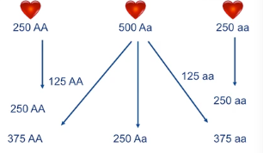

  - Population will become more and more homozygous from non-random mating (AA produces AA, aa produces aa and Aa, will produce some heterozygotes, some homozygotes)
  - Population is taken out of HWE, does NOT drive evolution; allele frequencies don’t change
characteristics of a scientific theory
- In the scientific sense: “a coherent set of testable hypotheses that attempt to explain facts about the natural world.”
  - Has to be testable and falsifiable
- Some scientific theories: Atomic theory of matter, germ theory of infectious disease, gravitational theory
- What do scientists mean by truth?
  - “An assertion for which there is so much evidence that it would be perverse to deny it.” ~SJ Gould
  - Theories ‘graduate’ to fact-hood after repeated testing fails to falsify them
  - Assertions that cannot possibly be falsified are not scientific (e.g. invisible spaghetti monster; cannot touch, feel, hear- this is not scientific because it is not falsifiable)

Components of the theory of evolution
- Evolution Happens:
- Change in allele frequencies in a population, between generations
- May happen as result of natural selection, random processes such as genetic drift (change in allele frequencies)
- Most evolution is gradual
- Evolution is not the result of “macromutations”
- Some evolution can occur quickly (HIV)
- This suggests that we should be able to link very ancient forms of organism to their modern forms via the fossil record.
- Speciation Happens
- At many points in evolution, lineage points diverge
- Without lineage life could have evolved but there would only be one ‘branch’ in the phylogeny of life
- All life is related through common ancestry
- For any two species we can trace back their ancestry and identify their most recent common ancestor (MRCA)
- LUCA is most recent common ancestor of all living organisms
- Much of evolutionary change is caused by selection
- Darwin was the first person to advance the idea of natural selection
- Evolution occurs in populations, not within individuals
- Populations change but individuals do not adjust in response to selection
- Evolution acts on variation that already exists in a population
- (See below) dark individuals are more ‘fit’
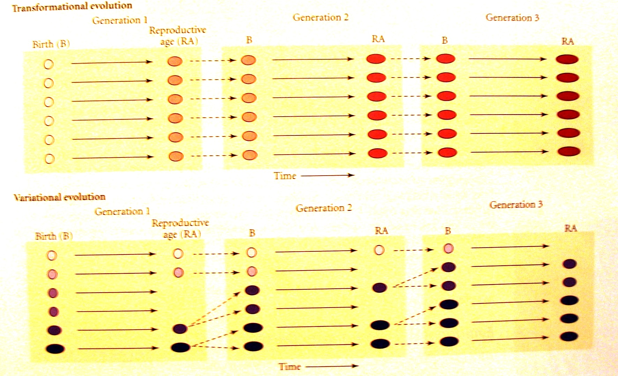
Variational (Darwin)
Transformational (Lamarck)
evidence for "descent with modification"
- Homologies
- Intermediates in fossil record; transitional forms
- Vestigial traits
- Earth must be old
- Fossil evidence that species change
- Fossil evidence that lineages split (speciate)
- Direct observation of evolution in real time
examples of homology and why they support the idea of evolution
- Homologies:
  - Defined as similarities between two species, not explainable by shared function, this reflects shared ancestry
  - Structural, development, molecular…
    - Molecular: genetic code
    - Structural: fins vs hands, vs wings in mammals (morphological)
    - Development: embryonic development-dolphin has hind-limb buds
  - E.g. every form of life on earth has a plasma membrane
examples of vestigial traits and why they support the idea of evolution
- Vestigial traits
  - Structures that may have had a functional purpose in ancestors
  - Vestigial traits only make sense in the context of evolution; predecessors needed these traits
  - Morphological vestigial traits:
    - e.g. dandelion.
    - It reproduces asexually, why waste energy on bright colour and producing pollen?
    - Likely it’s ancestor reproduced sexually.
  - Genetic vestigial traits:
    - “pseudo genes” (defunctional relatives of known genes, have lost protein coding ability); vestigial traits in a sense, they are descended from a fully functional gene
role of fossil record as evidence for evolution
- Intermediates in fossil record
  - Transitional Forms link related groups
  - e.g. feathered dinosaur shows that birds evolved from reptiles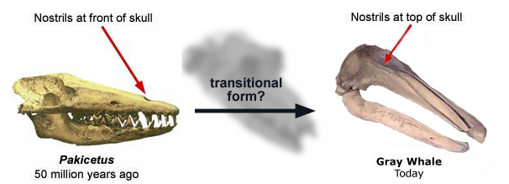
- fossil record shows organisms have been modified
  - e.g. evolution of the horse; shows change in size

Lecture 16: Why Sex?
Independent study outcomes:
Relationship between sexual reproduction and genetic variation
- Recombination or genetic exchange
  - Sections of chromosomes can exchange material (crossing over) thereby forming different linear arrays of nucelotides
  - Nucelotide sequences constitute genes, recombination provides different combinations of genes
  - Sex allows combination of beneficial mutations
- Unsure whether origination of sex and genetic recombination connected
- Prosposals of how sex originated;
  - Sex originated as way of overcoming DNA damage by using recombination DNA repair mechanism
  - Removal of deleterious alleles
  - Sex is advantageous in varying environments

Different modes of genetic sex determination
- Sex determination associated with chromosomal differences between two sexes
  - Human: Female (XX): Male (XY)
  - Nematode: Female (XX): Male (XO)
  - Birds & snakes: Female (ZW): Male (ZZ)
- Penis fencing in flatworms: sex depends on whether you are the first to pierce your opponent (mate) with your penis. First to do so is males, the other is female and invests resources in egg productions.
- Temperature dependent mechanisms: sex is determined by temperature at which eggs develop. (reptiles, alligators) Higher temperature determines maleness in some species.
- Fish that change sex as adults: tropical reef fish change sex during lifetime. Assumed to occur by hormonal changes.
- Compensatory Mechanisms in Chickens: females left ovary is functional, other is rudimentary. If functional ovary removed, rudimentary one may evolve into a testis, and ova testis (features from both sexes).

Different modes of environmental sex determination
- Bonellia:
  - free swimming larvae that settle on sea bottom form 10-20cm females
  - larvae that land on proboscis of female metamorphose form tiny 1-mm long males without digestive organs; live in genital ducts of female; only produce sperm
- Osedax:
  - Larvae that settle on bone devlop into females (as they have endoymbiotic basteria that help digest bone)
  - Larvae that settle on females becaome dwarf males
- Painted Turtles:
  - High temp egg incubation=males
  - Some species (as in the painted turtles) high temp egg incubation=females
- Social Fish
  - Loss of socially dominant male in school results in conversion of dominant female into male
  - Visual stimulation can trigger sex change (females become males when surrounded by small fish)
- Parasitoid Wasps:
  - Females deposit eggs that will develop into females into larger larvae
  - Eggs that will develop into males deposited into smaller larvae
- Warblers
  - Helper daughters increase parents reproductive success
  - When resources plentiful; high female: male ratio (6:1)
  - When resources scarce daughter compete for resources of offspring (1:3 ratio)
Meaning of haplodiploidy
- Hapolidiploidy: males develop from unfertilized eggs, so are haploid. Females develop from fertilized eggs and are diploid.
  - Facilitates evolution of sociality- females becomes queen and lays eggs (honeybees)
Meaning of hermaphrodite, and whether hermaphroditism is generally rare or common in plants
- Hermaphrodite: both male and female organs found within each individual
- Sex determination does not apply to most plants; 90% of seed plants produce both male and female gametes
- Minority of 5% of plant species with separate males and females has sex chromosomes

Lecture outcomes:
relationships among sexual reproduction, meiosis and genetic variability
- Recombinationgenerates and maintains genetic diversity (new combination of alleles)
  - Crossing over, Mendel’s independent assortment
  - Offspring are genetically distinct from either parent and each other (usually)
    - Exception; armadillo produces 4 genetically identical offspring
- Sex≠ reproduction

Mechanisms of asexual reproduction
- Reproduction without sex in bacteria- binary fission
- Sex “without” reproduction occurs in bacteria- genetic exchange through bacteria ‘penis’
- Plants and many other types of organisms produce asexually via
  - Vegetative propagation, every offspring is genetically identical to parent
  - Plants can also reproduce sexually- flowering plants have ‘gametes’
  - Facultatively sexual: can reproduce sexually, or asexually (aspen tree)
  - Obligately asexual: organisms that can only reproduce asexually (e.g. amazon molly: asexually reproduce eggs, but zygote must be in close proximity to sperm to grow)
Examples and predictions of size-advantage model of sex change
- Dioecious: male and female sex functions housed in different individuals. Every organism is either male or female, not both.
  - Humans
  - Ash trees, some other plants
  - More rare for plants
- Monoecious: every individual has both male and female sex functions. (Hermaphrodite)
  - e.g. roses have anthers and stamens- produce pollen & ovules (simultaneously monoescious)
  - Sequential monoecy: species that change sex at some point in their lives.
    - Common in coral reef fish; once the species reach a threshold size they become male, or male to female (clownfish))
- Body size affects reproductive success
- organisms should be born as the sex with the highest fitness payoff at a certain body size.
- Protandry: smaller males more fit; larger females more fit.
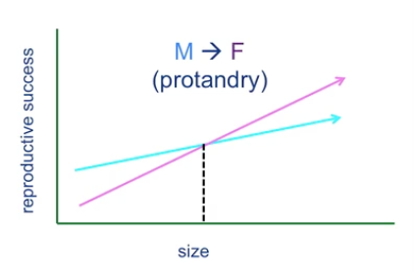
distribution of sexual reproduction among all life forms, and particularly among animals
- First life forms almost certainly reproduced asexually
  - Most things, except plants and animals, reproduce mostly asexually
  - May have been HGT, but reproduction wasn’t sexual
- Asexual= ancestral, sexual=derived
- Among animals, vast majority of reproduction involves sex

costs of sexual reproduction
- Cost of mating;
  - Exposed to dangerous elements in environment
  - Susceptible to predators
  - Risk of rejection
  - Contraction of disease
cost of meiosis
- Cost of meiosis:
  - only passing on 50% of genotype to each offspring
cost of sons
- Cost of males:
  - Only females contribute to growth of population
  - In asexual: only daughters produce next generation, asexual females should outcompete sexual females
"Muller's Ratchet" mutational load explanation for advantage of sexual reproduction
- Mutation explanation for sex:
  - Sexual recombination benefits the species by speeding up evolution
    - Discarding harmful deleterious mutations
    - Combining beneficial mutations
  - But sex decreases the likelihood of extinction
  - These are all fundamentally slow processes

- Muller’s Ratchet: asexual lineages accumulate harmful mutations, sex “breaks” ratchet
  - No way to get rid of harmful mutations in asexual reproduction with enough deleterious mutations could potentially go extinct
  - Sex “breaks’ ratchet so offspring could potentially have fewer mutations than parents
  - Sex doesn’t increase average fitness; increases variation in offspring
"Ruby in the Rubbish" hypothesis explanation for advantage of sexual reproduction
- Sex continually creates genotypes with fewer (and more) harmful mutation than parental genotypes
- Individuals with lots of mutations ‘weeded out’
combination of beneficial mutations for advantage of sexual reproduction
- Sexual reproduction speeds rate of combination of helpful mutations
- Drives faster evolution generally; species level benefit
- Beneficial mutations can quickly be found in the same individual under sexual reproduction
- Asexually: it will take much longer for an individual to get all three helpful mutations
  - If three asexual organisms have different beneficial trait; they are essentially competing; one mutation becomes fixed first

relationship between extinction rate and sexual reproduction
- On average; sex reduces risk of extinction
- Sexual reproducing animals outlast asexual populations
- Asexual lineages are very rare and very young; asexually has evolved at other times in the past and gone extinct
- BUT: traits do not spread “for the good of the species”
- Selection does not favour traits that benefit long-term persistence of ‘the group’ at the expense of immediate individual fitness.’
- Selection doesn’t anticipate the future

Lecture 17: Sexual Selection
Independent Study Outcomes:
Meaning of monogamy, polygamy, polygyny, polyandry, promiscuity, lek
- Monogamy: male and female form a pair bond for a mating season, or life.
- Polygamy: pattern of mating in which an animal has more than one mate of the opposite sex.
- Types of Polygamy:
  - Polygyny: one male has active pair bonds with more than one female. Males contribute nothing but sperm.
  - Polyandry: Females has active pair bonds with more than one male. Females contribute nothing but eggs.
- Promiscuity: males and females have no pair bonds beyond the time it takes to mate.
- Leks: congregations of displaying males, where females come only to mate . Each male has his own small territory
Conditions favouring the evolution of monogamous versus polygynous mating systems
- Monogamous:
  - When young require great deal of care
  - Higher rates of reproduction when both parents actively involved
- Polygynous:
  - If males have high-quality territories; females living there may be able to raise young on their own
  - Role is sperm donor and protector of space; not active parent to young
Handicap explanation for why females prefer males with extravagant ornaments
- Ornaments indicate health
- Ornaments indicate that he can harvest resources efficiently, has managed to survive to advanced age
- Large showy males may have large, rich territories
- Extravagance= male quality and reflects good genetic makeup
- Females want successful alleles for offspring
Meaning of sexual dimorphism, intersexual selection, intrasexual selection
- Sexual Dimorphism: differences in the size or appearance of males and females due to sexual selection.
  - When males compete for females often larger, more extravagant
  - When females compete for males opposite occurs.
- Intersexual selection: selection based on interactions between males and females
  - Explains extravagant structure of males because females find them more desireable
- Intrasexual selection: selection based on the interactions between members of the same sex.
  - Males use large body size, antler, tusks to injure, or kill rivals

Lecture Outcomes:
“lottery ticket hypothesis” and “red queen hypothesis” to describe the relationship
between environmental stability and benefits of sexual vs. asexual reproduction
- Ecological explanations for persistence of sex
  - Operate on shorter term
  - View sex as adaptation that can benefit the individual.
- Lottery Ticket Hypothesis:
  - environment is stable and predictable: should reproduce asexually
  - environment unpredictable: should reproduce sexually
    - Optimizing chances that some offspring will survive

- Red-Queen hypothesis: sex is favoured when your environment (natural enemies) is continually evolving
    - The greater the selection pressure from parasites in the environment, the greater the advantage of reproducing sexually
    - Benefit to rapidly producing different genotypes

long-term vs. short term advantages to sexual vs. asexual reproduction
- Long term advantages:
  - Removing harmful mutations, and combining helpful mutations
  - Benefits species
- Short-term advantages
  - Bet-hedging in a changing environment
  - Lottery hypothesis, Red queen hypothesis
- Which is more important to maintaining sex?
  - Short term benefits (ecological models)
  - Reduced extinction risk may just be a consequence of sex, not a causal force
why sex places different selective forces on males vs. females
- Sexual selection: Explains sexual dimorphism (males have more extravagant physical features)

relationship between sexual selection and investment in offspring
- When female invests more, she is choosy drives sexual dimorphism
role of parasites as an explanation for the persistence of sexual reproduction
- The greater the selection pressure from parasites in the environment, the greater the advantage of reproducing sexually
- Benefit to rapidly producing different genotypes

how sexual selection maintains traits seemingly incompatible with natural selection
- Explains traits that reduce survival
  - E.g. loud male frog call, he is not only attracting females, but predators
examples of traits favoured by intra vs. inter sexual selection
- Intersexual selection: one sex (normally female) choses from the males based on various features.
  - large tail feathers in peacocks
- Intrasexual selection: competition amongst males for access to females
- Distinction between female choice and competition can be ‘blurry’.
  - big horns in mountain goats
- Both intersexual and intrasexual selection can operate simultaneously:
  - E.g. Bower birds- female birds attracted to colour blue, hate colour red (intersexual) , but also, males will sneak into each others “bower” and sabotage to make the bower unattractive (intrasexual selection)

why males are more usually competing for access to females (rather than vice versa)
- For most animals, males maximize fitness by mating with more females (offspring quantity)
- Females are limited in number of offspring they can produce, therefore mating with many males does not maximize fitness (offspring quality)

relationship between parental investment and which sex is choosy vs. competing
- Direct Benefits:
- Males provide material resources to females & offspring
- Females can get a clue of how fit the male is by their appearance
  - E.g. house finch: males that are brighter red are better fathers.

- Indirect (genetic) benefits?
- Mating with best quality of males in population (best calls, longer tail feathers in peacock), produces best genetic quality in offspring
- Females don’t get material resources from males, but can still benefit through these indirect benefits

- Anisogamy= unequal gamete size
  - Eggs are metabolically expensive to produce, whereas sperm are “cheap”
- Generally females invest more in gestation and parental care
- “Sex differences in parental investment and potential fitness determine which sex is choosy, and which sex competes”

what happens (in terms of sexual selection) when both sexes invest heavily in offspring
- Offspring are very demanding to raise; both sexes must invest a lot into care of offspring (monogamous)
- In humans, sexual selection occurs in both sexes
- Both sexes are ‘choosy’ in seeking long-term partners
Jealousy
- In long term romantic relationship:
  - Males more upset if cheated on sexually
  - Females more upset if cheated on emotionally

average vs potential fitness of males vs females
Selective forces on males & females:
- What determines fitness of a male, vs. fitness of a female?
- Which sex as higher POTENTIAL fitness?
  - In the vast majority of animals, males have higher potential fitness; they invest less in each offspring and compete more for access to females
    - Moulay Ismael: had 888 children
    - Wife of Vassilyev: 69 children
- Which sex has higher AVERAGE fitness?
  - Assuming 50/50 sex ratio, average fitness of males and females is the same
  - More variation around average for males
- Male Pickiness:
- E.g. In red phalaropes, and sea horses the high investing sex is the male, and females must compete for mates
- Rare situation, but does occur

limiting factors on male vs. female fitness
- Males invest less in each offspring, compete more for female access
  - Focus on offspring quantity
- Females invest more in offspring, restricted by gestation period
  - Focus on offspring quality

traits valued in mate choice by human males vs. females
- Facial symmetry: indicates resilience to various stressors in early development. More symmetrical faces generally means the person is healthier.
- In societies with many parasites, symmetry is more important than it is towards the north or south where there are fewer parasites
- Symmetry indicates high developmental stability
- Females place importance on:
  - athletic ability (leads to direction benefits such as protection)
  - kindness to children
  - resource holding potential (wealth)
- Males place importance on:
  - youth, fertility, health
  - Facial attractiveness (full lips, large eyes)
  - Waist to hip ratio
  - Indicates circulating estrogen

Lecture 18: Cooperation and Conflict
Independent Study Outcomes:
identify the meanings of kin selection, altruism, reciprocal altruism, eusocial
- Kin Selection: individuals should be more likely to help close relatives because increasing a close relative’s fitness means that the individual is helping to propagate some of its own alleles.
  - E.g grey wolf help rear four pups (they each share 0.5 of his genes)
  - 0.5x4=2 copies of shared alleles
  - If he had reproduced two offspring instead, 0.5x2=1 copy of allele
  - This is NOT altruism
- Altruism involves doing something that enhances the situation of another individual.
- Reciprocal Altruism: individuals will help nonrelatives if they are likely to return the favor in the future. Each member of partnership can potentially benefit.
  - This is favored so long as non-reciprocating individuals are denied future aid
  - Longer lived species more likely to develop cooperative behaviour than shorter-lived ones
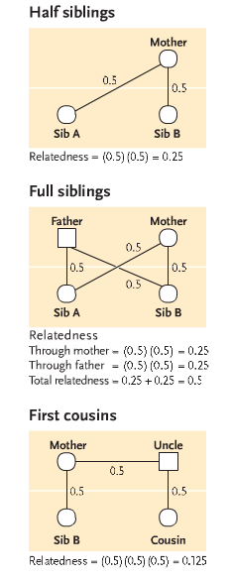
- Eusoical(insects): numerous genetically related individuals (a large percentage of them sterile female workers) live and work together in a colony for the reproductive benefit of a single queen and her mate.
calculate degree of relatedness between two individuals, given the type of relationship (parent-offspring, cousins, etc)
identify why haplodiploidy can favour high levels of cooperation in social insects
- In bees, haploidiploidy determines sex
  - Females diploid : 2 sets of chromosomes (one from each parent)
  - Males haploid: hatch from unfertilized egg.
- When reproducing, offspring all receive same allele from drone, may receive different allele from queen
- Offspring 50% related by allele received from drone
- Offspring 25% related through queen
- On average, workers 75% related
- High degree of relatedness may explain exceptional level of cooperation
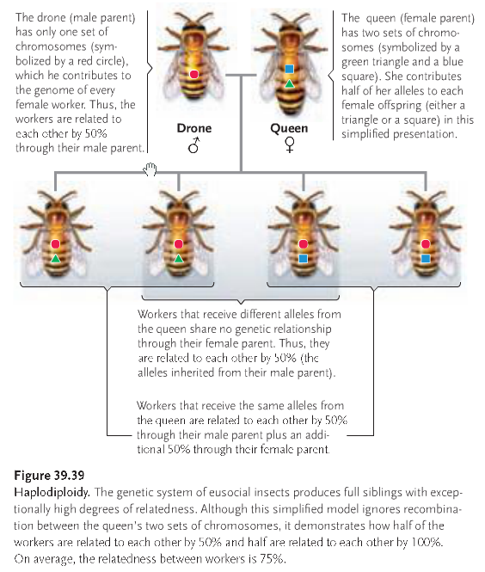
Lecture Outcomes:
examples of different types of social interaction
- Sexual selection is struggle for existence between individuals
- Group living, cooperation is taxonomically everywhere (from wolves, amoeba, schooling fish)
- Cooperation widespread, group living even more widespread
behaviours that are, or are not, "altruistic"
 | Actor benefits | Actor is harmed
Recipient benefits | Cooperation | Altruism
Recipient is harmed | Selfishness | Spite
- Cooperation: “win-win” situation, two individuals interact and both benefit
- Spite: actor and recipient are harmed
  - Very rare phenomenon, almost never happens
- Selfishness: Actor benefits, recipient harmed.
- Altruism: Actor’s fitness is reduced, but the recipient receives some benefit
  - Darwin said: Altruism is a “special difficulty, which at first appeared to me insuperable, and actually fatal to my whole theory.”
- Providing care to own direct descendants is self sacrifice, but NOT altruism
  - Fundamentally selfish, fitness benefit to parent
- Traditional explanation: sacrificing individual for the good of the group
  - Problem: highly altruistic groups are very vulnerable to the selfishness of other individuals
  - Not a good explanation
how kin selection theory explains selection for altruistic traits
- Kin selection: favours traits that increase indirect fitness
  - Explanation for behaviour of female calling in ground squirrel population
  - Despite cots to her direct fitness, there is payoff to indirect fitness

direct vs. indirect vs. inclusive fitness
- Personal reproduction direct fitness
- Additional reproduction by relatives, due to your ‘altruism’ indirect fitness
- Direct + indirect fitness= inclusive fitness
  - Offspring produced on own + offspring produced by close kin

Hamilton’s Rule determine whether altruistic (costly) traits favoured:
- rb>c
- Benefits received by donor’s relatives, b
- Weighted by degree of relationship, r
  - (0.5 to sibling, 0.25 to half-sibling, .125 to cousin etc.)
- Is r x b greater than cost to donor’s direct fitness (c)?
- when rb>c, the benefits of indirect fitness outweigh costs to donor’s direct fitness
reasons why cooperation can evolve in face of prisoners' dilemma
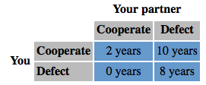
- Prisoner’s Dilemma: Gain Theory
- Each player can either
  - cooperate with partner (stay silent)
  - defect on partner (implicate them in the crime)
- Payoff depends on partner’s choice as well as your own

Prisoner’s Dilemma: Defecting is always rational choice
- But payoff for mutual defection is worse than payoff for mutual cooperation
- Both players would be better off it they could trust each other
- So how can cooperation evolve?

Solution for Prisoner’s Dilemma: Repeated interactions between individuals
- Selection can favour ‘altruism’ if it’s later reciprocated
- Reciprocal Altruism Most likely when…
  - groups are small and stable
  - individuals can recognize and remember helpers and cheaters (many primate social groups, humans)

role of human emotions in support of reciprocal altruism
- Human emotions (trust, resentments, guilt, gratitude) are adaptation for score-keeping of reciprocal altruism
conflicting interests of parents vs. offspring
- Inclusive fitness explains self-sacrificing behaviour but… explains conflict between relatives
- Parent-offspring conflict
- The longer a parent provides care to an individual offspring.
  - Benefits to P and O through increased offspring fitness… but can lead to diminishing returns
    - E.g. if give a newborn baby too much milk, baby isn’t happier than if they receive normal amount
  - Costs to P and O when parent provides care
    - Lost oppourtunity for P to produce offspring
    - Fewer resources for sibling of offspring
Relatives have overlapping, but not identical genetic interests
- P is equally related to all offspring, so ‘should’ cut O loose once b<c
  - Once oppourtunity costs outweigh benefits
- O is twice as related to itself as to siblings, so ‘should’ demand care until b<2c then become independent
  - Once costs are twice as high as benefits

Lecture 19: Speciation
Independent Study Outcomes:
identify the differences between morphological, biological and evolutionary species concepts
identify strengths and limitations of each of the above three species concepts
- Morphological Species concept: using morphology to identify species
  - A morphological species is a population of individuals that share more characters (features) with one another than they do with any other organism
  - Comparative anatomy: studying comparative relationships among anatomical structures in adults of different species
    - Differences represent divergent evolutionary pathways
  - Comparative embryology: study of comparative relationships among anatomical structures in embryos of different species
- Biological Species Concept: concerned with species as reproductive and genetically isolated entities
  - Biological species is sexually interbreeding group of individuals normally separated from other groups by reproductive barriers
  - Inability to interbreed indicates population is biological species
- Strengths:
  - Allows distinction between sibling species: species that look alike but can’t reproduce
  - Allows unification of polytpic species: a species with two or more subspecies that normally don’t interbreed because of geographic separation, but create narrow hybridization zone.
- Drawbacks:
  - Cannot determine whether fossils can interbreed
  - Does not apply to animals that asexually reproduce
  - Species that have long been isolated geographically may still be able to interbreed if brought into contact

- These two concepts give rise to…
- Phylogenetic Species Concept: ancestor-descendant relationships rather than reproductive isolation define a phylogenetic species.
  - Phylogenetic species is monophyletic group composed of the “smallest diagnosable cluster of individual organism within which there is a parental pattern of ancestry and descent.

- Evolutionary Species Concept: examining species as evolutionary lineages
  - An evolutionary species is a lineage (ancestor-descendent sequences of populations) evolving separately from others and with its own unitary evolutionary role and tendencies
- Strength:
  - Looks at change over time
  - Relationships between individuals derive from shared history, which rarely results in all individuals of a species being identical (this is where morphology falls apart)
- Drawback:
  - Defining age of separation is subjective

Lecture Outcomes:
why conflicts of interest can arise even between closely related individuals
Parent-offspring conflict before birth:
- Fetus selected to ‘demand’ more resources from mother than mother selected to give
- In mother’s best interest to invest equally to all offspring
  - Fetal tissue in placenta secrete allocrine hormones to manipulate maternal blood pressure and blood sugar; maternal sensitivity to these signals drop
  - Fetus is attempting to get more resources than the mother can provide
  - In response to allocrine hormones mother’s insulin level and insulin sensitivity drop
  - Conflict of interest is responsible for risk associated in pregnancy in mammals
    - If fetus is ‘winning’ tug-of-war, mother’s blood sugar levels will rise to extremely high levels
Why rational decisions by individuals can lead to the overexploitation of shared resources (tragedy of the commons)
Unrelated individuals may have similar, but not overlapping, interests
- Tragedy of commons: social dilemma(conflict) over use of shared resources
  - 10 farmers each own their own cows, but all share “the commons”
  - As more cows are added, cost of overgrazing shared by all the farmers
  - Benefits of owning another cow are not shared amongst group
  - Rational decisions by individuals (adding cow) overexploitation of shared resource
  - Costs of overgrazing shared amongst group, benefits not

Summary: Cooperation and Conflict
- Altruism, like sex is puzzling
- Many ‘altruistic’ traits can be explained by shared genetic interests; others by reciprocity; but rational decisions by individuals may deplete shared resources
- Even when genetic interests overlap (family groups) they can be different enough to induce conflict
  - Sharing alleles with someone is not always enough to avoid conflict of interest

-applications of, and strengths and weaknesses of, biological vs morphological species concepts (which species concept is being used, given ‘real world’ examples)
1. Morphological Species concept:
- Categorizes species as a cluster of individuals who look more similar to each other, compared to another cluster
- Looking at the phenotype of the individual to distinguish; colour, size, markings etc.
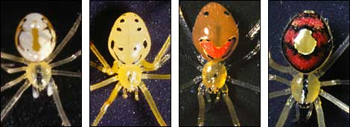
- (clear difference between above 4 individuals, but all are capable of mating with one another)
- easy concept to use in the ‘field’
Weakness of Concept:
- run into problem with sexual dimorphism: although the males and females look very different they are still the same species

2. Biological Species concept:
- Species; interbreeding (or potentially interbreeding) group of individuals, reproductively isolated form other such groups
- would say all the spiders are members of the same species because they are capable of interbreeding with one another
- Reproductive isolation is key factor in this model
- While lions and tigers can produce a hybrid offspring, their offspring is sterile, therefore they are still members of different species
Weakness to Concept:
- Geographic isolation: when individuals don’t occupy the same geographic area cannot determine if they will procreate
- Cannot apply this concept to fossil species (species that are extinct)
- Only applies to organisms that reproduce sexually in asexual reproduction there is not interbreeding

-which type of isolating mechanism is occurring, given ‘real world’ examples
Prezygotic isolating mechanisms
- Temporal isolation: differences in timing of breeding lead to isolation
- Habitat isolation: some individuals breed in different habitats, can be isolated by this.
- Courtship isolation: mating displays of one population may not be attractive to female in another population
- Mechanical isolation: isolation due to incompatibility of reproductive structures
(difference in copulation structures)

Postzygotic isolating mechanisms:
- Hybrid Inviability: hybrid offspring dies before born, or before it reaches adulthood.
  - more costly; female invests in offspring and then it dies
- Hybrid sterility: offspring can reach adulthood but are sterile. (horse with donkey)
-why coming into secondary contact is not required for speciation to occur, but can promote prezygotic isolation
Populations may come back into (secondary) contact
- If little divergence has happened, resume interbreeding (hybrid swarm)
- But, populations may have become reproductively isolated
  - Prezygotic isolation:
    - Evolved differences in courtship, etc.
  - Postzygotic isolation:
  - Unfit hybrids
    - Reinforcement: Directs selection favouring prezygotic isolating mechanisms because postzygotic costly
  - Uncertain whether post zygotic or prezygotic isolation usually happens first

-why most speciation occurs in allopatry (ie why parapatric and sympatric speciation are rare)
Most speciation occurs in allopatry (separate geographical ranges)
- Stages:
- Geographic isolation prevents physical gene flow between two locations (barrier)
- Populations diverge (different selection pressures, genetic drift)
- Secondary contact, if it occurs may either reinforce reproductive isolation or re-establish gene flow
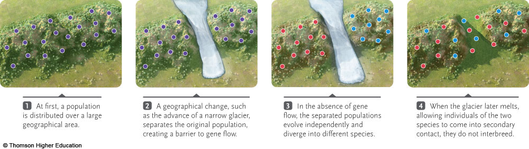
Types of allopatric speciation
Allopatric: classic glacier model- population essentially isolates into two separate populations.
Peripatric: small group of individuals separates off from larger. (Mainland population, and smaller island population) rare
Parapatric: ‘leaky barrier’, there can still be gene flow across the barrier and less likely to result in true speciation. It can still happen, but there would have to be very strong selection pressures on each side. Very rare

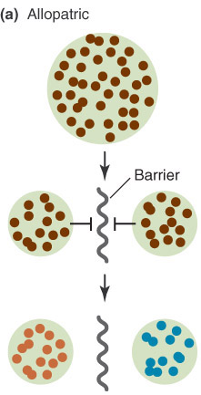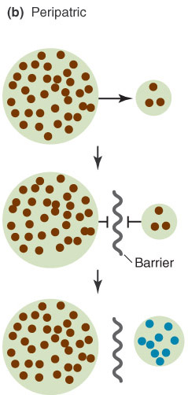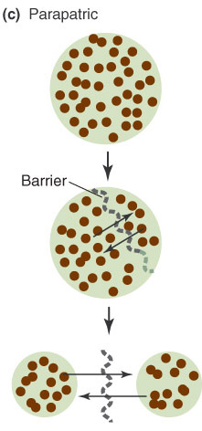

-role of islands in speciation
- Galapogos: 13 species of Darwin’s finches
- Islands are geographically isolated
- different selection pressures on the islands, or on island vs mainland
- Genetic drift is sped up in small populations
-how polyploidy can induce sympatric speciation
- Sympatric speciation; causes reproductive isolation even when populations are living in close proximity
- Polypoidy ‘instant’ sympatric speciation
  - Accidentally producing diploid gametes, triploid offspring will be reproductively isolated
sympatric speciation
- Adaptation to a new food type can sympatric speciation (new ecological niche)
  - Hawthorn tree maggot introduced to N.A.
  - Subset of maggots began feeding (and mating) only on apples
- One species mates only on Hawthorn, one only on apple
- Currently in process of speciating
- Competition, disruptive selection promote assortative mating sympatric speciation
  - Stickleback species pair
  - Each lake has a benthic and limnetic form
  - Closely related but no longer interbreed, disruptive selection as led to sympatric speciation; no benefit to intermediate niche
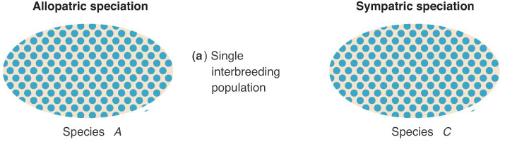
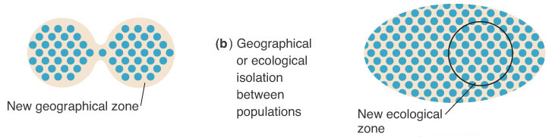
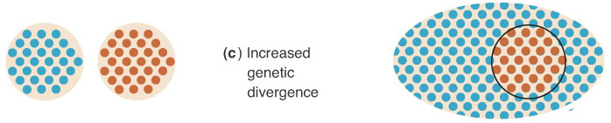
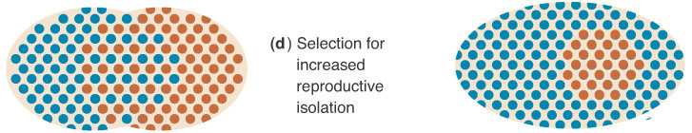
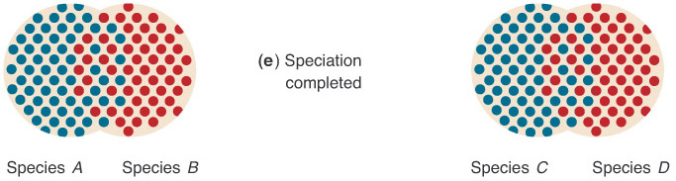

Lecture 20: Phylogeny
Independent Study Outcomes:
the meaning of systematics, phylogeny, phylogenetic tree, classification, taxon, taxonomic hierarchy
- Systematics biology: branch of biology that studies the diversity of life and its evolutionary relationships.
- Phylogeny: evolutionary history of group or organism.
- Phylogenetic tree: branching diagram depicting evolutionary relationships of groups of organisms.
- Classification: arrangement of organisms into hierarhcial groups that reflect their relatedness.
- Taxon: name designating a group of organisms included within a category of the Linnaean taxonomic hierarchy.
- Taxonomic Hierarchy: system of classification based on arranging organisms into even more inclusive categories.

why similarities in morphology or lifestyle do not necessarily reflect close relatedness, using examples
- Convergent Evolution: tendency among organisms living in similar environments to develop similar body forms. (parallel evolution refers to more closely related organism)
  - E.g. fugus that looks like a flower and emites flower odour
  - Carnivorous plants appeared in five evolutionary lines-not all share common ancestor
  - Looking at a mammals tail (may give different picture or relationships than looking at skull
    - i.e. the N.A. beaver has much different skull structure than Mesozoic beaver
the two major goals of systematics
- reconstruct phylogeny or evolutionary history of group of organisms
- taxonomy: identifying and naming species and their placement in classification

principles underlying the Linnaean system of classification (species, family etc) and which groupings include which other groupings
- (Domainkindgomphylumclassorderfamilygenusspecies)
- Organisms included within any category of taxonomic hierarchy make up taxon
  - E.g. woodpeckers are a taxon at the family level

Lecture Outcomes:
correct interpretation of evolutionary trees, close and distant relatives, and where extinct taxa would be placed in a tree

Phylogenetic Trees
- Branching points of the tree are nodes, leaves represent species
Reading Phylogenetic Trees:
- Different ways to represent phylogeny; diagonal, vs horizontal etc.
Time passes from root (base) to tips
- To determine relation of two organism, much know which way time is passing
- There are no scale bars on phylogeny, infer relative passage of time, not absolute
- D/E and C/F splits did not necessarily happen at the same time (see diagram below)
Various Representations Passage of Time from Root to Tips
Of Same Phylogeny
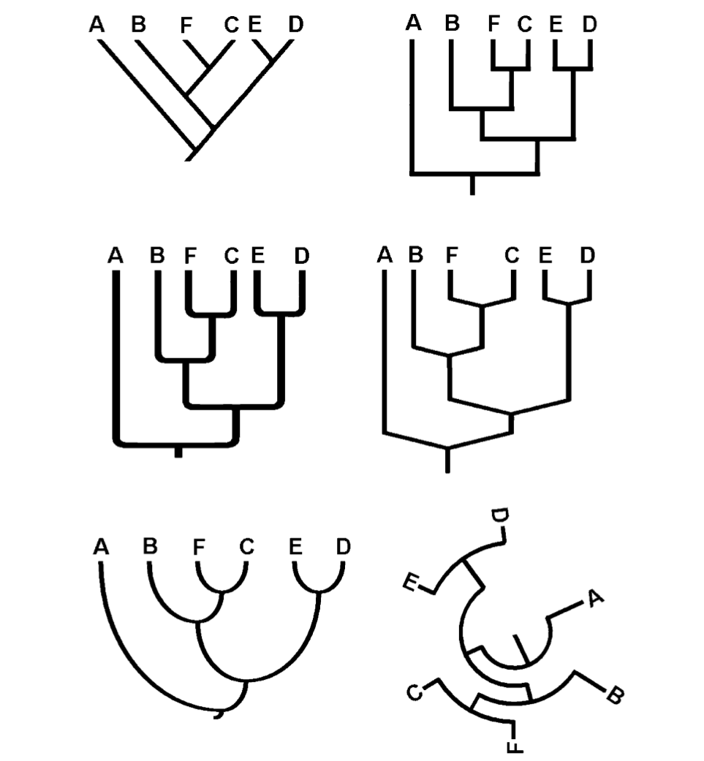
- Some phylogenies have scale bar present, can infer absolute ages of branching events
- Can use DNA sequence info to calibrate amount of change between lineages

principles of phylogenetics
Rotating nodes change nothing
- Relative order of branching is still preserved
Higher and lower life forms? Highly evolved and less highly evolved?
- Diagram a Indicates that humans are the highest evolved species; nonsense
- Phylogeny b below is valid, humans are not the most ‘highly evolved’ form of life
  - Just a rotation of the node
Which group is the most highly evolved?
- Because everything is descended from the same common ancestor, everything has been evolving for the same amount of time
- Don’t simply pay attention to tips of phylogeny, concentrate on internal branching order
- Read nodes; focus on recency of common ancestor
  - More recent common ancestor indicates closer relation

Phylogenies are like pedigrees
- Who is more closely related to your cousins; you or your sibling?
  - Both equally closely related
- Which is more closely related to species K? (Y, S, or both)
  - Both are equally closely related

homology vs. misleading similarities due to convergence of unrelated taxa or misleading
- Linnaeus based on similarity; the more traits to groups have in common, the more likely they shared a common ancestor
- Homology: similarity that reflect recent common ancestry
  - Based on homology, pig, dolphin, bat have close relation
  - 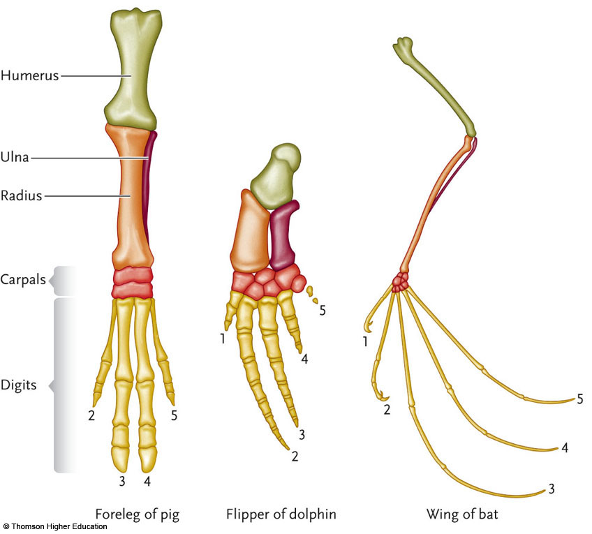
- Homoplasy: misleading similarity OR misleading dissimilarity
  - Convergent evolution can cause homoplasy; organisms adapted to similar environments appear to have similar traits
    - E.g. 1) crocodiles and hippos have similar eye placement but are not closely related
  - Divergent evolution can cause homoplasy; individuals within a species have adapted to different selection pressures to make them appear as unrelated
    - E.g 2) finches of the Galapagos islands- developed different traits due to selection pressures
- Homologous lead to correct phylogeny; homoplasious mislead

differences due to divergences among closely related taxa, and examples of each
synapomorphies, symplesiomorphies and autapomorphies on a phylogenetic tree
- Sometimes we can infer traits are due to homology from
  - structure or development or genes
- Another solution: cladistics
  - Only some similarities are informative, should only base phylogeny on synapomorphy
- Synapomorphy= shared traits that are derived
  - Shared by two or more groups
  - derived (from common ancsetor)
- Synmpesiomorphy=shared traits that are ancestral
  - Shared by two or more groups
  - Ancestral (trait was also already present before the groups diverged)
- Autapomorphy:=derived traits, not shared
  - Unique to a single group
  - Derived within the group

the significance of outgroup analysis
- How can we know what traits the common ancestor of the group had?
- Find an outgroup:close relative known to have branched off earlier than any of the groups of interest
  - E.g. butterflies
    - Caddis fly is not butterfly at all (six legs) , orange palm has six, monarch has four legs (derived form)
    - Six legs is ancestral state, four legs is derived

Lecture 21: Phylogeny
Independent Study Outcomes:
What happened to the dinosaurs?
- Extinct after Late Cretaceous Period (65 mya) from impact of asteroid
- Inability to cope with changing environment or competitive challenges explain extinciton
- More than half of all reptile species became extinct
- Stem mammals survived opening up niches vacated by dinosaurs
- Avian reptiles (birds) survived, appearing independently in two lineages

relative severity of the end-Cretaceous mass extinction, compared to other mass extinction events
Extinction Period | Date(mya) | %extinciton marine species
Late Ordovician | 440 | 85
Late Devonian | 365 | 82
Later Permian | 245 | 96
Late Triassic | 208 | 76
Late Cretaceous | 65 | 76
meaning of orthogenesis
- Orthogenesis: concept that evolution proceeds in a particular direction because of internal or vitalistic causes.
  - Like individuals are born, grow old and die, species may die from internal factors
  - i.e. 3.3m wide antlers of Irish elk to be cause of its senescence and extinction
  - NOT LIKELY EXPLANATION FOR DINOSAURS

factors that enabled mammals to diversify after the end-Cretaceous mass extinction
- Extinction allowed mammals to invade niches previously occupied by dinosaurs
- Breakup of Pangaea stimulus for mammalian radiation; led to evolving connections and separations that facilitated dispersal and/or isolation of major mammalian groups:
  - Uplifting mountains
  - Submersions and regressions of shallow seas
  - Delineation of new shorelines
- Shaping of new habitats from changes in vegetation
evidence supporting the collision theory regarding the end-Cretaceous mass extinction
- Collision Theory: mass extinction of Late Cretaceous era is due to collision of an asteroid with Earth.
  - Impact threw large number of particles into atmosphere
  - Dust cloud hindered photosynthesis food chain collapsed
  - Heat generated from asteroid entering atmosphere cause forest fires.
- Evidence:
  - Iridium (rare earth elements found in asteroids and meteorites) found in strata marking the Cretaceous-teritiary boundary
  - Some evolutionary biologists propose combination of extraterrestrial and stressful environments (both gradual and catastrophic explanation)
    - Small body size and efficient control of body temp may have been crucial to survival
    - Say dinosaur extinction may have taken millions of years

Lecture Outcomes:
whether a particular trait is probably ancestral or derived, given a phylogeny and a suitable outgroup
whether or not a particular trait is a synapomorphy, given its distribution among the outgroup and the ingroup
Is a trait ancestral or derived?
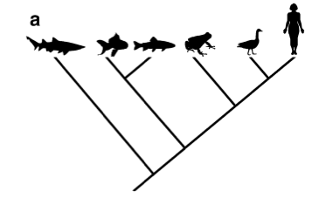
- Shark is the out-group species in this phylogeny
- trait is present in outgroup and all of group
  - The trait is ancestral; trait could evolve independently each time, but very unlikely
- Trait is in out-group and SOME of in-group?
  - Likely ancestral
- Trait absent in out-group, present in SOME of in-group?
  - Trait is likely derived
- Present in out-group, but NONE of in-group?
  - Cannot tell whether the trait is ancestral or derived
  - There are two equally likely possibilities; trait could have been derived, or ancestral
  - Bot instance involve one evolutionary step
- Absent in out-group, present in ALL of in-group?
  - Cannot tell whether the trait is ancestral or derived

why similarity does not always imply relatedness
- “Related to” ≠ descended from
  - Related to cousins, but not descended from any of them
- More complex≠ “more evolved”
- relatedness≠ similarity
  - convergence
  - not all similarities are homologies
  - not all homologies are synapomorphies; according to cladistics we only pay attention to synapomorphies (shared derived traits)

meaning of parsimony, as it relates to phylogenetic trees
Principle of Parsimony
- The simplest explanation is usually the best
- Whichever tree requires the smallest number of evolutionary changes (gains or losses of a trait), is probably correct
- Parsimony is often used to evaluate potential trees
- Important because as taxa increase, number of possible trees increases
  - 2 taxa; 1 possible trees
  - 3 taxa; 2 possible trees
  - 4 taxa; 15 possible trees
  - 10 taxa; 34.5 million possible trees
the most parsimonious phylogenetic tree among several options
Use parsimony to evaluate candidate trees
- outgroup: shouldn’t be too distantly related to ingroup (bacterium)
  - shark
- ingroup
  - chicken
  - bat
  - chipmunk
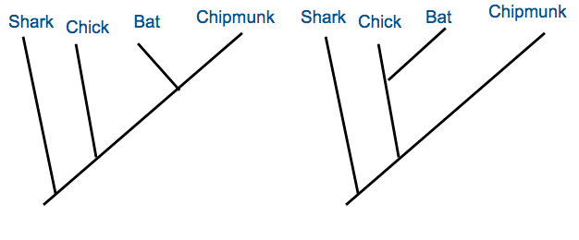
+M
+M
+F
+F
+M
+F
+W
+W
+W
question: is bat more closely related to chicken or chipmunk
- outgroup
  - Shark; no milk, no fur, no wings, no beak
- ingroup
  - Chicken; no milk, no fur, wings, beak
  - Bat; milk, fur, wings, no beak
  - Chipmunk; milk, fur, no wings, no beak.

- Milk is derived trait; synapomorphy
- Fur is synapomorphy
- Beak is not a synapomorphy; derived, not shared

TREE A (on left) is correct phylogeny
- Wings evolve twice
- Fur only evolves once
- Milk feeding evolves once
- 4 trait changes required
- in tree B, 5 trait changes are required, therefore tree A is more parsimonious
the importance of monophyletic groups
- in cladistics systematics, only monophyletic groupings are recognized
  - monophyletic group is defined as one that includes all the descendants of the group’s MRCA
  - blue circle is good monophyletic group
  - purple group in not monophyletic grouping
  - orange includes ¾ descendants or MRCA

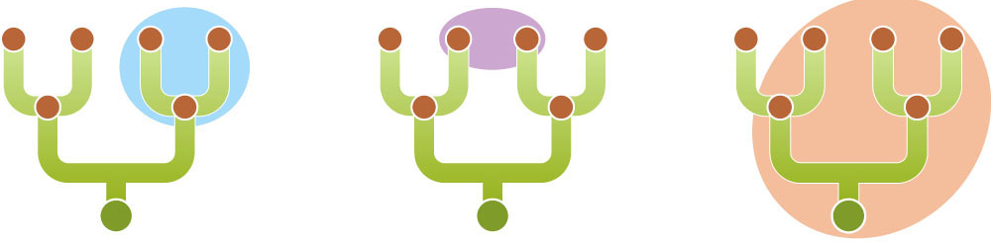
naturalvs. unnatural groupings of taxa, given a phylogeny
Traditional groups aren’t monophyletic!
  - Prokaryotes are not monophyletic
  - Monocots are monophyletic; dicots are non-monophyletic
    - Some dicots are more closely related to monocot plants than other dicots
  - Fish
    - Some are more closely related to reptiles or humans than other fish
  - Endotherms
    - Birds are more closely related to other lizards than other mammals

why biodiversity changes over time
- Ecology: interactions between organisms and their environment
  - Abiotic vs. biotic components
  - Abiotic; non-living factors (environmental)
  - Biotic; living organism, potential mates, competitors, disease, parasites etc.
- Theses interactions affect evolution
  - Origin and demise of species (rates of speciation, extinction)
  - Most species that have ever existed are now extinct… constant turnover and replacement
  - Biodiversity varies over time, reflecting the balance between speciation and extinction
meaning of adaptive radiation
- Adaptive Radiation; rapid speciation into many descendant lineages
factors that may trigger an adaptive radiation
- Ecological oppourtunity; competitive release after colonizing new environment
  - E.g. Finches of Galapagos islands- when founding species made it to the islands, there wasn’t a lot of competition, new ecological niches became available
- Adaptive radiation can occur on a larger scale, over a longer period of time
  - E.g. mammals released from competition when many other species went extinct after end-cretaceous era
  - Within 20 million years, huge amounts of adaptive radiation
- Evolutionary innovations can induce adaptive radiation
  - angiosperms are relatively young species, but dominate land plants
  - key evolutionary innovation; production of flowers to use animals as pollinators
  - this is very efficient way of reproduction, can act as isolating mechanism

Lecture 22: Phylogeny
Independent Study Outcomes
Factors influencing why some pathogens (disease-causing organisms) evolve towards greater virulence (harmfulness)
- Natural selection favours pathogens that take advantage of the host, if they don’t require the health of the host to thrive
- If the host must be healthy, the benign pathogens thrive
How reducing a pathogen's opportunity for water-borne and vector-borne transmission is predicted to affect its virulence
Malaria
- Vector born diseases more harmful than non-vector born diseases
- If you mosquito proof houses, the only successful mosquitos infect people who are healthy enough to walk outside
  - Could get malaria to evolve towards mildness
- Better solution than anti-malarial drugs; drugs are short-term solution
- Evolution towards mildness is long-term solution
- We should adjust our interventions to get organisms to evolve in the direction we want them to go
Diarrhea
- Chile- has most protected water source
  - Strains evolved to be more mild (produce less toxin)
  - No development of antibiotic resistance
- Ecuador-least-protected water source
  - Strains evolved to be more harmful in general
  - Higher degree of water transmission Favoured more harmful strains
Predicted relationship between virulence and antibiotic resistance

Lecture Outcomes
mutualistic, competitive and antagonistic relationships between species, given 'real world' examples
When two species interact…
- Both may benefit –evolutionary mutualism (e.g.plant with pollinator)
- Domestication by humans
  - Animals provide us with benefit
  - We promote their reproduction
- Both may suffer- competition
  - E.g. cheetah and lion both compete for limited food resources
  - Each party is ‘worse off’ by the other species’ presence
  - Plants also compete for sunlight, water etc…
- One may benefit at the expense of the other: antagonism
  - Predation: predator benefits from having prey around, but prey suffers
  - Herbivore-plant relationships show antagonism
  - Disease-causing organism benefit at the expense of their host individual (i.e. HIV)
Evolutionary arms race
Evolutionary Arms Race
- Adaptation by species A improves its ability to interact with species B
- This puts selection pressure on species B to evolve counter-adaptation
- Selection pressure on A to evolve counter-counter-adaptation
  - E.g. garter snake-newt relationship
  - Newt’s toxin causes garter snake to develop resistance puts selection pressure on newt to develop even higher levels of toxin
  - Both parties become worse-off by developing counter-adaptations, but wouldn’t survive if they didn’t
Arms races between mutualists
- e.g. plant-moth relationship
  - Over evolutionary time, pollinating creatures have evolved longer beaks/bills to reach nectar in plant
  - For the plant, this means the pollinator does not stay as long on the plant-not as much pollen may be transferred
  - Plants counteract by evolving longer pollen tube
Arms races within species can occur
- Sexual dimorphism: the most extravagant appearance wins

examples of Red Queen equilibrium
Winner of arms race?
- May keep escalating until costs outweigh benefits
- Red queen equilibrium; must keep evolving adaptations and counter-adaptations just to “keep up”
  - Newt-garter snake relationship
factors that advantage one side or the other in an evolutionary arms race
- Sometimes, one side has the advantage
- Generation time;
  - Population with rapid short generation time can evolve faster than species with longer generation time
- Population size;
  - Selection is more effective in large populations and often harper more genetic variation
- Strength of selection;
  - Is there equally strong selection on both sides?

meaning of 'life-dinner principle'
- Life Dinner Principle: Selection on one party in an arms race may not be as strong as selection on the other party involved
- (e.g. coyote-road runner analogy. If roadrunner loses, he dies. If coyote loses, he doesn’t eat that day)
- Selection is stronger on prey species than predator species
difference between prudent-parasite hypothesis and trade-off hypothesis, in terms of the evolution of virulence
Host-Parasite Antagonistic Arms Race
- Parasite gets resources at the expense of host fitness
- Some parasites are more virulent than others
  - HIV vs. rhino virus (common cold)
Prudent-parasite hypothesis:
- Parasite that kills its hosts too soon, before colonizing a new host is doomed
  - Optimal virulence is low; need host health to stay alive
  - High virulence suggests recent host/parasite interaction (hasn’t had enough time to become benign)
    - Eg. HIV in chimps is less virulent that HIV in humans because it has had more time to evolve towards mildness
Trade-off hypothesis:
- How does having a high replication rate benefit the parasite?
  - E.g. HIV can be found in extremely high concentrations in host (blood, saliva etc.), increasing its ability to spread to another host
- How does having a high replication rate harm the parasite?
  - May harm host too much, or kill them before they have oppourtunity to spread to new host

factors that influence the optimal virulence of a given host/parasite relationship
- Mode of transmission: more virulent by water and vectors, than person-person transmission
- Health of host: host has to be health enough to allow for contact with others and spread

costs and benefits of being highly virulent (from the point of view of the parasite)
Benefits
- increasing its ability to spread to another host
Harm
- May harm host too much, or kill them and lose

why improving equipment for survival does not always translate into 'winning' an evolutionary arms race
Improved equipment ≠ improved success
- Modern day lions are much faster than their ancestors would have been in order to catch prey
- The lions are not “better off” though, because their prey have also evolved to become faster

differences in virulence depending on mode of transmission
Transmission mode affects virulence
- Optimal virulence depends on how the parasite spreads
  - Some diseases require direct contact to spread;
    - spread effectively if host is healthy and mobile
  - Some spread indirectly; through contaminated water or insect vectors,
    - disease doesn’t have interest in keeping host healthy/mobile for extended period of time

disease management practices that might reduce virulence of parasites
- contraception barriers
- mosquito nets
predicted effects of given factors on virulence of parasites, given “real world” examples
. HIV-2 is less easily transmitted between hosts than HIV-1. What do you predict about its virulence, relative to HIV-1?
- HIV-2 is less virulent because it takes longer time for it to transmit between hosts
- Highly transmissible = highly virulent
- Less transmissible=lower optimal virulence

2. This nematode parasite is transmitted mainly vertically (from parent to offspring).
What would you predict about its virulence, compared to horizontally transmitted nematodes?
- Horizontal transmission: transmission between individuals of same generation
- Vertical transmission: parent to offspring. Virus often become so benign that they are no longer considered parasites
- Very low virulence in vertical transmission

3. Condom use reduces the oppourtunity for sexually transmitted diseases to spread. How will this likely affect their optimal virulence?
- Blocking oppourtunity for disease spread, reduces the optimal virulence of the disease
- Can influence evolution towards mildness; evolution works in our favour

Lecture 23: Evolutionary Medicine
Lecture Outcomes:
examples of relevance of evolutionary principles to human health
- Pathogens can evolve; we can manipulate their optimal virulence
- Traces of our evolutionary history affect our health
  - Evolutionary constraints can result in health problems that humans are subject to
- Trade-offs between competing demands
  - Competing demands associated with degenerative disease
- Symptoms may be defenses, but not defects
- May never be able to ‘close the book’ on infection diseases
trends in incidence of infectious vs. autoimmune disorders with respect GDP
Infectious diseases declining; autoimmune disorders rising
- Infectious disease decline reflects advances in modern medicine, countries are improving sanitation
- Autoimmune disorders (MS, asthma, allergies etc.) are much more common
  - Immune system turns upon itself
- Autoimmune disorders more of an issue in developed, wealthier countries

evolutionary basis of diseases of civilization
Metabollic Syndrome
- Human body has only recently adopted its current environment, filled with former rarities such as high-fat foods.
- Evolutionary medicine take of obesity; this reflects a mismatch to the environment we’re evolutionary adapted to (sweet, fatty foods limited) and our current environment
  - Historically we may have had slower metabolisms to account for limited availability to sweet and fatty foods
Myopia
- Myopia
  - Genetic basis…wait, what?
    - In evolutionary history if you didn’t have good vision this would have decreased fitness, so why is it still in existence?
    - More than simple genetic inheritance
  - Barrow Inuit study, 1970
    - Compared incidence of myopia for people under 35 and people over 35
      - 42% of 6-35 yr olds myopic
      - 5% of 36-88 yr olds myopic
    - Difference in environment when growing up accounts for this difference
      - younger people had upbringing in school; reading under artificial light
      - older people would have grown up in different visual environment; not traditional schooling
    - Alleles pre-disposing people to myopia did not cause myopia in ancestral visual environment

Major threats to health, then vs. now
Then:
- Infectious disease
- Starvation
- Predator
- Accidents
Now:
- Heart attack/stroke
- Cancer
- Metabolic syndrome
- Autoimmune disorders

evolutionary basis of the "hygiene hypothesis"
- In wealthier nations the environments have become “too clean” from reduced exposure to certain infectious ailments
- Ancestors were chronically infected with macro parasites (nematodes, worms, bacteria…etc)
- Used to have highly active immune system to fight against microbes; now less pressure for highly active immune system
- The “dirtier” your upbringing, the less likely to have allergies
reasons why harmful traits are maintained by trade-offs, antagonistic pleiotropy etc.
Historical constraints; traits have an evolutionary history
- All of our traits have an evolutionary history
- Ex. The design of the human eye leads to a blind spot and allows for detached retinas. The squid eye is free of such problems.
  - Problem; blow to eye can result in detached retina in humans
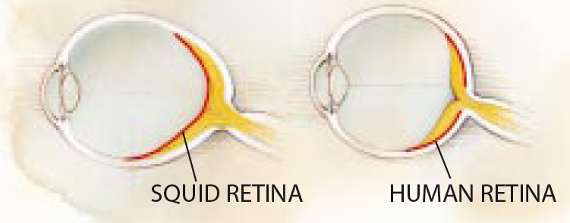

Why can’t we get rid of the Appendix; evolutionary constraint
- Appendix is vestigial treat
- Before modern surgery; appendicitis would have posed great risk to life
- The risk of appendicitis has paradoxally prevented reduction when appendix is smaller it is more likely to be clogged, or have poor blood flow and cause problems

Trade-offs and competing demands:
- Selection may maintain a ‘harmful’ trait (sickle cell allele) because it benefits fitness in another context (malaria)
- Some traits are beneficial in early life, become costly later in life
  - E.g. High levels of circulating sex hormones; high levels of estrogen in early life would help to increase amount of eggs produced; later in life high levels of estrogen could increase risk of cancer
- Antagonistic pleiotropy and Senescence
  - Selection should favor alleles that increase fitness/reproduction early in life, even at the expense of reproduction/survival late in life.
    - It’s not worth it to the body to repair itself later in life; this energy is better channeled into growth and survival ship early on in life
    - Less priority for tissue repair later in life (explains old droopy skin)
      - E.g Indy mutants of drosophila outlive wild type Drosophila, but produce fewer offspring earlier in life
Cancer
- Not until later in life do deaths from cancer take a toll on human life span
- Reproduction occurs well before selection pressure of cancer kicks in
- Predict that natural selection would not favour mutations that reduce risk of getting cancer
- This is true for many diseases of senescence

Result: energy channeled into early reproduction, not repair/longevity
- Selection is strong on early life history stages

Why do we get sick?
- Pathogens and parasites keep evolving
  - To steer their evolution, change their ecology
- Effects of history
  - Different selective pressures than in the past
  - Historical constraints
- Trade-offs: body is bundle of compromises (sexually selected traits, antagonistic pleiotropics alleles, heterzygote advantage traits)
- Selection acts on lifetime reproductive success, not on health, happiness or longevity

Lecture 24: Human Evolution
Lecture outcomes:
arguments for and against the notion that humans are still evolving.
possible reasons for why evolution may be slowing down among humans.
evidence for recent evolution in humans.

Why has evolution stopped?
- Weaker natural selection due to medical advances in developing world
  - We are effectively immune to effects of natural selection due to modern medicine
  - Not true in all parts of the world; millions of children in developing world die every year
- Weaker sexual selection, due to increased monogamy
  - Sexual selection is not important selective force on humans anymore
  - BUT… increased prevalence of sperm donation increases the reproductive success of the donor
- Fewer mutations, due to decreasing reproduction by old men
  - 29 year old male; 300 cell divisions
  - 50 year old male: >1000 cell divisions-contribute mutations
  - average paternal age at reproduction is decreasing, thus less oppourtunity for new mutation to arise
- Decreasing randomness (drift)
  - Human populations are huge and super-connected from travel
  - Not many small, isolated human populations anymore
  - Assortative mating is now easier than ever: online dating

Evidence for Ongoing Human Evolution
- Selective sweep; beneficial mutation rises quickly to high frequency, surrounding sequences consequently ‘dragged along’ with SNP, and increase in frequency
- Detect sweeps, and measure speed of adaptive evolution, by analyzing sequence variation around SNPs
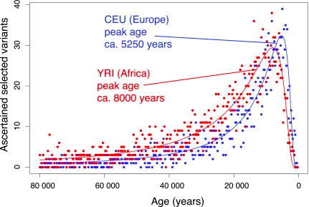
- A few thousand years ago humans were evolving faster than ever before
Evidence for ongoing human evolution:
- Several thousand nurses took part in a study
- Researchers wanted to identify what traits were favoured for high reproductive success
- Indicated selection is acting
- Selectively favours more stout women, lower circulating cholesterol, lower age at first reproduction, later age of menopause
- Rate of evolution is normal compared to other natural populations
- This is evidence that human evolution is continuing to happen

costs of large brains
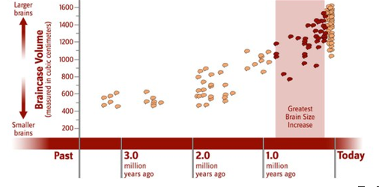
Why so intelligent?
- Big brains are costly
  - energetically (2% of mass, 20% of energy)
  - in children brains can account for over half of metabolic expenditure
  - logistics of childbirth
  - there must be big payoff in order for large brain to not be selected against
possible advantages of large brains with the "utility hypothesis" vs. "mating mind hypothesis"
Why did ancestors need big brains?
Utility Hypothesis: ancestors needed a large brain in order to survive
  - Language, tool use, planning survival
  - Ie. Coordinating buffalo hunt, or climbing tree to escape predator

But this seems like overkill….
- Explanation: sexual selection
  - In human, both sexes choose mates
  - Assessing intelligence of a potential mate requires that you yourself areintelligent

Mating Mind hypothesis:
- Word play, humour, artmating success
- Intelligence is socially impressive trait (cheesy puns, poems etc.)

