- CHAPTER 4: ECONOMIC ACTIVITY AND PERFORMANCE

- Macroeconomics studies:

- The national economy as a system in terms of:
- Economy’s total output of goods and services
- Expenditures on current output
- Employment and Incomes
- Money and Financial Markets
- Prices and Inflation
- Macroeconomic performance
- Monetary and fiscal policies (taxes, subsidies, etc.)

Macroeconomic Performance

Three main indicators of economic performance:

1. Output of goods & services (GDP)
  - Rate of growth and output
  - Real GDP: quantity of all final goods & services produced in an economy

  - Rate of growth of real GDP:

    - R.o.g. of real GDP = RealGDP_{year2} – RealGDP_{year1} x 100

RealGDP_{year1}
    - Example:
      - 2010: real GDP = $1,325 bil
      - 2011: real GDP = $1,360 bil

      - Rate of growth in 2011 = (1360 – 1325 / 1325) x 100 = 2.64%

- 2. Price level

  - Inflation:
    - Persistent increase in prices/cost of living in consecutive years
    - Purchasing power of money falls
    - Calculated using an index; CPI is the most used index
    - Positive rate = increase in price

  - CPI – Consumer Price Index: index that measures changes in the prices of consumer goods & services; information on prices of a basket of items is collected and average change over time is calculated

  - Rate of inflation: rate of change (%) in the average level of prices

    - Inflation rate = CPI_{year2} – CPI_{year1} x 100
  - CPI_{year1}

- 3. Employment
  - Unemployment rate: number of people unemployed expressed as a percentage of the labour force

  - Labour force: employed + unemployed (willing and able to work)

  - Participation rate = Percent of population that is either working or unemployed (labour force expressed as a percentage of the adult population); depends on the level of optimism of people (willingness to look for a job)

    - Participation rate = Labour force x 100

Non-institutional pop.

      - If LF increases, PR increases

    - Employment rate = Employed x 100

Non-institutional pop.

    - Unemployment rate = Unemployed x 100

Labour force

= Labour force – Employed x 100

Labour force

  - Unemployment rate will rise if optimism increases start looking for work increases participation rate
  - Unemployment rate will decline if optimism decreases no longer looking for work decreases participation rate
  - Employment rate however is not affected by participation rate

* Recession: decline in economic activity; GDP low, inflation high, unemployment high; two consec. quarters of negative growth in real GDP
  - Gives negative rate of growth in annual real GDP
  - Prices increase businesses don’t have enough money lay off employers unemployment

- 3 Types of Unemployment

- Cyclical: occurs due to business cycles; declines in aggregate expenditure and aggregate output by firms; such as during recessions (would be eliminated by a higher level of economic activity without putting pressure on wage rates and inflation)
- Frictional: occurs due to dynamics of the labour force (changing participation rate and employment opportunities; takes time to match job openings with candidates); results from people moving between jobs or entering/re-entering the labour force
- Structural: occurs due to structural changes in the economy and demand patterns; when skills are no longer in demand (technological replacement of jobs) (eg. as people become less reliant on the train industry, workers in this industry lose their jobs)

* Frictional & Structural = make up natural unemployment rate

National Accounts

- Provide:
  - Definitions and concepts for measuring GDP
  - A framework for aggregate demand (AD) and supply (AS) models of the economy

- * Circular flow diagram in textbook (James, p. 63)

- Measuring GDP

- GDP: sum of all final goods & services produced in a country in a given period

- 3 measures of Nominal GDP

- Nominal GDP: output of all final goods and services expressed in current dollars, money incomes generated by the production of that output, and the expenditure on the sale of that output in a specific time period

- Final goods & services: goods & services purchased by the ultimate users

- Output-based GDP = sum of all value added to economy by all industries
  - (Value added = market value of final good/output – cost of inputs or intermediate goods)

  - Intermediate goods/inputs: goods, services, materials purchased from other businesses to produce a final good

  - Value added: market value of output minus cost of inputs purchased from other businesses

- 2. Income-based GDP = earnings generated by the production of goods & services; sum of all payments to factors of production

  - Income-based GDP = DI + CCA + T_{IN}

  - DI = Domestic Income = W + BI
    - W = employment income
      - Sum of all wages, salaries, benefits (pensions, dental, health plans) paid to labourers
    - BI = profit, business income and investment income
      - Focus on investment income not investment itself (which is an expenditure item)
      - Income for individuals who provide financial capital to businesses (interest payments for businesses)
      - Sum of corporate profit before tax, other business income, and interest and investment
      - Includes income/rent earned by professional practices, unincorporated businesses
      - Government bonds excluded/not counted

  - CCA = capital consumption allowance to cover the depreciation of capital stock (machines, equipment used for production of a final good)
    - Capital consumption = loss of value in economy’s capital stock (capital is “consumed”/”used up” during production) therefore an allowance is made for this stock

  - GDP at basic price = DI + CCA
    - Price before indirect tax or subsidy

  - T_{IN} = net indirect tax = sales + excise tax – subsidies
    - Excise tax: taxes that producer pays to government (seen by consumers through price increases; retail sales tax; tobacco, gasoline industries)
    - Subsidies: government support to industries to help reduce their costs and increase competition (eg. farming industry); cause market prices to be lower than they would otherwise be; therefore must be subtracted to arrive at market prices

  - GDP at market price = W + BI + CCA + T_{IN}

- 3. Expenditure-based GDP = sum of expenditures on final goods & services

  - Expenditure-based GDP = C + I + G + (X – IM)

  - C = consumption household consumption on all goods & services

  - I = gross investment = net investment + depreciation; physical investment (equipment, building, machinery capital stock) in order to produce (not financial investments such as stocks and bonds)
    - Includes expenditure on newly-constructed residential housing
    - Net investment: gross investment – depreciation

  - G = government expenditures (roads, health, military, education) on production
    - Includes wages/salaries of gov. employees and military
    - Social assistance/welfare not included (not expenditure on current final output) called transfer payments: do not require provision of any goods or services in return; no output

  - X = exports expenditures by other countries on goods and services of this country
    - Net exports (NX): exports minus imports

  - I = imports expenditures on goods and services produced in other countries

- * 1 & 2: deal with supply side of economy
- * 3: deals with demand (consumers)
- * Different measures of GDP should all yield same number

- Nominal GDP, Real GDP, and the GDP Deflator

- Nominal GDP: output and incomes of a given year measured with current market prices of goods & services

- Real GDP/GDP in constant dollars: output and incomes of a given year measured with base year prices of goods & services
  - Nominal GDP adjusted by the GDP deflator

  - Real GDP = Nominal GDP x 100

GDP Deflator

- Changes in Nominal GDP: result of changes in prices and/or quantities of final outputs and factor inputs

- Changes in Real GDP: result of changes in quantities

- GDP Deflator: a price index; compares prices of all final goods & services produced in all industries in the economy to prices in a base year; used to measure inflation in consumer prices and the cost of living

  - GDP Deflator = Nominal GDP_{t} x 100

Real GDP_{t}

  - GDP deflator for base year always = 100 (nominal and real GDP are equal
  - Deflates the dollar value of current output to what it would have been in base year’s prices
  - The CPI, in contrast, is based on “representative baskets” of goods and services consumers buy

- The General Price Level (P)

- The general price level is equal to the sum of three components:

  - P = W + BI + CCA + T_{IN}

Y Y Y

  - W/Y = labour cost per unit of output

  - (BI + CCA)/Y = market and producer price setting that gives gross business income per unit of output

  - T_{IN}/Y = net indirect tax per unit of output

- * Changes in any one of the three components changes the general price level and nominal GDP

- Per Capita Real GDP

  - Real GDP per person
  - Measures the standard of living enjoyed by a person in the economy
  - Adjusts real GDP for population

  - Per Capita Real GDP = Real GDP

Population

- Limitations of Real GDP

  - Some production causes noise, pollution, congestion do not contribute to economic welfare
    - GDP should be adjusted for these costs to evaluate standards of living more accurately
  - Many valuable goods and services are excluded from the GDP because they are not marketed (making them hard to measure)
    - Home cleaning, maintenance, household improvements carried out for themselves, unreported jobs/incomes in economy
  - High GDP and high per capita GDP not necessarily good measures of economic wellbeing (not the only indicator of standard of living)
    - Eg. health care services have different effects than military expenditures

CHAPTER 5: OUTPUT, BUSINESS CYCLES, GROWTH & EMPLOYMENT

Aggregate Demand and Aggregate Supply

- Short-Run AD/AS Model

  - Framework used to explain the behaviour of real output and prices in the national economy
  - Illustrates determination of real GDP and GDP deflator
  - Explains level of economic activity and prices/reasons for changes in output and prices from time to time
  - Builds on national accounts framework

Short-Run Assumptions

- Constant prices for factors of production (esp. money wage rates for labour)
- Fixed supply of labour, fixed capital stock, fixed state of technology of production (that could enhance prod.)
- Fixed money supply

- Short Run: a time frame in which factor prices, supplies of factors of production (including state of technology), and the supply of money are fixed by assumption
  - In the short run: Δoutput cause Δemployment and Δcapital utilization (use of plant and equipment) as a result of the three assumptions
  - The changes not sustainable over longer time periods

- Aggregate Demand

- Aggregate: means total

- Aggregate demand:
  - Planned aggregate expenditure on final g/s at a certain price level, all other conditions held constant
  - Various levels of real output that will be demanded (that households, businesses, government would be willing to pay for) at various price levels
  - Relationship between aggregate expenditure on final g/s (real output) and the general price level
  - Real GDP (expenditure approach) measures this expenditure at the price level given by the GDP deflator

The AD/AS Model in a Diagram

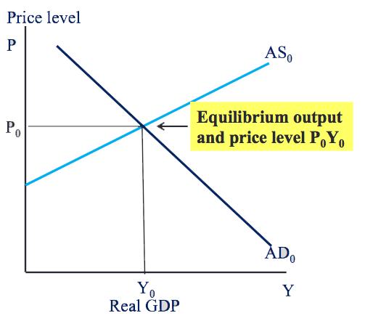

  - AD = (C + I + G + X – M) at diff. P levels
  - AS = P at different rates of real output
  - AS reflects unit costs of production with constant input prices and producer price setting
  - P = general price level

- Aggregate Demand

- * In the aggregate economy, an increase in price level raises money incomes by an equal amount
- * Changes in the price level do not make g/s more/less affordable in terms of incomes
- * Assumptions of constant income and other product prices that underlie market (individual) demand do not hold for aggregate demand

- The negative relationship between planned aggregate expenditure and the general price level (AD is downward sloping) is due to three effects caused by a change in P:

- 1. Interest rate effect
  - Changes in expenditure caused by interest rate changes
  - Increase in prices increase in interest (because households, bus., and gov. need higher money balances to pay expenses due to fixed money supply) expenditures decrease
  - Interest rates: cost of borrowing; determined in financial markets by demand for/supply of financial assets
  - Most important cause of downward-sloping curve

    - ⬆P ⬆i ⬇exp

- 2. Substitution effect
  - Effect of changes in P on exports and imports
  - A change in P may change the competitiveness of domestic g/s relative to foreign g/s, depending on what happens to the foreign exchange rate
  - Increase in prices changes in the foreign exchange rate decreased exports and increased imports decreased expenditure (net exports component of AD falls)

    - ⬆P ⬆P_{CAN}/P_{US} ⬇X + ⬆I ⬇exp

- 3. Wealth effect
  - Change in planned consumption caused by changes in household wealth (changes in the purchasing power of money balances)
  - Money balances = financial wealth (eg. bank deposits) used to pay for routine purchases, to cover routine expenses, as reserves for unpredictable expenses
  - Purchasing power of money balances depends on P a change in P changes the quantity of g/s that can be purchased with a fixed # of dollars
  - Not as significant in explaining negative slope because money balances make up a small part of economy’s total financial assets

    - ⬆P ⬇(nominal wealth)/P ⬇exp

- The Aggregate Demand Curve

- Shows: Δexpenditure caused by Δprice
- Assumes: that anything other than price that might affect expenditure plans is held constant

- Slope of AD: - ΔP/ΔY = - ΔY/ΔX

- Changes along AD curve: reflects a change in price in relation to expenditure
- Change in position of AD curve: depends on all other conditions except price that affect aggregate expenditure plans

- Aggregate Supply

- Aggregate supply:
  - The output of final g/s businesses (real GDP) that producers would be willing and able to produce at different price levels, all other conditions held constant
  - Relationship between the output of g/s produced by businesses and the general price level
  - Real GDP (income approach) measures this output and corresponding real incomes at the price level given by the GDP deflator
  - Reflects unit costs of production with constant input prices and production price setting

- The Aggregate Supply Curve

- 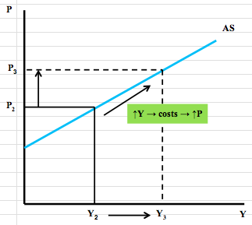

- The AS curve is based on the following 2 assumptions:
  - Prices of factors of productions (particularly money wage rates for labour) are constant
  - The stock of capital equipment and the technology of production are constant

- Slope of AS: ΔP/ΔY > 0 = ΔY/ΔX (positive)

- Changes along AS curve: reflect changes in output or price, all other conditions constant
- Change in position of AS curve: reflect changes in all other conditions except price that affect output decisions (esp. money wage rates and productivity)

  - As price level falls, o.b.e., the quantity of real GDP supplied falls
  - As price level increases, o.b.e., the quantity of real GDP supplied increases
    - Increase in price while input costs remain fixed more profit firms will produce more output level increases

- Equilibrium Real GDP and Price

  - AD and AS together determine equilibrium real GDP and general price level
  - Equilibrium: AD = AS; planned expenditure equals/buys current output
  - Business revenues = costs including profits
  - No change in output

- At disequilibrium:
  - Unplanned changes in inventories
  - Business revenues do not equal costs including profit
  - Change in output necessary to get back to equilibrium
    - AD < AS = unplanned increase in inventories (output not sold costs of prod. not recovered incentives to decrease output)
    - AD > AS = unwanted reductions in inventories (costs of production not recovered strong incentives to increase output)

- Numerical Example:

- AD: Y = 1000 – 2P
- AS: Y = -200 + 10P

- Equilibrium: AD = AS
- 1000 – 2P = -200 + 10P P = 100 Plug into AD & AS
- 1200 = 12P Y = 800

- Equilibrium Output vs. Potential Output

- Equilibrium output: determined by AD & AS conditions; planned expenditure equals current output and provides business revenues that cover costs including expected profit
  - Increases/decreases as AD & AS fluctuate

- Potential output: Real GDP the economy can produce on a sustained basis (not maximum output) with current labour force, capital stock and technology without generating inflationary pressures on prices
  - Not affected by general price level and short-run AD/AS conditions
  - Grows as labour force grows and labour productivity increases
    - Labour prod. grows as a result of advances in technology and knowledge coming from investments in capital equipment, education, training

- 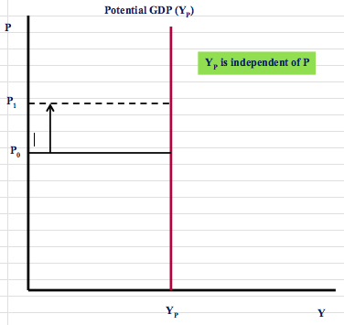

  - Changes in P have no effect on Y
  - Changes in supply of labour, capital stock, and tech. increase/decrease potential output and shift it horiz. right/left
  - When actual output falls below potential output unemployment increases, idle plant & equipment, excess capacity, low inflation
    - Creates a recessionary gap
  - When actual output surpasses potential unemployment falls, inflationary pressure
    - Creates an inflationary gap
  - When actual output = potential output: full employment, stable inflation

- Business Cycles and Output Gaps

- Business cycles: short-term fluctuations of actual real GDP
  - Caused by fluctuations in AD & AS
  - Cause differences between actual and potential GDP

Output gaps: measure differences between actual and potential GDP; indicators of macroeconomic performance
  - Y - Y_{P}
  - Output gap (%) = Y - Y_{P} x 100

Y_{P}

Adjustments to Output Gaps

Inflationary gap: Recessionary gap:

- 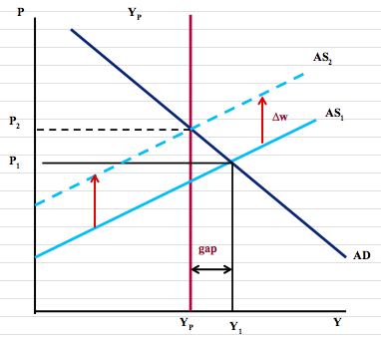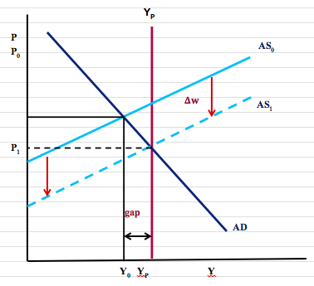

- To eliminate an inflationary gap:
  - Low unemployment and labour shortages increase in money wage rates increase in unit labour costs producers willing to produce less at higher input prices shifts AS curve up inflationary gap eliminated when AS = AD and output at Y_{P}

- To eliminate a recessionary gap:
  - High unemployment rate lowers wage rates & other factor prices change in factor costs lower costs means producers willing to produce/sell at lower prices shifts AS curve down recessionary gap eliminated when AS = AD and output at Y_{P}

- * This process assumes that AD curve is not affected by the fall in wage rates that shifts AS curve

- The Role of Macroeconomic Policy

  - Inflationary gaps push price level up raising cost of living standard of living reduced
  - Recessionary gaps reduce employment, real GDP, per capita real GDP standard of living reduced

- Two roles for macroeconomic policy:
  - To moderate short-term transitory fluctuations to stabilize output and employment
  - To change AD and AS to offset persistent output gaps

- These objectives pursued through a combo of policy design and policy changes

- Monetary policy:
  - Sets short term interest rate to achieve medium term inflation control target
  - Responds strongly to offset persistent output gaps in setting its interest rate

- Fiscal policy:
  - Sets annual budget plan to control deficits and debt ratios
  - Tax and transfer programs provide built-in short term AD stabilization
  - Change structural budget balances to offset persistent recessionary gaps

- CHAPTER 6: AGGREGATE EXPENDITURE & AGGREGATE DEMAND

- Short-Run Aggregate Demand and Output

- Assumptions for Short-Run AD Model:

- 1. Prices and wages are fixed
- 2. At fixed prices and wages, businesses produce the output that is demanded and labour accepts opportunities to work
- 3. Money supply, interest rates, and foreign exchange rates are fixed (ignore financial sector)
- 4. Assume a simple economy with no government, only households and firms

- Aggregate Expenditure

- 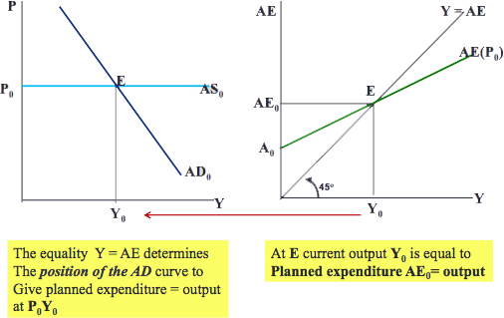

- Aggregate Expenditure (AE):
  - Planned expenditure on:
  - Consumption goods by households (C)
  - By businesses on investment goods (I)
  - Expenditure by non-residents on exports, minus imports (X – IM)

    - AE = C + I + X – IM

- With constant price (P), equilibrium real GDP:

    - Y = AE
    - What businesses wish to produce = what households/businesses wish to buy

- Consumption, Saving, and Investment

- The Consumption Function

- Consumption:
  - Planned expenditure by households on current output
  - Largest component of AE (90%)

- Consumption Function:
  - Relationship between consumption (C) and disposable income (YD)
  - Disposable income: income received from bus. + govt. transfers – direct taxes paid to govt.
  - Since we assume no govt., disposable income equals income received from employment in bus. firms (Y) which also equals national income
    - YD = Y
  - Positive relationship between income and consumption:
    - Positive slope
    - Changes in Y cause changes in C
    - As income increases consumption increases
    - As income decreases consumption decreases

    - C = C₀ + cY

    - C₀ = autonomous consumption (consumption not related to current income; g/s that you buy anyway or based on factors other than income; eg. medication); determined when Y = 0
    - c = marginal propensity to consume (MPC); the change in consumption expenditure caused by a change in income (induced expenditure)
      - c = ∆C/∆Y = MPC (slope); positive fraction between 0 and 1
      - cY = induced consumption; determined by change in Y

- 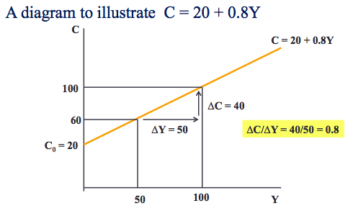

- The Saving Function

- Saving = Income – Consumption; income not spent to finance consumption
- So, we can deduce the saving function using the consumption function from the diagram.

- S = Y – C
- S = Y – [C_{o} + cY]
- S = Y – [20 + 0.8Y]
- S = Y[1 - 0.8] – 20
- S = - 20 + [1 - 0.8]Y

  - S = -C₀ + [1 – c]Y

    - Slope = MPS (marginal propensity to save) = [1 – c]; change in saving caused by a change in income
    - MPS = ∆S/∆Y

- If MPS or MPC is given in a problem, you can solve for either:
  - MPC + MPS = 1

- This is true because:

- MPC = c
- MPS = 1 – c
- MPC + MPS = c + 1 – c
- MPC + MPS = 1

- 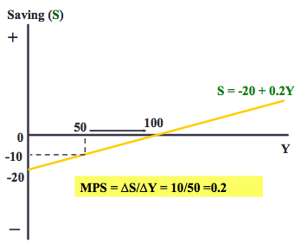

- *Below 0 = borrowing, dissaving, selling assets
- *Changes in income cause a movement along the consumption and saving functions, determined by MPC and MPS
- *Changes other than a change in income that change consumption and saving at every income level causes a shift in the consumption and saving functions autonomous changes changes in C₀ and S₀

- The Investment Function

  - Investment: planned business spending on plant equipment and inventories; expenditure on fixed capital to be used in production
  - Assume investment is independent of income (autonomous)
    - Depends on expectations about how fast demand for their output will increase & expected profitability of higher future output
    - Assume interest rates constant (i₀); usually, interest rate (IR) is the most important factor affecting investment since it determines the cost of financing investment
      - If IR⬆ cost of financing investments⬆ so inventories⬇
      - Therefore, the relation between investment and output is negative
  - Changes in investment plans or changes in expectations shift the investment func.
  - Slope is always 0 (horizontal line) because investment is independent of current output
  - Investment is more volatile (changes more rapidly) than consumption

    - I = I₀ – bi₀
    - Assume i is constant

- The Export and Import Function

- The Export Function

  - Exports: spending by residents of foreign countries on domestic output; i.e. g/s produced at home and sold to residents of other countries
  - Exports are autonomous expenditures (not determined by national income)

    - X = X₀

  - Exports are affected by expectations outside the country, foreign exchange rates, income levels in other countries, domestic and foreign price, tastes and preferences, etc.
    - Foreign exchange rate: domestic currency price of foreign currency
  - Volatile component of aggregate expenditure

- The Import Function

  - Imports: domestic expenditure on foreign output; i.e. g/s produced in other countries and purchased by domestic residents
  - Imports are imbedded in consumption, investment, and exports
    - Imports are consumed; can be purchased as investment in capital stock; can be used to produce exports
  - Imports depend on domestic income, foreign exchange rates, domestic and foreign price, tastes and preferences, etc.
  - Positive relation: as income increases, imports increase

    - IM = IM₀ + mY

    - IM₀ = autonomous imports
    - m = ΔIM/ΔY = MPM (marginal propensity to import: changes in imports induced by changes in income)

- 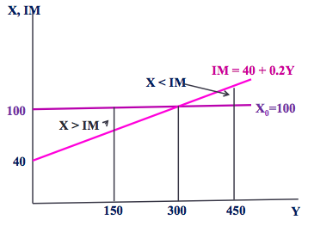

  - (X – IM) = net exports (can be positive or negative)

The Aggregate Expenditure (AE) Function

  - Shows relationship between aggregate expenditure and national income or GDP

  - AE = C + I + X – IM

- Example:
- C = 20 + 0.8Y
- I = 20
- X = 50
- IM = 10 + 0.2Y
- AE = 80 + 0.6Y

  - From (AE = C₀ + cY + I₀ + X₀ – IM₀ – mY) we get:
  - AE = A₀ + (c – m)Y
    - Slope = (c – m) = ΔAE/ΔY = MPC - MPM

  - AE is different at different income levels because of induced expenditure on consumption and imports; AE changes by (c – m) times any change in income

- Equilibrium Output

- Short-Run Equilibrium: when Y = AE
  - When output = aggregate expenditure
  - Business revenues cover costs and expected profit
  - No unplanned changes in inventories when in equilibrium
- Current Output: planned expenditure on current output

- 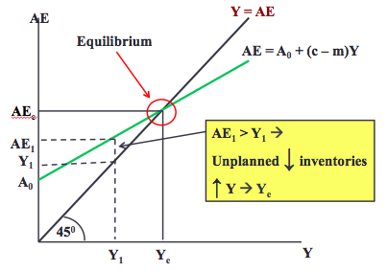

- Finding Equilibrium Output Using Algebra

- Example:

- Consumption: C = 20 + 0.8Y
- Investment: I = 20
- Exports: X =50
- Imports: IM = 10 + 0.2Y
- Agg Expend: AE = 80 + 0.6Y

- Equilibrium:
- Y = AE
- Y = 80 + 0.6Y
- Y – 0.6Y = 80
- (1 – 0.6)Y = 80
- Y = 80/(1 – 0.6)
- Y = 200

- Adjusting to Short-Run Equilibrium

- When Y does not equal AE (not in equilibrium) unplanned changes in inventories
  - Y > AE unplanned inventory⬆ and output⬇ (above equilibrium; when economy is producing more than AE, unwanted inventories build up and output is cut back)
  - Y < AE unplanned inventory⬇ and output⬆ (below equilibrium; firms get signals to sell more from inventories from previous production to increase output)

- Y levels must be changed appropriately to get back to Y = AE

- Equilibrium Output and Employment

- In equilibrium Y_{e} = AE

- However if:
  - (Y_{e} < Y_{P}) ≡ Recessionary gap & high unemployment
  - (Y_{e} > Y_{P}) ≡ Inflationary gap & low unemployment
  - (Y_{e} = Y_{P}) ≡ Full employment

- The Multiplier (ΔY_{e}/ΔA)

  - A number that predicts ΔY_{e} caused by ΔA
  - Larger MPC’s and MPM’s steeper AE functions and larger multipliers
  - Equilibrium output is autonomous expenditure multiplied by the multiplier

- Defined:
  - ΔY_{e}/(ΔA that caused it)
  - ΔA parallel vertical shift in AE
  - ΔA ΔY induced AE = (c – m)ΔY
  - ΔY/ ΔA = 1/(1 – slope AE) = 1/[1 – (c – m)] = 1/(1 – c + m)

- 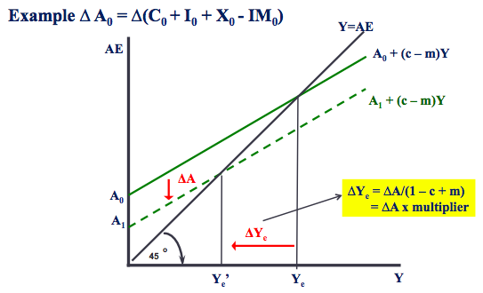

- 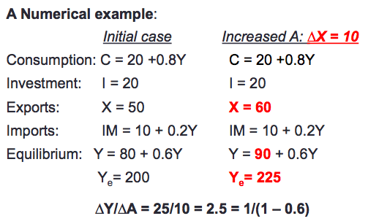

- Leakages and Injections

- An alternative view of equilibrium Y:
- From Y = AE
  - Y = C + I + X – IM, which gives
  - Y – C = I + X – IM , but Y – C = S

- Therefore S + IM = I + X also gives Y_{e}

- S & IM are leakages from AE (leak from the expenditure stream do not pass on current income to businesses through expenditure on current output)
- I & X are injections into AE (autonomous investment and exports are independent of current income that inject income into the expenditure stream)

- Injections = Leakages equilibrium Y
  - (output and income adjust to make injections equal leakages to establish equilibrium)

- Paradox of Thrift: An increase in S at every Y decrease in Y_{e} but no change in S
  - An increase in intended aggregate saving, o.b.e., will lead to a fall in total income and hence to a fall in actual aggregate saving

- Aggregate Expenditure, Equilibrium GDP, and Aggregate Demand

- Key model concepts:

- Autonomous expenditure:
  - Independent of current income
  - A₀ = C₀ + I₀ + X₀ + IM₀

- Induced expenditure:
  - Spending decisions based on current income
  - MPC & MPM (c – m) ΔY = ΔAE

- Equilibrium Y = A₀ x multiplier

Induced expenditure multiplier

ΔA x multiplier ΔY > ΔA

Volatility in A Business cycles in Y

The AD Function

- Y_{e} from Y = AE positions the AD curve
- ΔA ∆Y_{e} horizontal shift in AD = ΔA x multiplier
- Fluctuations in AD from fluctuations in A business cycles in Y_{e}

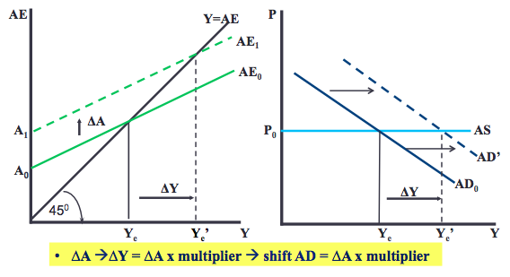

- CHAPTER 7: THE GOVERNMENT SECTOR

- Covered in this chapter:

- 1. Government in Canada
- 2. Gov. expenditure, taxes, and equilibrium real GDP
- 3. The gov.’s budget and budget balance
- 4. Fiscal policy and government budgets
- 5. Automatic and discretionary fiscal policy
- 6. The public debt and budget balance
- 7. Aggregate demand and equilibrium GDP

- Government Expenditure, Taxes, and Equilibrium GDP

  - Assume all taxes are direct taxes
    - With no indirect taxes market prices = basic prices
  - Continue to assume fixed wages, prices, int. rates, exchange rates

  - AE is now:
    - AE = C + I + G + X – IM
    - Slope AE = c(1 – t) – m
    - Direct taxes and tran. payments do not enter directly into AE

  - Govt expenditure: G = G₀ (autonomous part of AE; independent of income); govt spending on currently produced g/s
  - With govt: A₀ = C₀ + I₀ + G₀ + X₀ - IM₀
  - Net tax: direct tax – transfer payments = T_{d} – T_{r} = NT = tY
  - Net tax rate = t = ΔNT/ΔY
    - Assume net taxes proportional to national income
  - Disposable income: national income – net taxes = YD = Y – NT
  - ΔNT induced by ΔY Δslope AE Δmultiplier ΔY/ΔA

  - AE = A₀ + (c(1 – t) – m)Y

Net Taxes and Consumption

  - Net taxes reduce YD at every Y
    - YD = Y – NT = Y – tY = (1 – t)Y
  - To relate consumption expenditure to national income:
    - C = C₀ + cYD
    - C = C₀ + c(1 – t)Y

  - C is lower at every Y when t > 0
  - Δt ΔC at every Y, ΔC/Δt < 0

  - Increase in net tax rate t lowers slope of C function (lowers disposable income at every level of national income), lowers the multiplier, lowers eq output, lowers AD
  - A cut in t, Δt < 0 has the opposite effect

- 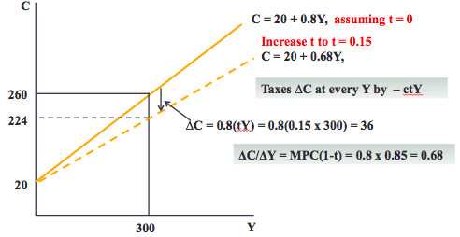

  - Recall equilibrium Y formula
    - Y_{e} = A₀ / 1 – c(1 – t) + m
    - Y_{e} = A₀ x multiplier

- Effect of ΔG on Equilibrium Y (Y_{e})

- If NT = 0, ΔG = 25
- Increase in G = Increase in AE
- ΔY_{e} = ΔAE x multiplier

- 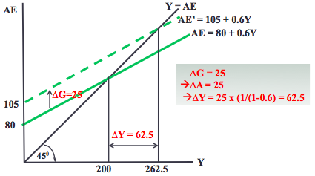

- New Govt Multiplier

- Multiplier = 1/1 – slope AE
- = 1/ 1 – c(1 – t) + m

  - m and t reduce slope of AE
  - Lower AE slope lower multiplier

- The Government Budget and Budget Balance

  - Budget: revenue and spending plan
  - Govt budget: describes what g/s the govt will buy during the coming year, what transfer payments it will make, and how it will pay for them
    - Most spending is financed by taxes, but some revenue comes from charges for services

  - Net tax revenue: NT = tY
  - Govt expenditure on g/s: G
  - Govt budget balance = revenue – expenditure
    - BB = tY – G

- The BB depends on THREE things:

  - Net tax rate (t) set by the govt
  - Level of govt expenditure (G) set by the govt
  - Level of GDP (Y) determined by AE and AD

- 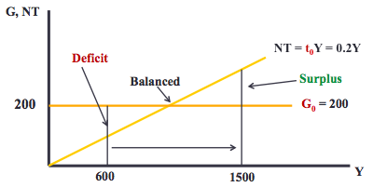

  - Surplus: tax revenues > expenditures
  - Deficits: tax revenues < expenditures (rev fall short of spending)
    - Financed by borrowing through sale of govt bonds
  - Balanced: tax revenues = expenditures

- G₀ and t₀ set by govt’s budget/fiscal plan
- So ΔY ΔBB

Fiscal Policy and Government Budget Balance

Budget function: shows different budget balances for one fiscal policy program at different levels of national income
  - Once fiscal program is set budget function is set, but budget balance is not
  - Budget balance (revenue – expenditure) depends on performance of economy in terms of national income
  - Budget function describes one fiscal plan; any change in the fiscal plan will change the BB line to show a new budget function
  - Shows that BB is smaller in recessions (when GDP is low) and higher in booms (when GDP is high)
  - Budget balance line

Fiscal policy: govt’s use of its taxes and spending powers to affect AE and Y_{e} (to offset changes in A₀ that would otherwise push economy away from equilibrium at potential output)

Fiscal Policy Objectives
  - Stabilize output by managing AD (keep Y_{e} equal or close to Y_{P})
  - Manage budget deficits and public debt
  - Reduce size and duration of business cycle fluctuations

- Fiscal Policy Instruments
  - Set net tax rate (t), both taxes and transfers
  - Set govt expenditure

- ΔFiscal Policy = ΔFiscal Plan = ΔBB function

- 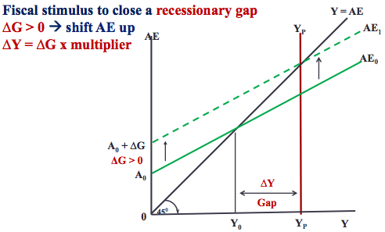

- 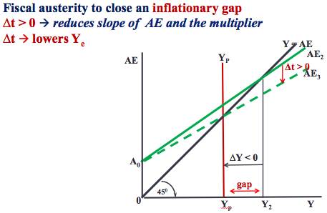

- The observed budget balance (whether surplus, balanced, or deficit) is a poor measure of govt’s policy intention or fiscal stance

- Does not show whether the fiscal policy is
  - Expansionary: aiming to raise national income or
  - Contractionary: aiming to reduce national income

- Why? Because the budget balance can change for reasons unconnected to fiscal policy
  - Any change in non-govt autonomous expenditure changes eq income, net tax revenue, and govt budget balance
  - NT = tY ΔY = ΔNT

- So, deficits or surpluses can be caused by recessions and booms rather than a change in fiscal policy

- The Structural Budget Balance (SBB)

  - Budget balance as an indicator of fiscal policy stance
  - Estimate of what the budget balance would be if economy were operating at Y_{P}
  - By evaluating at Y_{P} (fixed level of income), BB does not change as a result of business cycles fluctuations in output (recessions/booms)

  - Actual BB: an ambiguous fiscal indicator
    - ΔY and/or Δfiscal program ΔBB

  - Structural BB: SBB = BB estimated at Y_{P}
    - SBB = t₀Y_{P} – G₀
    - ΔFiscal policy program (Δt and/or ΔG₀) ΔSBB shift BF
    - ΔSBB shifts BB function = Δfiscal policy stance

  - Increase in tax rate: reduces multiplier
  - Cut in tax rate: decrease in slope of BF
    - Larger multiplier = larger change
    - Smaller multiplier = smaller change

- Automatic and Discretionary Fiscal Policy

- The budget plan sets t₀ and G₀ to give BB = t₀Y – G₀

- Automatic Fiscal Stabilizers: tax and transfer programs that reduce the size of the multiplier and the effects of transitory fluctuations in autonomous expenditures on equilibrium GDP
  - High t reduces slope of AE reduce ΔY/ΔA (multiplier)
    - High net tax rate = good automatic stabilizer
    - Reduces size of fluctuations in real GDP caused by fluctuations in A₀
  - Built into budget program by setting t in NT = tY and work automatically
  - ΔBB changes with ΔY moving along BB function
  - Income taxes and transfers (eg. unemployment benefits) also important auto stabs
  - Leakages from expenditures also auto stabs
    - Savings = lower MPC = lower multiplier
    - Imports = higher MPM = lower multiplier

- * Net tax rate = leakage

  - Automatic fiscal stabilization:
    - Net tax rate (t) reduces the size of the multiplier and the effects of transitory fluctuations in autonomous expenditures on equilibrium GDP

- However, auto stabs do not offset autonomous expenditure disturbances, they only reduce impact of the changes.
- There is no automatic change in G₀ or t these changes come from DFP

- Discretionary Fiscal Policies: Changes in net tax rates (Δt) and/or government expenditure introduced in new budget plan to offset persistent changes in autonomous expenditure
  - Eg. persistent drops in investment or exports can be offset by increase in G and/or cutting taxes
  - Export/investment boom offset by higher taxes and/or decreased govt expenditure
  - Shifts and stabilizes equilibrium GDP at Y_{P}
  - Δt and/or ΔG shift BB function ΔSBB
  - Shift AE and AD functions and Δslopes AE ΔY
  - Discretionary policy may provide stabilization but do not completely eliminate business cycle fluctuations in real world

- 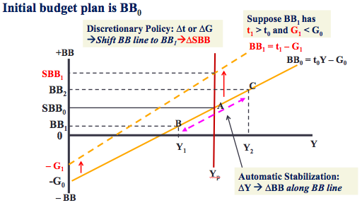

- The Public Debt and the Budget Balance

- Public debt (PD) = outstanding stock of govt bonds issued to finance deficits
  - The outstanding PD = sum of past govt budget balances; sum of borrowings – sum of repayments (result of borrowing to finance budget deficits)
    - Govts finance budget deficits by selling govt bonds to household and businesses
    - Budget surpluses reduce govt’s financing requirements
  - Annual ΔPD = -BB
    - Surplus (pos. balance BB > 0) reduces PD (ΔPD < 0)
    - Deficit (neg. balance BB< 0) increases PD (ΔPD > 0)
  - Public debt ratio = ration of outstanding govt debt to GDP = PD/Y

- Aggregate Demand and Equilibrium Output

  - Equilibrium condition is still Y = AE and AD = AS (output and income equal to planned expenditure)
  - Fluctuations in A₀ multiplied by the multiplier cause fluctuations in AD, output, income, and employment
  - Nevertheless, changes in AE are still the sources of business cycles
  - Larger multiplier = larger change or fluctuation in income and employment
  - Fall in AE = decrease (leftward shift) in AD curve

- 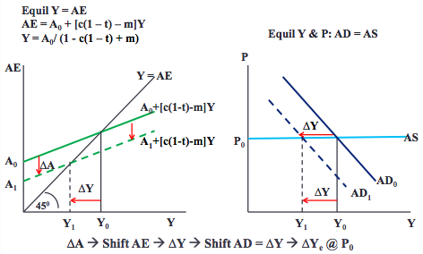

- The Multiplier in Canada

- Multiplier = 1.25

- Without taxes or imports, mult = 8.33
- Shows automatic stabilization from net tax rate and MPM (leakages)

- Higher multiplier = less stabilization

