What is an animal? Memorize******
  - Eukaryotic & multicellular
  - Heterotrophic
  - Reproduce sexually
  - Lack cell walls
  - Motile
  - Development includes gastrulation
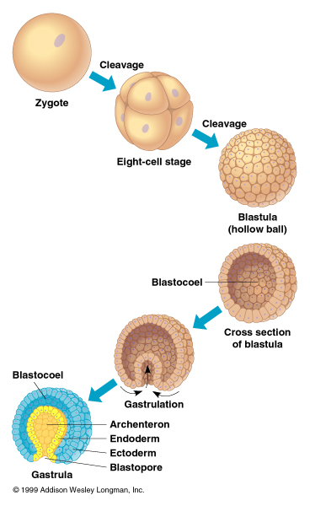
- Gastrulation

- Myoglobin
  - Sits in the muscle, regulates oxygen.
  - Muscles of diving mammals are packed with myoglobin, so their meat is dark. This is so that when they dive, oxygen is available for aerobic activity, without having to breath.
  - Myoglobin is a monomer.
  - Once oxygen is used up, lactose starts to build up. The point at when this happens is called the aerobic dive limit.
  - Knowing body mass and charge on the myoglobin, physiologist can account for 70 percent of aerobic diving limit variation.
- Krogh Principle
  - for such a large number of problems there will be some animal of choice, or a few such animals, on which it can be most conveniently studied
- Reverse-Krogh Principle – Boutilier
  - Never choose an experimental animal whose sole habitat is Cleveland, Ohio

- Isometry
  - Proportions stay the same with changes in size
    - Ie. Leg Length: Body Length doesn’t change with size
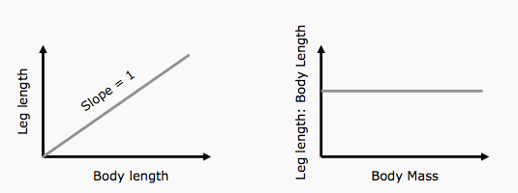

- Allometry
  - Most biological changes ARE NOT isometric
  - Scaling of a sphere - Surface Area is proportional to Volume^{2/3}
  - Scaling of Surface Area-Volume – On log scales, SA is linearly related to Volume with a slope of 2/3
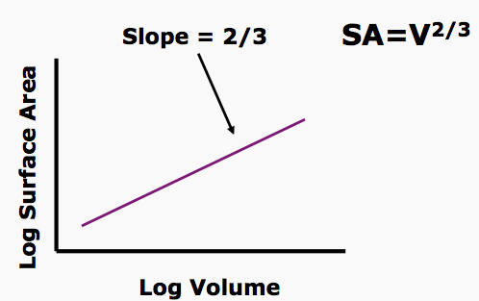

  - Surface area per unit volume – On log scales, SA/Volume is linearly related to Volume with slope of -1/3
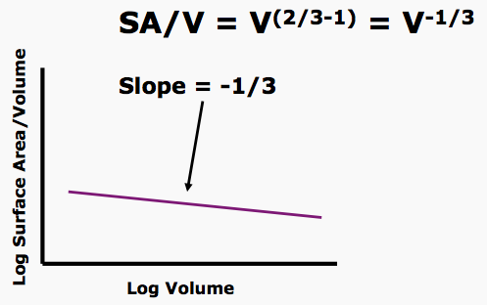

  - Lower surface area to volume ratio as the organism gets larger.
    - More heat is lost with more surface area
    - Heat will be lost faster in a small organism, since it has little mass.
    - Metabolic Rate is not directly proportional to Body Mass – BMR tapers off as mass increases, so larger organisms having lower BMR in relation to body size, exponential relationship on non log scale
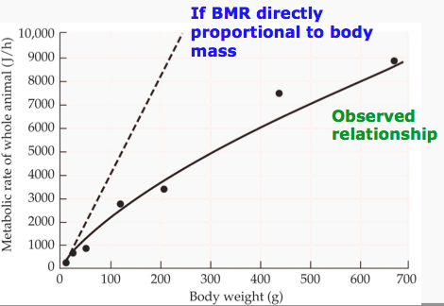

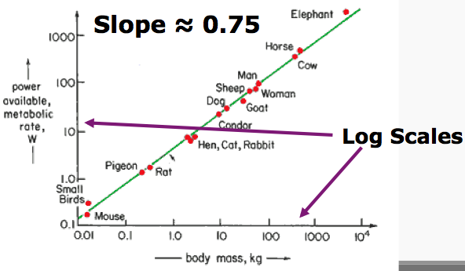
- Mouse to elephant curve shows relationship between MR and mass in a range of organisms – on log scale, so exponential relationship just as in graph above
a
b
M
W

- M = aW^{b}
- Metabolic Rate is not directly proportional to Body Mass

- Mass-specific metabolic rate
- 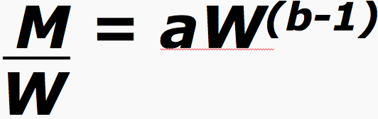
- Smaller mammals have a higher mass-specific MR (on log scale)

- 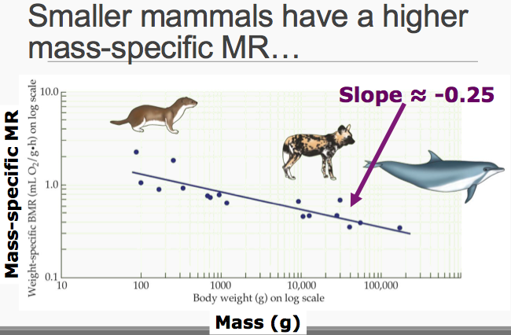
- Ectotherms will have a lower MR at any given weight because they do not regulate body temp.

- What doesn’t (necessarily) scale with body size? (Allometric)
  - Heart volume (!)
  - Biochemistry (e.g. Haemoglobin/red blood cell; Bohr effect)
  - Chemical measures (e.g. pH)
  - Electrical potentials
  - Nutritional efficiency
  - Behaviour
  - Colour

- Freshwater
  - Hyperosmotic, so there is more salt in the fish, so water flows in.
    - Pees a lot of dilute urine
    - Even though ion conc. In freshwater is low, the fish still take in ions
      - Through active transport
        - Trade bicarbonate for Cl
        - Trade protons, for Na
  - Have diuretic kidneys
    - U/P<1
    - Similar to permanently diuretic amphibian nephrons
    - High GFR (process a lot of blood)
    - Lots of nephrons ( need to excrete lots of water)
- Saltwater
  - Hyposmotic, so there is less salt in fish, so there is water rushing out.
    - Drinks a lot of water, since it loses a lot.
  - Sodium gradient set up by Sodium/potassium atpase, allows chloride build up in chloride cell, leaves by the cl channel.
  - Sodium leaves via paracellular route.
  - Kidneys
    - Ultrafiltration unimportant
    - (low GFR = low urine production)
    - Active secretion of ions and other molecules
    - Some marine fish are entirely aglomerular
      - Dependent entirely upon secretion

Ion regulation in fish
  - Occurs mainly at the gill epithelium
    - Specifically secondary lamellae, which have are rich in mitochondria
      - Top of the cell is called Apical crypt that allows local exchange of ions
  - FW Fish
    - Secondary lamellae covered in interlammelar cell mass, in normoxia, because doesn’t need much surface area to get its oxygen.
    - In hypoxia, the interlammellar cell mass is shed, to allow more lamellar SA to gain more oxygen, since less is available.
- Fish in two worlds:
  - Catadromous fishes are ones which migrate from fresh water into salt water to spawn.
    - Or stay in freshwater but go downstream to spawn
  - Anadromous fishes are ones which migrate from the sea to fresh water to spawn
    - Or stay in freshwater but go upstream to spawn
  - Euryhaline organisms are ones that can live in varying salinities.
- Parr-Smolt transition (fresh to saltwater) – Atlantic Salmon:
  - Gills
    - Shift from Ion-absorbing to Ion-excreting
    - Change in Na+/K+-ATPase α-subunit isoforms (α1a→ α1b) & upregulation
  - Kidneys
    - ↓GFR & Urine production
  - Gut
    - ↑Intestinal fluid transport
    - Mediated by increased permeability: change in aquaporin isoforms and expression levels
  - Increased drinking
  - Hormonally mediated (Cortisol, growth & thyroid hormones)
- Mummichog – Euryhaline
  - Lives in East Coast estuaries
  - Exposed to brackish (slightly salty), fresh and salt water
  - First fish in space (Skylab 3, 1973)
  - Exposed to both fresh and salt water, sometimes in quick succession (due to quick tide changes)
  - Response to transfer to freshwater
    - Gills: ↓ion loss, ↑ion uptake
      - ↓ paracellular permeability
        - Closure of paracellular junctions
        - Cell proliferation
      - ↓ active ion excretion
        - Protein internalization
        - Phosphorylation/inactivation
        - ↓ ion transporter expression (which ones? – chloride channels, sodium channels)
      - ↑ Ion absorption
        - ↑ ion transporter expression and activity (which ones? – bicarbonate chloride exhanger, sodium proton exchanger.)
      - ↓ Drinking rate by 2/3
        - Ion composition of water in intestine is maintained via ion secretion
          - Few changes in expression of ion transporter genes
      - Kidneys?
        - Increased GFR, produce more urine, also decrease conc. Of urine.

- Water Content in Food
  - Water from Urea production < uric acid production.
  - Lipids provide almost 1 to 1 per gram.
  - Carbohydrates are about half a gram of water per gram of food.
- Once an organism hits the threshold of death for a dehydrated animal, to adapt against death:
- can survive losing more water (purple)
- Can lose water more slowly ( maroon)
  - minimize respiratory, cuticle, feces and urine water loss
    - Highly concentrated urine means less water is lost.
    - mealworm cryptonephridial complex
      - production of dry faeces (malphigian tubules absorb water)
    - Must excrete water to rid N waste, cuz gas doesn’t leave fast enough
    - Spiracles in arthropods (ie caterpillars)
      - Sending blood to the spiracles in waves creates discontinuous gas exchange, which reduces it overall
    - Nasal turbinates in vertabrates
      - Increased surface area
      - Countercurrent exchange
      - Condensation, decrease EWL
    - Cuticles in insects
      - Accounts for up to 95% of water loss in insects
      - Can excrete wax to coat cuticles and reduce evaporation.
- Can carry more water (light green)
  - Females are larger, so can hold more water in general.
  - After selection by desiccation, Males go from surviving about 9 hours to about 20 hrs, females from 15 to about 50.
  - These flies carry more bulk water bound to glycogen, that’s how they survive.
  - Desert frogs and tortoises can carry water in their bladders for long periods of time.
- Can increase water along the way (dark green)
  - Namib desert beetle – water collection (stilting)
    - These organisms live in a desert, but live near the sea, so there is fog that rolls over the sand dunes.
    - The fog condenses on the beetle, and it drips down to its head, where it drinks it.
  - Pelvic patches in frogs
    - If soil is moist, frogs can absorb water through their pelvic patch.
  - Water vapour absorption - Tenebrionid beetle larvae
    - start absorbing water vapor from the atmosphere at the threshold with the purple arrow pointing to it.
    - Thin dotted line is the increasing water vapor conc.
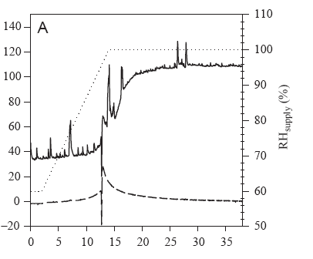

  - The mealworm cryptonephridial complex
    - Water reabsorption through the rectum. Air goes into rectum, then absorb the vapor with the hyperosmotic fluid, then transferred into the body through the malpighian tubules.
  - Springtails (folsomia) mostly live in the soil (beetle like creatures)
    - if the humidity is high, they lose water.
    - as they lose water, they produce disacchyrides called trehalose. This increases the osmolality in the blood until water is absorbed through the cuticle into the insect from vapour.

- Anhydrobiosis – life without water
- Anhydrobiotic animals are:
  - Are all small
  - Have little/no control over water loss out of their body
  - Are generally aquatic inhabitants of ephemerally wet habitats
  - All accumulate trehalose
  - All have Late Embryogenesis Abundant (LEA) proteins
- Once dry:
  - Without water there can be no biochemical reactions
  - Metabolism declines beyond detectable levels (0.01% of normal)
- Polypedilum vanderplanki (midge larva)
  - Largest known anhydrobiant
  - Requires slow drying
  - Accumulate large amounts of of trehalose
    - Has trehalose transporters for getting it form hemocoel (body cavity) to cells
  - Vitrification - is the transformation of a substance into a glass.
    - Glass formation (not crystallization) immobilizes molecules and structures in place when anhydrobiotic
    - Trehalose in the organism forms a glass.
    - No crystallization when a glass.
    - Slow vs quick larvae
      - No vitrification: no survival
    - Glass vs Rubber
      - Rubber transition at ~62 °C
        - Low – no survival above this temp.
      - Plasticise the glass with water vapour
        - WC above 10 % = decreased rubber transition temp = reduced survival
        - Note that glass-rubber transition is ~62 °C… highest temp recorded in habitat ~60 °C…
  - Water replacement
    - Trehalose hydrogen-bonds to molecules (especially in the membrane), maintaining biological structures that are normally dependent on water.
  - Larvae that are dried quickly, have a very low chance of survival after rehydration, slow have a decent percentage.
  - The quick dried larvae, are not able to build up enough trehalose.
- Steps of water replacement:
  - Initiation
    - Gene upregulation
      - LEA, Treahalose transporter, aquaporins, trehalose synthesis
    - Trehalose synthesised in FB and carried to cells via hemolymph and transporter
  - Replacement
    - Water Replacement
      - Membranes retained in crystalline state
    - Vitrification
      - Macromolecules immobilised

- Carry more water:
  - Frogs
    - A desert species, stores water in bladder and in patches under skin. Lives in Australian desert. Aborigines will pick them up, stress them (squeeze them!) and they will pee out some of the water which is so dilute it can be drunk.
    - Most frogs are capable of storing water to some extent.
- Absorbing Water
  - Behavioural
    - Forage choice
    - Stilting in Namib desert beetle
  - Physiological
    - Water vapour absorption
  - Arenivaga investigate
    - Sand dunes in California
    - Absorption by secreting high salt concentrations on bladders on the mouthparts
- Survive losing more water
  - Desert anhydrobionts are surprisingly rare
  - Crustacea, e.g. Triops
    - Polypedilum vanderplanki (Africa), but no other Polypedilum species, including in Australia
- Lose water more slowly
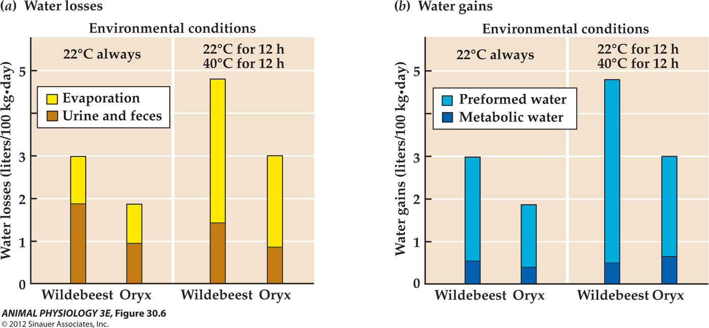

  - Increased kidney medullary thickness helps create more concentrated urine
    - Also as body weight increases (on log scale) relative medullary thickness decreases (on log scale) in a linear fashion
  - EVW minimization
    - Air is saturated with water vapour in the lungs, so must minimize water on the way out
      - Breathing out: Saturated air at 37 °C from lungs cools against cool nasal passages, water condenses
    - Decrease body temp when you can (ie. Oryx, decreases body temp overnight (in summer), and reheats over the day, so loses very little water when sleeping.
  - Brain cooling (ie in camels)
    - Blood cooled by evaporation in nasal turbinates
    - Cool blood used to cool blood incoming to brain
    - Camels DO NOT carry more water, just reduce EVW very effectively
      - Allow Tb to increase by up to 6 °C during the day
      - Dry faeces
      - Concentrated urine
        - 3200 mOsm
      - Reduced heat absorption
        - Insulation
        - Behavioural
      - Tolerates extreme water loss
        - ~40 % of body weight, cf ~15 % for humans

- Comes from degradation of proteins
- Ammonia
  - Ammonia is toxic!
  - Ammonia is corrosive!
  - Ammonia boils at -33 °C!
  - But…
    - Ammonia is highly soluble in water (urea)
    - Ammonium is (slightly) less toxic and reactive (uric acid)
- Aquatic organisms
  - can readily void Ammonia
    - Across epithelia (it’s very soluble!)
    - In copious, dilute urine = ammonotelic (excrete ammonia in soluble form not in urea)
- Urea production
  - Urea is soluble in water
  - Urea is less toxic than ammonia
  - All mammals
    - Mammalian kidneys are very efficient at concentrating Urea
  - All turtles
  - All terrestrial amphibians*
    - Frogs
      - As tadpoles, excrete soluble ammonia directly (ammonotelic)
      - As adults, excrete ammonia as urea (uricotelic)
  - Miscellaneous other animals
  - TMAO acts as a counteracting solute to urea to minimize toxic effects
- Uric Acid production
  - Requires more ATP than urea
  - All organisms have this for processing purine waste (e.g. from nucleic acids)
  - Highly insoluble (10⁻⁴ g/l at room temperature)
    - Gout, kidney stones
  - Uric acid can be excreted in a water-independent manner

- Kidney is usual route of urea excretion (except in fish)
  - Would require constant drinking (cuz have low efficiency kidneys…)
  - In brackish/sea water would lead to salt loading
  - Turtle kidneys can’t excrete monovalent cations
  - Salt gland in eye of (monophyletic) marine turtles – not present in FW turtles
  - So… need a less water-dependent route for N excretion?
    - Turtles rinse, but don’t swallow, excrete N through mouth glands
      - Urea is being actively transported across the buccal epithelium
      - Phloretin
        - Derived from apple trees
        - Inhibits glucose and urea transporters
        - So if phloretin is in mouth water, will stop any urea from being excreted from mouth, which is what happens

- Jellyfish
  - Cnidarians have a nerve net – a diffuse network where neurons interact wherever they cross one another.
  - Nerve nets are associated with radial symmetry, CNS with bilateral symmetry.
  - Nerve nets are the simplest multicellular nervous system.
  - Conduction in cnidarian nerve nets is unpolarised: it can run in either direction through the neurons.
  - A CNS coordinates the body of bilaterally-symmetrical animals, but not of sponges or radially-symmetrical animals.
  - Behaviours
    - Coordinated muscle contractions = swimming
    - Change in direction based on visual (non-prey) cues
    - Obstacle avoidance
      - Requires shape recognition
    - Modulation of swimming speed
    - Mating behavior
      - Some cubozoa have internal fertilization
    - Foraging behavior
      - Cubomedusae forage by swimming into shafts of light, and then sinking
  - Box Jellyfish (Cubozoa)
    - Most potent venom on earth (!)
    - Venom induces massive increase in K permeability
    - Kills 0-1 people per year (64 since 1883 in Australia)
    - Four rhopalia (eye type deal) provide swim pacemaker and sensory input
      - Statolith, provides information on which way is down.
      - Flap around during movement
      - In cubozoa, the rhopalia are connected directly via a compressed nerve ring
        - Includes ‘giant’ neurons connecting the rhopalia
          - Giant neurons are used for very fast conduction, which aids in coordinated contraction.
    - How does the jellyfish respond to light stimulus on these eyes?
      - A drop in light intensity increases swim pulse frequency
      - Shade: swim quickly
      - Sun: swim slowly (sink and catch stuff)
    - These jellyfish also navigate back into their mangrove habitat.. Using resolved visual cues from the upper lensed eye
- Mauthner neurons
  - activate the C-Start
  - One Mauthner Action potential = 1 AP in many different motor neurons
  - Sequence of events:
    - 1. Stimulus activates VIII cranial nerve
    - 2. Mauthner cell fires
    - 3a. Simultaneous contraction of muscles on contralateral side
    - 3b. Inhibition of contralateral Mauthner cell via interneurons
    - 3c. Inhibition of ipsilateral motor neurons
    - 3d. Inhibition of Mauthner cell that just fired
  - Fast Response
    - AP 3-5 ms after stimulus, first movement (head) ~8 ms later
    - Large axon (~100 μm and myelinated) conducts at ~ 100 m/s
      - (Largest mammalian axons ~20 micron, 80-120 m/s)
    - Mauthner neurons synapse with the largest (= fastest) motor neurons, near the spike initiating zone
    - Tendency towards electrical synapses
  - Variation
    - C-starts in prey- capture
      - Timing, strength and duration of c-starts varies.
    - During schooling, variation disappears (everyone turns in same direction)
  - Diminishing and Learning
    - Synaptic plasticity reduces the C-start response to repeated noises and other stimuli
      - Long-term potentiation via synaptic modification of both excitatory and inhibitory inputs

- Only in rorquals (whales)
- Lunge feeding:
  - Acceleration, rotation of jaws while opening
  - Incoming water inverts tongue
  - Expansion of ventral pouch
  - Coordinated, with active muscular resistance
  - Jaws close, contraction and movement of tongue to filter out food
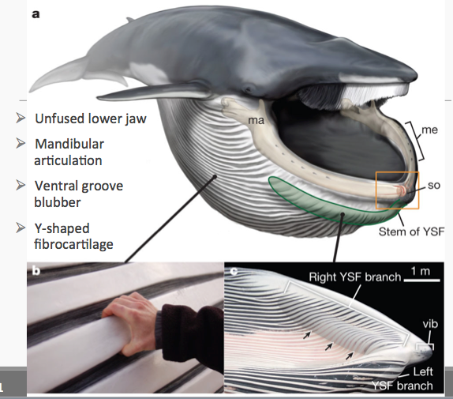
- Anatomy

  - Special organ
    - Organ is in a spheroidal cavity on dorsal side of region between symphyseal surfaces, cavity is filled with a gel-like matrix
      - Matrix supports small connective tissue papillae extending form inner surface, and that have nerves and encapsulated nerve termini
    - Position of organ allows mechanical linkages to both bony bits and (via YSF) to soft tissues
    - How it works:
      - 1) vibrissae on exterior of chin detect prey density =decision to lunge
      - 2) organ is compressed and sheared during rotation of the jaws
      - 3) full expansion of ventral pouch detected via YSF connected to the organ
        - Rorquals appear to control mouth opening and expansion rate to maximize volume captured – perhaps mediated by this organ?

- Magnetic bacteria use ‘magnetosomes’ to orient to magnetic fields
- Tenebrio molitor change orientation in different magnetic fields
- Blind cave salamanders navigate by magnetic fields
- Sticking magnets on birds’ heads disrupts navigation
- Migrating fin whales avoid areas of strong magnetic fields
- Pacific Salmon may use geomagnetic imprinting for homing
- Pigeons
  - Magnetic information is processed in vestibular nuclei in the pigeon brainstem
  - Identified regions of brain that are activated by magnetic pulse (histology)
  - Lesions in inner ear lagena receptor (vestibular otolith organ) prevented magnetic activation of a bunch of regions, including vestibular nuclei (which is the destination of the lagena afferents).
  - These vestibular cells respond to (and give directional and strength info about) magnetic field strength and direction (electrophysiology).
- Magnetite (Fe3O4) – aka Iodostone
  - Magnetization doesn’t vary across magnet
    - Smaller = superparamagnetic (direction of magnetism changes at room temperature), not stable… but do occur in humans and pigeons.
    - Larger: multidomain (magnetism varies across magnet)
  - If elongated, magnetized parallel to long axis
  - Seldom alone – usually in chains or other assemblages
  - Can form a dipole – allowing orientation, as long as magnetic energy higher than thermal energy
  - There are magnetite-containing neurons in the trout nose
  - Homing Pigeons
    - Clusters of magnetite on top of beak
- Light dependent magnetoreception
  - Light-receptive molecules can respond to magnetic fields when stimulated
  - Some species lose their magnetic orientation in the dark
    - Or when right eye is covered in some songbirds
  - Evidence in birds, alpine salamanders and other species
    - These species appear to be able to detect magnetic fields weaker than the theoretical lower limit for magnetite
  - How can light help an organism detect magnetic fields?
    - Cryptochromes
      - Absorb photon, elevated to singlet excited state…
      - …these form radical pairs – two molecules sharing a single electron
      - Singlet-triplet conversion: free electrons end up in parallel spin
      - This process is dependent on the orientation of the magnetic field
      - Eyes are necessary
        - Cryptochromes present in eyes (in pineal in salamanders)
- Sharks
  - Swim in straight lines across long distances of open ocean
  - Can detect electricity
    - Ampullae of Lorenzini
  - Is electromagnetic induction as they swim generating currents they can detect?
    - Possibly, but the Ampullae may not be long enough to detect this effect
- Thermosensory molecules
  - TRP (Transient receptor potential) family (cations) – 28 in humans
  - TRPV1 – capsaicin (heat)
  - TRPM8 – menthol (cool)
    - Work when purified and inserted back into membranes (i.e.: no protein cofactors required)
  - Anoctamin (Cl⁻)
  - TREK-1 (K⁺)
  - Rhodopsin?
    - Thermosensory behavior is modified in Rhodopsin mutants, but likely because of behavioural, rather than sensing issues.
- Thermoreception in mammalian skin
  - Thermoreception and nocioception (‘noxious’ stimuli)
  - Detecting low temperatures:
    - Cold fibers – ongoing action potentials at ‘normal’ temps
      - Firing rate decreases at lower and higher temps
      - Activated by menthol
      - Slow conduction velocity (9-15 m/s - thinly myelinated)
      - CLTMs – low-threshold mechanoreceptors
        - Transient response to a rapid (2 degC/s) temp drop
        - Primarily associated with touch
      - TRPM8 – ion channel activated below 26 degC
        - And by menthol, eucalyptol etc.
        - Cold inhibits K⁺ conductance in some neurons
    - Warm fibres
      - Unresponsive to mechanical stimuli
      - Bell-shaped discharge rate, max @ 40-43, stops at +50
      - 1 m/s
      - TRPV1, TRPV3
- Drosophila – warmth avoidance
  - requires dTRPA1
    - Expression of dTRPA1 in any neuron makes it warm-responsive
  - Different TRP channels needed for warm and cold perception
    - dTRPA1 is necessary for warm avoidance
    - TRPI necessary for cool avoidance
  - One more cold channel: Brivido – BRV1
- Vampire Bats
  - have large neurons in trigeminal ganglia with low-threshold TRPV1, to detect warm blood
- Rattlesnake IR detection
  - Pits containing a membrane expressing temperature-tuned TRP channels
  - Sensitivity dependent on the temperature of the pits
  - Connected to visual processing
  - Allow hunting prey in the dark
  - Most sensitive in rattlesnakes (all pit vipers, pythons and some others…)
  - Sensitivity increased by respiratory cooling of pit organs
  - Rattlesnake pit organs have directional sensitivity
  - Rattlesnakes use a low-temperature tuned TRPA1 for IR detection (warm detection)
- Insect IR detection
  - Acanthocnemus nigricans
    - Pit organs on thorax, directional detection of IR
    - Air-filled (= low thermal mass)
    - Analogous to rattlesnake pit organs
    - One thermally-sensitive multipolar neuron
  - Melanophila acuminate
    - Wax-filled pits lined with sensilla similar to insect mechanoreceptors
    - Heat conducted to sensilla, spherules in the sensilla expand slightly (i.e. temp is transduced to movement)
    - Lots of sensilla to increase sensitivity

- Stabilizing flight
  - Complex adjustments to maintain
    - Orientation
    - Direction
  - Requires accurate positional and rotational information
- Halteres: Fly gyroscopes
  - are small knobbed structures modified from the hindwings in some two-winged insects.
  - They are flapped rapidly and function as gyroscopes, informing the insect about rotation of the body during flight.
- What about insects that still have four wings?
  - dragonflies likely use visual cues…
  - but moths fly at night…
    - During flight, the antennae are held at a constant angle to one another
    - and rotate/vibrate at certain wingbeat frequencies
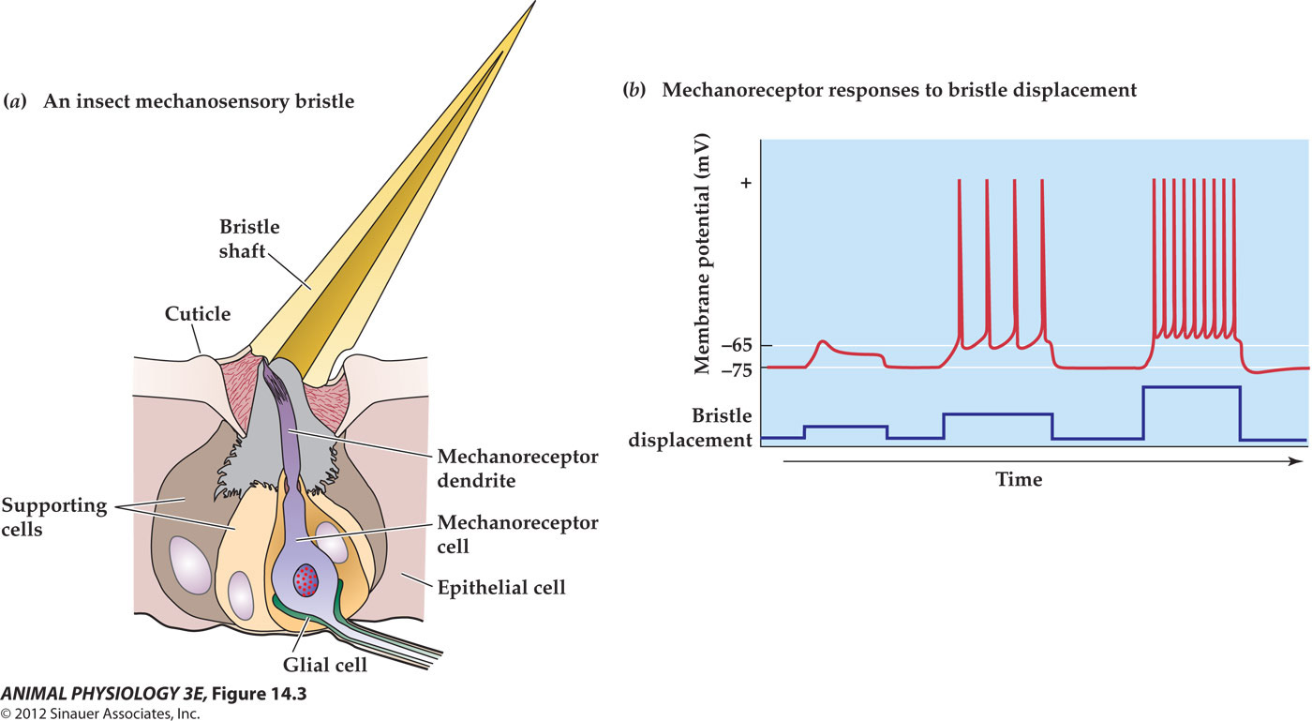
    - Insect mechanosensory bristles :

    - Is antennal rotation neurally-encoded
      - Yes, through Johnston’s organs
        - Rotation or movement of antenna is conducted through the nerve from the Johnston’s organ and relayed to the mechanosensory area of the brain
- Conclusion:
  - Moths use their antennae as gyroscopes in flight
- Holo metabolous moulting
  - Larva instars pupa adult
- Hemimetabolous moulting
  - Pronymph nymph instars adult
- PTTH (prothoracic tropic hormone)
  - Peptide hormone
  - Paired neurosecretory cells conduct signals from brain to Corpora Allata, produce PTTH
  - Needed to produce pupa
  - Also needed for eclosion (leaving from pupa) after chilling
    - Must experience cold (chilling) in order to be released from pupa.
    - If you take out prothoracic gland from chilled pupa, inject it into normal pupa (not chilled), then it develops normally as if chilled
    - If one chilled pupa is sewed to unchilled ones, all develop normally just because of the one chilled head.
- Corpora Allata
  - Secrete PTTH
  - Removal = precocious adults (adult too early)
  - Addition to juvenile = more instars
    - Therefore must be some Juvenile Hormone secreted that facilitates instar stages, but not adults
- Juvenile Hormone (JH)
  - Ensures molt as juvenile (no JH = adult)
- Endocrine pathway
  - Paired clusters of neurosecretory cells produce PTTH at the corpora allata
    - (Also produce eclosion hormones)
  - Corpora allata – is termination of neurosecretory cells
    - Also non-neural endocrine cells (JH)
  - PTTH stimulates prothoracic gland to secrete ecdysone
    - Ecdysone is converted into 20-hydroxylecdysone (20HE) in Fat body, MT and gut
  - Ecdyosone triggers ecdysis (moulting)
    - Slowly 20 HE declines
    - Triggers eclosion hormones to be secreted by brain
    - Stimulates ETH production by epitracheal glands
      - Starts stereotyped coordinated contractions associated with moulting
  - Ratio of 20HE/JH determines whether to moult into instar or adult (more JH = instar, less = adult)
    - Hemimetabolous insects: no JH in last larval instar
    - Holometabolous: JH down, Ecdysteroids up
- JH in adults?
  - Prothoracic glands degenerate in adults
  - Corpora allata produce JH, Ovaries produce 20-HE
  - JH
    - Egg development in females, accessory glands in males
  - Allatotropins – neuropeptides that stimulate JH production
  - Allatostatins – neuropeptides produced by brain that inhibit JH synthesis
- Mimics
  - Methoprene – JH mimic
    - Prevents development of larvae to adults.
    - The larger the cocoon the more silk, so treat the 6th instar larvae with JH mimic, so the larvae keep getting bigger for another couple of weeks extra, making their end cocoon bigger.
  - Farnesol – “The paper factor”
    - JH receptor agonist
    - So has similar effect as JH, so extra instars were created, no adults.
- Mammals
  - SRY – Sex-determining region on Y chromosome
  - Once there are Ovaries/Testes, sexual differentiation depends on hormonal signals.
- Birds (M:WW,F:WZ)
  - Females heterogametic
  - W Chromosome = ‘primordial gonad’ secretes estrogens
    - Proliferation of left gonad into ovary
      - (most birds only have a left ovary, but paired testes)
    - Overrides any male signals (e.g. from implanted tissue)
  - Male copulation behaviour = default
    - (takes estrogen treatment to get female behaviour, and treating females with aromatase inhibitors = male behavior)
- Sequential Hermaphrodites
  - Clownfish: mating male becomes female.
    - Protandry (change from a male to female)
  - Black Porgy: male develops into female
    - Driven by change in Aromatase expression
      - = increase in estradiol titre(conc.)
    - Estradiol feeding used in aquaculture to make more (larger) females
- Turtles
  - Male at low temps (25 Celsius)
    - And in shade
  - Female at higher temps (30.5 Celsius)
    - And in sun
    - Estradiol receptors are upregulated at feminizing temperatures at the beginning of gonadal development
  - Standard pet store turtle – red eared slider
    - Same pattern
      - 20-28.6 °C = all males, 29.4-35 °C = all females
      - Sensitive only during mid-trimester of development
  - Exogenous estradiol induces feminization at male-producing temperatures
  - Aromatase inhibitors block female development
  - Fitness
    - Males are most fit to go on to reproduce and live successfully at 27 Celsius
    - Females at 33 Celsius
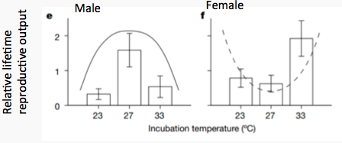
- Crocodiles
  - Female up until 31 Celsius, then start producing males, until 35 Celsius, then females again
- What is the advantage of TSD?
  - Thermal heterogeneity of nests = variation in sex ratio in the wild?
- Seasonal changes in hormonal profiles are associated with reproduction
  - Higher T in Breeding Season
- Seasonal recrudescence of testes in birds
  - Testes size increases during breeding season
  - Black headed Bunting
- Seasonal variation in aggressive behavior
  - Androgens – Testosterone (T) and dihydrotestosterone (DHT)
  - European Stonechat
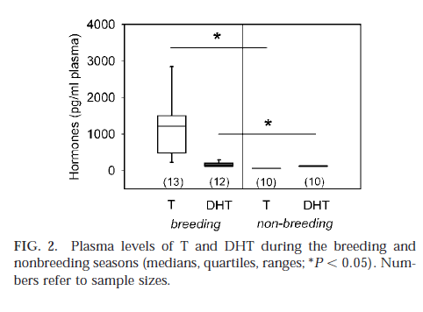
    - Androgens increase in breeding season

    - Measuring Aggression
      - Simulated terrestrial intruder (STI)
        - Measure minimum distance to indruder
        - Measure latency to first attack
    - Hormonal manipulation
      - Implants under skin, slow release
      - Flutamide inhibits androgens (T and DHT)
      - ATD inhibits aromatase (stops estrogen, the product of T breakdown, from having an effect)
    - Results
      - In breeding season exp. And cont. almost all attacked STI without implant, after implant most did not attack that were treated
      - In non-breeding season exp. And cont. almost all attacked STI with or without implant
      - Latency to attack was longer in non breeding season
      - Increased with treatment in breading season.
      - Comparison of the populations indicates that the migratory males ramp up the aggression more in the breeding season
  - Conclusions
    - Testosterone is not the sole driver of aggressive behaviour
      - But it is during the breeding season
      - More of an effect in birds with more extreme seasonal phenotypes
    - What does drive aggressive behaviour year-round?
      - Perhaps these are innate behaviours that don’t require activation because they have a selective advantage outside the breeding season?

- Photoperiod seasonality
  - Snow Hare
    - Long day breeder (during summer)
    - Short gestation (30 days til born)
    - Need to grow enough to survive winter
  - Sheep
    - Short day breeder
    - Offspring take advantage of new growth in spring to grow
  - Djungarian (Siberian) Hamster
    - Good Model – easy to handle in lab, and partially domesticated
    - Long day breeder
    - In spring and summer (March to August), darker hair, increased mass, decreased cold tolerance, increased testes size
- Genes and circadian rhythms
  - Clock gene products form dimers with BMAL1 products
    - Clock gene products trigger responses to photoperiod in rest of body
    - Also trigger transcription of PER and CRY genes
      - Form dimer and inhibit BMAL 1
      - Degrade over time, leads to less inhibition of BMAL1
      - With less inhibition on BMAL1, rev-erb alpha is positively fed by BMAL1, which is a transcription factor for BMAL1, so it has its own positive feedback.
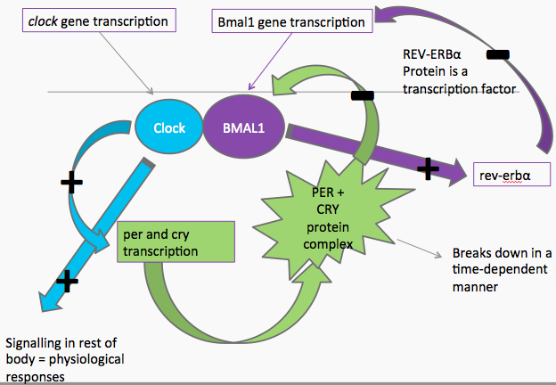
      - With BMAL1 increasing its activity, forms more dimers with Clock, which starts the whole cycle over again

- Suprachiasmatic Nuclei (SCN)
  - Contains cells that do timekeeping
  - If removed, circadian rhythm breaks down
- Day length cue pathway
  - Light in eye, triggers SCN, and Hypothalamus separately
  - Hypothalamus, triggers pineal gland to release less melatonin
- Melatonin Cycles
  - Retinal cells that sense light are not normal visual cells
    - ‘Blind’ animals like blind mole rat still respond to photoperiod
    - Specific opsin molecules (melanopsin)
  - In the pineal, melatonin production is controlled by
    - Light-dependent control of NAT (rodents)
      - (n-acetyl transferase, the rate limiting enzyme in production of melatonin)
    - Light-dependent breakdown of NAT (ungulates)
  - So if there is light, in rodents, there is less NAT activity and less melatonin, and in ungulates, NAT is broken down, so less melatonin
  - Animals know what time of day it is and what season it is, based on melatonin levels.
    - More melatonin in general means its night
    - More melatonin length at high levels, means it is winter because longer nights
  - Melatonin signals are decoded in the pituitary gland
    - Calendar cells measure length of melatonin burst against clock gene cycles
    - Then regulate pituitary production of (e.g.) gonadotropin, luteinising hormone, leptin, prolactin etc. that control seasonal endocrine changes.
    - Effects are species specific ie. Long days stimulate sex hormone release in hamsters but not sheep and vice versa
- HPG axis
  - Stimulates ovulation in females
  - Stimulates sperm production in males
- Reproduction deactivated with short days in hamsters (<12.5 hours of light), GnRH levels decrease
- Kisspeptin
  - Peptide encoded by KISS1
  - Binds to GPR54
    - Which then interacts with hypothalamic GnRH neurons to increase sex hormone release
  - Seasonality
    - KISS1 expression low with short days in hamsters
    - High in long days, and short day refractory hamsters when sex drive is trying to be reactivated
  - Testosterone does not have a direct affect on Kisspeptin levels, seems the other way around
    - but castration increases Kisspeptin levels
  - Excision of pineal gland, also increases kisspeptin levels
    - Means that pineal gland inhibits kisspeptin by melatonin, which is responsive to daylight
      - So less light, equals more melatonin, equals less kisspeptin, equals less GnRH release
  - Injection of Kisspeptin increases GnRH release regardless of sunlight, so kisspeptin is downstream, closer to GnRH release.
- HPG axis
  - Hypothalumus, pituitary, gonadal axis
- HPA axis
  - Hypothalamus, pituitary, adrenal axis
- Can sample steroids in fecal matter
- Baboons
  - Rank and glucocorticoid and testosterone levels were measured
  - Hypothesis
    - Testosterone
      - High in dominant males, especially during hierarchy instability
    - Glucocorticoids
      - Generally low in stable hierarchies
      - Increase in unstable hierarchies
  - Results – its stressful at the top
    - high-ranking males had higher testosterone and lower glucocorticoid levels than other males, regardless of hierarchy stability.
    - Exception
      - singular exception was for the highest-ranking (alpha) males, who exhibited both high testosterone and high glucocorticoid levels in both stable and unstable groups.
- Gouldian Finch
  - Two morphs, red and black
  - Female is choosy sex
    - Females prefer males with the same coloured head
    - Male offspring of Red-Black matings have 40% higher mortality than same-colour matings
      - Enforced red-black females produce more male offspring to compensate
      - Even black females will produce normal M:F ratio if paired with a dyed red male(actually black)
  - Measured corticosterone levels
    - Females socially paired with low-quality males delay the onset of reproduction and have a higher level of circulating corticosterone.
    - The physiological response to partner quality is the same regardless of whether the female chooses her own partner (from a limited pool in the aviary) or has no choice at all.
    - The physiological stress response to partner quality was both rapid (within hours of receiving a partner) and prolonged (sustained for many weeks).
      - The speed of the response suggests that the hormonal response was not driven by indirect effects of male behaviour on the female, but rather by her initial perception of him.
- Red eyed squirrels – pop. Density and pup growth rate
  - In fluctuating environments, mothers may enhance the fitness of their offspring by adjusting offspring phenotypes to match the environment they will experience at independence.
  - Selection favors faster-growing offspring under high-density conditions.
  - We show that exposing mothers to high-density cues, accomplished via playbacks of territorial vocalizations, led to increased offspring growth rates in the absence of additional food resources.
    - Experimental elevation of actual and perceived density induced higher maternal glucocorticoid levels
  - Females with naturally or experimentally increased glucocorticoids produced offspring that grew faster than controls.
- Blue Whale
  - Earplug reveals lifetime contaminant exposure and hormone profiles
  - (i) lipophilic compounds accumulate in cerumen (wax rings);
  - (ii) contaminants and hormones that accumulate in the cerumen lamina are chronologically archived;
  - (iii) trace analysis techniques can be used to measure contaminants and hormones in individual lamina; and
  - (iv) by combining chemical concentrations from individual lamina, we can reconstruct lifetime profiles for an individual whale (i.e., birth to death).

Endangered frogs – pee analysis
  - Maud Island frog
  - Hormones measured
    - Estrone (primary estrogen)
    - Testosterone
    - Progesterone
  - Estrone levels measured females 10X better than males
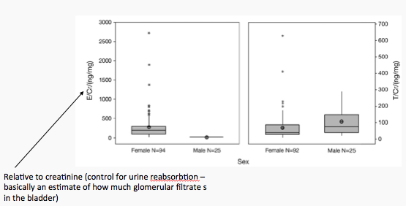
  - Testosterone levels measured males better than females

  - Testosterone metabolites in males and estrone and progesterone metabolites in females were at their peak during winter for both wild and captive frogs.
    - implies unexpected winter or early spring breeding in L. pakeka.
  - Overall, these results demonstrate use of urinary hormone metabolites for reproductive monitoring and sex identification in one of the world’s most threatened and evolutionarily distinct amphibians.
- Discovery of GnIH
  - An RF-amide neuropeptide
  - Discovered originally in clams
  - A survey of RF-amide neuropeptides in Japanese quail brains revealed a novel RF-amide, subsequently shown to inhibit GnRH release in quail anterior pituitaries in vitro
- Mammals?
  - Finding a GnIH neuron
    - Assumption: GnIH in birds and mammals will be homologous
      - therefore can use bird GnIH to find the appropriate hormone
      - Use a rabbit anti-white-crowned sparrow GnIH antibody
        - GnIH-ir = GnRH immunoreactive
    - Slice up brains, apply antibody, then stain with fluorescently-labelled Goat anti-rabbit
  - GnIH-expressing cells are only in the dorsomedial nucleus of the hypothalamus (DMH)
    - DMH is involved with responses to external stimuli
      - DMH lesions prevent seasonal onset of reproductive senescence in Syrian hamsters
        - Thought to be mediated by steroid feedback
  - The same cells that are immunoreactive are also producing GnIH mRNA
  - GnIH inhibits LH secretion
    - Hamsters = good model because very regular cycles of hormone secretion

  - D is when GnIH injected Intracranially
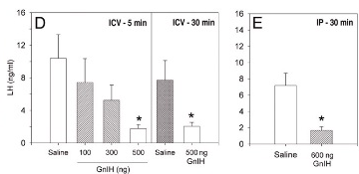
  - E is when GnIH injected Intraperitoneally (body)

  - To test if GnIH neurons interact with sex hormones
    - Take out ovaries of females (ovarectomised)
    - Inject with estradiol
    - If GnIH neurons activated = FOS expression
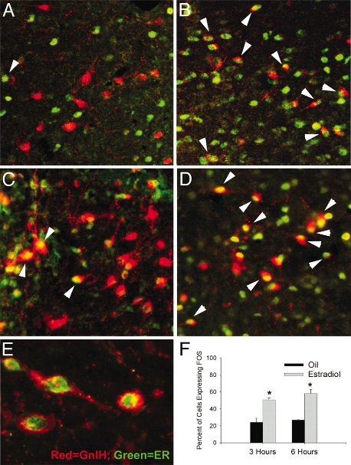
      - Did indeed get activated

  - But is this because there are estrogen receptors there, or because there is an upstream signal?
    - Double-label immunofluorescence was used to colabel GnIH cells and ERα.
      - ERα is expressed in a subset of GnIH cells in female hamsters, suggesting direct actions of estradiol on GnIH cell activation.

- Conclusions
  - There are GnIH neurons in the brain
    - These neurons talk to the GnRH neurons
  - GnIH inhibits GnRH release
  - Negative feedback on GnRH by estradiol is mediated by the GnIH neurons

- True hibernation:
  - A form of controlled hypothermia in which the body temperature is able to approximate ambient temperature continuously for two or more consecutive days during winter
- Ground squirrel
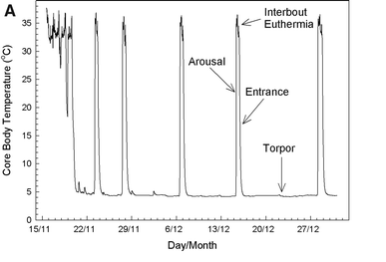
  - Phases of hibernation:
    - Arousal is when in torpor, the squirrel then approaches normal temp
    - Interbout euthermia, is at normal temp, before the entrance phase which approaches torpor again
    - Torpor is hibernation
  - Is MR low because of low body temperature?
    - No, When it becomes winter, metabolic rate drops before body temp, so is not necessarily dependent on body temp.
  - Body MR is significantly lower in torpor than normally, both in summer active state and normothermic state
  - Tb and MR during hibernation
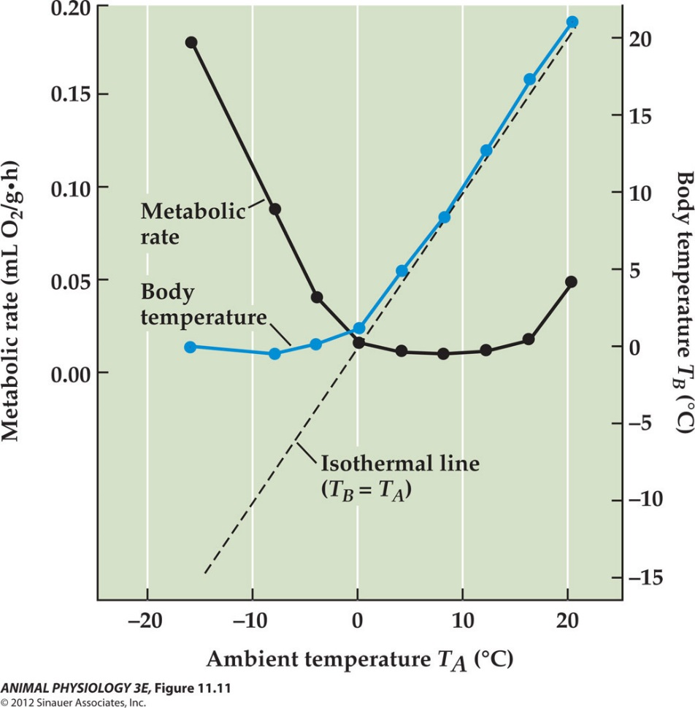
    - Arctic ground squirrels appear like poikilotherms, body temp dropping on the isothermal line, until about 0 degrees, where both MR and body temp plateu.
    - 0 degrees is the new set Tb point during hibernation
- Diet before hibernation
  - Ground squirrels and other animals that hibernate in winter, tend to curb their diet to eat a lot of polyunsaturated fatty acid (PUFA), to provide more energy for winter.
  - When animals were fed only SFA diet in winter:
    - Some didn’t hibernate
    - Didn’t lower Tb enough
    - Had higher MR
    - Hibernated for a shorter amount of time
  - This means that they need PUFA diet to be able to hibernate properly in winter.
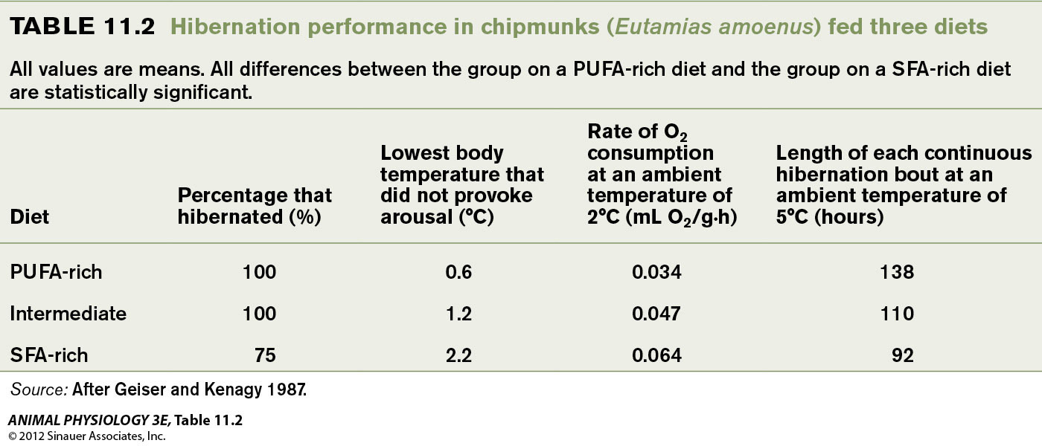

- Arousal
  - Thermogenesis, increasing MR, is inititiated periodically by brown adipose tissue (induces shivering), until it takes a big increase back to normal. Then Body temp follows.
  - Extremely energetically expensive
    - Up to 80% of entire winter energy costs.
  - Why do it?
    - To pee
      - Nitrogenous waste, increase GFR etc.
    - Immune function (fight off invaders)
      - Some bacteria do fine in cold
      - Detection? Or activity?
      - Fever…
    - Sleep (they don’t sleep in hibernation)
      - Or rewiring/maintaining synapses
- Bears
  - Bears do hibernate
  - Heart rate & breathing decreased in hibernation
    - EMG of muscles, shows muscles don’t do anything except for quick spurts at breaths
  - Bears show decreases in MR and T_{b} in a pattern similar to ‘true’ hibernation
    - However, sharp decrease in MR (top)
    - Much slower following of body temp (bottom).
    - 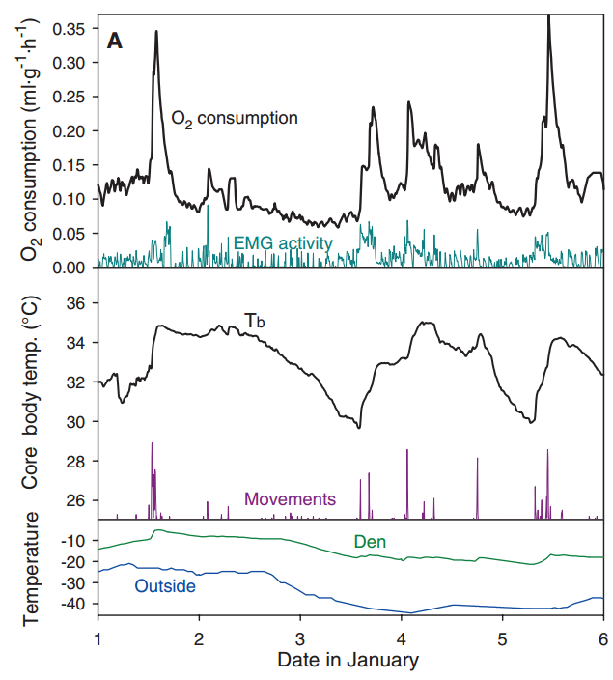
  - Conclusion – bears do hibernate
    - Decrease in MR followed by decrease in T_{b}
    - Arousals
    - High T_{b} likely because of thermal inertia (and perhaps reducing costs of rewarming)

- Ants increase their speed logarithmically with temperature (increases but starts to level off at high temp.)
- Q10
  - The Q₁₀ temperature coefficient is a measure of the rate of change of a biological or chemical system as a consequence of increasing the temperature by 10 °C
- Thermal adaptation of enzymes
  - Modification of structure/flexibility to optimize ligand binding/release
  - Trade-offs
    - Increase binding to a point, then too flexible to bind at all
  - Km
    - ½ Vmax = 1/Enzyme-substrate binding affinity
  - Kcat
    - Rate of substrate processing by the enzyme
      - E.g. reactions/s; molecules/s
  - Kcat/Km ~efficiency
- Km Preservation
  - Keeping Km (good efficiency range) over longer temp.
  - Km preservation is usually through selection at residues outside of the active site
- Thermal performance curve (TPC)
  - Performance declines either side of an ‘optimum’ temperature
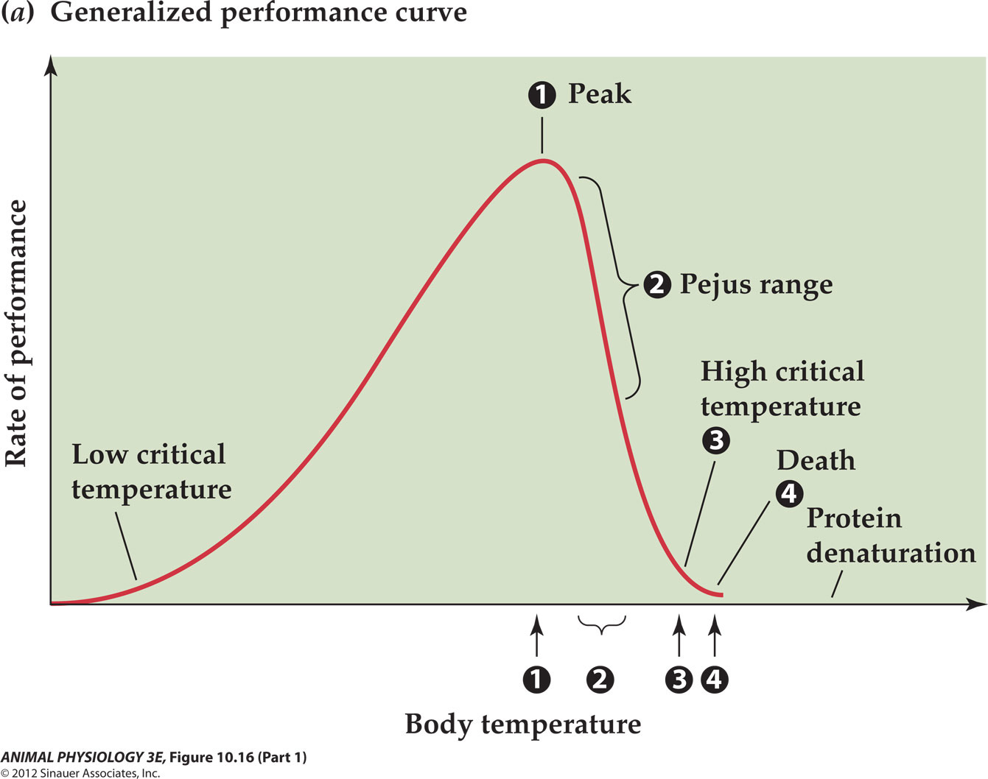

  - How can organisms change their thermal performance
  - 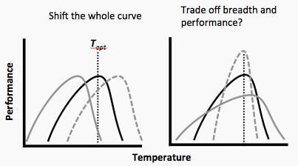
  - It doesn’t really matter what is on the Y-axis of the performance curve, as long as it is some type of performance, it will follow the curve
- Thermal developmental reaction norm curve (TDRN)
  - TDRN is measured among individuals as the final value of a trait (e.g., fecundity, size, or body composition) after a longer period of development at divergent environmental temperatures
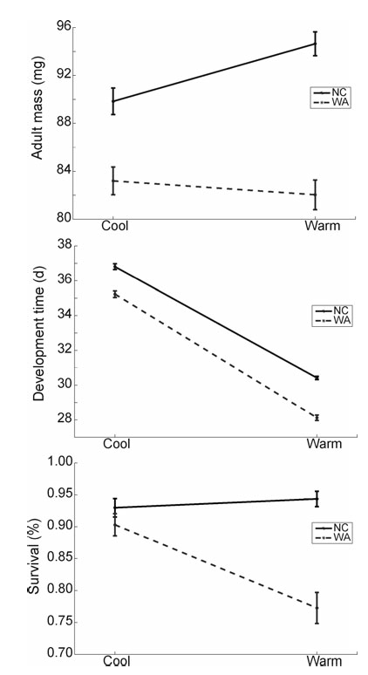

- Why is suboptimal Tb range optimal?
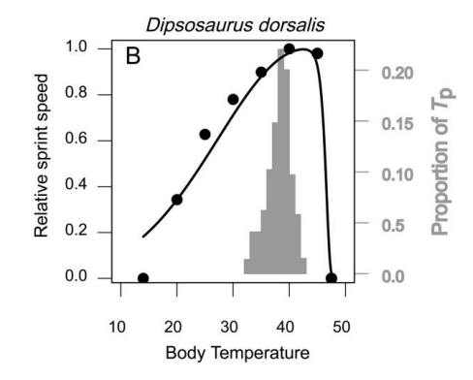

  - Body temperature (T_{b}) profoundly affects the fitness of ectotherms. Many ectotherms use behavior to control T_{b} within narrow levels. These temperatures are assumed to be optimal and therefore to match body temperatures ( ) that maximize fitness (r).
  - found that optimal body temperature (T_{o}) should not be centered at but shifted to a lower temperature.
  - This finding seems paradoxical but results from two considerations relating to Jensen’s inequality:
    - First, ectotherms are not perfect thermoregulators and so experience a range of T_{b}.
    - Second, temperature‐fitness curves are asymmetric, such that a T_{b} higher than depresses fitness more than will a T_{b} displaced an equivalent amount below .
- The effects of Jensen's inequality and thermal sensitivity on ectotherm metabolic rate under fluctuating temperatures.
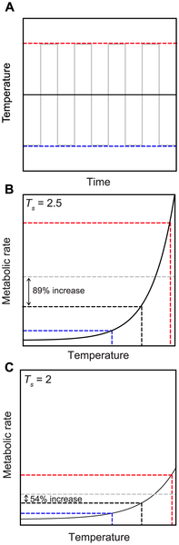
  - The gray dotted line shows the mean value of metabolic rate under the fluctuating regime, which is 89% higher than the mean value of metabolic rate under the constant regime. (C) The same curve (from equation 1) but with lower thermal sensitivity (T_{s} = 2), showing that the increase in mean metabolic rate imposed by thermal variability is reduced to 54% when thermal sensitivity is decreased compared to (B)
  - Basically, with reduced thermal sensitivity, the steepness of the curve is reduced, which in turn decreases the difference between a fluctuating temperature mean and a constant mean
    - Since a fluctuating temp around a certain temp will hit a high half the time and a low half the time, it will average out on the metabolic axis, however, when brought back down to the temp axis, the mean appears higher than if that temp was constant, because the slope is steeper on the high end, therefore having a larger increase above the mean on the metabolic side.
    - Therefore to increase fitness, you want a lower thermal sensitivity, therefore a lower Q10, which can be accomplished by lowering MR rate.
- Jensen’s inequality on a curvy line
  - Top is over long time range
  - Bottom is short time range representing one dip
  - Basically with a larger fluctuation, will be a larger increase between actual mean MR and the mean MR, if the temp it was fluctuating around was kept constant
  - So, when organisms have to experience a large temp range, it increases their overall metabolic demand.

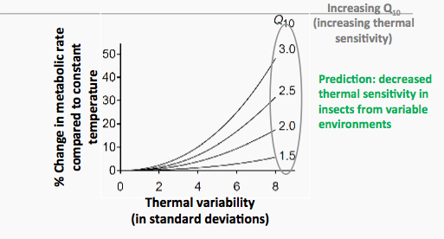

  - A Summary graph relating Q10, change in MR from actual compared to constant, and thermal variability (aka thermal sensititivity)
- Experiment:
  - Use Propertius duskywing, a butterfly which occurs down the west coast of north America across a considerable gradient in variability.
  - Used populations from VI and OR. These study sites are characterised by similar mean temps over winter but very different daily thermal amplitudes.
- Prediction: decreased thermal sensitivity in insects from variable environments
  - Found, Caterpillars from variable environments, or that experience variable environments, have decreased thermal sensitivity of metabolic rate
  - However, Metabolic suppression does not fully compensate for thermal variability
    - Even if the caterpillars suppress met rate, there is still more energy demand in a variable environment.
  - Also, Fall is the time of greatest energy expenditure (preparing for winter, lot’s of temp variability, ie hot then cold until it stays cold consistently)s
- Heat shock response
  - Tissières et al. 1974 (J. Molecular Biology) showed that the puffs were associated with protein production
    - Sequences, promoters etc. worked out… but function as chaperones only understood in 1980s!
  - Dealing with damaged proteins
    - Refold proteins (heat shock proteins)
    - Ubiquitinate and dispose of irreversibly damaged proteins
    - Make new replacement proteins
  - Heat shock proteins
    - Basic function: protein folding
    - Molecular chaperones
      - Prevent inappropriate interactions pre-folding
      - Hsp70: binds to hydrophobic sites (prevents aggregation with other proteins)
        - Released with ATP, allowing folding
        - Protein folding may be a major energetic cost of cellular function…
    - Work in teams:
      - E.g. hsp90 +hsp70+Hdj-1 (=hsp40)+ATP
- Response cycle (Hsp70, Hsp90 and HSF1)
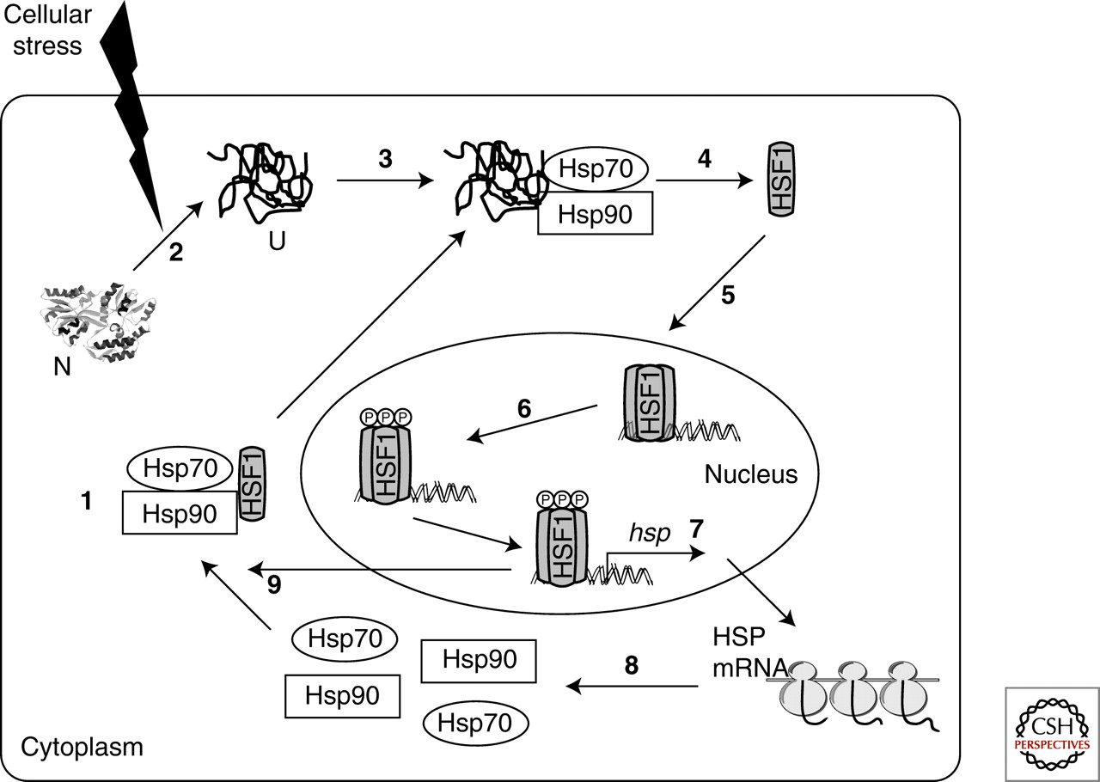
  - HSP70 and HSP90 bound to HSF (heat shock factor) to help repair enzyme damage from cellular stress.
  - After reaction, HSF gets re-triphosphorylated in the nucleus, then either:
    - binds to dna to produce more HSP Mrna,
    - or bind to the HSPs later on.
- Snail experiment
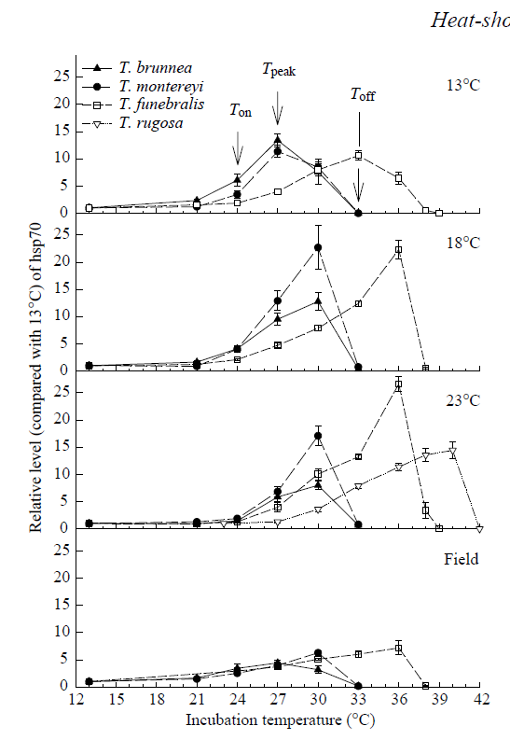
  - T. Funebralis above tide line, so exposed to warmer temps. Overall and larger variation
  - T. Brunnea below tide line, so exposed to less variation
  - Used robosnails to test temps exposed to, confirmed.
  - Results
    - Graph shows laboratory acclimation at 13 °C,18 °C and 23 °C for 30–34 days and ﬁeld acclimatization
    - Acclimation and evolution both affect sensitivity to heat shock
    - T. Funebralis acclimatized, shown by increased HSP70 expression when above 13 degrees, but still started production late, at about 21 degrees like normal, but the peak was higher, and came earlier compared to the field
    - T. Brunnea acclimatized by having a higher peak, earlier, but also started production at the same temp as normal.
- Drosophila experiment – HSP70 and development
  - When they had to spend a lot of energy on heat shock, they didn’t develop properly, eg. Messed up wing, or structural assymetry.
  - More abnormal flies were found in the unshaded flies.
    - Because were exposed to more sun, higher temp and needed to use more HSP70 which costs a lot of energy
  - Genetic manipulation
    - HSP70 gene either excised (slower and less production) or copied (more and faster production)
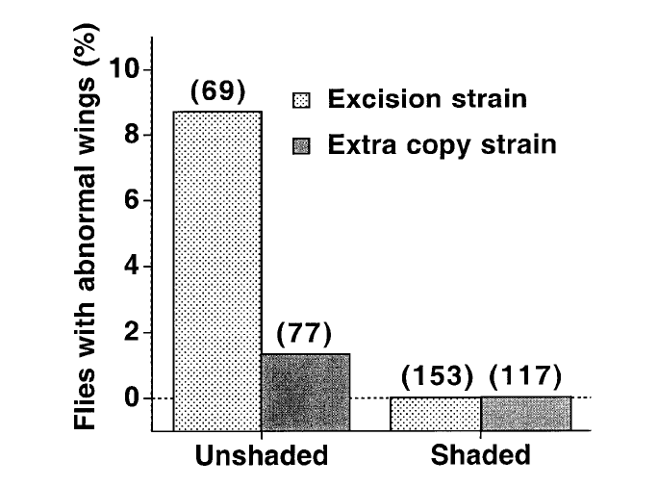
      - In shaded flies, the manipulation did not affect anything because they were not required to react to heat shock
      - In unshaded flies, excision were extremely abnormal, and extra copies were not as affected, as expected
- Antarctic fishes experiment
  - Know that they don’t upregulate HSP70, obviously cuz don’t have to at such low temps
  - Test if they actually can or not
    - Can’t
      - Exposed to cadmium, which affects enzyme stability, and they could not upregulate hsp70 to repair.
      - So they have lost the ability over evolutionary time to deal with heat stress, so they are stuck in the arctic and cannot live somewhere warmer.
      - Since it is so hard to keep proteins stable at these low temps, they actually have constitutive expression of HSC70 (cold repair protein) and are almost constantly refolding proteins, so life is expensive down there.
- HSPs in humans when exercising
  - HSP70 upregulated after exercise in mammalian muscle
    - Is this because muscle gets hot?
      - No, no increase in HSP amount if exercise at higher ambient temps, even though muscle is hotter
        - This suggests that in mammals, HSP production is not associated with temperature, it responds only to damage caused by exercise.

- Female takes a blood meal before every clutch of eggs
- Problem: blood feeding increase Tb and therefore heat shock
  - Feeding elicits a heat shock response – primarily in the gut
  - Is hsp70 upregulated because of the blood, or because of the heat?
    - Tested expression of HSP70 with heated saline injections or with cold blood
      - Showed that it was indeed the heat that elicited the heat shock response
  - Conclusions
    - Blood feeding is a heat shock, and elicits a HS response in the midgut
    - The response is specifically to temperature, and not to any components in the blood
    - The HS response is necessary to preserve digestion of the blood
    - Blocking the HS response decreases reproductive output and therefore fitness
      - When RNA interference is used to suppress expression of hsp70, protein digestion of the blood meal is impaired, leading to production of fewer eggs.

- How can we study physiology of extinct species:
  - Infer from colosely-related species
    - Only works if similar species around
    - We can use some birds, but they are much smaller than most dinosaurs
  - Ancient DNA (and proteins)
    - We can sequence this, but it only lasts so long since it is organic material.
- What is homeothermic endothermy?
  - Makes its own body heat, and also regulates it at a certain range.
- Given an extant animal, how would you determine that it is a homeothermic endotherm
  - Homethermic test- test (rectal temp) at a range of different temperatures and see if it can maintain a body temp
  - Endotherm test – eliminate all external heat sources and see if it can still maintain a body temperature.
- We KNOW that some dinosaurs are endotherms
- The main arguments in favour of homeothermic endothermy in (non-avian) dinosaurs
  - Circumstantial evidence
    - Polar dinosaurs
      - There have been dinosaurs found at the poles (were still poles even back then)
      - So it was dark for 6 months of the year. Temp would have been around 2 degrees year round, so not warm.
      - Reptiles currently don’t do so well in cool temps. So seems they may have to have been endothermic homeotherms to survive.
    - Growth rate
      - Dinosaurs had extreme teenage growth spurts, which is too fast to fit a reptilian growth model (aka must be endothermic because reptiles are mostly exothermic)
    - Scaling of aerobic metabolism
      - Increased size compromises aerobic power generation in large ectotherms… so endothermy is necessary beyond a certain size
      - Experiment:
        - Measured power output of various masses of crocodiles vs mammals
        - Could split up power that was aerobic vs anaerobic
        - They could not produce enough aerobic power at high weights, so must have been endothermic to maintain muscle heat to produce enough power to move around.
    - Blood pressure requirements of long necks
      - Having a long neck requires endotherm-like heart and blood pressure
        - or at least, the high blood pressure would require a 4-chambered heart and could support endothermy
          - If you don’t have a 4 chambered heart then you would blow out all the capillaries in your lungs with such a high blood pressure.
    - Biomechanics of running
      - Studying the morphology of the hips and limbs and spread of footprints etc.
      - Need a certain power output to move with these biomechanical measures.
      - Power output cannot only reach a certain range if endothermic.
  - Morphological evidence
    - Feathers
      - Small dinosaurs were insulated (had feathers)… but large ones were not
        - So large would need endothermy to maintain a liveable body temp.
    - Haversian canal size
      - Haversian canals are holes in bones, that can regulate inner bone nutrients etc.
      - Measured haversian canals across species. A is a turtle, b is a komodo dragon (large lizard), c is a wallaroo (mammal), d is a dinosaur.
      - Non varanid reptiles (turtles( are in blue, with lower blood flow per body size
      - Varanid like the komodo dragon, and mammals have higher blood flow per body size.
      - But dinosaurs have the highest. Since they are even more on the extreme end, they may have to have been endothermic homeotherms to move blood enough.
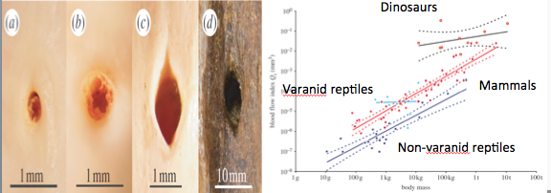
    - Evidence of body temperature
      - Models of heat loss and body size (gigantothermy) – evidence of homeothermy
        - Gigantothermy - When you are so big, it takes a really long time to lose heat.
      - Oxygen isotope ratios
        - Oxygen isotopic ratios
          - Depend on body water and body temperature at time of bone deposition
        - Varanid lizards: deposition over 10-15 degC range of Tb
        - Dinosaurs 2-7 in core and 3-8 in periphery (some regional heterothermy?)
        - Suggests stable body temperatures = homeothermy
          - Recent oxygen isotopic ratios indicate that big dinosaurs may have thermoregulated *below* the expected level from Gillooly’s model = homeothermy?!
            - Suggests that dinosaurs were warm blooded and regulating below what is expected.
            - May have spent a lot of energy to lose heat.
  - Some arguments against homeothermic endothermy in dinosaurs…
    - No nasal turbinates?
      - Normally prevent water loss. If they had to breathe enough to regulate homeothermy, they would lose too much water.
    - Bone structure: seasonal rings
      - Growth rings (lines of arrested growth:LAGs) suggest ecotherms, because the rings are caused by seasonal arrest of growth.
      - May be hibernation though, cuz bears also show these lines.
    - Is dinosaur physiology really incompatible with scaled-up reptiles?
      - Most projected dinosaur physiologies are consistent with scaled-up reptile physiology…
- End Notes:
  - Among all this, we may be putting dinosaurs into extant boses, when their metabolism was something different because of:
    - Low RMR, high scope
    - Gigantothermy
    - Intermediate metabolism

- Measuring performance in the cold
  - CCO (chill coma onset)
  - CCR (chill coma recovery)
    - Easy to measure
    - Non-lethal
    - (generally) Strong correlations with other measures of cold tolerance
    - Ecologically-relevant
    - Have a strong parallel with Ct_{max}
    - Allows calculation of thermal windows, prediction of distribution, response to climate change etc.
  - What causes a chill coma/recovery?
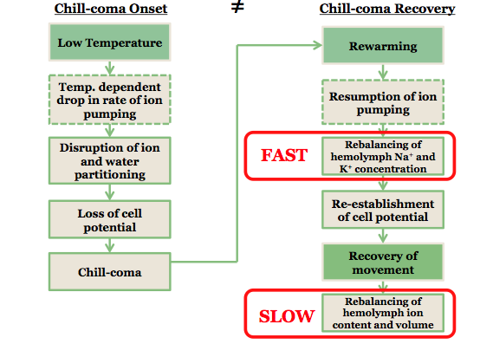

- Conclusions
  - Chill coma onset is caused by movement of Na⁺ and water to the gut
  - Chill coma recovery happens when normal concentrations are returned
    - But return to ‘normal’ takes a lot longer
  - Variation in chill coma onset associated with
    - Maintenance of ion homeostasis at low temperatures (crickets)
    - Changes in steady-state ion concentrations (flies)
      - Maintain K⁺ homeostasis in the cold...
      - perhaps by depressing the thermal sensitivity of the sodium pump
- Tolo Toucan Bill
  - Bill length = Body Length
  - Bill area = 40% of total body surface area
  - Hollow, but not dead tissue
- Thermal windows
  - capable of being “opened” within and above the thermal neutral zone and “closed” to conserve metabolic heat at lower temperatures
  - Useful thermal windows have adjustable blood flow
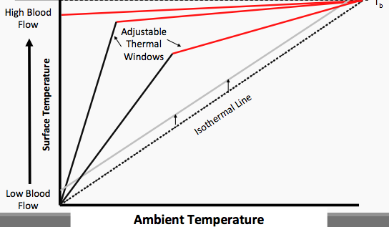

  - Hypothesis
    - Heat loss from the bill can be altered to:
      - increase overall heat loss at high temperatures
      - promote heat conservation at low temperatures
      - promote heat loss at constant temperature
  - Results
    - he proximal region of the bill was used mainly to dump heat at lower T_{a} (>16° to 25°C), and as temperature rose, the distal region began to receive increased blood flow, becoming warmer, helping the bird cope with the extra heat load.
    - Toucan bills might be the best thermal windows ever measured
  - Preventing dangerous heat loss
    - capacity for heat loss might become a liability at low temperatures.
    - toucans and toucanets are well known for tucking their bills beneath their wings and orienting their tail feathers rostrally during sleep
      - this posture increases insulation of the bill and mitigates heat loss incurred during sleep.
  - Flying toucans dump heat created by activity
  - Baby toucans grow bills fast
    - Changes in bill length follow a moderate trajectory during the first 4 to 5 weeks of life,
    - Thereafter, when the juvenile attains nearly 80% of its adult mass, the bill exhibits more rapid allometric growth
  - baby toucans are lousy at retaining heat
    - Heat loss in growing toucans may restrict them to the tropics and sub-tropics

- Sockeye Salmon lifecycle:
  - Lay eggs in freshwater
  - Hatch into Alevin, feed off yolk sac
  - Molt into Fry
  - Develop into Parr
  - Develop into Smolt – Head out to sea
- Objective – To see how climate change will affect salmon
  - Currently experiencing increasing temperatures fairly steadily over the past 50 years
- Limiting factors in performance
  - Aerobic scope
    - Decreases with increasing temperature, so fitness is decreased
    - The thing that limits fish at high temperatures is the availability of oxygen, and how well they can use it.
    - Oxygen- and capacity-limitation of thermal tolerance (OCLTT)
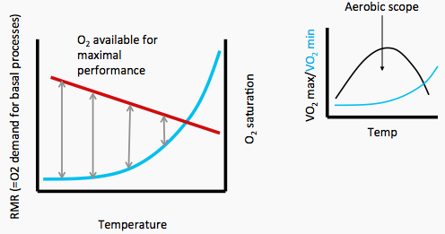

    - Above, the grey arrows indicate shrining aerobic scope, and aerobic scope is indicated on the right as well in terms of VO2 max.
    - Aerobic scope is really important for migrating salmon
      - Many salmon have to swim along way to hatch eggs.
- Study Fraser River Sockeye populations
  - Near base of the river (ie Weaver or Harrison), it is closer to the sea, so less distance to travel requires less aerobic output, also the water is still cool enough from the sea, so that overall aerobic stress is minimal
  - Far away from the base, Ie. Early stuart, they must travel great distance, and the water is warmer, so less O2 available. Therefore aerobic stress is extremely high.
- Hypothesis
  - Local adaptation among populations driven by migration conditions
    - Expect greater aerobic capacity in more ‘athletic’ populations
  - Expect populations with higher aerobic scope to have better thermal tolerance (OCLTT)

Experiment Design
  - Catch migrating fish, so that they are just warming up for the long excursion to hatching.
  - PIT tag is personalized, integrated transponder.
  - Bring to the lab
  - Have a continuous loop of pipe for fish to swim around, and can change temp and water flow, so they can measure heart rate and O2 consumption at the different changes.
- Results
  - Differences among populations correlates strongly with the difficulty of migration
    - Increasing aerobic scope with increasing distance to travel
  - Hard thermal limits seem to be set by heart rate because it has the smallest scope out of aerobic and cardiac scope.
    - Percent compact myocardium, measure amount of contractile muscle, cuz compact myocardium is what pumps the heart.
    - Then they found that the ones that should have the strongest hearts, do have the stronger heart (more compact myocardium)
  - Percentage of Maximum Aerobic Scope available
    - Comparison of temperature profiles for aerobic scope (as a percentage of maximum) among six populations reveal clear differences across populations in T_{crit} (when aerobic scope is zero and fish survival is passive, time-limited, and supported by anaerobic metabolism)
    - Chilko sockeye salmon may emerge as “superfish” with greater resilience to climate change by being able to maintain cardiorespiratory performance at higher temperatures.
    - Conversely, Weaver and Nechako populations are especially susceptible to high temperature.
      - If Weaver sockeye salmon continue to enter the Fraser River up to 6 weeks earlier than normal, exposing themselves to such high temperatures high mortality en route will continue
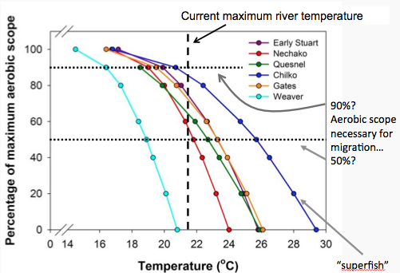

- Implications for a changing climate
  - Warmer rivers = potential for collapse of aerobic scope in Sockeye salmon
    - May also explain interannual variation in recruitment
    - Prediction of threshold temperatures for each population can be made from physiological information
      - i.e. don’t need many years of data to expand this info for other species
  - BUT… there is capacity for an evolutionary response
    - Thermal limits are variable (among individuals)
    - That variability is heritable (among populations)
    - Very significant fitness consequences (zero offspring) for failed migrants
  - Identification of genotypes that will survive in a warmer world?
- Ocean acidification
  - Anthropogenic CO₂ emitted to the atmosphere is absorbed by the oceans, causing a progressive increase in ocean inorganic carbon concentrations and resulting in decreased water pH and calcium carbonate saturation.
    - Calcium carbonate Cannot be mineralized below threshold pH
- Cellular affects
  - CO2 changes pH inside and outside a cell.
  - Changes in CO2 change bicarbonate levels
    - which affect the mitochondrial processes
      - which affect metabolic rate
        - Ion exchange rate changes as a results of metabolic changes.

Study
  - 167 studies with CO₂ impacts on physiological performance parameters of 153 species
  - Mostly post-embryonic stages
  - Most studies look at worst-case scenario (>936 ppm CO2 in 2100), not many at intermediate or low levels
    - 350 ppm is the threshold where there is harmful affects in the atmosphere.
  - Timeframes are based on relatively short time points (max 180 days), so we don’t really know the affects of long term CO2 exposure at high levels.
  - Most fishes studied in tropical habitats
    - Biased, because researchers like to do studies in pleasant places

Results of meta analysis
  - Increased PCO₂ (CO2 conc.) is mostly bad, has negative effects in all species as it increases.
  - Exponential increase of negative impacts after 1000ppm (ie log10 of 3)
  - Fishes are sensitive to CO2 changes at much lower concentrations than others.
  - P50 is the pC02 at which half of the species in each phyla that will be affected by CO2.
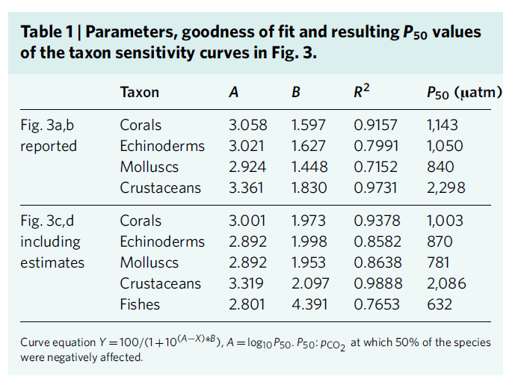
    - Seems fishes are the most sensitive to pCO2 increases, crustaceans least.

- These numbers are consistent with marine extinctions in the PETM
  - Palaeocene-Eocene Thermal Maximum (PETM)
  - CO₂ rate of change an order of magnitude slower than now
  - Extinction/survival associated with physiological tolerances
  - Matches patterns in this study (extant species): corals, echinoderms, molluscs, crustaceans (order of sensitivity same)
- Winners and losers
  - Some corals do OK
  - Echinoderms and molluscs particularly at risk
    - Large skeletons, low MR and low ability to change pH
  - Fishes
    - Great internal homeostasis, small skeleton
    - Therefore no major effect on calcification
    - Neural consequences of pH regulation?
      - Cl⁻ and HCO₃ change change GABA receptor behavior and affect fish behavior…

- Pharmacologically-active compounds in water
  - Synthetic hormones (birth control)
  - Industrial products
    - PCBs
    - TBT
    - Phthalates, BPA
    - DDT
  - Fluoxetine (FLX) aka Prozac
    - Selective Serotonin Reuptake Inhibitor (SSRI)
      - 14.5 million prescriptions in Canada in 2000
    - Binds to plasma proteins (esp. albumin)
    - Demethylated to a range of compounds, including norfluoxetine (NFLX) by the liver (this is the active ingredient)
    - Long half life in blood
      - 1-3 days after a single dose, 4-6 days when used regularly
    - Excreted in the urine – for 7+ weeks after discontinuation
      - 7% of metabolites are NFLX, 11% FLX (both pharmacologically active)
    - Is not filtered out when reaches ocean
      - Affects behavior of fish too
- Goldfish Reproductive endocrinology
  - GnRH -> LH, FSH, GH
  - HPG axis is activated by
    - 17,20β-dihydroxy-4-pregnene-3-one (17,20P)
      - Priming pheromone – initiates physiological changes
    - Prostaglandin F2_{α} (PGF2_{α})
      - Secondarily released
      - Stimulates repro behavior
  - Can inject these hormones to get an effect
    - This study looks at both basal and induced responses of the HPG axis
  - Both necessary for reproduction
    - can use milt (=sperm) release to gauge reproductive potential
      - Also, can look at testes morphology to see if it is producing sperm
        - Can measure Gonadosomatic index, so size of testes in relation to the body, however feeding them prozac does not change testes size
  - Gene Tests
    - slc6a4a expression in all tissues (serotonin transporter and target of FLX/NFLX)
    - Repro Hormones: Circulating LH and GH; pituitary fsh-β (no assay for FSH);
      - Circulating T and E_{2(estradiol)}
      - Also gonadal Cyp19a (aromatase) expression and aromatase activity – to see if T is being aromatized to E2
    - Isotocin and vasotocin expression in telencephalon (front of brain)
      - (neuropeptides that control reproductive behavior, like oxytocin in mammals)
    - Expression of receptors: fsr (follicle stimulating), lhr (leutinizing hormone), ghr(gonadotropin hormone), estrogen receptor esr1
      - measure levels and see if it is consistant with reproductive behaviour.
- Experiment
  - Put FLX in two concentrations (low and high consistant with real world, high from sewage plants) in the water.
  - Stimulate them with a vehicle (ethanol) to get them moving.
    - Goldfish are very good at breaking down ethanol because naturally it is a byproduct of metabolism.
  - Add vehicle and FLX (two different concs.) at regular intervals to maintain a concentration.
  - At 4am after 14 hrs, they injected the fish with stimulating hormones (vehicle plus 17,20P or PGF2), that would normally induce reproduction, then sacrificed them to see if there was actually a proper sexual activity afterward.
    - Saw if FLX inhibited or not.
  - The serotonin transporter (and FLX target) slc6a4a is expressed in all tissues, increasing in the reproductive season (March to May)
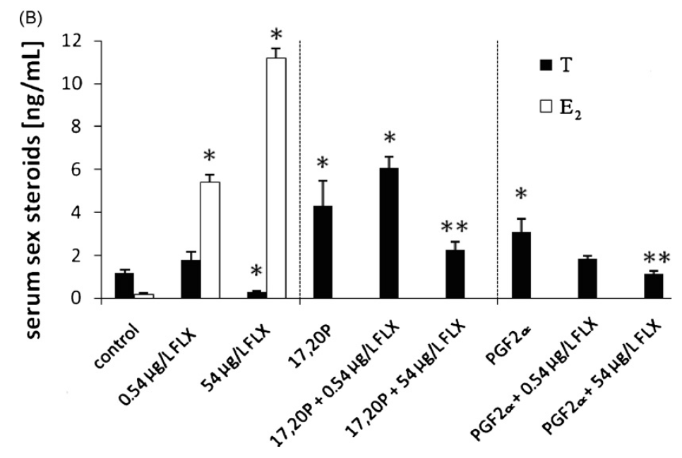
  - FLX decreases T and increases E2

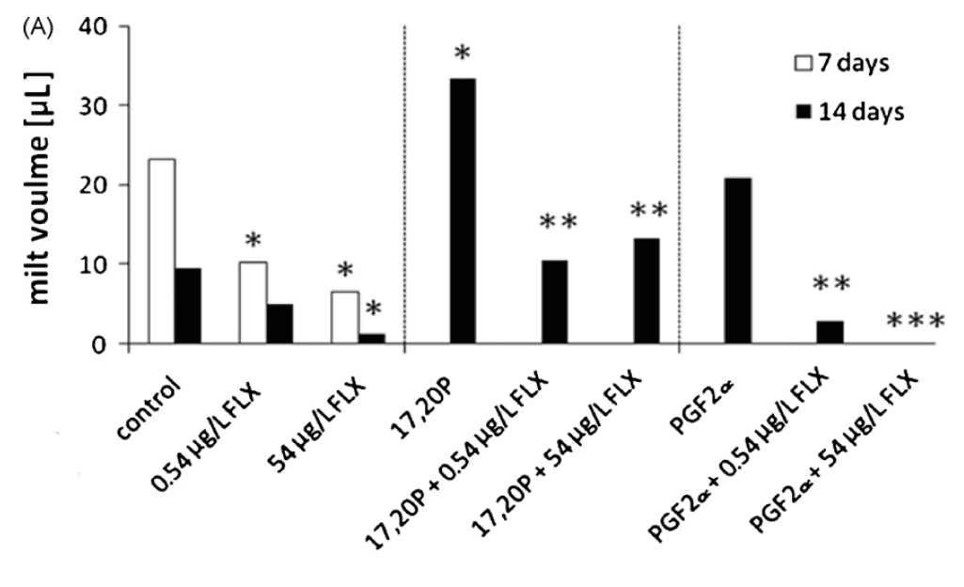
  - FLX inhibits basal and induced milt release (note: not associated with changes in gonadosomatic index or mass) … likely resulting from decreased T

  - FLX specifically reduces fsh-B expression (no diffs in LH, GH)
  - FLX reduces isotocin expression and increases vasotocin in response to PGF2_{α}
  - FLX has a big effect on LH receptors
  - FLX increases aromatase expression (but not activity)
  - FLX does not appear to change spermatogenesis
- Summary
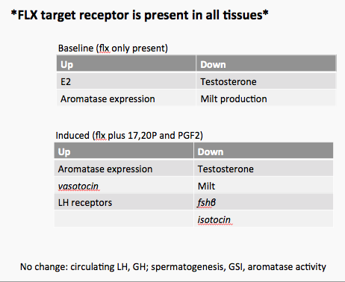
- What does this mean for water quality?
  - Indicate that envrironmental concentrations of FLX can disrupt critical components of male goldfish reproductive processes.
  - Future research should address potential effects of SSRIs on sperm release in the testis, especially with regard to PGF2-induced sociosexual stimulation of sperm release.
  - With increasing use of SSRIs in several sectors of the population, the impacts of human sewage effluents containing these and other pharmaceuticals should be more closely monitored.
  - Case Note
    - In london, england, they don’t have enough water, so they recycle most water through the thames and back. So the water appears to have gone through about 7 people per treatment cycle. Which ends up giving FLX to everyone, whether they are prescribed or not.

- Deepwater Horizon oil spill
  - Oil leaked for 87 days
  - 4.9 M Barrels = 780,000 m³, affected 180,000 km² of ocean
  - Oil mixes with water (a bit)
    - ‘weathering’ into tar balls
  - Containment and removal
    - Dispersants
      - ‘Correxit’ - probably worse than the oil
        - Increase toxicity
        - Disrupt membranes
        - Endocrine disruption
- Effects of oil spill
  - Acute oiling
  - Mortality from ingestion
  - Clogging of gills and feathers
  - Toxicity of dispersants
  - Why is oil toxic?
    - Acts on AHR pathway – aryl-hydrocarbon receptor (activates cytochrome P450s such as CYP1A1)
      - RNAi KD of AHR = decr. PAH and PCB toxicity
    - Small doses of toxins activate pathway -> metabolism in liver
    - BUT… large doses (or some compounds, such as PAH) lead to metabolism into more toxic compounds
    - Mutations and lesions in fishes
    - Spontaneous abortions in dolphins
- Experiment Use oil spill as a chance for experiment
  - Gulf Killifish
    - abundant
    - non-migratory
    - high site fidelity
    - relatively sensitive (among fishes) to toxicity from organic pollutants
- 1. Collect samples from fish over the timeframe of the oil spill

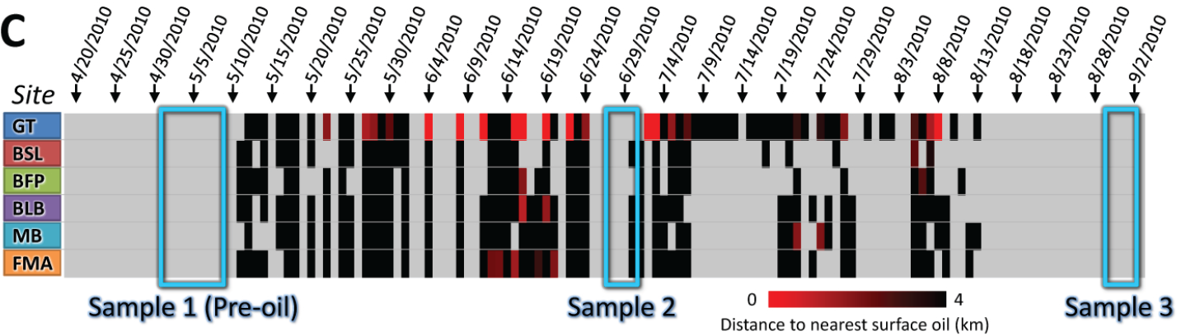

  - At sample 2, the oil spill was present, and all but GT and BFP were within 4km of the spill
    - Fish sampling
      - Fish caught in minnow traps
        - liver excised for transcriptomics
          - Liver = detox, integrates from multiple routes of entry (gills, skin, gut)
        - Gills fixed for histology
          - Most surface area of exposure
    - Microarrays and RNAseq (had same results)
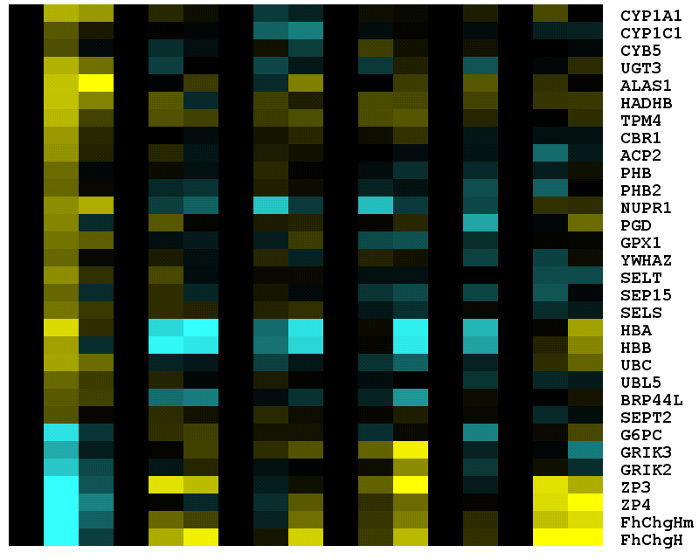

GT
BSL
BFP
BLB
MB
FMA

AHR ligand-regulated
-
4
+4

      - Expression levels for specific genes (rows) and treatments (columns), where cell color indicates up-regulation (yellow) or down-regulation (blue) scaled according to site-specific expression level at the preoil sample time, for genes with divergent expression at the GT site.
      - increased transcription is particularly diagnostic of exposure to select hydrocarbons.
      - Indeed, many genes that are transcriptionally induced or repressed by AHR activators (dioxins, PCBs, and PAHs) show induction or repression at the GT site coincident with crude oil contamination
- Key responses
  - ARH pathways
    - AHR protein targets sex steroid (estrogen and androgen) receptor proteins for proteasomal destruction, thereby impairing normal cellular responses to sex hormones in reproductive tissues.
  - CYP1A family
    - A cytochrome P450
    - Specifically responds to hydrocarbons
    - Upregulated over long term in fish, sea otters and harlequin ducks after Exxon Valdex oil spill
  - Ubiquitin-proteasome system
  - Reproduction-related genes downregulated
- CYP1A expression in gills
  - Histology clearly shows that expression was upregulated in the gills after the oil spill (red stain gets darker)
  - 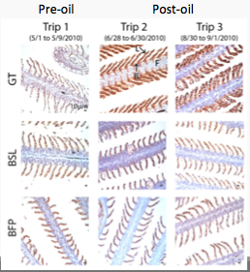
- 2. How sensitive are these fish to oil?
  - Embryos exposed to water collected from the field at each sampling point
    - Allowed to hatch, larvae sampled, and sectioned/stained
      - CYP1A in gills from larval killifish exposed to contaminated water showed same expression as adults in spill
    - Early life-stage impacts (sediment exposures)
      - Developmental phenotypes
      - Pericardial edema
      - Enlarged pericardial space
      - Tube heart
      - Decreased size at hatch
      - Enlarged guts
      - Listless at hatch
- Conclusions
  - Important, persistent sub-lethal effects, even after oil spill (oil now dissolved/in sediments)

