Assignment 3
Problem 15.13 & 15.14
- Min Z = 800X(A, 1) + 700X(A, 2) + 400X(A, 3) + 600X(B, 1) + 800X(B, 2) + 500X(B, 3)
Supply constraints
X (A, 1) + X (A, 2) + X (A, 3) ≤ 50
X (B, 1) + X (B, 2) + X (B, 3) ≤ 50
Demand constraints
X (A, 1) + X (B, 1) = 20
X (A, 2) + X (B, 2) = 20
X (A, 3) + X (B, 3) = 20
Other constraints
X (A, 1) + X (A, 2) + X (A, 3) + X (B, 1) + X (B, 2) + X (B, 3) = 60
X (A, 1), X (A, 2), X (A, 3), X (B, 1), X (B, 2), X (B, 3) ≥ 0
WHERE,
Z: Cost
X (i, j): i represents the plants (A and B), j represents the distribution centers (1, 2 and 3)
- Min Z = 800X(A, 1) + 700X(A, 2) + 400X(A, 3) + 600X(B, 1) + 800X(B, 2) + 500X(B, 3)
Supply constraints
X (A, 1) + X (A, 2) + X (A, 3) ≤ 50
X (B, 1) + X (B, 2) + X (B, 3) ≤ 50
Demand constraints
X (A, 1) + X (B, 1) ≥ 10
X (A, 1) + X (B, 1) ≤ 30
X (A, 2) + X (B, 2) ≥ 10
X (A, 2) + X (B, 2) ≤ 30
X (A, 3) + X (B, 3) ≥ 10
X (A, 3) + X (B, 3) ≤ 30

Other constraints
X (A, 1) + X (A, 2) + X (A, 3) + X (B, 1) + X (B, 2) + X (B, 3) = 60
X (A, 1), X (A, 2), X (A, 3), X (B, 1), X (B, 2), X (B, 3) ≥ 0
WHERE,
Z: Cost
X (i, j): i represents the plants (A and B), j represents the distribution centers (1, 2 and 3)
- Problem 15.13 Spreadsheet Formulation
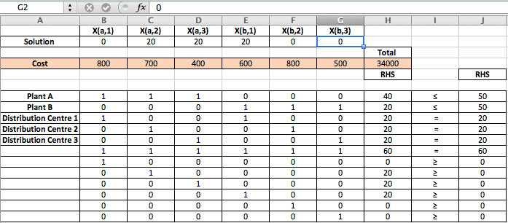
Problem 15.14 Spreadsheet Formulation
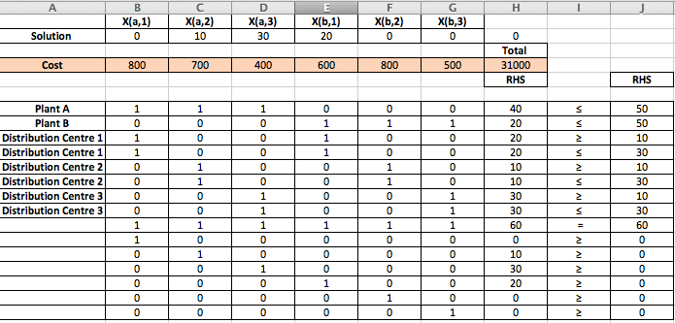

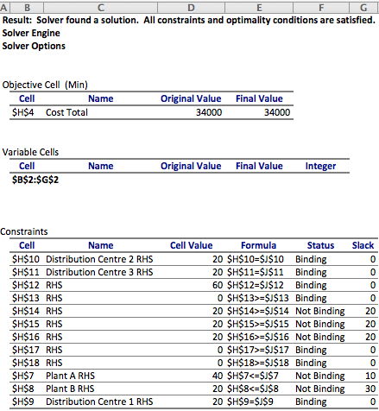
- Problem 15.13 Solver Result

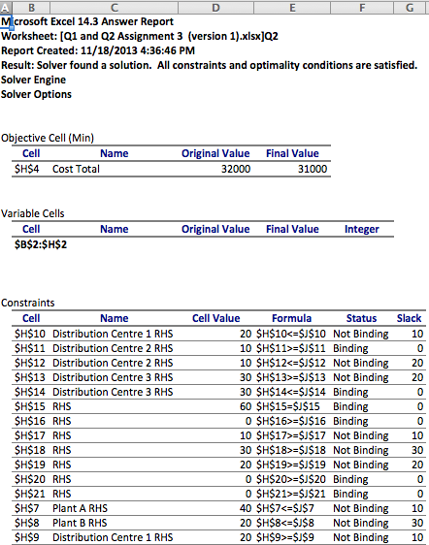
Problem 15.14 Solver Result

- Problem 15.13
To minimize the cost, the plants need 0 of X (A, 1), 20 of X (A, 2), 20 of X (A, 3), 20 of X (B, 1), 0 of X (B, 2) and 0 of X (B, 3). The cost will therefore be of $34,000

Problem 15.14
To minimize the cost, the plants need 0 of X (A, 1), 10 of X (A, 2), 30 of X (A, 3), 20 of X (B, 1), 0 of X (B, 2) and 0 of X (B, 3). The cost will therefore be of $31,000

Problem 17.3
- Max M = 20X1 + 15X2 + 25X3 – 6d1⁺ - 6d1⁻ - 3d2⁻
Goals:
Goal 1: 6X1 + 4X2 + 5X3 + d1⁻ - d1⁺ = 50
Goal 2: 8X1 + 7X2 + 5X3 + d2⁻ - d2⁺ = 75
Other constraints:
X1, X2, X3, d1⁻, d1⁺, d2⁻, d2⁺ ≥ 0
WHERE,
M: Overall performance
X_{i}: Products
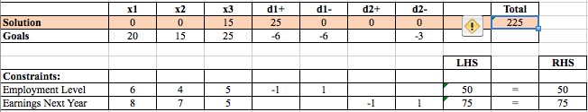
- Problem 17.3 Spreadsheet formulation

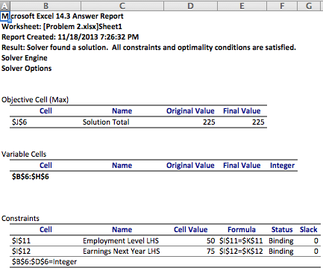
- Problem 17.3 Solver result

- Problem 17.3
To maximize the overall performance, the corporation needs 0 of X1, 0 of X2, 15 of X3, 25 of d1+, 0 of d1- , 0 of d2+ and 0 of d2-. The total maximum performance will be of 225

Problem 7.14
- Max NPV = 12X1 + 15X2 + 20X3 + 9X4 + 23X5
Constraints
8X1 + 10X2 + 12X3 + 4X4 + 14X5 + Y1 = 40
6X1 + 8X2 + 6X3 + 3X4 + 6X5 + Y2 = 29
3X1 + 7X2 + 6X3 + 2X4 + 5X5 + Y3 = 22
5X2 + 6X3 + 7X5 + Y4 = 17
X1 – X2 ≤ 0
X3 + X4 = 1
Other constraints:
X1, X2, X3, X4, X5, Y1, Y2, Y3, Y4 ≥ 0
WHERE,
NPV: Total expected value
X_{i}: Projects
Y_{i}: amount left over
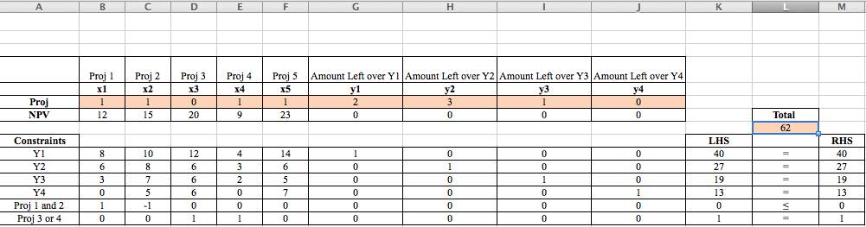
- Problem 7.14 spreadsheet formulation

- Problem 7.14 Solver result
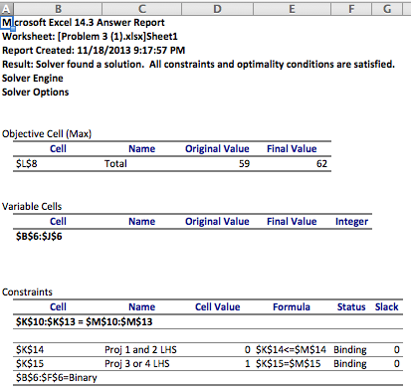

- Problem 7.14
The maximize the total expected value, the corporation needs 1 of X1, 1 of X2, 0 of X3, 1 of X4, 1 of X5, 2 of Y1, 3 of Y2, 1 of Y3 and 0 of Y4. The total will therefore be of 62.

