- Chapter 8: Developing New Products

- Product: anything of value to a consumer and can be offered through a marketing exchange. They could be places, ideas, organizations, people, or communities that create value for consumers in their respective competitive marketing arenas

- LO1
  - New markets provide value to both firms and customers
  - Completely new-to-the-market products represent fewer than 10% of all new product introductions each year
  - Innovation: the process by which ideas are transformed into new products and services that will help them grow
    - Without innovation and its resulting new products and services, firms would only have two choices: continue to market current products to current customers or take the same product to another market with similar customers
  - Changing Customer Needs
    - When they add new products to their offerings, firms can create and deliver value more effectively by satisfying the changing needs of their current and new customers or simply by keeping customers from getting bored
    - Companies can identify problems and develop products that customers never knew they needed
    - Firms take a well-known offering and innovate it to make it more interesting
  - Market Saturation
    - The longer a product exists in the marketplace, the more likely it is that the market will become saturated
    - Without products/services, the value of the firm will ultimately decline
    - Consumers tend to get tired of products before they wear out or break and seek variety
    - Example: Reebok introducing several lines a year, they sustain their growth
  - Managing Risk Through Diversity
    - Through innovation, firms often create a broader portfolio of products, which helps them to diversify risk and enhance firm value better than a single product can
    - If some products in a portfolio are doing poorly, other may be doing well
    - Firms with multiple products are better able to withstand external shocks, including changes in consumer preferences or intensive competitive activity
    - Example: Kellogg’s offering many variations of Special K including cereal bars and protein shakes
  - Fashion Cycles
    - In industries that rely on fashion trends and experience short product life cycles—apparel, books, software—most sales come from new products
    - Example: a motion picture generates most of its sales in theatre, DVD and cable TV revenues within a year of release
  - Innovation and Value
    - New product introductions, especially new-to-the-world products that create new markets, can add tremendous value to firms
    - These new products, services, or processes are called pioneers, breakthroughs or “disruptive” because they establish a completely new market or radically change both the rules of competition and consumer preferences in a market
    - Generally they require a higher level of learning from consumers and offer much more benefits than predecessor products
    - Example: eBay, Blackberry, or Canon’s desktop photocopiers
    - 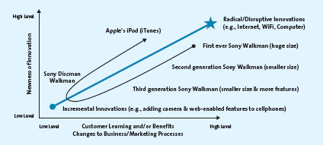
    - Pioneers have advantage of being first movers; as the first to create the market or product category, they become recognizable to consumers and thus establish a commanding and early market share lead
    - Not all pioneers succeed
    - In many cases, imitators capitalize on weaknesses of pioneers and subsequently gain advantage in the market
    - Pioneers often have a less sophisticated design and may be priced relatively higher, leaving room for better and lower priced competitive products
    - As many as 95% of all consumer goods fail, and products across all market and industries suffer failure rates of 50-80%
      - WHY?
      - They offer consumers too few benefits compared with existing products
      - They are too complex or require substantial learning and effort before consumers can use them
      - Bad timing (consumers aren’t ready for such p/s)
    - New-to-the-world products are not adopted by everyone at the same time

- LO2
  - Diffusion of innovation: the process by which the use of an innovation, whether a product or service, spreads throughout a market group, over time and over various categories of adopters
    - Helps marketers understand the rate at which consumers are likely to adopt a new product or service
    - It also gives them a means to identify potential markets for their products or services and predict their potential sales, even before they introduce the innovations
    - 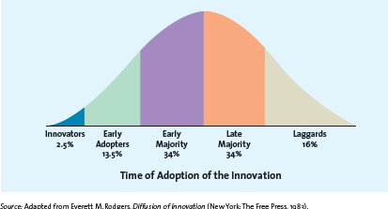
    - Innovators: 2.5% of the total market
      - Those buyers who want to be first on the block to have the new product or service
      - Enjoy taking risks, are regarded as highly knowledgeable, and are NOT price sensitive
      - Typically they keep themselves very well informed about the product category by subscribing to magazines, talking to other “experts”, searching the internet, attending product-related forums, seminars and special events
      - They are crucial to the success of any new product or service because they help the product gain market acceptance
    - Early Adopters: 13.5% of the total market
      - Second subgroup that begins to use a product or service innovation
      - Generally don’t like to take as much risk as innovators but instead wait and purchase a product after careful review
      - Tend to enjoy novelty and are often regarded as the opinion leaders for specific product categories
      - Crucial for bringing the other three buyer categories to the market
    - Early Majority: 34% of total market
      - Crucial because few new products and services can be profitable until this large group buys them
      - If the group never becomes large enough, the product typically fails
      - Differ in many ways—don’t like to take as much risk and therefore tend to wait until “the bugs” are worked out
      - When they are in the market, the number of competitors in the marketplace usually also has reached its peak, so they have many different price and quality choices
    - Late Majority: 34% of the total market
      - Last group of buyers to enter a new product market; when they do, the product has achieved its full market potential
      - By this time, sales tend to level off or may be in decline
    - Laggards: 16% of the total market
      - These consumers like to avoid change and rely on traditional products until they are no longer available
      - They may never adopt a product or service
      - Very few companies actively pursue these customers
    - Using the diffusion of innovation theory or adoption cycle, firms can predict which types of customers will buy their new product or service immediately after its introduction, as well as later as the product or service gets more and more accepted by the market
    - With this knowledge, the firm can develop effective promotion, pricing, and other marketing strategies to push acceptance among each customer group
    - The speed with which products are adopted depends on several product characteristics

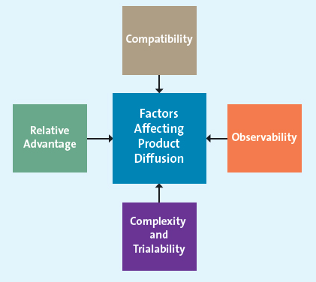
    - Relative advantage: if a product is perceived to be better than substitutes, then the diffusion will be relatively quick
    - Compatibility: most business professionals and executives have to make decisions in a timely fashion and be able to communicate their decisions in a timely manner also; they need real-time information to do this. I.e. compatible with people’s current behaviour
    - Observability: when products are easily observed, their benefits or uses are easily communicated to others, thus enhancing the diffusion process
    - Complexity and Trialability: products that are relatively less complex are also relatively easy to try. These products will diffuse more quickly than those that are not

- LO3
  - The new product development process begins with the generation of new product ideas and culminates in the launch of the new product and the evaluation of its success
  - The stages of the product development process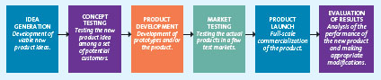
  - Depicts linear and sequential stages when in reality it is iterative, consisting of a number of feedback loops at various stages
  - Substantially new products will likely follow the process fairly closely, while products imitating a successful product from a competitor, having a low development cost, or involving incremental changes (such as line extensions) may skip one or more steps
  - 1) Idea Generation
    - a firm can use its own internal R&D efforts, collaborate with other firms and institutions, license technology from research intensive firms, brainstorm, research competitors’ products and services, and/or conduct consumer research
    - Sometimes new product ideas come from employees, customers, suppliers, and partners or are generated by attending trade shows and conferences
    - Companies also generate ideas by using reverse engineering or, in more extreme cases, even by digging through a competitor's garbage
    - Internal research and development
      - Many firms have their own R&D departments, in which scientists work to solve complex problems and develop new ideas
      - Product development costs are quite high, and the resulting new product or service has a good chance of being a technological market breakthrough
      - Firms expect such products to generate enough revenue and profits to make the costs of R&D worthwhile
    - Licensing
      - For many new scientific and technological products, firms buy the rights to use technology or ideas from other research intensive firms through a licensing agreement
    - Brainstorming
      - Firms often engage in brainstorming sessions during which a group works together to generate new ideas
      - One of the key characteristics of a session can be that no idea can be immediately accepted or rejected
      - Can use voting
    - Competitor’s Products
      - A new product entry by a competitor may trigger a market opportunity for a firm, which can use reverse engineering to understand the competitor’s product and then bring an improved version to the market
      - Reverse engineering: involves taking apart a competitor’s product, analyzing it, and creating an improved product that does not infringe on the competitor’s patents, if any exist
    - Customer Input
      - Listening to the customer is essential for successful idea generation
      - Prior studies have shown that as much as 85% of all new B2B product ideas come from customers
      - Input came come from a variety of sources
      - Particularly successful customer input approack is to analyze lead users, those innovative product users who modify existing products according to their own ideas to suit their specific needs
  - 2) Concept Testing
    - Ideas with potential are developed further into concepts, which in this context refer to brief written descriptions of the product; its technology, working principles, and forms; and what customer needs it would satisfy
      - May also include visuals
    - Concept testing: the process in which a concept statement is presented to potential buyers representative of the target market or users to obtain their reactions
    - These reactions enable the developer to estimate the sales value of the product or service concept, possibly make changes to enhance its sales value, and determine whether the idea is worth further development
    - Firm likely starts with exploratory research, after which it can undertake conclusive research
    - The most important question pertains to the respondent’s purchase intentions were the product or service be made available
  - 3) Product Development
    - Entails a process of balancing various engineering, manufacturing, marketing, and economic considerations to develop a products form and features or a service’s features
    - Prototype: the first physical form or service description of a new product, still in rough or tentative form
    - Alpha testing: an attempt by a firm to determine whether or not the product will perform according to its design and whether it satisfies the need for which it was intended
      - Tests occur in the firm’s R&D department
    - Beta testing: uses potential consumers, who examine the product prototype in a “real use” setting to determine its functionality performance, potential problems, and other specific issues to its use and then surveys those users to determine if the product worked as intended and to identify any issues
  - 4) Market Testing
    - The firm must test the market for the new product with a trial batch of products, but sometimes this step is skipped because of competition, timing or cost pressures
    - Premarket Tests
      - Firms conduct these before they actually bring a product or service to market to determine how many customers will try and then continue to use the product or service according to a small group of potential consumers
    - Test marketing
      - A method of determining the success of potential new product by introducing the offering to a limited geographical area (usually a few cities) prior to a national launch
      - Uses all elements of the marketing mix
      - Test marketing costs more and takes longer than premarket tests, which may provide an advantage to competitors that could get a similar or better product to market first
      - It offers a key advantage: the firm can study actual consumer behaviour, which is more reliable than a simulated test
  - 5) Product Launch
    - if the market testing returns with positive results, the firm is ready to introduce its product to the entire market
    - a product launch is the most critical step in the new product introduction and requires tremendous financial resources and extensive coordination of all aspects of the marketing mix
    - First, on the basis of the research it has gathered on consumer perceptions and the tests it has conducted, as well as any competitive considerations, the firm confirms its target market(s) and decides how the product will be positioned
    - Then the firm finalizes the remaining marketing mix variables for the new product, including the marketing budget for the first year
    - Promotion: the test results help the firm determine an appropriate integrated marketing communications strategy
    - Place: the firm must have an adequate quantity of products available for shipment and to keep in stock at relevant stores
    - Price: the firm needs to ensure that it gets the price right
    - Timing: the timing of the launch may be important, depending on the product
  - 6) Evaluation of Results
    - After the product has been launched, marketers must undertake a critical post-launch review to determine whether the product and its launch were a success or failure an what additional resources or changes to the marketing mix are needed, if any
    - Firms measure the success of a new product by 3 interrelated factors
      - Its satisfaction of technical requirements, such as performance
      - Customer acceptance
      - Its satisfaction of the firm’s financial requirements, such as sales and profits

- LO4
  - The product life cycle (PLC) defines the stages that new products move through as they enter, get established in, and ultimately leave the marketplace and thereby offers marketers a starting point for their strategy planning
  - Not every product follows the same life cycle shape, many products stay in the maturity period for a very long time
  - 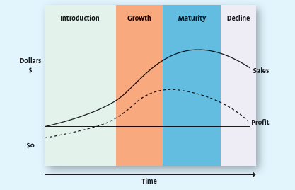
  - 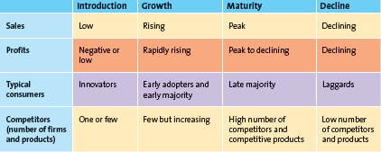
  - Introduction Stage
    - Usually starts off with a single firm, and innovators are the ones who try the new offering
    - Sensing the viability and commercialization possibilities of this market-creating new product, other firms soon enter the market with similar or improved products at lower prices
    - Characterized by initial losses to the firm because of high start-up costs and low levels of sales revenue as the product begins to take off
  - Growth Stage
    - Marked by a growing number of product adopters, rapid growth in industry sales, and increases in both the number of competitors and the number of available product versions
    - The market becomes more segmented and consumer preferences and producing different product variations which enables them to segment the market more precisely
    - Profits in the growth stage also rise because the economies of scale associated with manufacturing and marketing costs
    - Firms have not yet established a stronghold in the market, even in narrow segments, may decide to exit in what is referred to as an “industry shakeout”
  - Maturity Stage
    - Characterized by the adoption of the product by the late majority and intense competition for market share among firms
    - Marketing costs increase as they defend their market share
    - Intense competition price
    - Lower prices and increased marketing costs begin to erode the profit margins for many firms
    - In the later stages of the maturity stage, the market has become quite saturated, and practically all potential customers for the product have already adopted it
    - Firms may pursuer several strategies during this stage to increase their customer base and defend their market share
    - 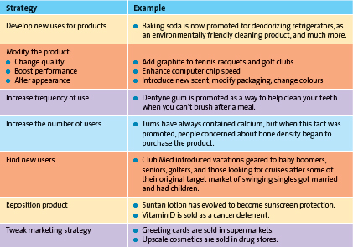
    - Entry into new market of market segments
      - Because the market is saturated at this point, firms may attempt to enter new geographical markets, including international markets that may be less saturated
    - Development of new products
      - Continually introduce new products with improved features or find new uses for existing products because they need constant innovation and product proliferation to defend market share during intense competition
  - Decline Stage
    - Firms with products in the decline stage either position themselves for a niche segment of diehard consumers or those with special needs, or they completely exit the market
    - The few laggards who have not yet tried the product or service enter the market at this stage
  - The shape of the product life cycle curve
    - Assumed to be bell-shaped with regard to sales and profits
    - Each product or service has its own individual shape
    - 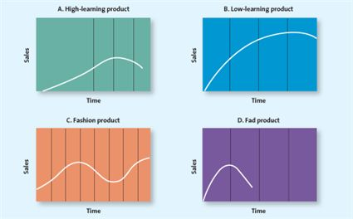
    - The most challenging part of applying the product life cycle concept is that managers do not know exactly what shape each product's life cycle will take, so there is no way to know precisely what stage a product is in
New research, based on the history of dozens of consumer products, suggests that the product life cycle concept is indeed a valid idea, and new analytical tools now provide “rules” for detecting the key turning points in the cycle

- Chapter 9: Product, Branding, and Packaging Decisions

- LO1: List the components of a product
- 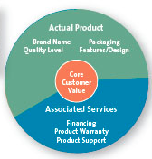
  - Complexity of Products
    - Marketers involved with the development, design, and sale of products think of them in an interrelated fashion
    - At the centre is the core customer value which are the basic problem-solving benefits that consumers are seeking
    - Marketers convert core customer value into an actual product
    - Attributes such as brand name, features, design, quality level, and packaging are considered, though the importance of these attributes varies depending on the product
    - The associated services/augmented product include the nonphysical aspects of the product, such as product warranties, financing, product support, and after-sale service
    - When developing or changing a product, marketers start with the core customer value to determine what their potential customers are seeking. Then they make the actual physical product and add associated services to round out the offering
  - Types of products
    - Two primary categories of products or services based on who is buying them: consumers and businesses
    - Consumer products: products and services used by people for their personal use

- LO2: Identify the types of consumer products

  - Specialty products/services
    - Customers show such a strong preference that they will expend considerable effort to search for the best suppliers
    - Ex. Luxury cars, legal or medical professionals, or designer apparel
  - Shopping products/services
    - Consumers will spend a fair amount of time comparing alternatives
    - Ex. Buying shoes, furniture, apparel, fragrances etc.
  - Convenience products/services
    - Consumer is not willing to spend any effort to evaluate prior to purchase
    - Frequently purchased commodity items, usually purchased with very little thought
    - Ex. Common beverages, bread or soap
  - Unsought products/services
    - Consumers do not normally think of buying or do not know about
    - These products require lots of marketing effort and various forms of promotion
    - Ex. When GPS’s first came out, or HeatMax HotHands Hand Warmers
  - Product Mix and Product Line Decisions
- 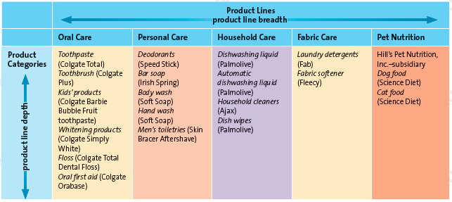
  - Product mix: complete set of all products offered by a firm
  - Product line: groups of associated items, such as those that consumers use together or think of as part of a group of similar products
  - Product Category: assortment of items that the customer sees as a reasonable substitute for one another
  - Product mix breadth (variety): the number of product lines offered by the firm
    - Ex. Oral care, personal care, household care, fabric care, pet nutrition
  - Product line depth: the number of products within a product line
    - Ex. Colgate’s oral care line: Toothpaste, toothbrush, kids’ products, etc.

- LO3: Explain the difference between a product mix’s breadth and a product line’s depth

  - Stock keeping units (SKUs): individual items within each product category; the smallest unit available for inventory control
  - The decision to expand or contract product lines and categories depends on several industry-, consumer-, and firm-level factors
  - Among the industry factors, firms expand their product lines (breadth) when it is relatively easy to enter a specific market (entry barriers are low) and/or when there is substantial market opportunity
  - When firms add new lines to their product mix, they often earn significant sales and profits
  - However, adding unlimited numbers of products can have adverse consequences
    - Too much variety in the product mix is often too costly to maintain, and too many brands may weaken the firm’s brand reputation
- 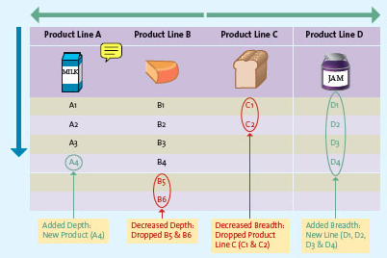
  - Changing Product Mix Breadth
    - Firms may change their product mix breadth by either adding to or deleting entire product lines
    - Increase breadth
      - Firms often add new product lines to capture new or evolving markets, increase sales, and compete in new venues
      - Example: addition of product line D above
    - Decrease breadth
      - Sometimes it is necessary to delete entire product lines to address changing market conditions or meet internal strategic priorities
      - Example: deletion of product line C above
  - Changing Product Line Depth
    - Firms occasionally either add or delete from their product line depth
    - Increase depth
      - Firms may add new products within a line to address changing consumer preferences or pre-empt competitors while boosting sales
      - Example: addition of A4 above
    - Decrease depth
      - From time to time, it is necessary to delete product categories to realign resources
      - Example: deletion of B5 and B6 above
      - The decision to delete products is never taken lightly
  - Change number of SKUs
    - A very common and ongoing activity for many firms is the addition or deletion of SKUs in existing categories to stimulate sales or react to consumer demand
    - Example: when jeans manufacturers lowered the waistline and flared legs for their products
  - Product Line Decisions for Services
    - Many of the strategies used to make product line decisions for physical products can also be applied to services
    - Example: a service provider such as a bank typically offers different product lines for its business and retail accounts; those product lines are further divided into categories based on the needs of different target markets
      - i.e. savings and chequing accounts for individual retail customers (equivalent to SKUs)
      - Offer a variety of chequing accounts

- LO4: Identify the advantages that brands provide firms and consumers

- Branding
  - A company lives or dies based on brand awareness
  - Provides a way for a firm to differentiate its product offerings from those of its competitors and can be used to represent the name of a firm and its entire product mix (General Motors), one product line (Chevrolet), or a single item (Corvette)
  - Various brand elements that firms use
    - Logos, symbols, characters, slogans, jingles, and distinctive packages
  - Brands add value to merchandise and services beyond physical and functional characteristics or the pure act of performing the service

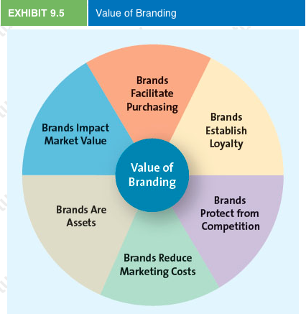
  - Brands facilitate purchasing
    - Brands are often easily recognized by consumers and because they signify a certain quality level and contain familiar attributes, brands help consumers make quick decisions
    - Enable customers to differentiate one firm or product from another
  - Brands establish loyalty
    - Customers learn to trust certain brands
    - Many customers become loyal to certain brands in much the same way that people become loyal to their university
    - As a result, companies can maintain great depth in their product lines since their customers will buy other brands within their product mix
  - Brands protect from competition
    - Strong brands are somewhat protected from competition and price competition
    - Such brands are more established in the market and have a more loyal customer base, neither competitive pressures on price nor retail-level competition is threatening to the firm
  - Brands reduce marketing costs
    - Firms with well-known brands can spend relatively less on marketing costs than firms with little-known brands because the brand sells itself
  - Brands are assets
    - Can be legally protected through trademarks and copyrights and thus constitute a unique ownership for the firm
    - Firms sometimes have to fight to keep their brand “pure”
  - Brands impact market value
    - Having well-known brands can have a direct impact on the company’s bottom line
    - The value of a brand can be calculated by assessing the earning potential of the brand over the next 12 months

- LO5: Summarize the components of brand equity
  - There are three areas of branding
    - Brand equity
      - The set of assets and liabilities linked to a brand that add or subtract from the value provided by the product or service
      - Brands are assets the firm can build, manage and harness over time to increase its revenue, profitability, and overall value
      - Experts look at four aspects of a brand to determine its equity
        - Brand awareness
          - Measures how many consumers in a market are familiar with the brand and what it stands for, and have an opinion about that brand
          - If the customer recognizes the brand, it probably has attributes that make it valuable
          - Marketers create brand awareness through repeated exposures of the various brand elements in the firm’s communications to consumers (ex. advertising and promos)
          - Firms are willing to spend tons of money creating a strong brand
        - Perceived value
          - The relationship between a product or service’s benefits and its cost
          - Customers usually determine the offering’s value in relationship to that of its close competitors
          - Good marketing raises customers’ quality perceptions relative to price
        - Brand associations
          - Reflect the mental links that consumers make between a brand and its key product attributes, such as logo, slogan, or famous personality
          - Often result from a firm’s advertising and promotion efforts
          - Firms also attempt to create specific associations for their brands with positive consumer emotions. Such as fun, friendship, good feelings, family gathering, and parties
          - Firms sometimes even develop a personality for heir brands, as if the brand were human
          - Brand personality: refers to a set of human characteristics associated with a brand, which has symbolic or self-expressive meanings for consumers
        - Brand loyalty
          - Occurs when a consumer buys the same brand’s product or service repeatedly over time rather than buying from multiple suppliers within the same category
          - Brand loyal customers are an important source of value for firms
          - Such consumers are often less sensitive to price and the marketing costs of reaching loyal customers are much lower and a high level of brand loyalty insulates the firm from competition
          - Firms can manage brand loyalty through a variety of CRM programs
          - The better CRM programs attempt to maintain some continuous contact with loyal customers by sending them birthday cards or having a personal sales associate contact them to inform them of special events and sales
  - Brand ownership
  - Brand names

- LO6: Describe the types of branding strategies used by firms
  - Firms institute a variety of brand-related strategies to create and manage key brand assets, such as the decision to own the brands, establishing a branding policy, extending the brand name to other products and markets, cooperatively using the brand name with that of another firm, and licensing the brand to other firms
  - Brand Ownership
    - Brands can be owned by any firm in the supply chain, whether manufacturers, wholesalers, or retailers
    - There are three basic brand ownership strategies
      - Manufacturer or national brands
        - Owned and managed by the manufacturer
        - Nike, Mountain Dew, KitchenAid & Marriott
        - Majority of brands in Canada are manufacturer brands
        - By owning their brands, manufacturers retain more control over their marketing strategy, are able to choose the appropriate market segments and positioning for the brand, and can build the brand and thereby create their own brand equity
      - Private-label or store brands
        - Owned and managed by retailers
        - Some manufacturers prefer to make only private-label merchandise because the costs of national branding and marketing are prohibitive, whereas other firms manufacture both their own brand and merchandise for other brands or retailers
        - Private-label brands are particularly common in supermarkets, discount stores, and drugstores
        - President’s Choice
      - Generic brands
        - Those sold without brand names, typically in commodities markets
        - The popularity and acceptance of generic products has declined
        - Consumers question the quality and origin of the products, and retailers have found better profit potential and the ability to build brand equity with manufacturer and store brands
        - Unbranded salt, grains, product, meat, or nuts in grocery stores
  - Brand Names
    - Firms use several very different strategies to name their brands and product lines
    - Naming Brands and Product Lines
      - Corporate or Family Brand
        - The use of a firm’s own corporate name to brand all of its product lines and products
      - Corporate and Product Line Brands
        - The use of a combination of family brand name and individual brand name to distinguish a firm’s products
      - Individual Brands
        - The use of individual brand names for each of a firm’s products
      - Choosing a Name
        - When it comes to naming new products, companies should consider the following desirable qualities:
          - (1) The brand name should be descriptive and suggestive of benefits and qualities associated with the product. For example, the name Sunkist evokes images of oranges ripening on the trees kissed by the sun.
          - (2) The brand name should be easy to pronounce, recognize, and remember, such as Tide, Crest, or Kodak.
          - (3) The company should be able to register the brand name as a trademark and legally protect it.
          - (4) For companies looking to global markets, the brand name should be easy to translate into other languages.
  - Brand Extension
    - Refers to the use of the same brand name for new products being introduced to the same or new markets
    - Several advantages to using the same brand name for new products
      - Because the brand name is already well established, the firm can spend less in developing consumer brand awareness and brand associations for the new product
      - If the brand is known for its high quality, that perception will carry over to the new product
      - The marketing costs for a new product by an established brand are lower because consumers already know and understand the brand
      - When brand extensions are used for complementary products, a synergy exists between the two products that can increase overall sales
      - Successful brand extensions can result in cross category trial and boost sales because adopters of the new extended brand may try other products in the brand family they are not already using
    - Not all brand extensions are successful; some can dilute brand equity
    - Brand dilution: occurs when brand extension adversely affects consumer perceptions about the attributes the core brand is believed to hold
  - Cobranding
    - The practice of marketing two or more brands together, on the same package or promotion
    - It enhances consumers’ perceptions of product quality by signaling otherwise unobservable product quality through links between the firm’s brand and a well-known quality brand
    - Can be a prelude to an acquisition strategy
    - There are some risks to cobranding
      - Financial disputes
      - Customer profiles too different
      - Firms that own the brands may change their priorities
      - Customer relationships and loyalty created could be lost
  - Brand Licensing
    - A contractual arrangement between firms, whereby one firm allows another to use its brand name, logo, symbols, and/or characters in exchange for a negotiated fee
    - Common for toys, apparel, accessories, and entertainment products
    - Licensing is an effective form of attracting visibility for the brand and thereby building brand equity while also generating additional revenue
    - There are some risks associated with it
    - For the licensor, the major risk is the dilution of its brand equity through overexposure of the brand, especially if the brand name and characters are used inappropriately
    - Licensors also run the risk of improperly valuing their brand for licensing purposes or entering into the wrong type of licensing arrangement
    - In entertainment licensing, both licensors and licensees run the risk that characters based on books and movies will be only a fad

- LO7: State how a product’s packaging and label contribute to a firm’s overall strategy
- Packaging
  - Packaging is an important brand element with more tangible or physical benefits than the other brand elements because packages come in different types and offer a variety of benefits to consumers, manufacturers, and retailers
  - Consumers typically seek convenience in terms of storage, use, and consumption
  - The package can also be an important marketing tool for the manufacturer if it is used to convey the brand's positioning
  - Packaging is considered by many marketers to be the last frontier in advertising because of its role in promoting products to consumers on the floor of the store at the point of purchase
- Labelling
  - Labels on products and packages provide information the consumer needs for his or her purchase decision and consumption of the product. In that they identify the product and brand, labels are also an important element of branding and can be used for promotion
  - The information required on them must comply with general and industry-specific laws and regulations, including the constituents or ingredients contained in the product, where the product was made, directions for use, and/or safety precautions
  - Many of the elements on the label are required by laws and regulations (i.e., ingredients, fat content, sodium content, serving size, calories), but other elements of the label remain within the control of the manufacturer
  - How manufacturers use labels to communicate the benefits of their products to consumers varies by the product

- Chapter 10: Services: The Intangible Product

- LO1: identify how marketing a service differs from marketing a product by applying the principles of intangibility, inseparability, inconsistency, and inventory
  - Customer service: refers to human or mechanical activities that firms undertake to help satisfy their customers’ needs and wants
    - By providing good customer service, firms add value to their products or services
  - The marketing of services differs from product marketing because of four fundamental differences unique to services: they are intangible, inseparable, variable, and perishable
  - Think of them as the four Is of services in that they are intangible, inseparable from their providers, inconsistent (variable), and cannot be held in inventory (perishable)
- 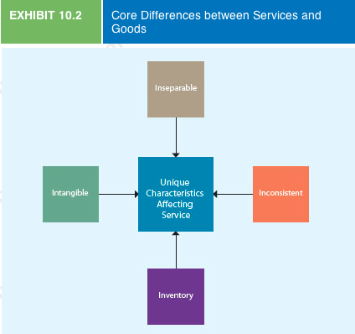
  - Intangible: they cannot be touched, tasted, or seen like a pure product can
    - A service is also difficult to promote because it can't be shown directly to potential customers. Marketers must therefore creatively employ symbols and images to promote and sell services
    - Example: Starbucks atmosphere & wifi adds tangibility to their service
    - Because of the intangibility of services, the images marketers use reinforce the benefit or value that a service provides
  - Inseparable Product and Consumption: A characteristic of a service: it is produced and consumed at the same time—that is, service and consumption are inseparable
    - Customers rarely have the opportunity to try the service before they purchase it and can’t be returned
    - Example: dentist
    - Purchase risk in these situations can be relativel;y high, services sometimes provide extended warranties and 100% satisfaction guarantees (such as First Choice Haircutters)
  - Inconsistency: a characteristic of a service, its quality may vary because it is provided by humans
    - If a consumer has a problem with a product, it can be replaced, remade, destroyed, or, if it is already in the supply chain, recalled. In many cases, the problem can even be fixed before the product gets into consumers' hands. But an inferior service can't be recalled; by the time the firm recognizes a problem, the damage has been done
    - Some marketers of services strive to reduce service inconsistency through training and standardization
    - Marketers also can use the inconsistent nature of services to their advantage. A micromarketing segmentation strategy can customize a service to meet customers' needs exactly
    - Some service providers tackle the inconsistency issue by replacing people with machines
      - i.e. self checkouts
    - The internet has reduced service inconsistency in several areas
  - Inventory: a characteristic of a service, it is perishable and cannot be stored for future use
    - The perishability of services provides both challenges and opportunities to marketers in terms of the critical task of matching demand and supply
    - Services cant be stockpiled in inventory
    - For services companies, excess demand results in having to turn customers away in peak periods, while excess capacity may mean less desirable expense to revenue ratios

- LO2: Explain why it is important that service marketers understand and manage customer expectations
  - Service gap: results when a service fails to meet the expectations that customers have about how it should be delivered
- 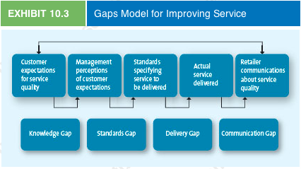
- There are 4 service gaps:
  - Knowledge gap
    - Reflects the difference between customers’ expectations and the firm’s perception of those customer expectations
    - Firms can close this gap by matching customer expectations with actual service through research
  - Standards gap
    - Pertains to the difference between the firm’s perceptions of customers’ expectations and the service standards it sets
    - Firms can narrow this gap by setting appropriate service standards and measuring service performance
  - Delivery gap
    - The difference between the firm’s service standards and the actual service it provides to its customers
    - This gap can be closed by getting employees to meet or exceed service standards
  - Communication gap
    - Refers to the difference between the actual service provided to customers and the service that the firm’s promotion program promises
    - Generally firms can close this gap if they are more realistic about the services they can provide and manage customer expectations effectively

- Evaluating Service Quality by Using Well-Established Marketing Metrics
  - Customers generally use five distinct service dimensions to determine overall service quality: reliability, responsiveness, assurance, empathy, and tangibles
- 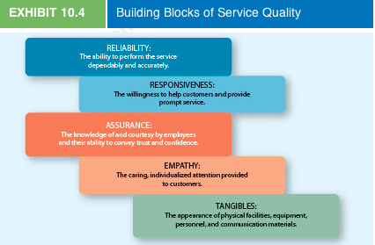
- 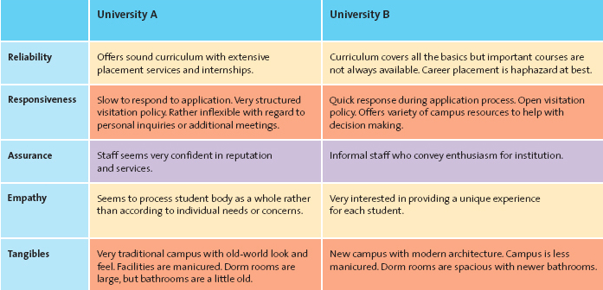
  - Voice-of-customer (VOC) program: collects customer insights and intelligence to influence and drive business decisions
  - An important marketing metric to evaluate how well firms perform on the five service quality dimensions, the concept of the zone of tolerance: the area between customers’ expectations regarding their desired service and the minimum level of acceptable service—that is, the difference between what the customer really wants and what he or she will accept before going elsewhere
  - To define the zone of tolerance, firms ask a series of questions about each service quality dimension that relate to:
    - The desired and expected level of service for each dimension, from low to high
    - Customers' perceptions of how well the focal service performs and how well a competitive service performs, from low to high
    - The importance of each service quality dimension

- LO3: Describe strategies that firms can use to help employees provide better service
- The Knowledge Gap: Knowing what customers want
  - Understanding customer expectations
    - Customers' expectations are based on their knowledge and experiences
  - Evaluating Service Quality by Using Well-Established Marketing Metrics
    - To meet or exceed customers' expectations, marketers must determine what those expectations are. Yet because of their intangibility, the service quality, or customers' perceptions of how well a service meets or exceeds their expectations, often is difficult for customers to evaluate
- The Standards Gap: Setting Service Standards
  - Achieving Service Goals Through Training
    - To deliver consistenly high-quality service, firms must set specific, measurable goals based on customers’ wxpectations; to help ensure that quality, the employees should be involved in the goal setting
    - A quality goal should be specific: “Greet every customer you encounter with ‘Good morning/afternoon/evening, Sir or Miss.’” Try to greet customers by name
  - Commitment to Service Quality
    - Service providers take their cues from management. If managers strive for excellent service, treat their customers well, and demand the same attitudes from everyone in the organization, it is likely employees will do the same
    - Employees who understand that operating on time is a critical component to service quality and guest experience work hard to improve on-time performance
- The Delivery Gap: Delivering Service Quality
  - Where “the rubber meets the road”, where the customer directly interacts with the service provider
  - Even if there are no other gaps, a delivery gap always results in a service failure
  - Delivery gaps can be reduced when employees are empowered to act in the customers' and the firm's best interests and are supported in their efforts so they can do their jobs effectively
  - Technology can also reduce delivery gaps
  - Empowering Service Providers
    - In this context, empowerment means allowing employees to make decisions about how service is provided to customers. When front-line employees are authorized to make decisions to help their customers, service quality generally improves
    - However, empowering service providers can be difficult and costly
    - Empowerment becomes more important when price points edge higher and services are more individualized
  - Providing Support and Incentives
    - A service provider's job can often be difficult, especially when customers are unpleasant or less than reasonable
    - The old cliché “Service with a smile” remains the best approach. To ensure that service is delivered properly, management needs to support the service provider
    - First, managers and co-workers should provide emotional support to service providers by demonstrating a concern for their well-being and by standing behind their decisions
    - Second, the support that managers provide must be consistent and coherent throughout the organization
    - Third, a key part of any customer service program is providing rewards to employees for excellent service
  - Using Technology
    - Using technology to facilitate service delivery can provide many benefits, such as access to a wider variety of services, a greater degree of control by the customer over the services, and the ability to obtain information
    - Management also benefits from the increased efficiency in service processes through reduced servicing costs and, in some cases, can develop a competitive advantage over less service-oriented competitors
- The Communication Gap: Communicating the Service Promise
  - The communication gap pertains to the difference between the service promised and the service actually delivered
  - Although firms have difficulty controlling service quality because it can vary from day to day and provider to provider, they do have control over how they communicate their service package to their customers. If a firm promises more than it can deliver, customers' expectations won't be met
  - The communication gap can be reduced by managing customer expectations
  - Promising only what you can deliver, or possibly even a little less, is an important way to control the communication gap
  - A relatively easy way to manage customer expectations considers both the time the expectation is created and the time the service is provided. Expectations typically are created through promotions, whether in advertising or personal selling

- LO4: Summarize three service recovery strategies
  - Despite a firm's best efforts, sometimes service providers fail to meet customer expectations. When this happens, the best course of action is to attempt to make amends with the customer and learn from the experience
  - Effective service recovery efforts can significantly increase customer satisfaction, purchase intentions, and positive word of mouth, though customers' post-recovery satisfaction levels usually fall lower than their satisfaction level prior to the service failure
  - Effective service recovery entails
    - Listening to the Customer
      - Whether the firm has a formal complaint department or the complaint is offered directly to the service provider, the customer must have the opportunity to air the complaint completely, and the firm must listen carefully to what he or she is saying
      - Service providers therefore should welcome the opportunity to be that sympathetic ear, listen carefully, and appear anxious to rectify the situation to ensure it doesn't happen again
    - Finding a Fair Solution
      - Customers want to be treated fairly, whether that means distributive or procedural fairness
      - Their perception of what fair means is based on their previous experience with other firms, how they have seen other customers treated, material they have read, and stories recounted by their friends
      - Distributive fairness: pertains to a customer's perception of the benefits he or she received compared with the costs (inconvenience or loss)
      - Customers want to be compensated a fair amount for a perceived loss that resulted from a service failure
      - The key is listening carefully to the customer
      - Procedural fairness: refers to the perceived fairness of the process used to resolve them
      - Customers want efficient complaint procedures over whose outcomes they have some influence
    - Resolving the Problem Quickly
      - The longer it takes to resolve a service failure, the more irritated the customer will become and the more people he or she is likely to tell about the problem
To resolve service failures quickly, firms need clear policies, adequate training for their employees, and empowered employees

- Chapter 11: Pricing Concepts and Strategies: Establishing Value

- LO1: Explain what price is and its importance in establishing value in marketing
  - Price is the most challenging of the four Ps to manage, partly because it is often the least understood
  - Managers have held an overly simplistic view of the role of price, considering it simply the amount of money a consumer must part with to acquire a product or service. We now know that price is not just a sacrifice but an information cue as well
  - Consumers judge the benefits a product delivers against the sacrifice necessary to obtain it, and then make a purchase decision based on this overall judgment of value
  - A price set too low may signal low quality, poor performance, or other negative attributes about the product or service
  - Price is the only element of the marketing mix that generates revenue
  - Marketers should view pricing decisions as a strategic opportunity to create value rather than as an afterthought to the rest of the marketing mix

- LO2: Illustrate how the five Cs influence pricing
- Successful pricing strategies are built through the five critical components: company objectives, customers, costs, competition, and channel members

- 1. Company Objectives
  - Each firm embraces an objective that seems to fit with where management thinks the firm needs to go to be successful, in whatever way they define success
  - These specific objectives usually reflect how the firm intends to grow
  - Company objectives are not as simple as they might first appear; they often can be expressed in slightly different forms that mean very different things
  - Also, objectives are not always mutually exclusive, because a firm may embrace two or more noncompeting objectives
- 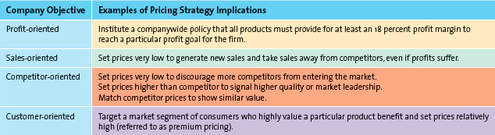
  - Product Orientation
    - Even though all company objectives may ultimately be oriented toward making a profit, firms implement a profit orientation by focusing on target profit pricing, maximizing profits, or target return pricing
      - Target profit pricing: a pricing strategy implemented by firms when they have a particular goal as their overriding concern; uses price to stimulate a certain level of sales at a certain profit per unit
      - Maximizing profits: a mathematical model that captures all the factors required to explain and predict sales and profits, which should be able to identify the price at which its profits are maximized
      - Target return pricing: a pricing strategy implemented by firms less concerned with the absolute level of profits and more interested in the rate at which their profits are generated relative to their investments; designed to produce a specific return on investment, usually expressed as a percentage of sales
  - Sales Orientation
    - Firms use sales orientation to set prices believing that increasing sales will help the firm more than increasing profits
    - Some firms may be more concerned about their overall market share than about dollar sales per se because they believe that market share better reflects their success relative to the market conditions than do sales alone
    - Adopting a market share objective does not always imply setting low prices
    - Rarely is the lowest-price offering the dominant brand in a given market
    - companies can gain market share simply by offering a high-quality product at a fair price, as long as they generate high-value perceptions among consumers
  - Competitor Oriented
    - Strategize according to the premise that they should measure themselves primarily against their competition
    - Competitive parity: some firms focus on this; setting prices that are similar to those of major competitors
    - Value is only implicitly considered in competitor-oriented strategies
  - Customer Oriented
    - Explicitly involves the concept of value
    - Sometimes a firm may attempt to increase value by focusing on customer satisfaction and setting prices to match consumer expectations
    - Firms also may offer very high-priced, “state-of-the-art” products or services in full anticipation of limited sales
      - These offerings are designed to enhance the company's reputation and image and thereby increase the company's value in the minds of consumers
    - Setting prices with a close eye to how consumers develop their perceptions of value can often be the most effective pricing strategy, especially if it is supported by consistent advertising and distribution strategies
- 2. Customers
  - Most important because it is about understanding consumers’ reactions to different prices
  - Economic theory that helps explain how prices are related to demand and how managers can incorporate this knowledge into their pricing strategies
  - Demand curves and pricing
    - Demand curve shows how many units of a product or service consumers will demand during a specific period of times at different prices
    - Can be straight or curved
    - Common downward-sloping demand curve; as price increases, demand for the product or service decreases
    - Knowing the demand curve for a product or service enables a firm to examine different prices in terms of the resulting demand and relative to its overall objective
    - Interestingly enough, not all products or services follow the downward-sloping demand curve for all levels of price
      - Prestige products which consumers purchase for their status rather than their functionality
    - Price Elasticity of demand
      - Marketers need to know how consumers will respond to a price increase (or decrease) for a specific product or brand so they can determine whether it makes sense for them to raise or lower prices
      - Price elasticity of demand measures how changes in a price affect the quantity of a product demanded
      - Formula: PEOD= % change in quantity demanded / % change in price
      - In general, the market for a product or service is price sensitive (or elastic) when the price elasticity is less than –1: that is, when a 1-percent decrease in price produces more than a 1-percent increase in the quantity sold
      - The market for a product is generally viewed as price insensitive (or inelastic) when its price elasticity is greater than –1: that is, when a 1-percent decrease in price results in less than a 1-percent increase in quantity sold
      - Consumers are generally more sensitive to price increases than to price decreases
      - The price elasticity of demand usually changes at different points in the demand curve unless the curve is actually a straight line
    - Factors Influencing Price Elasticity of Demand
      - Income Effect: refers to the change in the quantity of a product demanded by consumers because of a change in their income
      - Substitution Effect: refers to consumers’ ability to substitute other products for the focal brand. The greater the availability of substitute products, the higher the price elasticity of demand for any given product will be
      - Cross-price elasticity: the percentage change in the quantity of Product A demanded compared with the percentage change in price in Product B.
        - Complementary products: products whose demands are positively related, such that they rise or fall together
        - Substitute products: products for which changes in demand are negatively related—a percentage increase in the quantity demanded for Product A results in a percentage decrease in the quantity demanded for Product B
- 3. Costs
  - Firms must understand their costs structures so they can determine the degree to which their products or services will be profitable at different prices
  - In general, prices should not be based on costs because consumers make purchase decisions based on their perceived value; they care little about the firm's costs to produce and sell a product or deliver a service
  - Variable costs
    - Those costs, primarily labour and materials, which vary with production volume
  - Fixed Costs
    - The costs that remain essentially at the same level, regardless of any changes in the volume of production
  - Total Cost
    - Simply the sum of the variable and fixed costs
  - Break-Even Analysis and Decision Making
    - The point at which the number of units sold generates just enough revenue to equal the total costs. At this point, profits are zero
    - To determine the break-even point in units mathematically, we must consider fixed costs and the contribution per unit, which is the price less the variable cost per unit
    - Break-even points (units) = Fixed Costs / Contribution per unit
    - Limitations
      - Likely that there may be different charges for different products/services
      - Prices often get reduced as quantity increases because the costs decrease, so firms must perform several break-even analyses at different quantities
      - A break-even analysis cannot indicate for sure how many units will sell at a given price

4. Competition
  - Profound impact on pricing strategies
  - Four levels of competition
- 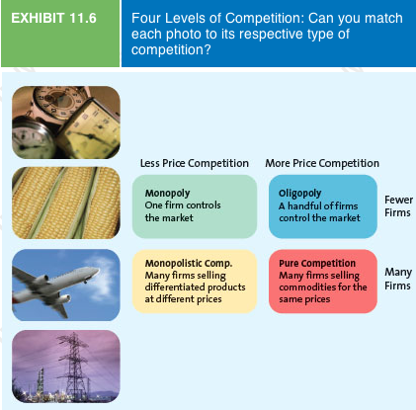
  - Price war: occurs when two or more firms compete primarily by lowering their prices
  - Monopolistic competition: occurs when there are many firms competing for customers in a given market but their products are differentiated
  - When a commodity can be differentiated somehow, even if simply by a sticker or logo, there is an opportunity for consumers to identify it as distinct from the rest, and in this case, firms can at least partially extricate their product from a pure competitive market

5. Channel Members
  - Channel members—manufacturers, wholesalers, and retailers—can have different perspectives when it comes to pricing strategies
  - Unless channel members carefully communicate their pricing goals and select channel partners that agree with them, conflict will surely arise
  - Channels can be very difficult to manage, and distribution outside normal channels does occur. A grey market, for example, employs irregular but not necessarily illegal methods; generally, it legally circumvents authorized channels of distribution to sell goods at prices lower than those intended by the manufacturer
- Other Influences on Pricing
  - Internet
    - Information online has made consumers more price sensitive
    - Allows consumers to purchase goods like electronics at highly discounted prices
    - A more recent trend affecting pricing has been the rapid growth of online daily coupon promotions from companies such as Groupon or WagJag
    - Not only do consumers know more about prices, they know more about the firms, their products, their competitors, and the markets in which they compete
  - Economic Factors
    - Two interrelated trends that have merged to impact pricing decisions are the increase in consumers' disposable income and status consciousness
    - Some consumers appear willing to spend money for products that convey status in some way
    - Such prestige products are still aimed at the elite, but more and more consumers are making the financial leap to attain them
    - A countervailing trend finds customers attempting to shop cheap
    - Retailers such as H&M and Loblaws, with its Joe Fresh line of clothing, have introduced disposable chic and cross-shopping into Canadians' shopping habits
    - Cross-shopping: the pattern of buying both premium and low-priced merchandise or patronizing both expensive, status-oriented retailers and price-oriented retailers
    - Finally, the economic environment at local, regional, national, and global levels influences pricing
      - By thinking globally, firms can seek out the most cost-efficient methods of providing goods and services to their customers
      - On a more local level, the economy still can influence pricing. Competition, disposable income, and unemployment all may signal the need for different pricing strategies
      - Retailers often charge higher prices in areas populated by people who have more disposable income and enjoy low unemployment rate

- LO3: Describe various pricing strategies and tactics and their use in marketing (e.g., cost-based pricing, competitor-based pricing, value-based pricing, new product pricing, psychological pricing, and pricing tactics targeted to channel members and consumers)

- Cost-Based Methods
  - Determine the final prices to charge by starting with the cost
  - This method does not recognize the role that consumers or competitors’ prices play in the marketplace
  - Requires that all costs can be identified and calculated on a per unit basis
  - The process assumes that these costs will not vary much for different levels of production
  - Prices are usually set on the basis of estimates of average costs
- Competitor-Based Methods
  - May set their prices to reflect the way they want consumers to interpret their own prices relative to the competitors’ offerings
  - Premium pricing: the firm deliberately prices a product above the prices set for competing products to capture those customers who always shop for the best or for whom price does not matter
- Value-Based Methods
  - Include approaches to setting prices that focus on the overall value of the product by offering as perceived by the consumer
  - Sometimes this method can be a bit unconventional
  - Improvement value method
    - The manager must estimate the improvement value of a new product or service
    - This improvement value represents an estimate of how much or less consumers are willing to pay for a product relative to comparable products
  - Cost of Ownership method
    - A value-based method for setting prices that determines the total cost of owning the product over its useful life
    - Consumers may be willing to pay more for a particular product because, over its entire lifetime, it will eventually cost less to own than a cheaper alternative
    - Sellers must know how consumers in different market segments will attach value to the benefits delivered by their products
    - They also must account for changes in consumer attitudes because the way customers perceive value today may not be the way they perceive it tomorrow
- New Product Pricing
  - One of the most challenging tasks a manager can undertake
  - When the product is truly innovative, determining customers’ perceptions of its value and pricing it accordingly becomes far more difficult
- Price Skimming
  - A strategy of selling a new product or service at a high price that innovators and early adopters are willing to pay to obtain it; after the high-price market segment becomes saturated and sales begin to slow down, the firm generally lowers the price to capture (or skim) the next most price-sensitive segment
  - For price skimming to work, the product or service must be perceived as breaking new ground in some way, offering consumers new benefits currently unavailable in alternative products
  - Firms use skimming strategies for a variety of reasons
    - Limit demand
    - Try to earn back some of the high R&D investments they made
    - Test consumers’ price sensitivity
  - Drawbacks
    - Relatively high unit costs often associated with producing small volumes of products
    - Customers can feel cheated when the price goes up
- Market Penetration Pricing
  - A pricing strategy of setting the initial price low for the introduction of the new product or service, with the objective of building sales, market share, and profits quickly
  - Profits flow through volume
  - Many firms expect the unit cost to drop significantly as the accumulated volume sold increases, an effect known as the experience curve effect
  - With this effect, as sales continue to grow, the costs continue to drop, allowing further reductions in the price
  - Pros of penetration pricing
    - Discourages competitors from entering the market because the profit margin is relatively low
    - If the costs to produce the product drop because of the accumulated volume, competitors that enter the market later will face higher unit costs, at least until their volume catches up with the early entrant
  - Drawbacks
    - The firms must have a capacity to satisfy a rapid rise in demand—or be able to add it quickly
    - Low price does not signal high quality
    - “leaving money on the table” as some consumers would be willing to pay more
- Psychological Factors Affecting Value-Based Pricing Strategies
  - Understanding the psychology underlying the way consumers arrive at their perceptions, make judgments, and finally invoke a choice is critical to effective pricing strategies
  - When consumers are exposed to a price, they assign meaning to it by placing it into a category, such as “expensive,” “a deal,” “cheap,” “overpriced,” or even “fair.”
- Consumers’ Use of Reference Pricing
  - Reference price: the price against which buyers compare the actual selling price of the product and that facilitates their evaluation process
  - External reference price: a higher price to which the consumer can compare the selling price to evaluate the deal
    - Typically, the seller labels the external reference price as the “regular price” or an “original price.” When consumers view the “sale price” and compare it with the provided external reference price, their perceptions of the value of the deal will likely increase
  - Internal reference price: Price information stored in the consumer's memory that the person uses to assess a current price offering—perhaps the last price he or she paid or what he or she expects to pay
  - External reference prices influence internal reference prices
    - When consumers are repeatedly exposed to higher reference prices, their internal reference prices shift toward the higher external reference prices, assuming their initial internal reference price was not too far away from it
- Everyday Low Pricing (EDLP) Versus High/Low Pricing
  - Everyday low pricing (EDLP): companies stress the continuity of their retail prices at a level somewhere between the regular, nonsale price and the deep-discount sale prices their competitors may offer
    - Adds value
  - High/Low Pricing: relies on the promotion of sales, during which prices are temporarily reduced to encourage purchases
- Odd Prices
  - Those prices that end in odd numbers, usually 9, are very common
  - Most marketers believe that odd pricing got its start as a way to prevent sales clerks from just pocketing money

- The Price-Quality Relationship
  - When consumers know the brands, have had experience with the products, or have considerable knowledge about how to judge the quality of products objectively, price becomes less important
  - Given the various psychological pricing factors that come into play for consumers, marketers must consider how they function when they set prices

- Pricing Tactics
  - It is important to distinguish clearly between pricing strategies and pricing tactics
  - Pricing strategy: a long-term approach to setting prices broadly in an integrative effort based on the five Cs of pricing
  - Pricing tactic: offer short-term methods to focus on select components of the five Cs
    - Usually a response to a competitive threat or a broadly accepted method of calculating a final price for the customer that is short term in nature
- Business-to-Business Pricing Tactics and Discounts
  - Seasonal Discounts
    - An additional reduction offered as an incentive to retailers to order merchandise in advance of the normal buying season
  - Cash discounts
    - Reduces the invoice cost if the buyer pays the invoice prior to the end of the discount period
    - Example: “3/10 n/30” = 3 percent, 10 days, net 30
    - By encouraging early payment, they benefit from the time value of money
  - Allowances
    - Lowers the final cost to channel members, such as advertising or listing allowances, offered in return for specific behaviours
    - Advertising allowance: offers a price reduction to channel members if they agree to feature the manufacturer’s product in their advertising and promo efforts
    - Listing allowances: are fees paid to retailers simply to get new products into stores or to gain more or better shelf space for their products
  - Quantity Discounts
    - Provides a reduced prices according to the amount purchased
    - Cumulative quantity discount: uses the amount purchased over a period of time and usually involves several transactions
    - Noncumulative quantity discount: based only on the amount purchased in a single order
  - Uniform Delivered Versus Geographic Pricing
    - Uniform: The shipper charges one rate, no matter where the buyer is located, which makes things very simple for both the buyer and seller
    - Geographic: sets different prices depending on a geographical division of the delivery areas
- Pricing Tactics Aimed at Consumers
  - Price Lining
    - When marketers establish a price floor and a price ceiling for an entire line of similar products and then set a few other price points in between to represent distinct differences in quality
  - Price Bundling
    - The practice of selling more than one product for a single, lower price
    - Example: internet, cable and phone bundle
  - Leader Pricing
    - A tactic that attempts to build store traffic by aggressively pricing and advertising a regularly purchased item, often priced at or just above the store’s cost
    - The rationale behind this tactic is that, while in the store to get the great deal on, say, milk, the consumer will also probably pick up other items he or she needs

- Consumer Price Reductions
  - The final price a customer pays for a product or service often has been adjusted from the original price because marketers have used various techniques designed to enhance value
  - Markdowns
    - Reductions retailers take on the initial selling price of the product or service
    - Integral component of high/low pricing strategy
  - Quantity Discounts for Consumers
    - Size discount: The most common implementation of a quantity discount at the consumer level; the larger the quantity bought, the less the cost per unit (e.g., per gram)
  - Seasonal Discounts
    - Price reductions offered on products and services to stimulate demand during off-peak seasons
    - Example: hotel rooms/ski lift tickets
  - Coupons and Rebates
    - Both provide discounts to consumers on the final selling price
    - Coupon: the retailer handles the discount
    - Rebate: a portion of the purchase price returned to the buyer in the form of cash and is issued by the manufacturer

- LO4: Summarize the legal and ethical issues involved in pricing

  - Firms often engage in pricing practices that can unfairly reduce competition or harm consumers directly through fraud and deception
- Deceptive or Illegal Price Advertising
  - Deceptive Reference Prices
    - Showing a sale and regular price that can convince consumers to buy the product
    - If the reference price has been inflated or is just plain fictitious, however, the advertisement is deceptive and may cause harm to consumers
  - Loss Leader Pricing
    - Leader pricing is a legitimate attempt to build store traffic by pricing a regularly purchased item aggressively but still above the store’s cost
    - LOSS leader pricing takes this tactic one step further by lowering the price below the store's cost
  - Bait and Switch
    - Lures customers in with a very low price on an item (the bait), only to aggressively pressure these customers into purchasing a higher-priced item (the switch) by disparaging the low-priced item, comparing it unfavorably with the higher-priced item, or professing an inadequate supply of the lower-priced item
- Predatory Pricing
  - When a firm sets a very low price for one or more of its products with the intent to drive its competition out of business
  - Illegal under the Competition Act
  - First, one must demonstrate intent—that is, that the firm intended to drive out its competition or prevent competitors from entering the market
  - Second, the complainant must prove that the firm charged prices lower than its average cost, an equally difficult task
- Price Discrimination
  - When firms sell the same product to different resellers at different prices (usually larger firms receive lower prices)
  - Many forms, but only some of them are considered illegal under the Competition Act
  - Quantity discounts is a legitimate method of charging different prices to different customers
  - But quantity discounts must be available to all customers and not be structured in such a way that they consistently and obviously favour one or a few buyers over others
  - A barter agreement, in which buyers and sellers negotiate a mutually agreed upon price, is commonplace and absolutely legal in retail settings such as car sales and collectibles markets
- Price Fixing
  - The practice of colluding with other firms to control prices
  - Horizontal price fixing: when competitors that product and sell competing products work together to control prices, effectively taking price out of the decision process for consumers
Vertical price fixing: occurs when parties at different levels of the same marketing channel work together to control the prices passed on to consumers

- Chapter 12: Marketing Channels: Distribution Strategy

- LO1: Explain the importance of distribution and the interrelationships among distribution channels, supply chain management, and logistics management
  - Distribution Channels, Supply Chain, and Logistics Are Related
    - Distribution channel: the set of institutions that transfer the ownership of and move goods from the point of production to the point of consumption
    - Distribution channels make products available to consumers, whether they are individuals or businesses

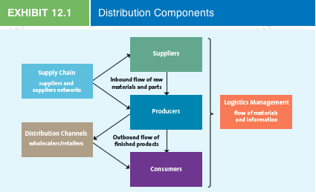
  - Supply chain management: refers to a set of approaches and techniques firms employ to efficiently and effectively integrate their suppliers, manufacturers, warehouses, stores, and transportation intermediaries into a seamless value chain in which merchandise is produced and distributed in the right quantities, to the right locations, and at the right time, as well as to minimize systemwide costs while satisfying the service levels their customers require
  - Wholesalers: firms that buy products from manufacturers and resell them to retailers, and retailers sell products directly to consumers
  - Many variations to the supply chain exist
    - Some retail chains, like Home Depot and Costco, function as both retailer and wholesalers
  - Logistics management: describes the integration of two or more activities to plan, implement, and control the efficient flow of raw materials, in-process inventory, and finished goods from the point of origin to the point of consumption
    - These activities may include, but are not limited to, customer service, demand forecasting, distribution communications, inventory control, materials handling, order processing, parts and service support, plant and warehouse site selection, procurement, packaging, return goods handling, salvage and scrap disposal, traffic and transportation, and warehousing and storage
  - Distribution channel management, supply chain management, and logistics management are related but have been handled differently in the pas
  - Distribution channel management traditionally has been the responsibility of marketing departments, under the direction of a marketing vice-president

- LO2: Identify how distribution channels add value to businesses and consumers
- Distribution Channels Add Value
  - They are composed of various entities that are buying, such as retailers or wholesalers; selling, such as manufacturers or wholesalers; or helping facilitate the exchange, such as transportation companies
  - Each channel member performs a specialized role. If one member believes that another isn't doing its job correctly or efficiently, it usually can replace that member
  - Distribution channels perform a variety of transactional, logistical, and facilitating functions
    - Transactional Function
      - Buying—purchase goods for resale to other intermediaries or consumers
      - Risk Taking—ownership of inventory that can become outdated
      - Promotion—promote products to attract customers
      - Selling—transact with potential customers
    - Logistical Function
      - Physical Distribution—transport goods to point of purchase
      - Storing—maintain inventory and protect goods
    - Facilitating Function
      - Gather information—share competitive intelligence about customers or other channel members
      - Financing—extend credit and other financial services to consumers

- LO3: Describe distribution channel design and management decision and strategies
- Channel Structure
  - When a firm is just starting out or entering a new market, it doesn't typically have the option of designing the “best” distribution channel structure—that is, choosing from whom it buys or to whom it sells
  - The problem can be equally daunting for manufacturers entering a new market, whose primary concern will be to find retailers that want to take a chance on their line
  - Every company must develop a distribution strategy for how it will sell goods to customers
  - May take the form of direct, indirect, or multichannel distribution
  - Direct Distribution
    - Allow manufacturers to deal directly with consumers
    - Direct distribution also plays a significant role in B2B dealings with companies that sell directly to their largest customers in the public and private sectors
    - Some companies may be forced to distribute their goods directly because they are unable to secure shelf space in retail outlets or are unable to pay the high listing fees demanded by retailers for the shelf space
  - Indirect Distribution
    - One or more intermediaries work with manufacturers to provide goods and services to consumers
    - There may be only one intermediary involved
    - Wholesalers are often used when a company does not buy in sufficient quantity to make it cost-effective for a manufacturer to deal directly with a retailer. The use of wholesalers is quite common for low-cost or low-unit value items such as candy and chips
    - Push or pull strategy
      - Push=focuses on promo efforts on channel members to convince them to carry the product
      - Pull=TV commercials or print ads or direct mail info or coupons regarding new products may approach local retailer sand request that they stock these products
    - Multichannel Distribution
      - Hybrid approach to distribution, uses a combination of both direct and indirect channels
- 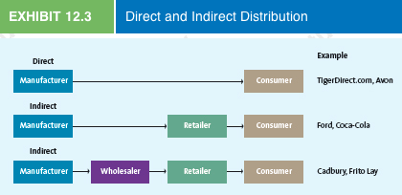
- Customer Expectations
  - Distribution channel management is an integral part of any marketing strategy
  - Must determine customer expectations
  - Need to know from which manufacturers it’s customers want to buy and where their target market customers expect to find the products and those of their competitors
- Channel Member Characteristics
  - Several factors pertaining to the channel members themselves will help determine the distribution structure
  - Larger firms often find that by performing the distribution functions themselves, they can gain more control, be more efficient, and save money

- Distribution Intensity
  - The number of channel members to use at each level of the supply chain
  - Three levels:
    - Intensive Distribution
      - Designed to get products into as many outlets as possible
      - The more exposure these products get, the more they sell
    - Selective Distribution
      - Lies between the intensive and exclusive distribution strategies; uses a few selected customers in a territory
      - Helps a seller maintain a particular image and control the flow of merchandise into an area
    - Exclusive Distribution
      - Strategy of granting exclusive rights to sell to one or very few retail customers so no other customers can sell a particular brand
      - Exclusive geographic territories: Territories granted to one or very few retail customers by a manufacturer using an exclusive distribution strategy; no other customers can sell a particular brand in these territories
      - Can benefit manufacturers by assuring them that the most appropriate customers represent their products
      - Can help a new firm ensure they have enough inventory to offer
- 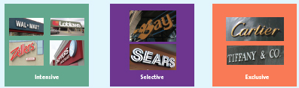

- Managing Distribution Channels
  - If a distribution channel is to run efficiently, the participating members must cooperate
  - Sometimes channel members have conflicting goals
  - Channel conflict: when channel members are not in agreement about their goals, roles or rewards
    - Can be resolved through good negotiations. But when the issues can't be worked out, relationships can fall apart, and the firms may go their separate ways
    - Companies can manage distribution channels by developing strong relationships with supply chain partners
    - OR they can coordinate the channel by using a vertical marketing system
  - Managing Channels Through Vertical Marketing Systems
    - In an independent distribution channel, the several independent members—a manufacturer, a wholesaler, and a retailer—each attempt to satisfy their own objectives and maximize their own profits, often at the expense of the other members. None of the participants has any control over the others
    - Vertical marketing system: A supply chain in which the members act as a unified system; there are three types: administrated, contractual, and corporate
      - Administered Vertical Marketing System
        - A supply chain system in which there is no common ownership and no contractual relationships, but the dominant channel member controls the channel relationship
        - Example: Zara/Tessuto relationship (fabric)
      - Contractual Vertical Marketing System
        - A system in which independent firms at different levels of the supply chain join together through contracts to obtain economies of scale and coordination and to reduce conflict
        - Example: a franchise (a contractual agreement between a franchisor and a franchisee that allows the franchisee to operate a retail outlet, using a name and format developed and supported by the franchisor)
      - Corporate Vertical Marketing System
        - A system in which the parent company has complete control and can dictate the priorities and objectives of the supply chain; it may own facilities
        - Example: Zara’s parent company Inditex, which owns the manufacturing plants, warehouse facilities, retail outlets, and design studios

- LO4: Explain how logistics and supply chain management affect distribution strategy
- Supply Chain Management Streamlines Distribution
  - As recently as the early 1990s, even the most innovative firms needed 15 to 30 days—or even more—to fulfill an order from the warehouse to the customer
  - The typical order-to-delivery process had several steps: order creation, usually using a telephone, facsimile, or mail; order processing, using a manual system for credit authorization and assignment to a warehouse; and physical delivery
  - Recently firms have been holding minimal inventory
- Supply Chain Management Affects Marketing
  - When products are designed and manufactured, how and when the critical components reach the factory must be coordinated with production
  - The sales department must coordinate its delivery promises with the factory or distribution centres
  - A distribution centre, a facility for the receipt, storage, and redistribution of goods to company stores or customers, may be operated by retailers, manufacturers, or distribution specialists
  - Advertising and promotion must be coordinated with those departments that control inventory and transportation
  - Five interrelated activities emerge in supply chain management: designing distribution channels (discussed earlier in this chapter), making information flow, managing the relationships among supply chain partners, making merchandise flow, and managing inventory
- Logistics Management: Making Information Flow
  - Flow 1: Customer to Store
    - Customer purchases product, the universal product code is scanned and the customer receives a receipt
  - Flow 2: Store to Buyer
    - POS data transferred to headquarters
  - Flow 3: Buyer to Manufacturer
    - The retailer and manufacturer exchange business documents through a system called electronic data exchange
  - Flow 4: Store to Manufacturer
    - Purchase information transferred to manufacturer from buyer
  - Flow 5: Store to Distribution Centre
    - Store communicates with distribution centre regarding inventory and delivery
- Data Warehouse
  - Consumers' purchase data collected at the point of sale (flow 2) goes into a huge database known as a data warehouse. The information stored in the data warehouse is accessible on various dimensions and levels
  - 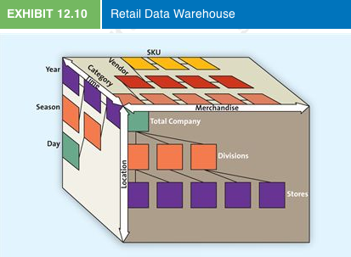
  - As shown on the horizontal axis, data can be accessed according to the level of merchandise aggregation: SKU (item), vendor, category (e.g., dresses), or all merchandise. Along the vertical axis, data can be accessed by level of the company: store, divisions, or the total company. Finally, along the third dimension, data can be accessed by point in time: day, season, or year
  - In some cases, manufacturers also have access to this data warehouse. They communicate with retailers by using electronic data interchange and use supply chain systems known as vendor-managed inventory and collaborative planning, forecasting, and replenishment
- Electronic Data Interchange
  - The computer-to-computer exchange of business documents from a retailer to a vendor and back. In addition to sales data, purchase orders, invoices, and data about returned merchandise can be transmitted back and forth
  - Many retailers now require vendors to provide them with notification of deliveries before they take place by using an advanced shipping notice, an electronic document that the supplier sends the retailer in advance of a shipment to tell the retailer exactly what to expect in the shipment
    - Using EDIs, suppliers can describe and show pictures of their products, and buyers can issue requests for proposals. The two parties can then electronically negotiate prices and specify how the product will be made and how it should look
  - Three main benefits:
    - Reduces cycle time and information flows more quickly
    - Improves the overall quality of communications through better record keeping; fewer errors in inputting and receiving an order; and less human error in the interpretation
    - The data transmitted by EDI are in a computer-readable format that can be easily analyzed and used for a variety of tasks
- Managing Supply Chains Through Strategic Relationships
  - More often than not, firms seek a strategic relationship, also called a partnering relationship, in which the supply chain members are committed to maintaining the relationship over the long term and investing in opportunities that are mutually beneficial
  - Successful strategic relationships require:
    - Mutual trust
    - Open communication
    - Common goals
    - Credible commitments (tangible investments)

- Logistic Management: Making Merchandise Flow
  - Inbound transportation
    - Dispatchers coordinate deliveries to distribution centres—they assign a time slot for each shipment to arrive and if it misses it, they are fined
  - Receiving and Checking
    - Receiving refers to the process of recording the receipt of merchandise as it arrives at a distribution centre or store
    - Checking is the process of going through the goods upon receipt to ensure they arrived undamaged and that the merchandise ordered was the merchandise received
    - Radio frequency identification (RFID) tags are tiny computer chips that automatically transmit to a special scanner all the information about a container's contents or individual product
  - Storing and Cross-Docking
    - There are three types of distribution centres: traditional, cross-docking, and combinations.
    - Traditional distribution centre: a warehouse in which merchandise is unloaded from trucks and placed on racks or shelves for storage
    - Cross-docking distribution centre: one to which vendors ship merchandise prepackaged in the quantity required for each store
    - Combinations: Most modern distribution centres combine the two previous approaches. It is difficult for a firm to operate without some storage facilities, even if merchandise is stored for only a few days
      - In these cases, the retailer must have a system to store the merchandise temporarily
  - Getting Merchandise Floor-Ready
    - Getting merchandise floor-ready entails ticketing, marking, and, in the case of apparel, placing garments on hangers
    - Easiest for a retailer to perform these activities at a distribution centre
  - Shipping Merchandise to Stores
    - To handle such complex transportation problems, distribution centres use a sophisticated routing and scheduling computer system that considers the rate of sales in the store, road conditions, and transportation operating constraints to develop the most efficient routes possible
  - Inventory Management Through Just-In-Time Systems
    - Just-in-time (JIT) inventory systems, also known as quick-response (QR) systems in retailing, are inventory management systems designed to deliver less merchandise on a more frequent basis than traditional inventory systems
    - The firm gets the merchandise “just-in-time” for it to be used in the manufacture of another product, in the case of parts or components, or for sale when the customer wants it, in the case of consumer goods
The benefits of a JIT system include reduced lead time (by eliminating the need for paper transactions by mail and overnight deliveries), increased product availability, and lower inventory investment. JIT systems lower inventory investments, but product availability actually increases

- Chapter 13: Retailing

- LO1 Explain the issues manufacturers consider when choosing retail partners
- Retailing: the set of business activities that add value to products and services sold to consumers for their personal or family use
  - Include products bought at stores, through catalogues, and over the Internet, as well as services such as fast-food restaurants, airlines, and hotels
  - Wholesalers, in contrast, are those firms engaged in buying, taking title to, often storing, and physically handling goods in large quantities, and then reselling the goods (usually in smaller quantities) to retailers or industrial or business users
  - Retail is Canada’s third largest industry by size
  - Factors for establishing a relationship with retailers
    - Choosing retail partners
    - Identifying types of retailers
    - Creating a Retail Strategy
    - Exploring a Multichannel Strategy
  - Many retailers and some manufacturers are exploring a multichannel strategy in which they sell in more than one channel (e.g., store, catalogue, kiosk, and Internet)
  - Channel Structure
    - The level of difficulty a manufacturer has in getting retailers to purchase its products is determined by the degree to which the channel is vertically integrated
      - The degree to which the manufacturer has a strong brand or is otherwise desirable in the market
      - The relative power of the manufacturer and retailer
  - Customer Expectations
    - It is important to know from which manufacturers its customers want to buy
    - Manufacturers need to know where their target market customers expect to find their products and those of their competitors
  - Channel Member Characteristics
    - Several factors pertaining to the channel members themselves will help determine the channel structure
    - Generally, the larger and more sophisticated the channel member, the less likely that it will use supply chain intermediaries
    - Larger firms often find that by performing the channel functions themselves, they can gain more control, be more efficient, and save money

- LO2 Identify what types of retailers are available to distribute products
  - Manufacturers need to understand the general characteristics of different types of retailers so they can determine the best channels for their products
  - Food retailers
    - You can buy food at drug stores, discount stores, and grocery stores now
    - Restaurants also compete for consumers’ food dollars
    - The characteristics of the 3 major categories of food retailers (below)
- 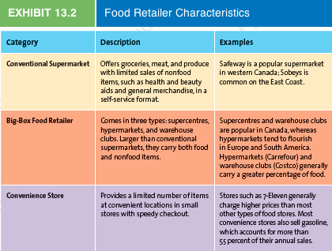
  - General Merchandise Retailers
    - discount stores, specialty stores, category specialists, department stores, drugstores, off-price retailers, and extreme value retailers
    - many of these retailers sell through multiple channels, such as the Internet and catologues
    - Discount store
      - Offers a broad variety of merchandise, limited service, and low prices
      - Walmart and Zellers dominate the discount store industry in Canada and vie for similar target markets
    - Specialty store
      - Concentrate on a limited number of complementary merchandise categories in relatively small stores
      - These stores tailor their energy toward very specific market segments by offering deep but narrow assortments and sales associate expertise
      - Payless Shoes
      - Estee Lauder’s MAC Cosmetics
      - Sephora
    - Category specialists
      - Offers a narrow variety but a deep assortment of merchandise
      - Most category specialists use a self-service approach, but some, such as Home Depot, provide extensive customer service
      - Chapters
      - Future Shop
      - Because category specialists offer such an extensive assortment in a particular category, they can so overwhelm the category that other retailers have difficulty competing; in these cases, the specialists are frequently called category killers
    - Department Stores
      - Refer to those retailers that carry many different types of merchandise (broad variety) and lots of items within each type (deep assortment), offer some customer services, and are organized into separate departments to display their merchandise
      - Largest remaining are Sears and The Bay
      - Department stores have lost market share to specialty stores, discount stores, and category specialists
    - Drugstores
      - Specialty stores that concentrate on health and personal grooming merchandise, though pharmaceuticals often represent more than 60% of their sales
      - Shoppers Drug Mart, Jean Coutu, PharmaSave
        - Face a major challenge because of the low margins they earn on prescription drugs; health insurance companies and government programs pay most of the cost of many prescriptions, and the health insurance companies negotiate substantially lower prices with drugstores
        - These drugstores therefore are attempting to make up for their lost profits on prescriptions by concentrating their efforts on nonpharmaceutical products
    - Off-Price Retailers
      - Offer an inconsistent assortment of merchandise at relatively low prices
      - They typically buy from manufacturers or other retailers with excess inventory or at the end of a season for one-fourth to one-fifth the original wholesale price
      - The key to off-price retailers’ success is the treasure hunt environment they create
      - Winners, HomeSense, or Designer Depot
      - Extreme value retailers are a subset of off-price retailers and have discounted general merchandise in lower-income urban or rural areas
        - Ex. Dollarama

- LO3 Describe how retailers use the four Ps to create value for customers

- Product
  - Providing the right mix of merchandise and services that satisfies the needs of the target market is one of retailers' most fundamental activities
  - Neither group likes to store inventory that isn't being used because doing so ties up money that could be used for something else
  - Retailers thus provide value to both manufacturers and customers by performing the storage function, though many retailers are beginning to push their suppliers to hold the inventory until they need it
  - It is difficult for retailers to distinguish themselves from their competitors through the merchandise they carry because competitors can purchase and sell many of the same popular brands
    - This is why many retailers have developed private-label brands
- Price
  - Price helps define the value of both the merchandise and the service, and the general price range of a particular store helps define its image
  - Manufacturers must consider at what price they will sell the product to retailers so that both the manufacturer and the retailer can make a reasonable profit
  - At the same time, both the manufacturer and the retailer are concerned about what the customer is willing to pay
  - Price must always be aligned with the other elements of the retail mix

Promotion
  - Retailers and manufacturers know that good promotion, both within their retail environments and in the media, can mean the difference between flat sales and a growing consumer base
  - Advertising in traditional media such as newspapers, magazines, and television continues to be important to get customers into the stores
  - Retailers use displays and signs, placed at the point of purchase or in strategic areas such as the end of aisles, known as end caps, to inform customers and stimulate purchases of the featured products
  - Cooperative Advertising: An agreement between a manufacturer and retailer in which the manufacturer agrees to defray some advertising costs
  - Some other subtle forms of promotion: credit cards/gift cards, coupons, rebates, in-store discounts, etc.
  - In addition to more traditional forms of promotion, many retailers are devoting more resources to their overall retail environment as a means to promote and showcase what the store has to offer
    - Displays, counters, atmosphere
  - Personal selling and customer service representatives are also a part of promotion
  - Using direct salesperson contact, targeted promotions, and services, they attempt to increase their share of wallet—the percentage of the customer's purchases made from that particular retailer—with their best customers
- Place
  - Retailers already have realized that convenience is a key ingredient to success, and an important aspect of this success is convenient locations
  - Many customers choose stores on the basis of where they are located, which makes great locations a competitive advantage that few rivals can duplicate
  - Example: 24-hour Shopper’s Drug Marts
- The Wheel of Retailing
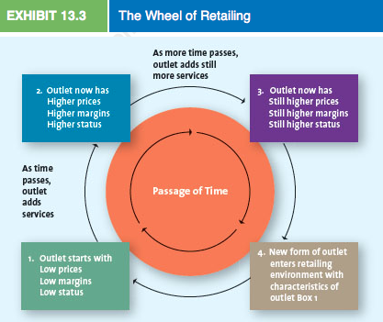
  - In the Wheel of Retailing concept, as stores add services and improvements expand the mix of merchandise carried and upgrade their facilities, costs are generally added to the day-to-day operations, which results in higher prices
  - This change opens up opportunities for new lean, mean entrants at the beginning of the wheel

- LO4 Describe the multichannel options available to retailers

- Channels for Selling to Consumers
  - Store Channel
    - Traditional stores, or bricks-and-mortar retailers offer several brands to benefit customers that they cannot get when they shop through catalogues or on the Internet
    - Browsing
    - Touching and feeling products
    - Personal service
    - Cash and credit payment
    - Entertainment and social interaction
    - Instant gratification
    - Risk reduction
  - Kiosk Channel
    - Retailers using a kiosk channel may simply provide store associates with access to the company website so that they can more easily help customers find product information or place orders
    - Broader selection
    - Access to items online that are out of stock in stores
    - Access to wish lists and gift registries
    - Access to loyalty program information
  - Catalogue Channel
    - The catalogue channel provides some benefits to customers that are not available from the store or Internet channels. Like all nonstore formats, catalogues offer the convenience of looking at merchandise and placing an order 24-7
    - Convenience
    - Information
    - Safety
  - Internet Channels
    - Shopping over the Internet provides the convenience offered by catalogues and other nonstore formats
    - It also has the potential to offer a greater selection of products and more personalized information about products and services in a relatively short amount of time
    - It also offers sellers the unique opportunity to collect information about how consumers shop—information that they can use to improve the shopping experience across all channels
    - Broader selection
    - More Information to evaluate merchandise
    - Personalization
    - Personalized customer service
    - Personalized offering
    - Challenges in selling merchandise via the internet
      - Because of the problems of providing touch-and-feel information, apparel retailers experience return rates of more than 20 percent on purchases made through an electronic channel but only 10 percent for purchases made in stores
        - Role of brands
          - consumers trust familiar brands, products with important touch-and-feel attributes, such as clothing, perfume, flowers, and food, with well-known name brands sell successfully through nonstore channels, including the Internet, catalogues, and TV home shopping
        - Using technology
          - Websites are going beyond offering the basic image to giving customers the opportunity to view merchandise from different angles and perspectives by using 3-D imaging and/or zoom technology
          - To overcome the limitations associated with trying on clothing, apparel retailers have started to use virtual models on their websites
        - Services
          - Some service providers have been very successful over the Internet, because the look-and-see attributes of their offering can be presented very effectively online
      - Perceived Risks in Electronic Shopping
        - The security of credit card transactions on the internet
        - Potential privacy violations
        - Ability of internet sellers to collect information about purchase history, personal information, and search behaviour

- LO5 Explain why traditional retailers are evolving into multichannel retailers
  - Traditional store-based and catalogue retailers and some manufacturers are placing more emphasis on their electronic channels and evolving into multichannel retailers—that is, retailers that sell merchandise in more than one retail channel (e.g., store, catalogue, and Internet)—for four reasons
    - Overcoming the Limitations of an Existing Format
      - By blending stores with internet-enabled kiosks, retailers can dramatically expand the assortment offered to their customers
      - Store-based retailers face inconsistent execution; the availability and knowledge of sales associates can vary considerably across stores or even within a store at different times during the day
      - A catalogue retailer can also use its electronic channel to overcome the limitations of its catalogue
    - Expanding Market Presence
      - The Internet has facilitated market expansions by traditional retailers
      - In addition to increasing sales by expanding the current customer base and attracting new customers, multichannel retailers can achieve economies of scale by coordinating their buying and logistics activities across channels and consolidating their marketing information and activities
      - Generally, those who shop at multichannel retailers typically buy more
    - Increasing Share of Wallet
      - Although offering an electronic channel may draw away some sales from other channels, using it with other channels can result in consumers making more total purchases from the seller
      - Many retailers will waive shipping charges when orders are placed online or through the catalogue if the customer physically comes to the store
      - Research has shown that multichannel consumers spend substantially more than those who shop at a single channel—between 25 to 100 percent more
    - Gaining Insights into Customers’ Shopping Behaviours
      - Online retailing provides key insights into the choices consumers make since the data can be collected unobtrusively
      - People often shop differently in the different channels
      - If a retailer gathers data about a customer's actions in all of its channels, it should be able to put together a clearer, more detailed picture of how and why customers patronize—or don't patronize—its channels and offerings
    - Disintermediation: occurs when a manufacturer sells directly to consumers, bypassing retailers
      - They lack many of the critical skills necessary to sell merchandise electronically, and retailers are typically more efficient in dealing with customers directly than are manufacturers
      - Retailers also have an advantage because they can provide a broader array of products are services
      - Manufacturers that sell directly to consumers risk losing the sipport of the retailers they bypass

- Chapter 14: Integrated Marketing Communications
  - Integrated marketing communications (IMC) represents promotion, the fourth P of the four Ps. It encompasses a variety of communication disciplines—advertising, personal selling, sales promotion, public relations, direct marketing, and electronic media—in combination to provide clarity, consistency, and maximum communicative impact
  - IMC programs regard each of the firm's marketing communications elements as part of a whole, each of which offers a different means to connect with the target audience
  - This integration of elements provides the firm with the best means to reach the target audience with the desired message, and it enhances the value story by offering a clear and consistent message
  - There are three components in any IMC strategy: the consumer or target market, the channels or vehicles through which the message is communicated, and the evaluation of the results of the communication

- LO1 Outline the process that firms use to communicate with consumers
  - As the number of communication media has increased, the task of understanding how best to reach target consumers has become far more complex
- 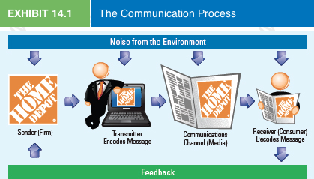
  - The Sender
    - Message originates from the sender, who must be clearly identified to the intended audience
    - In the quest for innovate ways to reach consumers, some marketers have been accused of deceptive advertising
  - The Transmitter
    - The sender works with the creative department, whether in-house or from a marketing (or advertising) agency, to develop marketing communications. Stanley likely develops advertising materials with its ad agency and provides the materials to Home Depot. Such an agent or intermediary is the transmitter
  - Encoding
    - Converting the sender's ideas into a message, which could be verbal, visual, or both
    - The most important facet of encoding is not what is sent but rather what is received
  - The Communication Channel
    - The medium—print, broadcast, the Internet—that carries the message
  - The Receiver
    - The person who reads, hears, or sees and processes the information contained in the message or advertisement
    - Decoding refers to the process by which the receiver interprets the sender’s message
  - Noise
    - Any interference that stems from competing messages, a lack of clarity in the message, or a flaw in the medium, and it poses a problem for all communication channels
  - Feedback loop
    - Allows the receiver to communicate with the sender and thereby informs the sender whether the message was received and decoded properly
    - Could come in many forms (example: complaint or compliment)

- How Consumers Perceive Communication
  - Receivers decode messages differently
  - Senders adjust messages according to the medium and receivers’ traits

- LO2 Explain the six tools of integrated marketing communications campaigns

  - Advertising
    - Perhaps the most visible
    - It is a paid form of communication from an identifiable source, delivered through a communication channel, and designed to persuade the receiver to take some action, now or in the future
    - Mass advertising can entice consumers into a conversation with marketers
    - However, advertising must break through the clutter of other messages to reach its intended audience
  - Personal Selling
    - The two-way flow of communication between a buyer and a seller that is designed to influence the buyer’s purchase decision
    - Personal selling can take place in various settings: face to face, video teleconferencing, on the telephone, or over the Internet
    - The cost of communicating directly with a potential customer is quite high compared with other forms of promotion, but it is simply the best and most efficient way to sell certain products and services
  - Sales Promotion
    - Special incentives or excitement-building programs that encourage the purchase of a product or service, such as coupons, rebates, contests, free samples, and point-of-purchase displays
    - While some sales promotions are offline (e.g., printed coupons or contest entries), others are online (e.g., e-coupons downloaded to a smartphone)
    - Marketers typically design these incentives for use in conjunction with other advertising or personal selling programs
    - Many sales promotions, such as free samples or point-of-purchase displays, are designed to build short-term sales; though others, such as contests and sweepstakes, have become integral components of firms' CRM programs as means to build customer loyalty
  - Direct Marketing
    - The component of IMC that has received the greatest increase in aggregate spending recently is direct marketing, or marketing that communicates directly with target customers to generate a response or transaction
    - Direct marketing contains a variety of traditional and new forms of marketing communication initiatives, including offline forms such as direct mail, direct response TV commercials (infomercials), catalogues, and kiosks, as well as online technologies such as email, podcasts, and cellphones
    - Direct marketing has four defining characteristics:
      - It is targeted
      - Motivates an action
      - Is measurable
      - And can provide information for the development of a marketing database
    - Can reach a wider target audience and cost is much lower to reach consumers
  - Public Relations
    - Public relations (PR) is the organizational function that manages the firm's communications to achieve a variety of objectives, including building and maintaining a positive image, handling or heading off unfavourable stories or events, and maintaining positive relationships with the media
    - PR activities support the other promotional efforts by the firm by generating “free” media attention
    - Can be crucial to a company’s success
    - Cause-related marketing: refers to commercial activity in which businesses and charities form a partnership to market an image, product, or service for their mutual benefit
    - Good PR has always been an important success factor. Yet in recent years, the importance of PR has grown, as the cost of other forms of marketing communications has increased
    - The influence of PR has become more powerful, as consumers have become increasingly skeptical of marketing claims made in other media
    - Event sponsorship: when corporations support various activities (financially or otherwise), usually in the cultural or sports and entertainment sectors
  - 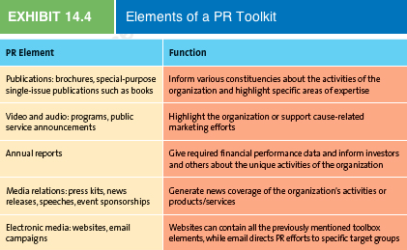
  - Electronic Media
    - Tools range from simple website content to far more interactive features such as corporate blogs, online games, text messaging, social media, and mobile apps
    - Marketers are using them more and more often for the following reasons, among others: they can be targeted to specific customer segments, their impact can be easily and quickly measured in real time, modifications can be quickly made to increase their effectiveness, and customers can be engaged to forward the message to their social networks
    - Some examples: Websites, Blogs, Online Games, Text Messaging, Social Media, Mobile Apps

- LO3 List the steps in planning an integrated marketing communications campaign
- LO4 Describe what appeals advertisers use to get customers' attention
- LO5 Identify how firms determine which media to use
- LO6 Summarize how firms budget for and measure integrated marketing communications success

STEPS IN AN IMC CAMPAIGN:
- Identify Target Audience
  - The success depends on how well the advertiser can do this
  - Firms conduct research to identify their target audience, then use the info they gain to set the tone for the program/to select the media
- Set Objectives
- These objectives can be short-term, such as generating inquiries, increasing awareness, and prompting trial. Or they can be long-term in nature, such as increasing sales, market share, and customer loyalty
- Generally, these objectives appear in the advertising plan, a section of the firm's overall marketing plan that explicitly outlines the objectives of the advertising campaign, how the campaign might accomplish those objectives, and how the firm can determine whether the campaign was successful
- All marketing communications aim to achieve certain objectives: to inform, persuade, and remind customers
- Generally, when advertising to consumers, the objective is a pull strategy in which the goal is to get consumers to pull the product into the supply chain by demanding retailers carry it.
- Push strategies also exist and are designed to increase demand by focusing on wholesalers, distributors, or salespeople, who push the product to consumers via distribution channels
- Determine Budget
- Firms use a variety of methods to plan their marketing communications budgets

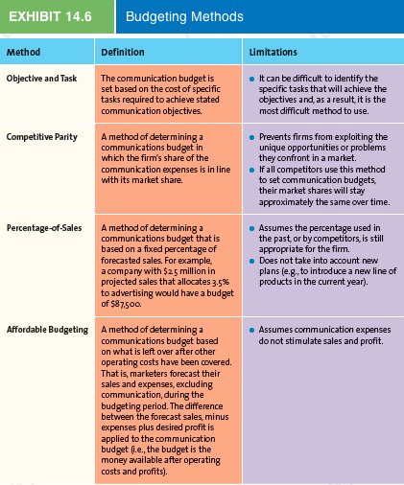
- Convey Message
- In this step, marketers determine what they want to convey about the product or service. First, the firm determines the key message it wants to communicate to the target audience. Second, the firm decides what appeal would most effectively convey the message
- Must be considered simultaneously
- Unique selling proposition: A strategy of differentiating a product by communicating its unique attributes; often becomes the common theme or slogan in the entire advertising campaign
- Three main types of appeals: logos (logical), ethos (ethical), and pathos (emotional)
- Rational vs. emotional types of appeals (LO4)
  - Rational appeals: help consumers make purchase decisions by offering factual information and strong arguments built around relevant issues that encourage consumers to evaluate the brand favourably on the basis of the key benefits it provides
    - Focus on consumers’ sense of reasoning, logic, and learning
    - Example: Kleenex Anti-Viral Tissue expressing it’s superior benefits of this product over regular facial tissue
    - Emotional appeals: aims to satisfy consumers' emotional desires rather than their utilitarian needs
      - The key is the use of emotion to create a bond between the consumer and the brand
      - Many other effective emotional appeals are used in advertising, ranging from sex appeal (e.g., Tag Body Spray), need for affiliation, need for guidance (e.g., Betty Crocker), and attention (e.g., cosmetics)
- Evaluate and Select Media (LO5)
- The content of an advertisement is tied closely to the characteristics of the media that firms select to carry the message, and vice versa
- Media planning refers to the process of evaluating and selecting the media mix—the combination of the media used and the frequency of advertising in each medium—that will deliver a clear, consistent, compelling message to the intended audience
- Because the media buy, the actual purchase of airtime or print pages, is generally the largest expense in the advertising budget, marketers must make their decisions carefully
- Mass and niche media
  - Mass media channels include national newspapers, magazines, radio, TV
  - Niche media channels are more focused and are generally used to reach narrower segments
- Choosing the right medium
  - For each class of media, each alternative has specific characteristics that make it suitable for meeting specific objectives
  - Each medium also varies in its reach and frequency. Advertisers can determine how effective their media mix has been in reaching their target audience by calculating the total gross rating points (GRP) (reach × frequency) of the advertising schedule
- Determining the advertising schedule
  - Specifies the timing and duration of advertising
  - 3 types:
    - Continuous: schedule runs steadily throughout the year and therefore is suited to products and services that are consumed continually at relatively steady rates and that require a steady level of persuasive or reminder advertising
    - Flighting: refers to an advertising schedule implemented in spurts, with periods of heavy advertising followed by periods of no advertising. This pattern generally functions for products whose demand fluctuates, such as tennis racquets
    - Pulsing: combines the continuous and flighting schedules by maintaining a base level of advertising but increasing advertising intensity during certain periods
- Create Communication
- After the advertiser has decided on the message, type of ad, and appeal, its attention must shift to the actual creation of the advertisement
- During this step, the message and appeal are translated creatively into words, pictures, colours, and/or music
- Often, the execution style for the ad will dictate the type of medium used to deliver the message
- Although creativity plays a major role in the execution stage, advertisers must be careful not to let their creativity overshadow the message
- Assess Impact
- The effectiveness of an advertising campaign must be assessed before, during, and after the campaign has run.
- Pretesting refers to assessments performed before an ad campaign is implemented to ensure that the various elements are working in an integrated fashion and doing what they are intended to do.
- Tracking includes monitoring key indicators, such as daily or weekly sales volume, while the advertisement is running to shed light on any problems with the message or the medium.
- Posttesting is the evaluation of the campaign's impact after it has been implemented. At this last stage, advertisers assess the sales and/or communication impact of the advertisement or campaign
- Some product categories experience so many influences that it is almost impossible to identify advertising's contribution to any individual consumer's choice to purchase a particular product, especially for addictive products such as cigarettes and alcohol or those with potentially negative health consequences, such as fast food or high-sugar breakfast cereals

Measuring IMC Success
  - When measuring IMC success, the firm should examine when and how often consumers have been exposed to various marketing communications
  - Therefore, marketers measure the frequency of exposure—how often the target audience is exposed to a communication within a specified period of time
  - The other measure used to determine consumers' exposure to marketing communications is reach, which describes the percentage of the target population exposed to a specific marketing communication, such as an advertisement, at least once
  - Marketing communications managers usually state their media objectives in terms of gross rating points (GRP), which represents reach multiplied by frequency (GRP = reach × frequency). This measure can be used for various media advertising—print, radio, or television
  - GRP can be measured for print, radio, or television but, when comparing the calculations, they must refer to the same medium
Click-through tracking measures how many times users click on banner advertising on website

- Chapter 15: Advertising, Sales Promotions, and Personal Selling

- LO1 Describe advertising and the objectives of advertising
  - To create effective advertising, marketers must understand how marketing communications work
  - Generally, marketing communications move consumers step-wise through a series of mental stages, for which there are several models. The most common is the AIDA model, which suggests that awareness leads to interest, which leads to desire, which leads to action
  - At each stage, the consumer makes judgments about whether to take the next step in the process
  - Customers actually have three types of responses, so the AIDA model is also known as the “think, feel, do” model
    - Awareness: a potential customer's ability to recognize or recall that the brand name is a particular type of retailer or product/service
      - Aided recall: when consumers recognize the brand when it’s name is presented to them
      - Top-of-mind awareness: the highest level of awareness, occurs when a brand has a prominent place in people’s memories that triggers a response without them having to put any thought into it
    - Interest: It isn't enough to let people know that the product exists; consumers must be persuaded that it is a product worth investigating
    - Desire: After the firm has piqued the interest of its target market, the goal of subsequent messages should move the consumer from “I like it” to “I want it.”
    - Action: If the message has caught consumers' attention and made them interested enough to consider the product as a means to satisfy a specific desire of theirs, they likely will act on that interest by making a purchase
  - The Lagged Effect: a delayed response to a marketing communication campaign
  - Objectives of Advertising (all advertising campaigns aim to achieve certain objectives: to inform, persuade, and remind customers)
    - Informative Advertising
      - Communicates to create and build brand awareness, with the ultimate goal of moving the consumer through the buying cycle to a purchase
    - Persuasive Advertising
      - Once a product has gained a certain level of brand awareness, firms use this to motivate consumers to take action
      - Generally occurs in the growth and early maturity stages of the PLC, when competition is most intense, and attempts to accelerate the market’s acceptance of the product
    - Reminder Advertising
      - Communication used to remind consumers of a product or to prompt repurchases, especially for products that have gained market acceptance and are in the maturity stage of their life cycle
    - Focus of Advertisements
      - To help determine the focus for advertisements, many companies consider the stages in the AIDA model
      - Product-focused advertisements are used to inform, persuade, or remind consumers about a specific product or service
      - The focus of institutional advertisements is to inform, persuade, and remind consumers about issues related to places, politics, an industry, or a particular corporation
      - Public service announcement (PSA) focuses on public welfare and generally is sponsored by nonprofit institutions, civic groups, religious organizations, trade associations, or political groups
      - PSAs represent a form of social marketing, which is the application of marketing principles to a social issue to bring about attitudinal and behavioural change among the general public or a specific population segment
        - Because they are often designed by top advertising agencies for nonprofit clients, PSAs usually are quite creative and stylistically appealing

- LO2 Summarize the regulatory and ethical issues of concern to advertisers
- 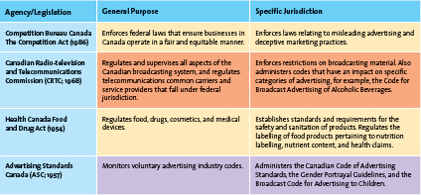
  - The Competition Bureau enforces the Competition Act, the most comprehensive legislation affecting the marketing activities of companies in Canada. The Competition Act maintains and encourages competition while protecting consumers from misleading and deceptive advertising practices. The CRTC controls the advertising industry and governs broadcast media and licensing. The CRTC must approve all TV and radio advertisements before they can be broadcast. The Food and Drug Act prohibits the advertising or selling of unsafe or misbranded foods, cosmetics, and drugs. It also requires companies to adhere to regulations regarding health claims.
  - The Consumer Packaging and Labelling Act requires manufacturers, packers, and distributors to disclose full information about their products. All pre-packaged products must be labelled in both French and English and bear the quantity in metric and imperial for weight, volume, or measures
  - A difference between advertising regulations in Canada and the European Union pertains to puffery, the legal exaggeration of praise, stopping just short of deception, lavished on a product
  - Stealth Marketing
    - A strategy used to attract consumers that employs promotional tactics which deliver a sales message in unconventional ways, often without the target audience knowing that the message even has a selling intent
    - Online games
    - Viral marketing: encourages people to pass along a marketing message to other potential consumers

- LO3 Explain how sales promotions supplement a firm's IMC strategy
  - Natural link between advertising and sales promotion
  - Sales promotions are special incentives or excitement-building programs that encourage consumers to purchase a particular product or service, typically used in conjunction with other advertising or personal selling programs
  - Consumer Sales Promotions
- 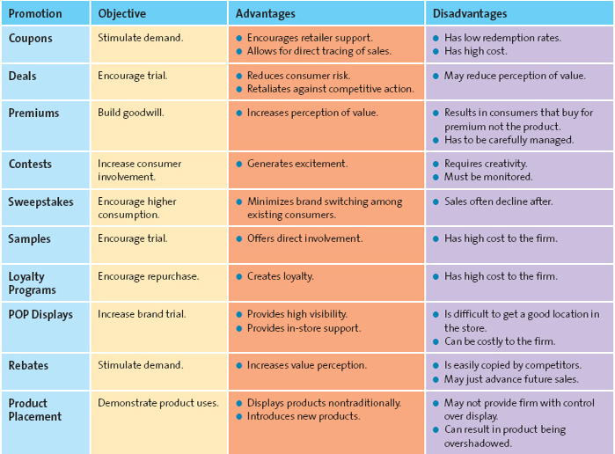
  - Trade Channel Sales Promotions
    - Trade channel promotions help convince retailers and wholesalers to stock a new brand, give it eye-level shelf space, and promote it in their flyers and other advertisements
    - Discounts and Allowances
      - Effective incentives used to maintain or increase inventory levels in the distribution channel
    - Co-operative Advertising
      - Co-operative (co-op) advertising helps to compensate trade channel members for money they spend promoting products and encourages them to feature products more often
    - Sales Force Training
      - This training gives a company's sales force more in-depth product knowledge, which enhances their confidence in the product and increases the likelihood of future sales
    - Using Sales Promotion Tools
      - Pop-up stores: exist for a limited time and generally focus on a new product or limited group of products offered by a retailer, manufacturer, or service provider
      - Cross-promoting: when two firms join together to reach a specific target market
    - Traditionally, the role of sales promotion has been to generate short-term results, whereas the goal of advertising was to generate long-term results
    - Though, both sales promotion and advertising can generate both long- and short-term effects. The effective combination of both types of activities leads to impressive results for the firm and the consumers
    - Evaluating Sales Promotions by Using Marketing Metrics
      - To evaluate a trade promotion, retailers consider:
        - the realized margin from the promotion
        - the cost of the additional inventory carried because of buying more than the normal amount of the product
        - the potential increase in sales from the promoted merchandise
        - the long-term impact on sales of the promotion
        - the potential loss suffered when customers switch to the promoted merchandise from more profitable TVs
        - the additional sales made to customers attracted to the store by the promotion

- LO4 Describe personal selling and how it adds value for customers
  - Personal selling is the two-way flow of communication between a buyer (or buyers) and a seller that is designed to influence the buyer's purchase decision
  - Personal selling can take place in various situations: face to face, via video teleconferencing, on the telephone, or over the Internet
  - Professional selling can be a satisfying career for several reasons
    - Can make your own schedule
    - The variety of the job—every day is different
    - Can be a very lucrative career
    - Visible to management—good position to get promoted if you are a high-performing salesperson
  - CRM programs
    - Customer database or data warehouse
    - record transaction information, customer contact information, customer preferences, and market segment information about the customer
    - Once the data has been analyzed and CRM programs developed, salespeople can help implement the programs
  - The Value Added by Personal Selling
    - Salespeople educate and provide advice
    - Salespeople save time and simplify buying

- LO5 Identify the steps in the personal selling process
- 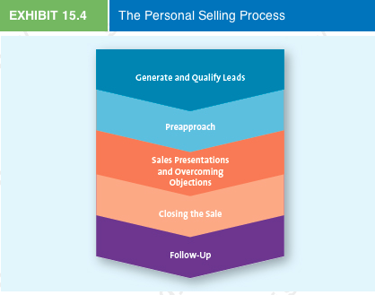
- 1) Generate and Qualify Leads
  - The first step in the selling process is to generate a list of potential customers (leads) and assess their potential (qualify)
  - Salespeople generate leads in a variety of ways
    - Networking events
    - Industry conferences
    - Trade shows
  - Cold calls: a method of prospecting in which salespeople telephone or go to see potential customers without appointments
  - Telemarketing: similar to a cold call, but it always occurs over the phone
    - Both of these have become less popular
  - After salespeople generate leads, they must qualify those leads by determining whether it is worthwhile to pursue them and attempt to turn the leads into customers
  - They should also assess whether the lead has the financial resources to pay for the product or service
- 2) Preapproach
  - Occurs prior to meeting the customer for the first time and extends the qualification of leads procedure
  - Although the salesperson has learned about the customer during the qualification stage, in this step, he or she must conduct additional research and develop plans for meeting with the customer
  - Having done the additional research, the salesperson establishes goals for meeting with the customer; it is important that he or she know ahead of time exactly what should be accomplished
- 3) Sales Presentation and Overcoming Objections
  - Once all the background information has been obtained and the objectives for the meeting are set, the salesperson is ready for a person-to-person meeting (presentation)
  - An integral part of the sales presentation is handling objections that the buyer might have about the product or service
  - Customers may raise objections pertaining to a variety of issues, but they usually relate in some way to value, such as that the price is too high for the level of quality or service
  - In an attempt to handle objections and start the process of closing the sale, a salesperson may offer creative deals or incentives that may be unethical
- 4) Closing the Sale
  - Obtaining a commitment from the customer to make a purchase. Without a successful close, the salesperson goes away empty-handed, so many salespeople find this part of the sales process very stressful
- 5) Follow-Up
  - With relationship selling, the sale is never really over, even after it has been made. The attitudes customers develop after the sale become the basis for how they will purchase in the future
  - The best way to nip a postsale problem in the bud is to check with the customer right after he or she takes possession of the product or immediately after the service has been completed

- Managing the Sales Force
  - Like any business activity involving people, the sales force requires management
  - Sales management: involves the planning, direction, and control of personal selling activities, including recruiting, selecting, training, motivating, compensating, and evaluating, as they apply to the sales force
  - Sales Force Structure
    - Company Sales Force or Manufacturer’s Representative
      - A company sales force is composed of people who are employees of the selling company.
      - Company sales forces are more typically used for established product lines. Because the salespeople are company employees, the manufacturer has more control over what they do
      - Independent agents, also known as manufacturer's representatives, are salespeople who sell a manufacturer's products on an extended contract basis but are not employees of the manufacturer. They are compensated by commissions and do not take ownership or physical possession of the merchandise
      - Manufacturer's representatives are useful for smaller firms or firms expanding into new markets because such companies can achieve instant and extensive sales coverage without having to pay full-time personnel
    - Recruiting and Selecting Salespeople
      - The most important activity in the recruiting process is to determine exactly what the salesperson will be doing and what personal traits and abilities a person should have to do the job well
    - Sales Training
      - Firms use varied methods to train their salespeople, depending on the topic of the training, what type of salesperson is being trained, and the cost versus the value of the training
    - Motivating and Compensating Salespeople
      - An important goal for any effective sales manager is to get to know his or her salespeople and determine what motivates them to be effective
      - Financial rewards
      - Nonfinancial rewards
    - Evaluating Salespeople
      - Sales, profits, and the number of orders represent examples of objective evaluation measures
      - Firms use ratios such as profit per customer, orders per call, sales per hour, or expenses compared to sales as their objective measures
      - Subjective evaluation measures seek to assess salespeople's behaviour—what they do and how well they do it—and reflect one person's opinion about another's performance

