PSYCHOLOGY OF AGING –PSY 3128 C
1.THEMES AND ISSUES IN AGING
A-Definition of age
*Chronological age: number of years since birth
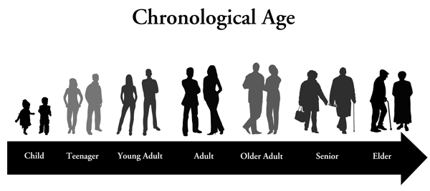

-Young-old: 65-74
-Old-old : 75-84
-Oldest-old: 85+
-Centenarians: 100+
-Supercentenarians: 110+
B-Indices of aging: Other than chronological age
*Functional age: categorize people not on their age but how they function
1.Biological age: use biological measures such as blood pressure to calculate biological age
2.Psychological age: use psychological measures such as cognitive functioning
3.Social age: use social roles such as whether they are retired or a grandparent.
Still these always have to be re-adjusted.
Further age distinctions:
Personal aging: Changes related to aging that occur within the individual
Social aging: Changes related to changes in the environment
1.Normative age-graded: aging s influenced by what is the norm at various ages (e.g in western society we retire around age 65)
2.Normative history-graded: aging is influenced by events that happen to everyone (e.g. war, natural disasters).
3.Nonormative: aging is influenced by things that cannot be predicted (e.g. car accident)
Historical influences on aging:
Education: educational attainment has increased across birth cohorts, GI Bill, changes in the curriculum and pedagogy
Occupational Status: change in retirement age, increase in woman’s work participation, increased work complexity
Changes in health and health behaviours –societal interventions: retirement and pension plan
C-Biopsychosocial perspective
Biological : physiological factors, genetics
Psychological: emotions, thoughts
Social: Culture, social context
Ex:
Elizabeth is an 84-yr-old woman who reports being distressed. She mentions not having any friends and family come visit her anymore. What biopsychosocial component is likely promoting her sense of distress?
Why is the biopsychosocial perspective important?
D- FOUR PRINCIPLES OF AGING
1.Changes are continuous over the life span
2.Individuality matters:
-inter-individual differences: differences between people
-intra-individual differences: differences within the same person
3.Only the survivors grow old
4. “Normal” aging is different from disease
Normal aging:
-also called primary aging
-changes related to aging that are universal and progressive
-e.g. cognitive changes, wrinkles
Impaired aging (disease):
-also called secondary aging
-abnormal changes that have an impact on a segment of older adults
-e.g. dementia, cancer
Optimal aging:
-also called successful aging
-aging process is slowed down because individual engages in preventive strategies
-e.g. individual engages in cognitively stimulating activities and physical activity
Factors that influence developmental change:
Gender & Sex
-physiological factors related to sex
-social role differences between men and women
Ethnicity:
-genetic inheritance related to ethnicity
-traditions and values inherent to certain cultures
Socioeconomic status
Religion
E- CANADA’S POPULATION OF OLDER ADULTS
Statistics Canada 2012 report:
-the promotion of older adults is growing rapidly
-it is projected that the number of older adults in Canada will more than double between 2005 and 2036
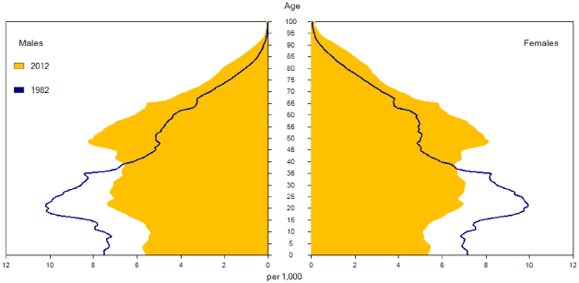
Age pyramid of population:

Canada’s median age:
-median age = 40 yrs; a 6.4 years increase since 1992
-median age will continue to increase
Median age by gender:
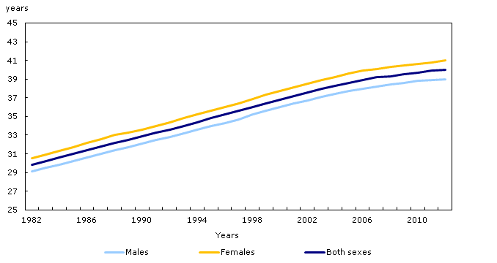
Proportion of population aged less than 15 yrs old and more than 65 yrs old
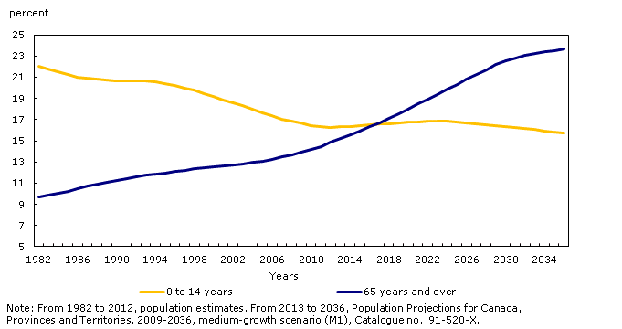
Profile of the older adults
More women then men
-greater number of older women than older men
-median age is higher for women (41 yrs) than men (39 yrs)
-more men die younger
The population of old-old compared to young-old is increasing
International Comparisons
-the population is also getting older around the world
-2010: 531 million over the age of 65
-2050: predicted to be 1.53 billion
-the percentage growth is expected to be especially pronounced in developing countries
Reasons for increases in 65 and older population:
-baby boomers
-increased life expectancy)/decreased mortality rate
Life expectancy at birth, by sex
 | Males | Females
Canada
1920 to 1922 | 59 | 61
1930 to 1932 | 60 | 62
1940 to 1942 | 63 | 66
1950 to 1952 | 66 | 71
1960 to 1962 | 68 | 74
1970 to 1972 | 69 | 76
1980 to 1982 | 72 | 79
1990 to 1992 | 75 | 81
2000 to 2002 | 77 | 82
2007 to 2009 | 79 | 83

-e.g. improved living conditions, medical advances, vaccinations, increased access to services
-decreasing birth rate
F- WHAT ARE THE IMPLICATIONS OF AN AGING POPULATION:
G-AGEISM
*Ageism: set of beliefs, attitudes and actions that discriminate people based on their age.
-underutilization of older peoples’ knowledge
-medical schools underemphasize geriatrics
-older adults receive less aggressive treatment- dismissed as normal aging
-abuse and neglect in nursing homes
-older adults in the media
More subtle
-talking exaggeratedly slow and loud
-distancing
Effects on older adults themselves:
-low self-esteem
-some will do just about anything to stay looking young
-internalize negative age stereotypes
Pessimism based on intergenerational interdependence
-resource threat
-benevolent prejudices
-prescriptive stereotypes
-age progressions

Optimism based on intergenerational interdependence
-age-specific interests
-improved elder image
-increased contact
-less cognitive impairment
-elder altruism
Combating ageism:
-changing older adult’s self-perception
-priming of positive age stereotypes
-increased research on optimal aging
2. METHODOLOGICAL ISSUES IN AGING
A- ETHICAL ISSUES IN RESEARCH
-Any research project involving human subjects, whether funded or not, must receive the approval of the Research Ethics Board
-ensure the rights of research participants are protected
-e.g. Guatemala syphilis study scandal
B-ROLE OF ETHICS BOARD
Research project description & importance of the new knowledge gained
-describe the project and its objectives
-situate the project in the scholarly literature and provide the rationale for the study
-describe the anticipated contribution of the research
Possible physical and psychological risks
-risk of physical harm and discomfort
-risk of psychological or emotional harm or discomfort
-legal and social repercussions
-economic inconveniences
Guarantee fair and impartial selection of subjects:
-will all eligible individuals who volunteer be included in the study?
-who will be recruiting participants?
Privacy of participants:
-anonymity: participants names are not associated with their responses
-will any information be collected which would permit specific research participants to be identified through identifiers such as their name, address, social insurance number etc?
-please describe how the identity of the individuals will be safeguarded
Confidentiality of data:
-describe the physical (e.g locked office) and technical (e.g. encryption) safeguards that will be used to securely store all sources of date
-indicate how long data will be conserved
Free and informed consent:
-individuals agree to participate in research voluntarily and that each participant understands as fully as possible the purpose of the research
-can withdraw from study at anytime
-describe the procedures that will be followed to obtain informed consent form
-could participants feel pressure to participate or perceive that they may be penalized?
Partial Disclosure/Deception:
-when incomplete disclosure of relevant information or an element of deception is necessary for the successful conduct of the research
-debriefing: information at study’s completion about its true purpose
C-ETHICS SPECIFIC TO OLDER ADULTS
Consent by older participants:
-impaired cognitive functioning, hearing, speech, vision
-use strategies to make sure they understand the procedure and the risks involved
-having a memory problem does not automatically mean they cannot give consent
-3 levels of capacity to consent:
-understanding and consent is clear
-it is impossible to judge whether the person understood
-understanding should be aided by family members or carers
D- EXPERIMENTAL DESIGNS
-dependent variable
-independent variable
-manipulation of the independent variable
-random assignment to treatment and control group or levels of exposure
e.g. drug trials
Challenges:
-I want to look at the effect of age on depression
-I want to look at the effect of depression on social support
-I want to look at the effect of abuse on depression
Quasi-experimental design:
-no randomization is needed
-control for as many confounding variables as possible
-no causation claims can be made
Laboratory Studies
-participants are tested in a systematic fashion using standardized procedures
-may not generalize to real-world
Qualitative Research
-analysis of any unstructured data
-not numerical in nature
-allows for examination of open-ended questions
-achieve a deeper understanding of issues/rich descriptive detail
Archival Research
-the use of existing resources
-e.g. newspapers, magazine reports, government data or reports
-can be more easily accessible
-no control over the information and how it was collected
Survey Research
-specific questions are asked
-survey: set of questions used to measure the participants’ attitudes, beliefs, health, work environement…
-Questionnaire: the participants read the questions and write their answers
-Interview (telephone or in-person): the researcher reads the questions and records the answers
Online surveys- Advantages
-certain populations may be made more accessible
-cross-cultural samples
-Internet surveys may achieve larger sample sizes
-the costs of email surveys are not dependent on the number of participants solicited
-possible to recruit from the whole population, rather than a randomly selected sample (e.g. email list of university students)
-less time consuming
-no need for printing or postage
-precision of data compilations
Challenges:
-sample representativeness
-response and nonresponse
-controlling testing conditions
Case reports:
-in-depth analysis of particular individuals
-can use multiple sources
-often used in early stages of research
-limitations:
-poor representation, cannot generalize beyond the participants
-poor replicability
-no causal inferences
-relies heavily on the judgement of the researcher
Focus groups:
-meeting of a group of respondents oriented towards a specific topic
-useful to use prior to conducting more systematic investigation
Observational research:
-a research method in which conclusions are drawn about behaviour through examination in particular setting
-direct observation, videotaping, participant observation

Correlational Research
-measure strength & direction of relationship between 2 or more variables
-variables are not manipulated
-does not establish causality
-measurement procedure is decided before data collection
A B
B A
A
C
B
Correlation between hostility and blood pressure
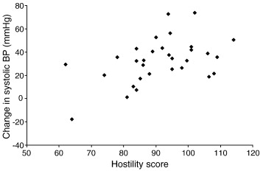
Multivariate correlational designs
-Relationship among more than 2 variables
-Control for confounds
Differential Research
-2 or more groups that are differentiated by a qualitative or quantitative variables
-participants are assigned to groups based on pre-existing characteristics
-no manipulation of IV, only measuring
-no causality
-artifacts and confounding variables
*Confounding: When 2 variables vary simultaneously during a study, thus not allowing us to determine which of these variables are responsible for the change in the DV
-e.g. Measure the effect of age on memory using 2 different measures
*Artifact: Effect of an independent variable that is actually the effect of another variable not properly controlled for.
-it is a results of confounding
Cross sectional design
Advantages:
-quick
-inexpensive
-newer, better measures can be used
Challenges:
-no causal effect
-no directionality
-compare individuals of different ages at one point in time
-age differences
-cannot untangle cohort effect from age effect
-selective survival
-what are range should be used
-differences in experience with testing between younger and older sampls
-applicability of measures for different age samples
Longitudinal Design
Advantages
-follow people repeatedly over time
-how individuals change over time (intra-individual differences) rather than individual differences
www.youtube.com/watch?feature=player_embedded&v=2wNJxJBuAOY
CLSA
Challenges:
-length of time
-selective attrition: loss of participants from original sample
-examine whether attrition was random
-used techniques to enhance long-term participation
-practice effect can lead to improved performance
-use alternate form of tests
-outdated tests
-change to newer measures
-untangling the effect of aging vs. historical time
Problem with selective attrition

Longitudinal designs- include different cohorts
Year of birth (Cohort) | Year of Testing (Time of Measurement)  1980 1990 2000 2010
1940 | 40 yrs | 50 yrs | 60 yrs | 70 yrs
1930 | 50 yrs | 60 yrs | 70 yrs | 80 yrs
1920 | 60 yrs | 70 yrs | 80 yrs | 90 yrs
Longitudinal designs- include different cohorts sequentially


