History of Computers
-computers are everywhere!
-90% of microprocessors are hidden inside common electronic devices
-Ex: thermostats, traffic lights, cars, watches, toys
-anything powered by electricity (a battery or house current) is candidate for microprocessor implant
-computer systems are developing rapidly but most of the underlying concepts remain constant
-important to understand the basics to keep up with the changes

-early humans counted with fingers or rocks the abacus
-by early 19th century the need for more accurate calculating tools became evident

Atanasoff-Berry Computer(ABC)
-created in 1942
-uses binary digits
-using electronics not mechanical switches
-computation and memory are separated
-not programmable
-used for a specific purpose to solve linear equations

Alan Turing
-1912-1954
-British mathematician
-father of computing science and artificial intelligence
-Turing machine: hypothetical device
-automatic machine machine, memory, algorithms
-general tasks
-Turing award
-1934: Alan Turing developed Colossus
-first programmable computer
-helped the Allies crack Nazi codes during WWII
-no internally stored programs
-used for a specific cryptanalytic task
-1944: Harvard Mark I
-could execute long computations automatically
-built at IBM
-used for the US navy
-addition and subtraction in a second, multiplication in 6 seconds, division in 15.3 seconds
-1946: ENIAC completed
-capable of being reprogrammed to solve a full range of computing problems
-used to calculate artillery firing tables US army
-many of the most important developments in the earliest days motivated by WWII
-1951: UNIVAC I
-first general-purpose commercial computer
-delivered to the US Census Bureau
-predicting the outcome of the US presidential election the following year

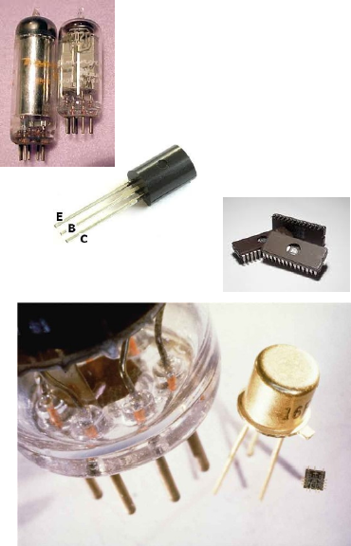
Computer Hardware
-3 generations of computer circuitry technology
-early computers used vacuum tubes which were replaced transistors
-by mid-1960s more powerful machines were based on integrated circuits
-silicon chips: containing hundreds of transistors
-development trends: smaller, faster, cheaper, more reliable, greener
-higher reliability: less prone to failure
-smaller size: single chips could replace entire boards
-better speed: electricity had shorter distances to travel
-better efficiency: small chips used less electrica power and created less heat
-lower cost: mass production techniques made it easy to manufacture inexpensive chips
-commonaity: still programmable, can serve specific purposes
-differences: more versatile, more powerful, used for general-purpose functions
-microcomputer: PC, portable computers, handheld devices, embedded systems
-big machine: mainframe, supercomputer

Network Structure
1. client-server
-server
-client: workstation
2. central computer-terminal

Personal Computers
-designed to be used by one person at a time
-SCAMP (Special Computer APL Machine Portable) completed in 1973 by IBM
-components:
-tower: contains microprocessor and other components
-monitor, keyboard, mouse, speakers

Embedded Systems
-microprocessor used as a component of a larger system
-first introduced in 1960s
-more than 90% of microprocessors are hidden inside common household and electronic devices
-anything powered by electricity is candidate for microprocessor implant

Workstations
-high-end desktop computer with massive computing power
-used for computationally intensive interactive applications, large-scale scientific data anaysis
-line seperating workstations and desktop omputer become less distinct

Portable Computers
-introduced in 1970s
-laptop computers: designed for portability
-sometimes called notebook computers
-netbooks: extra-small, extra-light, no frills computers designed mostly for Internet access

Handheld Devices
-personal digital assistants (PDAs)
-smart phones: combine the functions of a phone, camera, PDA, game machine, music/video player
-tablet computers: bridge the gap between smart phone and notebook/netbook PC

Servers
-computer that provides other computers connected to a network with access to data, programs and other resources
-any desktop computer can be used as a server but some are specifically designed for this purpose
-servers have faster processors, more memory or faster network connections
-often clustered together in groups to increase processing power

Mainframes
-large, room-sized computers
-expensive, need huge storage, hard to maintain
-today mainframe computers are used by large organizations
-Ex: airlines, banks
-can communicate with several users simultaneously through timesharing

Supercomputers
-1960s
-typically constructed out of thousands of microprocessors
-power users with special requirements need access to fastest, most powerful computers
-applications: weather forecasting, telephone network design, oil exploration computer animation, medical imaging

The Internet Revolution
-single PC has limited capacity
-multi-PCs provide more info and fault-tolerance
-internet: work began on experimental network in the late 1960s
-as it evolved it became known as the Internet
-in 1990s software became more usable
-was tranformed from text-only to include pictures, animation, sounds and video
-World Wide Wed (WWW) became accessible to millions who connect through a web browser
-few million users in 1990s about 2 billion users today
-Internet’s population reflects population at large
-experts to ordinary people are users
-areas with no Internet access are hard to find

Web 2.0
-new version of WWW
-getting popular in 2000s
-websites are built around contributions from Web users
-allow users to interact and collaborate with each other
-not imited to the passive viewing of content
-Ex: Facebook, Twitter, YouTube, Google Maps

Information Age
-10 000 years ago people learned to domesticate animals and grow their own food
-agricultural age: lasted until about 200 years ago
-industrial age: advances in machine technology ushered in this age
-information age: where most people earn their living working with words, numbers and ideas
-convergence of computer and network technology
-phases:
1. institutional computing phase: large, expensive mainframes
-starting about 1950
2. personal computing phase: millions of PCs joined mainframes
-starting about 1975
3. interpersonal computing phase: networks connected the PCs and mainframes
-starting about 1995
4. collaborative computing phase: smart phones, tablets and other digital devices join PCs on the Internet
-migration to Internet “cloud”
-starting about 2005

