Chapter 7 – Groups & Teamwork
Group Development

- A group is two or more people interacting interdependently to achieve a common goal. Interaction is the most basic aspect of a group. Interdependence simply means that group members rely to some degree on each other to accomplish goals.
- Group memberships are very important because they exert tremendous influence on us, they are social mechanisms by which we acquire many beliefs, values, attitudes and behaviours and groups also provide a context in which we are able to exert influence on others.
- Formal Groups: Established by organizations to facilitate the achievement of organizational goals. They are designed to channel individual effort in an appropriate direction. Most common formal group consists of a manager and the employees who report to the manager. Other types of formal groups include; task forces (temporary groups that achieve goals or solve problems) and committees (permanent group that handle assignments outside the usual work group structure like a committee on work-family balance).
- Informal Groups: Groups that emerge naturally in response to common interests of organizational members. They can either help or hurt an organization, depending on their norms for behaviour.
- People Join Groups to satisfy mutual interests, to achieve security, to fill social needs, to fill need for self-esteem.
- Characteristics of a well-functioning group are relaxed and informal atmosphere, tasks well understood, members listen and participate, consensus decision making, people express ideas, handle conflicts well, etc.

Typical Stages of Group Development
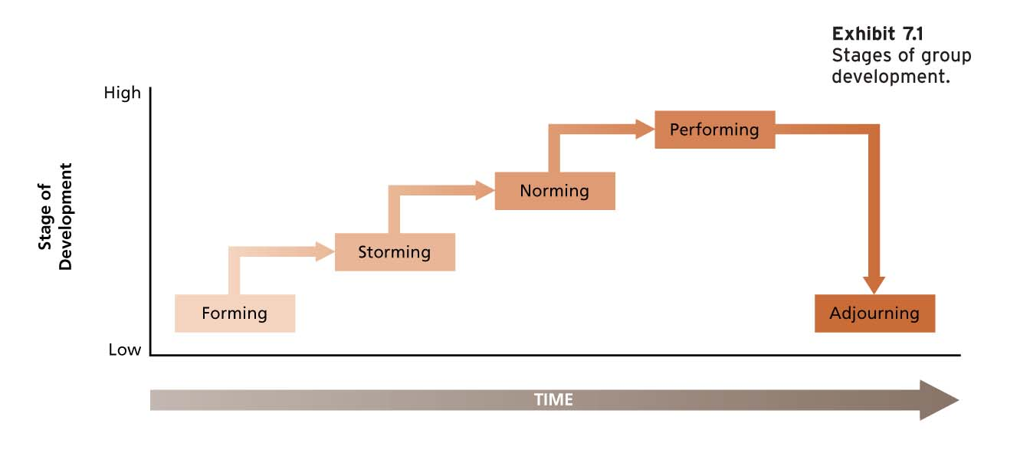
- Forming – Stage where group members try to orient themselves. Little agreement and unclear purpose.
- Storming – Stage where conflict often emerges, Sorting out roles and responsibilities. Increased conflict but clearer purpose, power struggles and coaching.
- Norming – Members resolve the issue that provoked storming, and develop social consensus. Agreement and consensus, clear roles and responsibilities and faciliatation
- Performing – Devote energy towards task accomplishment. Clear purpose and vision, focuses on goal, delegation.
- Adjourning – Group members disperse after achieving their goal. Task completion, feel good, recognition.
Punctuated Equilibrium
Punctuated equilibrium model – a model of group development that describes how groups with deadlines are affected by their first meetings, and crucial midpoint transitions
**applies ONLY to groups with DEADLINES (think of a school project)
- Phase 1
  - Begins with first meeting and continues until the midpoint of the group’s existence
  - First meeting is critical in setting the agenda for what will happen in remainder of phase
  - The group makes little visible progress toward the goal
- Midpoint Transition
  - Occurs at almost exactly halfway point in time towards group’s deadline
  - Marks a change in the group’s approach & is critical for the group to show progress
  - Crystallizes the group’s activities for Phase 2 just like the first meeting in Phase 1
- Phase 2
  - Decisions and approaches adopted at midpoint get played out in phase 2
  - Concludes with a final meeting that reveals a burst of activity and concern for how outsiders will evaluate the product
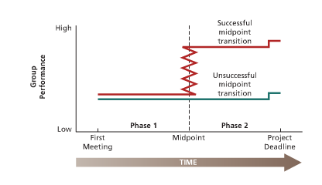

Group Structure and Its Consequences
Group structure refers to the characteristics of the stable social organization of a group – the way a group is put together

Group Size
- Size and Satisfaction
  - Members of larger groups rather consistently report less satisfaction with group membership than those who find themselves in smaller groups
  - As opportunities for friendship increase, the chance to work on and develop these opportunities might decrease owing to the sheer time and energy required
  - Larger groups might prompt conflict and dissension
  - Many people are inhibited about participating in larger groups
  - Individual members in larger groups identify less easily with the success and accomplishment of the group
- Size and Performance
  - Team size depends on the exact task that the group needs to accomplish and how we define good performance
  - Some tasks are:
    - Additive Tasks – Tasks in which group performance is dependent on the sum of the performance of individual group members
    - Disjunctive Tasks – Tasks in which group performance is dependent on the performance of the best group member
    - Conjunctive Tasks – Tasks in which group performance is limited by the performance of the poorest group member
  - As group performing tasks get bigger, they tend to suffer from process losses. Process losses are performance difficulties that stem from the problem of motivating and coordinating larger groups
Diversity of Group Membership
- More diverse groups have a more difficult time communicating effectively and becoming cohesive
- This means that diverse groups might tend to take longer to do their forming, storming and norming.
- Once they do develop, more and less diverse groups are equally cohesive and productive

Group Norms
- Social norms are collective expectations that members of social units have regarding the behaviour of each other. Acceptable standards of behaviour within a group that are shared by group members.
- They are codes of conduct that specify what individuals ought and ought not to do and standards against which we evaluate the appropriate behavior
- Typical Norms: Dress norms (military uniform is a formal norm), Reward Allocation norms (equity, equality, reciprocity, and social responsibility), and Performance norms.
- Norms develop to regulate behaviours that are considered important to their supporters.
- Shared attitudes form norms
- Groups have rewards and punishments available to induce conformity of norms.
Roles
- Roles are positions in a group that have a set of expected behaviors attaches to them
- Roles represent packages of norms that apply to particular group members
- There are two basic kind of roles in organizations:
  - Assigned Roles – formally prescribed by an organization as a means of dividing labour and responsibility to facilitate task achievement “who does what” and “who can tell others what to do”
  - Emergent Roles – Develop naturally to meet the social-emotional needs of group members or to assist in formal job accomplishment
-Role Ambiguity: Lack of clarity of job goals or methods. Confusion of how performance is evaluated, how good performance can be achieved, or what the limits of one’s authority and responsibility.

A model of the Role Assumption Process: Certain organizational factors lead to role sender (like managers) to develop role expectations and “send” roles to focal people (like employees). The focal person “receives” the role and then tries to engage in behaviour to fulfill the role. This model can lead to variety of elements that can lead to ambiguity.
-Organizational factors (roles seen ambiguous because of their function)
-Role sender (might have unclear expectations of a focal person)
-The focal person (role expectations may not get fully digested by focal person)

**Consequences of ROLE AMBUIGUITY: job stress, dissatisfaction, reduced organizational commitment, lower performance, intentions to quit.

-Role Conflict: Condition of being faced with incompatible role expectations
-Intrasender Role Conflict: A single role sender provides incompatible role expectations to a role occupant (a manager might tell an employee to take it easy and not work so hard, while delivering yet another batch of reports that require immediate attention).
-Intersender Role Conflict: Two or more role senders provide a role occupant with incompatible expectations.
-Interrole Conflict: Several roles held by a role occupant involve incompatible expectations
-Person-Role Conflict: Role demands call for behaviour that is incompatible with the personality or skills of a role occupant.

-Status: The rank, social position or prestige accorded to group members
-Formal Status: Most obvious to observers. Represents management’s attempt to publicly identify those people who have higher status than others. Status symbols might include titles, particular eorking relationships, pay, work schedules, work environment, etc.
-Informal Status: Status not well advertised.

Group Cohesiveness
- Group Cohesiveness – the degree to which group is especially attractive to its members
- Members are especially desirous of staying in the group and tend to describe the group in favorable terms. Strength of group members’ desire to remain part of the group. Can lead to productivity, satisfaction and learning
- Cohesiveness is a relative, rather than absolute, property of groups
- Things that can affect group cohesiveness: homogeneity, isolation, communication
- HIGH cohesiveness and norms = high productivity
- LOW cohesiveness and norms= low productivity

Factors Influencing Cohesiveness
- Threat and Competition
  - External threat to the survival of the group increases cohesiveness in a wide variety of situations
  - Honest competition with another group can also promote cohesiveness
  - Groups often become more cohesive in response to threat and competition because they feel a need to improve communication and coordination so that they can better cope with the situation at hand
- Success
  - A group becomes more attractive to its members when it has successfully accomplished some important goal
  - Cohesiveness will decrease after failure

- Member Diversity
  - Groups that are diverse in terms of gender, age, and race can have a harder time becoming cohesive than homogeneous groups
  - If the group is in agreement about how to accomplish some particular task, success in performing the task will often outweigh the surface dissimilarity in determining cohesiveness
- Size
  - Bigger groups should have a more difficult time becoming and staying cohesive
  - Bigger groups have a more difficult time agreeing on goals and more problem communicating and coordinating efforts to achieve those goals
- Toughness of Initiation
  - Groups that are tough to get into should be more attractive than those that are easy to join
Social Loafing
- Social Loafing – the tendency to withhold physical or intellectual effort when performing a group task
- It is a motivation problem
- Tendency for social loafing is more pronounced in individualistic North America than in more collective group-oriented cultures
- Social loading has two different forms:
  - Free Rider Effect - People lower their effort to get a free ride at the expense of their fellow group members
  - Sucker Effect – people lower their effort because of the feeling that others are free riding, that is, they are trying to restore equity on the group
- Ways to counteract social loafing
  - Make individual performance more visible (keep groups small, individual contribution becomes more obvious)
  - Make sure that the work is interesting (increases intrinsic motivation)
  - Increase feelings of indispensability (provide members with unique inputs)
  - Increase performance feedback (members might not be aware of their performance)
  - Reward group performance (members are more likely to monitor and maximize their own performance when the group receives rewards for effectiveness)

What is a Team?

- A group becomes a team when there exists a strong sense of shared commitment and when a synergy develops such that the group’s efforts are greater than the sum of its parts.
- Collective Efficacy: Shared beliefs that a team can successfully perform a given task.
- TYPES OF TEAMS:
- Problem Solving Teams: Group of 5-12 employees from same department who meet for a few hours each week to discuss ways of improving quality, efficiency and work environment.
- Self-Managed Work Teams (SMWTs): work groups that have the opportunity to do challenging work under reduced supervision. Groups are autonomous, semi-autonomous and self-directed. Typically 10-15 people in group. Tasks should be complex, challenging and requiring high interdependence among team members for accomplishment.
- Cross Functional Teams: Work groups that bring people with different functional specialties together to better invent, design, or deliver a product or service. People have to be experts in their own area but able to cooperate with others. Teams are combination of innovation, speed and quality.

163) Gary Lee is the supervisor of the sheet metal shop at Kaptser Enterprises. He is known for his friendly, easy going manner and mild temperament. Recently, he was asked by his boss to introduce several new policies designed to tighten-up break times and reduce unnecessary overtime. Gary has always considered himself to be a friend as well as a supervisor to his employees; in fact he often socializes with them just as he did before he was promoted to supervisor. Now his boss wants him to start adopting a tougher, more controlling leadership style. His workers, on the other hand, want Gary to "cut them some slack" and give them more freedom in their duties. Discuss the three types of role conflict which Gary is experiencing.
Answer: Gary is likely experiencing intersender role conflict (what the boss wants versus what the subordinates want), interrole conflict (he is both a friend and a supervisor to his workers), and person-role conflict (he may not have it in him to become tough on his employees􀁎or anyone else, for that matter).
Page Ref: 235
Skill: Applied
164) Distinguish between formal and informal work groups in organizations. Give an example of each.
Answer: Formal work groups are established to facilitate the achievement of organizational goals. Examples include departments, task forces, and committees. Informal groups emerge naturally in response to the common interests of organizational members. Examples might include a softball team, a fitness group or a wine tasting club.
Page Ref: 226
Skill: Applied
165) Describe the five stages of group development. At which stage is conflict most likely to emerge?
Answer: Forming, storming, norming, performing, and adjourning. Conflict emerges in the storming stage.
Page Ref: 227
Skill: Recall
166) Explain the difference between additive tasks, disjunctive tasks and conjunctive tasks. Give an example of each.
Answer: Additive tasks are those in which group performance is dependent on the sum of the performance of individual members (e.g. moving a heavy crate). Disjunctive tasks are those in which group performance is dependent on the performance of the best group member (e.g. debugging a software program). Conjunctive tasks are those in which the performance of the group is limited by its poorest performer (e.g. sequential tasks such as assembly lines).
Page Ref: 230
Skill: Applied
27
167) Julia Franco, the VP of Operations at Zeta Manufacturing, is concerned about the consistently low levels of productivity in the assembly plant. At a meeting with company executives, she proposes that the company introduce some social activities to increase cohesiveness among the workers, and thereby improve productivity. Gordon Wong, the VP of Human Resources disagrees. "This group of workers is known to frequent the local pub everyday after work and vacation together on long weekends. If you increase cohesiveness any further, productivity will probably come to a complete halt!" Who do you think is correct? Explain your answer.
Answer: This question is intended to test students' understanding of the relationship between cohesiveness, norms, and performance. Like Julia, many students automatically assume that high cohesiveness will lead to improved performance; however, this is only true if the group productivity norms support the goals of the organization. If, as Gordon suggests, cohesiveness is high and group productivity norms are poor from an organizational standpoint, then increasing cohesiveness will not lead to improved performance. Julia may have to reduce the cohesiveness of the group first (e.g. by removing key members, adding new members, or perhaps introducing competition or conflict into the group) and then encourage the adoption of better performance norms (e.g. perhaps through an incentive program) before trying to increase cohesiveness.
Page Ref: 240
Skill: Applied
168) Describe four types of reward allocation norms which may affect how workers are paid and rewarded in organizations. Which one do you think is the fairest, overall? Why?
Answer: Equity, equality, reciprocity, and social responsibility. The second part of the question challenges students to consider the merits of each norm, and take a position in support of one. Of course, they all have merit depending on the circumstances, but most organizations would officially support reward allocation based on some combination of equity and equality norms.
Page Ref: 233
Skill: Applied
169) Describe the two main forms of social loafing. What are some ways to counteract them?
Answer: Free rider effect and sucker effect. Ways to counteract them include increasing the visibility of individual performance, making the work more interesting, increasing workers' feelings of indispensability, increasing performance feedback, and rewarding group performance.
Page Ref: 241
Skill: Applied
170) What are self-managed teams and how should they be designed in terms of tasks, composition, and support.
Answer: Self-managed teams are groups that have the opportunity to do challenging work under reduced supervision. The tasks assigned to self-managed teams should be complex and challenging, requiring high interdependence among team members for accomplishment. The tasks should have the qualities of enriched jobs. The composition of self-managed teams should focus on: stability of membership; small size; high level of task expertise and social skills; similar enough to work well together but also have a diversity of perspectives and skills. In terms of supporting self-managed teams, they require: training in various areas, rewards tied to team accomplishment, and management support that encourages independence.
Page Ref: 243
Skill: Recall
28
171) What are cross-functional teams and the factors that contribute to their effectiveness?
Answer: Cross-functional teams are work groups that bring people with different functional specialties together
to better invent, design, or deliver a product or service. The factors that contribute to their effectiveness
include: composition that consists of all relevant specialties; superordinate goals; close physical proximity
of team members; autonomy from the larger organization; some basic decision rules and procedures; and
leaders with strong people skills in addition to task expertise.
Page Ref: 247
Skill: Recall
172) What are the lessons and things that managers should consider when developing virtual teams?
Answer: Recruitment in terms of attitude and personality and good interpersonal skills in addition to technical
expertise; invest in training for both technical and interpersonal skills; personalization (encourage team
members to get to know each other); goals and ground rules should be clearly defined as well as rules for
communication standards and responses, and provide feedback to keep team members informed of
progress and the big picture.
Page Ref: 251
Skill: Recall
173) Define virtual teams and discuss the advantages and challenges of virtual teams.
Answer: Virtual teams are work groups that use technology to communicate and collaborate across time, space,
and organizational boundaries. The have many advantages including: around-the-clock work; reduced
travel time and cost; and larger talent pool. The disadvantages include: miscommunication; trust is
difficult to develop; feelings of isolation; the costs of cutting-edge technology; and new challenges for
management such as dealing with employee who are no longer in view.
Page Ref: 249
Skill: Recall
174) What are the different kinds of role conflict and what can managers do to help prevent employee role conflict?
Answer: Intrasender role conflict occurs when a single role sender provides incompatible role expectations to a
role occupant; intersender role conflict occurs when two or more role senders provide a role occupant
with incompatible expectations; interrole conflict occurs when several roles are held by a role occupant
that involve incompatible expectations; and person-role conflict occurs when role demands call for
behaviour that is incompatible with the personality or skills of a role occupant. Managers can help
prevent employee role conflict by avoiding self-contradictory messages, conferring with other role
senders, being sensitive to multiple role demands, and fitting the right person to the right role.
Page Ref: 235
Skill: Recall
175) Members of your organization are complaining that they are not sure how they should be performing their job and what methods they should be using to perform it. You have been assigned the task of finding out more about this problem in terms of what it is, the causes of it, the consequences of it, and how to prevent it. What will you tell management about these issues?
Answer: The problem is role ambiguity which refers to a lack of clarity of job goals or methods. A number of factors or elements can cause role ambiguity including: organizational factors, role senders, and the focal person. The consequences include job stress, dissatisfaction, reduced organizational commitment, lower
performance, and intentions to quit. Managers can reduce role ambiguity by providing clear performance
expectations and performance feedback, especially for new employees and for those in more intrinsically
ambiguous jobs.
Page Ref: 233
Skill: Applied
29
176) You have just formed a group as a part of a class assignment to complete a group project. You have four weeks to complete the project and present it to the class. What can you tell the other group members about how the group will develop and how they should proceed? What advice will you give them?
Answer: According to the punctuated equilibrium model, the group will experience stretches of group stability
punctuated by a critical first meeting (Phase 1), a midpoint change (midpoint transition) in group
activity, and a rush to task completion (Phase 2). Based on the model, you can offer group members the
following advice: Prepeare carefully for the first meeting; as long as people are working, do not look for
radical progress during Phase 1; manage the midpoint transition carefully; be sure that adequate
resources are available to execute the Phase 2 plan; and resist deadline changes.

Chapter 8 – Social Influence &Culture
Social Influence in Organizations
Information Dependence and Effect Dependence
- Information Dependence – Gives others the opportunity to influence our thoughts, feelings, and actions via the signals they send to us
Effect Dependence – Reliance on others due to their capacity to provide reward and punishment
  - Involves two complementary processes
    - Group frequently has a vested interest in how individual members think and act because such matters can affect the goal attainment of the group
    - Members frequently desires the approval of the group
Social Influence in Action
Motives for Social Conformity
- Compliance – Conformity to a social norm prompted by the desire to acquire rewards or avoid punishment
- Identification – conformity to a social norm prompted by perceptions that those who promote the norm are attractive or similar to oneself
- Internalization – Conformity to a social norm prompted by the true acceptance of the beliefs, values, and attitudes that underlie the norm

Organizational Culture
What is Organizational Culture?
- An organization’s style, atmosphere, or personality
- Represents “way of life”, stable over time
- Culture provides uniqueness and social identity to organizations
- Organizational Culture – Consists of shared beliefs, values, and assumptions that exist in an organization
- CULTURE NORMS BEHAVIOUR
- Subcultures: Smaller cultures that develop within a larger organization culture that are based on differences in training, occupation, or departmental goals.

The “Strong Culture” Concept
- Strong Culture – is an organizational culture with intense and pervasive beliefs, values, and assumptions
- A strong culture provides great consensus concerning “what the organization is about” or what it stands for
- Weak cultures are fragmented and have less impact on organizational members

Assets of Strong Cultures
- Coordination – Different departments know what other departments are doing and thus strong cultures can facilitate such communication
- Conflict Resolution – Sharing core values can be a powerful mechanism that helps to ultimately resolve conflicts
- Financial Success – Strong cultures pay off in terms of dollars and cents

Liabilities of Strong Cultures
- Resistance to Change – The mission, strategy, or specific goals of an organization can change in response to external pressures, and a strong culture that was appropriate for past success might not support new order
- Culture Clash – Strong cultures can mix badly when a merger or acquisition pushes two of them together under the same corporate banner
- Pathology – Some Strong cultures can threaten organizational effectiveness simply because the cultures are in some sense pathological. Such cultures may be based on beliefs, values, and assumptions that support infighting, secrecy and paranoia.

Contributions to the culture
How are cultures built, maintained and changed
- The Founder’s Role
  - Many strong cultures reflect the values of an organization’s founder
  - Provides continuing reinforcement of the firm’s core values
  - Most experts agree that top management strongly shapes the organization’s culture
  - Sometimes the culture begun by the founder can cause conflict when top management wishes to see an organization change direction
- Socialization
  - Socialization is one of the primary means by which individuals can learn the culture’s beliefs, values, and assumptions
Diagnosing a Culture
One way to grasp a culture is to examine the symbols, rituals, and stories that characterize the organizations way of life. These symbols, rituals, and stories are mechanisms that teach and reinforce culture

BICULTURAL AUDIT
-Minimizes risk of cultural collision by diagnosing companies before merger
-3 steps in bicultural audit:
1) Collect artifacts
2) Analyze data for cultural conflict/compatibility
3) Recommend solutions

Harjit Dhaliwal is a new sales representative for Kapster Enterprises. He enjoys making sales calls and meeting with clients, but dislikes the weekly paperwork that he has to prepare for head office. He initially feels that weekly activity reports are a bureaucratic waste of time, but he dutifully completes them to avoid any trouble with head office. After several months, Harjit attends his first national sales meeting at which the VP of Marketing stresses the importance of accurate information from the field. Harjit begins to appreciate the importance of the reports and now understands why head office needs them on a timely basis each week. After the meeting, Harjit is asked by his boss to train a new sales rep who has just been hired in a nearby territory. In showing the new worker the ropes, Harjit is heard to say, "These weekly reports are very important􀁎you won't understand now, but you will later." Explain Harjit's metamorphosis in terms of compliance, identification, and
internalization.
Answer: At first, Harjit's motive for completing the reports is compliance. At the sales meeting, he begins to see
things from a head office perspective, and identification becomes the dominant motive. Finally, when he
is asked to train a new worker, Harjit's comments suggest that internalization has occurred; he now
supports the values of head office and truly believes that the weekly paperwork is important.

Discuss the assets and liabilities associated with strong organizational cultures.
Answer: Advantages include improved coordination, conflict resolution and financial success. Disadvantages include resistance to change, and the potential for pathology and culture clash.
Page Ref: 282
Skill: Recall
160) Describe three mechanisms which serve to diagnose, teach, and reinforce organizational culture. Give an example of each.
Answer: Symbols (e.g. pink Cadillacs are the symbols of success at Mary Kay Cosmetics); rituals (e.g. Mary Kay's revival meetings); and stories (e.g. Ray Kroc canceling a McDonald's franchise deal after finding a fly in the restaurant).

Chapter 11 – Power & Ethics
What is Power?
- Power – the capacity to influence others who are in a state of dependence
- Power is the capacity to influence the behavior of others
- It is not always perceived or exercised
- Target power is dependent on the power-holder does not imply that a poor relationship exists between the two
- Power is a broad concept that applies to both individuals and groups

The Bases of Individual Power
- Legitimate Power – Power derived from a person’s position or job in an organization
- Reward Power – Power derived from the ability to provide positive outcomes and prevent negative outcomes
- Coercive Power - Power derived from the use of punishment and threat
- Referent Power – Power derived from being well liked by others
- Expert Power – Power derived from having special information or expertise that is valued by an organization
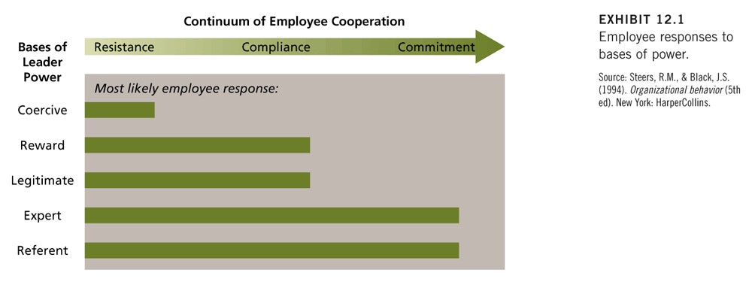
Influence Tactics – Putting Power to Work
Influence Tactics – Tactics that are used to convert power into actual influence over others
- Assertiveness – Ordering, Nagging, setting deadlines, and verbally confronting
- Ingratiation – using flattery and acting friendly, polite, or humble
- Rationality Using logic, reason, planning, and compromise
- Exchange – doing favors or offering to trade favors
- Upward appeal – Making formal or informal appeals to organizational superiors for intervention
- Coalition Formation – Seeking united support from other organizational members

Ethics in Organizations
- Ethics – Systematic thinking about moral consequences of decisions
- Moral consequences can be framed in terms of the potential farm to any stakeholder in the decision
- Stakeholder – People inside out outside an organization who have the potential to be affected by organizational decisions

The Nature of Ethical Dilemmas
- Honest Communication – Evaluate subordinates candidly, advertise and label honestly
- Fair Treatment – Pay equitably, respect the sealed bid process, do not give preference to suppliers with political connections
- Special Consideration – The “fair treatment” standard can be modified for special cases, such has helping out a long-time employee, giving preference to hiring the disabled…
- Fair Competition – Avoid bribed and kickbacks to obtain business, do not fix prices with competitors
- Responsibility To Organization – Act for the good of the organization as a whole not for self-interest
- Corporate Social Responsibility – Do not pollute, think about the community impact of plant closures, show concern for employee health and safety
- Respect For The Law – Legally avoid taxes, do not evade them, do not bribe the government inspectors

Causes of Unethical Behaviour
- Gain – The anticipation of healthy reinforcement for following an unethical course of action, especially if no punishment is expected
- Role Conflict – Many ethical dilemmas are actually forms of role conflict that get resolved in an unethical way.
- Competition – Stiff competition for scarce resources can stimulate unethical behavior. In cases in which essentially no competition exists, there is also a strong temptation to make unethical decisions
- Personality – Are there certain types of personalities that are more prone to unethical decisions? The Cynical and those with external locus of control are more likely to behave unethically
- Organizational and Industry Cultures – Aspects of an organization’s culture (& subculture) can influence ethics

Whistle-Blowing
- Whistle-blowing – Discloses illegitimate practices to some person or organization that may be able to take action to correct these practices
- Whistle-blowing may be blown either inside out outside the offending organization, depending on the circumstances
- Most organizations rely on vague open door policies rather than having specific channels and procedures for whistle-blowers to follow

Sexual Harassment – When Power and Ethics Collide
- Sexual harassment is a form of unethical behaviour that stems, in part, from the abuse of power and the perpetuation of a gender power imbalance.
- It involves coercion of sexual cooperation by threat of job-related consequences and unwanted and offensive sex-related verbal or physical conduct
- Many organizations are slow to react to complaints of sexual harassment.
- The deaf ear syndrome refers to the inaction or complacency of organizations in the face of charges of sexual harassment

Employing Ethical Guidelines
- Identify the stakeholders that will be affected by any decision.
- Identify the costs and benefits of various decision alternatives to these stakeholders.
- Consider the relevant moral expectations that surround a particular decision.
- Be familiar with common ethical dilemmas that decision makers face in your organizational role or profession
- Discuss ethical matters with decision stakeholders and others.
- Convert your ethical judgments into appropriate action.
- Training and education in ethics is important and has a positive impact on ethical attitudes

What are the five bases of individual power? Which one do you think is most powerful overall? Provide an example to illustrate your rationale.
Answer: Legitimate, reward, coercive, referent, and expert. Student opinions will vary somewhat on which power
base they consider to be the most powerful. Some students will correctly point out that the most powerful
base depends on the situational context and nature of the organization. Generally, the three most
common responses will be referent, expert, and legitimate 􀁎 each of which could be supported with valid
arguments. For example, referent power can be exercised by an individual regardless of their
organizational status or the situational context. Expert power accruing to managers has been most
consistently associated with employee effectiveness. Referent and expert power together are most likely
to generate true commitment and enthusiasm for the manager's agenda. However, legitimate power is
often accompanied by reward and coercive power, and studies across various cultures cite legitimate
power as the major reason for complying with the boss's wishes. Finally, in workplace "showdowns"
between legitimate power (e.g. the boss) and expert power (e.g. a highly competent employee), legitimate
power almost always prevails.

Chapter 9 – Leadership
What is Leadership?
- Leadership – The influence that particular individuals exert on the goal achievement of others in an organizational context. Effective leadership exerts influence in a way that achieves organizational goals by enhancing the productivity, innovation, satisfaction and commitment of the workforce.
- Strategic Leadership refers to a leader’s ability to anticipate, envision, maintain flexibility, think strategically and work with others to initiate changes that will create a viable future for the organization.
- They can provide an organization with a sustainable competitive advantage
- They are open and honest in their interactions with the organization’s stakeholders & they focus on the future

Are Leaders Born? – Leadership Traits
The assumption that those who become leaders and do a good job of it possess a special set of traits that distinguish them from others

Research on Leadership Traits
- Traits – are personal characteristics of the individual, including physical characteristics, intellectual ability and personality.
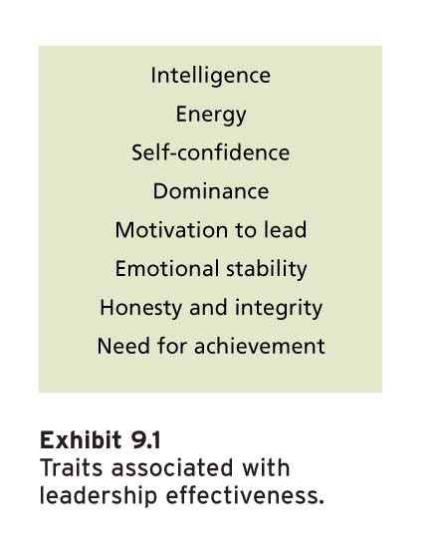
Limitations of the Trait Approach
Even though some traits appear to be related to leadership there are several reasons why it is not the best means of understanding and improving leadership
- It is difficult to determine whether traits make the leader or whether the opportunity for leadership produces traits
- We have few clues about what dominant or intelligent or tall people do to influence other successfully
- The most crucial problem of the trait approach to leadership is its failure to take into account the situation in which leadership occurs
The behaviour of Leaders
Consideration and Initiating Structure
- Consideration – The extent to which a leader is approachable and shows personal concern and respect for employees
  - Seen as friendly and egalitarian (equal), express appreciation and support, and is protective of group welfare
- Initiating Structure – The degree to which a leader concentrates on group goal attainment
  - The structuring leader clearly defines and organizes his role and the roles of followers, stresses standard procedures, schedules the work to be done, and assigns employees to particular tasks

The Consequences of Consideration and Structure
- Consideration and initiating structure both contribute positively to employees’ motivation, job satisfaction, and leader effectiveness
  - When employees are under a high degree of pressure due to deadlines, unclear tasks, or external threat, initiating structure increases satisfaction and performance.
  - When the task is intrinsically satisfying, the need for high consideration and high structure is generally reduced
  - When the goals and methods of performing the job are very clear and certain, consideration should promote employee satisfaction, while structure should promote dissatisfaction.
  - When employees lack knowledge as to how to perform a job, or the job itself has vague goals or methods, consideration becomes less important, while initiating structure takes on additional importance

-Leader Reward Behavior: The leader’s use of compliments, tangible benefits and deserved special treatment. When rewards are made contingent on performance, employees should perform at a high level and experience job satisfaction. Under such leadership, employees have a clear picture of what is expected from them and they understand that positive outcomes will occur if they achieve these expectations.
-Leader Punishment Behaviour: The leader’s use of reprimands or unfavourable task assignments and the active withholding of rewards.

Situational Theories of Leadership
*The basic premise of situational theories of leadership is that the effectiveness of a leadership style is contingent on the setting.

-Contingency Theory: Fred Fielder’s theory that states that the association between leadership orientation and group effectiveness is contingent on how favourable the situation is for exerting influence.

-Cognitive Resource Theory: A leadership theory that focuses on the conditions in which a leader’s cognitive resources (intelligence, expertise, and experience) contribute to effective leadership.

House’s Path-Goal Theory
- Path-Goal Theory – Concerned with the situations under which various leader behaviors are most effective
- The most important activities of leaders are those that clarify the paths to various goals of interest to employees
- Leader Behaviour – Concerned with the following four specific kinds of leader behaviour
  - Directive Behaviour – Directive leaders schedule work, maintain performance standards, and let employees know what is expected of them
  - Supportive behaviour – Friendly, approachable, and concerned with pleasant interpersonal relationships
  - Participative Behaviour – Consult with employees about work related matters and consider their opinions
  - Achievement-oriented behaviour – Encourage employees to exert high effort and strive for a high level of goal accomplishment
- Situational Factors – Concerned itself with two primary classes of situational factors – Employee characteristics and Environmental Factors

  - Employee Factors
    - Employees who are high need achievers should work well under achievement-oriented leadership
    - Employees who prefer being told what to do should respond best to a directive leadership style
    - When employees feel that they have rather low task abilities, they should appreciate directive leadership and coaching behaviour
  - Work Environment
    - When tasks are clear and routine, employees should perceive directive leadership as a redundant and unnecessary imposition
    - When tasks are challenging but ambiguous, employees should appreciate both directive and participative leadership
    - Frustrating, dissatisfying jobs should increase employee appreciation of supportive behavior

Participative Leadership: Involving Employees in Decisions
What is Participation?
- Participative leadership - Involving employees in making work related decisions
- Leaders can vary in the extent to which they involve employees in decision making
- Minimally, participation involves obtaining employee opinions before making a decision
- Maximally, it allows employees to make their own decisions within agreed-on limits

Potential Advantage of Participative Leadership
- Motivation – Participation can increase the motivation of employees
  - Participation permits them to contribute to the establishment of work goals to decide how they can accomplish these goals
  - Can increase intrinsic motivation by enriching employees’ jobs
- Quality – Participation can enhance quality in at least two ways
  - “Two heads are better than one”
  - High levels of participation often empower employees to take direct action to solve problems without checking every detail from their boss
- Acceptance – Participation can increase the quality of decisions
  - Especially likely when issues of fairness are involved

Potential Problems of Participative Leadership
- Time and Energy – Participation involves specific behaviors on the part of the leader and these behaviors use time and energy
- Loss of Power – Some leaders feel that a participative style will reduce their power and influence
- Lack of Receptivity or Knowledge – Employees might not be receptive to participation. Even when receptive, employees might lack the knowledge to contribute effectively to decisions
Vroom and Jago’s Situational Model of Participation
- Vroom and Jago begin with the recognition that there are various degrees of participation that leaders can exhibit. Three degrees of participation: Autocratic, Consultative, Group.
A=Autocratic
C=Consultative
G=Group
I=Individual
II=Group Involved
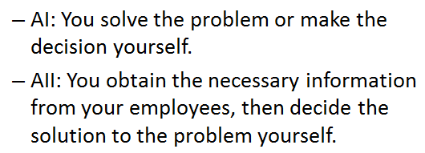
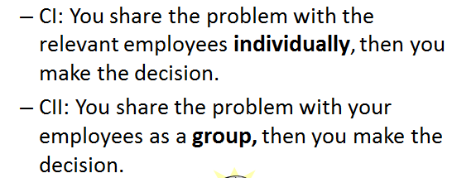
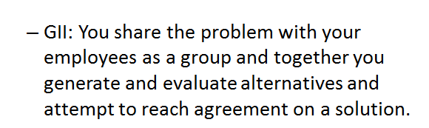
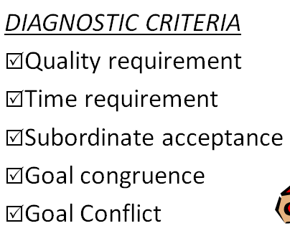

Transactional and Transformational Leadership
- Transactional Leadership – Leadership that is based on a straightforward exchange relationship between the leader and the followers
  - Employees perform well, and the leader rewards them
  - Leader uses participatory style and employees come up with good ideas
- Transactional leadership involves:
  - Contingent reward behaviour
  - Management by exception – The degree to which leaders take corrective action on the basis of results of leader-follower transactions
    - They monitor follower behaviour, anticipate problems, and take corrective actions before the behaviour creates serious problems
- Leaders have a more profound effect on followers by giving them a new vision that instilled true commitment to a project, a department, or an organization. Such leadership Is called transformational leadership because the leader decisively changes the beliefs and attitudes of followers to correspond to this new vision and motivates them to achieve performance beyond expectations
  - Transformational leaders are usually good at the transactional aspects of clarifying paths to goals and rewarding good performance. There are four key dimensions of transformational leader behaviour (4 I’s):
    - Intellectual Stimulation – People are stimulated to think about problems, issues and strategies in new wars. The leader challenges assumptions, takes risks, and solicits followers’ ideas.
    - Individualized Consideration – Involves treating employees as distinct individuals, indicating concern for their needs and personal development, and serving as a mentor or a coach when appropriate
    - Inspirational Motivation – The ability to command strong loyalty and devotion from followers and thus have the potential for strong influence among them. Prominent traits include self-confidence, dominance, and a strong convicton in one’s beliefs.
    - Idealized Influence (Charisma)

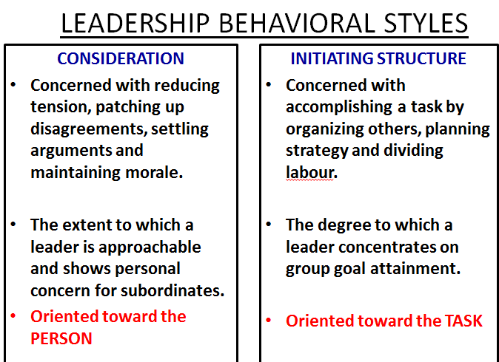

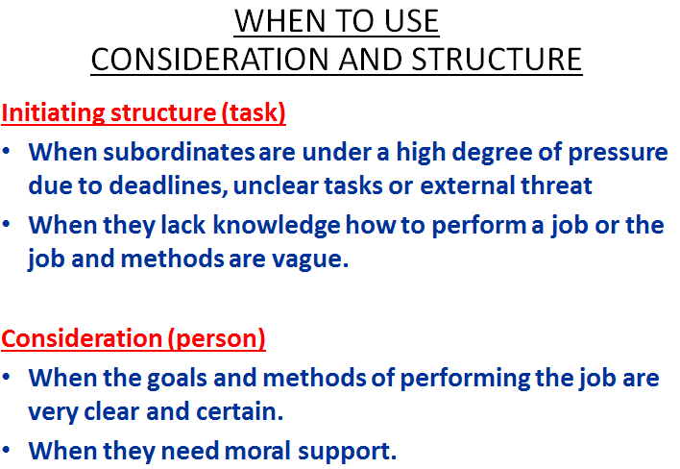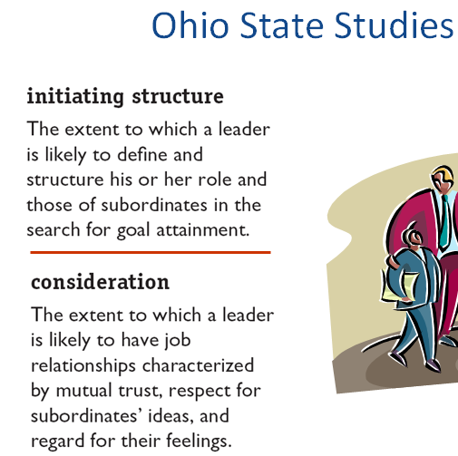

Describe two types of emergent leaders. Which member is most likely to emerge as the leader of any given group?
Answer: Task leader and social-emotional leader. The person who talks the most · as long as he or she has relevant experience · is the member most likely to emerge as the group leader (i.e. task leader).
Page Ref: 301
Skill: Recall
168) Using Fiedler's Contingency Theory, explain which type of leadership orientation is most effective at low, medium and high levels of situational favourableness. Give an example of a management job which might apply to each level of favourableness. Use different combinations of the three basic situation factors to construct low, medium and high levels of favourableness to support your examples.
Answer: Task-oriented leadership is most effective when the situation is either very favourable or very
unfavourable. Relationship-oriented leadership is most effective in conditions of medium
favourableness. An example for high favourableness might be an office manager where leader-member
relations are good, task structure is high, and position power is strong. Medium favourableness might be
applicable to a supervising nurse on a hospital ward where leader-member relations are good, but task
structure is low (due to the constant turnover of patients and their requirements), and position power is
weak since doctors, and not the supervising nurse, give most of the critical directions pertaining to
patient care. Very unfavourable situations may be characterized by an external expert, such as a
management consultant or project engineer, who is brought into an organization to solve a problem. For
the external expert, leader-member relations are poor and may even be hostile; task structure is low (that
is why they called in an expert); and position power is weak since the expert is an "outsider".
Page Ref: 305
Skill: Applied
169) According to House's Path-Goal Theory under what conditions should employees appreciate both directive and participative leader behaviours? Under what conditions are they not likely to appreciate them? Give examples of tasks which illustrate each set of conditions.
Answer: Employees will likely appreciate both directive and participative leader behaviours when they are working on challenging but ambiguous tasks (e.g. a manager developing a project proposal or a budget for a new department). Employees will generally not appreciate directive and participative leader
behaviours when the tasks are clear and routine (e.g. janitorial work).
Page Ref: 307
Skill: Applied
28
170) Describe the potential advantages and problems associated with participative leadership.
Answer: Potential advantages include increased motivation, quality and acceptance of decisions. Potential problems include concerns about loss of power, excessive time and energy requirements, and lack of receptivity or knowledge by employees.
Page Ref: 309
Skill: Recall
171) Distinguish between transactional and transformational leadership.
Answer: Transactional leadership describes the routine relationship between leaders and followers in which the
leader uses rewards and other management techniques to bring subordinate behaviour in line with
organizational goals. Transactional leadership behaviour involves contingent reward behaviour and
management by exception. Transformational leadership provides followers with a new vision that instills
commitment. The qualities that set transformational leaders apart from transactional ones are intellectual
stimulation, individualized consideration, inspirational motivation, and charisma.
Page Ref: 313
Skill: Recall
172) What are some of the key characteristics of successful global leaders?
Answer: According to research by Gregersen, Morrison and Black cited in the text, global leaders have unbridled inquisitiveness, strong personal character, savvy, and a quality called "duality" which enables them to balance the tensions between global integration and local differentiation.
Page Ref: 321
Skill: Recall
173) What is strategic leadership and its main components?
Answer: Strategic leadership involves the ability to anticipate, envision, maintain flexibility, think strategically,
and work with others to initiate changes that will create a viable future for the organization. The main
components are: determining the firm's purpose or vision; exploiting and maintaining core competencies;
developing human capital; sustaining an effective organizational culture; emphasizing ethical practices;
and establishing balanced organizational controls.

Chapter 10 – Decision Making
What is Decision Making?
-Decision Marking – The process of developing a commitment to some course of action
  - Decisions making involves making a Choice among several alternatives
  - Decision making is a process that involves more than simply the final choice among alternatives
  - The “Commitment” mentioned in the definition usually involves some commitment of recourses such as time, money, or personnel
  - Can be described as a process of problem solving.
    - Problem – A perceived gap between an existing state and a desired state
Well-Structured Problems
-Well-Structured problem – A problem for which the existing state is clear, the desired state is clear, and how to get from one state to the other is fairly obvious.
-Intuitively, these problems are simple, and their solutions arouse little controversy.
-This is because such problems are repetitive and familiar
-Because decision making takes time and is prone to errors, organizations attempt to program decision making for well-structured problems
-A Program is simply a standardized way of solving a problem

Ill-Structured Problems
-Ill-Structured problem – A problem for which the existing and desired states are unclear and the method of getting to the desired state us unknown
  - For example, a president or marketing might have a feeling that sales for a particular product are too low. However she might lack precise info about the product’s market share (existing state) and the market share of its most successful competitor (ideal state). In addition, she might be unaware of exactly how to increase the sales of this particular product

The Compleat Decision Maker - A Rational Decision-Making Model
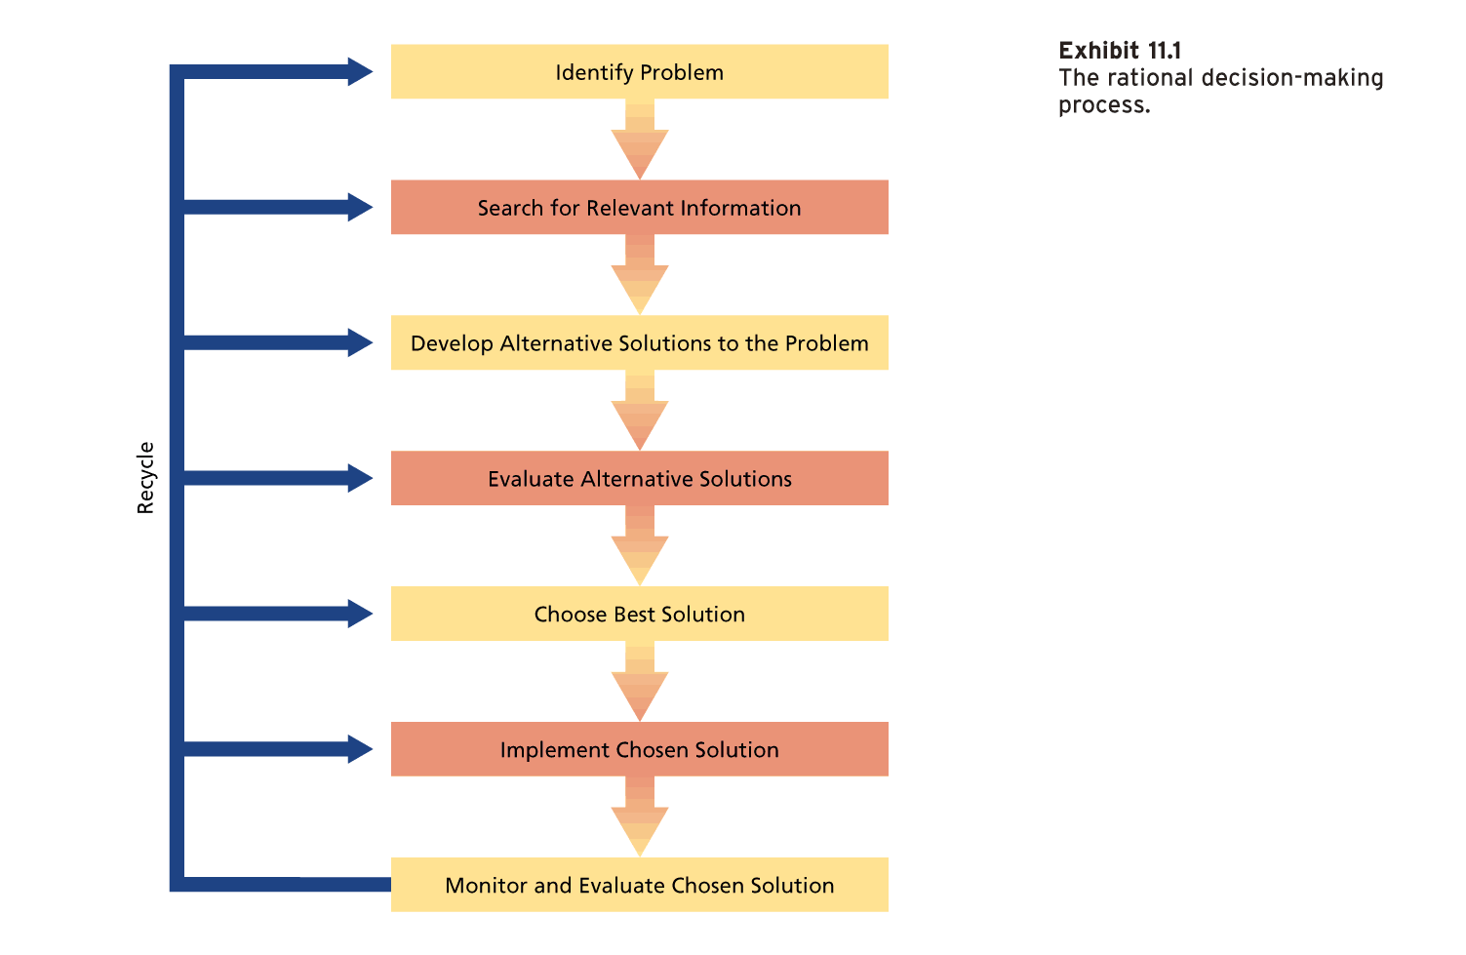
Perfect Versus Bounded Rationality
-Perfect Rationality (“Economic Person”) - A decision strategy that is completely informed, perfectly logical, and oriented toward economic gain
-The economic person is useful for theoretical purposes but does not exist in real decision makers
-Therefore, Managers use Bounded Rationality – A decision strategy that relies on limited information and that reflects time constraints and political considerations
-Framing and Cognitive biases both illustrate the operation of bounded rationality, as does the impact of emotions and mood on decisions
-Framing – Refers to the aspects of the presentation of information about a problem that are assumed by decision makers
-Cognitive Biases – Tendencies to acquire and process information in a particular way that is prone to error. These biases constitute assumptions and shortcuts that can improve decision-making efficiency, but they frequently lead to serious errors in judgment

Problem Identification and Framing
Bounded rationality can lead to the following difficulties in problem identification
-Perceptual Defense – The perceptual system may act to defend the perceiver against unpleasant perceptions.
-Problem defined in terms of functional specialty – Selective perception can cause decision makers to view a problem as being in the domain of their own specialty even when some other perspective might be warranted. (Marketing major sees a problem and relates it to marketing instead of the actual problem which is something else)
-Problem diagnosed in terms of symptoms - A concentration on surface symptoms will provide the decision maker with dew clues about an adequate solution

Information Search
-Perfectly Rational Economic person has free and instantaneous access to all information necessary to clarify the problem and develop alternative solutions
-Bounded rationality, presents a different picture. The information search might be slow and costly
-Decision makers can have too little or too much information
-Too little information
  - Confirmation Bias – The tendency to seek out information that conforms to one’s own definition or solution to a problem
-Too much information
  - Information Overload – The reception of more information than is necessary to make effective decisions.

Alternative Development, Evaluation and Choice
-Perfectly informed or not, the decision maker can now list alternative solutions to the problem, examine the solutions and choose the best one
-Maximization – The choice of the decision alternative with the greatest expected value
-For the decision maker working under bounded rationality, alternative solutions and probabilities of success are not all known.
-Cognitive biases also come into play.
-People are especially weak intuitive statisticians
  - People avoid incorporating existing data about the likelihood of events (“base rates”) into their decisions.
  - Large samples warrant more confidence than small samples. (but smaller ones may be focus groups versus large which can be anyone) (smaller is better sometimes)
  - Decision makers often overestimate the odds of complex chains of events occurring
  - People are poor at revising estimates of probabilities and values as they acquire additional information.
    - The anchoring effect illustrates that decision makers do not adjust their estimates enough from some initial estimate that serves as an anchor.
  - It is possible to reduce some of these cognitive biases by making people more accountable for their decisions
-It is possible to reduce some of these basic cognitive biases by making people more accountable for their decisions
-Bounded Rationality frequently “Satisfices” rather than maximizes
  - Satisficing – Establishing an adequate level of acceptability for a solution to a problem and then screening solutions until one that exceeds this level is found

Risky Business
-Choosing between decision alternatives often involves an element of risk
-Protecting the sure win but risking the sure loss

Solution Implementation
-When a decision is made, the solution must be implemented
-The perfectly rational decision maker will have factored any possible implementation problems in to his or her choice of solutions
-The Bounded decision maker will attempt to do the same when estimating probabilities of success

Solution Evaluation
-Perfectly rational decision maker should be able to evaluate effectiveness of the decision with calm, objective detachment
-Bounded decision maker might encounter problems at this stage of the process
  - Justification
    - People often “throw good resources after bad,” acting as if they can recoup sunk costs.
    - This process is known as escalation of commitment to an apparently failing course of action.
    - Escalation of commitment refers to the tendency to invest additional resources in an apparently failing course of action.
  - Hindsight - The tendency to review the decision making process to find what was done right or wrong
    - Knew-it-all-along effect – Tendency to assume, after the fact, that we knew all along what the outcome of a decision would be
    - Take personal responsibility for successful decision outcomes while denying responsibility for unsuccessful outcomes

How Emotion and Mood affect Decision Making
-People don’t like to be wrong, and they often become emotionally attached to the failing course of action that signals escalation of commitment
-Emotionless decision making would be poor decision making, and the rational model is not meant to suggest otherwise
-Strong emotions frequently figure in the decision-making process
-Despite examples of how emotion can help decision making, there are many cases in which strong emotions are a hindrance
-Mood affects what and how people think when making decisions
-Mood has its greatest impact on uncertain, ambiguous decisions of the type that are especially crucial for organizations

Group Decision Making
Why use Groups?
-Decision Quality
  - Groups or teams should make higher-quality decisions than individuals
    - Groups are more vigilant than individuals are – more people are scanning the environment
    - Groups can generate more ideas than individuals can
    - Groups can evaluate ideas better than individuals can
-Decision Acceptance and Commitment
  - A group decision will be more acceptable to those involved
  - This is especially important in getting a decision implemented
-Diffusion of Responsibility
  - The ability of group members to share the burden of the negative consequences of a poor decision
  - Each member of the group will share part of the burden of the negative consequences, and no one person will be singled out for punishment

Disadvantages of Group decision Making
-Time – Groups seldom work quickly or efficiently compared with individuals. The time problem increases with group size
-Conflict – Participants in group decisions have their own personal aces to grind or their own resources to protect. In general, groups will make better decisions when their members feel psychologically safe
-Domination – Advantages of group decision making will seldom be realized if meetings are dominated by a single individual or a small coalition. If the dominant person is particularly misinformed, the group decision is likely to be ineffective
-Groupthink – The capacity for group pressure to damage the mental efficiency, reality testing, and moral judgment of decision-making groups
-Groupthink Symptoms:
  - Illusion of invulnerability – Members are overconfident and willing to assume great risk
  - Rationalization – Problems and counterarguments that members cannot ignore are rationalized away
  - Illusion of Morality – Decisions are perceived as sensible and morally correct
  - Stereotypes of Outsiders – Group constructs unfavorably stereotypes of those outside the group
  - Pressure for Conformity – Members pressure each other to fall in line and conform with the group’s view
  - Self-Censorship – Members convince themselves to avoid voicing opinions contrary to the group
  - Illusion of unanimity - Members perceive that unanimous support exists for their chosen course of action
  - Mindguards – Some group members may adopt the role of “protecting” the group from information that goes against its decision
-Victims of groupthink are operating in an atmosphere of unreality that should lead to low-quality decisions

How do Groups Handle Risk?
-Risky Shift – The tendency for groups to make riskier decisions than the average rick initially advocated by their individual members
-Conservative Shift – The tendency for groups to make less risky decisions than the average risk initially advocated by their individual members
-Group discussions seems to polarize or exaggerate the initial position of the group

Improving Decision making in Organizations
Organizational decision making can improve if decision making receive encouragement to follow more closely the rational decision-making model

Training Discussion Leaders
-An appointed leader often convenes the group and guides the discussion
-The actions of this leader can “make or break” the decision
-If he’s bad and influences the group, the group fails, if he fails to exert any influence, low-quality outcome from the group

Stimulating and Managing Controversy
-Some controversy is good because if none happens and the team is going in the wrong direction, it hinders the outcome of the group
-One interesting method of controversy stimulation is the appointment of a
Devil’s Advocate – a person appointed to identify and challenge the weaknesses of a proposed plan or strategy

Traditional and Electronic Brainstorming
-Brainstorming – An attempt to increase the number of creative solution alternatives to problems by focusing on idea generation rather than on evaluation
  - Individual brainstorming will generate more ideas than brainstorming in teams
-Electronic Brainstorming – The use of computer mediated technology to improve traditional brainstorming practices

Nominal Group technique
-Nominal Group technique – A structured group decision-making technique in which ideas are generated without group interaction and then systematically evaluated by the group

The Delphi Technique
-Delphi Technique – A method of pooling a large number of expert judgments by using a series of increasingly refined questionnaires

Chapter 12 Conflict and Stress
What is conflict?
Interpersonal Conflict – The process that occurs when one person, group, or organizational subunit frustrates the goal attainment of another
- Conflict often involves antagonistic attitudes and behaviours. Antagonistic behaviours might include name calling, sabotage, or aggression.

Causes of Organizational Conflict
It is possible to isolate a number of factors that contribute to organizational conflict

Group identification and Intergroup Bias
-Identification with a particular group or class of people can set the stage for organizational conflict
-People have a tendency to develop a more positive view of their own “in-group” and a less positive view of the “out-group”
-Self-esteem is a critical factor of intergroup bias

Interdependence
- When individuals or subunits are mutually dependent on each other to accomplish their own goals, the potential for conflict exists
- Interdependence can set the stage for conflict for two reasons
  - First, it necessitates interaction between the parties so that they can coordinate their interests
  - Second, Interdependence implies that each party has some power over the other
- Interdependence does not always lead to conflict

Differences in Power, Status, and Culture
Conflict can erupt when parties differ significantly in power, status, or culture
Power – If dependence is not mutual but one-way, the potential for conflict increases
  - If A needs B to accomplish goals, but B doesn’t need A than B has power over A
Status – Status differences provide little impetus for conflict when people of lower status are dependent on those of higher status
  - Usually like this in the workplace except where servers tell chefs what to do
Culture – When two or more very different cultures develop in an organization, the clash in beliefs and values can result in overt conflict

Ambiguity
-Ambiguous goals, jurisdictions, or performance criteria can lead to conflict.
-Ambiguous performance criteria are a frequent cause of conflict between managers and employees

Scarce Resources
-Conflict often surfaces in the process of power jockeying
-Limited budget money, secretarial support, or lab space can contribute to conflict

Types of Conflict
-Relationship Conflict - Interpersonal tensions among individuals that have to do with their relationship per se, not the task at hand
  - Personality clashes are examples of relationship conflict
-Task Conflict – Disagreements about the nature of the work to be done
  - Differences of opinion about goals or technical matters are examples of task conflict
-Process conflict – Disagreements about how work should be organized and accomplished
  - Disagreements about responsibility, authority, resource allocation, and who should do what all constitute process conflict

Modes of Managing Conflict
Managing conflict are functions of both how ASSERTIVE you are in trying to satisfy your own concern and COOPERATIVE you are in trying to satisfy those of the other party

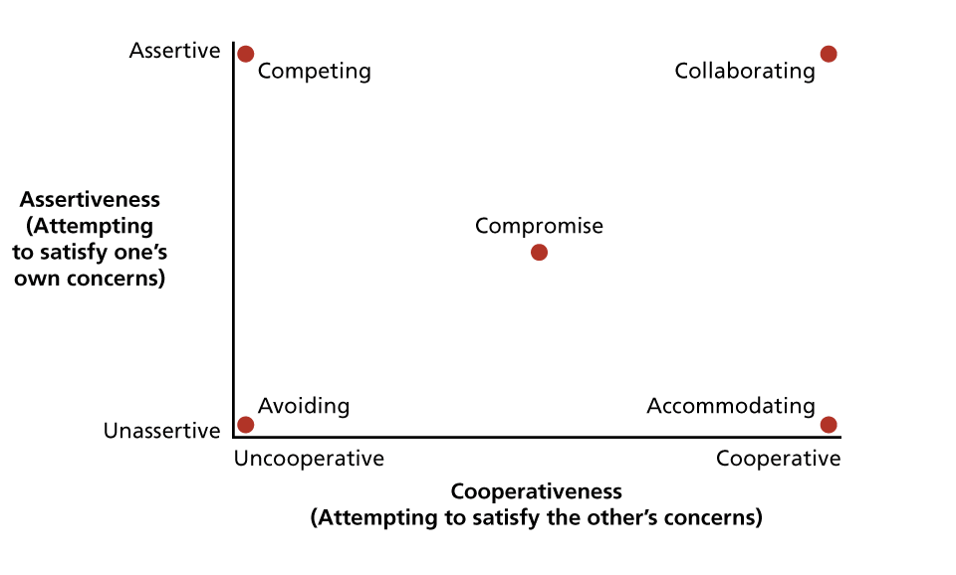
Avoiding – A conflict management style characterized by low assertiveness of one’s own interest and low cooperation with the other party. “Hiding the head in the sand”
Accommodating – A conflict management style in which one cooperates with the other party while not asserting one’s own interests
Competing – A conflict management style that maximizes assertiveness and minimizes cooperation
Compromise – A conflict management style that combines intermediate levels of assertiveness and cooperation
Collaborating - A conflict management style that maximizes both assertiveness and cooperation

Is all conflict bad?
-There is a growing awareness of some potential benefits of organizational conflict
-Conflict can be functional when it promotes necessary organizational change:
  - CONFLICT CHANGE ADAPTATION SURVIVAL
-Conflict might bring into consideration new ideas that would not be offered without conflict
-Conflict Stimulation – A strategy of increasing conflict to motivate change

A model of Stress in Organizations
Stressors
Stressors – Environmental events or conditions that have the potential to induce stress
-There are some conditions that would prove stressful for just about everyone
-These may include things as extreme hear/cold, isolation, or hostile people

Stress
Stress – a psychological reaction to the demands inherent in a stressor that has the potential to make a person feel tense of anxious because the person does not feel capable of coping with these demands
-Stress is not intrinsically bad
-All people require a certain level of stimulation from their environment, and moderate levels of stress can serve this function

Stress Reactions
-Stress Reactions – The behavioral, psychological and physiological consequences of stress.
-Attempts to cope with stress
-Can cost organizations money (if the employee is absent a lot, he avoids stress but leave the organization short handed which provokes stress in others)

Personality and Stress
-Locus of Control – A set of beliefs about whether one’s behaviors is controlled mainly by internal or external forces
  - Externals are more likely to feel anxious in the face of potential stressors
  - Internals are more likely to confront stressors directly because they assume that this response will make a difference
  - Externals are more prone to simple anxiety-reduction strategies that only work in the short run
-Type A Behavior Pattern – A personality pattern that includes aggressiveness, ambitiousness, competitiveness, hostility, impatience, and a sense of time urgency
  - Type B does not exhibit these extreme characteristics
  - Type A people report heavier workloads, longer work hours, and more conflicting work demands
-Negative Affectivity – Propensity to view the world, including oneself, and other people in a negative light
  - They are particularly likely to feel stressed in response to the demands of a heavy workload

Stressors in Organizational Life
Executive and Managerial Stressors
-Role Overload – The requirement for too many tasks to be performed in too short a time period
-Heavy Responsibility (Ex. Executives)
  - it can have extremely important consequences for the organization and its members
  - The personal consequences of an incorrect decision can be staggering

Operative-Level Stressors
-Poor Physical Working Conditions – Operative-level employees are more likely than managers and professionals to be exposed to physically unpleasant and even dangerous working conditions (heat, noise, cold, pollution, and the chance of accidents)
-Poor Job Design – It might seem paradoxical that jobs that are too simple or not challenging enough can act as stressors. Job scope can be a stressor at levels that are either too low or too high

Boundary Role Stressors, Burnout, and Emotional Labor
-Boundary Roles – positions in which organizational members are required to interact with members of other organizations or with the public
  - These occupants are especially likely to experience stress
  - This is yet another form of role conflict in which one’s role as an organizational member might be incompatible with the demands made by the public or other organizations
-Burnout – A syndrome of emotional exhaustion, cynicism, and reduced self-efficacy
  - Burnout was originally studied among those working in some capacity with people
  - However, it has now been established that burnout can occur even among non-boundary spanners

The Job Demands – Resources Model and Work Engagement
-Work Engagement - A positive work-related state of mind that is characterized by vigor, dedication, and absorption
-Job demands-resources model – A model that specified how job demands cause burnout and job resources cause engagement

Some General Stressors
-Interpersonal Conflict - The entire range of conflict, from personality clashes to intergroup strife, is especially likely to cause stress
  - Bullying – Repeated negative behaviour directed toward one or more individuals of lower power or status that creates a hostile work environment
-Work-Family Conflict – Occurs when either work duties interfere with family life or family life interferes with work responsibilities
-Job Insecurity and Change – Secure employment is an important goal for almost everyone, and stress may be encountered when it is threatened.
-Role Ambiguity – Exists when the goals of one’s job or the methods of performing the job are unclear. Such a lack of direction can prove stress
-Sexual Harassment – Abuse of power and a form of unethical behavior
  - Negative effects include decreased morale, job satisfaction, organizational commitment and job performance, and increased absenteeism, turnover, and job loss.

Reactions to Organizational Stress
Behavioral Reactions to Stress
-Problem Solving – terminating the stressor or reducing its potency. Examples of problem solving include:
  - Delegation
  - Time Management
  - Talking it out
  - Asking for help
  - Searching for Alternatives
-Seeking Social Support – Refers to having close ties with other people
  - Can affect stress by bolstering self esteem, providing useful information, offering comfort and humor…
  - Off the job, individuals might find social support in a spouse, family, or friends
  - On the job, individuals might find social support from one’s superior or co-worker
- Performance Changes – Stress frequently cause reduced job performance. Some stressors are “hindrance” stressors in that they directly damage goal attainment
- Withdrawal – Takes the form of absence and turnover
  - Only works short term. The better alternative is problem Solving
-Use of Addictive Substances – Smoking, drinking, and drug use represent the least satisfactory behavioral response to stress for both the individual and the organization.

Psychological Reactions to Stress
-Primarily involve emotions and thought processes rather than overt behavior
-The most common psychological reaction to stress is the use of defense mechanisms
-Defense mechanisms – psychological attempts to reduce the anxiety associated with stress
-Some common defense mechanisms include:
  - Rationalization – attributing socially acceptable reasons or motives to one’s actions so that they will appear reasonable and sensible, at least to oneself (male nurse becomes angry and abusive when learning he will not be promoted and claiming that the female head nurse discriminates against men)
  - Projection – Is attribution one’s own undesirable ideas and motives to another so that they seem less negative.
  - Displacement – Directing feelings of anger at a “safe” target rather than expressing them where they may be punished. (construction worker who is severely criticized by the boss for sloppy workmanship might take out his frustrations in an evening hockey league)
  - Reaction Formation – expressing oneself in a manner that is directly opposite to the way one truly feels, rather than risking negative reactions to one’s true position.
  - Compensation – applying one’s skills in a particular area to make up for failure n another area.

Physiological Reactions to Stress
-Work stress is associated with elevated blood pressure, cholesterol and pulse
-Stress has also been associated with the onset of diseases such as respiratory and bacterial infections due to its ill effects on the immune system
-The accumulation of stress into burnout has been particularly implicated in cardiovascular problems

Organizational Strategies for Managing Stress
Strategies to manage stress are either to reduce demands on employees or enhance their resources

Job Redesign
-Organizations can redesign jobs to reduce their stressful characteristics.
-It is possible to redesign jobs anywhere in the organization to this end
  - An overloaded executive might be given an assistant to reduce the number of tasks he or she must perform…

“Family-Friendly” Human Resource policies
-Policies include some combination of formalized social support, material support, and increased flexibility to adapt to employee needs

Stress Management Programs
-Programs designed to help employees “manage” work-related stress
-Some programs help physically and mentally healthy employees prevent problems due to stress
-Others are therapeutic aimed at individuals already experiencing stress problems

Work-Life Balance, Fitness, and wellness Programs
-Includes a variety of leisure activities combined with a healthy diet and physical exercises
-Which can increase commitment and reduce turnover
-Fitness training is associated with improved mood, a better self-concept, reduced absenteeism, enhanced job satisfaction, and better performance

What are the five modes or styles of managing conflict? Give an example which illustrates the relationship between assertiveness and cooperativeness for each mode.
Answer: The five modes are avoiding, accommodating, competing, compromising and collaborating. Examples: 1)
avoiding (low assertiveness, low cooperativeness) 􀁎 a manager who postpones meeting with an
employee who wants a raise; 2) accommodating (low assertiveness, high cooperativeness) 􀁎 going to the
movie that your date wants to see instead of the one that you would rather see; 3) competing (high
assertiveness, low cooperativeness) 􀁎 most transactions where buyer and seller do not expect to meet
again; 4) collaborate (high assertiveness, high cooperativeness) 􀁎 two department managers in the same
company must share limited resources to achieve their individual departmental objectives, and jointly
contribute to the attainment of the company's goals; 5) compromise (moderate assertiveness, moderate
cooperativeness) 􀁎 when it becomes clear to union negotiators and management that neither is going to
get the maximum deal they had hoped for, they settle for a deal that is adequate (satisficing).
Page Ref: 448
Skill: Applied
170) What is the difference between distributive and integrative negotiation? Discuss the main tactics used in each.
Answer: Distributive negotiation 􀁎 win-lose negotiation in which a fixed amount of assets is divided between the
parties. Integrative negotiation 􀁎 win-win negotiation in which it is assumed that mutual problem
solving can enlarge the assets to be divided between parties. Distributive tactics may include the use of
threats and promises, firm posturing, small concessions offered strategically, and verbal persuasion.
Integrative tactics may include exchanging large amounts of information, reframing differences as
opportunities, cutting costs for agreement, increasing resources and introducing superordinate goals.
Page Ref: 451
Skill: Recall
171) Suzie Desouza, the Manager of Industrial Relations at Zeta Manufacturing, has just been informed that the union representing the assembly workers has rejected management's latest offer and has issued a strike notice. Suzie is very angry at both her superiors and the union representatives for their intransigence on key negotiation issues, but she tries to keep her cool as she prepares for yet another marathon bargaining session. She is concerned that the strike will lead to layoffs in other areas of the company, and she worries about those individuals who will be adversely affected if the next round of negotiations fail. She has been told by her boss to try to avoid a strike at all costs; yet her boss was the one who recommended countering the union's previous offer with the current failed offer. Based on the pace of negotiations to date, she predicts that even round-the-clock negotiations will not result in a settlement soon enough to avert the strike. As she sits at her desk, she glances at the pictures of her two children who she has hardly seen since negotiations started last month. She also notices that the in-basket of her mail tray is overflowing and she has nearly 100 unopened email messages · half of them marked "URGENT". As she pops another pill for her high blood pressure problem, she sighs, "Where do I start?" Analyze Suzie's situation in terms of stressors, stress, and stress reaction.
Answer: The managerial stressors affecting Suzie are role overload (e.g. too much to do in too little time) and
heavy responsibility (e.g. she is worried about the layoffs which will result if she cannot reach an
agreement). There is also evidence of role ambiguity (e.g. the boss's directive to avoid a strike at all costs,
and yet he rejected the union's previous offer), and work-family conflict (e.g. she has not seen much of
her children lately). In addition, Suzie exhibits a Type A behaviour pattern, and her repressed anger for
her boss and the union representatives may be contributing to her high blood pressure problem.
Page Ref: 458
Skill: Applied
28
172) According to the job demands-job control model, what types of jobs are prone to increased risk of heart disease?
Give some examples.
Answer: Jobs involve high psychological demand and low decision control are prone to increased risk of heart disease. Examples include telephone operators, cooks, food servers, and assembly line workers.
Page Ref: 459
Skill: Applied
173) Describe some common defence mechanisms and give an example of each.
Answer: Rationalization, projection, displacement, reaction formation, and compensation. The text provides good
examples of each on page 437.
Page Ref: 467
Skill: Applied
174) Discuss several strategies for reducing or coping with stress.
Answer: Job redesign techniques, social support networks, "family friendly" human resource policies, stress management programs, and work-life programs.
Page Ref: 469
Skill: Recall
175) George Walters works in the accounting department at Kapster Enterprises. Recently, the department introduced a new computer system and adopted new documenting procedures which have had a considerable impact on George's job. As a result, George is feeling a bit "stressed-out" and needs to talk to someone in his social support network. Should he talk to a) his wife Judy; b) his co-worker Bill; or c) his old high school buddy Mike who is a bartender? Explain your rationale.
Answer: Evidence suggests that the buffering aspects of social support are most potent when they are directly
connected to the source of the stress; therefore, George might find that his coworker Bill is the best source
of support for his work-related woes. Note that this does not mean that George could not or should not
also discuss these matters with his wife and his old high school buddy · they can still offer comfort and
bolster his self-esteem even though they may not be knowledgeable about the specific work-related
problems he is dealing with.
Page Ref: 470
Skill: Applied
176) Describe burnout its stages.
Answer: Burnout is a form of stress that is experienced by some boundary role occupants. It follows a process that
begins with emotional exhaustion, leads to depersonalization, and then to low personal accomplishment.
Page Ref: 461
Skill: Recall
177) Describe the link between Negative Affectivity and stress and the factors responsible for it.
Answer: People high in negative affectivity report more stressors in the work environment and feel more
subjective stress. They are particularly likely to feel stressed in response to the demands of a heavy
workload. Several factors that might be responsible for their susceptibility to stress include: a
predisposition to perceive stressors in the workplace; hypersensitivity to existing stressors; a tendency to
gravitate to stressful jobs; a tendency to provoke stress through their negativity; or the use of passive,
indirect coping styles that avoid the real sources of stress.
Page Ref: 458
Skill: Recall
29
178) Discuss the role of personality on the experience of stress and three personality traits associated with stress.
Answer: Personality can affect both the extent to which potential stressors are perceived as stressful and the types
of stress reactions that occur. Three personality traits associated with stress are locus of control, Type A
behaviour pattern, and negative affectivity. Externals are more likely to feel anxious in the face of
potential stressors and prone to simple anxiety-reduction strategies. Type A individuals encounter or
perceive to encounter more stressful situations then Type B individuals and they exhibit adverse
physiological reactions in response to stress. People high in negative affectivity report more stressors in
the work environment and feel more subjective stress.
Page Ref: 457
Skill: Recall
179) What is bullying and what factors distinguish it as a stress-inducing form of conflict?
Answer: Bullying refers to repeated negative behaviour directed toward one or more individuals of lower power or status that creates a hostile work environment. Factors that distinguish it include the following:
Although it can involve physical aggression, it is most commonly a more subtle form of psychological
aggression and intimidation that can take many forms such as incessant teasing, demeaning criticism,
social isolation, or sabotaging others' tools and equipment. An essential feature of bullying is its
persistence - a single harsh incident would not constitute bullying. It is the repeated teasing, criticism, or
undermining that signals bullying. Another key feature of bullying is some degree of power or status
imbalance between the bully and the victim. Managers are often identified as bullies by subordinates.
However, there is power in numbers and subordinates might team up to harass their boss, a
phenomenon known as mobbing. Victims of bullying and mobbing experience stress because they feel
powerless to deal with the perpetrator(s).
Page Ref: 463
Skill: Applied
180) Discuss the relationship between stressors and job performance and give examples of hindrance and challenge stressors.
Answer: Stressors frequently cause reduced job performance, however, the nature of the relationship depends on
the type of stressor. Some stressors are hindrance stressors, such as role ambiguity and inteterpersonal
conflict and they damage performance. Other stressors are challenging such as heavy workload and
responsibility. While they can also damage performance they sometimes stimulate it via added
motivation.
Page Ref: 467
Skill: Recall
181) Carl has a good friend who seems to be reacting badly to the stress of his new job. You are starting to worry about the toll it is taking on him and realize that he would be better off he used problem solving as a way to cope with his stress. You have arranged to meet him for lunch and to propose this to him. What will you tell him about problem solving and what examples of problem solving can you suggest he consider trying?
Answer: Problem solving is directed toward terminating the stressor or reducing its potency rather than just
making the person feel better in the short run. It is reality oriented and most examples of it are just
routine, sensible, and obvious approaches that an objective observer might suggest. Examples that Carl
can suggest to his friend include: delegation, time management, talking it out, asking for help, and
searching for alternatives.
Page Ref: 466
Skill: Applied
30

