Lesson 2 Information Literacy

There are 9 objectives for this course.

- To enhance your information literacy level through an understanding of, and appreciation for, the variety of information available and its application. Many of us tend to use the same sources we have learned over the years. For some, your first instinct if to use google while other go further and start exploring encyclopedias and books. Thus, this objective is to take you beyond your immediate and traditional response to identifying other sources of information that might better serve your purpose.
- To provide you with an understanding of the research process. Because the proliferation of different types of information sources has become significantly more complex, in order to ensure that you have the best information available to you to write your paper or make your decision, an organized pathway or methodology is essentially to ultimately save you time. Like a treasure hunt, it is best to take advantage of the clues that are presented to you and not have to retrace your steps. Thus, this objective is to follow the flowchart of the research process.
- To introduce you to the variety of information sources available for research. (books, theses, dissertations, non-print material such as videos, conference papers…) This is called the publication cycle.
- This objective is to have you make use of this wealth of information sources available for your research
- To have you develop and apply effective search strategies for the different retrieval tools. There are so many types and sources of information, there has to be some method of finding the item you want. Basically, learn how to properly conduct searches to get only relevant sources.
- This objective has you evaluation the quality and suitability of sources for a specific topic using established criteria. (Is this a good source for my paper, is ist trust worthy…)
- To have you take notes from appropriate sources that will support synthesis of the material. Since you are drawing your information from published literature, it is important you are able to read, understand and synthesize the material.
- To organize these sources in a logical and effective manner, and to construct a working bibliography initially listing all of the sources you have found in your research.
- Properly document the information to be used in the research paper using a specific punctuation or attribution style. (sometimes using a guide can help, eg:apa style textbook)

In todays world, not finding information is not the problem, we find an abundance of information on a topic. The problem lies whether the information is credible and trust worthy.
Information literacy is considered an essential lifelong learning skill.
The American Library association defines information literacy as the set of abilities requiring one to recognize when information is needed and have the ability to locate, evaluate and use effectively.

Seven Pillars Model for Information Literacy

- Recognize information needed: You will identify a topic you wish to explore, identify through clustering technique
- Distinguish ways of addressing gap: how do I find the information I am missing
- Construct strategies for locating information: identify the types of information sources most appropriate to their needs and to develop a systematic strategy for researching the published literature to address the information gap
- Locate and access: develop efficient and effective search strategies though the use of “Boolean” logic, keyword and controlled vocabulary…
- Compare and evaluate: the information you have retrieved. Being able to use only what is necessary
- Organize, apply and communicate the information to others
- Synthesize and create: communicating your information to your audience.

Flowchart of Research Process
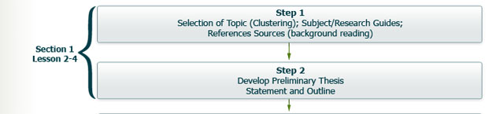
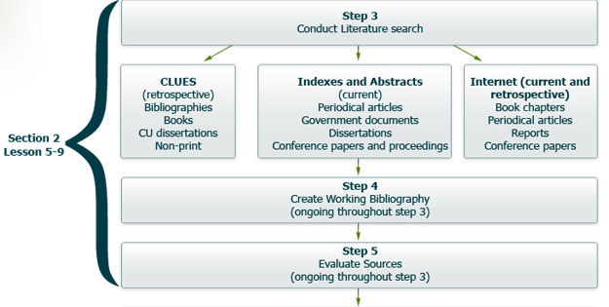

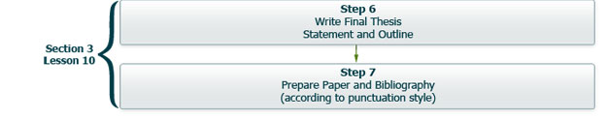

The Publication cycle:

- The inner most circle is the time cycle. Relative indication of the time it takes for information to be published in a specific form.
- Knowledge circle: Indicative of the stage of the original research on its journey from an idea being researched and recorded in Lab notebooks and research diaries =, to which we have no access to appearing as a technical report to being offered by ones peers to a final formalized publication in a textbook.
- Publication cycle: Indicates the format in which the information appears general moving from the more informal format such as a research diary to a more formal format.
- Access cycle: indicates the methods we used to access the published information.

Post Test
- The Conference Board of Canada categorizes the “Manage Information” skill as a
Fundamental skill
Personal management skill
Teamwork skill
In all categories skill
- The manage information skill includes the specific skills of
Gathering and organizing information
Gathering, organizing, and analyzing information
Locating, gathering, organizing, accessing, analyzing and applying information
Locating, gathering, organize, accessing, analyzing, applying, conserving and applying.
- Information literacy as the ability to recognize when information is needed and
have the ability to love, evaluate and use effectively the needed information is the definition of
Conference board of Canada
American Library Association
Canadian library association
Society of college, national and university libraries

- The SCONAL Pillar Model for Information Literacy includes how many pillars
5
8
6
7
- The access cycle of the publication cycle indicates
The format in which the publication appears
The length of time to publication
The method used to find the published information
The type of material format In which the publication appears

Lesson 3 My Research Topic (topics associated with steps 1&2 of the flowchart)

A good research topic must meet 3 demands:
- It must examine one narrowed issue, not a broad topic.
- It must address a knowledgeable reader and carry that reader to another level of knowledge
- It must have a serious purpose, in that it demands analysis of the issues, argues from a position, and explains complex details.
It should have a built-in issue so that the researcher can interpret the issue and cite the opinions of outside sources.

What is not suitable for a research paper?
- Too autobiographical: draws primarily on your own experience
- Too subjective: where your whole argument is based on personal taste
- Too current: today’s headlines
- Too restrictive: usually a mechanical process which can be explained by one source
- Too specialized: in that the terminology is too technically
- Too specialized for the published literature available to you: in that the paper would require specialized documents not in the library collection or not readily available to you.

Developing a Research Topic
Once you have settled on a broad subject area, the next step is to refine that into a manageable topic. Follow 3 steps: think about your prior knowledge of the topic, thinking about what you don’t know about the topic and keeping a journal. Brainstorming is an effective way to recall what you know.
Think about your prior knowledge: use clustering around central topic
Think about what you do and do not know: perform background reading, reference books
Keep a journal: jot down steps in preliminary investigations, look for keywords and concepts.

A good research topic should
-Be narrow enough to be developed fully: do not try to write a biography of Picasso or analyze all of his work, focus on perhaps the Blue period.
-Require research: and not just be an essay expounding what you know and your opinion, or drawing solely on your personal experience.
-Be a topic you consider objectively: if your convictions on a topic are so strong that they prevent you from acknowledging the other side of a controversial topic, then you might want to avoid that topic.
-Be a topic that you are curious about, but not thoroughly familiar with: it will hold your interest.

Background Reading in Reference Sources
There are two types of reference sources that are only consulted for specific information, they are rarely read completely.
1-General: those that are broad in scope, not limited to any one subject, but useful for many subjects. An example of this would be the encyclopedia Britannica, which is general encyclopedia covering most subjects.
2-Subject: In these reference sources, the material is devoted to a specific area such as art, or literature, or chemistry, such as the Kirk-Othmer encyclopedia of chemical technology.

Types of Encyclopedias
They are useful because they provide an overview of a topic, including definitions, description, background and references. They provide a summary of treatment of the different aspects of a subject, instant details (dates, events, names of key people).

Using encyclopedias for background reading and researching a topic
Encyclopedias can help you in your background reading and search for a topic. They provide an overview of a topic, including definition, description, and background information.

Dictionaries
They are recognized by most of us because they provide information about words such as their meaning or definition, their spelling, pronunciation, how they should be used in everyday language and sometimes in their history. They may also provide biographical and geographical information.
There are 6 types of dictionaries:
1-General: what we use in school
2-Historical: provide origins of a word (oxford)
3-Foreign language: one language or translating
4-Subject:geared to a specific field (dic. Of finance)
5-Special purpose: dictionary of slang
6-Biographical: essay and date

In addition to the two most common and well-known reference source types, that is, dictionaries and encyclopedias, there are a variety of other type of sources including almanacs, directories, gazetteers, handbooks and manuals, and yearbooks, each with its own subject content.
- ALMANACS: Compendiums of facts, dates, statistics relating to people, events, countries, and subjects. An example of an almanac would be the Almanac of British Politics [electronic resource] accessible through CLUES.
- BIOGRAPHICAL DICTIONARIES: A collection of sketches of varying length about the lives of individuals, arranged alphabetically by surname. Two types: 1) Essay; and 2) Data -- both of which can be broken down into current (lists only living persons) and retrospective (limited to the deceased). An example of a biographical dictionary is the Dictionary of Popes [electronic resource] accessible through CLUES.
- DIRECTORIES: Gives the names and addresses of persons, organizations, or institutions. It may provide other information such as the purposes, the dues, and the officers of organizations. An example of a directory is the Directory of Services and Programs for Abused Men in Canada = Répertoire des services et programmes pour hommes violentés au Canada [electronic resource] accessible through CLUES.
- GAZETTEERS (Geographical sources): Provides comprehensive geographic information such as topography, climates, populations, migrations etc. An example of a geographical source is The Kaguya Lunar Atlas: the Moon in High Resolution [electronic resource] accessible through CLUES.
- HANDBOOKS AND MANUALS: Contains common information in a concise form and provide a quick reference to more detailed sources. An example of a handbook is the HLAS online: Handbook of Latin American Studies [electronic resource] accessible through CLUES.
- YEARBOOKS: Provides concise summaries of the events of a particular year, or within a particular country. They are designed to be factual and statistical. An example of a yearbook is the European yearbook of international economic law 2011 [electronic resource] accessible through CLUES.
They can be useful as they provide snippets of useful information.

Facts vs. Opinions

Fact: denotes something that exists, can be verified or proven.
Opinion: is an idea about a fact or another opinion an interpretation, a deduction or a supposition.

The Thesis Statement
- It sets the argument to control and focus the entire paper
- It provides unity and a sense of direction
- It specifies to the reader the point of the research
Should never be a question or a topic. A final thesis can only be written once all your sources have been collected and you have evaluated all of them and formed an opinion. A preliminary thesis is one or two sentences that summarized your tentative response to the research question.

Developing a preliminary thesis
Ask the series of questions that include the 4 Ws. Your thesis should ideally be the result of “WHY”.
You begin by finding the main concepts and its synonyms to allow for the most accurate results for research. Do not select keywords that are off topic or irrelevant.

Outlines
There are basically two kinds of outlines; informal and formal.
Informal are used for your own needs and are usually performed before and during literature search. They will be modified throughout the process.
Formal are written prior to writing the paper, they show how the paper supports the thesis statement and are used as a means to check the papers organizations.

Post-Test
- An unsuitable research topic is one that is
Too autobiographical or too subjective
Too restrictive or too specialized
Too current or too specialized
All of the above
- Clustering is a technique used to
Identify what you do not know about a topic
Identify what you will find out during background reading
Identify sources used in your paper
Identify what you know about a topic
- The technical term for prior reading in reference books is referred to as
Information reading
Informative reading
Background reading
Preliminary reading
- The functions of the thesis statement is
Set the argument, focus the paper, list the sources used
Set argument, focus the paper, list sources, and provide unity and direction
Set the argument, focus the paper, provide unity/direction, state purpose for reader
Set the argument, focus the paper, provide univty/direction, state purpose, list sources

- The outline that helps you begin to structure your paper by using major/minor topics is the
Beginning outline
Preliminary outline
Basic outline
Background reading
Background outline

Lesson 4 Types of Material

Primary vs. Secondary Sources

Primary Sources are the original words of the writer.
Examples: novels, paintings, autobiographies, poems, films, diaries, speeches, letters, novels, interviews, case studies, findings from research
Secondary sources are the writings about the primary sources, about an author, or about somebody’s accomplishments.
Examples: critical reviews, newspaper reports and biographies

When using quotes in an essay, you should mostly use primary, secondary sources quotes should only be 10-15%.

CLUES record of a book:
Records are comprised of fields. An example of a field is author or title.
Call number: each item no matter its format is assigned a call number. Usually found on top of author section.
Author field: self explanatory
Title: it also adds information besides the title
Publisher: heading of imprint.
Location field: tells you exactly where to find what you are looking for

Evaluation printed materials
Purpose, Authority, Scope, Format and Audience
Purpose WHY. Why did the author write this document? Normally stated in the introduction of the book.
Authority WHO. Examines the authority of who wrote the document. What are their qualifications? Normally found in the preface of the book/article.
Scope WITHIN WHAT BOUNDARIES. Most helpful to the user to determine if the information in the document is appropriate to the topic being researched.
Format Any interesting helpful unique features? Graphs, stats, tables...
Audience knowledge level, maturity? Intended audience.

Periodicals are materials that are published at regular internals. These include, journals, magazines, newspapers, newsletters, and annual reports. They are more up to date than books, take less time to publish, reflect contemporary opinion or research on a topic. May be the only source for recent information.
Magazines are directed to a broad, general audience.
Periodicals with wide circulation and broad appeal.
Written for the general audience
Published frequently by commercial publishers
Not used for scholarly research

Journals intended to report on original research. Directed to a subject knowledgeable audience. Refereed journals are the most accurate; they are scholarly articles that have been reviewed. In order for it to be refereed journals, authors submit to referee journal publisher an article to be published. Article sent out anonymously and publisher sends out comments. Publisher then contacts author with recommendation. Authors then choose to adopt their comment or submit it to another journal. Publishers can also not to accept an article for several reasons. Peer reviewed are mostly found in journals.

Periodical formats
E-journals available over the web via a database or directly from the publisher.
Do not match their print counterparts and provides a direct link to the database or the publishers website.
Print entries are listed at WEB-VAN libraries

Government publications
Are for the most part not included in CLUES, unless the library as an independent, stand-alone publication treats them. They are documents issued under the authority of the government or one of its agencies, whether at the municipal, provincial or federal level.

Dissertations
Written by doctoral students in partial fulfillment or their degree. Original research. Extensive bibliography.

Theses
Written by Masters students in partial fulfillment of their degree. Small scale study or literature reviews.

Evaluating a printed source
Authority learn about author’s expertise in the preface.
Purpose & audience learn about this in the introduction of the book
Format in the field called description and bibliography
Scope contents/abstracts

Criteria for evaluating web sources
Accuracy, reliability, currency, value
An article must have; authors name, authors title or positions, authors organization affiliation, authors contact information, date it was created or updated.

Authority: who is the author, qualifications.
Accuracy: reliable and error-free?
Currency: date of creation, up to date into, date of last revision?
Coverage: comprehensive?
Objectivity: purpose of site, personal bias.

POST- TEST

- Primary sources include
Manuscripts, case studies, computer data and paintings
Manuscripts, speeches, drawings, journal articles
Manuscripts, biographies, speeches, plays
Manuscripts, sculptures, newsletters, journal articles
- Five commonly used criteria for evaluation printed sources such as books include
Purpose, authority, length, format, audience
Purpose, authority, length, scope, format
Purpose, authority, scope, format, audience
Purpose, authority, length, scope, audience
- A periodical
Includes journals and books published at regular intervals
Included magazines and monographs published at regular intervals
Included magazines, journals and annual reports published at regular intervals
None of the above
- A refereed journal is
The publisher anonymously sends the article manuscript to experts in the discipline for review
The publisher sends the article manuscript to experts in the discipline with the name of the writer
The publisher posts the article manuscript on the web to be votes on by anyone
The publisher posts the article manuscript on the web to be voted by anyone
- Five commonly used criteria for evaluating web sources include
Authority, accuracy, currency, coverage, objectivity
Authority, graphic design, accuracy, coverage, objectivity
Authority, accuracy, graphics appeal, coverage, objectivity,
Authority, length, currency, coverage, objectivity

Lesson 5 Conducting the Literature Search

Selecting the research material when faced with any kind of information you should be able to take notes and jot down the most important parts without really reading the entire book/article.

The art of skimming
When looking at source material, skim through it quickly to get the gist of what it covers.

For a journal article: quickly read the abstract, introduction and conclusion and maybe the discussion section
For a book: skim the table of contents, also check the index to see whether it refers to writers you have already found sources for.

Be sure to…
Keep your topic in sight to keep you focused.
Always think about how the material relates to your topic.
Do not take endless notes.
Do not feel you have to summarize the whole article- you just need the bits that relate to your topic.

Make your notes personal to you; express your own thoughts and ideas. Record personal responses to information provided in research sources. Distinguish original thoughts from those put forth in the literature. Provide a link to your working bibliography.

Note taking:
Takes three formats, which are summarizing, paraphrasing, and quoting.
Summarizing: general concepts or ideas of the original work are briefly condensed. Basically writing the main ideas. Used for background, history or theories inended as supportive information.
Paraphrasing: the ideas of the original author are restated in your own words. Must extract the principal idea from a passage.
Six steps to effective paraphrasing:
1-reread the original message until you fully understand it
2-set the original aside, and write your paraphrase on a note card
3-jot down a few words on the card to remind you later how you envision using this material.
4-check your version against the original to make sure that your version accurately expresses all the essential information in a new form.
5-place quotation marks around any unique term
6-record the source so that you can credit it easily if you decide to incorporate the material into your paper
Quoting: an exact copy of the original source including punctuations and capitalization.

When to quote
Quotations are usually used for one of three reasons:
-wording in the passage is so precise that it cannot be paraphrased without loss of meaning.
-the person that is being quoted is highly respected in the field and quoting them will bolster the argument.
-the stylistic qualities of the passage may demand comment

Quoting within the text: quotes of fewer than 40 words should be integrated into your text, and enclosed within double quotation marks (“Author, Year ”).
Block quotations: quotes that are longer than 40 words should be displayed as a block. Start the block on a new line, remove quotation marks and indent the entire passage approximately ½ inch from the left.
Miele (1993) found the following
Ifhvfibhghojbn;ognb’….. (p.298)
Words omitted: if you omit a work or passage from a quotation, insert an ellipsis (…)
Quote modified: If you modify a quote place square brackets […]

Plagiarism can be defined as passing off someone else’s words or thoughts as your own. Because it is theft, it is a serious offense, especially when and if the work is submitted for credit. Plagiarism excuses include: ignorance, pressure to complete something quickly, unacceptable excuses: its in my reference list, it comes from my course pack, it was part of my lecture.

When you finish making notes from a source, make sure to write down every reference details.
For a book: mark down the author, title, place of publication, publisher, and publication date and page numbers for the quote.
For an article: author, title of article, title of journal, volume number issue number if available, date and inclusive page numbers.
For an internet source: take down the URL, and as much info you can get such as author, title, publisher, date, date you accessed it etc.

Bibliographies
A list of works on a specific subject or topic. Listed at the end of a research paper, book, scholarly article etc. Can be published in a book form. Annotated bibliographies provide summaries for each entry.
For the reader: provides a reliable list of the works used by the author to write the paper. Provides a list of works on the topic that the reader might wish to consult.
For the writer: provides a reliable list of the sources used to write the paper, thus helping to ensure that the original source material of any given idea or other piece of information is acknowledged.
For the researcher: provides a ready-made list of sources to be consulted.

A working bibliography:
A preliminary list of sources on your thesis statement. The list will change as sources are added and deleted during the literature search. May include books, journal articles, dissertations, videos, documents from the web, government publication etc. Should be arranged alphabetically.

What is RefWorks?
A web-based tool that allows you to manage and organize the bibliographic references you find in the library catalogues and databases and it allows you to prepare a bibliography or list of references automatically.

Post-Test

- Note-taking generally takes three formats
Summarizing, paraphrasing, paragraphing
Summarizing, paraphrasing and quoting
Paraphrasing, paragraphing and quoting
Paraphrasing, quoting and acknowledging
- A bibliography is
A book about a person written by the person themselves
A book about a person written by another person
A book about a person written by a person with a list of sources
A list of sources
- A standard bibliography citation for a book would include
Author, title, date, place of publication, publisher
Author, title, date, issue number, publisher
Title, date, issue number, number of pages, publisher
Title, date, place of publication, publisher, number of pages
- A paraphrase must
Convey the meaning of the author, reducing the length of the material being paraphrased
Convey the meaning of the author in a longer text than what the author used
Convey the meaning of the author in your own words
Convey the meaning of the author in the authors words
- A working bibliography is defined as
A list of the final sources used in your paper
A list of all the sources you have retrieved during your entire literature search
A list of courses that you have discovered during the literature search that you determine may be of value to you in writing your research paper
None of the above

Lesson 6 Keyword Searching

Identifying key words or concepts, usually there are 3 or 4. These key concepts or keywords will help you when conducting your literature search. They may be modified as you conduct your research.

Be careful not to select keywords that are off topic that may yield irrelevant sources. Stick to very specific keywords that are used to describe the concept.
Try not to select keywords that are off topic or broader then concept - "learning disabilities" is not a synonym for "dyslexia"
Think about how an author would use the term in a title or abstract of their book or article.
Think about different endings - adolescents or adolescence or variant spellings - behavior or behaviour.
Also try not to pick commonly used words or words that have multiple meaning (called homographs) e.g. "primary" "present"

Constructing Search Statements
Boolean operators once the keywords and their synonyms have bee established, you are now able to logically arrange these keywords together into one statement. Three operators may be used: AND, OR & NOT. These are known as Boolean operators.
AND: is used between keywords that express different concepts. When “and” is used, both keywords must be present in order for an item to appear, so it decreases the number of items retrieved.
OR: is used between synonyms or related items, hence when you want to retrieve either keyword. Using the “or” operator increases the number of items retrieved.
NOT: is used to eliminate unwanted keywords from search results. Used to eliminate unwanted keywords from search results.

Using keywords can make it easy to conduct research.
Example topic: young children
Topics: literacy, young children, programs, at risk, reading, elementary, intervention, potential dropouts
Boolean phrases: (Literacy OR reading) AND (“young children” OR elementary) AND (programs OR intervention) AND (“at risk” or “potential dropouts”)

Conducting your literature search
The process of seeking out material is called the literature search. The three main categories of retrieval tools that will be covered are: online public access catalogues, a variety of databases that provide access to scholarly and government material, and web databases. (OPAC)

OPAC: electronic catalogue, or database, that provides access to all the material held in an institution’s library collection.
CLUES: Concordia libraries user enquiry system, is called innopac. It has books, periodicals, AV & non-print material, reserve lists, dissertations and special collections. No periodical articles or most government documents.

The standard type of search that is performed in CLUES is a basic keyword search. Use Boolean operators, phrase searching, truncation.

Phrase searching: along with the ability to use Boolean operators, phrase searching may be used when you want to retrieve two or more terms side by side. Use quotes around two or more words. Ex: “anorexia nervosa” or “sudden death syndrome in infants”
Truncation: truncation is used of ORing a keyword with multiple endings. Using a * ex: Canad* (can pick up Canada or Canadians)

Limiting fields: are those that contain information that is common to many records within a database. Most databases allow the user to restrict their search results by certain limits.

The call number system
Prior to locating an item by call number, it is useful to understand how the items are arranged on the shelves. Understanding this will allow you to zero in on the desired item quickly. Items with LC call numbers are shelved first by letter (so the “L” entries come before “LB” entries), then numerical order (LB10 comes before LB11). However the Cutter number is ordered by number (G330 comes before G35).

Post-Test
- In academic libraries, books are shelved by the code of letters and numbers which appear on their spines. Do these codes represent size?
True
False
- In academic libraries, books are shelved by the code of letters and numbers on their spines. These codes represent the subject matter?
True
False
- In academic libraries books are shelved by the code of letters and numbers. Does it represent the date it was received at the library?
True
False
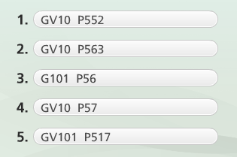
- Indicate using 1-5 the order of the following:

1, 4, 5, 2, 3

- Online public access catalogue in a typical academic library contains listings of
Journal Articles
Theses by students at the university
Articles in collected works
Journal articles
Audio-visual materials
Books

- I am searching for information on the health aspects of teenage pregnancy. Which
statement would give the most retrievals.
Teenage AND pregnancy AND health
Teenage OR pregnancy OR health
(Teenage AND pregnancy) OR (health)
7. I am searching for information on the health aspects of teenage pregnancy.
Which would give the most pertinent material.
Teenage AND pregnancy AND health
Teenage OR pregnancy OR health
(Teenage AND pregnancy) OR health
8. When performing a keyword search on CLUES, one runs the risk of
Locating false hits because keywords may be located in a variety of fields
including the contents, series, technical details and notes fields
Locating false hits because keywords may be located in a variety of fields
including author, publisher and date fields
Locating records that are not at Concordia
Nine of the answers are correct
9. An OPAC is
A bibliographical database of the contents of scholarly journals
An online catalogue which provides access to a library collection
A full-text multidisciplinary database such as Premier
A web search such as Google or Yahoo
None of the above

Lesson 7 Subject Searching

LCSH Listing (Library of Congress Subject Headings)
Published as a multi-volume set located in the Reference department of most libraries.
Standard list of subject headings used in mist North American academic libraries.
LCSH is easy because the headings are arranged alphabetically. Any word of phrase may be looked up.
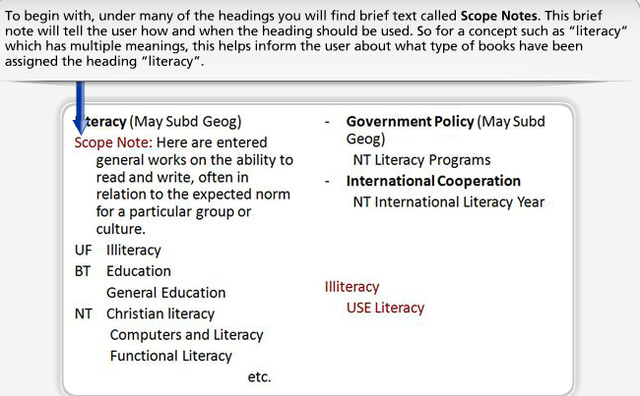

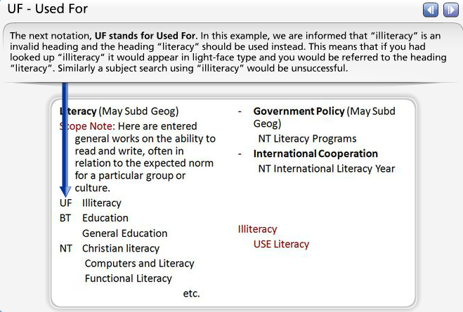

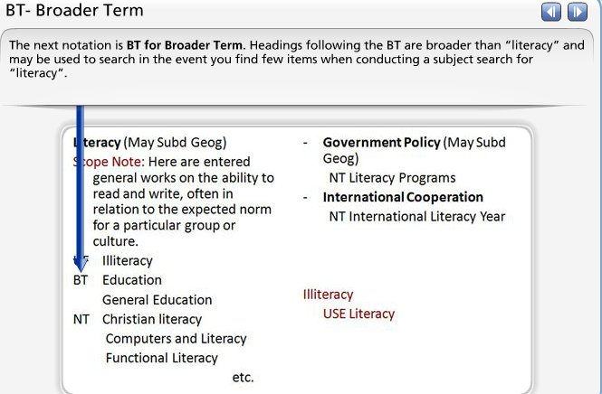

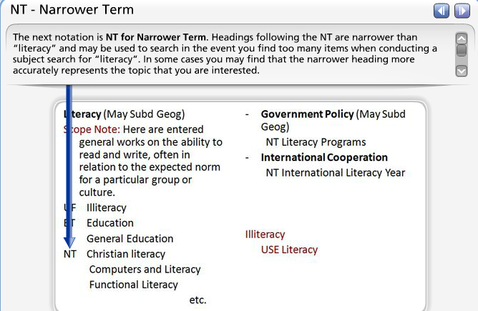
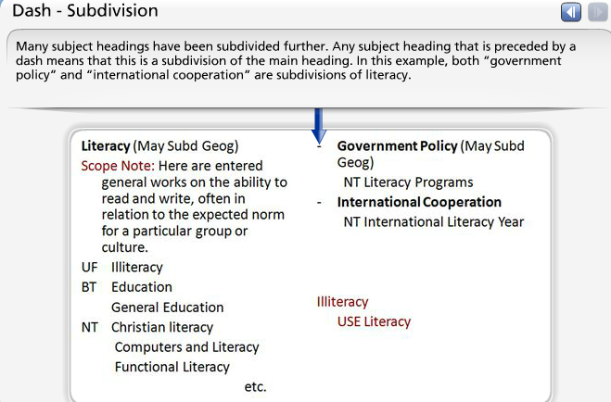

LCSH Subdivisions
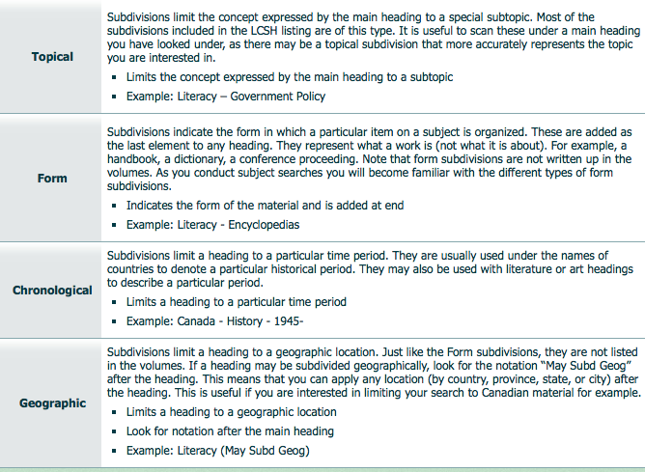
This is a way of combining a number of different concepts into a single subject heading. They are printed with a long dash without repetition of the heading. There are four categories of subdivisions.

LCSH and Research
Consulting the LCSH listing can help in your research as it:
- Identifies the subject headings used in CLUES and other OPACS
- Refers you to other subject headings that may be relevant
- Directs you from terms that are not used as headings to ones that are
- Lists subheadings used to divide a general subject into specific parts.
Some disadvantages are that there is a time lag before new or trendy topics are
covered, and you may find that the headings are not specific enough for your given
topic.

If you are unsure about what heading to lookup, then:
-browse the results of your keyword search, looking in the subject heading field of relevant records.
-jot down some relevant subject headings
-consult the LCSH listing to locate other relevant headings
Locating a Valid LCSH
If you are unsure or what heading to look under in the LCSH listing, then one strategy is to use your keyword search as a springboard to discover potentially relevant subject headings. If you have located some relevant items on this search, then scan the Subject Heading field of the CLUES record for each, jotting down some relevant headings. Consult the listing to learn more about these headings – for example if there are any narrower, broader or related headings that may be more appropriate to use, or perhaps whether there are some relevant topical subdivisions. Once you have established some valid headings for your topic, you are ready to conduct a subject search.

Subject Searching: Advanced
Allows a building block approach whereby a subject search can be combined with a keyword search. Use limit options to narrow your results.

Bibliographies a list of works on a specific subject or research topic. Listed at the end of a research paper, encyclopedia article, book, scholarly article etc.
Also published in book form: list works on a specific subject. It provides the groundwork for researchers; it is located in the reference department. Annotated bibliographies provide evaluative summaries for each entry.
Webliographies: is a list of hypertext links surrounding a common subject or theme.

Advantages: because they provide a comprehensive list of work on a specific topic, locating one will save you a lot of time and will lay the groundwork for your own research. Be aware of the currency of the bibliography, as some may contain dated info.

Literacy bibliography: it provides a list of sources related to literacy, including a section on literacy programs.

Comparison between subject and keyword search
Subject Search | Keyword Search
Scans the subject heading field only. | Scans the title, notes, contents, series, technical notes and subject heading fields.
Requires the use of LCSH | Uses natural language in the form of keywords
Is a more précises way of searching | More flexible way of searching

When we find something on CLUES, make sure to scan it to see if it is legit. Thus, begin by scanning the bibliographical record (click the title, and check the date of the bibliography) then look at the book cover.

Adding to Your Working Bibliography
Remember
- Marked items from CLUES can be exported to your RefWorks database.
- Different types of material may be transferred (e.g., books, dissertations, non-print).
- Review and edit entries within RefWorks to ensure information is complete and accurate.
  - Has the correct Ref Type been selected (e.g. is a book entry using the Book Ref Type)?
  - Has information been transferred into the correct field?
  - Have you manually entered the Source that was used to locate the item (i.e. CLUES), the date you retrieved it, and your personal notes?
- Do not include tools that were used to locate a citation (e.g. LCSH)
As you learned in Lesson 5, your working bibliography will be compiled using RefWorks, specially designed software that will allow you import marked records from a range of databases, edit and sort the entries alphabetically, and output them in a format of your choosing.
You have already been introduced to the various features on RefWorks, and hopefully have already set up an account. If so, you are ready to export your items! Any type of item that has been marked on CLUES can be exported. They should be entered into the appropriate Ref Type (or workform) within RefWorks.
However it is always worthwhile to review the bibliographic information within RefWorks to ensure the information has transferred correctly. Use the examples that were provided in Lesson 5 to ensure your working bibliography entries are complete. Once you have confirmed that the records are accurate, then edit each record and add information related to the Retrieval tool (or source) used, the date of retrieval, and your notes.
Post-Test
- To find all the documents about Canadian author, Margaret Atwood in the library’s online public access catalogue, I would do a search
By title
By publisher
By subject
By author
I do not know

- In order to locate books in the Concordia library system on a specific topic, one would
Perform a subject and/or keyword search on CLUES to ensure retrieving books that may be scattered throughout the library
Through a subject bibliography
Through a periodical index
Through a database
- The library of Congress Subject heading special education has which subdivisions
Topical
Form
Geographic
Both topical and form
Both topical and geographic
- A bibliography is a list of useful items about a subject. It can be found in
A book
A journal article
A subject encyclopedia article
Both a book and encyclopedia
All of the above
- Consulting the LCSH list is useful when doing research, as it
Helps one identify subject headings used in many OPACs including clues
Directs one from terms that are not used as headings to one that are
Helps one identify other related headings
Both directs one from terms that are not used as headings to ones that are and helps one identify other related headings
All of the above
- If one wanted to locate book on parent participation in reading to their children- with a focus on Canadian parents- what subject heading would they search under
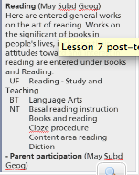
Reading
Reading – parent participation
Reading – study and teaching
Reading – parent participation – Canada
Can’t tell

- A student performed a subject search in Clues, under the subject heading “Reading-study and teaching” and receives 0 hits, what is the explanation
Concordia does not own any books on this topic
This is an invalid subject heading
This heading should have been entered in the plural form
Can’t tell

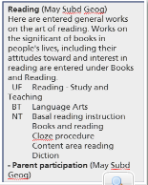

- If one wanted to locate books on attitudes towards reading what subject heading would they look under?
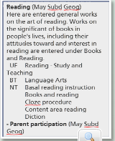
Reading
Reading – study and teaching
Books and reading
Reading – parent participation
Can’t tell

Lesson 8: Searching the Database

Subject Indexes/ Databases
List the articles written within a specific field in specified periodicals published over a specific period.
Designed to point out sources or information on a particular topic within a field.
Provide enough information for the user such that they can determine the location of the item.
Available in print form

Abstracting sources
Is a critical retrieval tool when searching for scholarly information within a particular field. Abstracting sources differ from indexes in tht they provide a summary of the items they list. Each abstract presents the contents of the work, the findings, and the conclusions all in an abridged form. Scanning an abstract can save you a lot of time, because it will reveal whether the article is relevant to your work or not. Abstracts also tend to be more comprehensive in their coverage of the material related to that discipline.

For abstracting sources, keep in mind….
They are a key tool for access to material within a given field.
Similar to subject indexes but differ:
- Along with the citation, provides an abstract of each item.
- Provides access to other material such as conference proceedings, reports, dissertations and books
- Provides access to foreign language material.

Types of databases (4)
- Subject
Equivalent to a printed subject index or abstracting source.
Provides access to the most recent scholarship within a field
Most important took within a field
Contains citation and abstracts to periodical articles and other material

- Numeric
Contains numeric, financial or statistical information
Often used in business or for government stats

- Multi-disciplinary
Contains citations, abstracts and the complete text of periodical articles.
May also include non scholarly information
Usually multidisciplinary with no print counterpart

- Other
Indexes specific material such as dissertations

Databases can be accessed by title or by subject.
While there are different types of databases, there are also different suppliers of databases. Each supplier has their own software to search the database, much like the different OPACs, so each system is searched differently.

Before beginning your search, it is a useful strategy to refer back to your preliminary thesis, outline and working bibliography. Once you have a clearer sense of what it is you are looking for, use the Research guide and database finder to help locate the appropriate databases.
-Review your thesis, outline and working bibliography
-Decide which type and kind of databases you need to search
-Gather information on the databases by clicking more info.

Planning the search strategy
Review your list of keywords, synonyms and related terms: are they still valid?
Prepare your search statement because it will: help to logically and systematically review what it is you are looking for and help to plan back up strategies on results found.
Review your original search statements: how many concepts, have the Boolean operators been used correctly.

Records can represent a citation to a book, a chapter in a book, an article, a conference paper etc.
Fields there are 4 kinds, author field, title field, abstract field and descriptor field.

Keyword searches in Databases
They are similar to conducting a keyword search in an OPAC as multiple fields are searched to locate your keywords.
Boolean operators and truncation should be used.
Limit commands are also recognized by limiting features and will differ from OPAC. They may include: document type, peer review, language and methodology used.
Full text is available.: full text is not available from subject databases.

Multidisciplinary databases
Are available via Concordia and the majority of these are offered as full-text databases. They provide the complete text to articles so that one does not have to track down the printed source.

The method of searching this database will be consistent with what we have learned previously, however one word of caution….
Subject terms are very general given this database indexes material from every discipline. You can access the online thesaurus by clicking on “Look Up Subject terms” from the Advanced search screen.
Things to keep in mind...
- Supplied by ProQuest
- Access to over two million doctoral dissertations and masters theses published since 1861.
  - Indexes 90% of dissertations and theses published in North America and 10% of the content represents documents published elsewhere in the world.
  - Abstracts are included for dissertations since July 1980, and for masters theses since 1988.
  - Most of the full text starts from 1997 to the present including some that go as far back as the early 1900's.
  - Subjects are broad categories - controlled vocabulary
  - Keywords - Supplied by author or editorial staff

More database resources
- Government documents
- Canadian Research Index
- Statistics Canada Catalogue
- Statistics Canada Website
- Statistics Canada Publication

Evaluating Material found on databases
Prior to marking records for inclusion in your working bibliography, scan the title and abstract, using the criteria that was discussed in Lesson 4 to evaluate the quality and usefulness of the source.
Purpose: Why was the item written or why was the study conducted?
Authority: Is the author credible and knowledgeable on the subject?
Scope: Is the item directly related to an aspect of your topic that you wish to discuss?
Format: Does the author include any interesting features that are of value (e.g. a survey that was used to gather data, tables of findings, a bibliography)?
Audience: Is the item intended for a scholarly audience?

All databases allow the ability to export your marked records to RefWorks. Remember that you will be retrieving different types of material on these databases, so make sure that they have been transferred into the correct Ref Type.
- Marked items from any of the databases can be exported to your RefWorks database.
- Different types of material may be transferred (e.g., articles, reports, dissertations, chapters from books, government documents).
- Review and edit entries within RefWorks to ensure information is complete and accurate
  - Has the correct Ref Type been selected (e.g. is a journal entry using the Journal Ref Type)?
  - Has information been transferred into the correct field?
  - Have you manually entered the Source that was used to locate the item (i.e. CLUES), the date you retrieved it, and your personal notes?
- Manually enter the Location information for each of the items
  - Include library & call numbers for journal articles found in the printed volumes, or the supplier and database name for articles found in a full-text database

Post-Test
- When searching a subject or multi-disciplinary database for documents on my subject, it is recommended to use the terminology specific to the database. To identify the necessary specific terminology I would consult
An ideogram
A subject/specialized dictionary
A thesaurus for the database
A general purpose dictionary
I do not know
- A friend told me that I should read a journal article published in May 2010, issue of internet guide. Searching the invisible web by mark Jacobs. To check the availability of this article at the library, I search in the online public access catalogue under
Internet Guide
Mark Jacobs
Searching the invisible web
A,b,c
I do not know
- Subject databases are necessary to consult when conducting the literature search as they
Help to locate books and non-print available within Concordia libraries
Provide access to an array of scholarly material
Help to store bibliographic references obtained from one’s searches
They are not useful
- Limiting fields in databases such as CLUES or ERIC contain information that
Allows you to locate the complete text of the item
Allows you to restrict your search to a specific database
Describe the subject of the record
It is common to many records within the database
- Which of the following are examples of databases suppliers
ERIC, PsycINFO, Digital dissertations and theses
CLUES, MUSE, Atrium
ProQuest, EBSCO, ISI
RefWork, Columbo, Metafind
None
Lesson 9: Searching the Web
The internet is the world’s largest library, as full of lies as truths, with no card catalogue, no librarian, and someone has torn the cover off all the books.
It is a worldwide network of interconnected computers that allows users to access and transfer information remotely. The information viewed on the internet is actually on other computers, and viewed VIA the internet. It provides access to a wonderful array of information sored on remote computers. However given its size, the lack of control over what is posted, and the lack of organization of the information. Its large and dynamic nature presents problems for those trying to index its content, as well as for those who are trying to access the content.
Developed in the early 1990s.
Users experience problems due to the
Sheer size and dynamic nature of information. At times, searchers experience problems using retrieval tools such as search engines because of the sheer size of the web. The current version of the internet protocol, version 4 was designed in the 70s to be able to handle 4.3 billion distinct web addresses.
No bibliographic control the fact that there is no bibliographic control or no list of standardized headings or controlled vocabulary. This means documents do not have edition numbers, elements that you would find in the printed sources that provides control over when a particular edition of an item was published.
Queries under-specified and ambiguous there is no controlled vocabulary, so keyword searching is the only method of accessing the information. Most users don’t design a precise search strategy, but instead punch in one or to words. This is compounded by the fact that the entire website is scanned for these keywords. There is a higher risk of retrieving broad search results with many false hits.
Lack of understanding of search engines users don’t often understand how search engines are interpreting their query. They are poor and searchers oftentimes don’t understand how the retrieval tools are interpreting their search query.

Automation of search tools because search tools are automated, they don’t have the ability to focus a search or ask questions as a librarian would.
Inaccessible from retrieval tools invisible web and the fact that much is inaccessible from retrieval tools. Only 30% of the web is indexed.

What type of information am I looking for?
Opinions, facts, statistics, scholarly, product info | Much like the databases, it is necessary to make some decisions before getting online. Given the array of information that can be found, including opinions, facts, stats, company and product info, the first step is to determine the type of information that you’re looking for as search strategies can be designed to zero in on what is needed.
What type of information have I found?
Using domain names (see next slide) | Following a search, a quick scan of the domain name can help you form a judgment about the type of information that would be posted to the website.
Looking beyond the home page | A common problem is that users retrieve information directly from a website’s home page rather than using it as a springboard to locating a relevant document. Your goal when searching the web is to locate the same type of information that you would have found in printed sources…. An article, government document, research report etc. So scanning a website’s home page to look for useful links to this type of information is a good strategy. Various hyperlinks to watch for are: Resources, Publications, or Research.
What is the quality of the information that I have found?
Using evaluation criteria for the web | Finally you must determine the quality of the information found. In Lesson 4 we reviewed a useful set of criteria that one can use. We will revisit this criteria at the end of the lesson.

Generations of search engines
The first generation search engines were released during the 1990s when the web first came to scene. During this time, rudimentary search engines determined their relevancy ranking based solely on an analysis of the location and frequency of words on a page. During this phase, the industry was really in its infancy with many companies coming and going.
The second generation search engines were led by google in the 200s. This generation determined relevancy ranked based on a complex link analysis formula that looked at the number of links a website had pointing to it from other websites. This strategy uses the same premise as a citation index. A search engine’s software would look at how often other websites link to these pages to determine how popular or useful each one is.
The third generation is the most recent since about 2009 until now. It built on the successful formulas used in the second generation engines, but we have enhanced these. Many companies are now moving forward toward offering personalized searches, which means providing better intelligence to guide users to the results they are looking for.

Zuula Meta, fazzle, clusty, dogpile, clipblast are all search engines, they are a search query that allows multiple search engines databases in on query. Saves time because only one search is performed, collates and displays the results in one listing.

When to use what tool
Directories (table of contents browse)
Search engines (index search by keyword)

Summary of Online Health Topics Search | Evaluation of Online Health Topics Search
- Eighty percent of American internet users, or some 113 million adults, have searched for information on at least one of 17 health topics.  - Among the internet users who say their last search had any kind of impact:  - 58% say the info they found affected a decision about how to treat an illness or condition.  - 55% say the info changed their overall approach to maintaining their health or the health of someone they help take care of.  - 39% say the info changed the way they cope with a chronic condition or manage pain. | - How many actually evaluated the quality of the info?  - 15% say they “always” check the source and date of the health information they find online.  - 10% say they do so “most of the time.”  - 75% say they check the source and date “only sometimes,” “hardly ever,” or “never”.  - This translates to about 85 million Americans gathering health advice online without consistently examining the quality indicators of the information they find.  - One third later talked to a doctor about what they found online. Two thirds did not.

It is your job, as searcher, to evaluate what you locate in order to determine if it suits your needs.
Look for basic information, authors name, date of document, contact information, URL…

When browsing through the results of your searches, review the information on the website and decide on the:
- Purpose: Why was the item written or why was the study conducted?

- Authority: Is the author credible and knowledgeable on the subject?
- Scope: Is the item directly related to an aspect of your topic that you wish to discuss?
- Format: Does the author include any interesting features that are of value (e.g. a survey that was used to gather data, tables of findings, a bibliography)?
- Audience: Is the item intended for a scholarly audience?

Post-test

- There are both meta-search engines and search engines, which serves as two different types of web retrieval tools. What is the difference?
A search engine has its own database, while a meta search does not maintain its own database but instead scans the search engines’ databases
Meta search engines allow for advanced searching, while search engines just offer a basic search
Meta search engine is larger
Meta search engine are no longer used
None

- When using a search engine, there are many factors that affect which websites you see first, that is, those which are highly ranked. Which of the following factors will produce a higher ranking?
Location of key words on page
Size of the website
Quality of graphics
Repeated use of key words on page
Number of links a site has to other pages
Number of times a web page has been accesses

- Why is it important to include the date that one accessed a website in a bibliographic citation?
Because it is the only way to retrieve the website again
Because it informs your reader about the currency of information that you have found
Because it provides some bibliographic control over content that may be changing frequently
It is not important to not this date
None

- Using the advanced search option offered in search engines is useful as it allows to
Export their search results to RefWorks
Save their search strategy
Search multiple search engines
Use features such as Boolean logic and limiting commands easily
None
- When searching in a directory, the following are recommended strategies to use
Browse subject categories moving from general to specific
Browse subject categories moving from specific to general
Scan the alphabetical listing to look for relevant websites
Consult the thesaurus for relevant keywords
None of the above
- Scanning the domain name of a website is useful as it
Provides an indication of when the information was posted to the website
Provides an indication of how the website was retrieved
Scanning the domain name dos not provide any useful information
Provides an indication of the credibility of the information that has been posted to the website

Lesson 10: Putting the information to work

In-text References and Citations
Definition: the process of acknowledging sources used for a research paper.
Notes are integrated into paper and must blend into the research paper.
Remember: whenever you use other people’s material make certain you do not unintentionally echo the author’s language.

You must include a reference to the source when
- You se another persons ideas, opinions or theories
- You use facts, statistics, graphics, drawings, music, etc or any other type of information that does not compromise common knowledge
- You use quotations from another person’s spoken or written word
- You paraphrase another person’s spoken or written word

APA style of an In-text citation
- The author’s last name
- The date of publication
- The page number of the reference (only if it’s a direct quote)

Blending in a quote
A good way of blending in a quote, credits the source properly, correctly uses paraphrases and quotation, and demonstrates that the writer has as understanding of what the author did.

Some additional advice
- Use a full independent clause of your own to introduce the source material.  - Morrow views personal ads as an art form: “The personal ad is like a...”  - Avoid using a weak lead-in verb.  - Poor: “The author says”  - Good: “The author questions” | - Integrate text into the logic and order of your sentence.  - Explain to your reader why the idea is significant in the context of your ideas.  - Smoothly integrate the quotation into the surrounding language.

What is a thesis it advances a conclusion the writer will defend. It serves as the focus of the paper. The paper will develop, defend and support the thesis statement.
The purpose of which is to:
- Provide a focus for the paper, states the papers subject
- Provide control over what you might write
- Give order to the paper by providing unity and a sense of direction
- Tell the reader the purpose of the paper in that it answers the question “whats the point of the research”
- Limit the subject to a narrow focus
- Help to determine the major subdivisions in your outline
- Point to a conclusion
- Use specific language

Preliminary thesis: not quite final, a few sentences to continue research and further develop your final one.
Final thesis: final thesis statement used in your paper
Although the thesis statement points to the conclusion of the paper, it is not the conclusion. Instead, it should set in motion your examination of facts so that you can reach a conclusion.

A thesis statement provides a focus for the paper and is an assertion or a claim.
Poor example: | Good example:
- The health benefits of exercise such as riding a bicycle to work  This is actually not a statement because it is not saying anything. It is a topic, but not a statement. There is no claim here and the reader is prompted to ask “What about the health benefits? What do you want to tell me about it?”  - Not a claim, it does not make a statement.  - Reader’s response is “What about the health benefits?”  - What point do you want to make to your reader? | - The health benefits of exercise, such as riding a bicycle to work, include increased cardiac capacity and muscle strength.  Our good example meets the criteria of a good thesis statement.  - The reader is aware of the focus.  - The reader is aware of the direction.  - The reader is aware of what the writer wants to support with their research.
Hints:
- Never use “I”: “I think the health benefits from exercise, such as riding a bicycle to work, include increased cardiac capacity and muscle strength.”
- Don’t be undecided: There might be health benefits from exercise, such as riding a bicycle to work, that include increased cardiac capacity and muscle strength.
- Do not formulate as a question: Are there health benefits from exercise?
- Remember, use an assertion and make a point: Complexities in technological development contribute to the rising cost of automobile repairs.

Step by step approach to formulating a thesis statement

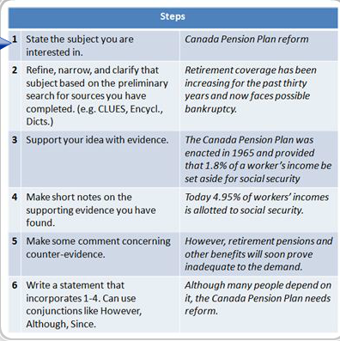

Formal outline its purpose is to help organize the arrangement of your final paper and save time. Visually shows how parts fit together. Helps to organize your thoughts so that you do not overemphasize a minor point or ignore a major one. Exposes strengths and weaknesses of your paper in time to make adjustments. Finally, it reveals the development of your thesis.

Topic Outline | Sentence Outline
Notice that each entry is not a sentence so they therefore do not end with a period. Also notice the logical arrangement in which the topics are organized. In addition each item is a word or phrase. | This is that same outline, but in a sentence format. Notice that each entry is a full sentence, thus requiring a period. Also each item is a complete sentence and takes longer

There are 9 formal conventions for outlining.
- Indentations: show differing levels. A lower level is indented within a broader level.
- Notation: included the use of numbers and letters. Roman numerals are the most general level, followed by capital letters, followed by Arabic numbers, followed by lower case letters. The principle then, with the indentation and notation, is that within each major subdivision each succeeding level shows more specific detail than the one before it.
- Principles of division and subdivision: Each level must have more than one entry. This is based on the premise that when you divide something, it must be into at least two parts. Therefore you cant have an a without b.
- Level of generality: Refers to all divisions and must be at the same level of generality, meaning that a main idea cant be paired with a supporting detail.
- Overlap: Headings do not overlap.
- Parallelism: all entries within a level are parallel
- Capitals: only the first word of each entry is capitalized.
- End each sentence with a period
- Introductory and concluding paragraphs they are usually omitted, the thesis is given above the outline.

References
Throughout the term you have been compiling your working bibliography. The sources included in the working bibliography will be used in the final bibliography. Just as a note, the APA style calls the “Works Cited” or “Bibliography” at the end of your research paper the “References”. However, in this course, we will continue to refer to it as you "Bibliography".
Works Cited, aka Bibliography
Purpose: To provide the exact location of all facts, ideas, statistics, comments, opinions or quotations that are not your own.
- Include all sources cited in your paper
- Do not include background material
- Must be formatted according to a punctuation style
- Use Publication Manual of the APA (6th ed.)
At the end of a research paper, you must provide a full bibliographic entry in the bibliography section for each of the items from which you have drawn information for your paper. The purpose of the bibliography is to provide the exact location of all facts, ideas, statistics, comments, quotations or opinions that are not your own.
This section should include all of the sources cited in the paper's text. Include no other works no matter how useful they may have been to you at some in your research. This means that the References section will not include works that contributed background information (or common knowledge) to your research such as an encyclopedia article.

Why cite?
When preparing a piece of work, it is inevitable that you will refer to sources written by other authors. It is essential that you provide detailed, accurate information about the sources you have used. This information must be provided for a number of reasons:

- You must correctly acknowledge your use of the statements, opinions, findings etc. of other authors that you have used in your research. Not to do so amounts to plagiarism.
- Correct citations allow others to use your work as a research source for which you will be cited!
- Accurate citation allows you to return to your work at a later date and still make use of the research previously undertaken.
- As a general rule, a citation must enable another person using your work to easily identify and locate the source that you have used in your research.

APA References

When formulating your bibliography and verifying that RefWorks has done its job to your satisfaction, there are several factors to keep in mind.
- Place the bibliography on a separate page from the rest of your research paper and entitle it Bibliography.
- Arrange each item alphabetically by last name of author, or by the first significant word of the title if no author is given.
- Use double spacing for each entry, and skip a line between each entry
- Use hanging indents.
- Use periods to separate the major sub-divisions of information in the entry (e.g. author, title, publishing information).
- Use initials for authors' first names. All names are inverted. Enter all of the authors' names, unless there are six or more, in which case use the first author name followed by et al., meaning 'and others' in Latin.
- The first character of the first word in a book title or article title should be capitalized only (unless proper name).
- Use an ampersand (&) in front of the last name in the case of joint authors.
When listing multiple works by the same author list them in chronological order by date of publication.

Citation Styles is a set of rules and guidelines for how to document references to information sources in the text of your document and in the bibliography.

Annotation is a compact descriptive or critical note of an item. Its purpose is to convey in a brief paragraph, a clear, valid and interesting summary of the item’s qualities and characteristics.

Post-Test

- The three basic elements of an in-text citation, according to APA are
Authors full name, date of publication, page numbers
Authors full name, date of publication, publisher
Authors last name, date of publication, title
Authors last name, date of publication, page numbers
- The thesis statement is useful to
Focus the paper and provide control over what is written
Focus the paper and show the relationship between major and minor divisions
Focus the paper and provide a summary
Focus the paper and link the list of references
- A sentence outline is
Composed of topic statements
Composed of sentences
Composed of paragraphs
Composed of both topic statements and sentences
- According to APA, a final bibliography included
All of the sources encountered during the literature search
Only the sources used in the writing of the paper
All of the background reading sources
All of the sources and the in text citation
- Annotations can
Be used to replace an outline
Be used to replace in-text references
Be used to characterize an item
None of the above

