Topic 1 – Perception, Emotions, Values

Perceptions Does not equal reality

What Influences Perception:
1. The Perceiver emotions, attitudes, personality, motives, experiences
2. The Target how loud, attractive/unattractive, moving
3. The Situation context of everything, location, day vs night time

Perceptual Errors:
Attribution Theory
1. Distinctiveness if behaviour is same across variety of situations = internal
2. Consensus if everyone would behave in the same way = external
3. Consistency the behaviour the same every time = internal

-Selective Perception seeing what we want to see to make sense of the situation; angel with friends
-Halo effect drawing a general impression based on one characteristic, Contrast effect reaction to one person put against another, Stereotyping judging based on group, prejudice dislike because of stereotype

Personality = Stable, unchanging, consistent with how they react and interact with people

Big 5 Personality Test:
1. Openness – (incentive/curious vs consistent/cautious)
2. Conscientiousness – (efficient/organized vs easy-going/careless)
3. Extraversion – (outgoing/energetic vs shy/reserved)
4. Agreeableness – (friendly/compassionate vs competitive/outspoken)
5. Neuroticism – (sensitive/nervous vs secure/confident)

Machiavellianism – ends justifies means, Narcissism —i love me, Type A – get shit done, Type B – relax

Emotions = intense feelings directed at someone/something that come and go, Moods = less intense and lack stimulus + keep for longer

Emotional Labour – performing organizationally desired emotions e.g faking being nice
Emotional dissonance – inconsistencies with emotions they feel and emotions they show
Surface acting – hiding feelings to display what is required e.g boothgirls
Deep acting – convincing yourself to feel one way, worst one

Emotional intelligence – reduce stress, read situations, optimize environment
Emotions vary between countries pride in U.S.A vs China

Values = a specific mode of conduct or end state of existence is personally preferable than the other
- Rokeach’s Value Terminal Values—desirable end states, instrumental values – ways to behave to reach end states.

Hofstede’s Framework for Assessing Cultures
1. Power Distance: high = accepting of how much power is distributed, comfortable with inequality
2. Individualism: high = prefer to act as individuals, low = collectivism, tight social framework
3. Masculinity vs Femininity: M = men should be this, female should be that. F = overlap
4. Uncertainty Avoidance: high = feels threatened by uncertain situations, need laws. South Africa
5. Long T = future, persistence, saving. Short T = tradition, past and present (asia)

Shared Values = most positive work attitude, lower turnover, greater productivity
Generational Differences: Elders(over 60): belief in authority, discipline, play by rules. Baby Boomers (1940-1960): spoiled, rejection of authority, environment + equality. Generation X (1960-1980): flexibility, job satisfaction, work-life balance. Generation Y (1977-1997): meaning in work, diversity, technology

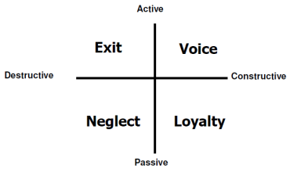
Attitudes: Pos/neg feelings towards people, events, objects (unlike values, can change at anytime)
3 Ways Attitude Affects Jobs:
1. Job Satisfaction: how happy you are with job, responses to dissatisfaction=
2. Org Commitment: Affective (i like here), Normative (obligation, loyal), Continuance
(calculated cost is worse if leave)
3. Employee Commitment: how involved, engaged and passionate someone is

Topic 2 – Teamwork

Pros: Resource Pooling, Synergy, Easier implementation
Cons: Time, dysfunctional groups (dominant, responsibility, over conformity)
1. Set ground rules: e.g how to resolve conflicts
2. Consider Location: where+ when to meet
3. Start + end on time, keep people on track + avoid tangents
4. have an agenda and stick with it
5. incorporate roles, make sure everyone knows what they’re doing
6. align priorities, participation, open communication,

Topic 3 – Communication + Presentation Skills

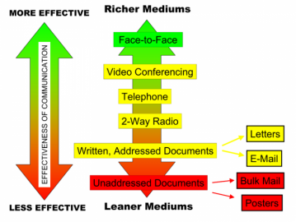
Communication Richness:

Communication= access to information to make good decisions
Downward = newsletters, info books, emails, meetings
- initiated by management, delivering “need to know” to all levels of employees
- Negs = information overload, telephone game, too much info or too little, *make it regular
- CEO visits, negatives? – not accurate of whats happening, CEO promise things that wont be delivered, have to be consistent to be taken seriously
Upwards =opinion surveys, suggestion programs, focus groups
Negs = fear of reprisal, filters (telephone game as it moves up), lack of action (discourages)
- Be aware of grapevine

- Why orgs fail at effective communication: physical barriers, stress, politics, fear, hesitation to be honest, status differences, culture, written vs personal communication

6 C’s of Communication
1. Completeness necessary info, answers all questions
2. Conciseness eliminate wordy expressions
3. Consideration show audience benefits and interest
4. Concreteness Specific facts and figures are inputted
5. Clarity Precise word and effective sentences
6. Courtesy respectful, thoughtful, non-discriminatory

Presentations Be prepared, small talk, know your audience, what benefits them, using 6 C’s of communication,

Topic 4 – Org Culture + Structure

JOB DESIGN=the way that a set of tasks, or entire position is organized
Job Rotation: doing a variety of tasks instead of too much of a routine
Pros: More motivated, increased morale, less mundane, more flexible workplace
Cons: Reduces productivity, no specialization, time wasted on training
Job Enlargement: horizontal expansion of jobs increased variety of tasks at same level
Pros: people feel more useful- filling potential
Cons: doesn’t add challenge, just more to do
Job Enrichment: Vertical expansion
Pros: responsibility, freedom + independence, less of hierarchy if more people in charge
Cons: extra training costs + time, people might not want more responsibility

Job Design/Dimensions: 5 Aspects
1. Skill Variety: degree to which a job requires different activities. High = management decisions, low = painter who does the same thing every day
Increase job enlargement + enrichment

2. Task Identity: degree to which job requires completion of a whole and identifiable peace of work
High = cabinet maker who designs, makes, furnishes everything
Low = assembly line worker
Increase Job enrichment

3. Task Significance: degree to which a jo as substantial impact on lives or work for other people
High = doctor
Low = janitor

4. Autonomy: degree to which you have freedom, independence, discretion to individual scheduling
Provide higher job enrichment

5. Feedback: degree to which you can obtain direct and clear info about your performance

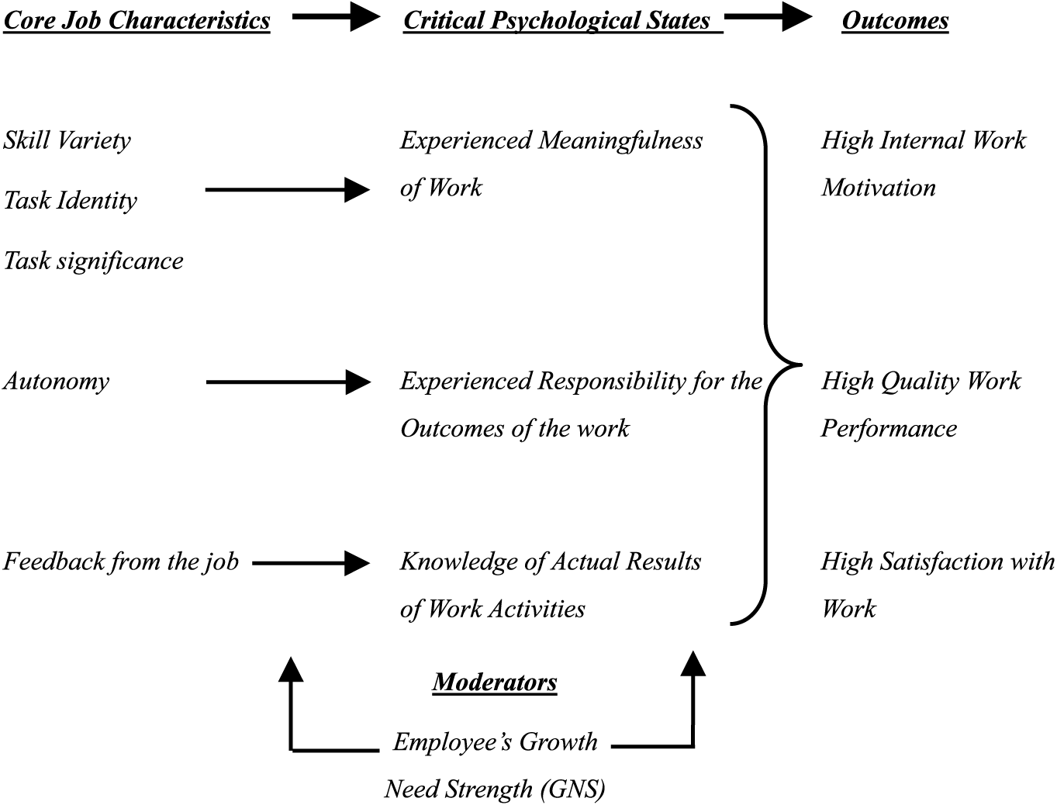

How to create a Flexible Workplace:
1. Compressed Work-week: four-day 10hour shifts enthusiasm, commitment
2. Flextime: work when you want productivity + satisfaction, but not suitable for all jobs
3. Job Sharing: Good for flexibility, but difficult finding compatible people + managing them
4. Telecommuting: Can be more productive, but miss out on social aspect

Org Culture= a system of shared values (what matters) and norms (accepted attitudes + beliefs)
-iceberg= top is physical artifacts, what we can see + hear. Bottom = underlying values, beliefs.
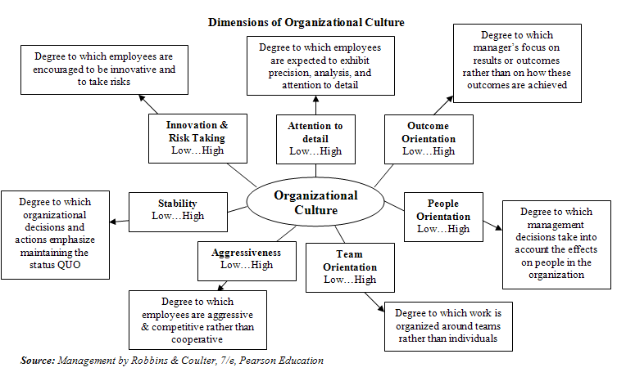
How Employees learn culture: language (starbucks), stories, rituals (red robin bday cheer), material symbols (clothes, furniture)
- Founders usually have huge impact on the culture

Ways to Read an Organizations Culture:
1. Observing physical surroundings: signs, pictures, office layout. E.g servicescaping 5star hotel, or las vegas gives you clear understanding of what to expect
2. Music: fast tempo + loud music makes people more aroused, match, sports game
Slow: restaurant, slower, stay longer
3. Scent: ambient smell that influences of environment, e.g smell at hospital
4. Color: red is warm, blue is dependable, purple means royalty, e.g
5. People you Meet: serious vs jovial, informal vs formal
6. Background of company, how they handled a crisis

Org Structure= how tasks are formally divided, grouped, and coordinated
6 Ways of Defining a Structure:
1. Work Specialization: high = each task is divided into separate job. Pros = efficient and less costly to train. Cons = boredom, fatigue, low productivity.
2. Departmentalization: How jobs are grouped together. Functional, product, geographical, process, customer.
3. Chain of Command: who reports to whom continuous line of authority
4. Span of Control: Wider span = more employees report to one manager pros: efficient in terms of time and cost, cons: employee support, less opportunity for progression. Narrow span = less employees report to manager Pros = can maintain close control. Cons = expensive, discourages autonomy, and vertical communication becomes complicated (which manager do i report to?)
5. Centralization: Decentralization = decision making is distributed to low level employees. Pros= customer issues can be taken quickly, employees feel more involved.
6. Formalization: Degree to which jobs are standardized and formal, lots of rules, clearly defined procedures to provide consistent service. High = mcdonalds, low = salesperson

3 Types of Traditional Org Structures
1. Simple structure
-Most small businesses flexible, fast, low maintenance = low departmentalization (low # of employees), high span of control + centralization (decisions made by founders), low formalization (not many procedures + very flexible)
however, no specialization so efficiency is lower. Not suitable for growth à have to spread out workloads to others. If you have low formalization and high centralization à work overload
2. Bureaucracy
high specialization, chain of command, centralization, formalization. Low span of control
-strength ability to perform standardized activities in highly efficient manner
-weakness can create subunit conflict getting handed over to department to department
-e.g telus many different departments
3. Matrix:
combines functional and product departmentalization – has a dual chain of command
-e.g employee has 2 bosses e.g functional department managers and their product managers
-e.g two different ways to progress in a company
Strength very flexible, efficient allocation of specialists and great to facilitate growth
Weakness àconfusion, power struggles, stress if my division chair asked me to do something, but the head of the bcom program asked to do something else, what happens? Requests can conflict between 2 bosses

Modular Organization small org that outsources major business functions. Pros = respond quickly, can devote talent to most critical areas. Cons =reduces management control of key parts of business

Org change = utilize change agents, who are catalysts and assume responsibility of managing change
Purpose, strategy, tech, structure, people, culture can all be changed

Kotters 8-step Plan for Change
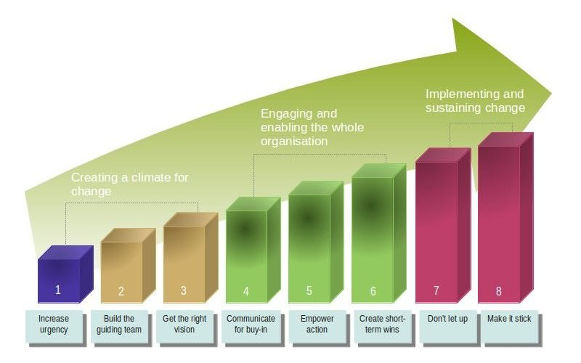
Individuals reject change b/c = self interest, misunderstanding, different viewpoints, low tolerance, and cynicism (why try again)
Orgs reject change b/c = loss of stability, threat to expertise, established relationships and resource allocations

Overcome Resistance with 6 steps
Education and Communication (logic) Participation and Involvement (put them in charge) Building support (training, therapy) Implementing fairly and consistently (logic) Select people who accept change explicit and implicit coercion (last resort)

Decision Making, Creativity, Ethics
Rational Decision Making= are consistent with value-maximizing within specific constraints
- Utilizes 6 steps
1. Define the Problem 2. Identify Criteria 3. Allocate Weights 4. Develop Alternatives 5. Evaluate Alternatives 6. Select best alternative
- Issues? can’t assume you have all information.
-e.g problem clarity, aware of all options, clear preferences to provide weighting, constant preferences, maximum payoff. All of this is assumed

How do people actually make decisions?
1. Bounded Rationality = being rational with the limited info that you have, you don’t research everything, e.g university choosing
2. Intuition – subconscious created by a person’s many experiences follow your heart, more people you talk to = more advice = more confusing. GUT instinct

8 Judgement Shortcut Issues:
1. Overconfidence bias – too optimistic about own performance
2. Anchoring Bias – fixated on initial info and dont adjust to new info
3. Confirmation Bias – selective perception, seek out info that reaffirms past choices
4. Availability Bias – base judgement on readily available info
5. Escalation of Commitment “i already put this much money in, yolo” carrying on with bad decision
6. Randomness Error – believing can predict outcome of random events
7. Winners Curse – maybe overestimating and paying too much
8. Hindsight Bias – believing after outcome that one could have predicted it

Group Decision Making= good and bad
Good =more complete info, creativity, accuracy, diversity, degree of acceptance around table
Bad = time consuming, can be dominated, groupthink

Nominal Group Technique survivor worksheet individually write down possible solutions, group takes turn to evaluate ideas individuals silently rank or vote. Does not restrict independent thinking

Creativity = needed to seek better solutions, simulated through 3 factors
1. Expertise: must be proficient with something to be creative in it
2. Motivation: Must have intrinsic motivation, find it exciting, challenging, satisfying
3. Skills: seeing things in a different light, be flexible

Ethics = Moral values or principles that guide our behaviour. Tell us what is right and wrong
- Difficult to teach because everyone has different opinions

People judge based on four criteria
1. Utilitarianism – greatest good for greatest number
2. Rights – fundamental liberties
3. Justice – fair and impartial distribution of benefits and costs
4. Care – protecting relationships

-Social entrepreneurships for profit but aim to solve a social cause. Ambitious and mission driven. Teaching how to fish rather than giving a fish. Utilizes triple bottom line.

Topic 5 – Motivation

Motivation = Intensity, direction, and persistence one shows in reaching a goal
Intrinsic internal desire to do something, or challenge yourself
Extrinsic from the outside, tangible rewards, etc bonuses pay

Maslow’s Hierarchy
-satisfying your extrinsic motivations than moving onto your intrinsic
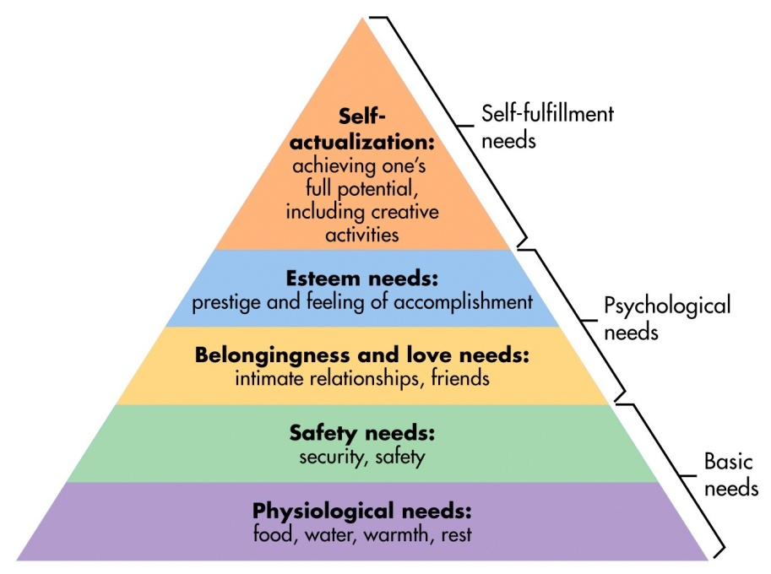

Motivation Hygiene Theory
- If you have hygiene you will be neutral, if you dont have it bad (extrinsic)
- If you have motivation happy, if you dont have it neutral (intrinsic)

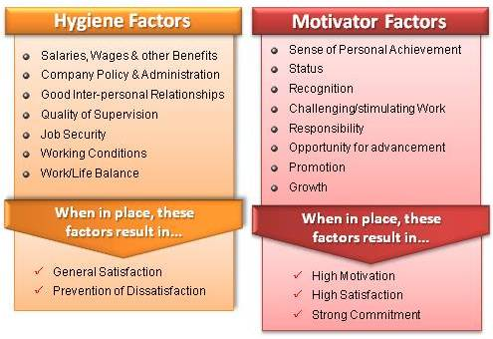

McClelland Framework
People have 3 needs. 1 Need for achievement (give them challenging projects with reachable goals), 2. Need for power (ability to manage others), 3. Need for affiliation (work with others)

Expectancy Theory
-Motivational Force = product of 3 factors
1. Expectancy Will my effort actually lead to good performance?
2. Instrumentality How likely you will get the reward given your performance
3. Valence How much the reward actually matters to you, is it valuable?
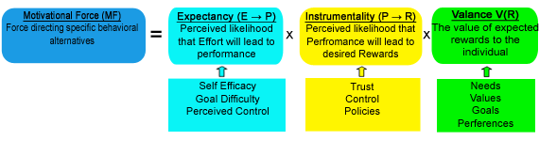
Importance of Recognition
- Important way to motivate employees that many people do not do
- e.g employee of month, respect, putting into positions of power, praise in public
-What gets measured gets done

Compensation all forms of financial returns and services+benefits an employee receives
1. Direct = Salary, base pay, incentives
2. Indirect = Benefits, worklife balance
Internal equity = within organization (sauder + arts dean), external equity = across organizations

Ways to get paid
1. Merit Pay increase in base salary safe for future years good credit
2. Bonus one time pay fluctuates, good for motivating individual output. Good for company because you are paying on their productivity.
Cons= very competitive environment. People might focus too much on a specific issue due to the metric, rewarding the right behaviour?
3. Profit Sharing – payments based on company’s profits, not part of employees base pay
Pros =employees think like owners, labor costs automatically reduced because during down times their pay goes down as well
Cons = individual effort and org performance is ambiguous (how much can one person influence the company?). Also, free rider problem if payment is always distributed equally

Topic 6 – Negotiation

Conflict = one party perceives that another party has negatively affected something that the first party cares about
1. Cognitive task orientated and relative to the different perspective and judgements
2. Affective emotional and aimed at a person rather than the issue

Conflict comes from: 1. Too much or too little communication, 2. Structural differences (sales vs production department) 3. Personal variables (personality conflicts)
Best way to resolve conflict Collaborating

In order to get to this Collaboration, need NEGOTIATION
- Need to listen, separate people from the problem, be well prepared, and have high EQ

Principled (Mutual Gains) Negotiation
1. Focuses on interests, not positions
2. Separate people from the problem
3. Invent options for mutual gain
4. Use objective criteria

Target Point result they hope to achieve
Resistance Point Lowest point, bottom line that party will accept
Initial Position first offer
BATNA Represent a point where walking away > making a deal. Good for anchoring your negotiation, harder to get swayed not your resistance point.
*Understand values and cost for opponents and value and cost for you (airplane example)

Negotiation Strategies
1. Differentiate Positions and interests
2. Don’t assume party has same info you do
3. Incorporate breaks/silences effective, people are uncomfortable with silences
4. Be clear and state your goals build relationship + guanxi
5. Remain Calm, no emotions unless planned
6. Signal early that there is a willingness to co-operate
7. Get info while guarding yours
8. Keep resistance point a secret, even after deal hold on to relationships

Negotiation Hard-Ball tactics
- Good Cop/Bad Cop e.g “let me talk to my manager (bad cop)”, “I want to give you deal, but i cant”
-High ball vs low ball
- Bogey pretend an issue is very important
- Nibble continuously ask for small concessions
- Chicken threats + ultimatums “im walking out” have to live with consequences
- Aggressiveness: intimidate, curse, pound table shock
- Always appear reluctant hide your emotions, poker face
- Flinch to offer “cant believe you would offer me that” influencing their bottom line

Research 3 issues
1. Relevancy
2. Acceptable to Opponents
3. Conflicting Conclusions

3 Steps
1. Get info that strengthens your points
2. Get research that weakens their points
3. Decide on relevancy based on underlying interests getting someone to agree with your underlying principle before revealing your research.

Planning Process 9 steps
1. Define Issues simple or complex
2. Prioritize see any links?
3. Define Interests Differences with positions?
4. Know limits and alternatives resistance points and batna
5. Set Targets and Openings what would you be satisfied with?
6. Assess Constituents and Social Context family member, stranger, employer, potential future?
7. Analyze other party issues, preferences, priorities, alternatives, targets, reputation
8. How to present Issues research, supporting facts
9. Consider Protocols where to negotiate? Agenda? Timing?

Concessions
-people expect them actually feel better when there are more concessions b/c they feel they influenced the other side
- signify that you acknowledge other position and moving towards it
- must give yourself enough room to give concessions, utilize bogeys
- Look for patterns in opponents concessions, if unwavering perhaps they are high/low balling

BATNA
- strengthen your BATNA, always improving your alternatives, and also suggest reasons why other side’s BATNA is weak (e.g pay raise)

THINGS TO CONSIDER
Anchoring - First impression, and makes small adjustments based on negotiation
Precision - $1000 vs $999. General anchors made people automatically adjustment more compared to a specific anchor.. $21 $20 vs $19.75 $19.25
Make first offer allows you to anchor
Aggression – should be so that you can influence other side

Closing the Deal
1. Assume the Close – salesmen
2. Split Difference
3. Exploding Offer – “only have 2 hours” stop looking for alternatives
4. Offer Sweetener – “ill give you x if you agree to the deal”

Topic 6 – Power and Politics
Power = capacity that A has to influence behaviour of B, so that B acts in accordance to A’s wishes

6 Bases of Power
1. Coercive: based on fear, making it difficult for other people. Using strength, embarrass etc
2. Reward: Achieves compliance based on ability to distribute rewards that other view as valuable
3. Legitimate: Result of position in formal hierarchy. Accepted by others due to authority of position
4. Expert: Influence based on special skill or knowledge somewhat overrated b/c everyone is expert
5. Referent: Possession of desirable resource or personal traits. Enjoy doing things for them
6. Information: access and control of information. Has data/knowledge that you need.

3 responses to Power
1. Commitment referent + expert
2. Compliance legit + reward
3. Resistance coercive

Dependency = key to someone’s power, have to increase this
Political Behaviour using your power and doing activities that influence the distribution of advantages and disadvantages within the org

In org, do key things to establish power:
1. frame arguments in terms of orgs goals, makes you more credible
2. Develop the right image by knowing the org culture
3. Gain control of resources, make yourself more valuable
4. Make yourself appear indispensable you are carrying the company
5. Be visible, make sure people are aware of your contributions
6. Develop powerful allies networking, blend in with powerful people
7. Avoid tainted members (ppl whos loyalty and/or performance is questionable)
8. Support your manager even if your boss is tainted, you don’t want people questioning your loyalty

Influence Tactics
1. Rational Persuasion using facts, data, and logic to present your ideas, ALWAYS viable
2. Inspirational Appeals appealing to values, ideals and goals when making a request
3. Personal Appeals appealing to loyalty or friendship
4. Exhange offering favours or benefits
5. Coalitions getting support of other people to provide backing
6. Pressure using threats and demands, only works if its people below you

Topic 7 – Leadership
Leadership = ability to influence a group to achieve established goals
1. Exert influence
2. Motivate and Inspire
3. Help others realize potential
4. Lead by example
5. Selfless
6. Make a difference
Differences between managers and leaders? managers provide stability, leaders bring in change
- Managers implement (coordinate, handle day-day problems) the leaders (CEO) vision and strategy

Leaders must develop a toolbox skills, and awareness to know when to use what skill

4 Frames of Leadership
1. Structural need order, rules, structure. Do their homework, focus on implementation, experimentation and evaluation
2. Human Resource = more of a family, relationships and empowering people. Believe in people and communicate that belief
3. Political = Jungle, where coalitions + conflict are necessary. Persuade, negotiate and coerce.
4. Symbolic = Temple, inspire people, framing experience through history and story, lead by example, communicates a vision

3 areas to Develop Leadership Skills
1. Knowledge = immerse yourself, self enrichment, observe other peoples situations. Utilize your gut instinct. And UTLIZE CRISIS’ = don’t waste it
2. Energy/ Passion = Optimism, when you enjoy something it is not work, don’t put limits on yourself or others. Link between physical, mental, spiritual and emotional.
3. Interpersonal Skills = get out of comfort zone, associate with many different people. Learn to communicate effectively and concisely.

Leaders challenge the norm = question why things are instead of sticking with the flow. Thinking out of the box

-Leaders should stick with important but not urgent columns, to prevent problems, establish growth for long term.

