Marketing Plan
Industry Analysis
The meal preparation industry has experienced exceptional growth over the past decade. Meal preparation business strive to provide busy families or elders who do not have time or difficulties to go grocery shopping, yet still want to enjoy home made food possible by delivering food ingredients to their door step. (at this point I don’t know if I should mention pre-cut meal deliveries. Afterall, most of other meal prep businesses provide pre-cut ingredients. However, we are different. If we need to define general term of food prep business If we were to describe VODS very briefly, we should mention family theme, allergies, etc I wonder if we need to talk about them in this section)
The industry revenue has risen from $7.2 million US in 2003 to $117 million US in 2005 (Lee Young, 2007). In the United States, by the end of 2005, there were approximately 550 meal assembly outlets. In that year, it was projected that the number of outlets will reach over 10,000 by 2010 (Severs, 2006). In addition to the expansion of the meal preparation businesses, online grocery industry is also projected to grow rapidly. It is predicted that UK’s market value of online shopping will double by 2015 (William Reed Business Media, 2010).
VODD’s product and service is a hybrid model that fits into both of the meal preparation and grocery delivery industry. We believe that these two industries are still young and have not yet reached market saturation. We are convinced that this industry has a strong growth potential based on consumer consumption, price, and firm production trends shown by the data presented in Agriculture and Agri-Food Canada, BC Stats, Statistics Canada, and Metro-Vancouver City Statistics.

SWOT Analysis

Competitive Analysis & Sustainable Competitive Advantage
Direct | Indirect | Future
Super Delivery | Green’s Earth Organics | Famous Foods
Westwood (located in the center of Kerrisdale, provide organic choices, and long history, wide range of loyal customers) | Green’s | Safeways
Choices | Stongs | IGA
SPUDS | Caper’s | Save on Foods
Many more | Many More | Many More

Direct competitors were chosen based on three characteristics namely, locality, meal planning and delivery industries, and sale of organic products. Indirect competitors were chosen based on philosophy of healthy nutritious organics, but outside of our proximity. Future competitors are companies that have high potential to enter our market segment with by providing more convenient online services they may also include large industries that are
We believe there are many different segments in our competitors as VODS offer both organic fruits and prep-meal deliveries.
VODS’ products are different from other competitors. We are targeting Kerrisdale community. Our long-term strategies are to develop a loyal customer base that will sustain our competitive advantage. We seek to improve economies of scale, gain higher power of bargaining power, reduce cost disadvantages independent of scale, and consistently improve product differentiation. We will achieve these goals by using our annual net income to our advantage by reinvesting into our company for proposes of financial progression. Through this process we hope to gain sufficient returns on equity and efficient return on assets.

Target and Segment Market Identification

Target and Segment Market Identification:
Describe at least 2 target markets for your product/service. Not too broad/narrow. Include demographics, geographic, psychographic, and consumer characteristics. Support with quantitative estimates and data for each target.
Data: city of Vancouver

Target Segment Location: Kerrisdale/ Quilchena Electoral district
Demographic
Neighbourhood Demographics

Total Adult Population | 10,407
Single | 36.6%
Married | 42.0%
With post-secondary ed. | 76.4%
Total Families | 2,740
Couples with children at home | 43.5%
Married with children at home | 41.7%
Common-law with children at home | 1.8%
Lone parent families | 15.9%
Avg. number of children/family | 1.1
Total Households | 5,604
Owners | 45.0%
Renters | 55.0%
Houses | 31.3%
Apartments | 65.6%
Avg. household income | $113,286
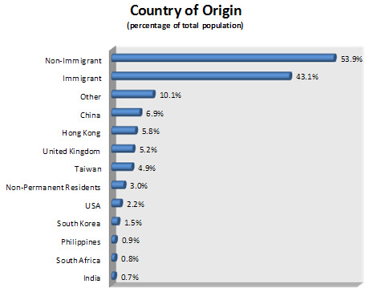 | 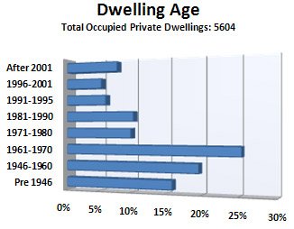

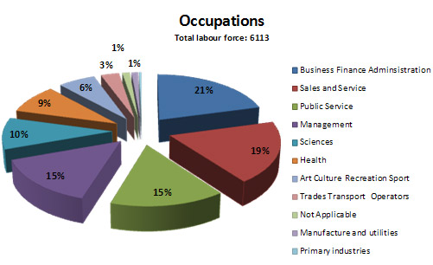

Geographic

Psychographic
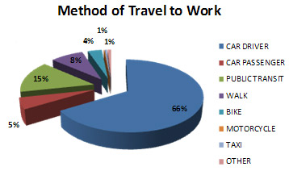

31.3% ELECTRIC AVENUES
Young upper-middle-class urban singles
Electric Avenues bring together a diverse mix of cultures in a vibrant city setting: apartment-dwelling singles from a dozen Asian and European countries all united by a youthful, educated sensibility.

13% GREY PRIDE
Midscale suburban apartment-dwelling seniors
Grey Pride residents have average educations an live in detached houses and apartment complexes built since the 1970s.

19.8% DAYTRIPPERS & NIGHTOWLS
Young lower-middle-class urban singles and couples
Their household incomes may be modest- -an average $41,000- -but Daytrippers and Nightowls residents are well-educated and pegged for advancement in their mix of white collar and service sector jobs.
http://www.blocktalk.ca/vancouver/kerrisdale/lifestyle/ - KERRISDALE
http://www.blocktalk.ca/vancouver/kitsilano/lifestyle/ - KITS
VODS Consumer Targets
Since our products and services are designed to contain 100% organic ingredients, customers have to be willing to pay premium for such goods. It is recognized that there exists a direct correlation between spending of food, household size, and income level (Ryomoto, 2009). Within Greater Vancouver, these households are located in communities such as Kerrisdale, Point Grey, Shaughnessy, West End (Downtown), and to a lesser extent various communities throughout Metro Vancouver (BC-Stats, 2006). VODS will specifically target residents at Kerrisdale and Kitsilano.

It is recognized that Kerrisdale is culturally efficient location and it is a hotspot for trendy food. Kerrisdale is highly residential to family oriented families. Many new immigrants and international students also reside at Kerrisdale. Many of residents in Kerrisdale are very comfortable in paying premium for organic groceries.

Kitsilano is located northwest end of Vancouver, another high-income area in Vancouver. Kitsilano is composed of mostly white and elder population. The residents at Kitsilano are health conscious and many are comfortable paying for organic products.

Over view of Human Resources

Manager’s salaries depend on net income of VODS and equally divided by 4.

- Meal planning assistants-
  - Part time employees prepping VODS pods
  - $10.50/hr
- Cashiers-
  - Greeting customers, explain our products, take calls, cash transactions
  - $10.50/hr
- IT Programmer-
  - Creating VODS website, maintenance of website, and in charge of online transactions.
  - $35/hr
- Truck Driver-
  - In charge of driving the delivery truck and successfully deliver VODS Pods to the customer
  - $25/hr

